APPLICATION FOR VARIATION/REMOVAL OF CONDITION
CASE OFFICER REPORT

APPLICATION REFERENCE: | PL/2026/01223
APPLICATION TYPE: | Removal/variation of conditions
SITE ADDRESS: | Manorfield Farm, Manningford Abbots, Pewsey, Wiltshire, SN9 6HY
DEVELOPMENT DESCRIPTION: | Variation of Conditions 2 (Plan Numbers), 3 (Materials), 6 (Landscaping) 9 (Documents) and 10 (Updated Wording) of planning consent PL/2025/04825
RECOMMENDATION: | Approve with Conditions

SITE DESCRIPTION/CONTEXT

The application site comprises an existing residential plot and dwelling known as Ross Poultry Bungalow, together with adjoining agricultural land containing three former chicken sheds and associated structures and areas of hardstanding, where works have already commenced. The site is large in scale and benefits from an established vehicular access onto the public highway to the east.

The site is located within a countryside setting, with other residential dwellings situated to the north and east, and agricultural fields adjoining the site to the south and west. The application site is generally enclosed by mature vegetation and lies within the North Wessex Downs National Landscape (formerly the Area of Outstanding Natural Beauty).

PROPOSAL

This report considers a Section 73 application for the variation of conditions imposed on planning permission PL/2025/04825. The application relates to the site at Manor Field Farm, Manningford Abbots, and seeks to vary conditions 2, 3, 6, 9 and 10 to planning permission PL/2025/04825 under Section 73 of the Town and Country Planning Act 1990 in order to allow for minor amendments to the approved scheme.

The proposed changes do not alter the overall nature or principle of the development, and are limited to modest design refinements, including a minor increase in the height of the dwelling and garage, the addition of a dormer to the front elevation, amendments to fenestration, minor internal reconfiguration, and increased soft landscaping. The variations are principally required to update the approved plans and associated documents, as well as to make minor adjustments to the wording of certain conditions so that they accurately reflect the amended drawings, materials schedule, landscaping proposals and updated site plans, as detailed in the submitted supporting information.
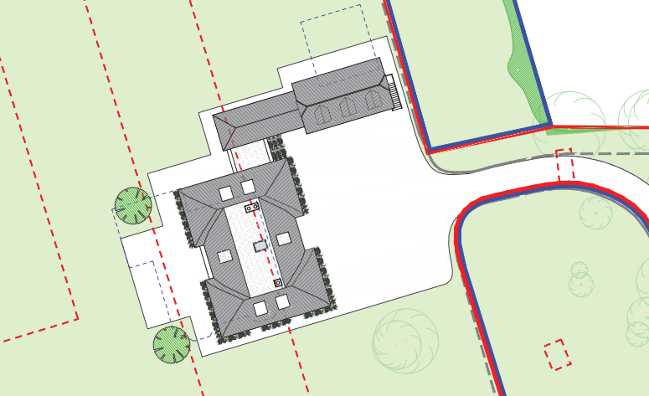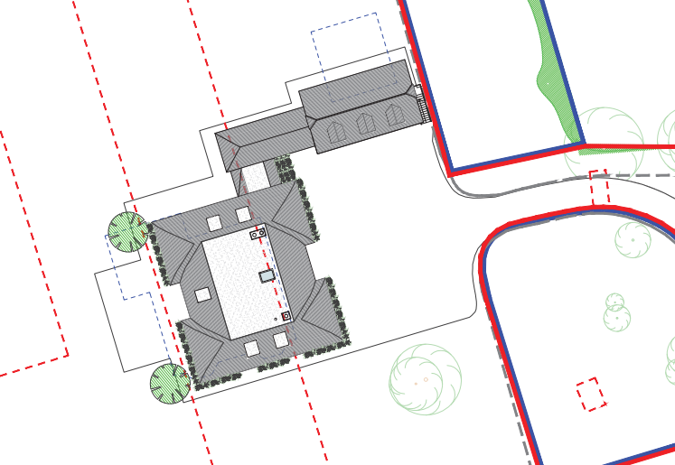
Approved scheme - Previous Approved scheme – PL/2025/04825

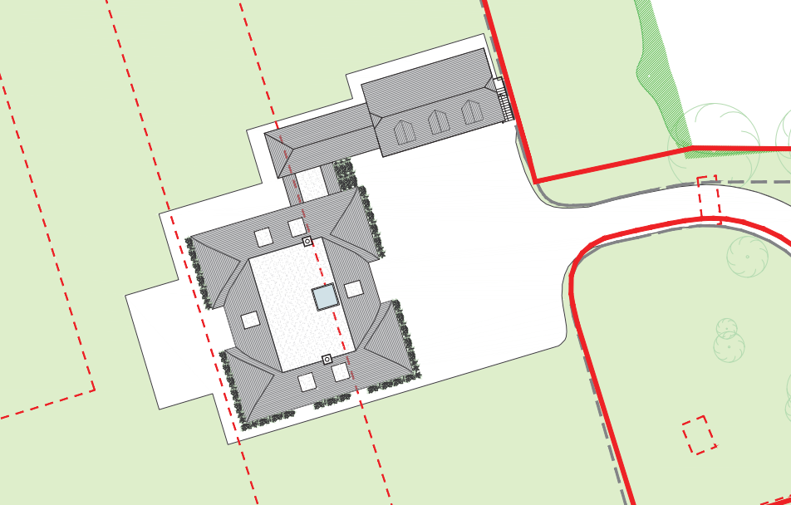

Proposed Scheme

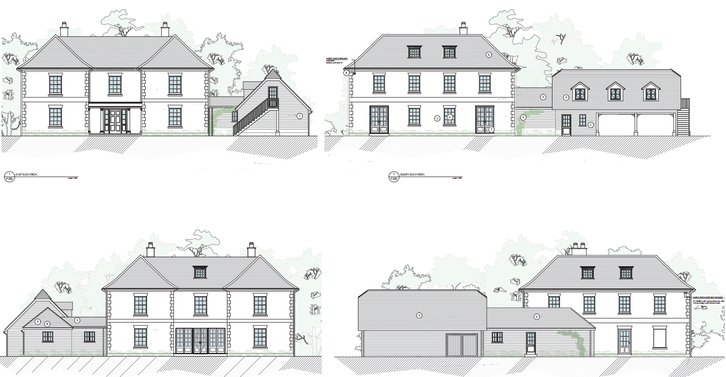

Approved scheme – PL/2025/04825

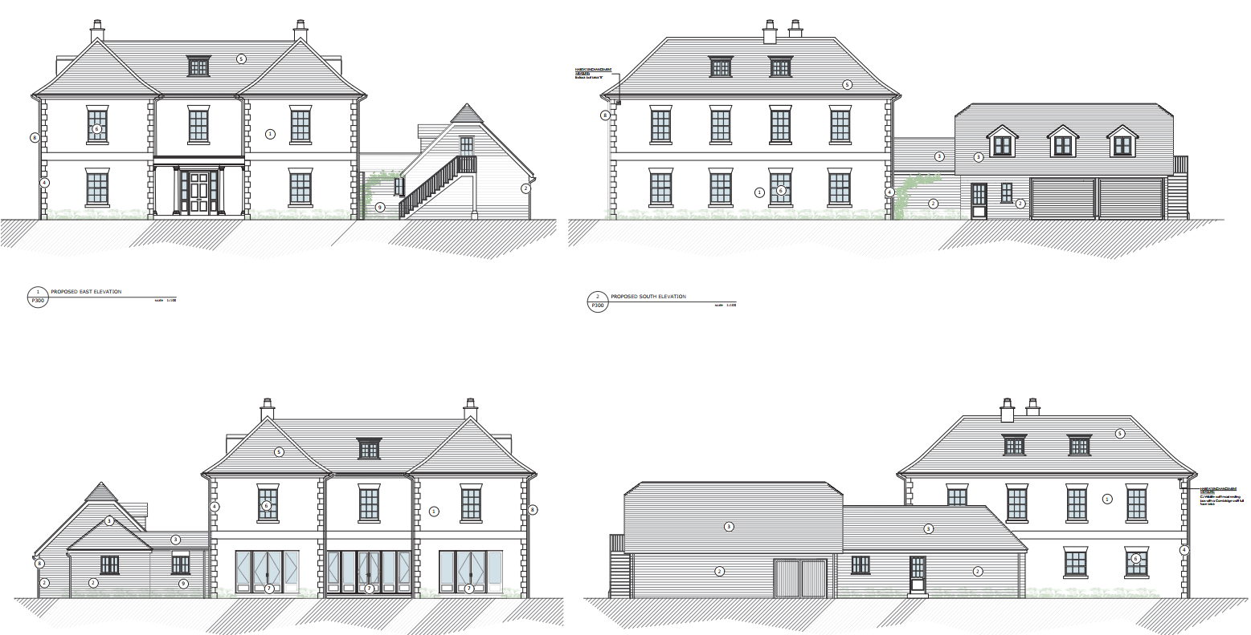

Proposed Scheme

RELEVANT PLANNING HISTORY

Proposal / Summary
PL/2025/04825 - Variation of Conditions 2 (Plan Numbers), 3 (Materials), 4 (Wording), 5 (Contamination), 6 (Landscaping), 8 (Updated Wording), 9 (Documents) , 10 (Updated Wording) and 11 (Compliance with approved CMP) – Approved conditionally
PL/2025/08169 - Non-Material Amendment on planning application PL/2025/04825 - Fenestration alterations - Refused
PL/2025/04824 - Discharge of conditions 3 materials, 5 investigation of the history, & 6 hard and soft landscaping of planning application PL/2023/04825 (Demolition of 3 agricultural buildings and the existing dwelling on the site and the erection of a replacement dwelling with a garage, associated change of use from agricultural to residential land, and hard and soft landscaping) - Approved
PL/2023/08332 - Discharge of Conditions 4,5,10 and 11 on PL/2023/04825 (Demolition of 3 agricultural buildings and the existing dwelling on the site and the erection of a replacement dwelling with a garage, associated change of use from agricultural to residential land, and hard and soft landscaping.) – Approved.
PL/2023/04825 - Demolition of 3 agricultural buildings and the existing dwelling on the site and the erection of a replacement dwelling with a garage, associated change of use from agricultural to residential land, and hard and soft landscaping - Approve with Conditions
PL/2022/04883 – Demolition of 3 agricultural buildings and the existing dwelling on the site and the erection of a replacement dwelling with a detached garage and associated change of use from agricultural to residential land, and hard and soft landscaping – Granted 01.12.2022
PL/2021/11879 – Demolition and part demolition of 2x agricultural buildings and the conversion of another to form 2 dwellings with associated garaging and hard and soft landscaping – Refused 17.03.2022

RELEVANT LEGISLATION, POLICIES AND GUIDANCE

Town and Country Planning Act. 1990 (as amended)

Section 73 of the Town and Country Planning Act. 1990 (as amended) relates to the determination of applications to develop land without compliance with conditions previously attached. It states that:

(2) On such an application the local planning authority shall consider only the question of the conditions subject to which planning permission should be granted, and—

- if they decide that planning permission should be granted subject to conditions differing from those subject to which the previous permission was granted, or that it should be granted unconditionally, they shall grant planning permission accordingly, and

- if they decide that planning permission should be granted subject to the same conditions as those subject to which the previous permission was granted, they shall refuse the application.

The National Planning Practice Guidance (PPG) states the following:

- Nature of the Application: A Section 73 application is treated as a new planning permission, although it does not alter the original permission itself. The original permission remains intact and can still be implemented unless it has expired or been superseded.
- Limitations:
  - Section 73 cannot be used to change the description of development or the operative part of the permission (e.g. the nature or extent of the approved use).
  - It cannot be used to extend the time limit for implementing the original permission.
  - If the proposed changes go beyond what can reasonably be considered under Section 73, a new planning application under Section 70 would be required.
- Decision-making: The local planning authority must consider the application only in relation to the conditions subject to which the original permission was granted. However, it may impose new or revised conditions if granting a new permission.
- Legal Agreements: Because a Section 73 application results in a new permission, any existing Section 106 agreement may need to be varied or replaced via a deed of variation to ensure obligations continue to apply to the new permission.

National Planning Policy:
- National Planning Policy Framework (NPPF)
- Planning Practice Guidance (PPG)
- National Design Guide
Development Plan:
The development plan for Wiltshire comprises the Wiltshire Core Strategy (WCS) (adopted January 2015) and any made neighbourhood plans, which remains the principal statutory planning document guiding development across the county. In line with Section 38(6) of the Planning and Compulsory Purchase Act 2004, planning decisions must be made in accordance with the development plan unless material considerations indicate otherwise.

Though the development plan is considered as a whole, those parts deemed to be particularly relevant to this application are listed below:

The adopted Wiltshire Core Strategy (WCS), with particular regard to:

- Core Policy 1 Settlement Strategy;
- Core Policy 2 Delivery Strategy;
- Core Policy 19: Pewsey Community Area
- Core Policy 41 Sustainable Construction and Low-Carbon Energy;
- Core Policy 45 Meeting Wiltshire’s Housing Needs;
- Core Policy 48 Supporting Rural Life
- Core Policy 50 Biodiversity and Geodiversity;
- Core Policy 51 Landscape
- Core Policy 57 Ensuring High Quality Design and Place Shaping;
- Core Policy 58 Ensuring the Conservation of the Historic Environment;
- Core Policy 60 Sustainable Transport;
- Core Policy 61 Transport & Development;
- Core Policy 64 Demand Management
- Core Policy 67 Flood Risk;
- Core Policy 68 Water Resources;
- Core Policy 69: Protection of the River Avon SAC
Kennet Local Plan Saved Policy
- HC25: Replacement of existing dwellings
Draft Wiltshire Local Plan Policies

The examination of the emerging Wiltshire Local Plan has been paused and the weight to be afforded to any part of the emerging plan can be no more than very limited. A decision on how to proceed will be made by the Council in May 2026.

Neighbourhood Plan:

N/a

Supplementary Planning Documents:
- Waste Storage and Collection: Guidance for Developers
- Revised Wiltshire Planning Obligations Supplementary Planning Document (October 2016)
- Wiltshire Local Transport Plan 2011 – 2026 – Car Parking Strategy (March 2011)
- North Wessex Downs Area of Outstanding Natural Beauty Management Plan 2019-2024
- Section 66 of the Planning (Listed Buildings and Conservation Areas) Act 1990
- Memorandum of Understanding – River Avon Special Area of Conservation
ISSUES

The key considerations in the assessment of this application are as follows:

- Determining whether the proposed amendments fall within the scope of Section 73 of the Town and Country Planning Act 1990 which allows for the variation or removal of conditions attached to an existing planning permission.
- Assessing whether the development, as amended, remains in accordance with the relevant policies and provisions of the development plan, and whether the changes materially alter the nature or impacts of the approved scheme.

CONSULTATION RESPONSES

Highways – No comment

Parish/Town Council:

Manningford Parish Council – Summary of Objection
- Objection to amendments to planning consent PL/2025/04825.
- The dwelling is already very large; increasing its height would make it more imposing and dominant.
- The property is within the village, with close neighbouring dwellings, including a listed building and a small cottage opposite, and should not tower over them.
- Claimed screening is not provided by the site itself; all screening is from trees on neighbouring properties.
- Contrary to the applicant’s statement, there is a public footpath (Manningford 16) to the south with views towards the house.
- The proposed new dormer window faces Corner Cottage, resulting in loss of privacy.
- The enlarged garage is considered excessive in scale, appearing more like an additional dwelling than a garage.
- No objection to the proposed materials or new landscaping scheme.

REPRESENTATIONS
Below is a summary of the representations received during the consultation period. Only material planning considerations have been taken into account in the assessment of this application. Non-material issues, such as property values or private legal disputes, cannot be considered in the determination process.

Neighbour Objections – Summary
- The dwelling has grown progressively larger and taller through variations and is now around 1 m higher than originally approved, with no clear justification.
- Its scale and height are out of keeping with the historic hamlet and would appear dominant among smaller, traditional cottages.
- The development would harm the setting of nearby listed buildings.
- The east-facing upper dormer would cause overlooking and loss of privacy to properties opposite.
- Visual impacts are currently softened only by neighbouring vegetation, which is not permanent and may be lost over time.
- A condition is sought to retain and maintain screening vegetation.
- Concern over future plant equipment (e.g. heat pumps) causing visual and noise impacts; request control over siting away from neighbouring dwellings.

ASSESSMENT
Section 38(6) of the Planning and Compulsory Purchase Act 2004 states:

"If regard is to be had to the development plan for the purposes of any determination to be made under the planning Acts, the determination must be made in accordance with the plan unless material considerations indicate otherwise."

In accordance with this statutory requirement, this application has been assessed against the relevant policies of the Development Plan, including the Wiltshire Core Strategy (2015) and, where applicable, any made Neighbourhood Plans. Consideration has also been given to the policies of the National Planning Policy Framework (NPPF) as a material consideration in the assessment.

Principle of the Development – Do the proposed amendments fall within the scope of s73?

The proposed amendments have been reviewed and are considered to fall within the scope of Section 73 of the Town and Country Planning Act 1990. The changes do not result in a fundamentally different development from that originally approved, nor do they seek to alter the description of development or extend the time limit for implementation. As such, the application is valid under Section 73 and can be determined as a variation of condition(s) attached to the original planning permission.

Compliance with the Development Plan

The application is a valid submission under Section 73 of the Town and Country Planning Act 1990, seeking to vary conditions attached to an existing, extant planning permission. The principle of development has therefore already been established by the parent consent.

In assessing this application, officers have had due regard to the adopted development plan and other material considerations. It is considered that the proposal continues to accord with:
- The relevant policies of the Wiltshire Core Strategy, including those relating to settlement strategy, design quality, landscape character, heritage assets, residential amenity, ecology and sustainable development;
- Any applicable Neighbourhood Plan policies (noting that none introduce additional requirements that would alter the acceptability of the scheme in this case); and
- The National Planning Policy Framework (NPPF), particularly sections relating to sustainable development, good design, conserving the natural and historic environment, and decision-making.

Officers have also considered whether any material changes in national or local planning policy since the grant of the original permission would render the amended proposal unacceptable, or alternatively more acceptable. It is concluded that no such policy changes arise that would materially alter the planning balance or justify a different outcome. The proposed amendments remain acceptable in planning terms and do not give rise to new or additional policy conflicts.

Assessment of Conditions

This application seeks to vary several conditions attached to planning permission PL/2025/04825, which was issued subject to 13 conditions and one informative. No changes are proposed to Conditions 1, 4, 5, 7, 8, 11, 12 or 13. In order to accommodate the design changes proposed the following conditions are proposed to change, conditions 2, 3, 6, 9 and 10.

The plans list in Condition 2 is proposed to be updated to allow these changes.

Revised wording:
2 - The development hereby permitted shall be carried out in accordance with the following approved plans and documents:
- 23/806/P102 - Proposed Site Block Plan
- 23/806/P103 - Proposed Site Plan
- 23/846/P200 – Proposed First and Ground Floor Plans
- 23/846/P201 - Proposed Second Floor Plan
- 23/846/P300 - Proposed Elevations
- Landscape Plan 1 of 2 Rev C
- Landscape Plan 2 of 2 Rev C
- REASON: For the avoidance of doubt and in the interests of proper planning.

3 - Development shall be carried out in accordance with the Materials Schedule V3 Dated 16/02/2026, unless otherwise agreed in writing with the Local Planning Authority.
REASON: In the interests of visual amenity and the character and appearance of the area.

6 - The development hereby permitted shall be carried out in accordance with the following approved plans and documents:
- Landscape Plan 1 of 2 Rev C
- Landscape Plan 2 of 2 Rev C
REASON: To ensure a satisfactory landscaped setting for the development and the protection of existing important landscape features.

9 - The development shall be carried out in strict accordance with the following documents, including the referenced mitigation measures:
- Preliminary Ecological Appraisal Report dated June 2023 by Ecosupport
- Reptile Survey and Outline Mitigation Report dated June 2023 by Ecosupport
- Proposed Site Plan P103 by RBA Architects Ltd
- Biodiversity Net Gain Assessment, June 2023 by Ecosupport
REASON: For avoidance of doubt and for the protection, mitigation and enhancement of biodiversity.

10 - The development hereby approved shall be carried out in accordance with the following approved documents:
- Proposed Site Plan Drawing no 23/806/P103
- Proposed Elevations Drawing no 23/846/P300
- Letter from Project Ecologist re condition 10 – 19.3.24
REASON: To mitigate for impacts to bats arising from the development.

No changes are proposed to Conditions 1, 4, 5, 7, 8, 11, 12 or 13 by the applicant.

The following conditions 1, 5, 8, 11, 12, 13, 14 are to be retained as previously approved.

Minor administration amendments required to the following conditions have now been addressed:

4 - The development hereby approved shall be carried out in accordance with the approved details of the Written Scheme of Investigation (WSI) that was prepared by AC Archaeology and approved by Wiltshire Council on 3rd October 2023. This programme will also include the preparation of a report on the results of the monitoring that shall be submitted to and approved in writing by the Local Planning Authority.
REASON: To enable the recording of any matters of archaeological interest.
The monitoring is to be carried out by qualified archaeologists following the standards and guidelines for such work as set out by the Chartered Institute for Archaeologists (CIfA). The costs of the work are to be borne by the applicant.

7 - No part of the development hereby permitted shall be first brought into occupation, until the turning area and parking spaces have been completed in accordance with the details
shown on the approved plans. The areas shall be maintained for those purposes at all times thereafter.
REASON: In the interests of highway safety.

The proposed variations to the conditions attached to planning permission PL/2025/04825 have been carefully considered in the context of the amended scheme. Where changes are proposed, these have been assessed to determine whether they are reasonable, necessary and justified, and whether they continue to secure an acceptable form of development. The implications of the proposed amendments for other conditions, including those relating to approved plans, have also been taken into account to ensure internal consistency.

Conditions that have previously been discharged under the original permission have been reviewed, and where necessary updated or removed to reflect their status. Any conditions that are now obsolete or no longer relevant have similarly been identified and omitted. Overall, the revised suite of conditions remains comprehensive, enforceable, and compliant with the relevant tests, and is considered to adequately control the development as amended.

Subject to the revised conditions, the variation of conditions is therefore considered acceptable.

Material Considerations/Issues

In assessing this application, due regard has been given to the consultation responses received from the Parish Council and neighbouring residents, as well as to the amended plans and supporting information submitted by the applicant. Only material planning considerations have been taken into account.

Design and Visual Impacts
Core Policies 51 and 57 of the Wiltshire Core Strategy require development to respond positively to local character, protect landscape quality and achieve a high standard of design. The site lies within the North Wessex Downs National Landscape, where great weight must be given to conserving and enhancing natural beauty.

The proposed amendments would result in a dwelling that is larger and taller than the originally approved scheme, and concerns have been raised by the Parish Council and neighbouring residents regarding its scale, height and perceived dominance within the village. It is acknowledged that the dwelling is substantial for its context and that its height has increased through successive variations. It is further acknowledged that any further revisions would not be supported. However, the principle of a large replacement dwelling on the site has already been established by earlier permissions.

The dwelling would be accommodated within a sizeable plot with clear separation from neighbouring properties, and would be read within a mixed hamlet context rather than as an isolated feature in the landscape. While some existing screening vegetation lies outside the applicant’s control, approved on-site landscaping would assist in softening the visual impact of the development when viewed from neighbouring properties and public vantage points, including the nearby footpath to the south.

The enlarged garage, although sizeable, would remain clearly ancillary to the main dwelling by reason of its siting, design and functional relationship, and would not appear as an independent or competing structure.

On balance, while the increased scale and height of the dwelling are noted, the proposal is not considered to result in unacceptable harm to the character or appearance of the settlement or the wider National Landscape. Subject to the implementation and retention of the approved landscaping, the development is considered to comply with Core Policies 51 and 57.

Impact upon Designated Heritage Assets
Section 66 of the Planning (Listed Buildings and Conservation Areas) Act 1990 places a statutory duty on the Local Planning Authority to have special regard to the desirability of preserving the setting of listed buildings. This is reflected in Core Policy 58 of the Wiltshire Core Strategy and the National Planning Policy Framework.

Neighbour objections raise concerns that the increased scale and height of the dwelling would harm the setting of nearby listed buildings, including the Grade II listed Manor House and other traditional buildings within the village.

The application site lies within the wider setting of these heritage assets but does not form part of their immediate curtilage or key views. The relationship between the proposed dwelling and the listed buildings is mediated by intervening distance, changes in ground levels, existing development and vegetation. While the new dwelling would be visible in some longer-range views, it would be experienced within a mixed village context rather than as a direct backdrop to any listed structure.

Although the increased scale of the dwelling is acknowledged, it would not compete visually with the listed buildings in terms of architectural presence, nor would it disrupt their historic significance or appreciation. The proposal would therefore result in less than substantial harm, and in this case no demonstrable harm, to the significance of designated heritage assets.

Accordingly, the scheme is considered to preserve the setting of nearby listed buildings, satisfying the statutory duty under Section 66 and complying with Core Policy 58 and relevant sections of the NPPF.

Residential Amenity
Core Policy 57 requires that development does not have an unacceptable impact on the amenity of existing or future occupiers, including through overlooking, loss of privacy, overbearing impact or visual dominance.

Objections have been raised in relation to loss of privacy, particularly arising from the proposed east-facing upper-floor dormer window, which faces Corner Cottage. It is acknowledged that this window would introduce a degree of intervisibility between properties. However, the separation distance between the buildings, approximately 68m elevation to elevation at the closest point, combined with the relative orientation and intervening boundary treatments, would limit the extent of direct overlooking. The relationship created would not be materially different from that typically found within rural village settings, and would not result in an unacceptable loss of residential amenity.

Concerns have also been expressed regarding the cumulative increase in scale and height of the dwelling causing an overbearing or dominant presence for neighbouring occupiers. While the dwelling is sizeable, it is set within a large plot with clear separation from neighbouring properties. The increased height would not result in unacceptable overshadowing, loss of daylight or enclosure.

Visual impacts are currently softened in part by existing vegetation, some of which lies within neighbouring ownership. To ensure ongoing amenity protection, it would be reasonable for retained landscaping to be safeguarded by condition.

Overall, while the concerns of neighbours are noted, the proposal would not result in such material harm to residential amenity as to warrant refusal, and it is considered to comply with Core Policy 57.

Highways
The Highway Authority has raised no objection to the proposal. The development would continue to utilise the existing access, and sufficient on-site parking provision is available to serve the dwelling. No highway safety or capacity concerns arise, and the proposal accords with Core Policies 60 and 62 of the Wiltshire Core Strategy.

Contaminated Land
The site’s historic poultry farming use gives rise to potential contamination risks, including asbestos and hydrocarbons. Conditions relating to contamination were imposed on the parent permission and have been addressed through submitted reports and investigations. Retaining and enforcing the existing contamination condition is sufficient to ensure the land is made safe for residential use. The proposal therefore accords with Core Policy 57 and relevant environmental protection guidance.

Ecology
The proposed scheme continues to accord with the ecological mitigation measures approved under the parent permission. Relevant measures, including bat mitigation and habitat protection, are shown on the amended plans and secured by condition.

As this is a Section 73 application linked to a permission granted prior to the mandatory Biodiversity Net Gain regime, BNG requirements do not apply. Subject to full compliance with existing ecological conditions, the proposal is acceptable in ecological terms and complies with Core Policy 50.

PLANNING BALANCE AND CONCLUSION
This application has been considered under Section 73 of the Town and Country Planning Act 1990 and seeks to vary a number of conditions attached to an extant planning permission. The assessment has focused on whether the proposed amendments fall within the scope of Section 73 and whether, taken as a whole, the development as amended would remain acceptable in planning terms.

The principle of redevelopment and the erection of a large replacement dwelling on the site has already been established through earlier permissions. The proposed amendments comprise relatively minor design changes, updated plans and documents, and revised condition wording, and do not result in a fundamentally different form of development to that previously approved. The application is therefore capable of being determined as a Section 73 variation.

Objections from the Parish Council and neighbouring residents have been carefully considered, particularly in relation to the increased scale and height of the dwelling, visual prominence, residential amenity impacts and reliance on existing vegetation for screening. While these concerns are acknowledged, for the reasons set out in the report it is concluded that the amended scheme would not give rise to unacceptable harm to landscape character, the setting of heritage assets, residential amenity, highway safety, ecology or land contamination, when assessed against the relevant policies of the development plan and the National Planning Policy Framework.

Any identified impacts are considered to be appropriately mitigated and controlled through the revised and retained planning conditions. No material changes in policy or site circumstances have been identified that would justify reaching a different conclusion to that of the parent permission.

On balance, the proposal is considered to remain in accordance with the development plan and relevant national guidance. There are no material considerations that indicate otherwise, and the application is therefore recommended for approval, subject to the conditions set out in this report.

RECOMMENDATION:
That Planning Permission be GRANTED subject to the following conditions:

