APPLICATION FOR FULL PLANNING PERMISSION
CASE OFFICER REPORT

APPLICATION REFERENCE: | PL/2026/00342
APPLICATION TYPE: | Full planning permission
SITE ADDRESS: | Conholt Park, Conholt Lane, Conholt, Andover, SP11 9HA
DEVELOPMENT DESCRIPTION: | Retention of an existing exit roadway connecting the Main Working Access to Middle Access (Retrospective)
RECOMMENDATION: | Approve with Conditions

SITE DESCRIPTION/CONTEXT

The application site relates to a large, extended detached dwelling with associated outbuildings, courtyard stables, walled garden and wider gardens all situated within approx. 2500 acres of rural estate parkland. The dwelling is grade 2* listed and the Conholt Stable and Carriage House are Grade II listed buildings as identified by the dark black hatching on the map extract below:

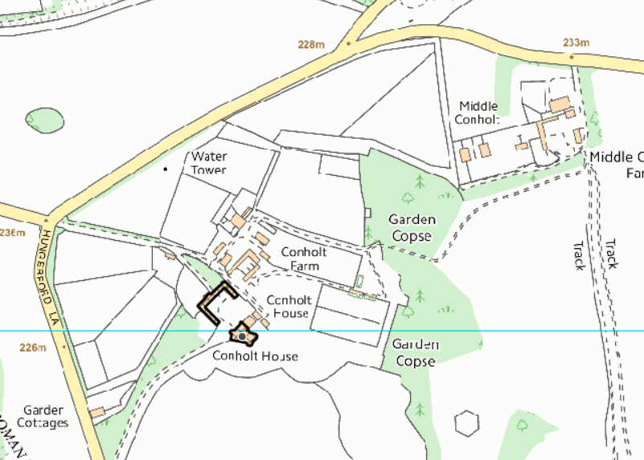

The site is located within the North Wessex Downs Area of Outstanding National Landscape (Formerly AONB).

Over the last three/four years, the application site has been undergoing a huge program of works following a change of owner to many buildings on site as well as within the grounds of the house and the parkland. There is therefore an extensive site history associated with the property.

This current application relates to a strip of land located to the west of the main dwelling, which the applicant refers to as the ‘Upper Parkland’ at Conholt Park. The application site links the existing main working access (at the junction with Chute Causeway) with the existing access point at middle access approximately 350m south of the Main Working Access entry point, as showing in figure 1 below which is taken from the submitted planning statement.

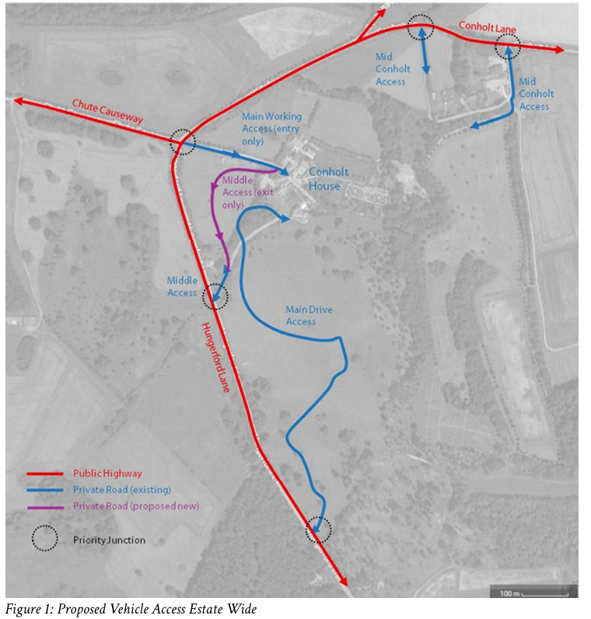

PROPOSAL

The application is seeking permission for the retention of an internal road within the upper parkland area of Conholt Park. Wider location plan showing the context of the site in comparison to the dwelling and focused site plan included below.
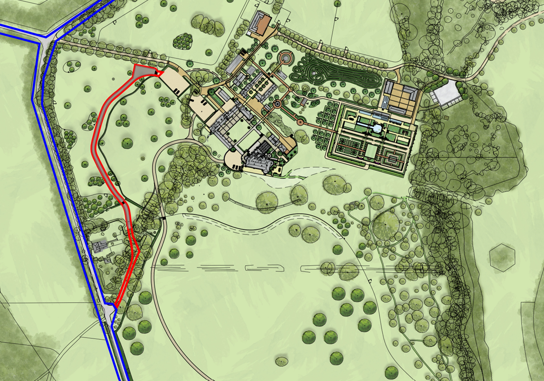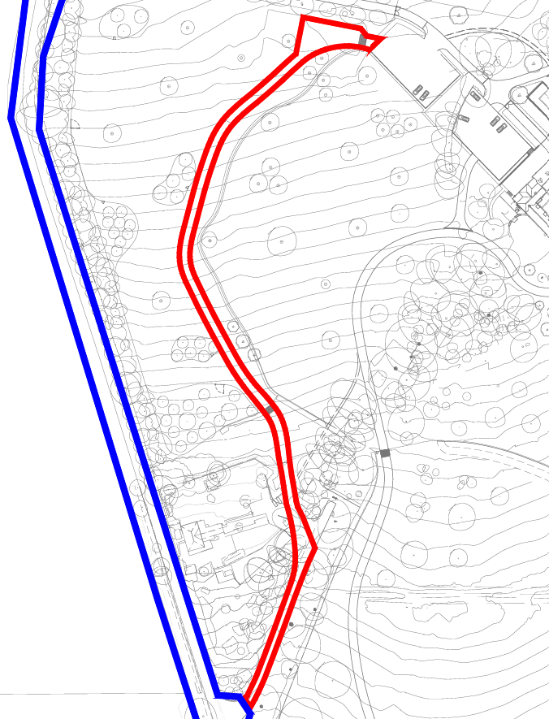

The following is taken from the submitted Planning Statement and explains the development subject to this planning application.

This application seeks planning permission for the permanent retention of the temporary roadway at Conholt Park within the area of the estate identified as ‘Upper Parkland’. The provision of this roadway is necessary to support the safe day to day running of the estate and to ensure operational efficiency across the wider site. Retention of the roadway is essential to ensure safe vehicle movements across the site following completion of development. The one-way system prevents vehicle conflict between road users within the estate and delivers a significantly safer exit than the existing approved arrangement. The roadway will remain in its existing position, with only minor refinements to its edges to improve definition and create a cleaner alignment. It will retain its current width of 4.5m, and will continue to use tarmac as its surface material. This surface treatment is both durable and low maintenance, allowing it to withstand the demands of the traffic movements within the estate. To further enhance the appearance and integration of the route, new landscaping is proposed, including the planting of a beech hedge along the eastern boundary.

Proposed site plan below which includes proposed landscaping.

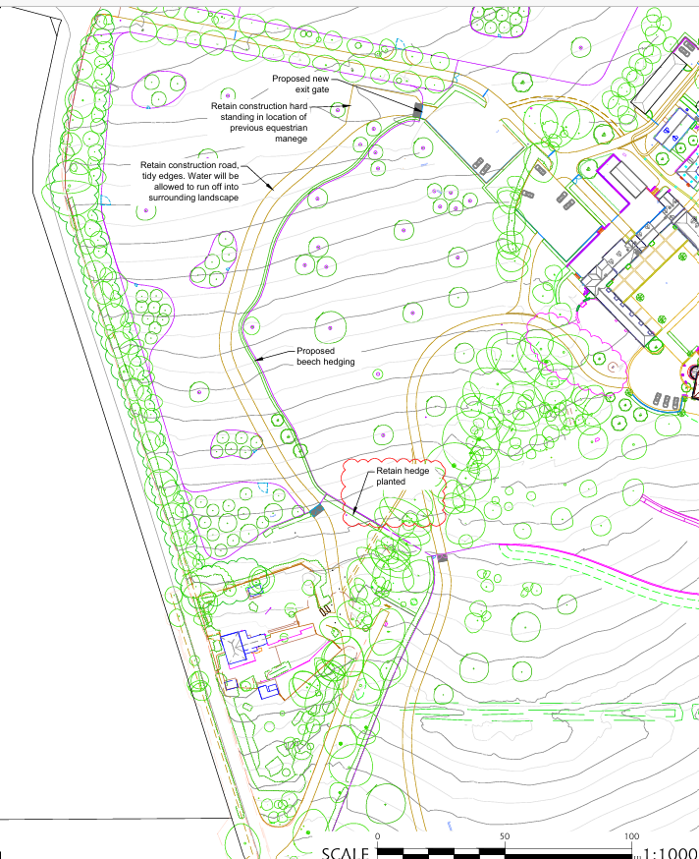
Included below are a couple of photos taken by the case officer of the exit road
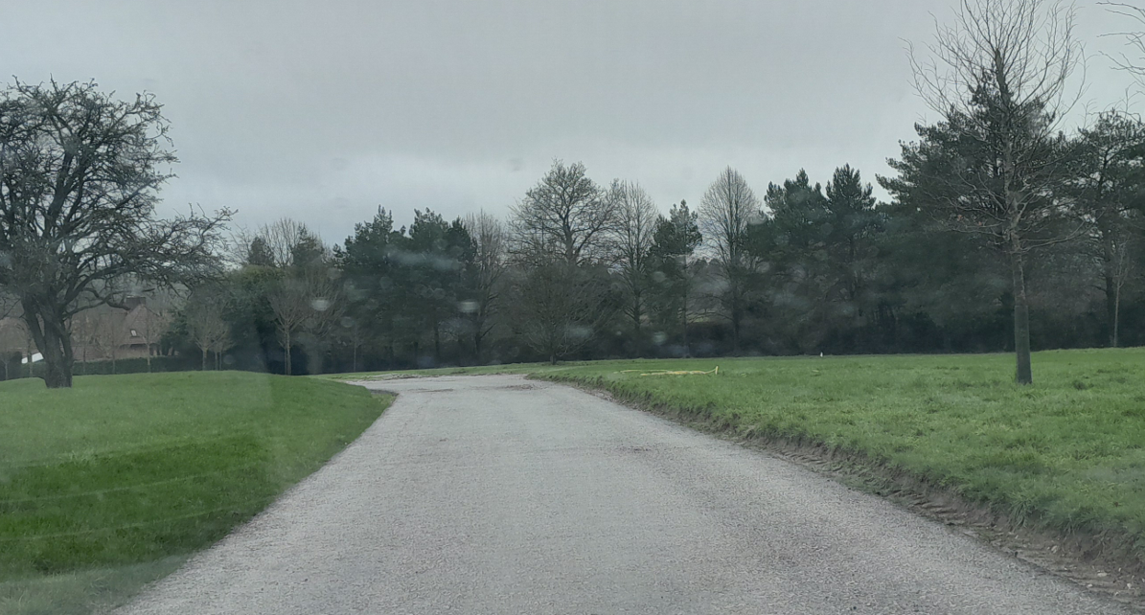

Exit road in approx. position of the red arrow where the existing roadside grass bank can be seen; this photo is taken from the east closer to the main complex of listed buildings and looking towards the existing road to show how the exit road is seen from the view.
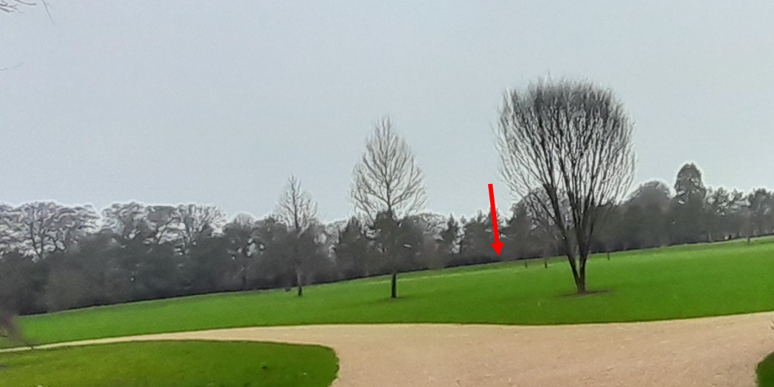

PLANNING HISTORY

Proposal / Summary
PL/2021/06218 - Householder planning permission Decision - Approve with Conditions Date: 27/9/2021 – New circular window, alteration to 2 doors, addition of one louvred dormer window to match the existing and associated internal and external alterations.
PL/2021/07087 - Listed building consent Decision - Approve with Conditions Date: 27/9/2021 – New circular window, alteration to 2 doors, addition of one louvred dormer window to match the existing and associated internal and external alterations.
PL/2023/01271 - Prior notification: Demolition Decision - Prior Approval Not Required Date: 9/3/2023 – Building 6 - A redundant, modern Field Shelter, last used for equestrian housing and agricultural storage. The building consists of brick walls on a concrete slab under a fibre cement roof.

Building 10 - A redundant, modern general-purpose agricultural building, constructed from breeze block walls on a concrete slab under a fibre cement roof.
PL/2023/01783 - Full planning permission Decision - Approve with Conditions Date: 15/9/2023 – Construction of an Energy Centre to serve the main house and wider estate; Demolition of the existing modern swimming pool and enclosure and the creation of a new, three-storey extension on the site of the lost north-western wing; Proposed alterations to, and refurbishment of, the existing main house including the creation of a new external Kitchen Link to provide direct access from the main house to the new kitchen in the proposed extension; Removal of the brick WC tower on the north-western elevation.
PL/2023/02290 - Listed building consent (Alt/Ext) Decision - Approve with Conditions Date: 27/9/2023 – Construction of an Energy Centre to serve the main house and wider estate; Removal of the existing modern swimming pool and enclosure and the creation of a new, three-storey extension on the site of the lost north-western wing; Proposed alterations to, and refurbishment of, the existing main house, including the conversion of the existing Kitchen into a Dining Room, restoring the traditional hierarchy of polite rooms and service spaces within the house, the creation of a new external Kitchen Link to provide direct access from the main house to the new kitchen in the proposed extension; Replacement of the existing casement windows and doors to the bay of c.1900 within the proposed Dining Room with new sash windows and doors to match the nineteenth-century southern elevation; Rationalisation of some of the twentieth-century internal decoration including Stair Hall; Creation of a new back of house staircase in the east corner of the north wing, replacing the existing modern laundry, small bedroom, WC and bathroom; Rearrangement of the bathrooms on the first floor removing twentieth-century partitions and rationalising access; Removal of the brick WC tower on the north-western elevation.
PL/2023/03301 - Full planning permission Decision - Approve with Conditions Date: 5/12/2023 – Alterations and refurbishment of the Courtyard comprising external works (buildings 2, 3 and 4 withdrawn from this application)
PL/2023/03489 - Prior notification: Demolition Decision - Prior Approval Not Required Date: 26/5/2023 – Demolition of Building 7 (timber framed store with plain tile roof)
PL/2023/03656 - Listed building consent (Alt/Ext) Decision - Approve with Conditions Date: 5/12/2023 – Alterations and refurbishment of the Courtyard comprising internal and external works (buildings 2, 3 and 4 withdrawn from this application)
PL/2023/04076 - Full planning permission Decision - Approve with Conditions Date: 12/1/2024 – Estate regeneration including demolition, refurbishment and conversion of Stable Courtyard buildings to provide ancillary staff accommodation, construction of detached Garage and Storage Building, construction of Laundry Building, repair and refurbishment of The Old Granary, construction of detached Stables, refurbishment of Garden Room, construction of Loggia within the Walled Garden, Construction of Staff Mess Room, Workshop and Tool Store and Machine Store within new Service Yard, and associated scheme of hard and soft landscaping.
PL/2023/04587 - Listed building consent (Alt/Ext) Decision - Approve with Conditions Date: 12/1/2024 – Estate regeneration including demolition, refurbishment and conversion of Stable Courtyard buildings to provide ancillary staff accommodation, construction of detached Garage and Storage Building, construction of Laundry Building, repair and refurbishment of The Old Granary, construction of detached Stables, refurbishment of Garden Room, construction of Loggia within the Walled Garden, Construction of Staff Mess Room, Workshop and Tool Store and Machine Store within new Service Yard, and associated scheme of hard and soft landscaping.
PL/2024/01809 - Approval of details reserved by a condition Decision - Approve Date: 4/3/2024 – Discharge of conditions 13 & 14 relating to application PL/2023/04076 (Estate regeneration including demolition, refurbishment and conversion of Stable Courtyard buildings to provide ancillary staff accommodation, construction of detached Garage and Storage Building, construction of Laundry Building, repair and refurbishment of The Old Granary, construction of detached Stables, refurbishment of Garden Room, construction of Loggia within the Walled Garden, Construction of Staff Mess Room, Workshop and Tool Store and Machine Store within new Service Yard, and associated scheme of hard and soft landscaping.)
PL/2024/02033 - Full planning permission Decision - Approve with Conditions Date: 22/5/2024 – Proposed revised location of Package Treatment Plant as originally approved by application PL/2023/04076
PL/2024/02281 - Full planning permission Decision - Approve with Conditions Date: 10/7/2024 – Fourth phase of proposals for the restoration of the designed landscape of Front Park including: the extension of the south lawn with the creation of new ha-ha; the creation of new lake for habitat creation and biodiversity enhancement, water capture and storage and fire protection; new parkland tree planting; the creation of new entrance and approach drive through Front Park; and construction of eye-catcher.
PL/2024/02347 - Removal/variation of conditions Decision - Approve with Conditions Date: 22/5/2024 – Variation of condition 5 of approved application PL/2023/04076 relating to the wording of the condition
PL/2024/02344 - Approval of details reserved by a condition Decision - Approve Date: – Discharge Conditions 13 (B10, B29, B20 and B21) on PL/2023/04076 - Estate regeneration including demolition, refurbishment and conversion of Stable Courtyard buildings to provide ancillary staff accommodation, construction of detached Garage and Storage Building
PL/2024/02791 - Full planning permission Decision - Approve with Conditions Date: 7/6/2024 – Alterations and refurbishment of the Courtyard stable (B4) comprising external works for purposes ancillary to the use of Conholt House
PL/2024/03197 - Listed building consent (Alt/Ext) Decision - Approve with Conditions Date: 7/6/2024 – Alterations and refurbishment of the Courtyard stable (B4) comprising internal and external works, and alterations to two ancillary buildings (B2 & B3) comprising internal and external works
PL/2024/03919 - Approval of details reserved by a condition Decision - Approve Date: 21/5/2024 – Discharge of condition 13 (PL/2023/04076 ) - Large scale details of new joinery details, large scale eaves details, rainwater goods materials relating to the stables B17) including the doors and ‘horse’ windows. Discharge condition 14 (PL/2023/04076 ) - Roofing slate/tiles block plan detail for B10, B17, B20, B21, B27.
PL/2024/06492 - Biodiversity Gain Plan Discharge of Condition Application Decision - Approve Date: 12/7/2024 – Discharge of condition 13 of PL/2024/02281 (Biodiversity Gain Plan)
PL/2024/08005 - Full planning permission Decision - Approve with Conditions Date: 2/12/2024 – (Retrospective) Temporary site works and buildings supporting approved development works around the Conholt Park Estate, encompassing tarmac car park, welfare/office facilities, construction access roads, pathways, and surfacing of existing tracks in tarmac, stockpiles of various materials, vehicle, and storage compounds. Implementation of landscape restoration measures following completion of works and the removal of all temporary site works.
PL/2024/08241 - Approval of details reserved by a condition Decision - Partial Discharge of Condition(s) Date: 23/9/2024 – Partial discharge of condition 3 (stone and flint) of planning application PL/2024/02281 (Fourth phase of proposals for the restoration of the designed landscape of Front Park including………………..)
PL/2024/09236 - Approval of details reserved by a condition Decision - Approve Date: – Discharge of condition 14 (Habitat Mitigation and Monitoring Plan) of PL/2024/02281
PL/2024/10026 - Removal/variation of conditions Decision - Approve with Conditions Date: 18/12/2024 – Variation of condition 2 (Approved Plans) of PL/2024/02281 - To facilitate design changes to the main gates
PL/2025/01412 - Approval of details reserved by a condition Decision - Approve Date: – Discharge of condition 18 of PL/2024/10026 (entrance gate details and specifications)
PL/2025/02127 - Removal/variation of conditions Decision - Withdrawn by Applicant Date: 16/10/2025 – Variation of conditions 1 (Site logistics plans has been amended to address identified impacts on the local highway network. The estate will consolidate deliveries to ease pressure on local roads. The fewer, larger deliveries will be received at a newly designated facility accessed via a new track running around the north side of the approved temporary car park, which will then be distributed by smaller loads within the estate, reducing overall trips.), 4 and 5 (Condition 4 / 5 - To be amended to compliance conditions as this submission provides the necessary details for the LPA discharge these conditions) of application PL/2024/08005.
PL/2025/03606 - Approval of details reserved by a condition Decision - Approve Date: 25/6/2025 – Discharge of condition 8 (Water Efficiency Report) of PL/2023/03301
PL/2025/03760 - Approval of details reserved by a condition Decision - Approve Date: 17/7/2025 – Discharge of condition 4 (Water Efficiency Report) of PL/2024/02347
PL/2025/06214 - Removal/variation of conditions Decision - Approve with Conditions Date: 19/1/2026 – Variation of condition 2 (capturing minor changes to the scheme) for application PL/2023/01783
PL/2025/06221 - Removal/variation of conditions Decision - Withdrawn by Applicant Date: 29/9/2025 – Variation of condition 2 (Capturing minor changes to the scheme under Section 19 of the Planning (Listed Buildings and Conservation Areas) Act 1990) for application PL/2023/02290
PL/2025/06419 - Removal/variation of conditions Decision - Approve with Conditions Date: 21/1/2026 – Variation of condition 2 (Approved Docs/ Plans) relating to application PL/2023/03301 - Please see Covering Letter
PL/2025/06420 - Removal/variation of conditions Decision - Withdrawn by Applicant Date: 29/9/2025 – Variation of condition 2 (Approved Plans) relating to application PL/2023/03656 - Please see Covering Letter
PL/2025/06421 - Removal/variation of conditions Decision - Approve with Conditions Date: 22/1/2026 – Variation of condition 2 (Approved Docs/ Plans) relating to application PL/2024/02791 - Please see Covering Letter
PL/2025/06423 - Removal/variation of conditions Decision - Withdrawn by Applicant Date: 29/9/2025 – Variation of condition 2 (Approved Docs/ Plans) relating to application PL/2024/03197 - Please see Covering Letter
PL/2025/06424 - Non-Material Amendment Decision - Approve with Conditions Date: 18/8/2025 – Non-Material Amendment on planning application PL/2023/04076-NMA for the inclusion of an additional window in the rear elevation of the approved detached stables building.
PL/2025/08670 - Listed building consent (Alt/Ext) Decision - Approve with Conditions Date: 19/1/2026 – Retention of works comprising of alterations to the Chimney, Lintels, Ground Floor Stair Drum, WWII Air Raid Tunnel and Minor Landscaping
PL/2025/08671 - Listed building consent (Alt/Ext) Decision - Approve with Conditions Date: 21/1/2026 – Retention of works comprising of Fireplace Reinstatement in Building B5; Oculus Window Revised Infill Design (North-West Elevation) and Bargeboard Enhancements (North-West and North-East Elevations).
PL/2025/08672 - Listed building consent (Alt/Ext) Decision - Approve with Conditions Date: 22/1/2026 – Retention of works comprising of New Internal Doorway to Crockery Store relating to Ancillary Building B3.
PL/2025/09358 - Approval of details reserved by a condition – Discharge of Conditions 4 Bats & 5 Mitigation for birds of planning application PL/2023/04587 (Estate regeneration including demolition, refurbishment and conversion of Stable Courtyard buildings to provide ancillary staff accommodation, construction of detached Garage and Storage Building, construction of Laundry Building, repair and refurbishment of The Old Granary, construction of detached Stables, refurbishment of Garden Room, construction of Loggia within the Walled Garden, Construction of Staff Mess Room, Workshop and Tool Store and Machine Store within new Service Yard, and associated scheme of hard and soft landscaping).
PL/2025/09361 - Approval of details reserved by a condition – Discharge of conditions 6 (Bat mitigation photographic evidence) and 7 (Birds mitigation photographic evidence) of PL/2024/02347 - Variation of condition 5 of approved application PL/2023/04076 relating to the wording of the condition
PL/2025/09402 - Approval of details reserved by a condition – Condition 6 (To mitigate for impacts of Bats arising from the development) of application PL/2023/03301
PL/2026/00416 - Full planning permission – Retention of a Staff Car Park. UNDER CONSIDERATION

RELEVANT LEGISLATION, POLICIES AND GUIDANCE

Planning (Listed Building and Conservation Areas) Act 1990
Section 66: Special considerations affecting planning functions

Government Guidance:
National Planning Policy Framework (NPPF)
Planning Practice Guidance
National Design Guide

Adopted Wiltshire Core Strategy (January 2015):
Core Policy 1 – Settlement Strategy
Core Policy 2 – Delivery Strategy
Core Policy 26 – Development in the Tidworth Community Area
Core Policy 48 – Supporting rural life
Core Policy 50 - Biodiversity and Geodiversity
Core Policy 51 - Landscape
Core Policy 52 – Green Infrastructure
Core Policy 57 - Ensuring high quality design and place shaping
Core Policy 58 - Ensuring the conservation of the historic environment
Core Policy 61 - Transport & Development
Core Policy 62 - Development Impacts on the Transport Network
Core Policy 64 - Demand Management

Wiltshire Local Transport Plan 2011-2026

The North Wessex Downs National Landscape Management Plan
The North Wessex Downs Landscape: A landscape assessment of the Area of Outstanding Natural Beauty 2002
Wiltshire Design Guide
Conservation of Habitats and Species (Amendment) (EU Exit) Regulations 2019
Chute Design Guide
Wildlife and Countryside Act 1981, as amended

Listing

CHUTE - SU 35 NW 6/66 Conholt Park 4.6.52 II*

House in parkland. Late C17, C18 and early C19. Red brick, extended in buff-grey brick with stone dressings to openings, green slate roof. Two storeys, attics and cellars. Original building of late C17, probably 4 bays but partly demolished at north east end. Large south wing forming new front, 1810-11 of 7 bays, further extended later C19 by projecting and canted bay on right, and with billiard room with canted bay to rear. Original block and front build at angle to each other, with entrance at junction, a semicircular Tuscan portico of 4 columns and entablature. Glazed doors. South front has 15-pane sashes to ground floor, 12-paned to upper floor, all with moulded architraves, pulvinated frieze and cornice. Facade has cornice with paired modillion eaves and parapet. Interior has two elegant early C19 drawing and sitting rooms in south west. Through wide corridor from entrance leads to oval central stair hall at rear, with good flying stair and metal balustrade. Earlier wing has mid C18 close-balustered dog-leg stair. Externally, in north re-entrant angle, a disused horse gin by Tasker & Sons of Andover.

Listing NGR: SU3244355004

CHUTE - SU 35 NW 6/67 Stable and carriage house at Conholt Park II

Stable and carriage house on 3 sides of yard. Early-mid C18, extended in late C18. Brick with tiled roofs. Central block facing main house, 4 bays of vitrified header bond. Two central bays slightly broken forward and pedimented, with brick strings representing cornices. Clock in pediment. Bell tower on 6 columns with domed lead roof and wind vane. Two large carriage arches with timber doors. Outer bays similar large arches and parapet. Block is extended either side as groom's and stable boy's dwellings, each of 2 bays with 6-panelled doors and leaded 3-light windows. Courtyard formed by stable wings, that to left of flint with brick dressings and tiled roof. Varied openings, including 4 doors and timber windows with leaded glazing. Right wing has 5-bay blank shallow arcade. Two carriage house doors now covered with later C19 steel glazed roof on columns. Stable doors and leaded windows. Passage at junction with main block leads to farm to rear.

Listing NGR: SU3240655018

ISSUES

Principle
Visual impact, impact on setting of heritage assets and National Landscape
Amenity
Highways
Ecology

CONSULTATION RESPONSES

Parish Council – None received

Conservation Officer – Initial comments

The application refers to the retention of the temporary road built for construction purposes. Aerial photos clearly show that the temporary road was a direct straight line, yet the plans show a meandering lane. Echoing Historic England, I am concerned at the lack of consideration of the character of the park to the northwest of the house, and clear explanation or justification for the multiple access roads is needed. It is not sufficient just to say that exit somewhere else would be safer...to what degree, for how many vehicles, encountering how much other traffic etc. It would seem less harmful to improve the northern/main access than to have a second road in a strangely severed portion of the park. At present I am concerned at the potential impact on the setting of the listed building, with regard to section 66 of the PLBCA Act 1990, the NPPF and CP58.

Comments received after the applicant provided further justification for the works and heritage impacts

Having reviewed the response to my earlier comments and extensive photos, I'm minded to consider the impact of the scheme is toward the lower end of 'less than substantial' harm, and if there are irrefutable other benefits (safety in particular) then I would raise no objections.

Historic England – First response to initial submission – Objection due to harm to the setting of the listed building.

Further justification was provided by the applicant for the works and heritage impacts, Historic England provided a further comment stating

Whilst we maintain that the Staff Car Park and Exit Road will have a cumulative impact on the setting of the Grade II* House, we also acknowledge the Applicant’s letter of 13/03/26 that responds to our original comments (20/02/26). For example, we acknowledge that the Upper Parkland, where the application sites are located, makes a lower contribution to the significance of the setting of the Grade II* house and that its role within the designed landscape is more peripheral. Thus, potential harm caused will be at the lower end of ‘less than substantial’. We also consider the response letter helps to provide clearer justification for the proposals. Your authority will need to assess if, based on this response, the public benefits it outlines outweigh the level of harm caused to the designated heritage assets.

Highways – No objection subject to condition

Test Valley Borough Council – No objection

Hampshire County Council - None received

REPRESENTATIONS

None received

ASSESSMENT

Section 38(6) of the Planning and Compulsory Purchase Act 2004 states:

"If regard is to be had to the development plan for the purposes of any determination to be made under the planning Acts, the determination must be made in accordance with the plan unless material considerations indicate otherwise."

In accordance with this statutory requirement, this application has been assessed against the relevant policies of the Development Plan, including the Wiltshire Core Strategy (2015) and, where applicable, any made Neighbourhood Plans. Consideration has also been given to the policies of the National Planning Policy Framework (NPPF) as a material consideration in the assessment.

Principle of Development

The principle of retaining a separate internal exit road to serve the dwelling in this rural location is acceptable in planning terms. The arrangement provides a clear and functional means of managing vehicular movements by separating entry and exit within the grounds of the Conholt Park Estate. However, the overall acceptability of the development remains subject to detailed consideration of other material planning matters, including potential impacts on heritage assets, the character and appearance of the nationally protected landscape, and highway safety.

Visual impact, impact on setting of heritage assets and National Landscape

From the point of view of the historic environment the main statutory tests are set out within the Planning (Listed Building and Conservation Areas) Act 1990.

Section 66 requires that special regard be given to the desirability of preserving listed buildings, their settings or any features of special architectural or historic interest which they possess.

Core Policy 58: Ensuring the conservation of the historic environment. Requires that designated and non-designated heritage assets and their settings will be conserved, and where appropriate enhanced, in a manner appropriate to their significance and encourages proposals which improve the condition of heritage assets at risk.

Core 57: Ensuring high quality design requires a high quality of design in all new developments. The policy requires applicants to “demonstrate how the proposal will make a positive contribution to the character of Wiltshire through (amongst other things) responding to the value of the natural and historic environment and being sympathetic to and conserving historic buildings and landscapes. Development is required to respond positively to the existing in terms of building layouts, built form, height, mass, scale, building line, plot size, elevational design, materials, streetscape and rooflines to effectively integrate the building into its setting.

CP51 requires that proposals protect, conserve and, where possible, enhance the character and quality of Wiltshire’s landscapes. Particular weight is given to National Landscapes (formerly AONBs), locally valued landscapes, and key visual receptors.

The exit roadway as submitted with this application has resulted from the large scale temporary works which were necessary for use during the construction phase of the development of the Conholt Park site. The majority of the temporary works have now been removed and the parkland in the process of being restored to its former state, however, part of the internal roadway that was used during construction to provide a way-one vehicle movement during construction works has been retained. The main access to the site is from the west and was originally used as a two-way entrance and exit. The entrance driveway is narrow and, due to the level of vehicle movements associated with the site, this arrangement was not considered adequate. Consequently, the existing south‑west access has been utilised, with the exit road forming the necessary internal connection between the western entrance and the south‑west exit. The south‑west access is an established feature, and the proposal relates only to development that links the entrance and exit points within the site rather than the creation of a new access.

The main impact relates to the impacts on the setting of the listed buildings. Historic England and the Council’s conservation officer has been consulted. Initially objections were raised due to concerns relating to unacceptable harm to the setting of the listed buildings particularly in relation to the change of character to the parkland. Historic England stated

The Upper Parkland provides the western setting to the House, and as evidenced by the 1st edition Ordnance Survey, has remained relatively unchanged since the 19th century. The introduction of an additional drive, and car parking, within the parkland would therefore have a cumulative impact on the setting of the House, altering previously undeveloped areas of its historic parkland setting.
In our previous planning response to the new approach drive through the Front Park (PL/2024/02281), we considered there would be a small degree of harm to the significance of Conholt Park due to the loss of the historical evidence associated with the front drive. The drive was a significant remnant of a 19th century, or older, longer route that continued into West Park.
We therefore consider that the cumulative impact of the additional drive and parking will cause some additional harm to the significance of Conholt Park that is derived from its setting. In accordance with the NPPF, this harm must be balanced by the public benefits of the proposals including safe vehicle movements on the estate.

Position
The proposal would result in harm to the Grade II* listed Conholt Park by altering its historic parkland setting. This harm will require clear and convincing justification in accordance with paragraph 213 of the NPPF.
Recommendation
Historic England has concerns regarding the application on heritage grounds. We consider that the issues and safeguards outlined in our advice need to be addressed in order for the application to meet the requirements of paragraphs 208, 212, 213 and 215 of the NPPF.

In response to the above comments from Historic England, the applicant provided further justification for the works and a further analysis of the heritage asset, its setting and significance.

Following the receipt of the further assessments and justification, Historic England have stated

Whilst we maintain that the Staff Car Park and Exit Road will have a cumulative impact on the setting of the Grade II* House, we also acknowledge the Applicant’s letter of 13/03/26 that responds to our original comments (20/02/26). For example, we acknowledge that the Upper Parkland, where the application sites are located, makes a lower contribution to the significance of the setting of the Grade II* house and that its role within the designed landscape is more peripheral. Thus, potential harm caused will be at the lower end of ‘less than substantial’.
We also consider the response letter helps to provide clearer justification for the proposals.
Your authority will need to assess if, based on this response, the public benefits it outlines outweigh the level of harm caused to the designated heritage assets.

The applicant has stated that the visual and heritage impacts of the proposal have been carefully assessed in the context of alternative access arrangements across the estate. Options including widening the existing main working access, use of the middle access near the main house, or routing vehicles via Middle Conholt were discounted as they would result in greater visual intrusion, loss of established landscape features, unacceptable harm to tree root protection areas, and increased activity within the setting of the listed house and the wider National Landscape. The proposed site exit road represents the option with the lowest overall impact.

The exit roadway has taken a meandering form and is located a sufficient distance from the listed buildings themselves to minimise direct impacts on their significance. It was observed by the case officer during a site visit that the exit road was screened from the principal heritage assets due to its design as a sunken road with grassed soil banks which not only use the topography of the site to its advantage but also the use of existing and proposed landscaping including various planting and hedging, ensures that views from the main drive and key heritage receptors are effectively screened, also limiting wider visual impacts within the National Landscape.

While it is acknowledged that the development will introduce a degree of change within the historic landscape, with the cumulative effects of the various elements of recent development across the whole wider Conholt Estate creating a notable change. It is considered that the overall development has a whole has resulted in the restoration of the site to a high standard with well design development.

In this instance, the harm arising is therefore considered to be less than substantial and is outweighed by the operational, safety and landscape benefits of the chosen solution. The following benefits have been outlined by the applicant

1. Improved Safety across the Estate The introduction of the Exit Road provides a safer, more coherent circulation system with staff no longer needing to manoeuvre in constrained areas. This reduces conflict points around the House, gardens, and principal arrival areas. It also means cars do not have to exit via the main working access where there are safety concerns as the visibility splay here is significantly obscured by existing mature vegetation. A safer estate environment for staff, contractors, residents, and visitors delivers a material public benefit consistent with NPPF and the Wiltshire Core Strategy.
2. Enhanced Operational Efficiency of the Estate. The Exit Road streamlines circulation for delivery vehicles, maintenance contractors, and estate staff. The Car Park sits within an existing cluster of built form, immediately adjacent to the previously approved Staff Car Park. This reduces the need for staff vehicles to disperse across the estate. These operational efficiencies directly support the optimum viable use of the heritage asset, which the NPPF recognises as a public benefit in its own right.

3. Reduction of Vehicle Pressure in Sensitive Historic Areas The new circulation pattern and Car Park ensure that servicing and staff movements are routed away from the principal designed frontage and formal approach to the House. In practice, this protects the highest-value parts of the setting from unnecessary disturbance.

4. Landscape Enhancements, Management and Visual Mitigation As part of both the Exit Road and Staff Car Park applications, landscaping has been proposed to provide screening and enhance opportunities for biodiversity. Over time, this soft landscaping will further reduce visibility, strengthening the landscape character rather than weakening it.

Therefore, on balance, it is considered that the proposal is compliant with Core Policies 58, 57 and 51, S66 of Planning (Listed Building and Conservation Areas) Act 1990 and the relevant provisions of the NPPF.

Amenity

Core Policy 57 (Point vii) of the Wiltshire Core Strategy requires development to respect the amenity of existing occupants and ensure appropriate amenity levels for future residents.

The National Planning Policy Framework (NPPF), particularly Paragraph 135, reinforces the need for development to provide a high standard of amenity for both existing and future users.

Given the context of the site and the surrounding landscape, there are no immediate neighbours that will be affected by the proposed development.

Highways Impacts and Parking

Relevant policies include Core Policies 60–64 of the Wiltshire Core Strategy, supported by the Wiltshire Local Transport Plan, Car Parking Strategy, and Cycling Strategy. The Local Cycling and Walking Infrastructure Plan (LCWIP) and LTN 1/20 (DfT) provide further design guidance for active travel infrastructure.

The retention of the internal exit road initially raised concerns from the Highway Authority due to discrepancies with the submitted details and visibility splays. Amendments were made to the submitted plans, and the objections were lifted by the Highway Authority subject to condition.

Ecology and Biodiversity

Core Policy 50 of the Wiltshire Core Strategy and the National Planning Policy Framework requires that the planning authority ensures protection of important habitats and species in relation to development and seeks enhancement for the benefit of biodiversity through the planning system.

From 12 February 2024 Biodiversity Net Gain (BNG) became mandatory under Schedule 7A of the Town and Country Planning Act 1990 (as inserted by Schedule 14 of the Environment Act 2021). Based on the information available the biodiversity gain planning condition is not considered to apply to this application as the application is for retrospective consent and BNG does not apply to retrospective development.

Whilst the proposals result in the introduction of a further area of hardstanding within the Upper Parkland area, the proposals also include a landscape plan which shows more trees and hedges to be planted. The proposed native planting and habitat creation is considered to provide additional opportunities for ecological enhancement. Therefore, overall, it is not considered that the retention of the exit road will have an adverse impact on biodiversity.

PLANNING BALANCE AND CONCLUSION

At the heart of the NPPF there is a presumption in favour of sustainable development requiring local planning authorities to approve development proposals that accord with an up-to-date development plan without delay; and where there are no relevant development plan policies, or the policies which are most important for determining the application are out-of-date, permission should be granted unless (taken from paragraph 11d of the NPPF):

The application of policies in the NPPF that protect areas or assets of particular importance provides a clear reason for refusing development proposed; or
any adverse impacts of doing so would significantly and demonstrably outweigh the benefits, when assessed against the policies in the NPPF taken as a whole.

The retention of the staff car park as built appears to be needed in the context of Conholt Park, the chosen location is considered appropriate and has less impacts than would occur either through ad hoc parking or through the creation of another car park elsewhere on the estate. Whilst there are identified harms to the setting of the heritage assets, these are less than substantial. Whilst many of the benefits or private for the Conholt Estate, there are public benefits through highway safety, the local employment opportunities and through the maintenance and improvements to the grade 2* listed property and other listed building on the estate which help to ensure they are maintained in a good condition to ensure their survivable going into the future.

RECOMMENDATION: That Planning Permission be GRANTED, subject to conditions

1. The development hereby permitted shall be carried out in accordance with the following approved documents and plans:

Application form received 19/01/2026
Parking exit road-red line Boundary Dwg no 076 Rev E received 27/01/2026
Parking exit road-site location plan Dwg no 073 Rev D received 27/01/2026
Parking exit road - existing site location plan Dwg no 079 Rev B received 27/01/2026
Parking exit road-proposed site plan Dwg no 075 Rev B received 27/01/2026
Visibility splay at junction of middle access & Hungerford Lane received 13/03/2026

REASON: For the avoidance of doubt and in the interests of proper planning.

2. Any external lighting that is installed across the site shall be designed and implemented to minimise sky glow, glare and light trespass. It shall be designed in a downward facing position at all times and shall meet the criteria for Environmental Zone E0 as defined by the Institute of Lighting Professionals ‘Guidance Notes for the Reduction of Obtrusive Light’ 2021. Any external lighting installed at the site shall be retained and maintained as such thereafter for the lifetime of the development.

REASON: To ensure appropriate levels of amenity are achieved; to protect the National Landscape and to avoid illumination of habitat used by bats

3. All soft landscaping comprised in the approved details of landscaping shall be carried out in the first planting and seeding season following the completion of the development. All shrubs, trees and hedge planting shall be maintained free from weeds and shall be protected from damage by vermin and stock. Any trees or plants which, within a period of five years, die, are removed, or become seriously damaged or diseased shall be replaced in the next planting season with others of a similar size and species, unless otherwise agreed in writing by the local planning authority. All hard landscaping shall also be carried out in accordance with the
approved details unless otherwise agreed in writing with the Local Planning Authority.

REASON: To ensure a satisfactory landscaped setting for the development and the protection of existing important landscape features.

4. The visibility splays shown on the approved plans (1165/240/H/003 Rev B) show there will be no obstruction to visibility at or above a height of 900mm above the nearside carriageway level. The visibility splays shall always be maintained free of obstruction in accordance with the approved plan (1165/240/H/003 Rev B) for the lifetime of the development.
Reason: In the interests of highway safety.

INFORMATIVE TO APPLICANT:

1. Protected Species - The applicant should note that under the terms of the Wildlife and Countryside Act 1981 (as amended) and the Habitats Regulations 2017 (as amended) it is an offence to disturb or harm any protected species including for example, breeding birds and reptiles. The protection offered to some species such as bats, extends beyond the individual animals to the places they use for shelter or resting. Please note that this consent does not override the statutory protection afforded to any such species. In the event that your proposals could potentially affect a protected species you should seek the advice of a suitably qualified and experienced ecologist and consider the need for a licence from Natural England prior to commencing works. Please see Natural England’s website for further information on protected species.

2. BNG not required

The effect of paragraph 13 of Schedule 7A to the Town and Country Planning Act 1990 is that planning permission granted for development of land in England is deemed to have been granted subject to the condition (biodiversity gain condition) that development may not begin unless:

(a) a Biodiversity Gain Plan has been submitted to the planning authority, and
(b) the planning authority has approved the plan.

The planning authority, for the purposes of determining whether to approve a Biodiversity Gain Plan, if one is required in respect of this permission would be Wiltshire Council.

There are statutory exemptions and transitional arrangements which mean that the biodiversity gain condition does not always apply. For further information on exempt developments please refer to:
https://www.gov.uk/guidance/biodiversity-net-gain-exempt-developments
Based on the information available this permission is considered to be one which will not require the approval of a biodiversity gain plan before development is begun because one or more of the statutory exemptions or transitional arrangements is considered to apply.

