HOUSEHOLDER PLANNING APPLICATION.
CASE OFFICER REPORT

APPLICATION REFERENCE: | PL/2026/01088
APPLICATION TYPE: | Householder
SITE ADDRESS: | 20 St. Margarett’s Gardens, Melksham, SN12 7BT.
DEVELOPMENT DESCRIPTION: | Proposed single storey rear extension, two storey side extension, pitched roof over existing attached garage, new porch and driveway enlargement.
RECOMMENDATION: | Approve with Conditions.

PROPOSAL
The proposal seeks planning permission for the construction of a two-storey side extension on the building’s north elevation and also for the siting and construction of a single storey east orientated rear extension. The scheme would also include a pitched roof over the attached garage, the construction of a new porch and slight enlargement of the existing driveway.

SITE DESCRIPTION/CONTEXT
The site consists of a two-storey, red brick constructed detached house, located within a corner location within an established residential estate/area, within the Market Town of Melksham. The site is outside of any established bat zones such as the Trowbridge Westbury Bat Mitigation Strategy (TWBMS) and The Bath and Bradford on Avon Bat SAC.

RELEVANT PLANNING HISTORY

Proposal / Summary
N/A

RELEVANT POLICIES AND GUIDANCE
Wiltshire Core Strategy:

- Core Policy 15 Spatial Strategy for Melksham
- Core Policy 57 Ensuring High Quality Design and Place Shaping
- Core Policy 50: Biodiversity and Geodiversity
- Core Policy 51: Landscape
- Core Policy 58: Ensuring the Conservation of the Historic Environment
- Core Policy 61: Transport and New Development
- Core Policy 64: Demand Management
- Core Policy 67: Flood Risk

Melksham ‘Made’ Neighbourhood Plan.

Wiltshire Design Guide: Appendix D – Design Guidance for Householder extensions

The National Planning Policy Framework (NPPF)

The Planning Practice Guidance

National Design Guide

Emerging Wiltshire Local Plan:
The examination of the emerging Wiltshire Local Plan has been paused and the weight to be afforded to any part of the emerging plan can be no more than very limited. A decision on how to proceed will be made by the Council in May 2026.

CONSULTATION RESPONSES
Melksham Town Council: No objections.

Highways: No objections subject to conditions.

REPRESENTATIONS
No comments received.

PRINCIPLE OF THE PROPOSAL.
The principle of the proposed scheme is considered to be acceptable for the reasons as discussed below.

ASSESSMENT
Section 38(6) of the Planning and Compulsory Purchase Act 2004 states:

"If regard is to be had to the development plan for the purposes of any determination to be made under the planning Acts, the determination must be made in accordance with the plan unless material considerations indicate otherwise."

In accordance with this statutory requirement, this application has been assessed against the relevant policies of the Development Plan, including the adopted Wiltshire Core Strategy (2015) and the Neighbourhood Plan for Melksham.

Design and Impact upon the upon the character and context of the area
Core Policy 57 - Ensuring High Quality Design and Place Shaping of the Wiltshire Core Strategy seeks to ensure that all new development is of high design quality, reflecting local context, character, and distinctiveness.

The proposals can be viewed within the plan snippets taken from the submitted plans:

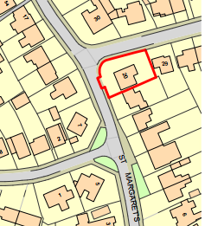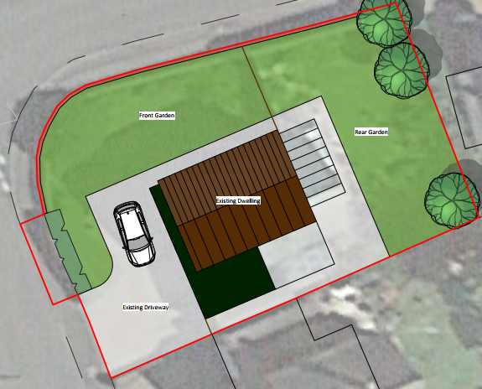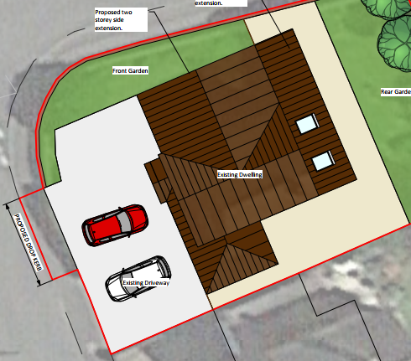
Location Plan Existing Site Plan Proposed Site Plan

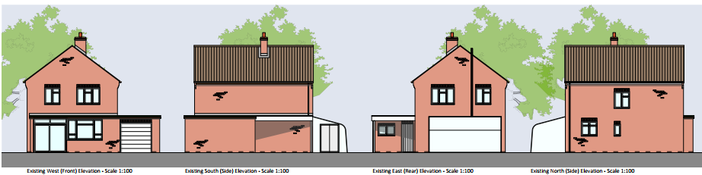
Existing Elevations.

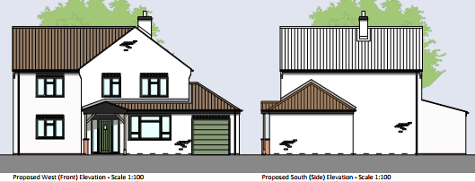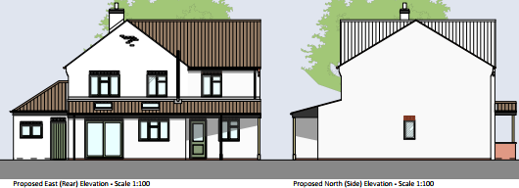
Proposed Elevations.

The proposal would see the removal of an aged conservatory on the rear east elevation of the building and for its replacement with a single storey lean-to extension, which would serve to provide an enlarged kitchen dining area within the property. The two-storey element of the scheme would be located on the north side elevation, as shown above, with the scheme providing an office and utility room at ground floor level, with a new master bedroom and en-suite at first floor level. The proposed porch would be on the front elevation with its tiled roof extending onto the side and over the existing garage, which currently has its original flat roof.

The proposed extensions would have a contrasting off white rendered finish with matching roof tiles.
Therefore, in summary, having regard to the above, the proposal complies with the design principles set out in Core Policy 57 of the Wiltshire Core Strategy and Appendix D of the Wiltshire Design Guide.

Amenity
Point vii of Core Policy 57 - Ensuring High Quality Design and Place Shaping of the Wiltshire Core Strategy seeks to ensure that developments do not adversely affect neighbouring properties. The National Planning Policy Framework (NPPF), particularly Paragraph 135(f), stresses that planning decisions should ensure developments provide a high standard of amenity for existing and future users.
The main proposed extension would be two storey and would look out onto and face its front and rear garden areas. The building is located in a developed urbanised area where the principle of high-level mutual overlooking is an established principal, in this instance however, due to the established fenestration within the building, there would not be the introduction of new overlooking, with the outlook from the high-level windows remaining the same. Notwithstanding this, the rear facing high level window would serve an en-suite and so would be frosted to promote privacy.
Likewise, due to the location and orientation of the proposal, there would not be any significant overshadowing or loss of light to neighbours.

The proposal therefore accords with Core Policy 57 point vii. in respect of safeguarding residential amenity and Appendix D of the Wiltshire Design Guide.

Highway Matters.
Core Policy 57 (xiv) of the Wiltshire Core Strategy seeks to ensure that development must meet the requirements of Core Policy 61. This policy requires proposals to be capable of being served by safe access to the highway network. Core Policy 64 seeks to ensure compliance with parking standards set out in the Local Transport Plan.

The National Planning Policy Framework (NPPF), particularly Paragraph 115 and 116, requires that development proposals do not have an unacceptable impact on highway safety and that safe and suitable access to the site can be achieved for all users.

The proposed development would continue to use the established site access which would be widened to accommodate the off-road car parking provision for three vehicles and so, would not have adverse impact on highway safety. Adequate parking and turning provision are provided within the site and such access arrangements are acceptable. The council’s highways officer has been consulted who has not raised any objections, subject to conditions.

The first suggested condition relates to lowering the height of a hedgerow to that of the existing low level boundary wall between St. Margaret’s Gardens and St. Andrew’s Road, to allow for highway visibility. The proposed plans show the removal of a section of straight hedgerow to allow for the site access arrangements. However, visibility needs to be provided from the site’s vehicular access, of traffic approaching the junction from St Andrew’s Road and vehicles emerging from there. The highways officer has applied a condition stating that the high level hedgerow at this location be reduced in height to that of the low level boundary brick wall, to allow visibility. This is considered to be relevant and necessary for highway safety reasons. The following photograph snippet from Street View shows this situation with the tall domestic hedgerow by the road sign;

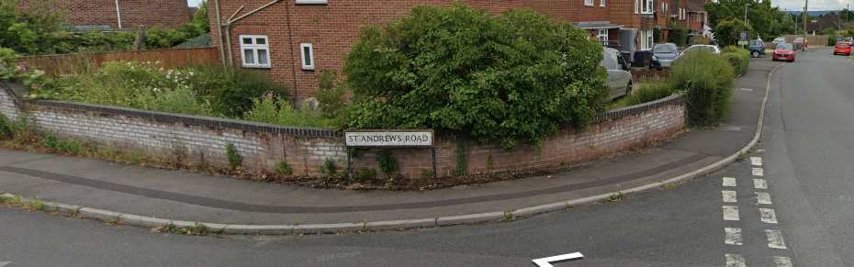

Other suggested conditions relate to the consolidation the first 5m of the access surface, surface water disposal, and the provision of the revised and enlarged access and parking provisions, to be completed prior to the first use of the scheme, all of which are considered to be acceptable.

A condition in relation to the prevention of gates being installed has also been suggested, but is considered to be unreasonable as its implementation would prevent basic security measures being installed.

The proposal is therefore considered to comply with Core Policies 57 (xiv), 61 and 64 of the Wiltshire Core Strategy, the NPPF, and the Wiltshire Local Transport Plan.

Ecology Impact CP50 requires no net loss of biodiversity on site. The site is not located within any bat zone and so the proposals are acceptable in this regard. As such, the development complies with Core Policy 50 of the Wiltshire Core Strategy and the relevant provisions of the NPPF.

Biodiversity Net Gain. This application is exempt from the requirement to deliver Biodiversity Net Gain under Schedule 7A, Section 4(2)(a) of the Town and Country Planning Act 1990, as inserted by the Environment Act 2021, because the proposal is a householder extension.

CONCLUSION
The proposed development is acceptable in terms of its design, scale, and relationship with the surrounding area. It would not result in any unacceptable harm to the character of the locality, the amenities of neighbouring occupiers, or the interests of highway safety, heritage, or ecology.

The proposal is therefore considered to comply with the relevant policies of the Wiltshire Core Strategy, the Wiltshire Local Plan, and the National Planning Policy Framework. As such, the application is recommended for approval, subject to the conditions set out below.

RECOMMENDATION: Planning Permission be GRANTED subject to conditions.

