APPLICATION FOR LISTED BUILDING CONSENT
OFFICER DELGATED REPORT

APPLICATION REFERENCE: | PL/2025/08126
APPLICATION TYPE: | Listed building consent (Alt/Ext)
SITE ADDRESS: | 45 London Road, Chippenham, SN15 3AJ
DESCRIPTION OF WORKS: | Repair and rebuild the left-hand side of the frontage of the boundary wall
RECOMMENDATION: | Approve with Conditions

SITE DESCRIPTION/CONTEXT
The subject property is a GII designated dwelling that lies behind an attached wall and gate piers that are specified within the Historic England’s listing.

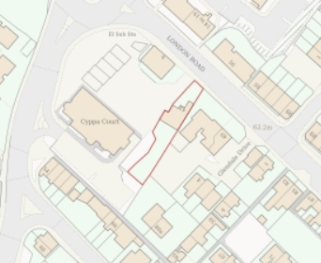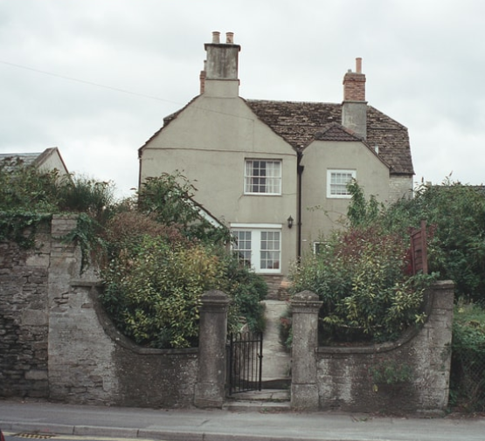
Location Plan and Google Earth Site Photo

43-45 London Road, also known as Albert Cottage, the name being carved into the gate pillars, lies within a post-medieval area of Chippenham; a later expansion from the historic core, now primarily residential, in which historic form and layout survives.

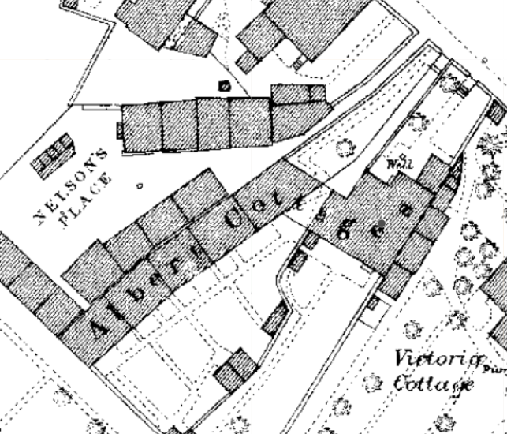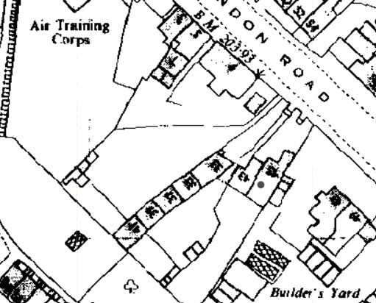
The building was once part of a long terrace known as Albert Cottages, as seen on the 1st epoch mapping above. The front boundary walls are visible in this map as is the absence of the neighbouring wall and gate piers to the remainder of the cottages around Nelson’s Place.

Demolition of Albert Cottages begin piecemeal in the 5th epoch, as per the map above right.

The site is within a southeast arm of the Chippenham Conservation Area that flanks the London Road and the numerous listed and non-designated heritage assets dispersed along, with pockets of modern infill.

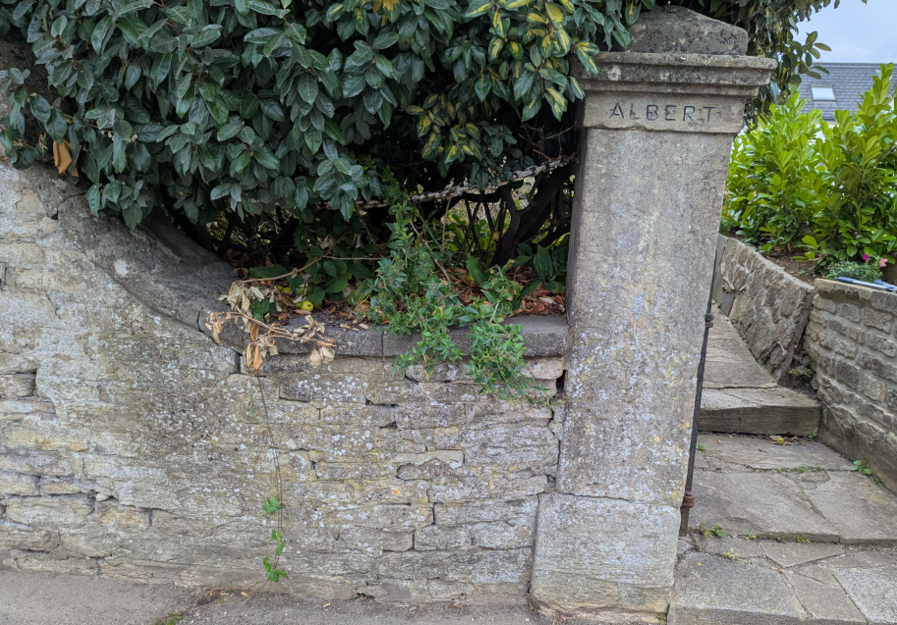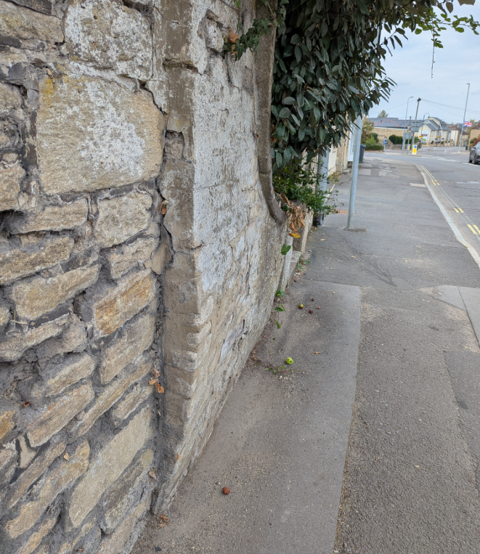
Submitted Site Photos

The list entry, notes that the house, once two dwellings, is mid C18 with early C19 wings. 2m high rubblestone walls are attached on either side and sweep ‘boldly’ down to the street and both sides to the central ashlar gate piers with pyramidal tops which flank steps to the house and are inscribed ‘Albert Cottages.’

The walls and gates piers are highly visible on the streetscape and make a positive contribution to the Conservation Area and retain features of special interest that contribute to the dwelling’s significance.

The application states that gaps between coping stones and long-term bulging of the wall has led to further water ingress and damage, meaning the wall leaf will need to be repaired/rebuilt to vertical, using existing stone, replacing the various layers of cement-based mortar for lime mortars.

The other paired side of the wall/other pillar has already been rebuilt some years prior.

Building Control advice, ref: BR/2025/24942, August 2025, includes details of the wall being registered as a Dangerous Structure, following complaints that it bows outwards over the pavement, and site photos show the gate pier leaning. It also states that it is not considered immediately dangerous as street view images in 2014 show the wall in a similar condition but do suggest that the wall is monitored.

PROPOSAL
The proposal is to rebuild the bowing section of boundary rubble stone wall, left of the gate piers, restabilising footings, using lime mortar. Matching local stone will be sourced if any existing rubble stone material is damaged beyond repair.

A schedule of works notes that shrubs within the curtilage garden abutting the wall will need to be removed; their roots partly responsible for the bowing out, make good the footings and excavate new foundations for a 9” block retaining wall, with weep holes and stainless-steel ties to the front elevation of the stone wall.

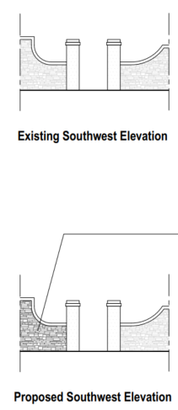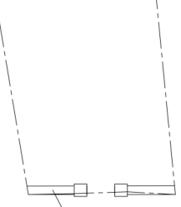

Exiting and Proposed Elevation and Floor Plan

RELEVANT PLANNING HISTORY
19/07295/FUL - Full planning permission Decision - Approve with Conditions Date: 15/11/2019 – Proposed car parking area on part of garden and the reinstatement of the boundary wall
19/07324/LBC - Listed building consent Decision - Approve with Conditions Date: 15/11/2019 – Proposed car parking area on part of garden and the reinstatement of the boundary wall
19/10935/FUL - Full planning permission Decision - Approve with Conditions Date: 9/1/2020 – Concrete piled retaining wall with rendered block work facing leaf, reconstituted stone coping and metal railing above – no.9
N/08/01946/LBC - Listed building consent Decision - Approve with Conditions Date: 23/10/2008 – Alterations to the Ground Floor Including Installation of New Iron Railings to Front of Property, Re-building a Section of the Front Wall, Removal of Existing Timber Fence and Construction of New Timber Fence and Gate and Relocation of Shed – nos.47-49 London Road
N/08/01964/FUL - Full planning permission Decision - Approve with Conditions Date: 23/10/2008 – Alterations to the Ground Floor Including Installation of New Iron Railings to Front of Property, Re-building a Section of the Front Wall, Removal of Existing Timber Fence and Construction of New Timber Fence and Gate and Relocation of Shed – nos.47-49 London Road
N/11/01723/LBC - Listed building consent Decision - Approve with Conditions Date: 8/7/2011 – Erection of Fence Enclosing Boundary to Front of Property – nos.47-49 London Road
N/11/01744/FUL - Full planning permission Decision - Approve with Conditions Date: 8/7/2011 – Erection of Fence Enclosing Boundary to Front of Property – nos.47-49 London Road

RELEVANT LEGISLATION, POLICIES AND GUIDANCE

Legislation
From the point of view of the historic environment the main statutory tests are set out within the Planning (Listed Building and Conservation Areas) Act 1990. Section 16 requires that special regard be given to the desirability of preserving listed buildings, their settings or any features of special architectural or historic interest which they possess.

Section 72(1) of the Planning (Listed Building and Conservation Areas) Act 1990 also requires the Council to pay special attention to the desirability of preserving or enhancing the character or appearance of designated Conservation Areas.

National Policy and Guidance
The National Planning Policy Framework (NPPF) sets out government policy, including in respect of the historic environment.

Section 16 of the NPPF ('Conserving and enhancing the historic environment') sets out the Government's high-level policies concerning heritage and sustainable development.

Paragraphs 213-215 of the NPPF require a balanced approach with any harm which would be caused being weighed against the potential public benefits which might be achieved. Paragraph 210 requires local planning authorities to take account of the desirability of sustaining and enhancing the significance of heritage assets and of new development making a positive contribution to local character and distinctiveness.

Wiltshire Core Strategy:
Whilst not directly relevant to listed building consent applications, the below policies give an indication of the Council’s approach to development affecting heritage assets:

- Core Policy 57 ‘Ensuring high quality design and place shaping’: A high standard of design is required in all new developments, including extensions, alterations, and changes of use of existing buildings. Development is expected to create a strong sense of place through drawing on the local context and being complementary to the locality.

- Core Policy 58 ‘Ensuring the conservation of the historic environment’ requires that “designated heritage assets and their settings will be conserved, and where appropriate enhanced, in a manner appropriate to their significance.”

ISSUES
Impact upon the preservation of the listed structure, setting of the listed building, any features of special architectural and/or historic interest.

CONSULTATION RESPONSES
Chippenham Town Council: no objection
Highways Department: no objection. Informative deemed necessary.

REPRESENTATIONS
Internal works to Grade II:
In accordance with the requirements of Section 5(1) of the Planning (Listed Buildings and Conservation Areas) Regulations 1990 (as amended) the application for listed building consent was publicised by way of:

- A site notice displayed near the site;
- An advertisement placed in the local press.

These methods were used to inform interested parties and to allow a statutory consultation period of 21 days for representations to be submitted.

No comments were received.

ASSESSMENT
In accordance with Section 16(2) of the Planning (Listed Buildings and Conservation Areas) Act 1990, special regard has been given to the significance of the listed building, including its architectural and historic interest, and the desirability of preserving both the building and its setting. Relevant policies within the National Planning Policy Framework (NPPF), particularly Section 16: Conserving and Enhancing the Historic Environment, have also been taken into account. These policies require that any harm to the significance of a designated heritage asset must be clearly justified and weighed against the public benefits of the proposal.

Information considered/submitted
Paragraph 207 requires that applicants describe the significance of any heritage assets affected, including any contribution made by their setting. This should include sufficient information to provide a clear understanding of the significance of the heritage asset and its setting and the potential impact of any proposals on that significance.

The application is supported by a Design and Access Statement, a schedule of works and quote, photos of the existing wall, existing and proposed elevations. A Heritage Statement was not submitted.

Paragraph 208 also provides for the local planning authority to make its own assessment of impact and the following heritage recommendations are offered on this basis.

Assessment of significance:
According to the National Planning Policy Framework (NPPF), significance is defined as:

“The value of a heritage asset to this and future generations because of its heritage interest. The interest may be archaeological, architectural, artistic or historic. Significance derives not only from a heritage asset’s physical presence, but also from its setting.”

Historic England further categorises significance into four key values:

- Evidential – the potential of the asset to yield evidence about past human activity.
- Historic – the ways in which the asset illustrates aspects of history.
- Aesthetic – the sensory and design qualities of the asset.
- Communal – the meanings and associations attached to the asset by people.

In this case the significance of the subject boundary wall and gate pier lies largely with its architectural detailing, scale, form, use of both rubble stone and ashlar, and contribution to the setting of the listed building lying behind the symmetrical entrance/garden stairs.

The proposal seeks to rework the rubble stone element of the southeastern section of boundary wall, abutment of the gate piers all replicated exactly in scale, form and materiality of the listed walls and gate pier.

Impact of proposals on the significance and setting of the building/structure:
Understanding the impact of proposed works on a listed building requires a careful and proportionate assessment of how those changes affect the asset’s heritage significance and its setting. This includes both the physical alterations to the building itself and any changes to its spatial or visual relationship with surrounding structures or spaces.

The significance of a heritage asset is not static; it is shaped by its architectural, historic, and communal values, and by how these are experienced in context. Therefore, any intervention must be considered in light of the asset’s identified significance, with attention given to both potential harm and benefits. Benefits may include repairs that support the long-term conservation of the building, improved energy performance, or enhanced public access and understanding.

This assessment is grounded in the statutory duty under Section 16 of the Planning (Listed Buildings and Conservation Areas) Act 1990, which requires special regard to be given to the desirability of preserving the building and its features of special interest. It is also informed by national policy, particularly paragraphs 199–208 of the National Planning Policy Framework (NPPF), and relevant local heritage policies and guidance.

The proposal seeks to dismantle the existing section of wall and rebuild it as an exact replica, as it would have first been built, repairing damage, inappropriate mortar and structural movement.

Whilst the historic fabric would be dismantled, translating as harm, it would be retained and reused. Only damaged rubble stone would be discarded. This harm is justified and proportionate to the risk of collapse and loss of historic fabric, as part of considered repairs, so enhancing the setting of the listed building and the wall’s contribution to the special character of the conservation area.

Site photos show a wall in danger of collapse, if not immediately, but inevitably, which has the potential to smash the gate pier. The proposal seeks to ensure the wall is safe to all footpath and highway users, reinstate long-term structural integrity, protect the historic fabric from further damage by inappropriate mortars, and replicate design, scale, and form, so protecting historic significance, the setting of the listed dwelling and the special character of the Conservation Area.

CONCLUSION
The NPPF confirms that when considering the impact of a proposed development on the significance of a designated heritage asset, great weight should be given to the asset’s conservation (and the more important the asset, the greater the weight should be). It makes clear that any harm to a designated heritage asset requires clear and convincing justification.

In this case the proposals will also result in considerable heritage benefits by virtue of the proposed investment in repair and upgrading/structural repair which will help to secure the future/stability of the boundary wall.

The proposed works would preserve the listed building, its setting, and any features of special architectural or historic interest. It is considered necessary to attach conditions

RECOMMENDATION:
That Listed Building Consent be GRANTED, subject to conditions.

