APPLICATION FOR FULL PLANNING PERMISSION
DELEGATED REPORT

APPLICATION REFERENCE: | PL/2026/00705
APPLICATION TYPE: | Full Planning Permission
SITE ADDRESS: | Holt Farm, Ground Corner, Holt, Trowbridge, BA14 6RT
DEVELOPMENT DESCRIPTION: | Proposed installation of 95 panels mounted via a low profile ground mounted racking system.
RECOMMENDATION: | That Planning Permission be GRANTED

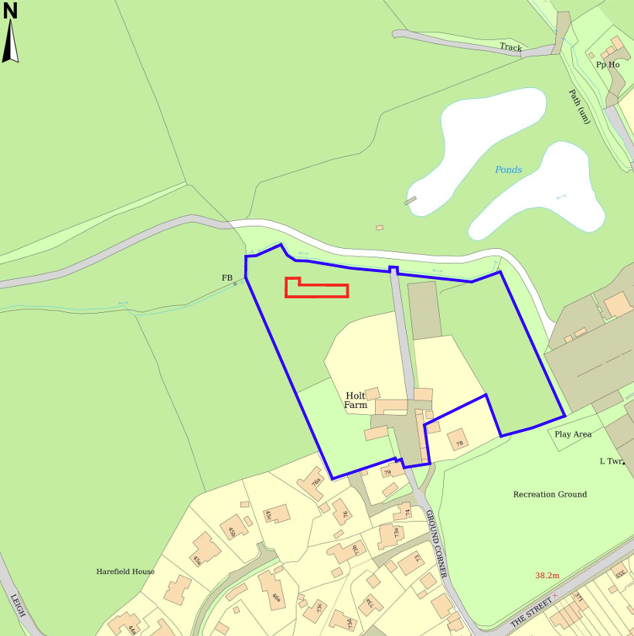

PROPOSAL

The proposal seeks planning permission for the installation of 95 ground‑mounted monocrystalline 475W solar photovoltaic panels within an agricultural field associated with Holt Farm. The array would be positioned on a low‑profile, ballasted racking system with no ground penetration, with the highest point of the panels sitting approximately 0.4m above ground level.

SITE DESCRIPTION / CONTEXT

The application site comprises an agricultural field forming part of the landholding associated with Holt Farmhouse, located to the south of Holt village. The field is enclosed by established hedgerow and tree cover and lies just south of a small watercourse. Holt Farmhouse, a Grade II listed building, lies approximately 80m to the southeast, marking the start of the Holt Conservation Area, although the proposed development falls just outside its boundary (the wider landholding extends into it). Public Rights of Way HOLT16 runs directly adjacent to the western boundary, with HOLT25 and HOLT18 connecting nearby. The site lies within Flood Zone 1, is not identified as being at risk of surface or groundwater flooding in the Strategic Flood Risk Assessment, and sits outside the Holt Settlement Boundary by approximately 110m. The land also falls within the 4km Core Roost Buffer for the Bath and Bradford on Avon Bats SAC.

PLANNING HISTORY

Reference No. | Proposal / Summary | Decision
21/01854/FUL | Installation of ground-mounted Solar PV panels for residential power generation | Approved
13/01777/FUL | Conversion of cow byre into an artist's studio and storage | Approved
13/01797/LBC | Conversion of cow byre into an artist's studio and storage | Approved
W/05/02736/LBC | Replace current white aluminium double glazed units within the stone mullion surrounds with black metal windows | Approved

RELEVANT LEGILSATION, POLICIES AND GUIDANCE

Wiltshire Core Strategy:

Core Policy 1 Settlement Strategy;
Core Policy 2 Delivery Strategy;
Core Policy 7 Spatial Strategy: Bradford on Avon Community Area;
Core Policy 41 Sustainable Construction and Low-Carbon Energy;
Core Policy 42 Standalone Renewable Energy Installations;
Core Policy 50 Biodiversity and Geodiversity;
Core Policy 51 Landscape;
Core Policy 57 Ensuring High-Quality Design and Place Shaping;
Core Policy 58 Ensuring Conservation of the Historic Environment;
Core Policy 60 Sustainable Transport;
Core Policy 61 Transport and Development;
Core Policy 64 Demand Management;
Core Policy 67 Flood Risk;

Holt Neighbourhood Plan 2016 to 2026 (January 2017)

The National Planning Policy Framework (NPPF)

The Planning Practice Guidance (PPG)

Wiltshire Design Guide

Emerging Policy – Wiltshire Local Plan Review

The examination of the emerging Wiltshire Local Plan has been paused and the weight to be afforded to any part of the emerging plan can be no more than very limited. A decision on how to proceed will be made by the Council in May 2026.

- Policy 1 Settlement Strategy
- Policy 85 Sustainable construction and low carbon energy
- Policy 88 Biodiversity and Geodiversity
- Policy 89 Biodiversity Net Gain
- Policy 95 Flood Risk
- Policy 98 High Quality Design and Place Shaping
- Policy 99 Ensuring the Conservation of the Historic Environment

CONSULTATION RESPONSES

Holt Parish Council – No Objection

Public Protection (Wiltshire Council) – No Objection (subject to condition)
Construction hours limitation requested.

Ecology (Wiltshire Council) – No Objection

REPRESENTATIONS

No comments received.

ASSESSMENT

Section 38(6) of the Planning and Compulsory Purchase Act 2004 states:

"If regard is to be had to the development plan for the purposes of any determination to be made under the planning Acts, the determination must be made in accordance with the plan unless material considerations indicate otherwise."

In accordance with this statutory requirement, this application has been assessed against the relevant policies of the Development Plan, including the adopted Wiltshire Core Strategy (2015) and, where applicable, any made Neighbourhood Plans.

Core Policies 1 and 2 restrict most forms of development outside the limits of development; however, the Core Strategy must be read as a whole. Core Policy 42 provides a specific policy framework for assessing standalone renewable energy proposals, and its criteria are directed at development occurring within rural or open countryside settings. While Core Policy 42 does not explicitly state that such proposals are acceptable outside settlement boundaries, it is the relevant topic-based policy for renewable energy installations and therefore provides the appropriate route for considering the principle of development in this location.

Core Policy 42 supports standalone renewable energy proposals where all site‑specific constraints can be satisfactorily addressed. In this case, the policy requires consideration of the proposal’s effects on the surrounding landscape, local biodiversity interests, and the historic environment, as well as potential impacts on residential amenity, including matters such as visual impact, noise, odour, and safety. The policy also expects assessment of whether the development would lead to the loss or deterioration of best and most versatile agricultural land. In this case, there is no anticipated harm to the historic environment, as site observations confirm no direct views between the listed Holt Farmhouse, the conservation area, and the proposed array, with existing boundary vegetation providing additional seasonal screening. Detailed landscape, biodiversity, and residential amenity considerations are addressed within the respective sections of this report. With regard to agricultural land quality, Natural England mapping identifies the land as Grade 3, and although the applicant has not provided further classification or justification, the proposed ballasted, non-penetrative mounting system is fully reversible, ensuring that the long-term agricultural potential of the site would not be compromised.

Paragraph 168 of the NPPF states when determining planning applications for all forms of renewable and low carbon energy developments and their associated infrastructure, local planning authorities should recognise that small-scale and community-led projects provide a valuable contribution to cutting greenhouse gas emissions.

Additionally, the Holt Neighbourhood Plan outlines support for renewable energy by encouraging development that promotes green energy (Policy E.1) and that demonstrates responsible management of energy, water, drainage, waste, and wider infrastructure impacts (Policy E.2).

Taken together, these factors indicate that the proposal meets the relevant Core Policy 42 criteria, as well as policies E.1 and E.2 of the Holt Neighbourhood plan, and as such the proposal is considered to be acceptable in principle and will be considered further through the following report.

Design and Impact upon the upon the character and context of the area

Core Policy 57 Ensuring High Quality Design and Place Shaping of the Wiltshire Core Strategy seeks to ensure that all new development is of high design quality, reflecting local context, character, and distinctiveness. Core Policy 51 of the WCS states that development should conserve and protect existing landscape character. It additionally states that local features such as hedgerows and watercourses must be considered as part of any analysis, as well as other matters which relate to the overall distinctive quality of the specific locality in question.

The proposal comprises a ground-mounted solar photovoltaic array covering approximately 320 m², with a maximum height of 0.4 m above ground level, set within an enclosed agricultural field. A full inspection of the site and its surroundings confirmed that external visibility of the installation is very limited. The eastern and southern boundaries are well screened by existing tennis courts, tree belts, and established hedgerow, such that the array is entirely obscured from views in these directions. To the north, the site is only partially perceptible from within the Glove Factory open space; however, visibility is restricted to instances where an individual is positioned directly against the boundary vegetation, looking through the hedgerow. This does not give rise to any meaningful visual effect. The only location where the array would be appreciably noticeable is along the Public Right of Way HOLT16 on the western boundary, where the field is more open. Nevertheless, the low profile of the panels, their limited overall footprint, and their dark, recessive appearance ensure that any visual impact would remain minimal and confined to immediate foreground views.

The field is visually contained by dense vegetation on all sides, and does not read as part of the wider open landscape. This enclosure, combined with the low height of the installation, substantially reduces any potential landscape impact. Boundary planting will also thicken seasonally, further diminishing visibility throughout the year. Overall, the development is considered to integrate acceptably with the character and appearance of the area and does not give rise to any harmful landscape or visual effects.

The proposal also includes a minor trench connection running southwards to an existing outbuilding. As this will be fully covered once installed, it will not be visible and therefore carries no landscape or design impact.

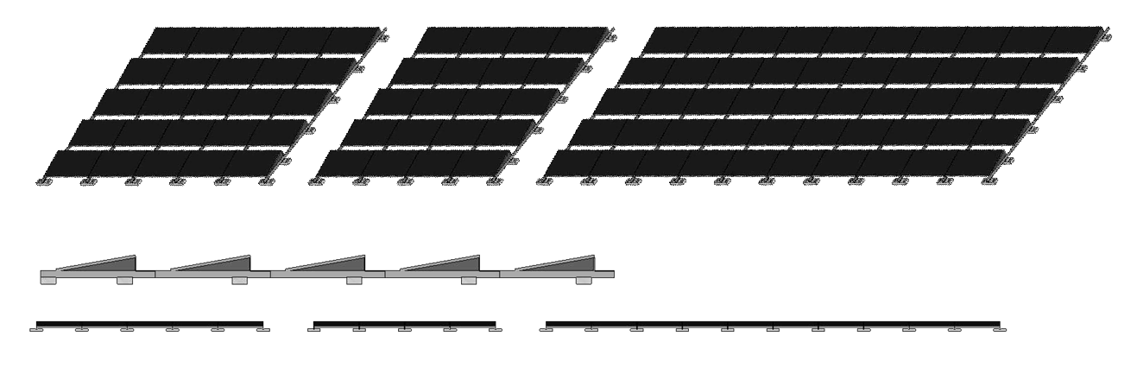
Proposed Isometric Plan, Front and Side Elevations

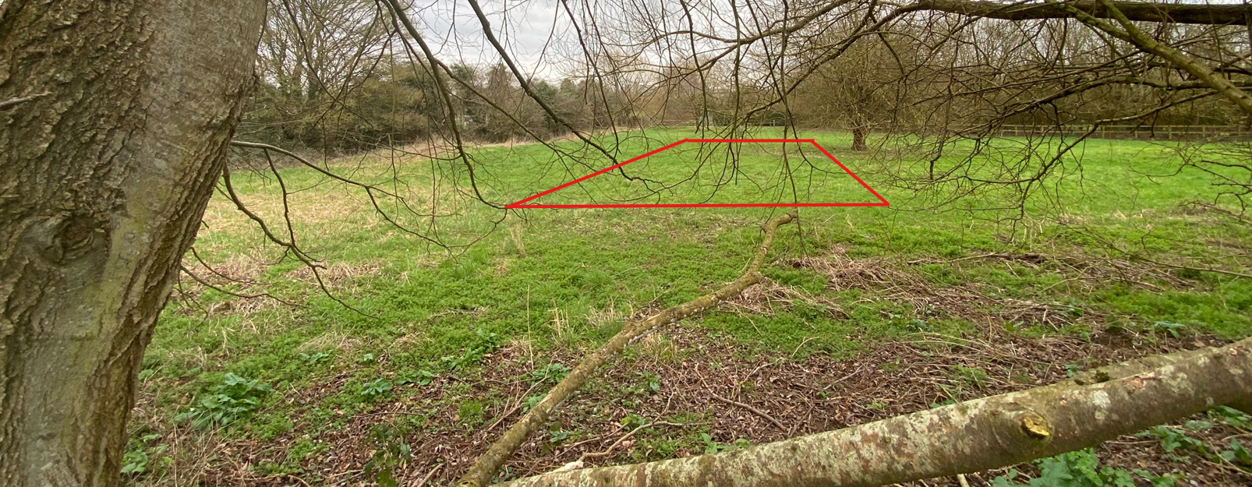
Site visit Image from PROW (HOLT16) and indicative location

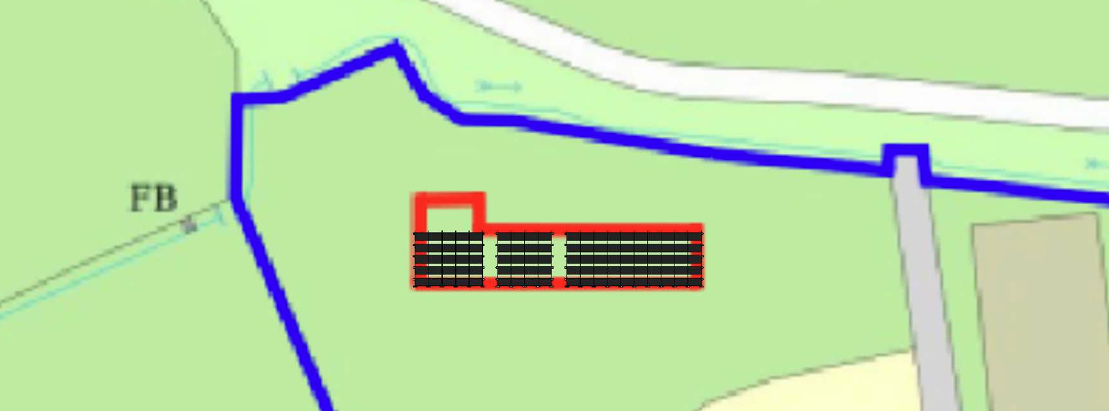
Block Plan
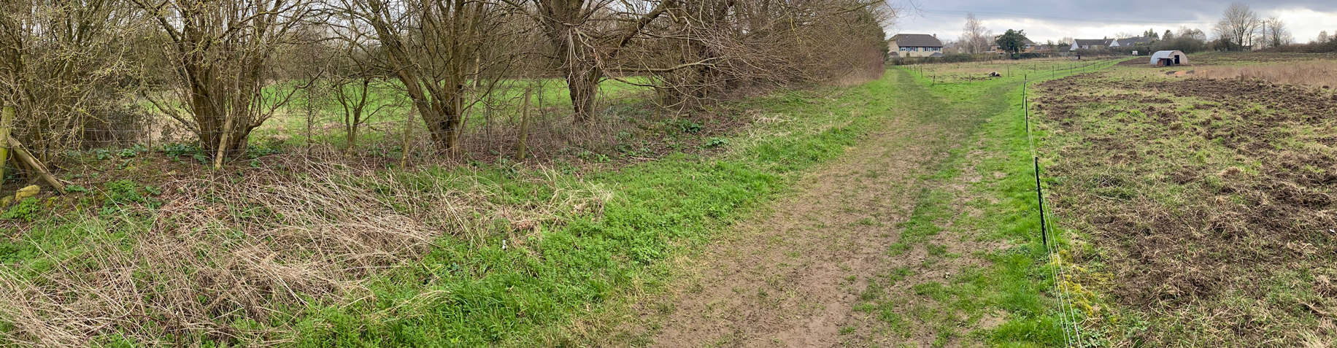
Image facing South along PROW (HOLT 16)

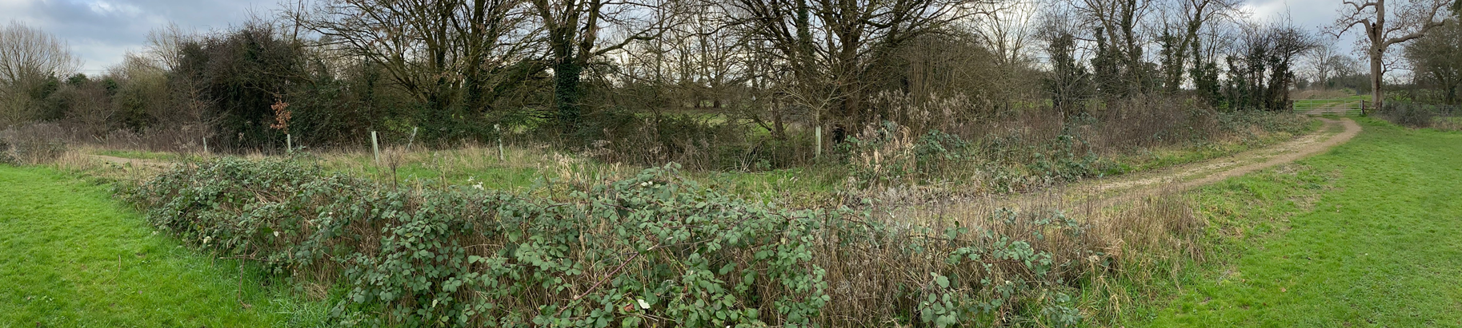
Image facing South (into site) from within the Glove Factory open space

Having regard to the above, the proposal complies with the design principles set out in Core Policy 57 of the Wiltshire Core Strategy and the Wiltshire Design Guide.

Conservation and Heritage

Core Policy 58 outlines development consideration with regard to the historic environment. The policy states that heritage assets and their settings must be conserved and, where appropriate, enhanced through any proposed development.

There is no identified harm to the setting or significance of the nearby heritage assets. During the site visit it was clear that there are no direct or meaningful views between the proposed solar array and the Grade II listed Holt Farmhouse, owing to the combination of distance, intervening vegetation and the contained nature of the application field. Likewise, although the development site lies just outside the edge of the Holt Conservation Area, existing hedgerow and tree cover around the field form a consistent visual buffer, with boundary vegetation becoming denser seasonally. As a result, the proposal would not affect the character, appearance, or experience of the conservation area, nor would it diminish the setting of the listed building. The development is therefore considered to give rise to no heritage harm.

Amenity

Point vii of Core Policy 57 Ensuring High Quality Design and Place Shaping of the Wiltshire Core Strategy seeks to ensure that developments do not adversely affect neighbouring properties.

The National Planning Policy Framework (NPPF), particularly Paragraph 135, stresses that planning decisions should ensure developments provide a high standard of amenity for existing and future users.

The nearest dwelling to the proposed installation is the host property, with all other residential dwellings located at least approximately 110 m from the site. Given the very low profile of the array (0.4 m in height), its limited footprint, and the strong degree of natural screening provided by boundary vegetation, the development would not give rise to any concerns relating to overbearing impact, loss of outlook, noise, or general residential amenity. The Public Protection Officer has also raised no objection, subject only to the imposition of a standard construction hours condition, further indicating that no amenity issues are anticipated. Overall, the proposal is considered to have no unacceptable effect on residential amenity.

The proposal therefore accords with Core Policy 57 point vii in respect of safeguarding residential amenity and Appendix D of the Wiltshire Design Guide.

Ecology

The WCS, through Core Policy 50, states that development proposals are expected to avoid and reduce disturbance of sensitive wildlife species and habitats. Biodiversity Net Gain (BNG) was established as a mandatory aspect of planning evaluation through Schedule 7A of the Town and Country Planning Act 1990 (as amended by the Environment Act 2021 Schedule 14). It is considered that the development does trigger the threshold for required BNG in association with the development proposal and as such must be considered further.

The applicant proposes a low-impact scheme in ecological terms, as the array will sit on a fully reversible, non-penetrative mounting system that allows the existing grass cover beneath the panels to be retained, avoiding any need for gravel or hard surfacing. To address and offset any minor ecological effects, the applicant also proposes the planting of 11 new trees behind the array as part of their on-site biodiversity enhancement measures. These details are confirmed within the submitted Biodiversity Gain Plan, which demonstrates a measurable net increase in biodiversity units resulting from the development. The Council’s Ecology Officer has reviewed the submitted information, raised no objection, and accepted the proposed mitigation and enhancements as sufficient. The ecological impacts of the scheme are therefore considered acceptable.

Transport and Highways

Core Policy 60 of the Wiltshire Core Strategy seeks to support safe and efficient movement across the county and to ensure that development appropriately mitigates any transport impacts on local communities. Core Policy 61 further requires proposals to demonstrate consideration of the transport user hierarchy and, where relevant, to provide safe and suitable access to the highway network. National policy reinforces this approach: paragraph 116 of the NPPF states that development should only be refused on highway grounds where it would result in an unacceptable impact on highway safety or where the residual cumulative impact on the road network would be severe. In this case, the proposal relates solely to the positioning of a small-scale solar array and does not alter access, egress, parking arrangements, or generate any material increase in vehicle movements. As such, there are no highway or transport concerns arising from the development, and the scheme is considered wholly acceptable in this regard.

Flooding and Drainage

Core Policy 67 of the Wiltshire Core Strategy requires new development to be planned and designed to manage flood risk appropriately, while paragraph 172 of the NPPF emphasise the need for a sequential, risk‑based approach and the incorporation of sustainable drainage measures. In this case, the site lies within Flood Zone 1, and the Strategic Flood Risk Assessment identifies no risk of surface water or groundwater flooding at this location. The proposal maintains the existing grass cover beneath the solar array, and the installation involves no hard surfacing, meaning rainwater will continue to infiltrate naturally into the ground. Surface water run‑off will therefore be no different from existing conditions. As such, the development presents no increased flood risk and is considered fully acceptable in terms of flood risk and drainage.

CONCLUSION

The proposal is considered to be acceptable and in accordance with the relevant policies and guidance outlined above.

RECOMMENDATION: That Planning Permission be GRANTED subject to the following conditions:

1.
The development hereby permitted shall be begun before the expiration of three years from the date of this permission.
REASON: To comply with the provisions of Section 91 of the Town and Country Planning Act 1990 as amended by the Planning and Compulsory Purchase Act 2004.

2.
The development hereby permitted shall be carried out in accordance with the following approved plans and documents:

Top Plan – Proposed 40621-3 A
Trenching Details 40621-6 A
Block Plan 40621-1 A
Trees and Hedges 40632-7 A
Front Plan – Proposed 40621-4 A
Location Plan (2 Feb 2026)

REASON: For the avoidance of doubt and in the interests of proper planning.

3.
Construction hours shall be limited to 0800 to 1800 hrs Monday to Friday, 0800 to 1300 hrs Saturday and no working on Sundays or Bank Holidays.

REASON: To ensure the creation/retention of an environment free from intrusive levels of noise and activity in the interests of the amenity of the area.

