DESIGN & ACCESS STATEMENT
Proposed Development: Change of Use of Agricultural Land to Padel Sports Facility
Location: Fairfields, Semington, Trowbridge, BA14 6JD
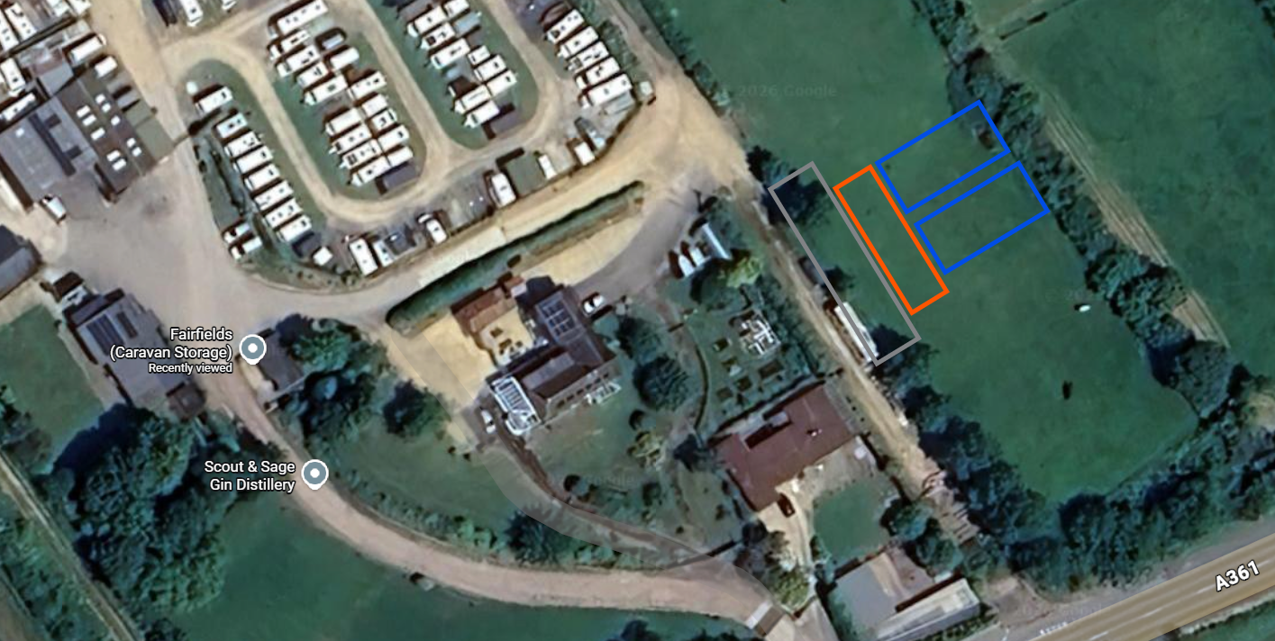

1. Introduction
This Design and Access Statement has been prepared in support of a planning application for the change of use of agricultural land to a sports and recreational facility, comprising two outdoor padel courts and associated ancillary development.
The proposal has been designed with careful consideration of its rural context, neighbouring amenity, and environmental impact, ensuring a low-impact and reversible form of development.

2. Site Context
The site forms part of Fairfields in Semington, situated within a rural setting characterised by open agricultural land and limited residential development.
Access is taken from the A361 via an existing site entrance, with the development area located approximately 40 metres from the highway.
The land is currently unused grassed agricultural land, relatively flat and well-suited to the proposed development without requiring significant alteration.
The nearest residential properties are located approximately 25 metres from the rear of the proposed courts.

3. Amount of Development
The proposal comprises:
- 2 no. padel courts (20m x 10m x 4m high each)
- Associated circulation space (2m between courts and at ends)
- Small decking/seating area
- Portacabin building for welfare facilities
- Parking area for approximately 6–8 vehicles
The scale of development is modest and proportionate to the site.

4. Layout
The layout has been designed to:
- Position courts side-by-side for efficient land use
- Maintain separation distances to boundaries and neighbouring properties
- Provide safe and logical pedestrian movement
- Retain a clear relationship between courts, seating, and welfare facilities
Parking is located to the rear of the welfare building to minimise visual impact and ensure safe vehicle manoeuvring.
The arrangement ensures that activity is contained within the central part of the site, reducing impact on surrounding land uses.

5. Scale
The proposed courts have a maximum height of approximately 4 metres, which is typical for padel facilities and considered appropriate within the open rural context.
Lighting columns will extend to 6 metres in height, designed to ensure adequate illumination while minimising light spill.
Ancillary structures (decking and portacabin) are small-scale and subordinate to the primary use.

6. Appearance
The development will adopt a simple, functional appearance consistent with recreational use in rural areas.
- Courts will be constructed using a modern modular system
- Materials will be neutral and unobtrusive
- The portacabin will be of standard finish and screened where possible
- Timber decking will provide a natural visual element
Overall, the appearance is designed to blend with the surroundings and avoid visual intrusion.

7. Access
Vehicular Access
Access to the site will be via the existing track from the A361. No changes to the access point are proposed.
Traffic generation is expected to be low and consistent with a small-scale recreational facility.
Pedestrian Access
Users will access the courts via a short walking route from the parking area.
The layout provides safe and clear routes for all users.

8. Inclusive Access
The development has been designed to be accessible to all users:
- Level access across the site
- Step-free entry to courts and facilities
- Accessible toilet provision within the portacabin
This ensures inclusivity in line with best practice.

9. Environmental Considerations
Ground Impact
The courts will be installed using an “iframe” system, allowing them to sit on a steel ring beam rather than a traditional concrete base.
This approach:
- Minimises excavation
- Reduces permanent ground alteration
- Allows for potential reversibility
Drainage
- Foul drainage will be managed via a septic tank, consistent with existing arrangements
- Water supply will be sourced from an existing connection along the site boundary
- Parking will be finished in a permeable surface (e.g. gravel) to reduce visual and drainage impact.
Lighting
- 4 no. 200W LED lights per court
- Mounted at 6 metres
- Downward-facing to reduce light spill
- Controlled via timer during winter months
This ensures minimal impact on neighbouring properties and the rural environment.
Noise
Padel is a low-impact recreational activity. Given:
- Limited number of courts
- Controlled hours (08:00–22:00)
- Separation from residential properties
Noise impacts are expected to be minimal and acceptable.

10. Sustainability
The proposal promotes sustainability through:
- Encouraging outdoor physical activity
- Supporting local community health and wellbeing
- Minimising construction impact via modular system
- Avoiding extensive groundworks
The development represents a sustainable diversification of rural land use.

11. Planning Policy Considerations
The proposal aligns with key planning objectives, including:
- Supporting rural diversification
- Promoting sport and recreation
- Protecting rural character through sensitive design
The scale and nature of the development ensure compliance with local and national planning principles.

12. Conclusion
This Design and Access Statement demonstrates that the proposed development:
- Is appropriate in scale and design
- Minimises environmental and visual impact
- Provides valuable community recreational facilities
- Respects neighbouring amenity
The proposal is therefore considered to represent sustainable development, and planning permission is respectfully sought.

Applicant: Jamie Hughes – Tri Padel Courts
Date: 26/03/2026

