APPLICATION FOR FULL PLANNING PERMISSION DELEGATED REPORT

APPLICATION REFERENCE: | PL/2026/01427
APPLICATION TYPE: | Full planning permission
SITE ADDRESS: | Meadow Cottage, Kings Lane, Ansty, Salisbury, SP3 5QA
DEVELOPMENT DESCRIPTION: | Proposed 3m x 3m Field Storage Shed
RECOMMENDATION: | That Planning Permission be GRANTED

PROPOSAL

The proposal seeks planning permission for the erection of a storage shed to be located within an agricultural field for the purposes of agricultural storage. The proposed storage building is to be located alongside the northern boundary of the field and will measure approx. 3m by 3m with a height of 2.30m. The agricultural storage building will be of a timber construction and timber clad.

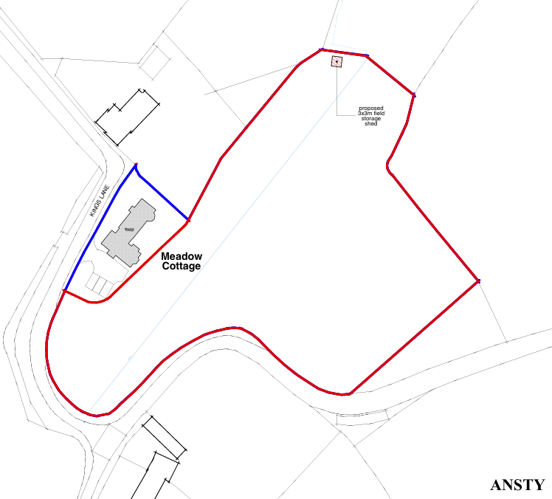

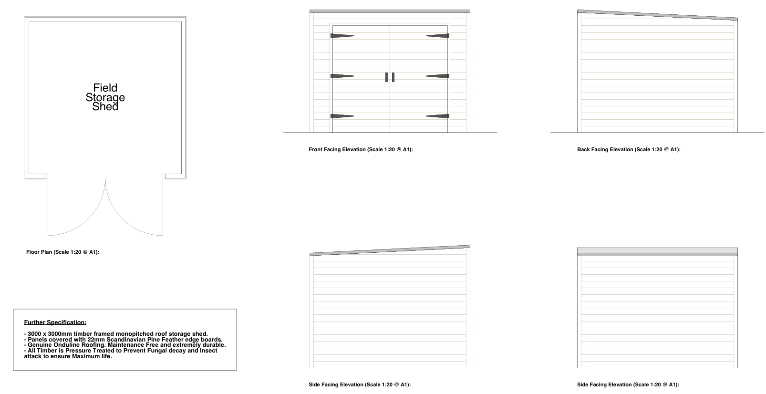

SITE DESCRIPTION/CONTEXT

The application site relates to agricultural land located to the south of the associated dwelling known as Meadow Cottage. The site is situated within a rural location outside of any settlement boundary. The field to divided by a narrow stream, the site is located within flood zone one, is note at risk of ground water flooding but parts of the site are at risk of surface water flooding. The site is located within the Hampshire River Avon Catchment.

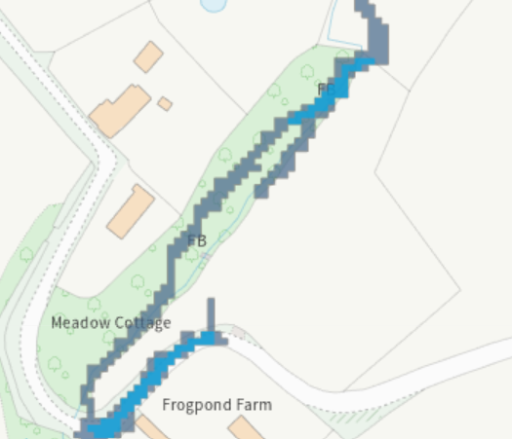

The site is located outside of the conservation (shaded dark green on the map extract below), two listed buildings are located close to the site (mark with black hatching below), 87 King's Lane to the north and Frog Pond Farmhouse to the south.

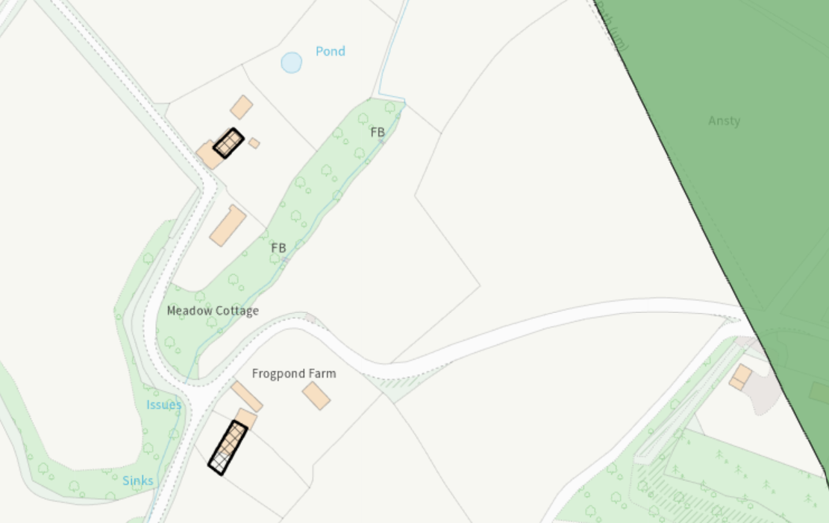

The site is located within the Cranborne Chase & West Wiltshire Downs National Landscape (formerly AONB).

PLANNING HISTORY

None relevant

RELEVANT POLICIES AND GUIDANCE

Section 66 of the Planning (Listed Buildings and Conservation Areas) Act 1990

The National Planning Policy Framework (NPPF)
The Planning Practice Guidance
National Design Guide

Wiltshire Core Strategy:

Core Policy 1 Settlement Strategy
Core Policy 2 Delivery Strategy
Core Policy 27 Tisbury Community Area
Core Policy 51 Landscaping
Core Policy 57 Ensuring high quality design and place shaping
Core Policy 58 Ensuring the conservation of the historic environment
Core Policy 69 Hampshire River Avon SAC

Wiltshire Design Guide
Creating Places Design Guide
AONB Management Plan – now known as National Landscape.

CONSULTATION RESPONSES

Parish Council: No comment

REPRESENTATIONS

No comments were received.

ASSESSMENT

Section 38(6) of the Planning and Compulsory Purchase Act 2004 states:

"If regard is to be had to the development plan for the purposes of any determination to be made under the planning Acts, the determination must be made in accordance with the plan unless material considerations indicate otherwise."

In accordance with this statutory requirement, this application has been assessed against the relevant policies of the Development Plan, including the adopted Wiltshire Core Strategy (2015) and, where applicable, any made Neighbourhood Plans.

Principle

The proposal comprises the erection of a building for agricultural storage within an open field located outside the defined settlement boundary. Such development may be acceptable however, this is subject to compliance with other relevant planning considerations. These include the impact on the character and appearance of the countryside, the appropriateness of the building’s scale, siting and design, and any effects on heritage assets or the setting of the National Landscape.

Character & Design, Impact on Heritage Assets and National Landscape.

Section 66 requires that special regard be given to the desirability of preserving listed buildings, their settings or any features of special architectural or historic interest which they possess.

Section 72(1) of the Act requires the Council to pay special attention to the desirability of preserving or enhancing the character or appearance of designated Conservation Areas.

The Council’s Core Strategy Policy CP58 ‘Ensuring the conservation of the historic environment’ requires that designated and non-designated heritage assets and their settings will be conserved, and where appropriate enhanced, in a manner appropriate to their significance and encourages proposals which improve the condition of heritage assets at risk.

The Council’s Core Strategy CP 57: Ensuring high quality design requires a high quality of design in all new developments. The policy requires applicants to “demonstrate how the proposal will make a positive contribution to the character of Wiltshire through (amongst other things) responding to the value of the natural and historic environment and being sympathetic to and conserving historic buildings and landscapes. Development is required to respond positively to the existing in terms of building layouts, built form, height, mass, scale, building line, plot size, elevational design, materials, streetscape and rooflines to effectively integrate the building into its setting.

Core Policy 51 of the Wiltshire Core Strategy requires all development to protect, conserve, and where possible enhance the character and quality of Wiltshire’s landscapes, giving particular weight to designated areas such as National Landscapes.

The location of the proposed building is in excess of 88m from the road to the south and is not prominent from public views. The proposed building is a modest structure with a low profile and is to be used to house agricultural machinery within an agricultural field.

The photos included below show a distance view of the site where the existing hard standing is just visible behind the trees, the second photo is a closer view of the site, the siting for the building is where the green tarpaulin can be seen in the second photo. .

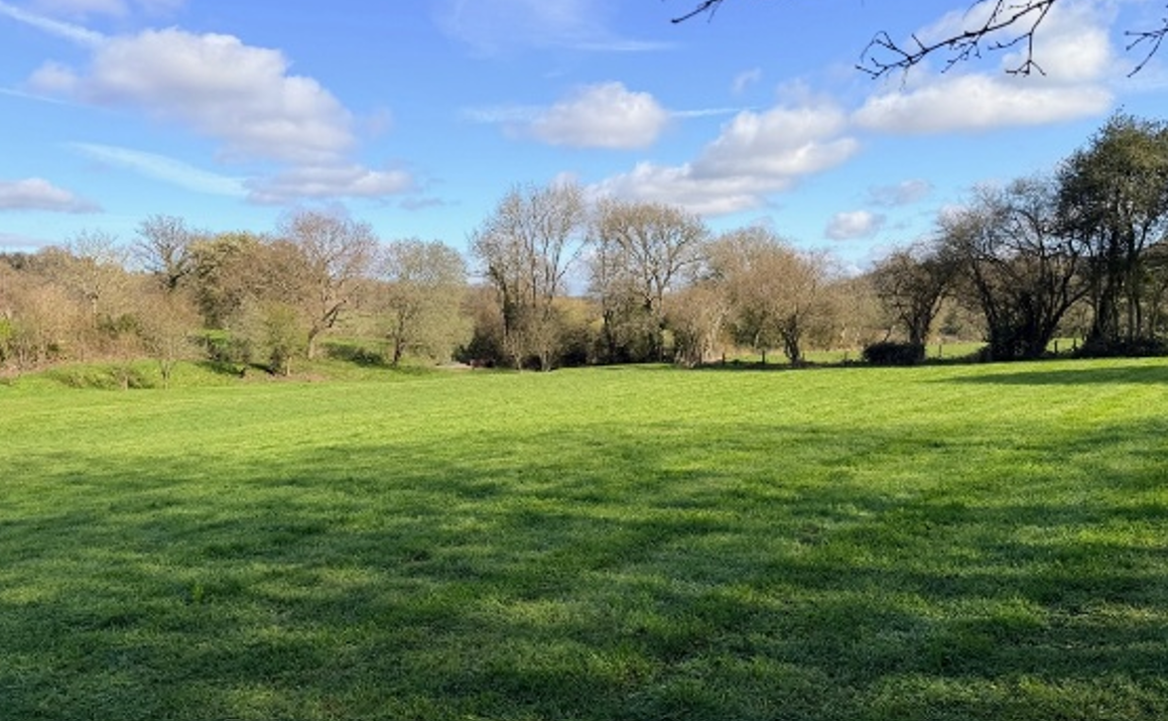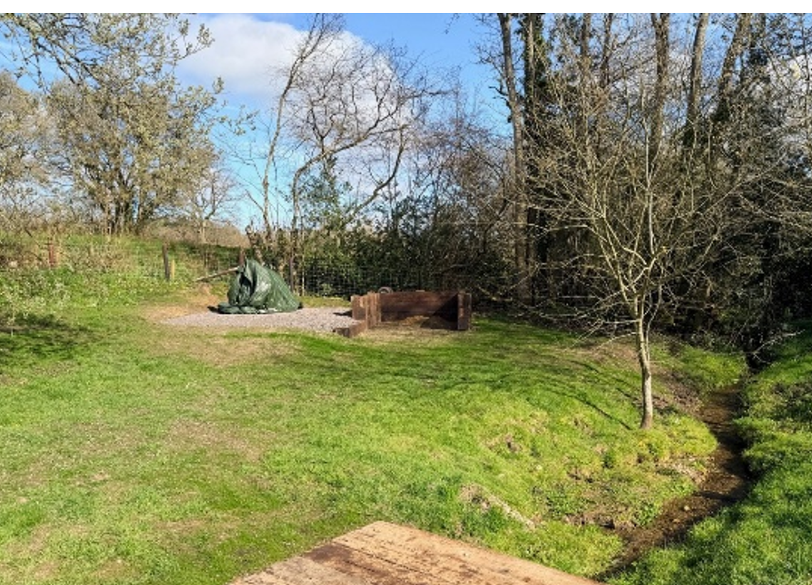

Whilst the proposals represent a new building within the countryside, in this context including the proposed use of the structure for agricultural storage on agricultural land it is not considered that there are grounds in this instance, to warrant refusal on impact to the character of the area including National Landscape. It is considered prudent to include a condition relating to external lighting to protect the dark skies status of the National Landscape.

The siting of the proposed building is close to a number of trees, however, the proposed building does not have footings and is to be placed on existing hardstanding. The height and footprint of the building are modest; it is therefore unlikely that the proposals will be harmful to the nearby trees (noting the trees are not protected by virtue of a tree preservation order or by being within a conservation area).

The siting and scale of the proposed building; distance from the nearest listed buildings and conservation area is considered sufficient to conclude that the proposals will not have a detrimental impact on the setting of these heritage assets.

Having regard to the above, the proposal complies with the design principles set out in Core Policies 51, 57 and 58 of the Wiltshire Core Strategy and the aims of the NPPF.

Amenity

Point vii of Core Policy 57 - Ensuring High Quality Design and Place Shaping of the Wiltshire Core Strategy seeks to ensure that developments do not adversely affect neighbouring properties.

The National Planning Policy Framework (NPPF), particularly Paragraph 135(f), stresses that planning decisions should ensure developments provide a high standard of amenity for existing and future users.

The proposed development has been assessed in terms of its potential impact on the residential amenity of neighbouring properties, with particular regard to loss of light, overshadowing, loss of privacy, and overbearing effects.

Given the scale, design and siting of the proposed building and the separation distance from the nearest residential properties, it is not considered to pose harm to neighbour amenity.

The proposal therefore accords with Core Policy 57 point vii in respect of safeguarding residential amenity, the Wiltshire Design Guide and the relevant provisions of the NPPF.

Ecology Impact

Core Policy 50 of the Wiltshire Core Strategy seeks to protect and enhance biodiversity and geodiversity, including through ensuring that development avoids harm to protected species and habitats.

The National Planning Policy Framework (NPPF), in Paragraphs 193, requires that development minimises impacts on and provides net gains for biodiversity, including ensuring mitigation is secured where harm cannot be avoided.

Hampshire River Avon Special Area of Conservation (SAC) Catchment - This development falls within the catchment of the River Avon SAC and has potential to cause adverse effects alone or in combination with other developments through discharge of phosphorus in wastewater. Appropriate Assessment must be carried out by the relevant Competent Authority (the LPA) to determine the potential significant effects, and the suitability of any measures proposed to avoid or mitigate those effects.

A test of likely significance has been conducted by the relevant Competent Authority (Wiltshire Council). This assessment determined that, due to the nature of the development, with no increase in dwellings and the lack of any increase in water supply, drainage installation within this development, there will be no mechanism for effect on the River Avon catchment. The Habitat Regulation Assessment (HRA) has concluded that the application is not likely to have significant impacts on the River Avon Catchment, and the proposal is screened out of Appropriate Assessment.

Biodiversity Net Gain - From 12 February 2024 Biodiversity Net Gain (BNG) became mandatory under Schedule 7A of the Town and Country Planning Act 1990 (as inserted by Schedule 14 of the Environment Act 2021). Based on the information available the biodiversity gain planning condition is not considered to apply to this application as the proposal is for a new detached building to be sited on an area of existing hardstanding within an agricultural field with a floor area of 9 metres square, therefore it would fall within one of the exemptions - development that does not impact a priority habitat and impacts less than 25 square metres (3m by 3m) of on-site habitat.

As such, the development complies with Core Policy 50 and 69 of the Wiltshire Core Strategy and the relevant provisions of the NPPF.

Flood Risk

Core Strategy and paragraph 181 of the NPPF requires that all new development avoids increasing flood risk on-site or elsewhere and, where appropriate, incorporates sustainable drainage measures. Development must also comply with national policy on flood risk management and drainage design.

As mentioned above, part of the site is within an area at risk of surface water flooding, no flood risk assessment has been submitted with the application however, the applicant has confirmed that the building will have no footings and will be placed on the ground surface. The proposed building will house machinery currently just located in the same place but in the open and in need of being undercover. As the use and size of the proposed building is small scale and for agricultural storage there are no flood risk concerns in this instance.

The proposal therefore complies with Core Policy 67 of the Wiltshire Core Strategy and the policy in the NPPF, ensuring that flood risk is not increased.

CONCLUSION

The proposed development is considered to be acceptable in terms of its design, scale, and relationship with the surrounding area. It would not result in any unacceptable harm to the character of the locality, the amenities of neighbouring occupiers, National Landscape, heritage, or ecology.

The proposal is therefore considered to comply with the relevant policies of the Wiltshire Core Strategy, and the National Planning Policy Framework. As such, the application is recommended for approval, subject to the conditions set out below.

RECOMMENDATION: That Planning Permission be GRANTED subject to conditions.

1. The development hereby permitted shall be begun before the expiration of three years from the date of this permission.

REASON: To comply with the provisions of Section 91 of the Town and Country Planning Act 1990 as amended by the Planning and Compulsory Purchase Act 2004

2. The development hereby permitted shall be carried out in accordance with the following approved plans:

Application form received 11/03/2026
Site Plan and Location Map - Field Shed Dwg no 1484/31A received 11/03/2026
Field Storage Shed Details Dwg no 1484/42 received 02/03/2026

REASON: For the avoidance of doubt and in the interests of proper planning.

3. The materials to be used in the construction of the external surfaces of the development hereby permitted shall match in material, colour and texture to those detailed on the application form and approved plans.

REASON: For the avoidance of doubt and in the interests of visual amenity and the character and appearance of the area.

4. Any external lighting that is installed across the site shall be designed and implemented to minimise sky glow, glare and light trespass. It shall be designed in a downward facing position at all times and shall meet the criteria for Environmental Zone E0 as defined by the Institute of Lighting Professionals ‘Guidance Notes for the Reduction of Obtrusive Light’ 2021. Any external lighting installed at the site shall be retained and maintained as such thereafter for the lifetime of the development.

REASON: To ensure appropriate levels of amenity are achieved; to protect the Dark Skies Initiative and to avoid illumination of habitat used by bats

Informatives to Applicant

1. BNG not required

The effect of paragraph 13 of Schedule 7A to the Town and Country Planning Act 1990 is that planning permission granted for development of land in England is deemed to have been granted subject to the condition (biodiversity gain condition) that development may not begin unless:

(a) a Biodiversity Gain Plan has been submitted to the planning authority, and
(b) the planning authority has approved the plan.

The planning authority, for the purposes of determining whether to approve a Biodiversity Gain Plan, if one is required in respect of this permission would be Wiltshire Council.

There are statutory exemptions and transitional arrangements which mean that the biodiversity gain condition does not always apply. For further information on exempt developments please refer to:
https://www.gov.uk/guidance/biodiversity-net-gain-exempt-developments
Based on the information available this permission is considered to be one which will not require the approval of a biodiversity gain plan before development is begun because one or more of the statutory exemptions or transitional arrangements is considered to apply.

2. Wildlife and countryside act

The applicant should note that under the terms of the Wildlife and Countryside Act (1981) and the Habitats Regulations (2010) it is an offence to disturb or harm any protected species, or to damage or disturb their habitat or resting place. Please note that this consent does not override the statutory protection afforded to any such species. In the event that your proposals could potentially affect a protected species you should seek the advice of a suitably qualified and experienced ecologist and consider the need for a licence from Natural England prior to commencing works. Please see Natural England’s website for further information on protected species.

