HOUSEHOLDER PLANNING APPLICATION.
CASE OFFICER REPORT

APPLICATION REFERENCE: | PL/2025/09876
APPLICATION TYPE: | Householder
SITE ADDRESS: | 206 Chantry Gardens, Southwick, BA14 0LH
DEVELOPMENT DESCRIPTION: | Construction of new two storey side extension and single storey rear extension.
RECOMMENDATION: | Approve with Conditions.

PROPOSAL
The proposal seeks planning permission for the construction of a two-storey side extension and a single storey rear extension.

SITE DESCRIPTION/CONTEXT
The site consists of a two-storey, brick constructed semi-detached house, located within an established residential area, within the Large Village of Southwick. The site is also within the grey zone of the adopted Trowbridge Westbury Bat Mitigation Strategy (TWBMS).

RELEVANT PLANNING HISTORY
Proposal / Summary
N/A

RELEVANT POLICIES AND GUIDANCE

Wiltshire Core Strategy:

- Core Policy 57 Ensuring High Quality Design and Place Shaping
- Core Policy 50: Biodiversity and Geodiversity
- Core Policy 51: Landscape
- Core Policy 58: Ensuring the Conservation of the Historic Environment
- Core Policy 61: Transport and New Development
- Core Policy 64: Demand Management
- Core Policy 67: Flood Risk

Southwick ‘Made’ Neighbourhood Plan

Wiltshire Design Guide: Appendix D – Design Guidance for Householder extensions

The National Planning Policy Framework (NPPF)

The Planning Practice Guidance

National Design Guide

Emerging Wiltshire Local Plan:
The examination of the emerging Wiltshire Local Plan has been paused and the weight to be afforded to any part of the emerging plan can be no more than very limited. A decision on how to proceed will be made by the Council in May 2026.

CONSULTATION RESPONSES
Southwick Parish Council: No objections.

Highways: Offer comments as discussed below.

REPRESENTATIONS
No comments were received.

PRINCIPLE OF THE PROPOSAL.
The principle of the proposed scheme is considered to be acceptable for the reasons as discussed below.

ASSESSMENT
Section 38(6) of the Planning and Compulsory Purchase Act 2004 states:

"If regard is to be had to the development plan for the purposes of any determination to be made under the planning Acts, the determination must be made in accordance with the plan unless material considerations indicate otherwise."

In accordance with this statutory requirement, this application has been assessed against the relevant policies of the Development Plan, including the adopted Wiltshire Core Strategy (2015) and the Neighbourhood Plan for Southwick.

Design and Impact upon the upon the character and context of the area

Core Policy 57 - Ensuring High Quality Design and Place Shaping of the Wiltshire Core Strategy seeks to ensure that all new development is of high design quality, reflecting local context, character, and distinctiveness.

The proposals can be viewed within the following plan snippets taken from the submitted plans:

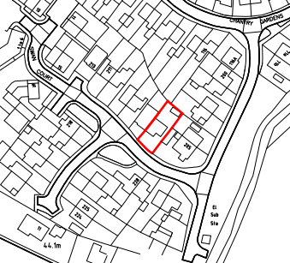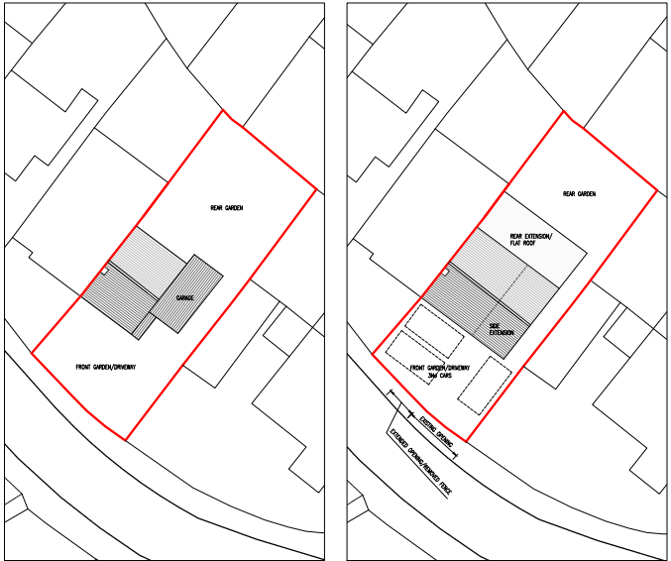
Location Plan Existing & Proposed Site Plan
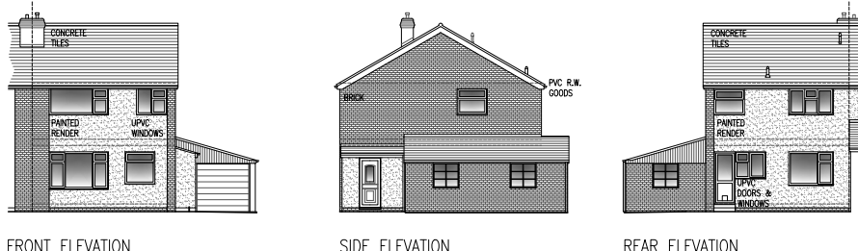
Existing Elevations.

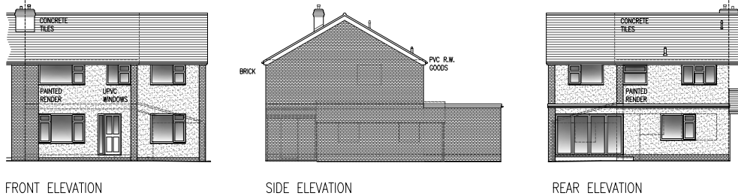
Proposed Elevations.

The proposal would see the removal of a small sized entrance porch on the southeast elevation to allow for the construction of a two-storey side extension atop the existing garage and for the construction of a single storey extension on the rear northeast elevation; this would serve as an enlarged kitchen/dining area. This element of the scheme would have bifold doors leading out on the dwelling’s private rear garden area. The main entrance to the property would be relocated to the front of the house. The proposed first floor addition would become the master bedroom with en-suite and materials would match those as existing.

In summary, having regard to the above, the proposal complies with the design principles set out in Core Policy 57 of the Wiltshire Core Strategy and Appendix D of the Wiltshire Design Guide.

Amenity
Point vii of Core Policy 57 - Ensuring High Quality Design and Place Shaping of the Wiltshire Core Strategy seeks to ensure that developments do not adversely affect neighbouring properties. The National Planning Policy Framework (NPPF), particularly Paragraph 135(f), stresses that planning decisions should ensure developments provide a high standard of amenity for existing and future users.
The proposed two story extension would look out onto and face its front garden/parking area, the building is located in a developed urbanised area where the principle of high level mutual overlooking is an established principal. In this instance however, due to the established fenestration within the building, there would not be the introduction of new overlooking, with the outlook from the high-level windows remaining the same. Notwithstanding this, the rear facing high level window would serve an en-suite and so would be obscure glazed to promote privacy.
Due to the location and orientation of the proposal, there would not be any significant overshadowing or loss of light to the most immediate neighbour at No.205.

The proposal therefore accords with Core Policy 57 point vii. in respect of safeguarding residential amenity and Appendix D of the Wiltshire Design Guide.
Highway Matters.
Core Policy 57 (xiv) of the Wiltshire Core Strategy seeks to ensure that development must meet the requirements of Core Policy 61. This policy requires proposals to be capable of being served by safe access to the highway network. Core Policy 64 seeks to ensure compliance with parking standards set out in the Local Transport Plan.

The National Planning Policy Framework (NPPF), particularly Paragraph 115 and 116, requires that development proposals do not have an unacceptable impact on highway safety and that safe and suitable access to the site can be achieved for all users.

The proposed development would have four bedrooms and in accordance with the Council’s adopted car parking strategy, there is a requirement to provide three off road spaces. This was provided as shown in Fig. 1 with the highways officer commenting that the suggested spaces were impracticable and would be difficult to access without excessive manoeuvring, which would be likely to lead them to not being used. The officer expressed a preference for the spaces to be perpendicular to the highway, with the dropped kerb being extended for access.
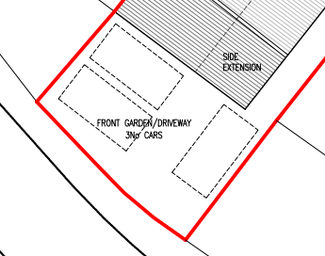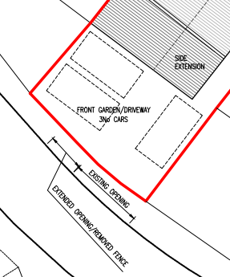
Fig.1. Fig.2.

The applicant’s agent responded with clear photographic evidence that many households within the estate were utilising this manner of parking. The highways officer did not accept this and maintained her stance. The planning officer for the application does not agree with this highways request/reasoning within these particular circumstances, because in the event of a planning appeal, the Inspector would see this as the accepted method of parking within the immediate vicinity and would have no option but to allow an appeal, putting the council at risk of costst. Similarly, the NPPF at paragraph 116 is very clear in that applications should only be refused where the harmful highway impacts are severe, which is not the case here, with the road network serving a quiet residential housing estate. Notwithstanding this, vehicles are able to park on the public highway.

As a way of a compromise, the agent submitted a final revised plan, as shown in Fig.2 extending the existing access opening by the slight removal of the low-level boundary fence. This together with the dropped kerbing is appraised as being wholly acceptable.

Ecology Impact CP50 requires no net loss of biodiversity on site. The site is located within the grey hatched zone of the Trowbridge Westbury Bat Mitigation Strategy Area. The proposed development because of its minor nature and high-density urban location is considered unlikely to result in harm to bats or their habitat. There is no mechanism for significant effects from recreational pressure since it does not result in the creation of a new dwelling. Accordingly, the proposal is acceptable in this regard. As such, the development complies with Core Policy 50 of the Wiltshire Core Strategy and the relevant provisions of the NPPF.

Biodiversity Net Gain. This application is exempt from the requirement to deliver Biodiversity Net Gain under Schedule 7A, Section 4(2)(a) of the Town and Country Planning Act 1990, as inserted by the Environment Act 2021, because the proposal is a householder extension.

CONCLUSION
The proposed development is acceptable in terms of its design, scale, and relationship with the surrounding area.

The proposal is therefore considered to comply with the relevant policies of the Wiltshire Core Strategy, the Wiltshire Local Plan, and the National Planning Policy Framework. As such, the application is recommended for approval, subject to the conditions set out below.

RECOMMENDATION: Planning Permission be GRANTED subject to conditions.

