PL/2023/03359 – Landscape consultation Response (interim)
Site: Land West of Ashton Road, Ashton Keynes, Wilts, SN6 6QT.
Development: Construction and operation of anaerobic digestion facility, ancillary infrastructure and construction of new access from Ashton Road.
Case Officer: Ruaridh O’ Donoghue
Comments by: Mark Goodwin CMLI, Senior Landscape Officer Wiltshire Council
Background
Previous landscape consultation responses have already been provided by Paul Robertson, CMLI, and myself in relation to this application. With the passage of time further information has been submitted by the applicant the following of which is considered most relevant to this latest response.
- 29419 F104 Rev D Manure Processing Building – Plans as Proposed (GGP)
- 29419 F105 Rev C Manure Processing Building - Sections and Elevations as Proposed (GGP)
- 29419 F115 Rev B Elevations Views – Previous and New Planning Scheme (GGP)
- 29419 F103 Rev C Site Elevations as Proposed (GGP).
- 29419/P2/102 Rev P02 Proposed Levels (GGP).
- P24-1022_EN_010_B_A1 L Landscape Strategy Plan (Pegasus).
- A Planning, Design and Access Statement Addendum 2025 (PDAS Addendum 2025).
- Lighting Mitigation Design Strategy.
- ES Addendum 2025, with appended Additional visualisation of the Proposed Development (Viewpoint 10).
- Replacement LVIA / ES chapter 7.
Summary
I maintain my landscape objection in this instance. However, I intend to provide further detailed comment on the Applicant’s Response to Wiltshire Council’s Landscape Officer consultation response dated 18.04.2024 (a detailed 15-page point by point rebuttal of my last consultation response) and provide more detailed comments on the new replacement LVIA prepared by Pegasus to expand on these interim comments that follow.
Comments
I note content of the additionally submitted ‘Locational Justification’ document, prepared by Savills on behalf of the applicant Under Environmental Constraints the document highlights ‘’Location on minerals allocation sites is not possible, as this would contravene planning policy on minerals safeguarding.’’ My understanding is that the site is included within a Minerals Safeguarding Area for sand and gravel. See below extract taken from the council’s GiS layer;
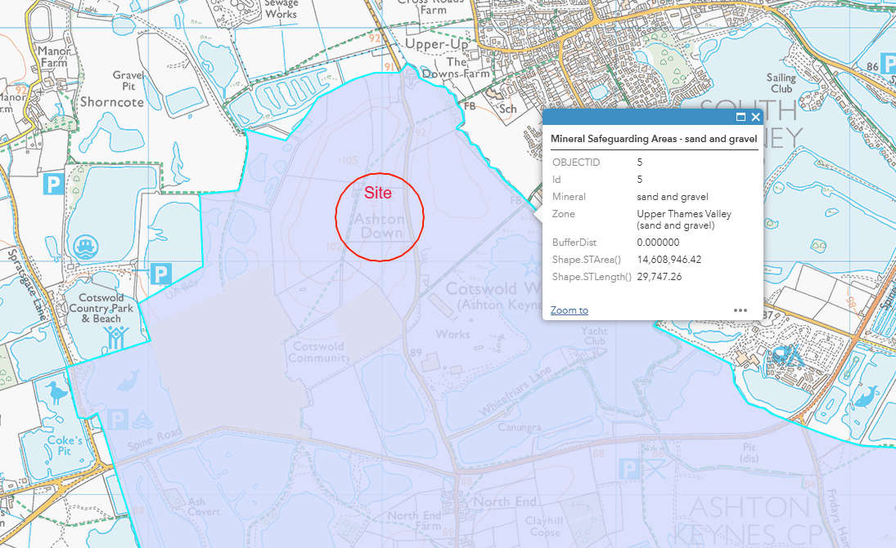
Initial comments on the submitted replacement LVIA chapter 7 - Landscape and visual.
The revised, substituted landscape and visual chapter states in its overall conclusion that...
‘’The Proposed Development has been landscape led and incorporates a range of embedded design measures. Temporary Significant landscape and visual effects during the construction phase would be highly localised and have been minimised by the scheme design. Adverse effects during the operational phase of the project would also be minimised by a range of embedded landscape led mitigation measures including low level earth mounding and mitigation woodland planting. The only Significant residual effect identified, would be to the landscape character of the Site itself, which is inevitable with any green field development of a modern AD facility.’’
Firstly, I take issue with the claim that this project has been landscape led. This is a much over used term and certainly does not apply in this case. In my opinion the requirement for the mitigation measures (not betterment as referenced in the PDAS) proposed are largely derived and necessary as a direct consequence of the unsuitable nature of the site for a development of this nature, located on the hillside of Ashton Down, and only after concerns were raised about the height, bulk and massing of the initially presented development proposal.
I concur with the LVIA’s general findings, in that the greatest resulting landscape and visual effects arising from the insertion of this industrialising development onto this local hill feature will be largely localised. However, the degrees of harm, the value and sensitivity of certain receptors used within the assessment are not agreed with, ultimately resulting in a greater level of localised residual harms in my opinion. The LVIA and photomontages also overstate the effectiveness of the proposed mitigation within its consideration of residual effects at year15 year operation.
Conclusion
The site is not considered to be a suitable location for a development of this industrialising nature and scale, in my opinion the development will result in unacceptable levels of localised landscape and visual harm contrary to WCS, CP51 which needs to be factored into the wider planning balance.
The scheme plans to remove part of a recognised local hillside feature extending up to 7 hectares in area. It proposes this in order to create the level building slab/platforms required to construct and operate an anaerobic digestion plant for a period of 25 years, and then after this time, it plans to remove the buildings from the site and as I understand then restore the hillside back to its original profile and baseline use as arable farmland.
This will involve the removal of 1000’s tonnes of spoil, which is most likely to be sand, which is unlikely be stored for restoration purposes, and if so, then where is it planned to be stockpiled? (If sand or gravel is the primary constituent of this spoil (noting the site is included within a sand and gravel Minerals Safeguarding Area), then this is more likely to be sold on as a valued building material) which raises further questions of what fill material will be used or imported to restore the land and hillside following decommissioning after 25 years?
I seriously question how a development which proposes substantial hillside excavation and removal over a 7-hectare site, and then after 25 years proposes to remove the built development and restore the hillside back to its original profile could be viewed as a sustainable form of development.
End.

