APPLICATION FOR HOUSEHOLDER PLANNING PERMISSION AND LISTED BUILDING CONSENT
DELEGATED REPORT

APPLICATION REFERENCE: | PL/2026/00571 and PL/2026/00716
APPLICATION TYPE: | Householder planning permission and listed building consent
SITE ADDRESS: | Maplecroft Farmhouse, 110 Bath Road, Leigh Road, West, Bradford On Avon, BA15 2RB
DEVELOPMENT DESCRIPTION: | Single storey side extension and internal alterations
RECOMMENDATION: | That Planning Permission be GRANTED  That Listed Building Consent be GRANTED

This is a joint report for both PL/2026/00571 (HPP) and PL/2026/00716 (LBC). Each considers different legislation, guidance and policy.

SITE DESCRIPTION/CONTEXT
The subject property is a GII designated, C17, detached dwelling, within a cluster of listed and non-designated heritage assets associated with historic Maplecroft Farm where historic from and character remain legible despite modern expansion.

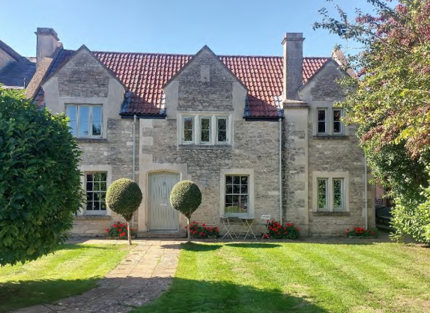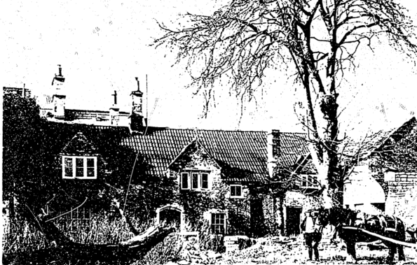

East Elevation and photo of same elevation within a 1997 application W/97/0645 to rebuild following partial collapse.

Historic maps show that the building was once two linear elements running north to south; an east and west unit, as clearly shown on the map below left. The eastern section being the subject dwelling, was the original farmhouse, with the western section now known as Maplecroft House, being a later addition.

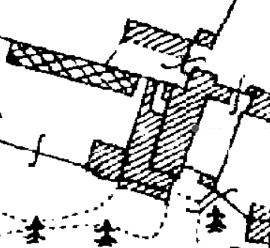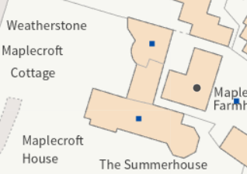

Planning history includes 1990s applications, showing that 65% of the building had collapsed, with the resulting rebuild not being identical, but separating the two linear elements and incorporating a substantial rebuild of the front/east elevation and chimney stack. This created a spatial gap between the two original linear elements of the building, becoming Maplecroft House and the subject Farmhouse. Within the intervening courtyard, on the west elevation, is a fireplace; once the internal wall of the original Maplecroft Farmhouse before the rebuild set-back, now outside within the created spatial gap.

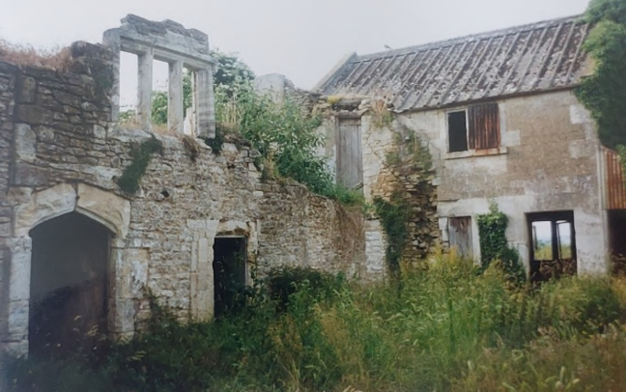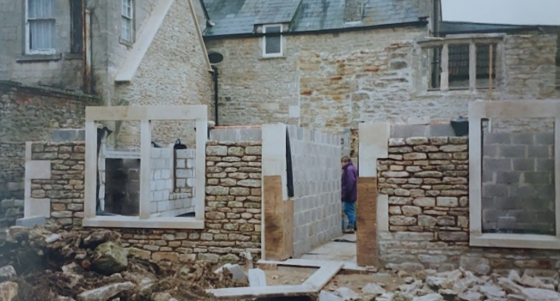

According to the 1990 application, the rebuilt layout reflects, but not rigorously, the original layout. As such, only the sections of wall highlighted in red below, are original, the rest being the 1990 rebuild.

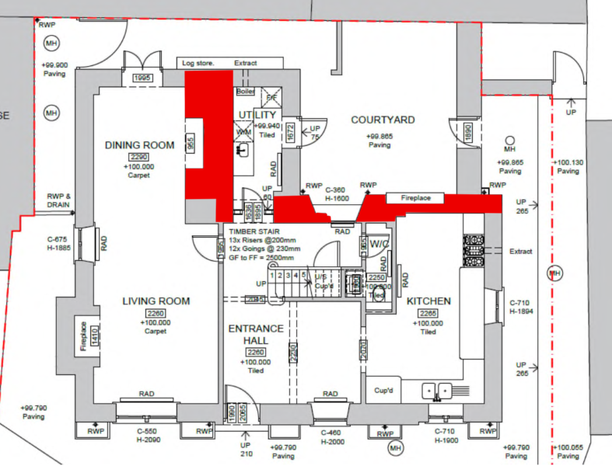

The relationship between the two units is unknown; if they were designed and occupied as two separate units or one larger farmhouse, and the 1990s rebuild has removed the opportunity to understand this relationship, clearly now presenting as two separate dwellings with no physical or functional connection.

Only the east elevation therefore retains historic fabric and is the most unaltered architecturally. However, as photos show, this elevation has been substantially rebuilt too, only the ground floor surviving for the 1990 application. Existing original details of the building are therefore few, but include this GF masonry on the east elevation, a doorway, part of a mullion window at FF and potentially the stack on the north elevation of the southern wing. As the photos show, the rebuild reimagined the building, altering the dormer sizes, scale, form, openings and relationship to the building to the rear and north.

Together, Historic England listings note that the GII, late C18 house known as ‘Maplecroft House with gatepiers and walls,’ GII, C18 ‘Pigeon Cote,’ and the subject property; GII C17 ‘110 Bath Road,’ create a historic group.

The GII Barn at Maplecroft Farm, which lies approx. 50m to the east of the subject property, is however older; being late medieval, demonstrating that the area has been an active high-status farm/manor for many centuries.

To the north is Dairy House, once attached to the subject farmhouse, and to the northeast Stable House; both residential conversions of historic farming structures, and both considered NDHAs.

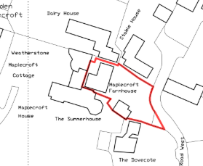

Location Plan

The application site is subject to the following planning policy constraints:

- West Wiltshire Green Belt
- Within buffer zones of various bat roosts and the SAC

PROPOSAL

The proposal seeks planning permission for:
- Partial demolition of the north elevation to enable a single storey extension, with reused/matching stonework and tiles on a mono-pitch/lean-to with two windows facing north towards Dairy House, and rooflights.
- Removal of internal division between entrance hallway and kitchen to create an open-plan space.
- Internal reorganisation such that the Dining room would become a snug around the original fireplace.
- New kitchen installed

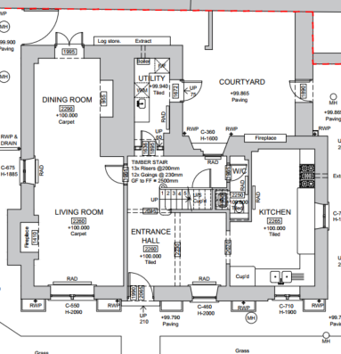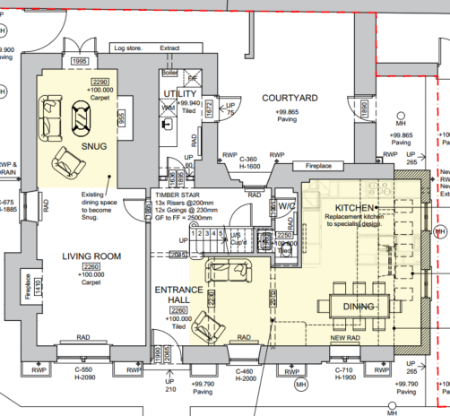

Existing and Proposed Ground Floor Plan

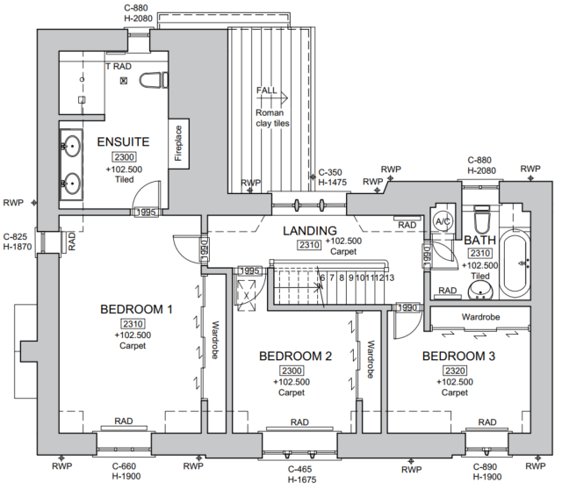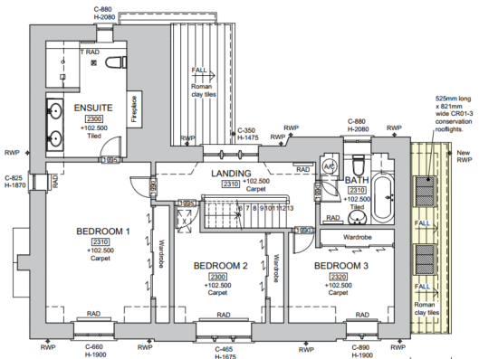

Existing and Proposed First Floor Plans

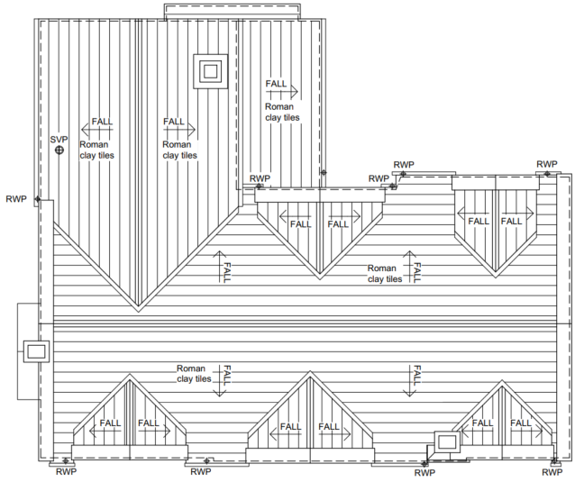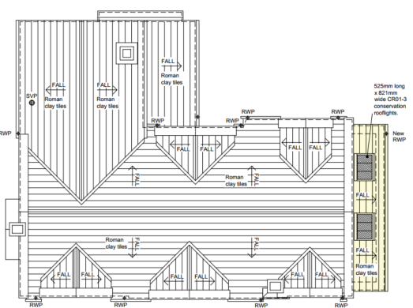

Existing and Proposed Roof Plans

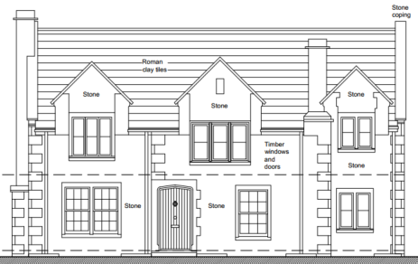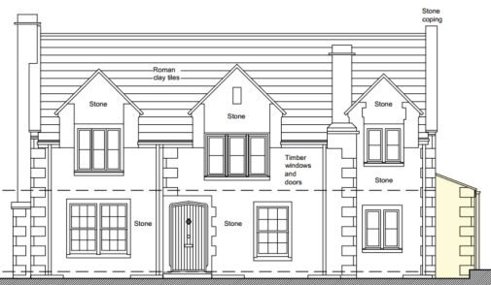

Existing and Proposed East Elevation – facing the Garden

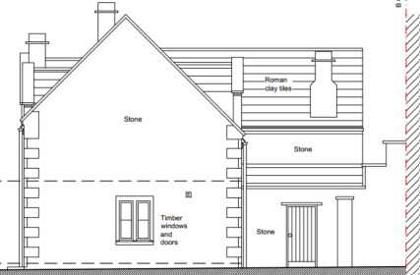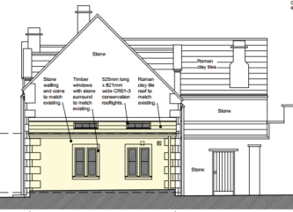

Existing and Proposed North Elevation – facing Dairy House

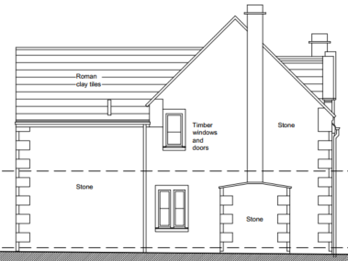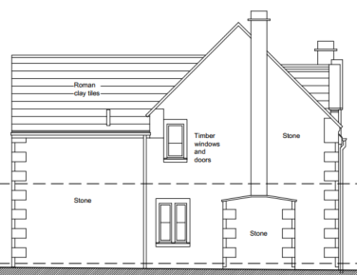

Existing and Proposed South Elevation – facing Maplecroft House - unchanged

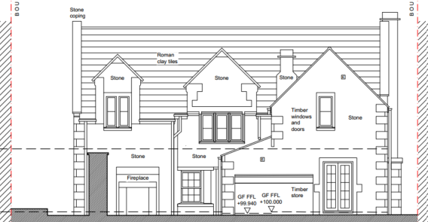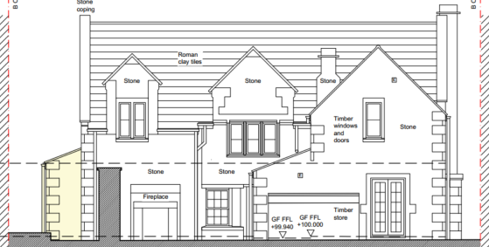

Existing and Proposed West Elevation – facing Weatherstone and Maplecroft Cottage

PLANNING HISTORY
W/87/01862/FUL - Full planning permission Decision - Approve with Conditions Date: 1/3/1988 – Renovations and alterations to farmhouse
W/88/00031/LBC - Listed building consent Decision - Approved Date: 15/3/1988 – Renovation of farmhouse, removal of redundant chimney stack and left front elevation, rebuild to match existing
W/90/01598/LBC - Listed building consent Decision - Approve with Conditions Date: 27/8/1991 – Reconstruction of farmhouse to original detail
W/90/01599/LBC - Listed building consent Decision - Approved Date: 27/8/1991 – Collapse of 65% of the structure during conversion demolition of existing chimney and part of rear wall
W/93/01087/FUL - Full planning permission Decision - Refused Date: 8/11/1994 – Reconstruction of farmhouse to original detail
W/95/00335/LBC - Listed building consent Decision - Approve with Conditions Date: 21/12/1995 – Restoration of farmhouse, change of use of farm buildings to residential, construction of garages, restore dovecot
W/95/00334/FUL - Full planning permission Decision - Approve with Conditions Date: 21/12/1995 – Restoration of farmhouse to dwelling conversion and extension of west byre and dairy to dwelling conversion of old stables todwelling conversion of great barn to granny annexe
W/96/00906/FUL - Full planning permission Decision - Refused Date: 27/2/1997 – Rebuild former farmhouse
W/96/00907/LBC - Listed building consent Decision - Refused Date: 27/2/1997 – Demolition of former farmhouse and rebuild on a new site 8 metres forward
W/97/00643/FUL - Full planning permission Decision - Approve with Conditions Date: 8/12/1997 – Rebuilding of former farmhouse provision of garage
W/97/00645/LBC - Listed building consent Decision - Approve with Conditions Date: 8/12/1997 – Rebuild farmhouse - retaining remains of former building
W/98/00175/FUL - Full planning permission Decision - Approve with Conditions Date: 9/3/1998 – Addition of fireplace and chimney
W/98/00178/LBC - Listed building consent Decision - Approve with Conditions Date: 9/3/1998 – Addition of fireplace and chimney
W/01/01060/FUL - Full planning permission Decision - Approve with Conditions Date: 20/8/2001 – Stores to the side of existing garage
W/03/00004/LBC - Listed building consent Decision - Approved Date: 13/2/2003 – Retention of French doors to garage and chimney flue

RELEVANT POLICIES AND GUIDANCE
The National Planning Policy Framework (NPPF)
The Planning Practice Guidance
National Design Guide
Wiltshire Design Guide: Appendix D – Design Guidance for Householder extensions

The Planning (Listed Building and Conservation Area) Act 1990,
Sections 16 and 66: Listed Buildings
Section 72: Conservation

Wiltshire Core Strategy:
- Core Policy 57 Ensuring High Quality Design and Place Shaping
- Core Policy 58 Ensuring the Conservation of the Historic Environment
- Core Policy 50: Biodiversity and Geodiversity
- Core Policy 51: Landscape

Bradford on Avon Neighbourhood Plan, made 2017

CONSULTATION RESPONSES
Bradford on Avon Town Council: No objection.

Bradford on Avon Preservation Trust: Object, on the grounds of harm to character and integrity of the listed building which lacks justification, by the removal of a large length of the original ground floor external wall, with an extension that bears no design relationship to the original, and a row of rooflights. An objection is also made in reference to the amenity of neighbours, as the extension would create a dark, narrow corridor between the subject dwelling and Dairy House.

Conservation: No objection, but comment made requesting revisions to rooflights; 5 being considered to create a visually cluttered appearance.

REPRESENTATIONS
No comments were received.

ASSESSMENT
Section 38(6) of the Planning and Compulsory Purchase Act 2004 states:

"If regard is to be had to the development plan for the purposes of any determination to be made under the planning Acts, the determination must be made in accordance with the plan unless material considerations indicate otherwise."

In accordance with this statutory requirement, this application has been assessed against the relevant policies of the Development Plan, including the adopted Wiltshire Core Strategy (2015) and, where applicable, any made Neighbourhood Plans.

Principle of Development in the Green Belt:
CP51 of the WCS, states that ‘development should protect, conserve and where possible enhance landscape character and must not have a harmful impact upon landscape character.’
The NPPF, paragraph 153, is clear in asserting that inappropriate development is ‘harmful to the Green Belt and should not be approved except in very special circumstances’.

Paragraph 142 states that “the fundamental aim of Green Belt Policy is to prevent urban sprawl by keeping land permanently open; the essential characteristics of Green Belts are their openness and their permanence.”

Paragraph 154 however lists exceptions which includes:
c) the extension or alteration of a building provided that it does not result in disproportionate additions over and above the size of the original building.

The NPPF does not, elaborate on the definition of ‘disproportionate’ addition nor does it quantify what would represent a disproportionate addition. In light of the above and in accordance with well-established planning practices, each case must be assessed on its own individual merits.

The LPA takes a broad reading of the meaning of paragraph 154(c), for ‘extensions or alterations of a building’ when assessing householder applications.

The proposals include a 2m² extension by the rebuilding of the northern wall 0.6m further north.

At these dimensions, the proposals are not considered disproportionate and are modest in comparison to much precedent development within the cluster, including the rebuilding of the subject dwelling, set back and therefore smaller than the original.

The development would be an extension to an existing residential structure, maintaining front and rear building lines and does not seek to alter the experience of the dwelling within the cluster of residential conversions of heritage assets and as such is acceptable as an extension that does not result in disproportionate additions.

Heritage, Design and Impact upon the character and context of the area:
From the point of view of the historic environment the main statutory tests are set out within the Planning (Listed Building and Conservation Areas) Act 1990.

Section 66(2) requires that special regard be given to the desirability of preserving listed buildings, their settings or any features of special architectural or historic interest which they possess.

The Council’s Core Strategy Policy CP58 ‘Ensuring the conservation of the historic environment’ requires that designated and non-designated heritage assets and their settings will be conserved, and where appropriate enhanced, in a manner appropriate to their significance and encourages proposals which improve the condition of heritage assets at risk.

The Council’s Core Strategy CP 57: Ensuring high quality design requires a high quality of design in all new developments. The policy requires applicants to “demonstrate how the proposal will make a positive contribution to the character of Wiltshire through (amongst other things) responding to the value of the natural and historic environment and being sympathetic to and conserving historic buildings and landscapes. Development is required to respond positively to the existing in terms of building layouts, built form, height, mass, scale, building line, plot size, elevational design, materials, streetscape and rooflines to effectively integrate the building into its setting.

The NPPF outlines government policy for planning. Chapter 16 of the NPPF 'Conserving and enhancing the historic environment' sets out the Government's high-level policies concerning heritage and sustainable development.

The building, being GII, must be assessed as to the proposals impact to the historic fabric of the building, impact to its setting, impact to the setting of surrounding listed and non-designated heritage assets.

The LBC application must be considered for its impact to the subject dwelling.

The Conservation Officer notes that the significance of the subject dwelling, was assessed when designated in 1974, when it was a standing building which was roofed and possibly occupied. By c.1975 it is evident that the building had collapsed and was in ruins with little more than the masonry of the ground floor of the front wall evident and part of the stack at ground floor level.

The significance of the building was related to its historic and aesthetic interest, and also communal and group value. As now only its east elevation and just a handful of architectural details remain, there is very little left of significance. With so much historic fabric having been lost, but also altering/loss of scale, form, reimagining of layout, all undermined by the inserted spatial gap between the two dwellings, altered dormers, openings and reimagined layout, the significance of the building has been substantially and irreversibly lost, and so it no longer holds special architectural or historic interest.

Extensive harm was done to the listed building, primarily by the collapse, and then the subsequent unsympathetic reimagined rebuild. The proposal does not propose further harm, but builds upon this earlier removal of historic fabric, form, layout and context.

The section of the north wall proposed to be demolished, was rebuilt in 1998, and therefore has no intrinsic historic significance. Historic maps show the original north wall extended to Dairy House beyond, so this section doesn’t even enable legibility of the earlier form.

The subject dwelling remains as an echo of the former farmhouse, so whilst it retains some historic value, the proposal seeks to alter only a modern wall.

The site of the proposed extension, as stated, is a modern narrow space, inserted between the dwelling and its neighbour Dairy House in the 1990s and so would not visually impact the setting of the rebuilt listed asset, is visually isolated from neighbouring listed assets nor neighbouring NDHAs.

The proposed design is simple, utilising a standard mono-pitch of matching roman clay roof tiles, with reused/matching stonework, stone quoins/detailing, with two timber windows facing north towards Dairy House replacing an existing single window, and insertion of two rooflights.

The lean to is a standard form of extension within a farmyard setting, in a site which was previously part of the larger original farmhouse.

The extension would be set-in and have thinner walls to allow legibility so enabling a successful integration.

The latterly submitted revisions of rooflights to just two slightly larger units, aligned with the windows below, reduces visual clutter, so not further challenging the heritage asset and is a simplified elegant solution.

The various structures surrounding the subject property are primarily residential conversion of agricultural buildings; their proximity reflecting the close functional association to the farmhouse. The proposed extension at these dimensions, at this location would not harm the setting of any of the surrounding heritage assets.

The setting of the listed building would not be harmed by the proposal, again, the narrow spatial gap between the building and immediate neighbours, means this area is largely concealed from view, the proposal impacting only this hidden section and not the only remaining original elevation/façade, is of only a single storey, in complementary, recycled materials and of a traditional mono-pitch design and scale.

As stated within the Heritage Statement, there is a question of delisting the building. There do remain elements of significance, however. I would direct the applicant to Historic England’s advice on delisting an asset: Guidance on De-listing a Building | Historic England

The proposal, by virtue of its scale, design, and use of materials, is considered to preserve the setting of the listed buildings, and listed neighbouring properties, and would not result in harm to the significance of any heritage assets.

As a result, the requirements of current conservation legislation, policy and guidance are considered to be met, for the LBC and there is therefore no objection to the approval of the application.

Having regard to the above, the proposal is therefore considered to comply with Core Policy 58 of the Wiltshire Core Strategy and Sections 66 of the Planning (Listed Buildings and Conservation Areas) Act 1990, as well as the relevant provisions of the NPPF.

Amenity
Point vii of Core Policy 57 - Ensuring High Quality Design and Place Shaping of the Wiltshire Core Strategy seeks to ensure that developments do not adversely affect neighbouring properties.

The National Planning Policy Framework (NPPF), particularly Paragraph 135(f), stresses that planning decisions should ensure developments provide a high standard of amenity for existing and future users.

The proposed development has been assessed in terms of its potential impact on the residential amenity of neighbouring properties, with particular regard to loss of light, overshadowing, loss of privacy, and overbearing effects.

As a single storey extension, of 0.6m increased projection, there are no concerns with loss of light or overbearing.

The application W97/0644 for the residential conversion of neighbouring Dairy Building and West Byre (modern link between), shows the south elevation facing the proposal site.

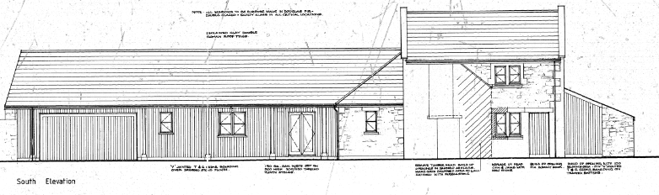
The submitted elevation shows one window directly in front of the proposed extension. The floorplan within the application confirming this is to a ground floor bedroom. No third-party comments were received.

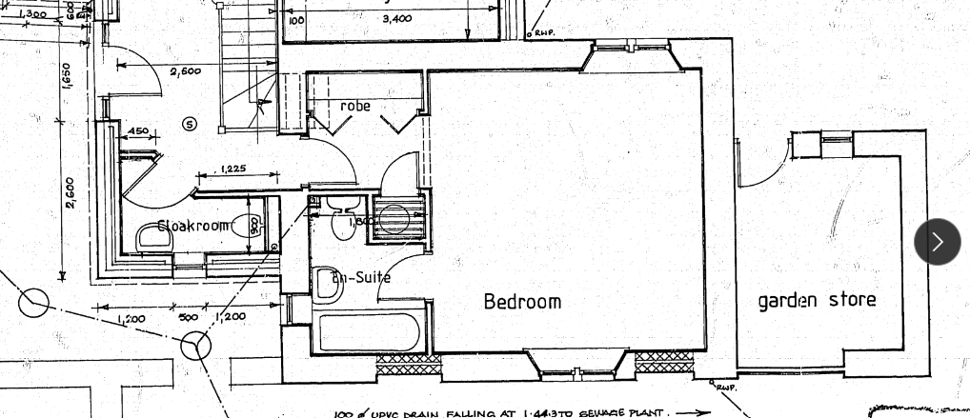

The subject dwelling already includes a window on its north elevation facing The Dairy. A proposed second window would not substantially increase impact to privacy on the current situation and what is effectively a footpath between the properties.

The rooflights would be at a height to not impact privacy.

Of note, this application also shows that W97/0644 included the removal of the party wall remains of The Dairy and The Farmhouse being removed, which is worthwhile including here to demonstrate the evolution of the site in line with the heritage assessment.

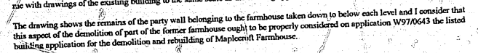

The proposal therefore accords with Core Policy 57 point vii in respect of safeguarding residential amenity and Appendix D of the Wiltshire Design Guide.

Ecology Impact
The National Planning Policy Framework (NPPF), in Paragraphs 193, requires that development minimises impacts on and provides net gains for biodiversity, including ensuring mitigation is secured where harm cannot be avoided.

As per CP50, ‘development proposals must demonstrate how they protect features of nature conservation … as part of the design rationale.There is an expectation that such features shall be retained, buffered and managed favourably in order to maintain their ecological value, connectivitiy and functionality in the long-term.’

The application site is not subject to any statutory or non-statutory ecological designations, but is within buffer zones of bat roosts, yet the scale and nature of development is such that significant harm to biodiversity is unlikely.

The proposals pose no loss of biodiversity, and the application does not meet the threshold set out in legislation to demonstrate BNG.

All UK bat species are protected by European and UK legislation; the Conservation of Habitats and Species Regulations and the Wildlife and Countryside Act. Considering the scale and form of proposed development, as a first floor extension to an existing ground floor inhabitated structure, within a suburban area, no substanitave ecology impact is raised and as such does not meet the threshold for a habitat regulations assessment.

An informative is included as a precautionary measure, raising the profile of the Bat SAC, including that if any evidence of bat activity is detected, that the applicant should follow the advice of a professional ecologist or contact Natural England.

CONCLUSION
The proposed development is considered to be acceptable in terms of its design, scale, and relationship with the surrounding area. It would not result in any unacceptable harm to the character of the locality, the amenities of neighbouring occupiers, or the interests of heritage, or ecology.

The proposal is therefore considered to comply with the relevant policies of the Wiltshire Core Strategy, the Wiltshire Local Plan, the National Planning Policy Framework and Conservation Legislation.

RECOMMENDATION: That Planning Permission be GRANTED subject to conditions.

