APPLICATION FOR FULL PLANNING PERMISSION DELEGATED REPORT

APPLICATION REFERENCE: | PL/2026/00978
APPLICATION TYPE: | Full planning permission
SITE ADDRESS: | Pizza Hut, Mid Summer Place, Amesbury, Salisbury, SP4 7SQ
DEVELOPMENT DESCRIPTION: | New drive-thru lane, collection window pod and associated works to landscaping.
RECOMMENDATION: | That Planning Permission be GRANTED

PROPOSAL

The proposal seeks planning permission for a new drive-thru lane, collection pod and associated landscaping. This application follows a recent approval for the similar development at Pizza Hut in Solstice Park.

The submitted covering letter states

Planning permission was granted for a drive-thru lane and associated works to landscaping on 9 May 2025 (LPA reference PL/2025/00720). This facility was required to support Pizza Hut’s takeaway function. Since the grant of planning permission, required refinements to the layout have been identified. To ensure the unit operates in a consistent format to its other outlets, and to ensure the drive-thru takeaway function can operate efficiently for customers, minor changes are required to the previously-consented drive thru layout and the building’s elevations.

Detailed Description of Proposals -The purpose of the new drive-thru route is to ensure that the unit operates in a consistent format to other outlets for the brand, and to ensure the drive-thru takeaway function can operate efficiently for customers. This application seeks permission for the following:

• Realignment of the approved drive-thru route to provide a shallower left-hand turn into the drive-thru, bringing it closer to the site entrance, and to straighten out the exit section to the north of the unit;

• Provision of a new pedestrian crossing from the parking area to the front entrance of the unit and pedestrian dedicated walkways throughout the car park;

• Relocation of disabled parking bays closer to the unit entrance;

• Relocation of existing bin store;

• Soft landscaping to align with proposed changes to road alignment; and

• A new drive-thru collection window pod on the north elevation.

Existing and proposed site plans included below for comparison

Existing

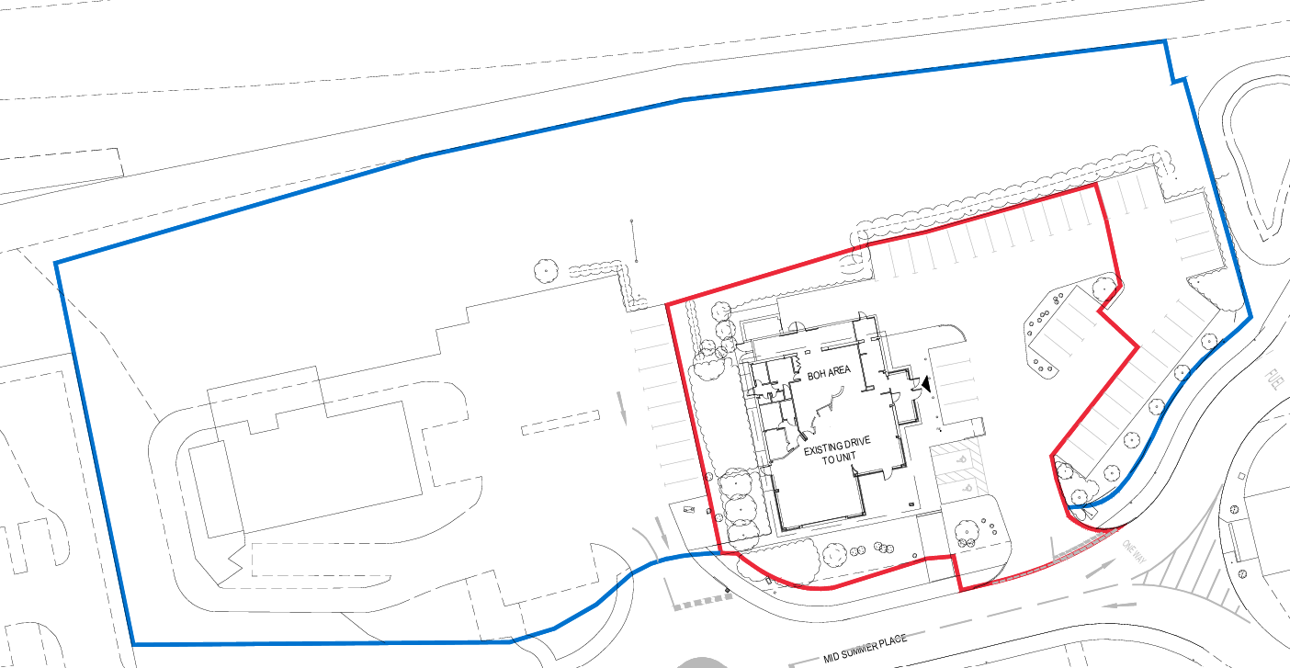

Proposed

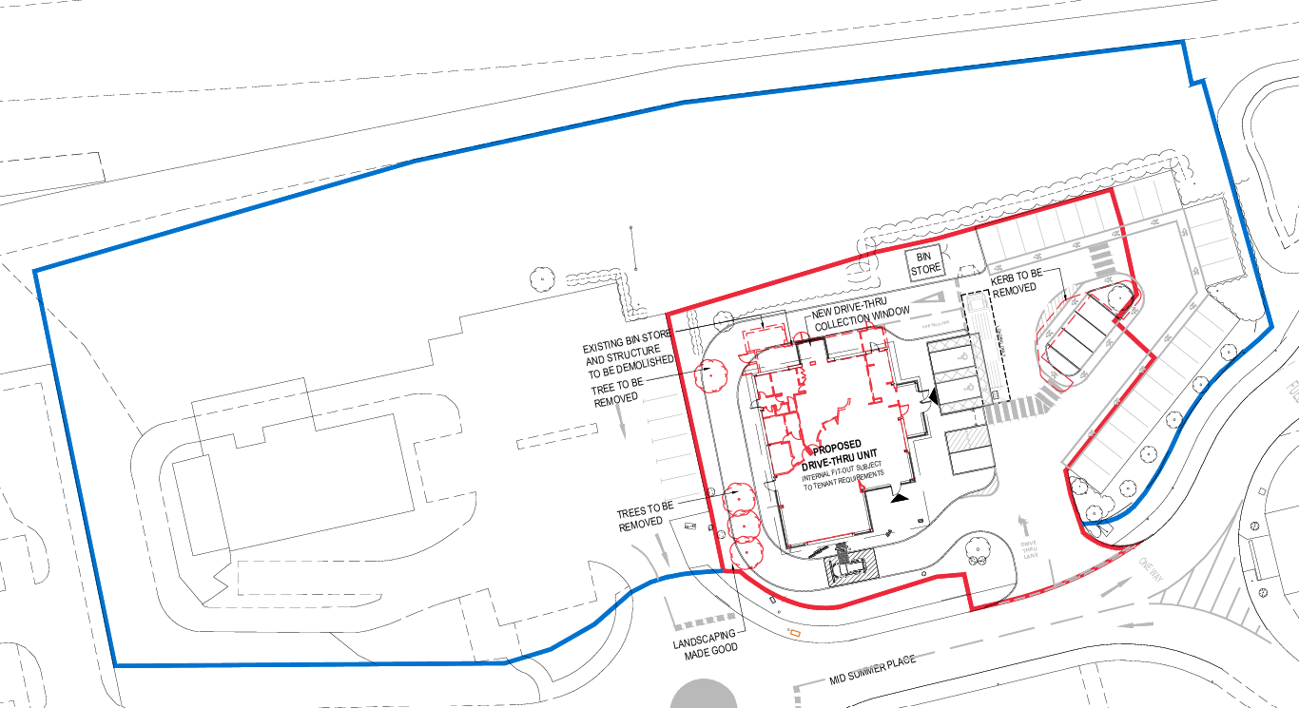

Existing and proposed ground floor plans included below for comparison.

Existing

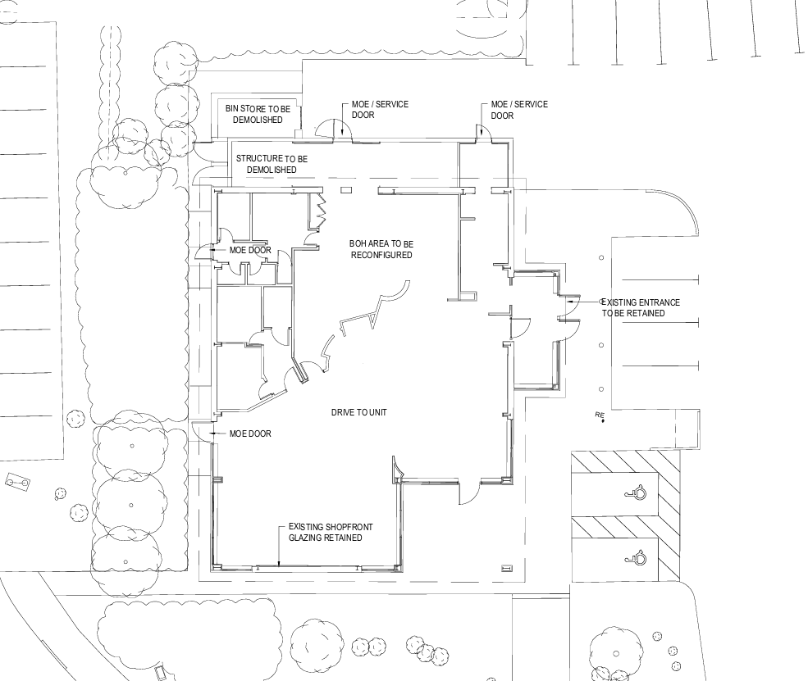

Proposed

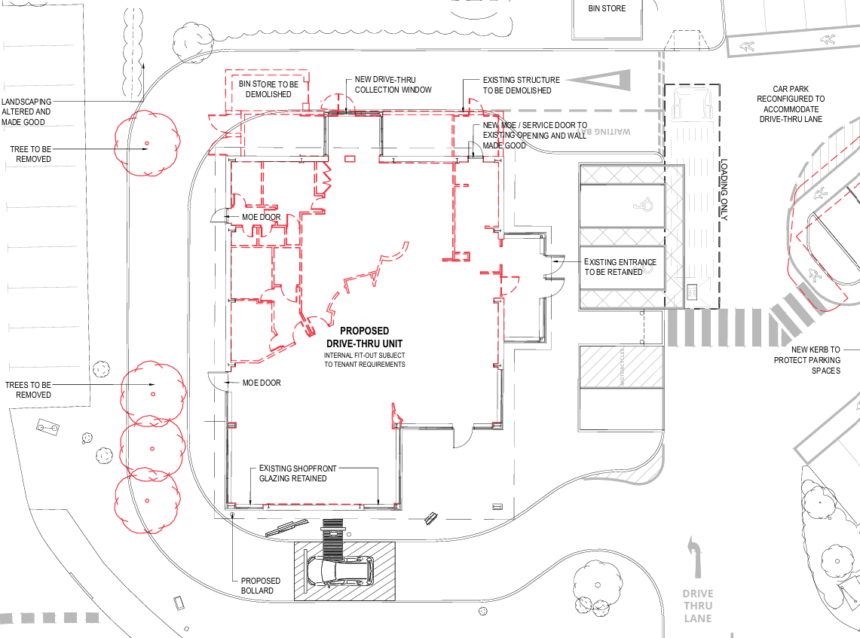

Existing and proposed elevations included below for comparison.

Existing

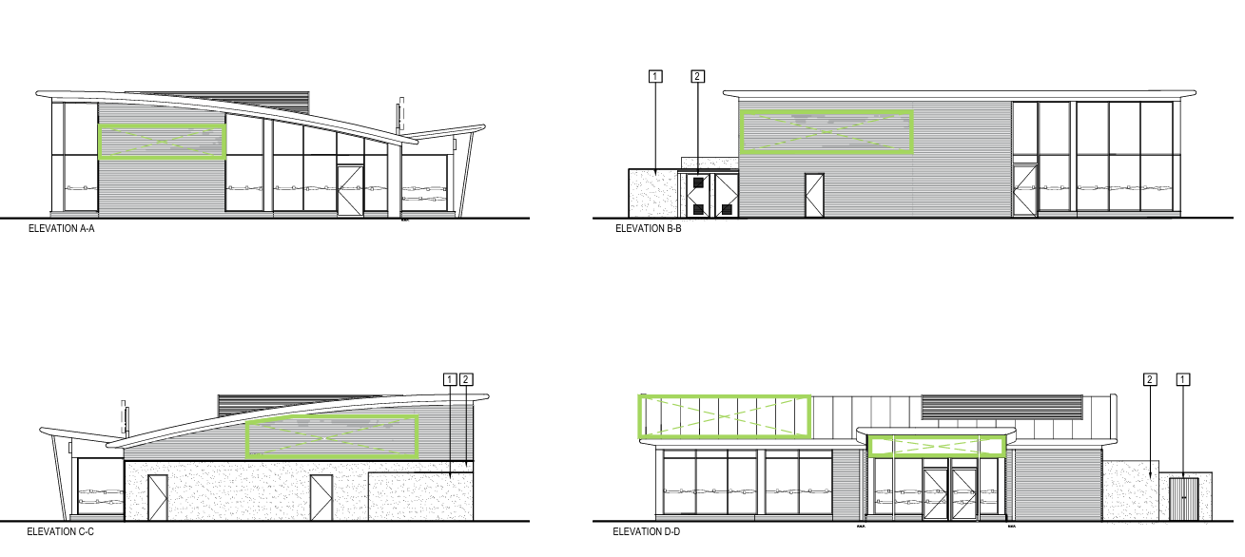

Proposed

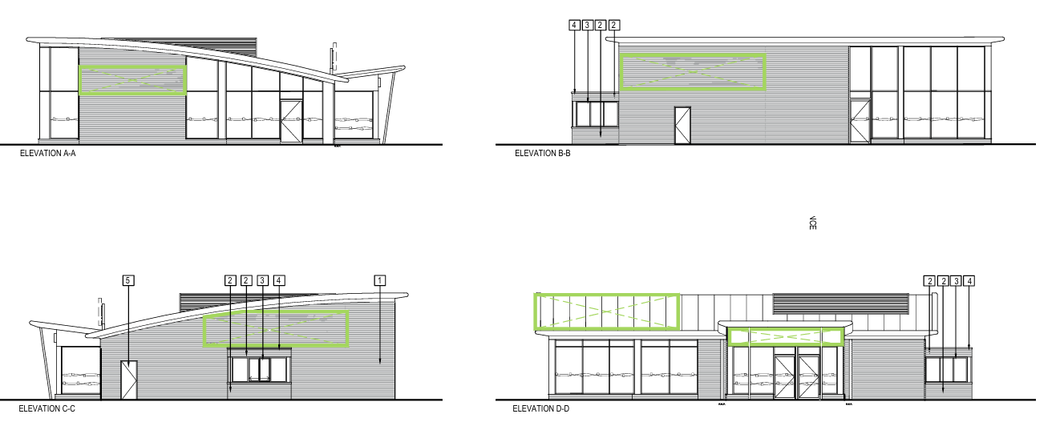

SITE DESCRIPTION/CONTEXT

The site is located on Solstice Retail Park in Amesbury, approximately 1.5 miles from Amesbury town centre. It comprises an existing Pizza Hut with 40 car parking spaces and associated hard and soft landscaping. The Park as a whole is accessed via Solstice Park Avenue with the application site entered via the estate road, Mid-Summer Place to the south. The site is bounded to the north by the A303. Solstice Park comprises several other restaurant units, a petrol station and a hotel.

The site is within flood zone 1 (i.e. at the lowest risk of flooding from rivers and the sea). It does not appear to be at any significant risk from either ground or surface water flooding. There are no heritage assets nearby.

The site lies within the 6.4km buffer zone of the Salisbury Plain Special Protection Area (SPA) and Hampshire River Avon Special Area of Conservation (SAC) catchment.

PLANNING HISTORY

PL/2025/00720 - Full planning permission Decision - Approve with Conditions Date: 9/5/2025 – New drive-thru lane and associated works to landscaping

It is also noted that many other nearby establishments including Costa, Greggs, KFC, McDonalds and Taco Bell all have drive-thrus.

RELEVANT POLICIES AND GUIDANCE

National Planning Policy Framework
National Planning Policy Guidance
National Design Guide

Wiltshire Core Strategy (WCS)

Core Policy 1: Settlement Strategy
Core Policy 2: Delivery Strategy
Core Policy 4: Spatial Strategy for the Amesbury Community Area
Core Policy 35: Existing Employment Land
Core Policy 57: Ensuring High Quality Design and Place Shaping
Core Policy 60: Sustainable Transport
Core Policy 61: Transport and Development
Core Policy 62: Development Impacts on the Transport Network
Core Policy 64: Demand Management
Core Policy 69: Hampshire River Avon Catchment

Other

The Wiltshire Design Guide Supplementary Planning Document
Solstice Park Design Guide
Creating Places Design Guide
Wiltshire Local Transport Plan 2011-2026

CONSULTATION RESPONSES

Town Council: Support

Highways: No objection subject to condition

Public Protection: No observations to make

Landscape: No objections

Ecology: No objections subject to condition

REPRESENTATIONS

No comments were received.

ASSESSMENT

Section 38(6) of the Planning and Compulsory Purchase Act 2004 states:

"If regard is to be had to the development plan for the purposes of any determination to be made under the planning Acts, the determination must be made in accordance with the plan unless material considerations indicate otherwise."

In accordance with this statutory requirement, this application has been assessed against the relevant policies of the Development Plan, including the adopted Wiltshire Core Strategy (2015) and, where applicable, any made Neighbourhood Plans.

Principle of development

The site is within the settlement boundary of Amesbury which is defined as a Market Town by Wiltshire Core Strategy (WCS) policies CP1 (Settlement Strategy), CP2 (Delivery Strategy) and CP4 (Amesbury Community Area); the site is also identified as being within a principal employment area (CP35 of the WCS).

The application relates to forming a drive-thru for the existing commercial unit operated by the chain Pizza Hut. It is noted that various other fast-food and drink takeaways in the locality already have drive-thrus, therefore the application site is currently a slight anomaly in this respect as it doesn’t have one. The lawful use of the site will remain unchanged. Providing a drive-thru will provide customers with an additional option.

The principle of a drive-thru at Pizza Hut (the application site) was confirmed as acceptable through a recent planning permission for the similar development under planning reference PL/2025/00720.

There is no identifiable conflict with any local plan policies with no changes to policy since the previous permission was granted, therefore there is no objection to the principle of development.

Design and Impact upon the character and context of the area

Core Policy 57 - Ensuring High Quality Design and Place Shaping of the Wiltshire Core Strategy seeks to ensure that all new development is of high design quality, reflecting local context, character, and distinctiveness.

The application site is located within Solstice Park, an existing business park comprising a range of industrial, commercial, office, retail and restaurant uses.

The proposals would be well contained within the site and the nature of the works and overall impact on the character and appearance of the area would be minimal. The completed drive-thru would have a very similar appearance to existing drive-thrus which already exist on nearby commercial premises. New/replacement planting as shown on the submitted landscaping plan is welcomed and implementation can be secured by condition. Details of the replacement bin storage provision can also be secured by condition.

Having regard to the above, the proposal complies with the design principles set out in Core Policy 57 of the Wiltshire Core Strategy, the Wiltshire Design Guide and the relevant provisions of the NPPF.

Amenity

Point vii of Core Policy 57 - Ensuring High Quality Design and Place Shaping of the Wiltshire Core Strategy seeks to ensure that developments do not adversely affect neighbouring properties.

The National Planning Policy Framework (NPPF), particularly Paragraph 135(f), stresses that planning decisions should ensure developments provide a high standard of amenity for existing and future users.

The proposed development has been assessed in terms of its potential impact on the residential amenity of neighbouring properties, with particular regard to loss of light, overshadowing, loss of privacy, and overbearing effects.

The application site relates to an existing Pizza Hut located on Solstice Park, an existing long established business park comprising industrial, distribution, office, hotel, restaurants and retail establishments.

Drive-thrus are clearly a feature of commercial premises in the immediate locality. The proposal will be positioned some distance away from the nearest unit and there are no residential properties within the vicinity. it is concluded that the proposal would be in keeping with the area, and there would be no detriment to any neighbouring premises.

The proposal therefore accords with Core Policy 57 point vii in respect of safeguarding residential amenity, Wiltshire Design Guide and the relevant provisions of the NPPF.

Highways Impact

Core Policy 57 (xiv) of the Wiltshire Core Strategy seeks to ensure that development must meet the requirements of Core Policy 61. This policy requires proposals to be capable of being served by safe access to the highway network. Core Policy 64 seeks to ensure compliance with parking standards set out in the Local Transport Plan.

The National Planning Policy Framework (NPPF), particularly Paragraph 115 and 116, requires that development proposals do not have an unacceptable impact on highway safety and that safe and suitable access to the site can be achieved for all users.

The Highway Authority has been consulted and has provided the following comments -

I note the submission seeks to provide a drive-thru lane to the existing Pizza Hut restaurant. I am also aware that this submission is essentially an amended scheme from that previously approved under PL/2025/00720.
The main alteration in highway terms is that of access to the drive-thru lane, which is now better located and requires a less severe manoeuvre than previous. Swept paths for the drive-thru lane and for a refuse vehicle are also welcomed. These sufficiently demonstrate that access for all required vehicles, including that of a delivery vehicle, would be adequate. Car parking has been increased from 31 spaces to 32 spaces from the last approved proposals and this meets Wiltshire’s Car Parking Standards in full.
As such, I recommend that no Highway objection is raised, subject to the following condition being attached to any permission granted;
No part of the development hereby permitted shall be first brought into use until the access, turning area & parking spaces [32] have been completed in accordance with the details shown on the approved plans. The areas shall always be maintained for those purposes thereafter
REASON: In the interests of highway safety.

Given the above no objections from the Highway Authority, it is considered that the new drive-thru facilities would not create an unacceptable/unsafe access to the restaurant and the site as a while. Sufficient parking provision will be available which accords with the adopted car parking guidance. Servicing and delivery will take place as per the existing arrangement. It is concluded that the application is fully acceptable from a highway’s perspective subject to the imposition of a standard highway condition as recommended by the Highways Officer. The proposal is therefore considered to comply with Core Policies 57 (xiv), 61 and 64 of the Wiltshire Core Strategy, the NPPF, and the Wiltshire Local Transport Plan.

Ecology Impact

Core Policy 50 of the Wiltshire Core Strategy seeks to protect and enhance biodiversity and geodiversity, including through ensuring that development avoids harm to protected species and habitats.

The National Planning Policy Framework (NPPF), in Paragraphs 193, requires that development minimises impacts on and provides net gains for biodiversity, including ensuring mitigation is secured where harm cannot be avoided.

Salisbury Plain Special Protection Area (SPA) - This application lies within the 6.4km zone of influence of the Salisbury Plain SPA and in light of the HRA for the Wiltshire Core Strategy and the HRA for the Wiltshire Housing Site Allocations Plan it is screened into Appropriate Assessment due to the potential impact of recreational pressure on stone curlew in combination with other plans and projects.

However, since this is an application for non-residential works, the above strategy does not apply.

Hampshire River Avon Special Area of Conservation (SAC) Catchment - This development falls within the catchment of the River Avon SAC and has potential to cause adverse effects alone or in combination with other developments through discharge of phosphorus in wastewater. Appropriate Assessment must be carried out by the relevant Competent Authority (the LPA) to determine the potential significant effects, and the suitability of any measures proposed to avoid or mitigate those effects.

A test of likely significance has been conducted by the relevant Competent Authority (Wiltshire Council). This assessment determined that, due to the nature of the development, with no increase in dwelling and the lack of any increase in water supply, drainage installation within this development, there will be no mechanism for effect on the River Avon catchment. The Habitat Regulation Assessment (HRA) has concluded that the application is not likely to have significant impacts on the River Avon Catchment, and the proposal is screened out of Appropriate Assessment.

Protected Species - The application site comprises of a small patch of modified grassland, trees and introduced shrub which may support common and widespread wildlife. The site offers suitable habitat for nesting birds during the breeding season. All British birds, their nests and eggs are protected under Section 1 of the Wildlife and Countryside Act 1981 (as amended) and the Countryside and Rights of Way Act 2000 while birds are nesting, building nests and sitting on eggs. Where possible, vegetation removal should be scheduled outside the bird breeding season (1st March–31st August) to avoid potential disturbance. If removal during this period is unavoidable, a pre-works nesting bird inspection must be conducted no more than two weeks before tree felling begins. The applicant is advised to check any structure or vegetation capable of supporting breeding birds and delay removing or altering such features until after young birds have fledged. Damage to extensive areas that could contain nests/breeding birds should be undertaken outside the breeding season. This season is usually taken to be the period between 1st March and 31st August but some species are known to breed outside these limits.

Biodiversity Net Gain (BNG) - Under Schedule 7A of the Town and Country Planning Act 1990 (as inserted by Schedule 14 of the Environment Act 2021) this application is required to deliver 10% Biodiversity Net Gain (BNG). The Biodiversity Gain Plan condition will automatically apply if approval is forthcoming.

A completed statutory metric calculation (29 January 2026. R1) confirming the baseline and predicted post- development biodiversity units of the site has been submitted (including the baseline habitat maps). Information in the completed on-site baseline habitat tabs is accepted as accurate based on the information submitted. The pre-development (baseline) situation is summarised below.
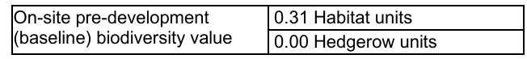
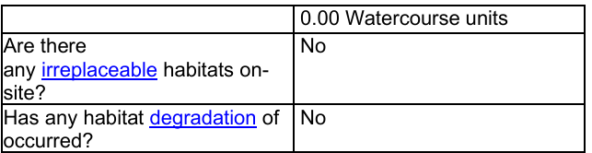

Confirmation of how the development will achieve BNG is a post-determination matter and a deemed condition will be added to any permission given, the applicant must apply to discharge this condition before commencing works.

Core Policy 50 - Core Policy 50 of the Wiltshire Core Strategy requires all development to demonstrate no net loss of biodiversity and to seek opportunities to enhance biodiversity. The NPPF also encourages applications to deliver measurable net gains (para 186 d). It is anticipated that all developments will deliver no net loss of biodiversity. For this application, biodiversity measures should focus on delivering continued ecological functionality for birds.

The Council’s ecologist has suggested a condition be added to any permission that prior to the commencement of any works, including vegetation removal and demolition, details of the number, design and locations of ecological enhancement features including bird boxes, shall be submitted to the Local Authority for approval. However, given the nature of the proposed works and the context of the location of the application site and that this condition was not requested and therefore not included with the precious planning permission given for the same development, which is extant, it is not considered reasonable or necessary to now add this condition. The proposals include a landscape plan which can be conditioned which is considered acceptable.

CONCLUSION

This application submission forms an amended scheme to a previously approved and extant permission for a drive-thru at Pizza Hut, Solstice Park. Drive-thrus are a feature of commercial premises in the immediate locality and there is no objection to forming such provision for the existing premises which will increase the provision for customers. There would be no harm to the prevailing character and appearance of the area and new/replacement planting can be secured by condition. Subject to the imposition of other conditions, the application is concluded to be acceptable from a highways and ecology perspective. There would also be no harm to any neighbouring premises as a result of the development.

RECOMMENDATION: That Planning Permission be GRANTED subject to conditions.

1. The development hereby permitted shall be begun before the expiration of three years from the date of this permission.
REASON: To comply with the provisions of Section 91 of the Town and Country Planning Act 1990 as amended by the Planning and Compulsory Purchase Act 2004.

2. The development hereby permitted shall be carried out in accordance with the following approved plans and documents:

Application form received 12/02/2026
Site location plan Drg no 2879-URB-ZZ-00-DR-A-208100 Rev P00 received 12/02/2026
Elevations as Proposed Drg no 2879-URB-ZZ-XX-DR-A-208250 Rev P01 received 12/02/2026
Proposed site/block plan Drg no 2879-URB-ZZ-00-DR-A-208150 Rev P02 received 12/02/2026
Tracking assessment Drg no 26490-02 received 12/02/2026
Ground Floor Plan as Proposed Drg no 2879-URB-ZZ-00-DR-A-208151 Rev P02 received 12/02/2026
Landscape Plan. The Landscape Service. Drg no 839 - 1 - R1 received 12/02/2026
Biodiversity Habitats Plan. The Landscape Service. Drg no 839 - 2 - R1 received 12/02/2026
The Statutory Biodiversity Metric. received 08/04/2026
BNG Condition Assessments - Solstice Park Drg no 839 – 5- R1 received 08/04/2026

REASON: For the avoidance of doubt and in the interests of proper planning.

3. Before the first use of the approved drive-thru, the applicant shall provide full details (including elevational plans showing any enclosure and the materials which it will be constructed from) for the replacement bin store for the written agreement with the local planning authority. The replacement bin store shall be completed and made available before the first use of the approved drive-thru. It shall be maintained as such thereafter unless the local planning authority gives written consent to any changes.

REASON: To ensure adequate bin storage is available for the premises.

4. All soft landscaping comprised in the approved details of landscaping shall be carried out in the first planting and seeding season following the first use of the approved drive-thru or the completion of the development whichever is the sooner; All shrubs, trees and hedge planting shall be maintained free from weeds and shall be protected from damage by vermin and stock. Any trees or plants which, within a period of five years, die, are removed, or become seriously damaged or diseased shall be replaced in the next planting season with others of a similar size and species, unless otherwise agreed in writing by the local planning authority. All hard landscaping shall also be carried out in accordance with the approved details prior to the occupation/use of any part of the development or in accordance with a programme to be agreed in writing with the local planning authority.

REASON: To ensure a satisfactory landscaped setting for the development and the protection of existing important landscape features.

5. No part of the development hereby permitted shall be first brought into use until the access, turning area and parking spaces [32] have been completed in accordance with the details shown on the approved plans. The areas shall always be maintained for those purposes thereafter.

REASON: In the interests of highway safety.

Informatives

1. Any alterations to the approved plans, brought about by compliance with Building Regulations or any other reason must first be agreed in writing with the Local Planning Authority before commencement of work.

2. The applicant is requested to note that this permission does not affect any private property rights and therefore does not authorise the carrying out of any work on land outside their control. If such works are required, it will be necessary for the applicant to obtain the landowners consent before such works commence. If you intend carrying out works in the vicinity of the site boundary, you are also advised that it may be expedient to seek your own advice with regard to the requirements of the Party Wall Act 1996.

3. Nesting Birds -The adults, young, eggs and nests of all species of birds are protected by the Wildlife and Countryside Act 1981 (as amended) while they are breeding. Please be advised that works should not take place that will harm nesting birds from March to August inclusive. All British birds, their nests and eggs are protected under Section 1 of the Wildlife and Countryside Act 1981 (as amended) and the Countryside and Rights of Way Act 2000 while birds are nesting, building nests and sitting on eggs. The applicant is advised to check any structure or vegetation capable of supporting breeding birds and delay removing or altering such features until after young birds have fledged. Damage to extensive areas that could contain nests/breeding birds should be undertaken outside the breeding season. This season is usually taken to be the period between 1st March and 31st August, but some species are known to breed outside these limits.

4. BNG – Gain Plan Required

The effect of paragraph 13 of Schedule 7A to the Town and Country Planning Act 1990 is that planning permission granted for the development of land in England is deemed to have been granted subject to the condition “(the biodiversity gain condition”) that development may not begin unless:

(a) a Biodiversity Gain Plan has been submitted to the planning authority, and
(b) the planning authority has approved the plan.

The planning authority, for the purposes of determining whether to approve a Biodiversity Gain Plan if one is required in respect of this permission would be Wiltshire Council. There are statutory exemptions and transitional arrangements which mean that the biodiversity gain condition does not always apply. For further information on exempt developments please refer to: https://www.gov.uk/guidance/biodiversity-net-gain-exempt-developments

Based on the information available this permission is considered to be one which will require the approval of a biodiversity gain plan before development is begun because none of the statutory exemptions or transitional arrangements are considered to apply. Irreplaceable habitat If the onsite habitat includes irreplaceable habitat (within the meaning of the Biodiversity Gain Requirements (Irreplaceable Habitat) Regulations 2024) there are additional requirements for the content and approval of Biodiversity Gain Plans.

The Biodiversity Gain Plan must include, in addition to information about steps taken or to be taken to minimise any adverse effect of the development on the habitat, information on arrangements for compensation for any impact the development has on the biodiversity of the irreplaceable habitat.

The planning authority can only approve a Biodiversity Gain Plan if satisfied that the adverse effect of the development on the biodiversity of the irreplaceable habitat is minimised and appropriate arrangements have been made for the purpose of compensating for any impact which do not include the use of biodiversity credits.

