APPLICATION FOR FULL PLANNING PERMISSION
OFFICER DELEGATED REPORT

APPLICATION REFERENCE | PL/2026/00464
APPLICATION TYPE | Full planning permission
SITE ADDRESS | Emmaus School, School Lane, Staverton, Trowbridge, BA14 6NZ
DEVELOPMENT DESCRIPTION | Retrospective application for approval of security fencing
RECOMMENDATION | Planning permission be REFUSED

SITE CONTEXT

The site lies at the northern end of School Lane where it joins New Terrace (the B3105) situated within Staverton (which is a designated Small Village in the Wiltshire Core Strategy (WCS)) and is within the Bradford on Avon Community Area. In reality, the site is geographically more related to Trowbridge (which is a designated Principal Settlement in the WCS); and adjoins the northern aspect of the town and is identified as forming part of its settlement development limits on the WCS Policy Map. The site location is shown below.

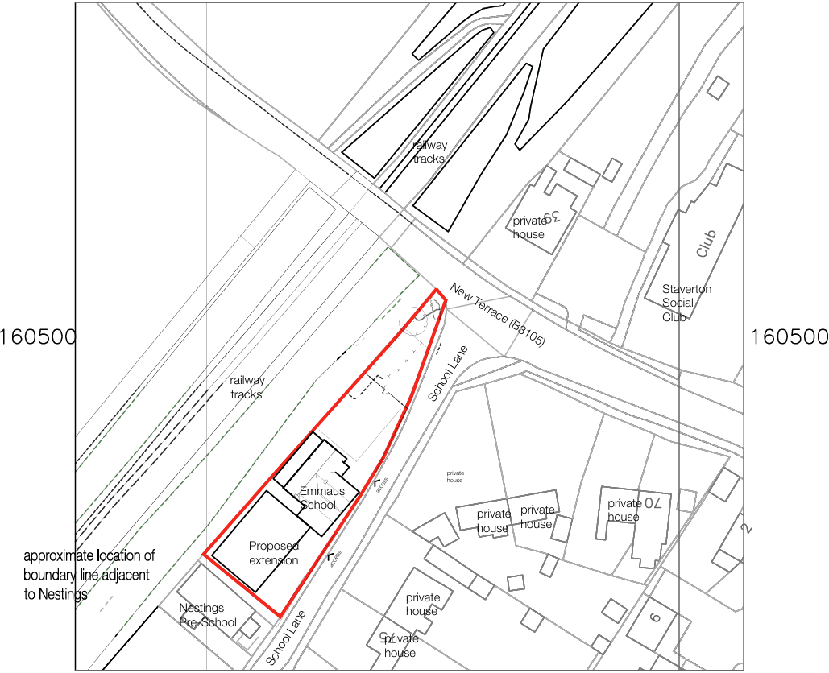
Figure 1: Site plan and OS plan with site outlined in red.

Emmaus School is a small independent, co-educational, Christian school providing education for 5 to 16-year-olds. It has a maximum capacity of 75 pupils with circa 60 currently enrolled.

The school occupies an elongated site and comprises an extended main building which spans the centre and southern part of the site with a small area of hardstanding to the north that is used for outdoor play with a car parking area beyond. The main building consists of the central historic Victorian structure which was extended to the south with a two-storey contemporary building, that was approved in 2024 under application PL/2023/10641. The host building is not listed, however it is considered to be a non-designated heritage asset given its age, vernacular design and traditional materials palette, including its Bath stone walling. The playground is laid as tarmac hardstanding and was created as part of the part of the aforementioned 2024 consent.

The north, west and southern aspects of the school are enclosed by new fencing which is the subject of this retrospective planning application. This fencing replaced a low historic wall and a short chain-linked fence. The new fencing consists of a 2m high metal black metal rail fence fronting the street and opposite the 2-storey modern extension as shown in Figure 2.

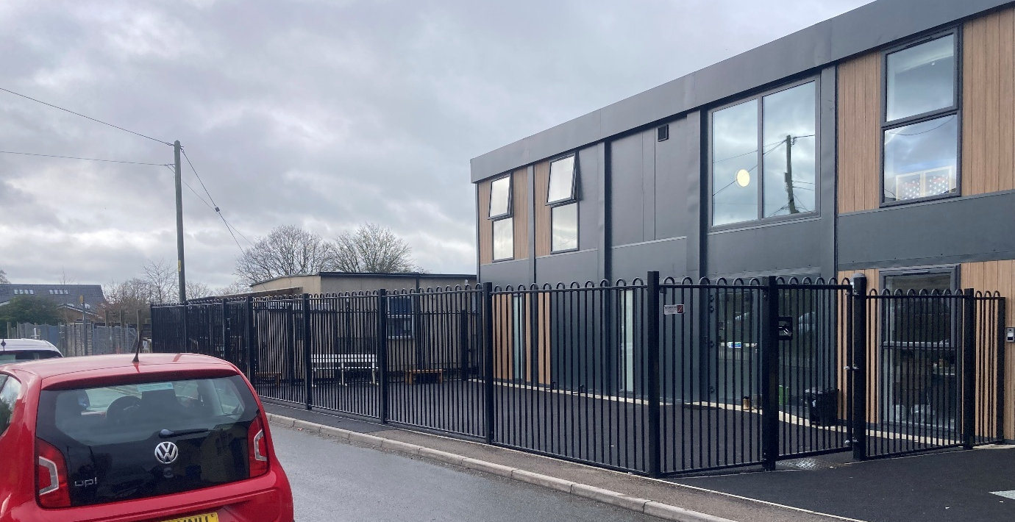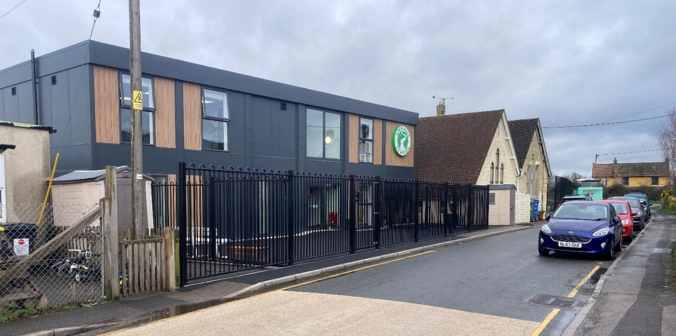
Figure 2. Views along school lane showing the 2m high metal rail fencing

The application also seeks permission to regularise the erection of a 3m black steel fence fronting the street and enclosing the playground as shown in Figure 3.

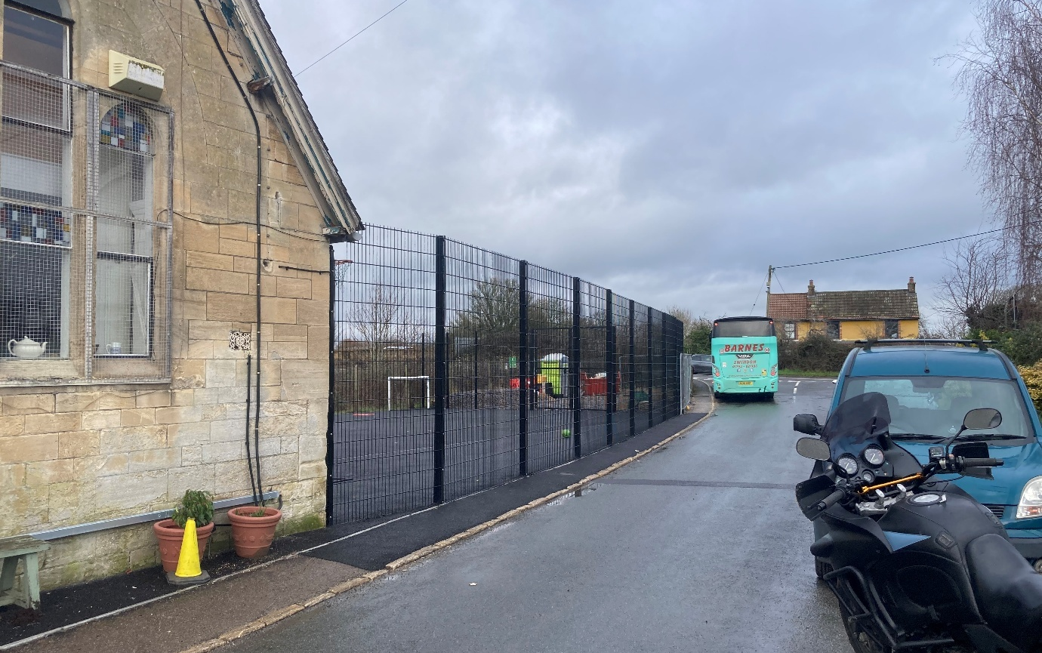
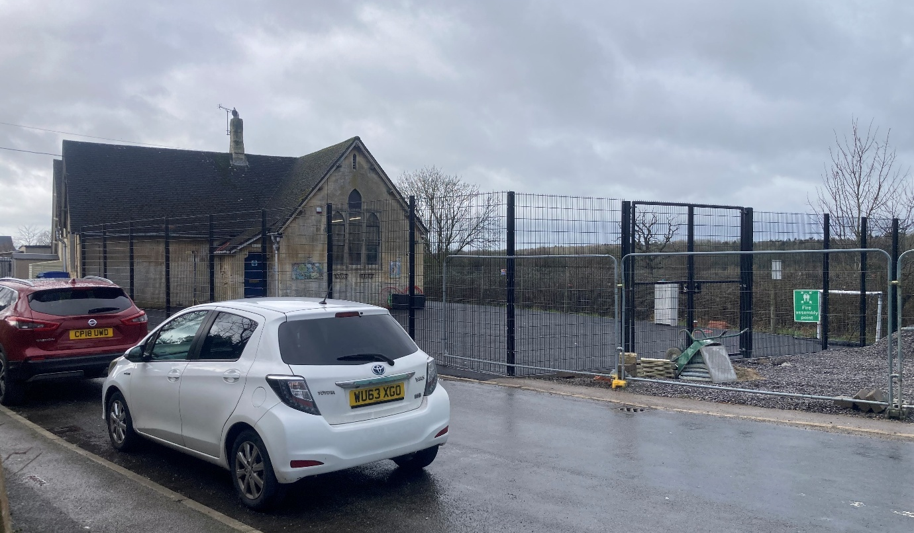
Figure 3: Images of the site from school lane and the unauthorised 3m high fence

Immediate surroundings: The site is surrounded by the following properties and/or land uses and features:

- North: New Terrace (the B3105).
- East: School Lane with low density semi-detached modern dwellings beyond.
- South: Nestlings Pre-school with a play area beyond.
- West: Railway embankment with agricultural land beyond.

Constraints and designations: The site and its surroundings are subject to the following constraints/designations:

- Heritage:
  - Previous planning records have established that the historic Victorian School building merits being considered as a non-designated heritage asset.
- Flood risk:
  - The western site boundary is subject to low surface water flood risk.
- Ecology:
  - The site lies within Trowbridge Westbury Bat Mitigation Strategy – Grey hatched zone.
  - The site lies within 4km buffer area of the Bath & Bradford on Avon bats Special Area of Conservation (SAC).
- Public (environmental) protection:
  - The site lies within the Trowbridge Air Quality Assessment Zone.

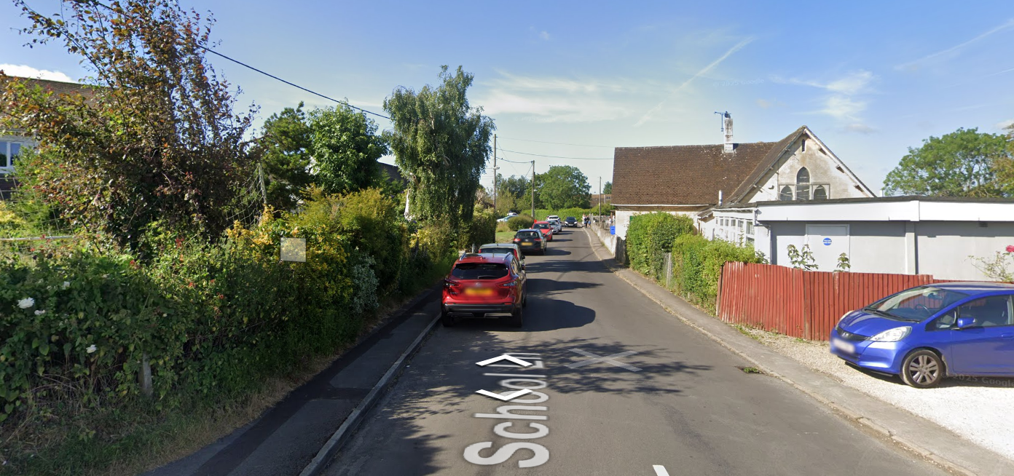
Figure 4: street view along school lane looking south-westerly prior to the 2023 consented extension and the unauthorised fencing works – revealing former boundary treatments

PLANNING HISTORY

Relevant Planning Records
Reference | Description | Decision | Date
W/06/01108/FUL | Demolition of existing side room to main building and separate mobile classroom, 2 new extensions to sides of existing school building and conversion of part of existing roof space to provide additional classrooms, sanitary facilities and new reception/entrance area | Approved | 30/05/2006
W/10/00272/FUL | Removal of existing mobile classroom and demolition of existing single storey extension, to allow replacement single storey rear extension, and two storey side extension | Approved | 31/03/2010
15/12696/FUL | Refurbishment and two storey extension | Approved | 27/04/2016
PL/2023/10641 | Demolition of existing modular classroom and rear extension to main school building to accommodate the erection of two storey building on existing playground with erection of single storey rear extension and associated landscaping | Approved | 05/09/2024
PL/2025/04495 | Discharge of conditions 4 (features for wildlife and new planting for biodiversity), 5 (materials) and 6 (Drainage Strategy) of PL/2023/10641 | Approved | 18/09/2025
PL/2025/05832 | Non-Material Amendment to planning application PL/2023/10641 – Window changes | Approved | 14/10/2025
PL/2025/08325 | Unstable existing boundary wall to be removed and replaced with 2m high bow topped fencing in front of new building and with 3m high fencing at car park end of site, Existing "lean to" single storey extension at rear of existing building to be demolished | Refused | 05/11/2025

For clarification, the property retains permitted development rights.

PROPOSED DEVELOPMENT

The proposal seeks retrospective planning permission for the removal of the historic stone wall and short chain link fence and the retention of a black-coated 2m high metal railing fence spanning the site frontage to the south of the historic building and a black-coated 3m high open mesh steel fence enclosing the playground to the north of the school building. The existing and proposed site plans and elevations are shown at Figures 5, 6 and 7 respectively.

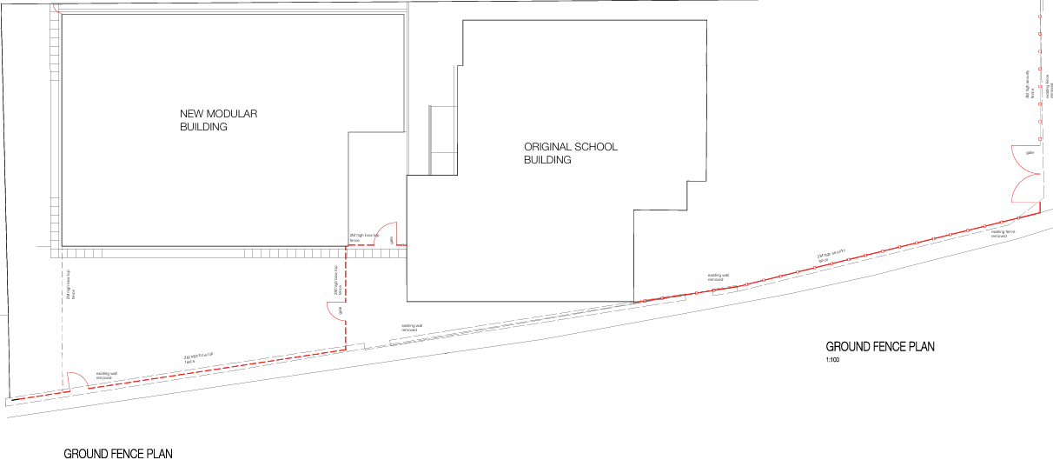
Figure 5: Proposed site plans with the existing wall/fence marked with dashed grey line and new fence marked with red lines.

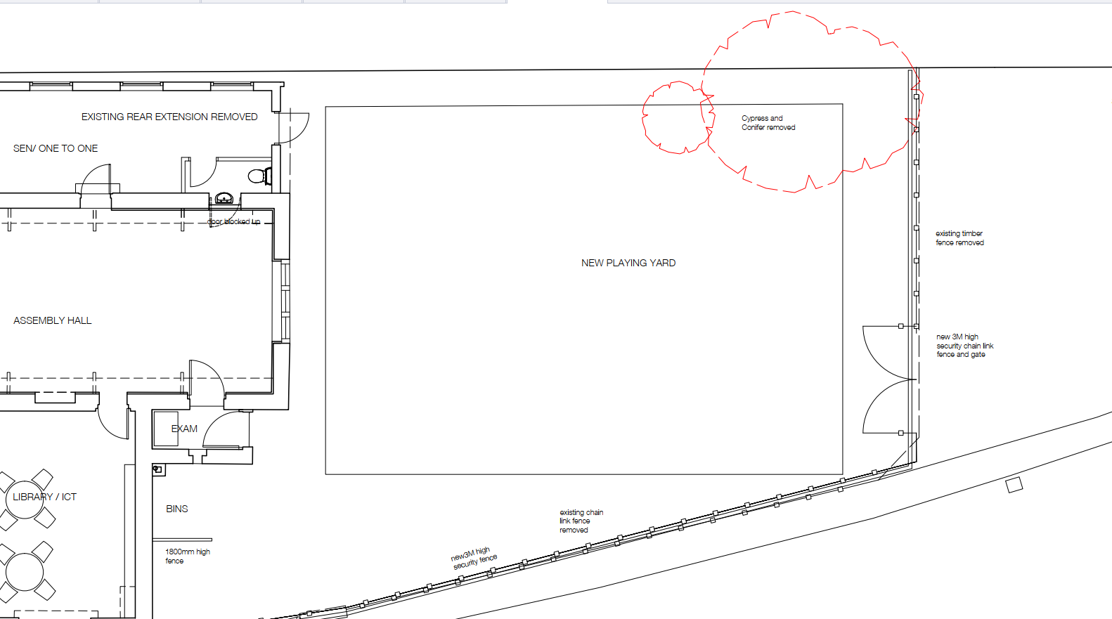
Figure 6: Close up insert of site plan of fenced boundary to playground and car park
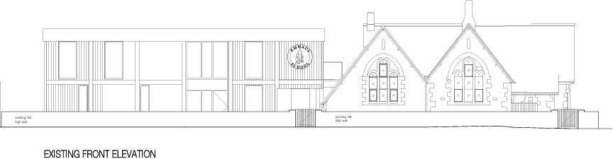

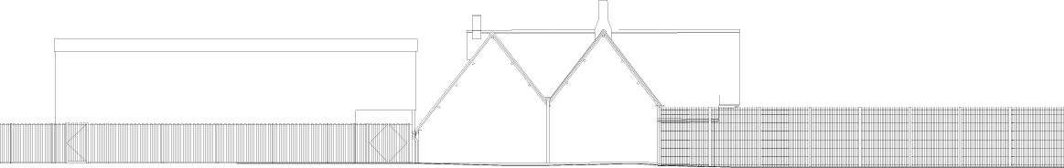
Figure 7: Existing and proposed elevations, upper and lower images respectively.
PLANNING LEGISLATION, POLICY AND GUIDANCE

Planning Legislation:

- Town and Country Planning Act 1990
- Planning and Compulsory Purchase Act 2004

Development Plan:

- Wiltshire Core Strategy (WCS, adopted January 2015):
  - Core Policy 1 Settlement strategy
  - Core Policy 2: Delivery strategy
  - Core Policy 7: Spatial Strategy for the Bradford on Avon Community Area
  - Core Policy 57: Ensuring high quality design and place shaping
  - Core Policy 58: Ensuring the conservation of the historic environment

- West Wiltshire Leisure & Recreation Development Plan Document (L&RDPD, adopted January 2009):
  - Policy SC1: Dual-use of school facilities

Material Considerations (Policy):

- National Planning Policy Framework (NPPF, revised December 2024)
  - Section 2. Achieving sustainable development
  - Section 8. Promoting healthy and safe communities – particularly paragraph 100(a)
  - Section 12. Achieving well-designed places
  - Section 16. Conserving and enhancing the historic environment

- Wiltshire Local Plan Submission Draft 2020-2038 (WLP, Regulation 24): The examination of the emerging Wiltshire Local Plan has been paused and the weight to be afforded to any part of the emerging plan can be no more than very limited. A decision on how to proceed will be made by the Council in May 2026.

Material Considerations (Guidance):

- National Planning Policy Framework (Dec 2024) and Planning Practice Guidance
- National Design Guide (January 2021)
- Wiltshire Design Guide (March 2024)
- British Standards Institution BS 1722 Part 14 Fences. Specifications for open mesh steel panel fences (endorsed by Department for Education site security guidance)
- Secured by Design – New Schools (2014)

CONSULTATION REPONSES

Cllr Trevor Carbin (divisional ward member): Issued a call-in request for this application to be determination at Planning Committee should planning officers recommend the application for approval, citing the following concerns:

- The scale of development;
- The visual impact upon the surrounding area;
- The relationship with the adjoining properties; and
- The design – bulk, height, general appearance.

Staverton Parish Council: No comments.

Wiltshire Council – Highways: No objections.

Wiltshire Council – Public Protection: No objections. The Public Protection team recommended a condition restricting any further construction work to standard working hours; however, as the development is already complete, such a condition would be unnecessary if the application is to be approved.

REPRESENTATIONS

One third-party representation has been received objecting to the proposal and is summarised below:

- Design:
  - The new fence is out of keeping with the historic site frontage and appears overbearing and visually dominant in contrast to the original lower stone wall. The proposal conflicts with WCS Policy 57 in this regard.
  - There was no structural reason to remove the original stone wall.
  - The previous 2010 and 2015 proposals to construct a 2.4m fence behind the stone wall would have been preferable.

- Ecology and Biodiversity Net Gain:
  - No meaningful biodiversity measures have been delivered, with the site largely tarmacked. It appears that the ecological enhancement measures secured by condition on the 2024 consent have not been delivered, meaning the approved development has not been lawfully implemented in relation to that condition.

PLANNING ASSESSMENT

Section 38(6) of the Planning and Compulsory Purchase Act 2004 states that planning decisions must be made in accordance with the development plan unless material considerations indicate otherwise. In accordance with this requirement, this application has been assessed against the relevant policies of the development plan and the material considerations listed above.

Having regard to the planning context and nature of the proposal, the following key matters are considered pertinent to the assessment of the proposal and are addressed in turn:

- Principle of development
- Design
- Heritage
- Other matters

Principle of Development

WCS Core Policy 1 establishes the settlement hierarchy for Wiltshire and the scale of development appropriate for each settlement type.

It defines Principal Settlements as strategically important centres and the primary focus of development in order to safeguard and enhance their strategic roles as employment and service centres. It identifies Trowbridge is a Principal Settlement.

It defines Small Villages as settlements with a low level of services and facilities, and few employment opportunities and states that development at Small Villages will be limited to that needed to improve employment opportunities, services and facilities.

WCS Core Policy 2 states that there is a presumption in favour of sustainable development within the Principal Settlements. The policy states that development at Small Villages will be limited to infill within the existing built-up area. Development at Small Villages will be supported where it, in relation to this case, provides services and facilities, provided that the development: (i) respects the character and form of the settlement, (ii) does not elongate the village or impose development in sensitive landscape areas and (iii) does not consolidate loose knit development.

WCS Core Policy 7 establishes the spatial strategy for the Bradford on Avon Community Area and identifies that Staverton is a Small Village. However, supporting paragraph 5.35 notes that Staverton adjoins Trowbridge and should be considered in relation to both Trowbridge and Bradford on Avon, with the Area Strategy for the urban area of Trowbridge including Staverton.

L&RDPD Policy SC1 encourages the dual use of school sports facilities to help meet the needs of local communities.

NPPF section 8 states that planning decisions should aim to achieve healthy, inclusive and safe places. Paragraph 100(a) sets out that great weight should be given to the need to alter schools through decisions on planning applications.

The retrospective application proposal relates to an established school which falls within a Small Village, albeit the WCS includes Staverton within the settlement development limit of Trowbridge, a Principal Settlement where the presumption in favour of sustainable development applies.

Irrespective of whether the site is categorised as a Small Village or a Principal Settlement, the proposal is associated with an established community facility. The fencing has replaced the previous adhoc mixed boundary treatments including the loss of an old low stone wall (which previously enclosed the former playground.

Officer recognise that the fencing has provided a degree of security and containment for pupils at the school and other users.

With regard to the Core Policy 2 criteria for development in Small Villages, the proposal is not considered to respect the character of the settlement in accordance with criterion (i) – see the Design and Heritage sections for more information.

With regard to Policy SC1, the applicant has advised that: “Regarding current use of the MUGA, we offer support to home schoolers in various ways, including sports sciences, and use of sports facilities. We also host other small schools for sports events that do not have adequate sports facilities themselves… We are looking to make the facilities available to summer school students, including internationals, and we are open to exploring widening the use of the MUGA for afterhours clubs”.

No details of the specific events or arrangements have been provided, and as such, this potential benefit can only be afforded limited weight.

Turning to NPPF paragraph 100(a), the proposal is for a form of operational development at a school, and the containment of the school grounds will assist with promoting a healthy, inclusive and safe space for pupils to learn and play. This principle attracts great weight.

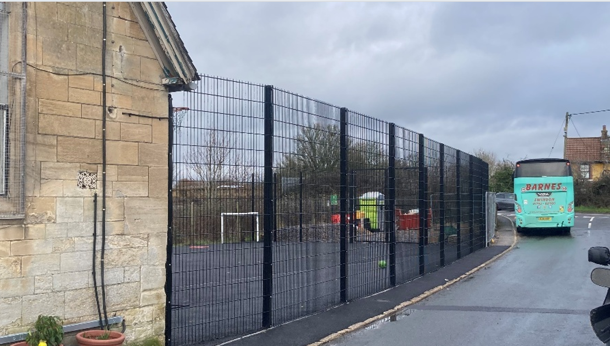
Figure 8: 3m fence enclosing playground – not supported by officers

In recognition that LPAs cannot issue part approval / part refusal (unlike planning inspectors), any application that has an element that cannot be supported, or be satisfactorily mitigated, should be refused in its entirety. For this application, officers have no objection to the 2m high black metal rail fencing that fronts the modern school extension facing School Lane. Officers do however, object to the 3m high fencing (shown in Figure 8) that has an unacceptable and harmful effect on the character and appearance of the surrounding area and an awkward juxtaposition with the original stone built school building where the fence competes with the eaves of the building and as set out in the following section, this part of the application cannot be supported by officers,

Design Matters

Adopted WCS Core Policy 57 requires that all development be of high design quality, create a strong sense of place and complement its context, including through enhancing local distinctiveness and responding positively to local characteristics. The 3m fence conflicts with this policy requirement.

Section 4.5 Expectation: Quality Detailing of the adopted Wiltshire Design Guide advocates high quality detailing and materials to be employed for boundary walls and other means of enclosure to enhance the public realm.

The Dept of Education Guidance on Site Security for schools etc acknowledges that “No two schools are identical and the design of the buildings and the layout of the site will differ from school to school. However, many of the issues revolving around security are generic”.

Officers are also fully aware that for a school, the boundary is the first line of defence and should be protected with a suitable secure fence or railings. Officers are equally aware of the standard set out within the BS:1722, however each application must be assessed on its merits and local context, and a standard specification for a fence or enclosure requires a case-by-case assessment, rather than any slavish adherence to a standard.

The 3m fence encloses a relatively small playground at the school, which offers only limited external play provision. Officers are equally cognisant that on the other side of the school, also fronting School Lane, a lower 2m high fence is provided that has a far more appropriate relationship with the streetscene and the school building.

Officers are also fully aware of the provisions set out within Schedule 2 (Permitted development rights), Part 11 (Heritage and demolition), Class C – demolition of gates, fences, walls etc of the Town and Country Planning (General Permitted Development) (England) Order 2015 (as amended) (the ‘GPDO’) allows the demolition of any means of enclosure, provided the enclosure is not a listed structure nor that it constitutes ‘relevant demolition’ (this meaning the demolition of an unlisted building in a conservation area where the structure exceeds a particular size/height threshold).

In addition, Schedule 2, Part 2 (Minor operations), Class A – gates, fences, walls etc of the GPDO allows for the construction of any means of enclosure adjacent to a public highway of up to 2m high where it serves a school. As such, the 2m high metal rail fence qualifies as permitted development and does not technically require the consent of the LPA. The 3m high fence is not however permitted development.

Officers have illustrated within Figure 9 below how PD fencing / site enclosure at the school would appear in comparison to the proposed/part unauthorised element of the submission.
Figure 9: Proposed elevations with fencing height allowed under permitted development shaded red.

Turning to local character, the street scene is defined by the historic Victorian school building, which is a quaint structure reflecting historic rural vernacular. The site and its surroundings are further characterised by the low‑density suburban setting, with a strong green character generated by verdant front gardens associated to the nearby residential properties, along with mature boundary hedgerows and some tree planting. Indeed, previously the school frontage featured a small hedgerow along with a chain‑link fence before they were removed as part of the 2024 consent. In addition, Staverton C of E Primary School to the south is enclosed by a substantial mature hedgerow and trees. While it is acknowledged that the site backs onto the railway, which has a more utilitarian character, this corridor is also softened by a dense landscape buffer that further reinforces the overall green character of the area.

When viewed in this context, the black 3m open mesh fence, seen together with the fully tarmacked playground and site frontage of the school, results in a very harsh visual appearance that is incongruous with the rural vernacular and quaint character of the historic building and the low-density and the green suburban local essentially residential street character. The fencing is also of a scale that rises above the eaves of the Victorian building and is taller than any other fencing in the vicinity – including the fencing found at Staverton Primary School (as shown in Figure 10).
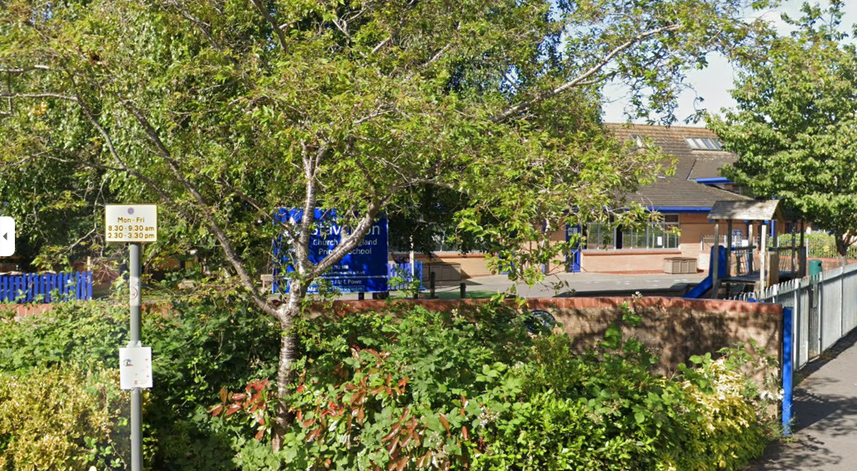
Figure 10: A site frontage view of Staverton Primary School located further along School Lane

The 3m fence at the Emmaus School reads as an incongruous and inconsistent feature (noting the 2m fencing elsewhere at the school) that does not satisfy the requirements of Core Policy 57 that development should promote local distinctiveness, harmonise with its context and represent high quality design. It also fails to meet the expectations of section 4.5 of the adopted Wiltshire Design Guide.

In light of the above, officers sought design betterment through direct liaison with the applicants appointed agent to secure a reduction in the height of the fencing and/or the incorporation of soft landscaping to assist in assimilating the development more effectively into its surroundings. This request was effectively declined in an email from the agent dated 31 March 2026. In that correspondence, the agent cites the need for the fencing to accord with relevant guidance, which recommends heights of 2–2.4 metres for security purposes and in excess of 3 metres for MUGAs. The agent also noted that the fencing is located to the rear of the Victorian building, which they contend is less sensitive.

Officers challenge the agent’s assertion that the fence affects the rear of the Victorian school building. It very clearly impacts the front of the building. Officers also challenge the agent’s reference to the playground requiring a 3m high fence. There is a clear inconsistency within the application submission pursuant to site security where it is being argued that one part justifies a 3m fence and another only a 2m high fence. Notwithstanding this anomaly, officers maintain that any fence that requires planning permission, must properly assess the impacts as part of a balanced planning judgement, and in this case, the 3m fence is found to be materially harmful to the character and appearance of the surroundings and has a deleterious impact on the character of the Victorian school building and diminishes the appearance of the non-designated heritage asset. Consequently, officers maintain their position that the proposal conflicts with Core Policy 57.

Having regard to the above, it is considered that, by reason of its 3‑metre height, which is considered harmful and disproportionate to the scale of the Victorian built school building and the surrounding street scene, and its harsh, utilitarian appearance, is at odds with both the historic vernacular character of the asset and the immediate suburban character of the streetscene, the 3m high fence appears incongruous and overly dominant. As such, the proposal fails to deliver a high‑quality design that respects local character and distinctiveness and is consequently contrary to WCS Core Policy 57 and the Wiltshire Design Guide.

Heritage Matters

Adopted WCS Core Policy 57(i) and (iv) require that development proposals be sympathetic, respond positively to and conserve the historic environment.

Core Policy CP58 states that development should protect, conserve and, where possible, enhance the historic environment. The policy requires that heritage assets and their settings be conserved and/or enhanced in a manner appropriate to their significance.

Paragraph 207 of the NPPF states that local planning authorities should require applicants to describe the significance of any heritage asset affected by development, including any contribution made by their setting. The level of detail should be proportionate to the asset’s importance and no more than is sufficient to understand the potential impact of the proposal on the asset’s significance.

NPPF Paragraph 212 clarifies that great weight should be given to an asset’s conservation, irrespective of the level of harm.

NPPF Paragraph 215 states that where a proposal leads to less than substantial harm to a heritage asset, the harm should be weighed against the public benefits of the proposal.

NPPF Paragraph 216 states that a balanced judgement will be required having regard to the scale of any harm or loss and the significance of any non-designated heritage asset.

As set out above, the original Victorian-built school building is considered to be a non-designated heritage asset (along with the now removed historic low stone boundary wall at the site frontage) contributes positively the local streetscene character. The loss of the low height wall is regrettable but was undertaken as works that are permitted development. Similarly, the construction of fencing up to 2 metres in height does not require planning permission and, regardless of its detailed design or materials, it would be unreasonable to attribute harm to this element.

For reasons similar to those identified in the design section above, the 3m high fencing that ecloses the playground is considered to be incongruous in terms of its height, appearance and materiality when assessed against the Victorian school building, and consequently does not conserve the historic environment. Taking into account the modernised character of the wider site context, alongside the limited aspect of the development requiring planning permission, it is considered that the proposal would result in a low level of less than substantial harm to a non‑designated heritage asset which merits being given great weight. Accordingly, the proposal conflicts with WCS Core Policies 57 and 58 and NPPF section 16, unless it can be demonstrated that the heritage harm is outweighed by the public benefits of the proposal, which is assessed in the conclusion section.

Other Matters

Transport and public protection: Given the lack of objection from the statutory consultees and as officers observed no issues relating to transport and public protection matters when visiting the site, the proposal is considered acceptable in terms of the relevant development plan policies pursuant to highway and public protection matters.

Ecology: With regard to the concerns raised by a member of the public, the asserted non-compliance of the school with previously imposed ecological enhancements condition requirements set out within Condition 4 of application PL/2023/10641 is not a matter for consideration of this application. It should be noted that details of ecological enhancements were submitted to and were approved by the Council under application PL/2025/04495. These included the installation of one wall‑mounted Beaumaris bat box and two VivoPro sparrow boxes on the new building, along with the retention of the green area and associated planting to the north of the car park.

It is unclear whether the bird and bat boxes have been installed. Officers also observed during the site visit that the green area had been cleared and was being used temporarily for the storage of building materials and a skip. Given that minor site works were ongoing at the time of the visit, the matter will be forwarded on to the Council’s enforcement team to review and to take any appropriate action. In addition, the applicant has been reminded of their obligations to implement the approved ecological enhancements in accordance with the details discharged under PL/2025/04495.

CONCLUSION (PLANNING BALANCE)

Planning law states that planning decisions must be made in accordance with the development plan unless material considerations indicate otherwise. In this case, two material considerations are of particular relevance: permitted development rights and the local and national policy and the adopted Design Guide.

The proposal seeks retrospective permission for new fencing at Emmaus School, an established school within the settlement development limits. Part of the application proposal relates to a 2m high black metal rail fencing that does not require permission from the LPA since it qualifies as permitted development.

The only part of the application that technically requires the consent from the LPA is the 3m high fence that encloses the playground.

Notwithstanding the applicant’s justification to maintain site security, the 3m high fencing enclosing the playground has material harmful impacts on the character and appearance of the surrounding area and its relationship with the old school stone-built Victorian building. By reason of its height, utilitarian form and visually harsh appearance, the proposed 3m high open mesh fencing appears incongruous within the street scene and fails to respect both the rural vernacular of the Victorian school building and the suburban character of the immediate area.

For similar reasons, the same part of the application proposal causes a low level of less than substantial harm to the significance and character of the Victorian school building and diminishes its value as a non-designated heritage asset which is given great weight. As such, the proposal conflicts with WCS Core Policies 57 and 58, in addition to NPPF sections 12 and 16 and the Wiltshire Design Guide.

The NPPF attributes great weight to the need to create, expand and alter schools, and requires that public benefits be weighed against any less than substantial harm to a heritage asset, the conservation of which deserves being afforded great weight.

In this instance, officers do not support the 3m high fencing fronting School Lane. Elsewhere at the school, a 2m high fence is provided that purports to provide the necessary degree of site security for children and officers hold the view that the playground could be appropriate encloses with a 2m fence at this location, exercising permitted development allowances. The arguments made by the applicants in support of the fence do not outweigh the harm identified to the character and appearance of the area and to the significance of the non-designated heritage asset, which are afforded great and most determinative weight.

As such, and having regard to all relevant material considerations, the proposal fails to comply with the development plan and material considerations when read as a whole. The application is therefore recommended for refusal.

RECOMMENDATION: That Planning Permission be REFUSED for the following reasons:

- By reason of its height and its incongruous relationship with the host building and streetscene, the 3m high fence that encloses the school playground (which is considered the most important part of the application submission), is disproportionate and harmful to the scale of the Victorian-built stone school building (which is considered to be a non-designated heritage asset) and is equally harmful to the character and appearance of the immediate surroundings and streetscene, through its harsh, utilitarian appearance, which is at odds with both the historic vernacular character of the identified local asset and the suburban character of the immediate area. As such, the proposal fails to deliver the required high‑quality design that respects local character and distinctiveness and is consequently contrary to WCS Core Policy 57 and the Wiltshire Design Guide and the NPPF.

- By reason of its height and juxtaposition with the host building, the 3m high fence has a low level less than substantial harm to the significance, character and appearance of the Victorian-era school building on-site which is considered to be of merit as a non-designated heritage asset that this harm is afforded great weight in the decision-making process. No heritage justification has been provided, nor have sufficient public benefits been demonstrated that would outweigh the identified harm. The proposal therefore fails to conserve or enhance the historic environment and is contrary to Core Policies 57 and 58 of the Wiltshire Core Strategy, the Wiltshire Design Guide, and section 16 of the NPPF.

