APPLICATION FOR HOUSEHOLDER PLANNING PERMISSION
DELEGATED REPORT

APPLICATION REFERENCE: | PL/2026/00811
APPLICATION TYPE: | Householder planning permission
SITE ADDRESS: | 11 King Alfred Way, Winsley, Bradford on Avon, BA15 2NG
DEVELOPMENT DESCRIPTION: | Proposed Single Storey Rear Extension
RECOMMENDATION: | That Planning Permission be GRANTED

PROPOSAL

The proposal seeks planning permission for a single storey rear extension positioned on the northwest elevation of the host dwelling.

SITE DESCRIPTION/CONTEXT

The application relates to a detached chalet bungalow, 11 King Alfred Way, located in Winsley near Bradford on Avon. The host dwelling benefits from an off-road parking area to the side elevation and detached garage to the rear. Similar single storey properties line this area of King Alfred Way, with semi-detached properties sitting immediately adjacent to the application site.

The application site lies within a Special Landscape Area and within the Bath and Bradford on Avon Special Area of Conservation for bats.

PLANNING HISTORY

N/a

RELEVANT POLICIES AND GUIDANCE
Wiltshire Core Strategy:

- CP2 - Delivery Strategy
- CP7 - Spatial Strategy for Bradford on Avon
- CP50 - Biodiversity and Geodiversity
- CP51 - Landscape
- CP57 - Ensuring High Quality Design and Place Shaping

C3 Special Landscape Areas (saved policy from the West Wiltshire District Plan 1st Alteration)

Wiltshire Design Guide: Appendix D – Design Guidance for Householder extensions

The National Planning Policy Framework (NPPF)

The Planning Practice Guidance

National Design Guide

CONSULTATION RESPONSES
Winsley Parish Council: No objection

REPRESENTATIONS
One letter of objection was received – The objection relates to potential neighbouring amenity impacts, the points raised will be appraised within the officer report below.

ASSESSMENT
Section 38(6) of the Planning and Compulsory Purchase Act 2004 states:

"If regard is to be had to the development plan for the purposes of any determination to be made under the planning Acts, the determination must be made in accordance with the plan unless material considerations indicate otherwise."

In accordance with this statutory requirement, this application has been assessed against the relevant policies of the Development Plan, including the adopted Wiltshire Core Strategy (2015) and, where applicable, any made Neighbourhood Plans.

Design and Impact upon the character and context of the Special Landscape area
Core Policy 57 - Ensuring High Quality Design and Place Shaping of the Wiltshire Core Strategy seeks to ensure that all new development is of high design quality, reflecting local context, character, and distinctiveness.

Saved Policy C3 requires the landscape character of this area to be “conserved and enhanced and development will not be permitted which is considered to be detrimental to the high quality of these landscapes”.
The application site is located within a Special Landscape Area (within the southern fringes of the Cotswolds) therefore due consideration has to be given to any development that may adversely impact upon the scenic quality of the special landscape designation

The scale and development within this designated area should be limited, while development within its setting should be sensitively located and designed to avoid or minimise adverse impacts on the designated area.

The single storey extension would be positioned to the rear elevation of the host dwelling and will not be visible from the public realm. The pitched roof would sit at a maximum height of 4.3m, with the footprint of the extension extending over 21m2.

The design would be sympathetic to the existing bungalow, and the proposed ridge height would sit below the main roofline, ensuring the proposal would be subservient to the existing built form of the host dwelling. Whilst the resultant architectural proportions are slightly incongruous, this is considered not to be sufficiently harmful to warrant a recommendation of refusal in design terms.

Patio doors and a window would be inserted on the rear elevation of the extension, alongside a window inserted in the southwest side elevation.
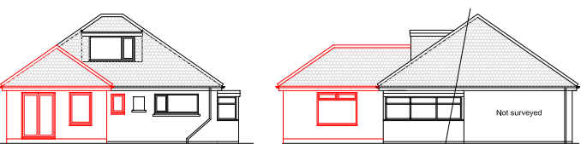
Proposed rear (left) and southwest side (right) elevation of the extension.

The use of matching materials (concrete block elevations under concrete roof tiles) with matching white UPVC fenestration would ensure the proposal would integrate into the built form of the host dwelling and surrounding setting.

It is considered that the extension would by virtue of its height, scale and design constitute a complementary addition to the host dwelling that would appear commensurate to the size of the property and plot.

Officers consider that the proposal would not detrimentally impact the wider much valued landscape character of the Special Landscape Area, as any additional form would be read within the built envelope of the application site. The development therefore complies with Core Policy 51 of the Wiltshire Core Strategy and Paragraph 189 of the NPPF in conserving and enhancing the National Landscape.

Having regard to the above, the proposal complies with the design principles set out in Core Policy 57 of the Wiltshire Core Strategy and Appendix D of the Wiltshire Design Guide.

Amenity
Point vii of Core Policy 57 - Ensuring High Quality Design and Place Shaping of the Wiltshire Core Strategy seeks to ensure that developments do not adversely affect neighbouring properties.

The National Planning Policy Framework (NPPF), particularly Paragraph 135(f), stresses that planning decisions should ensure developments provide a high standard of amenity for existing and future users.

The proposed development has been assessed in terms of its potential impact on the residential amenity of neighbouring properties, with particular regard to loss of light, overshadowing, loss of privacy, and overbearing effects.

The adjacent neighbour has objected to the proposal citing concerns that the ridge height of the extension is too high, and that the proposal would introduce adverse neighbouring amenity impacts, and this is duly noted.

All windows proposed would overlook the applicant’s private residential rear curtilage and with the absence of any windows on the northeast side elevation, closest to the neighbour at No.9 King Alfred Way, no overlooking concerns are raised.

The extension would sit at a maximum height of 4.3m (of the pitched roof design) with the eaves sitting at a height of 2.5m adjacent to the common shared boundary. Officers acknowledge that there would be some overshadowing introduced by the proposal, however it also worth acknowledging that a degree of overshadowing, across to the driveway area of the property at no.9 King Alfred Way already exists, created by the host property at No.11.

The proposed extension would cast a shadow across the neighbouring plot at No.9 at certain times of the day and year (depending on the sun’s orbit position and angle).The case officer has tested the likely shadow to be cast by the proposed 4.3m high rear extension by inputting the application site and proposal details into the ‘SunCalc’ website tool which can be interrogated by adjusting the time of any day of the year to appreciate when and to what extent a shadow may be cast.

It is however imperative that as part of this appraisal, due cognisance is given to the existing built development on site and within the immediate environs since these will cast a shadow of their own and in terms of this application, the existing dwelling at 11 already casts a far more extensive shadow across to the neighbouring property and plot than the single storey extension being proposed.

Having said that as illustrated by the SunCalc snip insert below, the extension would create a degree of overshadowing for a limited part of the day, but crucially, the impact would be limited and would not be substantive to justify a refusal of planning permission.

This is illustrated by an extract reproduced below which is produced from the ‘SunCalc’ website – which is considered a useful tool in terms of appreciating the potential impacts of a development. It is however important not to rely solely on the web tool site, but instead to impart some planning judgement based on the specific site circumstances and appraising the existing neighbouring area as part of a holistic planning assessment.

For the avoidance of any doubt, the extract is represented by a red circle positioned at the rear of No.11 where the highest point of the roof of the proposed extension would be constructed with the approximate height of the extension identified as the object of the shadow cast test. Each extract can be manipulated online to reveal the effects at different times of the day.

The extract below for the summer solstice reveals that around 6pm, there would be a degree of overshadowing across the driveway of No. 9 (depicted by the black line extending beyond the red circle), however the overshadowing would not reach the side elevation of the adjacent property at No. 9. Therefore, no overshadowing concerns are raised.

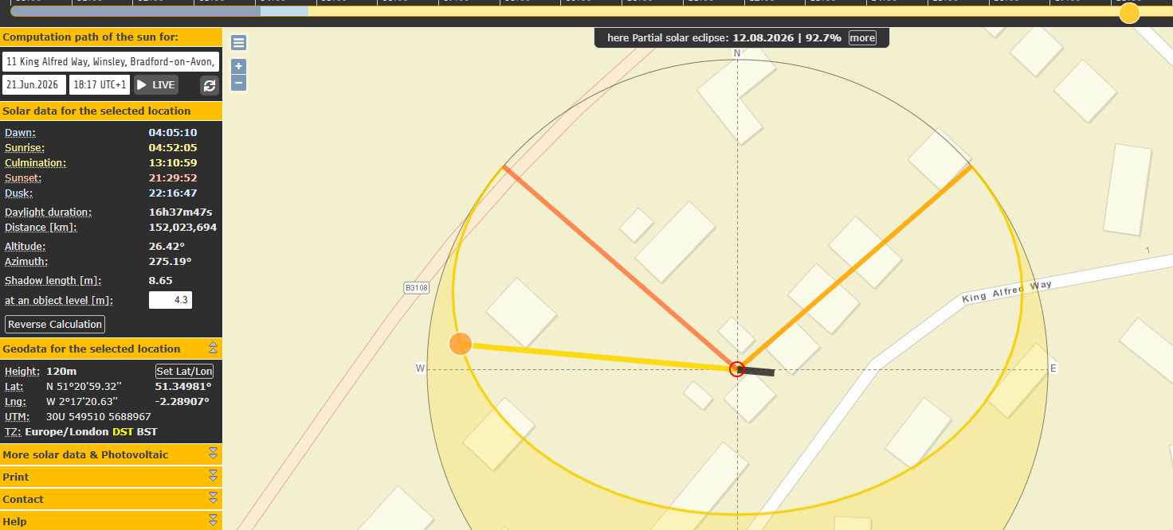

Officers have also appraised the application against the 45 degree ‘test’, which also helps to test a proposed development affecting neighbouring properties. The 45-degree test works for extensions that are perpendicular to a window in a neighbouring property. This test is suited to residential dwellings where occupants have a reasonable expectation of daylight.

A centre line was marked on the plan of the neighbouring window to create a 45-degree line, to establish if the proposed extension would satisfy the 45-degree test wholly or in part. On the plan insert below, the 45-degree test is illustrated with the line taken from the centre of the closest window (within the rear elevation of the property at No.9 King Alfred Way) to the host dwelling.

The extract below reveals that the rear extension would not breach the 45-degree test, however the plan illustrates that the garage building to the rear of the neighbouring property, does already lead to loss of light to the rear windows of the property at No.9.
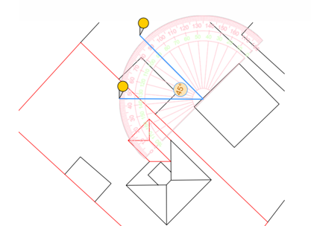

The proposed development would not result in a substantive overbearing effect on the immediate neighbour or loss of light to warrant the refusal of the application. Officers are satisfied that the proposed height and projection of the rear extension would not lead to significant overbearing, overshadowing or loss of light to the immediate neighbour to the detriment of No. 9 King Alfred Way.

The proposal therefore accords with Core Policy 57 point vii in respect of safeguarding residential amenity and Appendix D of the Wiltshire Design Guide.

Ecology Impact
Core Policy 50 of the Wiltshire Core Strategy seeks to protect and enhance biodiversity and geodiversity, including through ensuring that development avoids harm to protected species and habitats.

The National Planning Policy Framework (NPPF), in Paragraphs 193, requires that development minimises impacts on and provides net gains for biodiversity, including ensuring mitigation is secured where harm cannot be avoided.

The application site is located within one of the ‘consultation zones’ for the buffer zone of the Bath and Bradford-on-Avon Bat Special Area of Conservation (SAC), therefore due consideration has to be given to the potential disturbance of any bats because of this proposed new development.

The proposed works comprises an extension to existing residential development consisting of limited built form close to the existing dwelling which does not involve works to the roof. Given the established high density residential nature of the location, it is considered highly unlikely that any bats would be affected and significant effects relating to the disturbance to bats can be ruled out.

As a precautionary measure an informative would be added to any decision that in event any evidence of bat activity is detected that the applicant should follow the advice of a professional ecologist or contact Natural England.

As such, the development complies with Core Policy 50 of the Wiltshire Core Strategy and the relevant provisions of the NPPF.

Biodiversity Net Gain
Householder planning applications are exempt from the requirement to deliver Biodiversity Net Gain under Schedule 7A, Section 4(2)(a) of the Town and Country Planning Act 1990, as inserted by the Environment Act 2021.

CONCLUSION
The proposed development is considered on balance to be acceptable in terms of its design, scale, and relationship with the surrounding area. It would not result in any unacceptable harm to the character of the locality, the amenities of neighbouring occupiers, or the interests of ecology.

The proposal is therefore considered to comply with the relevant policies of the Wiltshire Core Strategy, the Wiltshire Local Plan, and the National Planning Policy Framework. As such, the application is recommended for approval, subject to the conditions set out below.

RECOMMENDATION: That Planning Permission be GRANTED subject to conditions.

Conditions
- The development hereby permitted shall be begun before the expiration of three years from the date of this permission.
REASON: To comply with the provisions of Section 91 of the Town and Country Planning Act 1990 as amended by the Planning and Compulsory Purchase Act 2004.

- The development hereby permitted shall be carried out in accordance with the following approved plans and documents:
Existing & Proposed Elevations, Floor Plans, Block Plan & Location Plan DWG No AH/202611 Sheet 1 of 1
Plan Received 05.02.2026

REASON: For the avoidance of doubt and in the interests of proper planning.

Informative

Ecology
If bats or evidence of bats are found during the works, the applicant is advised to stop work and follow advice from an independent ecologist or to contact Natural England’s Bat Line through the internet.

