APPLICATION FOR HOUSEHOLDER PLANNING PERMISSION AND LISTED BUILDING CONSENT DELEGATED REPORT

APPLICATION REFERENCE: | PL/2026/00344 and PL/2026/00346
APPLICATION TYPE: | Householder planning permission and Listed Building Consent
SITE ADDRESS: | 6 George Street, Warminster, BA12 8QA
DEVELOPMENT DESCRIPTION: | Retrospective permission for demolition of lean to at rear of property
RECOMMENDATION: | That Planning Permission be GRANTED

This is a joint report for PL/2026/00344 (Householder) and PL/2025/09622 (LBC)

PROPOSAL

The proposal seeks retrospective householder planning permission and Listed Building Consent to regularise the unauthorised removal of a single storey rear extension to the rear of a Grade II listed Building, 6 George Street.

SITE DESCRIPTION/CONTEXT

The host building, 6 George Street comprises of a ground floor commercial space with first floor and second floor residential accommodation. The building lies adjacent to the public highway set within the town centre of Warminster within the conservation area. The building is flanked by two listed buildings, within many listed buildings within the immediate vicinity.

This proposal falls within the recreational impact zone of the Salisbury Plain Special Protection Area for birds and located within the Hampshire catchment area of the River Avon SAC.

PLANNING HISTORY

Proposal / Summary
W/78/01339/HIS - Historic apps 1974 to 1983 Decision - Approved Date: 13/3/1979 – Conversion of three cottages into one dwelling

RELEVANT POLICIES AND GUIDANCE

Wiltshire Core Strategy:
Core Policy 2 – Delivery Strategy
Core Policy 31 – Spatial Strategy for the Warminster Community Area
Core Policy 50 – Biodiversity and Geodiversity
Core Policy 57 - Ensuring High Quality Design and Place Shaping
Core Policy 58 - Ensuring the Conservation of the Historic Environment
Core Policy 67 – Flood Risk
Core Policy 69 – Protection of the River Avon SAC
Warminster Neighbourhood Plan 2015- 2026 Made November 2016
Wiltshire Design Guide: Appendix D – Design Guidance for Householder extensions
The National Planning Policy Framework (NPPF)
The Planning Practice Guidance
National Design Guide
Planning (Listed Buildings and Conservation Areas) Act 1990

CONSULTATION RESPONSES
Warminster Town Council: No objection
Wiltshire Council Conservation: No objection

REPRESENTATIONS
No comments were received.

ASSESSMENT
Section 38(6) of the Planning and Compulsory Purchase Act 2004 states:

"If regard is to be had to the development plan for the purposes of any determination to be made under the planning Acts, the determination must be made in accordance with the plan unless material considerations indicate otherwise."

In accordance with this statutory requirement, this application has been assessed against the relevant policies of the Development Plan, including the adopted Wiltshire Core Strategy (2015) and, where applicable, any made Neighbourhood Plans.

Heritage, Design and Impact upon the character and context of the area:
From the point of view of the historic environment the main statutory tests are set out within the Planning (Listed Building and Conservation Areas) Act 1990.

Section 66 requires that special regard be given to the desirability of preserving listed buildings, their settings or any features of special architectural or historic interest which they possess.

Section 72(1) of the Act requires the Council to pay special attention to the desirability of preserving or enhancing the character or appearance of designated Conservation Areas.

The Council’s Core Strategy Policy CP58 ‘Ensuring the conservation of the historic environment’ requires that designated and non-designated heritage assets and their settings will be conserved, and where appropriate enhanced, in a manner appropriate to their significance and encourages proposals which improve the condition of heritage assets at risk.

The Council’s Core Strategy CP 57: Ensuring high quality design requires a high quality of design in all new developments. The policy requires applicants to “demonstrate how the proposal will make a positive contribution to the character of Wiltshire through (amongst other things) responding to the value of the natural and historic environment and being sympathetic to and conserving historic buildings and landscapes. Development is required to respond positively to the existing in terms of building layouts, built form, height, mass, scale, building line, plot size, elevational design, materials, streetscape and rooflines to effectively integrate the building into its setting.

The NPPF outlines government policy for planning. Chapter 16 of the NPPF 'Conserving and enhancing the historic environment' sets out the Government's high-level policies concerning heritage and sustainable development.

The host building is Grade II listed and lies within the vicinity of a number of listed buildings that line George Street, one of the principal routes through the town centre. The application site is also located within the Warminster Conservation Area, which covers the historic core of the town. The proposal relates to retrospective permission for limited development to the rear of 6 George Street where a non-original extension has been removed, without consent.

The Local Authority Conservation officer was consulted on the proposal and offered the following response.

“Site and assets considered:
6 George Street is a grade II listed building (listed in 1978) which covers the whole building ie inside and out. The list entry, which is a means by which a building can be identified (and is not intended as a catalogue of all that is significant about a building), reads as follows:

‘Late C18. 2 storeys and attic. Painted brick with ashlar stone quoins on projecting plinth. String at 1st floor level now part obscured by fascia of recent shop front. Moulded bracketed eaves cornice removed since previous list. Half-hipped mansard old tile roof with flanking chimneys. Two semicircular headed lead covered dormer casements with radiating glazing. 2 windows to central panel on 1st floor, glazing bar sashes. Ground floor altered; plain C19 shop window.’

The building is within the Warminster conservation area.

Proposal:
The application is retrospective for the demolition of a rear lean-to structure.

Background planning history:
W/78/01339/HIS
Conversion of three cottages into one dwelling.
(Note: no LBC application. Seems cottages were in separate ownership from principal building.)

Issues: impact on the listed building, impact on the setting of neighbouring listed buildings, impact on the conservation area.

Information considered/provided:
Paragraph 207 requires that applicants describe the significance of any heritage assets affected, including any contribution made by their setting. This should include sufficient information to provide a clear understanding of the significance of the heritage asset and its setting and the potential impact of any proposals on that significance.

In this case, whilst the applications are accompanied by a “Design, Access and Heritage Statement”. The document provides limited information about the building and fails to provide any objective assessment of the fabric affected, its date or significance or of the impact of the proposals and, as a result, it fails to meet the requirements of the NPPF.

However, paragraph 208 also provides for the local planning authority to make its own assessment of impact and the following heritage recommendations are offered on this basis
.
Significance of assets and contribution of setting
In respect of the lean-to structure, it is difficult to assess its significance in its absence. However, comprehensive photographs have been supplied.
In terms of historical development:
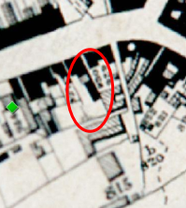 1840s tithe map

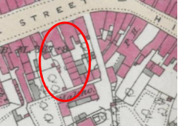 1844-1888 1st series OS map
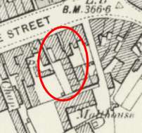 1894-1903 OS map
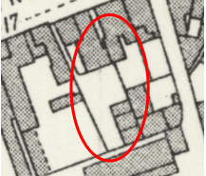 1921-1943 OS map

The historic mapping evidences a range of cottages to the rear of the principal building (6 George Street). These are subsequently demolished with only 3 surviving at the southern end of the site (and which are subsequently converted into one dwelling ie 6a in 1978).
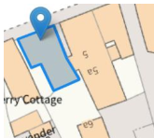

Assessment:
Photographs ‘before’ and ‘after’ have been supplied.
The before photographs evidence a single-storey lean-to structure of some possible age although it is difficult to judge as traditional materials have been used which acquire a patina.
The exterior, particularly the southern end wall (which was covered with a concrete render) was in a particularly poor condition (including the joinery). Internal photographs evidence a lined-out structure in poor condition. No features of historic interest are discernible in the photographs.
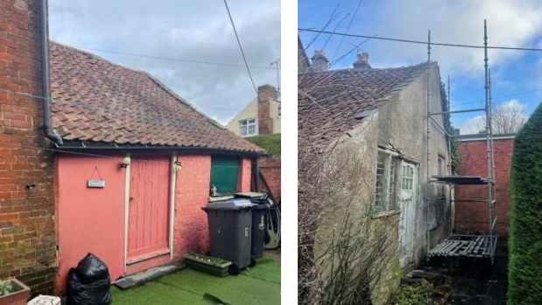

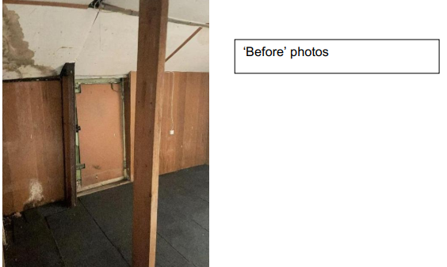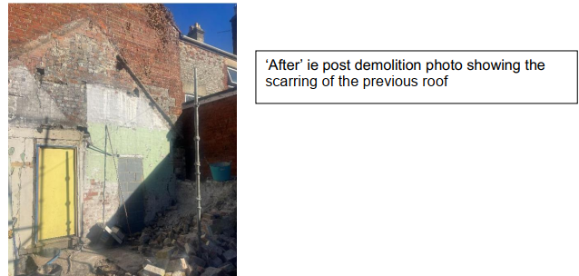

It is possible that this structure was erected post the demolition of the rear cottages (ie some time after 1943) to provide additional commercial storage space to the ground floor of number 6. As such, it is judged to have no particular historic interest, born out by the interior photographs.

However, there is the remnant of a boundary wall to the side (eastern) which is old. It is clearly in a poor condition but nevertheless I would wish to see this repaired and retained (it is quite possible that sections will need to be dismantled to ‘release’ the ivy roots that are well established).
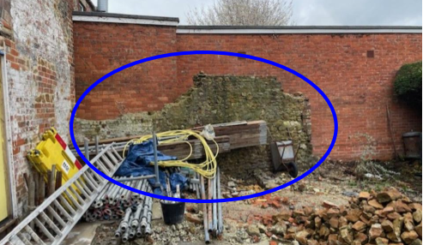

Summary & conclusion:
The NPPF confirms that when considering the impact of a proposed development on the significance of a designated heritage asset, great weight should be given to the asset’s conservation (and the more important the asset, the greater the weight should be). It makes clear that any harm to a designated heritage asset requires clear and convincing justification.
In this case, I consider that the rear lean-to addition was of limited/no interest. As such, I consider that its demolition has not harmed the special interest of the listed building and as such, the proposals are considered to be in accordance with Sections 16 and 66 of the Planning LBCA Act 1990. In respect of the Warminster Conservation Area, the proposals are considered to preserve the character of the area and as such, are in accordance with Section 72 of the Act”

Officers are of the opinion that the development has not resulted in harm to the significance of any heritage assets. However, whilst the works have been deemed acceptable, in the event of any approval, a number of relevant conditions would be added to ensure that appropriate details are submitted to the LPA to complete the works on site. These conditions relate to submission of joinery details, a schedule of repairs, and works to ensure the ongoing repair to the existing boundary wall. Subject to these conditions, no objections have been raised by the Conservation Officer.

The development is therefore considered to comply with Core Policy 57 and 58 of the Wiltshire Core Strategy and Sections 66 and 72 of the Planning (Listed Buildings and Conservation Areas) Act 1990, as well as the relevant provisions of the NPPF and the Wiltshire Design Guide.

Amenity
Point vii of Core Policy 57 - Ensuring High Quality Design and Place Shaping of the Wiltshire Core Strategy seeks to ensure that developments do not adversely affect neighbouring properties.

The National Planning Policy Framework (NPPF), particularly Paragraph 135(f), stresses that planning decisions should ensure developments provide a high standard of amenity for existing and future users.

The proposed development has been assessed in terms of its potential impact on the residential amenity of neighbouring properties, with particular regard to loss of light, overshadowing, loss of privacy, and overbearing effects.

The proposal relates to retrospective development in relation to the removal of a single storey extension that sat on the rear elevation of the host building, removing previous built form. The removal of the extension has opened up the rear elevation of the host building, however no windows are present on this end wall. Therefore, no overlooking to neighbouring occupiers would be introduced.

Given the nature of the scheme, officers raise no concerns in regard to any overbearing or overshadowing impacts or loss of light to neighbouring properties.

The proposal therefore accords with Core Policy 57 point vii in respect of safeguarding residential amenity and Appendix D of the Wiltshire Design Guide.

Ecology Impact
Core Policy 50 of the Wiltshire Core Strategy seeks to protect and enhance biodiversity and geodiversity, including through ensuring that development avoids harm to protected species and habitats.

The National Planning Policy Framework (NPPF), in Paragraphs 193, requires that development minimises impacts on and provides net gains for biodiversity, including ensuring mitigation is secured where harm cannot be avoided.

This proposal falls within the recreational impact zone of the Salisbury Plain Special Protection Area for birds. Therefore, potential disturbance to nesting birds through the creation of additional visitor numbers to the Salisbury Plain has to be assessed. However, given that this proposal relates to retrospective permission for the removal of a single storey rear extension without the creation of separate independent living accommodation, it is considered that there would not be any adverse impacts on the Special Protection Area.

The site is located within the Hampshire catchment area of the River Avon SAC where phosphates and nutrients are carefully controlled and monitored. However, given that this proposal relates to retrospective permission for the removal of a single storey rear extension, without the creation of separate independent living accommodation, it is considered that there would not be any adverse impacts on the phosphates/nutrient discharge.

As such, the development complies with Core Policy 50 of the Wiltshire Core Strategy and the relevant provisions of the NPPF.

Drainage and Flood Risk
Core Policy 67 of the Wiltshire Core Strategy and paragraph 181 of the NPPF requires that all new development avoids increasing flood risk on-site or elsewhere and, where appropriate, incorporates sustainable drainage measures. Development must also comply with national policy on flood risk management and drainage design. Paragraph 176 (via footnote 62) of the NPPF states that householder development should not be subject to the sequential test, nor the exception test.

Paragraph 170 of the National Planning Policy Framework (the Framework) states that inappropriate development in areas at risk of flooding should be avoided by directing development away from areas at highest risk (whether existing or future). Where development is necessary in such areas, the development should be made safe for its lifetime without increasing flood risk elsewhere.

Paragraph 181 of the Framework states that when determining any planning applications, local planning authorities should ensure that flood risk is not increased elsewhere. Where appropriate, applications should be supported by a site-specific flood risk assessment. The footnote to this paragraph states that a site-specific flood risk assessment should be provided for all development in Flood Zones 2 and 3.

Paragraph 051 of the Planning Practice Guidance (Reference ID: ID: 7-051-20220825) states that minor developments “are unlikely to raise significant flood risk issues unless; they would have an adverse effect on a watercourse, floodplain or its flood defences; they would impede access to flood defence and management facilities, or; where the cumulative impact of such developments would have a significant effect on local flood storage capacity or flood flows”.

The area where the works have been completed is located within flood zone 1 however it does lie within an area subject to surface water flooding. Therefore, officers need to appraise the development to ensure the development would not increase flooding from surface water.

The proposal relates to retrospective development that involved the removal of an extension to the rear of the property set within an enclosed courtyard area, bounded by existing brick elevations on all sides. Officers consider that the proposal involved limited development with the exposed gable wall of the host building sitting over an existing concrete hardstanding, and the vulnerability of use is not increasing, therefore no concerns are raised in relation to any risk to surface water flooding.

Officers are satisfied that the works undertaken have not exacerbated flood risk, and the development is not at risk from flooding as outlined in Paragraphs 170 and 181 of the NPPF 2024.The proposal therefore complies with Core Policy 67 of the Wiltshire Core Strategy and the policy in the NPPF, ensuring that flood risk is not increased and that surface water drainage is appropriately managed.

Biodiversity Net Gain
Householder planning applications are exempt from the requirement to deliver Biodiversity Net Gain under Schedule 7A, Section 4(2)(a) of the Town and Country Planning Act 1990, as inserted by the Environment Act 2021. Applications for retrospective development are also not subject to the requirement to deliver Biodiversity Net Gain at present

CONCLUSION
The proposal has been assessed to have a neutral impact on the significance of the designated heritage assets and would not harm the setting of listed buildings nor the special character of the Conservation Area.

The development is considered to be acceptable in terms of its design, scale, and relationship with the surrounding area. It would not result in any unacceptable harm to the character of the locality, the amenities of neighbouring occupiers, the interests of heritage, or ecology.

The proposal is therefore considered to comply with the relevant policies of the Wiltshire Core Strategy, the Wiltshire Local Plan, and the National Planning Policy Framework. As such, the application is recommended for approval, subject to the conditions set out below.

RECOMMENDATION: That Planning Permission be GRANTED subject to conditions.

Conditions
- The development hereby permitted shall be carried out in accordance with the following approved plans and documents:

Existing Site Plan DWG No 0142-SLA-01-00-DR-A-0001 P01 - Received 16.01.2026
Location Plan with outbuilding annotated - Received 23.01.2026

REASON: For the avoidance of doubt and in the interests of proper planning.

- The development hereby permitted requires details of all new external door joinery to be submitted to and approved in writing by the Local Planning Authority. The works shall be carried out in accordance with the approved details.

REASON: The matter is required to be agreed with the Local Planning Authority in order that the development is undertaken in an acceptable manner, in the interests of preserving the character and appearance of the listed building and its setting.

- The development hereby permitted requires a schedule of works for the remedial repair of the scarred end elevation to be submitted to and approved in writing by the Local Planning Authority. The works shall be carried out in accordance with the approved details.

REASON: The matter is required to be agreed with the Local Planning Authority in order that the development is undertaken in an acceptable manner, in the interests of preserving the character and appearance of the listed building and its setting.

- The development hereby permitted will include repairing the existing boundary wall, to be repaired and retained with materials to match existing.

REASON: In the interests of visual amenity and the character and appearance of the area.

