Plaque location photos
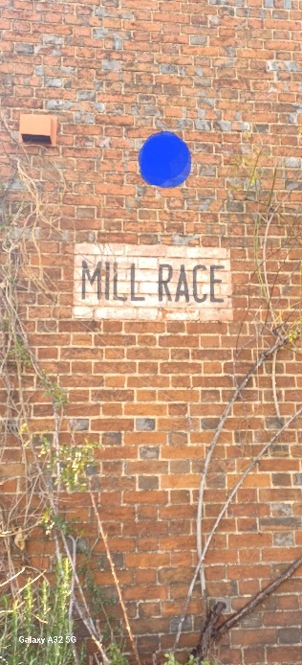
Suggested plaque location on Mill Road side of property (east side)

Plaque height from ground level: 2.79m
Plaque diameter: 33cm

Distance photo taken 27th January 2026 showing location of ‘Mill Race’ signage
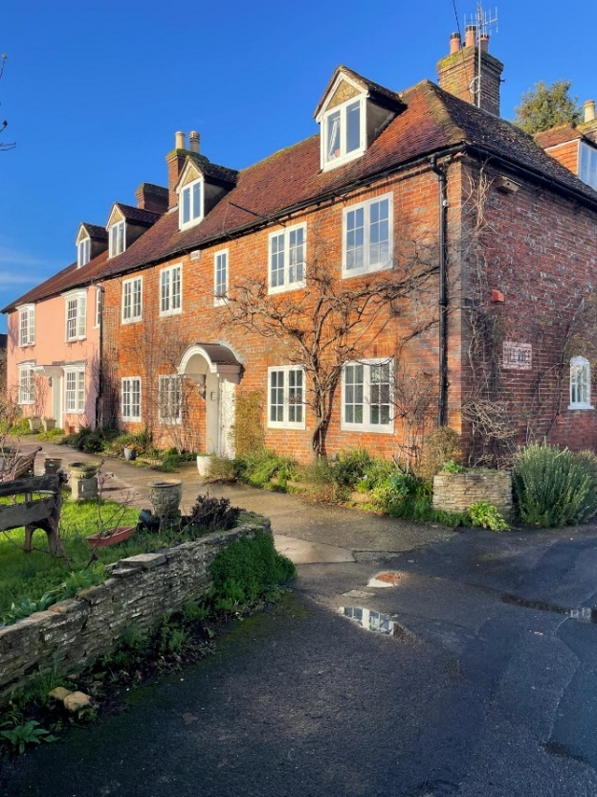

Plaque design and wording: Please see separate document from Leander Architectural titled 15240 – Pelly Plaque V1.0

