HOUSEHOLDER PLANNING APPLICATION.
CASE OFFICER REPORT

APPLICATION REFERENCE: | PL/2026/01257
APPLICATION TYPE: | Householder
SITE ADDRESS: | 2 Heddington Close, Trowbridge, BA14 0LH
DEVELOPMENT DESCRIPTION: | Proposed Replacement Single Storey Rear Extension & roof alterations
RECOMMENDATION: | Approve with Conditions.

PROPOSAL
The proposal seeks planning permission for the construction of a replacement single storey rear extension and also for slight alterations to the building’s side roof design.

SITE DESCRIPTION/CONTEXT
The site is an end of terrace single storey bungalow located within an established residential area of Trowbridge, the property is surrounded by similar styled dwellings and is not within a Conservation Area. The site is within the grey zone of the TWBMS

RELEVANT PLANNING HISTORY

No relevant history identified.

RELEVANT POLICIES AND GUIDANCE

Wiltshire Core Strategy:

- Core Policy 57 Ensuring High Quality Design and Place Shaping
- Core Policy 50: Biodiversity and Geodiversity
- Core Policy 51: Landscape
- Core Policy 58: Ensuring the Conservation of the Historic Environment
- Core Policy 61: Transport and New Development
- Core Policy 64: Demand Management
- Core Policy 67: Flood Risk

Trowbridge Emerging Neighbourhood Plan (Status: Designation of Trowbridge Neighbourhood Area).

Wiltshire Design Guide: Appendix D – Design Guidance for Householder extensions

The National Planning Policy Framework (NPPF)

The Planning Practice Guidance

National Design Guide

Emerging Wiltshire Local Plan:
The examination of the emerging Wiltshire Local Plan has been paused and the weight to be afforded to any part of the emerging plan can be no more than very limited. A decision on how to proceed will be made by the Council in May 2026.

CONSULTATION RESPONSES
Towbridge Town Council: No objections, subject to no significant adverse impact on amenity.

Drainage: No objections and comment that there was no requirement for consultation.

REPRESENTATIONS
No comments were received.

PRINCIPLE OF THE PROPOSAL
The principle of the proposed scheme is considered to be acceptable for the reasons discussed below.

ASSESSMENT
Section 38(6) of the Planning and Compulsory Purchase Act 2004 states:

"If regard is to be had to the development plan for the purposes of any determination to be made under the planning Acts, the determination must be made in accordance with the plan unless material considerations indicate otherwise."

In accordance with this statutory requirement, this application has been assessed against the relevant policies of the Development Plan, including the adopted Wiltshire Core Strategy (2015).

Design and Impact upon the upon the character and context of the area

Core Policy 57 - Ensuring High Quality Design and Place Shaping of the Wiltshire Core Strategy seeks to ensure that all new development is of high design quality, reflecting local context, character, and distinctiveness.

The proposals can be viewed within the plan snippets taken from the submitted plans below:

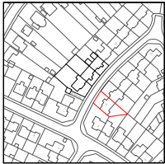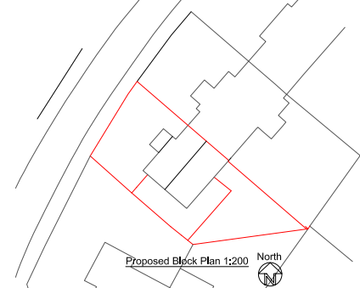
Location Plan Proposed Block Plan

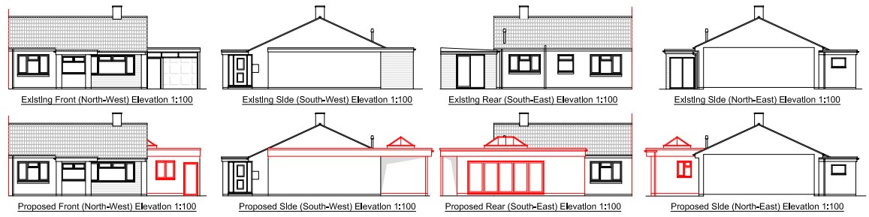
Existing & Proposed Elevations.

The proposal would see the existing side garage, which is utilised as a storage area, being retained for storage purposes and having a walk-through side corridor incorporated that would lead into the newly created utility room and extended area. The creation of the passageway would also include a new front door access together with the replacement of the existing garage door with a new window, as shown in the above snippets. The scheme would continue to use a flat roof design which would have side parapets and a centrally located lantern. Materials would match existing as detailed within the submitted plans.

The roof height of the proposal would be significantly lower than that of the main roof and so would be a subservient addition to the principal dwelling. Given the relationship to the existing projection to the side of the main part of the dwelling, the rear extension would not be seen from the public realm since the rear of the property is enclosed by existing built form within Kingsdown Road and Heddington Close.

Therefore, in summary, having regard to the above, the proposal complies with the design principles set out in Core Policy 57 of the Wiltshire Core Strategy and Appendix D of the Wiltshire Design Guide.

Amenity
Point vii of Core Policy 57 - Ensuring High Quality Design and Place Shaping of the Wiltshire Core Strategy seeks to ensure that developments do not adversely affect neighbouring properties. The National Planning Policy Framework (NPPF), particularly Paragraph 135(f), stresses that planning decisions should ensure developments provide a high standard of amenity for existing and future users.

The proposed extension would be single storey and would look out onto and face its private rear garden area. There is a small side window facing the boundary with 4 Heddington Close which serves a bathroom which is not considered to introduce potential for overlooking which would be not be mitigated by obscure glazing and boundary treatment. Similarly the relationship with No. 9 Kingsdown Road would not be materially altered by the proposal, this property is at an angle and mutual overlooking would be mitigation by existing boundary treatment. Therefore, it is considered that there would not be any adverse overlooking of neighbours.
Due to the siting, orientation and low level roof height of the proposal, there would not be any significant overshadowing or loss of light to the most immediate neighbours at No.4 or 7a Kingsdown.

The proposal therefore accords with Core Policy 57 point vii. in respect of safeguarding residential amenity and Appendix D of the Wiltshire Design Guide.

Highway Matters.
Core Policy 57 (xiv) of the Wiltshire Core Strategy seeks to ensure that development must meet the requirements of Core Policy 61. This policy requires proposals to be capable of being served by safe access to the highway network. Core Policy 64 seeks to ensure compliance with parking standards set out in the Local Transport Plan.

The National Planning Policy Framework (NPPF), particularly Paragraph 115 and 116, requires that development proposals do not have an unacceptable impact on highway safety and that safe and suitable access to the site can be achieved for all users.

The number of bedrooms within the property would remain at two and would not be increased by the proposals. The site would continue to use the established site access which would not be altered and would not have any adverse impact on highway safety. Whilst there would be a nominal loss of garage provision, adequate parking provision (2 spaces) is provided within the site and as such the existing parking and access arrangement remains acceptable.

The proposal is therefore considered to comply with Core Policies 57 (xiv), 61 and 64 of the Wiltshire Core Strategy, the NPPF, and the Wiltshire Local Transport Plan.

Ecology Impact CP50 requires no net loss of biodiversity on site. The site is located within the grey hatched zone of the Trowbridge Westbury Bat Mitigation Strategy Area. The proposed development because of its minor nature, flat roof of the existing garage and high-density urban location is considered unlikely to result in harm to bats or their habitat. There is no mechanism for significant effects from recreational pressure since it does not result in the creation of a new dwelling. Accordingly, the proposal is acceptable in this regard and significant effects on protected species can be ruled out. As such, the development complies with Core Policy 50 of the Wiltshire Core Strategy and the relevant provisions of the NPPF.

Biodiversity Net Gain. This application is exempt from the requirement to deliver Biodiversity Net Gain under Schedule 7A, Section 4(2)(a) of the Town and Country Planning Act 1990, as inserted by the Environment Act 2021, because the proposal is a householder extension.

CONCLUSION
The proposed development is acceptable in terms of its design, scale, and relationship with the surrounding area. It would not result in any unacceptable harm to the character of the locality, the amenities of neighbouring occupiers, or the interests of highway safety or ecology.

The proposal is therefore considered to comply with the relevant policies of the Wiltshire Core Strategy, the Wiltshire Local Plan, and the National Planning Policy Framework. As such, the application is recommended for approval, subject to the conditions set out below.

RECOMMENDATION: Planning Permission be GRANTED subject to conditions.

