APPLICATION FOR PRIOR NOTIFICATION - AGRICULTURAL
CASE OFFICER REPORT

APPLICATION REFERENCE: | PL/2026/01831
APPLICATION TYPE: | Prior notification: Excavation/waste material
SITE ADDRESS: | Land South of 6 Acre Lane, Hungerford
DEVELOPMENT DESCRIPTION: | Farm wetland creation project. Scrapes will be made to allow water to flow onto farmland.
RECOMMENDATION: | Prior Approval Refused

SITE DESCRIPTION/CONTEXT

The application site comprises an area of open rolling agricultural farmland, forming part of a wider tract of working countryside. The land is predominantly Grade 3 Agricultural Land and is generally open in character, with a gently undulating topography typical of this part of Wiltshire. The fields are enclosed by mature hedgerows, which provide landscape structure and visual containment. Along the watercourse corridor, the banks are lined with mature trees, creating a distinct vegetated feature within the agricultural landscape.

The site lies within the North Wessex Downs National Landscape, meaning it is “washed over” by this nationally protected designation. Consequently, the surroundings are characterised by a high-quality rural landscape with strong scenic qualities and limited built form.

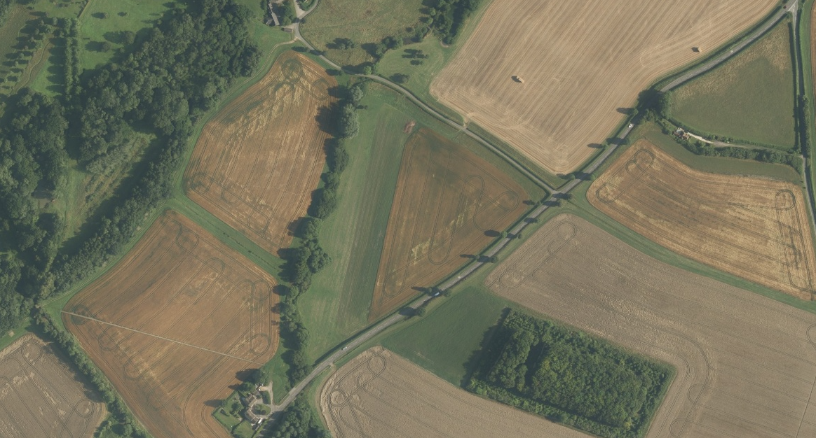
Aerial of the site

According to the Landscape Character Assessment (County level), the site falls within the Wooded Downland typology, specifically Area 2A – Savernake Plateau, assessed as being in good condition with strong landscape character, and subject to a conserve strategy. At District level, the site sits within the Savernake Plateau – Wooded Downland character area, sharing similar characteristics of wooded ridgelines, open arable fields, and intact hedgerow networks. At the broader national scale, the site lies within the Berkshire and Marlborough Downs Countryside Character Area, contributing to its expansive, rural, chalk downland qualities.

The Shalbourne Stream runs through the site, forming a notable natural feature and part of the area’s ecological network. Mature riparian trees define parts of the stream embankment. The watercourse also flows northwards to Freeman’s Marsh SSSI, an ecologically important wetland, indicating the site’s hydrological sensitivity and downstream ecological connectivity.

Surrounding land uses are predominantly agricultural, with no intrusive industrial or urban features in the immediate setting. A public right of way (SHAL 41) crosses or borders the site, providing recreational access and an important landscape and amenity receptor. The presence of the PRoW increases the site’s visual sensitivity, as users experience open views across the fields and towards the wooded horizons typical of the plateau landscape.

Overall, the site sits within a visually exposed and environmentally sensitive rural landscape, defined by high scenic value, strong landscape structure, mature vegetation, and ecological connectivity associated with its watercourse and proximity to designated habitats.

PROPOSAL

The application seeks prior approval for a “farm wetland creation project” comprising engineering operations including the diversion of the Shalbourne Stream, creation of scrapes and re‑profiled ground, hydrological changes intended to create a “floodplain meadow” to improve summer grass growth for grazing “native cattle”. The total area of physical works: 2.54ha (≈25,386 sqm).

The site lies partly within 25 m of the metalled part of a classified highway, falls within the North Wessex Downs National Landscape (AONB), and contains public right of way SHAL 41 across the works area. The Shalbourne Stream flows north towards Freeman’s Marsh SSSI, a sensitive wetland ecology.

RELEVANT PLANNING HISTORY

Proposal / Summary
Non applicable

RELEVANT LEGISLATION, POLICY AND GUIDANCE
This application is assessed under Article 3 of the Town and Country Planning (General Permitted Development) (England) Order 2015 (as amended), which grants planning permission for certain types of development described in Schedule 2 of the Order. The grant of permission is subject to the limitations, conditions, and provisions set out within the relevant Classes of permitted development.

Under Schedule 2, Part 6, Class A of the Town and Country Planning (General Permitted Development) (England) Order 2015 (as amended), certain types of agricultural development may be permitted, including:

- The erection, extension, or alteration of a building;
- The formation or alteration of a private way;
- Excavations or the deposit of waste material (where the relevant area exceeds 0.5 hectares);
- The placing or assembly of a tank in any waters.

Where such development is proposed, the developer is required to apply to the local planning authority for a determination as to whether prior approval is needed. This prior approval process is limited in scope and relates only to the following matters:

- The siting, design, and external appearance of the building;
- The siting and means of construction of the private way;
- The siting of the excavation or deposit;
- The siting and appearance of the tank.

ASSESSMENT

Does the Proposal Qualify as Permitted Development?

Having completed the detailed assessment checklist at Appendix 1 of this report, it is concluded that the proposed development does not qualify as permitted development, and therefore planning permission would be required for the proposed works.

Part 6 Class A permits:
“(b) any excavation or engineering operations, which are reasonably necessary for the purposes of agriculture within that unit.”

Development is not permitted where any of the Class A limitations in A.1 apply. The following are directly relevant:
- A.1(h): within 25 m of a trunk or classified road
  - Development is not permitted where “any part of the development would be within 25 metres of a metalled part of a trunk road or classified road.”

The proposal cannot benefit from Class A agricultural permitted development rights for the following reasons:

(1) Breach of A.1(h): Part of the development within 25 m of a classified road
The application details confirm that part of the site lies within 25 m of the metalled surface of a classified road.

Under A.1(h), any incursion into this zone removes PD rights.

Conclusion on PD Status

Because the proposal fails A.1(h) which prohibits PD, the development is not permitted development under Part 6 Class A.
Consequently, the Local Planning Authority cannot grant prior approval.

Is Prior Approval Required?

A.2(2)(c): prior approval required - Where the relevant area for excavations exceeds 0.5ha, prior approval is required.

A public right of way runs along the line of the Shalbourne Stream, and the application site extends to the northwest, encompassing approximately 290 m of this route. The siting of the proposed engineering operations therefore has the potential to directly affect the use, character, and experience of the PRoW, which is a sensitive public vantage point across the open landscape. The site also lies within Flood Zones 2 and 3 and is susceptible to both surface water and groundwater flooding, indicating that any ground disturbance, re‑profiling or redirection of water could have implications for local hydrology and the stability or usability of the surrounding land.

The site is wholly within the North Wessex Downs National Landscape, a nationally protected and highly sensitive landscape where alterations to landform, watercourses, or vegetation can have disproportionate visual and character impacts. The Shalbourne Stream and its associated riparian corridor are valued features within this landscape, containing mature trees along the embankment and forming part of a priority habitat network. The stream also flows into Freeman’s Marsh SSSI, a designated wetland ecology of recognised sensitivity, indicating that changes to water flow, sedimentation, or soil levels at the site could have downstream ecological consequences.

From the information submitted, it is not clear:
- the full extent of the proposed engineering works,
- how spoil would be managed or where it would be deposited,
- whether excavations would affect the root protection areas of the mature riparian trees,
- how the diversion or redirection of water might impact ecological or biodiversity systems along or beyond the site, including within the SSSI’s hydrological catchment, and
- whether the siting and scale of the intervention would integrate acceptably with the existing landform, landscape features, or sensitive receptors.

Given the absence of sufficient detail to understand the siting, scale, and potential effects of the proposed excavations and watercourse modifications on landscape character, ecological features, hydrology, and the PRoW, the Local Planning Authority cannot be satisfied that the works are appropriately located or that their impacts would be acceptable. Accordingly, prior approval would also be required in respect of the siting of the excavation and/or deposit, as the submitted information does not allow the LPA to determine the implications of the proposal against the criteria set out in Part 6 of the GPDO.

Such environmental impacts reinforce the conclusion that the works require full planning scrutiny. Large-scale wetland creation and watercourse diversion could increase off-site flood risk. Any formal application would require a Flood Risk Assessment, groundwater assessment and LLFA consultation.

CONCLUSION

In conclusion Prior Approval should be REFUSED because the development is not permitted development under Part 6 Class A of the GPDO, failing:
- A.1(h) – development within 25 m of a classified road.

Accordingly, the proposed development cannot proceed under agricultural permitted development rights.

The proposed development has been assessed against the provisions, limitations, and conditions set out in Schedule 2, Part 6, Class A of the Town and Country Planning (General Permitted Development) (England) Order 2015 (as amended). Based on the submitted plans, supporting documentation, and the findings of this report the proposal does not comply with the criteria for permitted development under Class A, and therefore planning permission is required for the proposed works and the application is refused.

RECOMMENDATION: That prior approval be REFUSED.

Reason for Refusal
The Local Planning Authority considers that the proposed development does not constitute permitted development under Schedule 2, Part 6, Class A of the GPDO, for the following reasons:
- Proximity to Classified Road (A.1(h))
Part of the development would take place within 25 m of the metalled carriageway of a classified road. Development in this location is expressly not permitted under limitation A.1(h).

As the development is not permitted development, the Local Planning Authority cannot grant prior approval.

Informative
The applicant is advised that any works to divert, alter, or interfere with the Shalbourne Stream may require separate consents, including but not limited to:
- Environment Agency Flood Risk Activity Permit for works affecting a main river or its flow regime.
- Lead Local Flood Authority Land Drainage Consent for works affecting ordinary watercourses.
- Engagement with Natural England may be required due to the hydrological connection to Freeman’s Marsh SSSI.

No works would be able to proceed until all necessary permissions and consents have been obtained from the relevant regulatory bodies.

A
APPENDIX 1 – PERMITTED DEVELOPMENT CHECKLIST
 | Permitted Development | Yes / No
A | Does the proposal involve the carrying out, on agricultural land forming part of an agricultural unit of 5 hectares or more, of either:  (a) works for the erection, extension, or alteration of a building; or  (b) any excavation or engineering operations,  which are reasonably necessary for the purposes of agriculture within that unit? | The application submission explains that the proposal is for farm wetland creation project involving diversion of the Shalbourne Stream and formation of scrapes to allow water to spill onto farmland.  The unit is in agricultural use, and the works are described as intended to improve the productivity and resilience of the grazing land. Improving grass growth to support grazing livestock forms part of ordinary agricultural land management.  The proposed development is therefore for the purposes of agriculture.
Criteria (A.1) – Development not permitted by Class A:
(a) | Is the development proposed to be carried out on a separate parcel of land forming part of the agricultural unit that is less than 1 hectare in area? | No
(b) | Would the development consist of the erection or extension of any agricultural building on an established agricultural unit where development under Class Q or Class S of Part 3 (changes of use) has been carried out within the last 10 years? | No
(c) | Would the development consist of, or include, the erection, extension, or alteration of a dwelling? | No
(d) | Would it involve the provision of a building, structure or works not designed for agricultural purposes? | No
(e)(i) | Would the ground area covered by any works or structures (excluding fences) for accommodating livestock or plant/machinery arising from engineering operations exceed 1,000 square metres? | Yes – site area is 2.54ha, however, the works are not for the accommodation of livestock or plant or machinery
(e)(ii) | Would the ground area of any building erected, extended, or altered under Class A exceed 1,500 square metres? | N/a
(f) | Is any part of the proposed building, structure, or works within 3 kilometres of the perimeter of an aerodrome and would exceed 3 metres in height? | No
(g) | Is any part of the proposed building, structure, or works not within 3 kilometres of an aerodrome and would exceed 12 metres in height? | No
(h) | Would any part of the development be within 25 metres of a metalled part of a trunk road or classified road? | Yes – parts of the site lie within 25m of a classified road
(i) | Would the development consist of, or include, the erection or construction of, or works to, a building, structure, or excavation used or intended for the accommodation of livestock or storage of slurry/sewage sludge, and be within 400 metres of the curtilage of a protected building? | No
(j) | Would the development involve excavations or engineering operations on or over article 2(4) land that are connected with fish farming? | No
(k)(i) | Would any building for storing fuel for or waste from a biomass boiler or anaerobic digestion system be used for storing waste not produced by that system or fuel not produced on land within the unit and be within 400 metres of the curtilage of a protected building? | No
(k)(ii) | Would any building for storing fuel for or waste from a biomass boiler or anaerobic digestion system and be within 400 metres of the curtilage of a protected building? | No
(l) | Would the erection or extension of a building be carried out on land or a building that is, or is within the curtilage of, a scheduled monument? | No

