APPLICATION FOR HOUSEHOLDER PLANNING PERMISSION
DELEGATED REPORT

APPLICATION REFERENCE: | PL/2026/00977
APPLICATION TYPE: | Householder Planning Permission
SITE ADDRESS: | 6 Carriers Close, Sherston, Malmesbury, SN16 0PG
DEVELOPMENT DESCRIPTION: | Single storey side extension.
RECOMMENDATION: | That Planning Permission be GRANTED

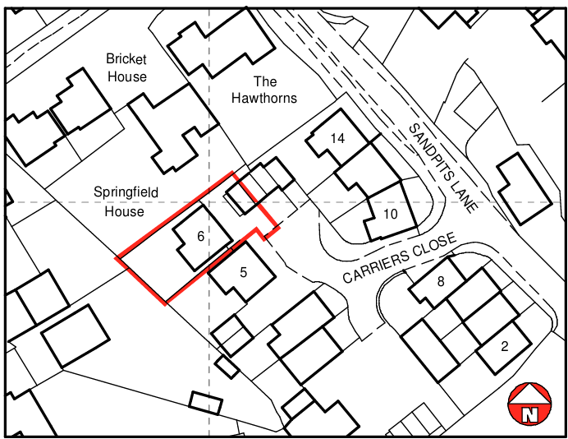

PROPOSAL

The proposal involves removing the existing small shed on the southern elevation and constructing a single‑storey side extension along the boundary. The extension would provide a utility room accessed from the dining area and a separate garden store accessed externally. It would have rendered walls, an aluminium‑edged flat roof. No trees or boundary treatments are shown as being affected.

SITE DESCRIPTION / CONTEXT

The site consists of a modern detached dwelling within a uniform residential estate on the village edge, featuring stone at ground level, render above, slate roofing, and uPVC openings consistent with surrounding properties. The site sits within the Sherston Settlement Boundary and the Cotswolds National Landscape, on level ground and within Flood Zone 1, with only low groundwater-flood risk identified by the sFRA.

PLANNING HISTORY

Reference No. | Proposal / Summary | Decision
N/04/00560/OUT | RESIDENTIAL DEVELOPMENT 14 DWELLINGS | Approved
N/05/01578/REM | Residential Development - Fourteen Dwellings | Approved
N/06/00959/REM | Landscaping Reserved Matters (04.00560.OUT) | Approved

RELEVANT LEGILSATION, POLICIES AND GUIDANCE

Wiltshire Core Strategy:

Core Policy 1 Settlement Strategy;
Core Policy 2 Delivery Strategy;
Core Policy 13 Spatial Strategy: Malmesbury Community Area;
Core Policy 50 Biodiversity and Geodiversity;
Core Policy 51 Landscape;
Core Policy 57 Ensuring High-Quality Design and Place Shaping;
Core Policy 60 Sustainable Transport;
Core Policy 61 Transport and Development;
Core Policy 64 Demand Management;
Core Policy 67 Flood Risk;

Sherston Neighbourhood Plan 2006 to 2026 (May 2019)

The National Planning Policy Framework (NPPF)

The Planning Practice Guidance (PPG)

Wiltshire Design Guide - Appendix D – Design Guidance for Householder extensions

The Wiltshire Local Transport Plan 2011 – 2026: Car Parking Strategy (March 2015).

The Wiltshire Local Transport Plan 4 (LTP4) (March 2025)

Emerging Policy – Wiltshire Local Plan Review

The examination of the emerging Wiltshire Local Plan has been paused and the weight to be afforded to any part of the emerging plan can be no more than very limited. A decision on how to proceed will be made by the Council in May 2026.

- Policy 88 Biodiversity and Geodiversity
- Policy 89 Biodiversity Net Gain
- Policy 95 Flood Risk
- Policy 98 High Quality Design and Place Shaping

CONSULTATION RESPONSES

Sherston Parish Council – No Objection

REPRESENTATIONS

No comments received.

ASSESSMENT

Section 38(6) of the Planning and Compulsory Purchase Act 2004 states:

"If regard is to be had to the development plan for the purposes of any determination to be made under the planning Acts, the determination must be made in accordance with the plan unless material considerations indicate otherwise."

In accordance with this statutory requirement, this application has been assessed against the relevant policies of the Development Plan, including the adopted Wiltshire Core Strategy (2015) and, where applicable, any made Neighbourhood Plans.

Householder extensions are generally acceptable in principle, as they typically fall within the established residential curtilage of a property and do not result in new residential development in the open countryside. In this case, the proposal also lies within the defined limits of development set out in the Core Strategy, further reinforcing its acceptability in principle.

Design and Impact upon the upon the character and context of the area

Core Policy 57 Ensuring High Quality Design and Place Shaping of the Wiltshire Core Strategy seeks to ensure that all new development is of high design quality, reflecting local context, character, and distinctiveness.

Policy 98 of the emerging Wiltshire Local Plan reiterates the position outlined in Core Policy 57, that new development must enhance local distinctiveness, and relate positively to its landscape setting, as well as demonstrating a positive response to existing townscape and built form features such as height, scale, massing, building line, materials, and appearance.

Core Policy 51 seeks to ensure that development safeguards the character, features, and special qualities of Wiltshire’s landscapes, including designated National Landscapes, by requiring proposals to conserve, protect, and where possible enhance the established landscape character. The policy emphasises the need for proposals to consider locally distinctive elements—such as hedgerows, watercourses, trees, topography, and settlement pattern—as part of a thorough assessment of the site and its wider setting, ensuring that development responds positively to the attributes that define the local landscape.

In design terms, the proposed extension is modest and proportionate to the host dwelling, utilising rendered external walls that match the established material palette already present on the property. Given its limited footprint and single‑storey height, the structure would read as a clearly subordinate addition that respects the existing form and character of the dwelling. Its position at ground‑floor level, replacing an existing shed, further ensures that the development sits comfortably within the site without altering the balance or appearance of the principal elevations. Owing to its enclosed location between the application property and the adjacent dwelling, the extension would have minimal visibility from the public realm and would not contribute to or detract from the wider streetscene. This degree of containment also ensures that the proposal has no intervisibility with, or influence upon, the Cotswolds National Landscape. Overall, the scheme is considered to be an appropriate and sympathetic form of development that accords with relevant design policies.
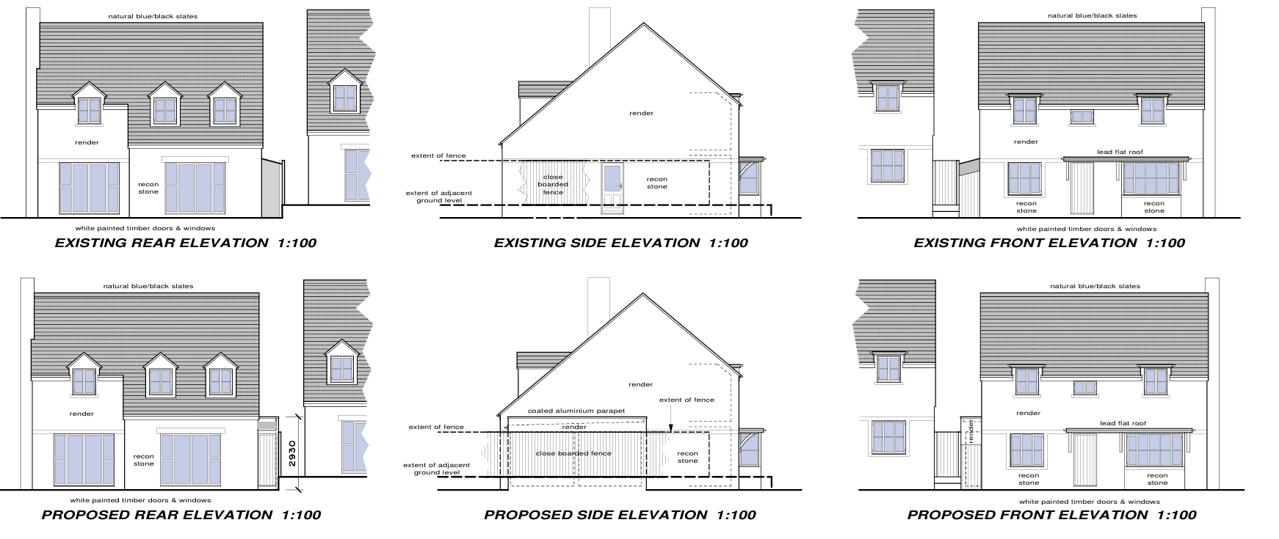
Existing and Proposed Elevations

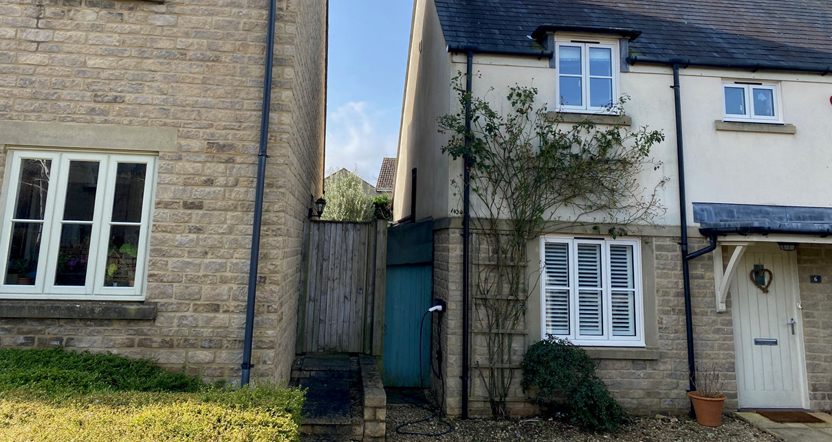
Site Visit Image

Having regard to the above, the proposal complies with the design principles set out in Core Policy 51 and 57 of the Wiltshire Core Strategy and Appendix D of the Wiltshire Design Guide.

Amenity

Point vii of Core Policy 57 Ensuring High Quality Design and Place Shaping of the Wiltshire Core Strategy seeks to ensure that developments do not adversely affect neighbouring properties.

The National Planning Policy Framework (NPPF), particularly Paragraph 135, stresses that planning decisions should ensure developments provide a high standard of amenity for existing and future users.

The proposed single‑storey flat‑roof side extension is modest in scale and positioned such that it would not overbear or overshadow any neighbouring private amenity space, particularly as it lies to the north of the adjoining property and only marginally exceeds the height of existing boundary treatments by approximately 0.6 m. Its siting does not obstruct outlook from any neighbouring windows, and with only a ground‑level door facing the rear garden and no new windows proposed, the development would not give rise to overlooking or privacy concerns. Overall, the proposal is considered acceptable in terms of residential amenity.

The proposal therefore accords with Core Policy 57 point vii in respect of safeguarding residential amenity and Appendix D of the Wiltshire Design Guide.

Other Issues

Core Policies 60 and 61 of the Wiltshire Core Strategy and paragraph 116 of the NPPF require development to ensure safe and efficient movement, consider the transport user hierarchy, and avoid unacceptable impacts on highway safety. As the proposal does not introduce any additional bedrooms or alter existing access or parking arrangements, it would not increase traffic generation or affect highway safety. The scheme therefore raises no transport or highway concerns and is considered acceptable in this regard.

Core Policy 50 of the WCS and emerging Policy 88 require development to avoid harm to sensitive habitats and demonstrate application of the mitigation hierarchy, while mandatory Biodiversity Net Gain does not apply to householder development under Schedule 7A of the Town and Country Planning Act 1990. The proposal replaces an existing small shed within an already domestic and built up part of the curtilage, where ecological value is low and potential for habitat disturbance is minimal. The development is therefore considered acceptable with respect to its impact on ecology.

Core Policy 67, emerging Policy 95, and NPPF guidance require a risk-based approach to flood risk and appropriate surface-water management, although householder development under 250m² is exempt from the sequential and exception tests. The site lies in Flood Zone 1 with only low groundwater-flood risk identified, and the extension would result in only a minor increase in impermeable area, with drainage expected to utilise the existing site systems. Given the small scale of works and absence of any identified concerns, the proposal is considered acceptable in terms of flooding and drainage.

CONCLUSION

The proposal is considered to be acceptable and in accordance with the relevant policies and guidance outlined above.

RECOMMENDATION: That Planning Permission be GRANTED subject to the following conditions:

1.
The development hereby permitted shall be begun before the expiration of three years from the date of this permission.
REASON: To comply with the provisions of Section 91 of the Town and Country Planning Act 1990 as amended by the Planning and Compulsory Purchase Act 2004.

2.
The development hereby permitted shall be carried out in accordance with the following approved plans and documents:

Location Plan 2814-1 (12 February 2026)
Proposed Plans and Elevations 2814-2 (12 February 2026)

REASON: For the avoidance of doubt and in the interests of proper planning.

