APPLICATION FOR HOUSEHOLDER PLANNING PERMISSION
DELEGATED REPORT

APPLICATION REFERENCE: | PL/2026/02049
APPLICATION TYPE: | Householder Planning Permission
SITE ADDRESS: | 6 Edinburgh Road, Trenchard Avenue, Calne, SN11 8QT
DEVELOPMENT DESCRIPTION: | Single Storey Pitched Roof, Front, Side and Rear Extension incorporating Garage, Store and additional Utility space.
RECOMMENDATION: | That Planning Permission be GRANTED

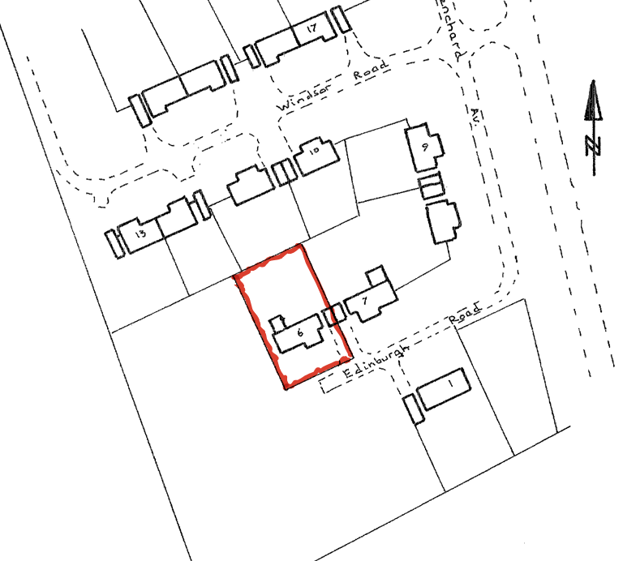

PROPOSAL

The proposal seeks planning permission for a single-storey pitched-roof extension wrapping around the front, side and rear of the existing two-storey detached dwelling. The works include the incorporation of the existing detached garage—currently conjoined to the neighbouring garage at No. 7—into the main dwelling through an infill extension, resulting in the detachment of the two garages. The enlarged garage structure would then be extended rearwards into the garden to provide additional utility and storage space. The proposed extension would be single storey in scale and is stated to utilise matching red brickwork and concrete roof tiles to reflect the character and material palette of the host property.

SITE DESCRIPTION / CONTEXT

The application site comprises a detached two-storey dwelling located within the Lower Compton residential estate, approximately 500 metres east of the Calne Settlement Boundary, within an area defined as open countryside. The surrounding dwellings are similarly detached, two-storey brick-built properties with concrete tiled roofs and white uPVC fenestration, forming a consistent residential character. The site benefits from a large rear garden and currently contains a detached garage linked to the neighbouring garage. The wider area is characterised by the edge-of-settlement setting, with open countryside, farmland, hedgerows, and tree belts providing expansive rural views. The Council’s sFRA identifies no risk of ground or surface water flooding on the site.

PLANNING HISTORY

No relevant planning history has been identified for the site subject of this application.

A separate application for the adjacent site, 7 Edinburgh Road, has been submitted which would deal with the treatment of the existing double garage which serves each property and is to be demolished:

PL/2026/01102 - Single Storey Pitched Roof Side, Front and Rear Extension incorporating Garage, Store and Porch – pending determination.

RELEVANT LEGILSATION, POLICIES AND GUIDANCE

Wiltshire Core Strategy:

Core Policy 1 Settlement Strategy;
Core Policy 2 Delivery Strategy;
Core Policy 8 Spatial Strategy: Calne Community Area;
Core Policy 50 Biodiversity and Geodiversity;
Core Policy 51 Landscape;
Core Policy 57 Ensuring High-Quality Design and Place Shaping;
Core Policy 60 Sustainable Transport;
Core Policy 61 Transport and Development;
Core Policy 64 Demand Management;
Core Policy 67 Flood Risk;

The National Planning Policy Framework (NPPF)

The Planning Practice Guidance (PPG)

Wiltshire Design Guide - Appendix D – Design Guidance for Householder extensions

The Wiltshire Local Transport Plan 2011 – 2026: Car Parking Strategy (March 2015).

The Wiltshire Local Transport Plan 4 (LTP4) (March 2025)

Emerging Policy – Wiltshire Local Plan Review

The examination of the emerging Wiltshire Local Plan has been paused and the weight to be afforded to any part of the emerging plan can be no more than very limited. A decision on how to proceed will be made by the Council in May 2026.

CONSULTATION RESPONSES

Cherhill Parish Council – No Objection
The Parish Council raises no objection to the proposal, noting that while the extensions at Nos. 6 and 7 Edinburgh Road may slightly reduce the gap between the dwellings, they broadly comply with the Calne Community Neighbourhood Plan Design Guide and are considered an improvement over the existing poor-quality garage structures. On balance, the Council considers that the proposals respect the Lower Compton character area and will enhance the overall street scene, with only minor concerns regarding potential terracing and the absence of EV charging provision.

REPRESENTATIONS

No comments received.

ASSESSMENT

Section 38(6) of the Planning and Compulsory Purchase Act 2004 states:

"If regard is to be had to the development plan for the purposes of any determination to be made under the planning Acts, the determination must be made in accordance with the plan unless material considerations indicate otherwise."

In accordance with this statutory requirement, this application has been assessed against the relevant policies of the Development Plan, including the adopted Wiltshire Core Strategy (2015) and, where applicable, any made Neighbourhood Plans.

Householder extensions are generally acceptable in principle, as they typically fall within the established residential curtilage of a property and do not result in new residential development in the open countryside. In this case, the proposal also lies within the defined limits of development set out in the Core Strategy, further reinforcing its acceptability in principle.

Design and Impact upon the upon the character and context of the area

Core Policy 57 Ensuring High Quality Design and Place Shaping of the Wiltshire Core Strategy requires all new development to achieve a high standard of design that responds positively to its local context. Proposals must reinforce and enhance local character and distinctiveness, relate appropriately to the surrounding landscape, and demonstrate a thoughtful response to existing townscape features. This includes careful consideration of elements such as building height, scale, massing, building line, materials, and overall appearance, ensuring new development integrates harmoniously with its setting.

The proposed extension is modest in scale and presents as a simple, single-storey addition that sits comfortably below the massing of the host dwelling, maintaining a clearly subordinate relationship to the main two-storey form. Its length and width replicates both the existing rear projection at the western end of the property and the garage structure it replaces, resulting in a balanced and coherent appearance when viewed in context. The arrangement effectively mirrors the footprint and rhythm of the existing built form, ensuring a logical and sympathetic evolution of the dwelling’s layout, even though the existing rear extension is two storeys and therefore not mirrored in elevation. Materials are proposed to match the host property, preserving the existing aesthetic and integrating the works seamlessly with the established character of the dwelling. Overall, the proposal represents a straightforward and uncontentious householder extension that maintains the visual integrity of the property and respects its immediate surroundings.

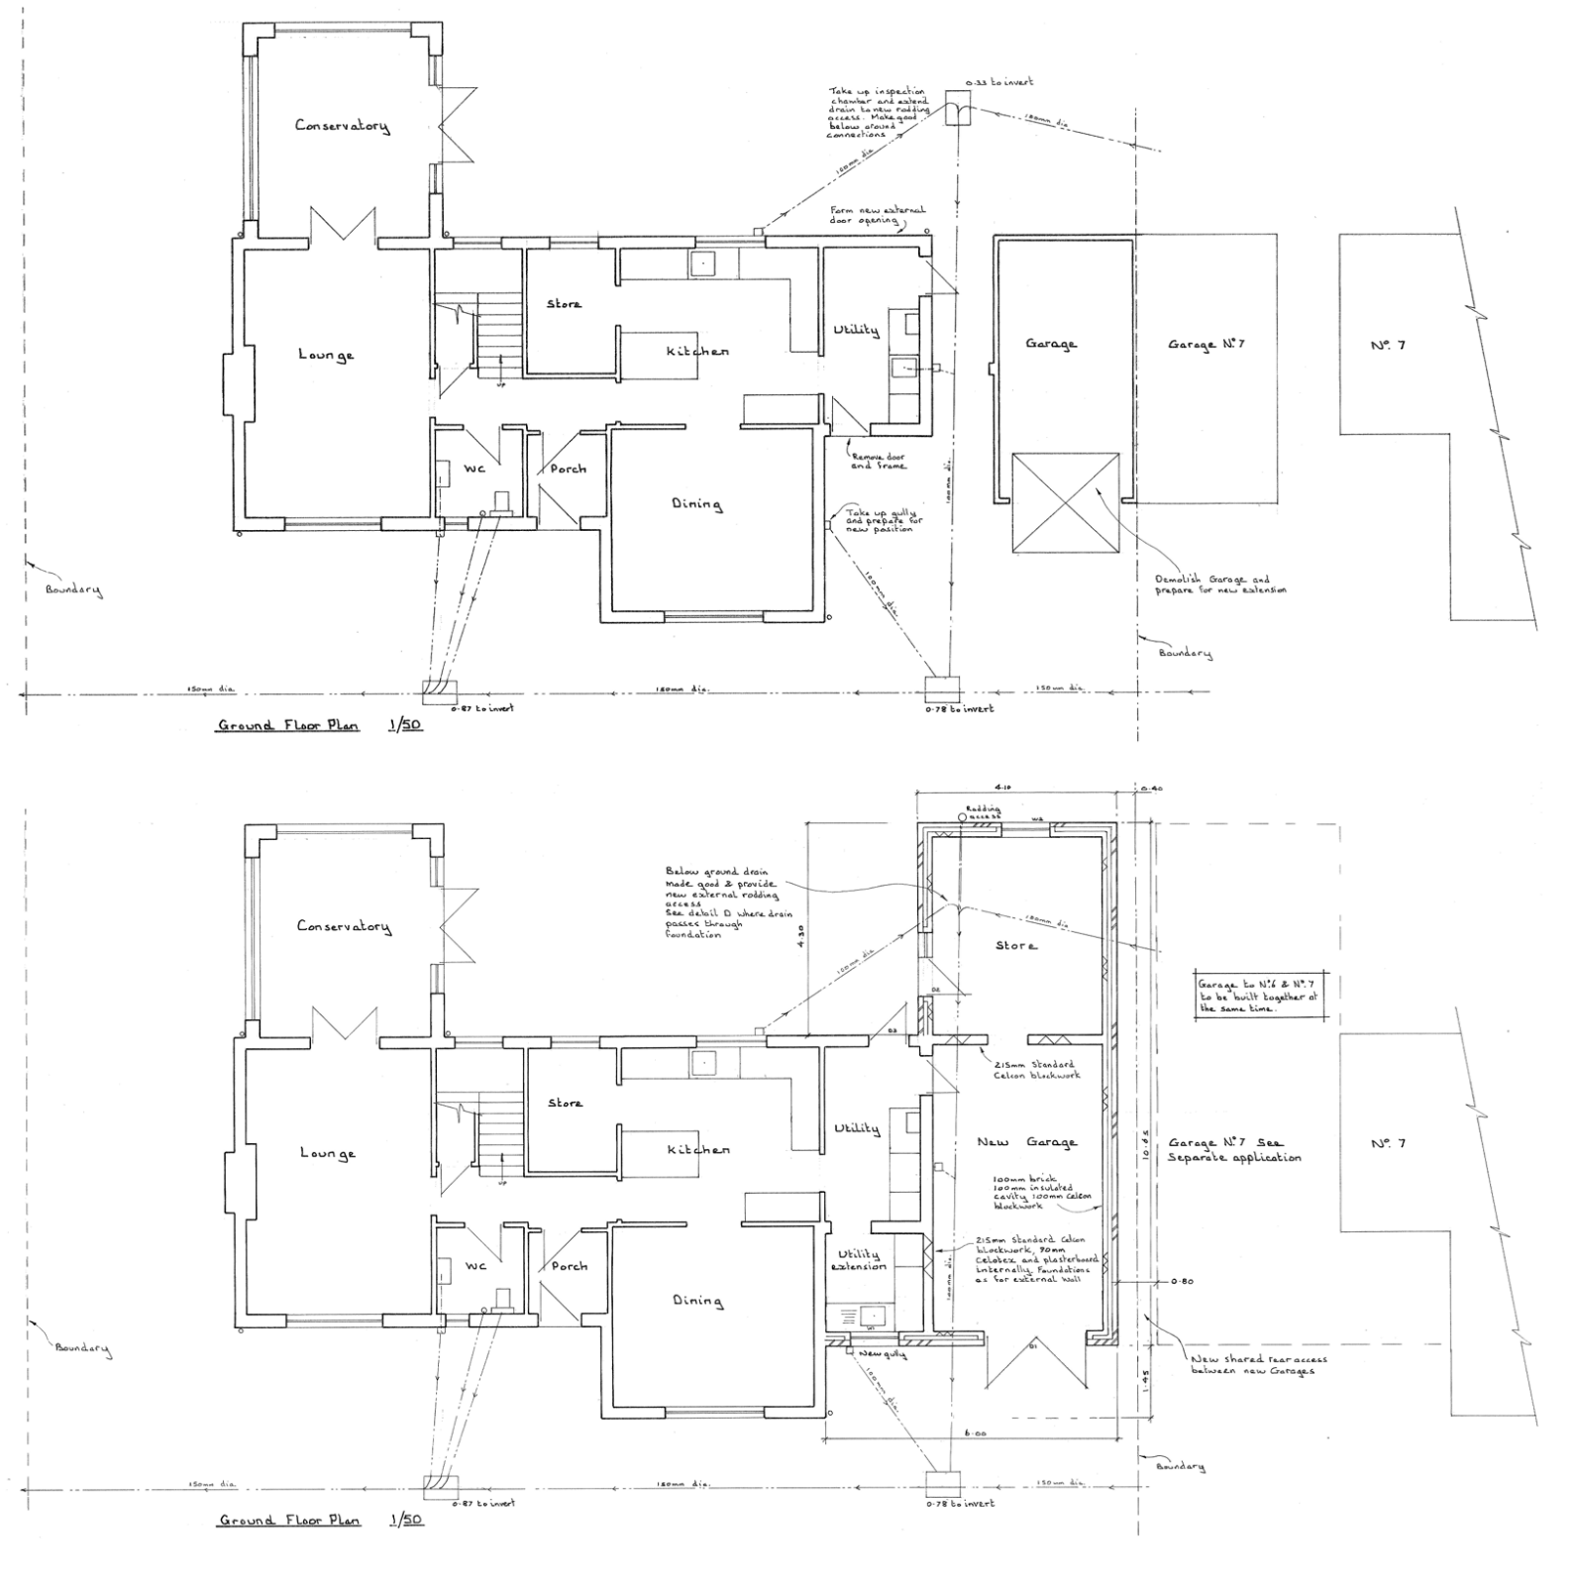
Existing Ground Floor Plan

Existing and Proposed Ground Floor Plan

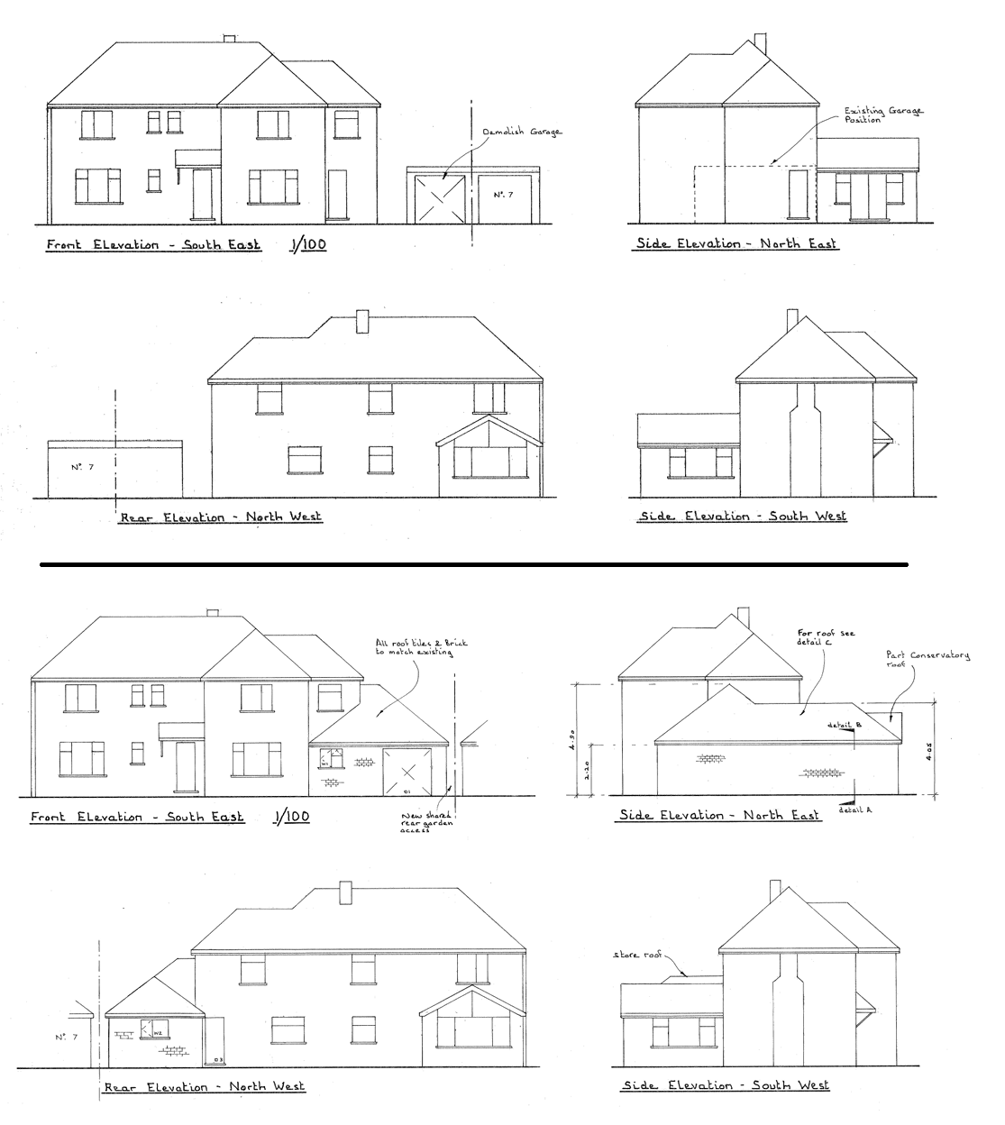
Existing and Proposed Elevations

Having regard to the above, the proposal complies with the design principles set out in Core Policy 57 of the Wiltshire Core Strategy and Appendix D of the Wiltshire Design Guide.

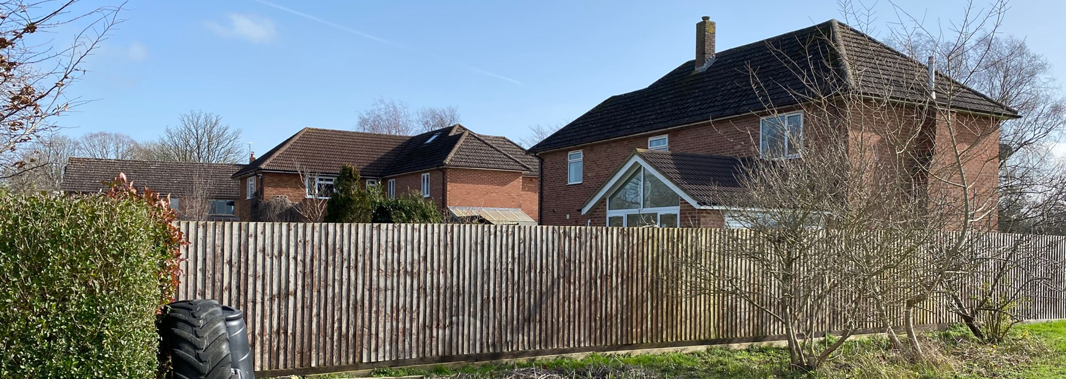
Site Visit Rear Elevation
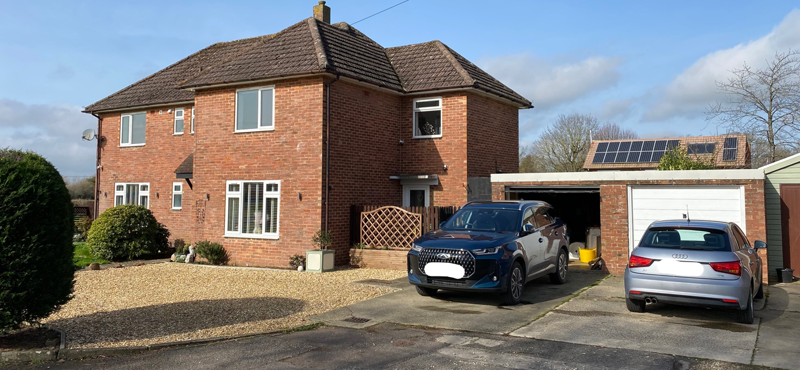
Site Visit Front Elevation
Amenity

Point vii of Core Policy 57 Ensuring High Quality Design and Place Shaping of the Wiltshire Core Strategy seeks to ensure that developments do not adversely affect neighbouring properties.

The National Planning Policy Framework (NPPF), particularly Paragraph 135, stresses that planning decisions should ensure developments provide a high standard of amenity for existing and future users.

The proposal is single storey in nature, and as such any windows would be at ground-floor level, facing either into the applicant’s own private garden or toward existing boundary treatments, avoiding any opportunity for harmful overlooking. Along the elevation closest to the shared boundary, the wall height would be approximately 2.2 metres, with the pitched roof rising away from the boundary to around 4 metres; this ensures the structure sits only marginally above the existing boundary line and would not result in an overbearing impact. The host dwelling lies slightly southwest of the neighbouring property, and there is a substantial separation to the dwellings to the north, meaning that the southern passage of the sun would not cause any significant overshadowing beyond that already created by the existing two-storey house. Overall, the scale, positioning and orientation of the extension ensure no material harm to neighbouring residential amenity.

The proposal is appropriately sited, designed, and oriented to ensure that it would not result in unacceptable impact upon/to the amenities or living conditions of neighbouring residential occupiers, particularly in terms of outlook, privacy, or access to natural light.

The proposal therefore accords with Core Policy 57 point vii in respect of safeguarding residential amenity and Appendix D of the Wiltshire Design Guide.

Other Issues

The proposal for the demolition of one half of the double garage which is shared with No. 7 Edinburgh Road is addressed in a separate householder application by the owner/occupiers of the neighbouring property which would also see the demolition of the remainder of the garage in order to undertake a similar development to this application. As such there are no concerns in this respect. Separate legislation under The Party Wall Act will be applicable for the individual householders in agreeing the works which cross the shared boundary.

The application does not propose the introduction of any additional bedrooms to the property, nor does it include any alteration to the existing parking and access arrangements given that the garage is to be retained as part of the proposal. It is therefore considered that there is no highway or transportation concerns present with the proposal, and it is otherwise considered acceptable.

The proposal falls within the scope of Core Policy 50, which seeks to ensure development avoids and reduces harm to sensitive habitats and species; however, the application is a simple householder extension within an established residential plot, where existing built form and maintained garden areas significantly limit the likelihood of ecological impact. Householder applications are exempt from mandatory Biodiversity Net Gain requirements under Schedule 7A, Section 4(2)(a) of the Town and Country Planning Act 1990 (as amended), and no ecological designations or constraints have been identified in relation to the site. As such, the development is not considered to give rise to any adverse ecological effects.

The site lies within Flood Zone 1, where the risk of fluvial flooding is lowest, and the Council’s SFRA confirms there is no identified risk of surface water or groundwater flooding. In accordance with Core Policy 67, the development is required to ensure that surface water can be managed safely without increasing flood risk elsewhere; given the small scale of the proposal and its location within an established residential plot, there is no evidence to suggest this cannot be achieved through normal building-scale drainage measures. Paragraph 176 of the NPPF confirms that householder development under 250 m² is exempt from the sequential and exception tests, and as such the proposal is considered acceptable in flood-risk terms.

CONCLUSION

The proposal is considered to be acceptable and in accordance with the relevant policies and guidance outlined above.

RECOMMENDATION: That Planning Permission be GRANTED subject to the following conditions:

1.
The development hereby permitted shall be begun before the expiration of three years from the date of this permission.
REASON: To comply with the provisions of Section 91 of the Town and Country Planning Act 1990 as amended by the Planning and Compulsory Purchase Act 2004.

2.
The development hereby permitted shall be carried out in accordance with the following approved plans and documents:

Proposed Floor Plan, Elevations and Site Plan 02 (16 February 2026)
Location Plan (16 February 2026)

REASON: For the avoidance of doubt and in the interests of proper planning.

