APPLICATION FOR CONSENT TO DISPLAY AN ADVERTISEMENT
DELEGATED REPORT

APPLICATION REFERENCE: | PL/2025/08730
APPLICATION TYPE: | Consent to display an advertisement
SITE ADDRESS: | Cradle Bridge Retail Park, County Way, Trowbridge, Wiltshire, BA14 8FS
DEVELOPMENT DESCRIPTION: | Free standing totem signage at the entrance to InstaVolt's EV charging site.
RECOMMENDATION: | That Advert Consent be GRANTED

SITE DESCRIPTION/CONTEXT
The site is within the Cradle Bridge Retail Park. Within the parking area are 4 rapid electric vehicle charging stations. The proposal site is an area between a retail unit and the Highway.

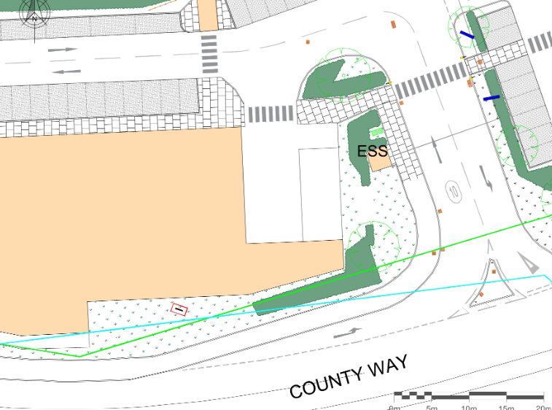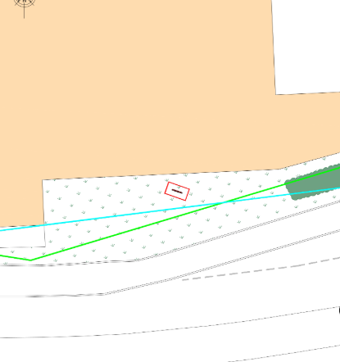
Location Plan and Proposed Block Plan

PROPOSAL

The proposal seeks advert consent for a free-standing totem sign at the entrance to the InstaVolts EV charging site.

The sign would measure 2m high x 1m wide and 0.1m deep of an aluminium composite materials on 3mm aluminium for 0.19m legs. Lettering in red and grey on a white background, the largest lettering being 8cm, direction of arrow obviously to be site specific, as drawings below:

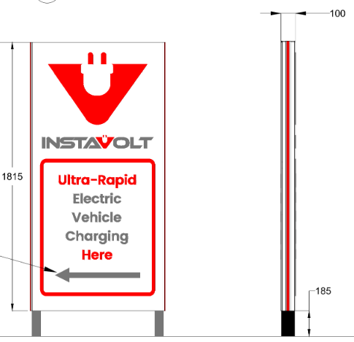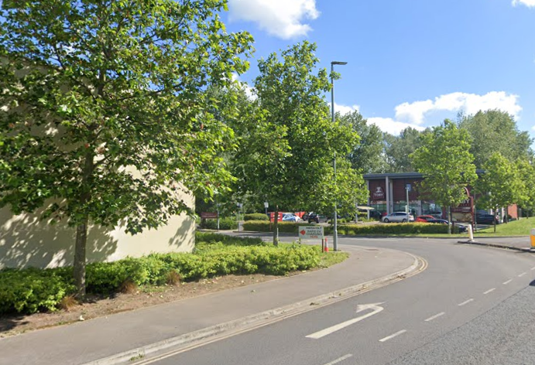

Proposed Elevations and Google Earth Site Photo

PLANNING HISTORY
15/00636/FUL - Full planning permission Decision - Approve with Conditions Date: 29/4/2015 – Demolition of existing buildings and development of four retail units with associated car parking, highways works, and landscaping. Construction of cycle and footbridge across the river Biss. (Units 1 & 2 are proposed for A1, A2, A3, A5, and D1 uses, Unit
W/92/00791/FUL - Full planning permission Decision - Approve with Conditions Date: 26/1/1993 – New access at Egress Road
W/08/00255/OUT - Outline Planning Decision - Approve with Conditions Date: 12/10/2009 – The demolition of the existing building and redevelopment of the site for a mix of uses including a food store, cafes, bars and restaurants, a hotel, residential apartments and associated access, car parking, landscaping and the ecological enhancement of
W/77/00014/ADV - Consent to display an advertisement Decision - Approve with Conditions Date: 7/10/1977 – Two illuminated sign
W/83/00540/ADV - Consent to display an advertisement Decision - Approved Date: 5/7/1983 – Illuminated trade sign
W/85/00288/ADV - Consent to display an advertisement Decision - Approve with Conditions Date: 16/4/1985 – 3 illuminated signs
16/11148/ADV - Consent to display an advertisement Decision - Approve with Conditions Date: 17/1/2017 – 2 internally illuminated fascia signs
PL/2025/04095 - Full planning permission Decision - Approve with Conditions Date: 27/6/2025 – Proposal for the installation of four additional EV charging stations, including the installation of one fully accessible EV charging bay, and ancillary equipment, as well as the upgrade of existing equipment within the car park of Pinehurst Securities -
16/08195/ADV - Consent to display an advertisement Decision - Approve with Conditions Date: 17/10/2016 – 6 no. internally illuminated fascia signs and graphics to trolley bays
16/11207/ADV - Consent to display an advertisement Decision - Approve with Conditions Date: 6/1/2017 – One freestanding non illuminated sign in association with occupation of Unit 1A.

RELEVANT LEGISLATION, POLICIES AND GUIDANCE
The display of advertisements is subject to a separate consent process within the planning system. This is principally set out in the Town and Country Planning (Control of Advertisements) (England) Regulations 2007. Advertisements are controlled with reference to their effect on amenity and public safety only. Those parts of the development plan relevant to the determination of this application are as follow:

The Town and Country Planning (Control of Advertisements) (England) Regulations 2007
National Planning Policy Framework (NPPF)
- Paragraph 141

Planning Practice Guidance (PPG)
- Advertisements

Wiltshire Core Strategy 2015 (WCS):
- Core Policy 57 Ensuring High Quality Design & Space Shaping
- Core Policy 58 Ensuring the Conservation of the Historic Environment
- Core Policy 62 Highways impacts

Trowbridge has a designated Neighbourhood Plan area but no made plans as yet.
Supplementary Planning Documents:
Institute of Lighting Professionals: The Brightness of Illuminated Advertisements (2014) PLG 05.

CONSULTATION RESPONSES
Trowbridge Town Council: No objection.
Highways: No objection.

REPRESENTATIONS
No comments were received.

ASSESSMENT
Regulation 3 of The Town and Country Planning (Control of Advertisements) (England) Regulations 2007 requires that local planning authorities exercise their powers in relation to the display of advertisements in the interests of amenity and public safety, taking into account the provisions of the development plan, in so far as they are material, and any other relevant factors.

The NPPF (141) is clear that the quality and character of places can suffer when advertisements are poorly sited and designed and should be subject to control only in the interests of amenity and public safety, also considering the cumulative impacts.

Impact on Amenity:
“Amenity” is not exhaustively defined in the Town and Country Planning (Control of Advertisements) (England) Regulations 2007 but is generally understood to include both visual and aural amenity. Factors relevant to amenity include the general characteristics of the locality, such as the presence of features of historic, architectural, cultural, or similar interest.

In broader planning terms, as reflected in the National Planning Policy Framework (NPPF), amenity refers to the quality or character of an area and the elements that contribute to the overall enjoyment and liveability of a place.

CP57 requires a high standard of design in all proposals, including (x) the sensitive design of advertisements and signage.

The proposal site is within a modern retail park that abuts the Trowbridge Conservation yet makes no contribution to the character of the area, which is purely modern, such that the proposal is considered to not impact the streetscape or Conservation Area.

The proposed totem signage is considered to be of an appropriate scale and in keeping with the wider site.

The sign would be permanently fixed and so does not have the potential to create a noise disturbance and as such the proposals are acceptable in terms of aural and visual amenity impact and would therefore comply with the relevant provisions of the Town and Country Planning (Control of Advertisements) Regulations 2007.

Impact on Public & Highway Safety:
“Public & Highway safety” is not exhaustively defined in the Town and Country Planning (Control of Advertisements) (England) Regulations 2007, but it generally refers to the potential impact of a development or advertisement on the safe use and operation of public spaces, including roads, footpaths, and other areas accessible to the public.

The National Planning Policy Framework (NPPF) also supports the principle that planning decisions should ensure developments create places that are safe, inclusive, and accessible, and that they do not undermine public safety or security.

CP62 advises that proposals should provide appropriate mitigating measures to offset any adverse impacts on the transport network at both the implementation and operational stages.

Due to the location of the site by the access to an established retail park from a dual carriageway, Highways have advised throughout the application’s lifecycle regarding siting to ensure the visibility splay is not compromised and have no objections.

The proposal is for a single totem and in combination with the limited nearby signage does not pose cumulative visual clutter. It is considered that the proposal would not result in an unacceptable impact on highway or public safety, either individually or cumulatively, and would therefore satisfy the relevant provisions of the Town and Country Planning (Control of Advertisements) Regulations 2007.

CONCLUSION:
The proposed advertisement has been assessed in accordance with the relevant provisions of the Town and Country Planning (Control of Advertisements) (England) Regulations 2007.

It is considered that the advertisement, by reason of its design, scale, siting, and method of illumination, would not result in harm to the visual amenity of the area. Furthermore, the proposal is not considered to pose a risk to public and highway safety, either individually or cumulatively with other signage in the vicinity.

Subject to the recommended conditions, the proposal is therefore considered acceptable, and it is recommended that advertisement consent be granted.

