APPLICATION FOR HOUSEHOLDER PLANNING PERMISSION AND LISTED BUILDING CONSENT DELEGATED REPORT

APPLICATION REFERENCE: | PL/2026/01050 and PL/2026/01197
APPLICATION TYPE: | Householder planning permission and Listed Building Consent
SITE ADDRESS: | Ansty Manor, High Street, Ansty, Salisbury, SP3 5QD
DEVELOPMENT DESCRIPTION: | Construction of a new link structure to a swimming pool and provision of a laundry.
RECOMMENDATION: | That Planning Permission and Listed Building Consent be GRANTED

PROPOSAL

The proposal seeks planning permission for the construction of a new link structure to the swimming pool and the provision of a laundry.

Existing and proposed site plans shown below -

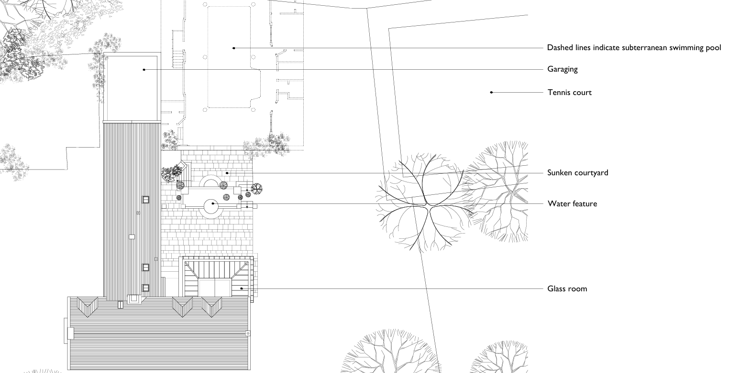

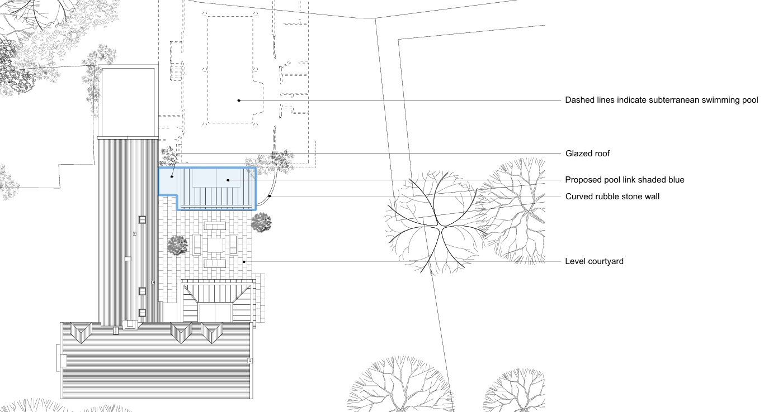

Existing and proposed basement plan shown below –

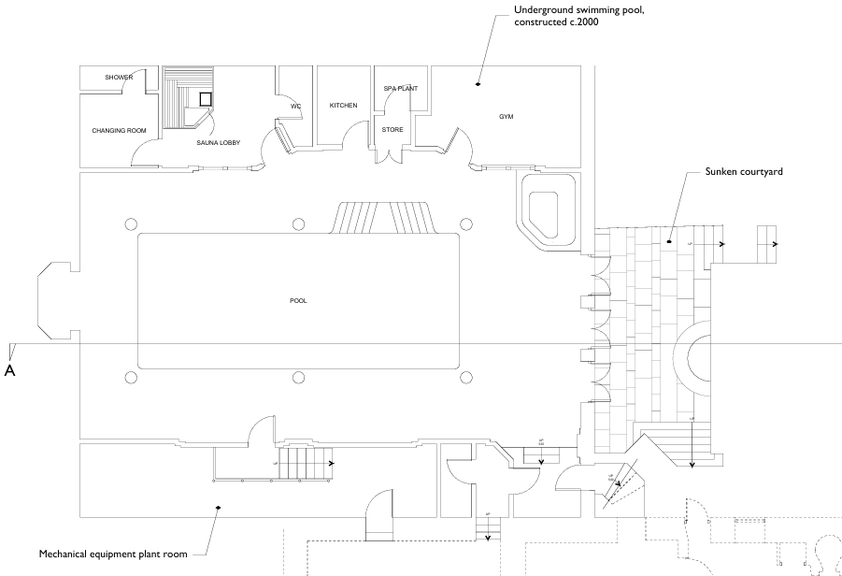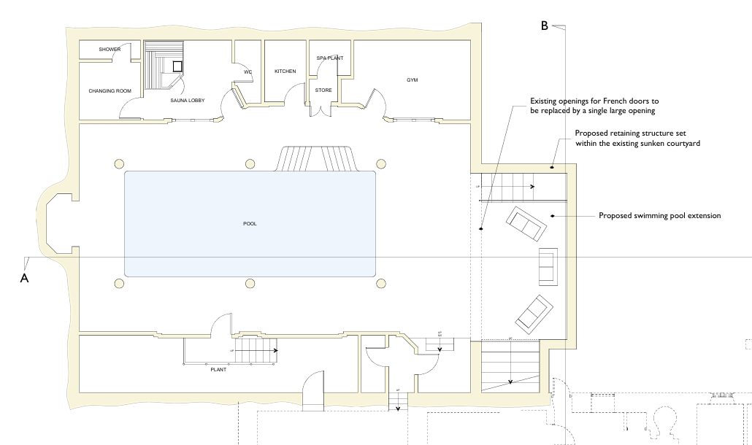

Existing and proposed ground floor plan shown below –

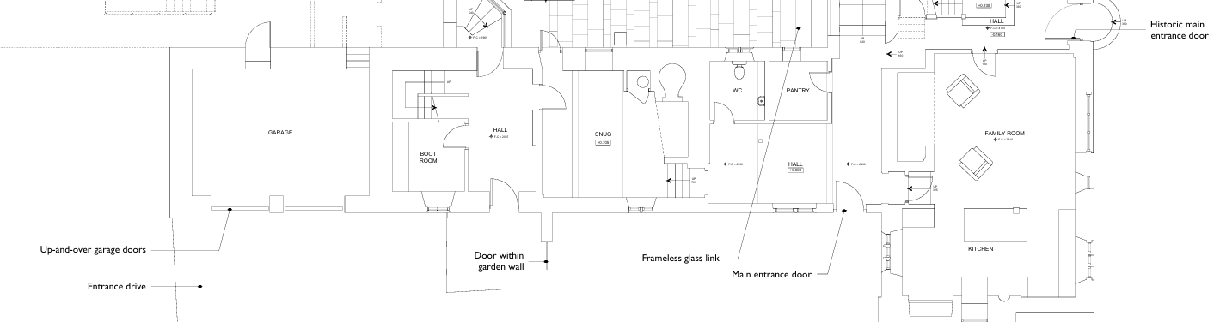

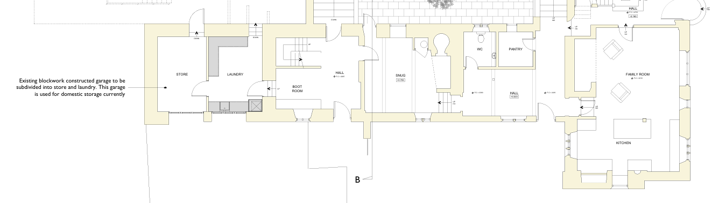

Existing and proposed east courtyard elevation shown below -

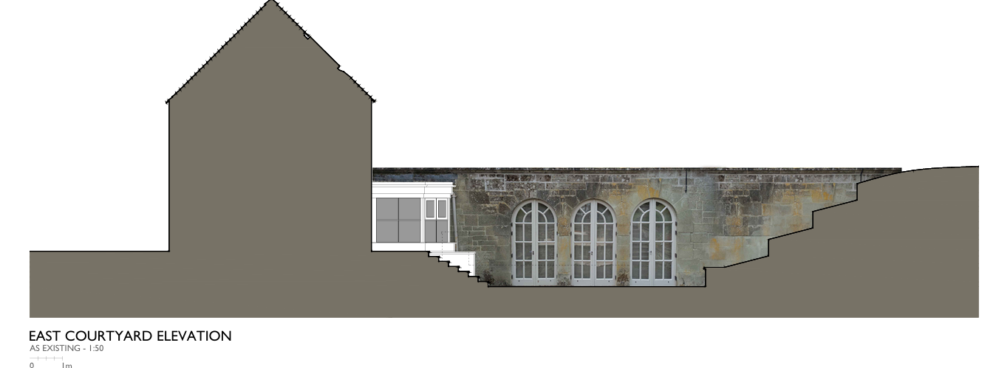

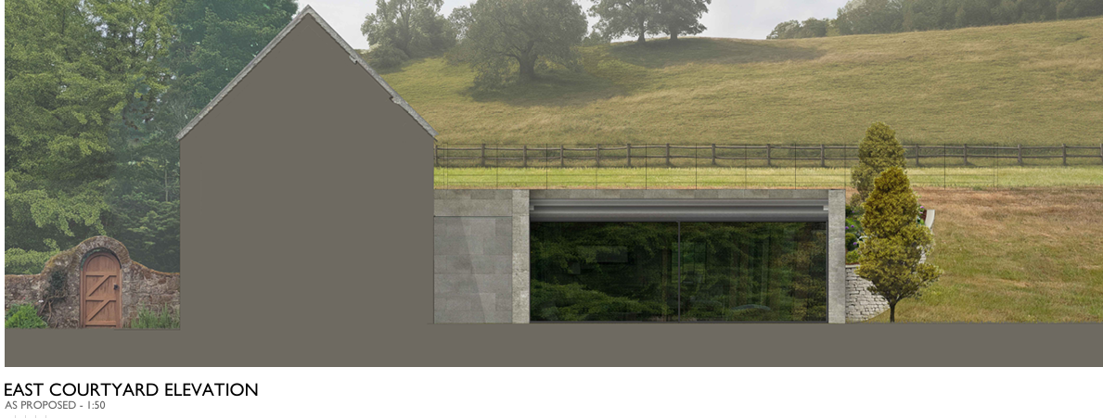

Existing and proposed north elevation shown below

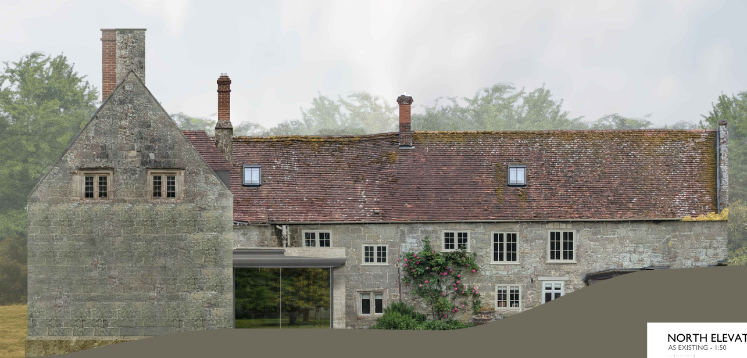

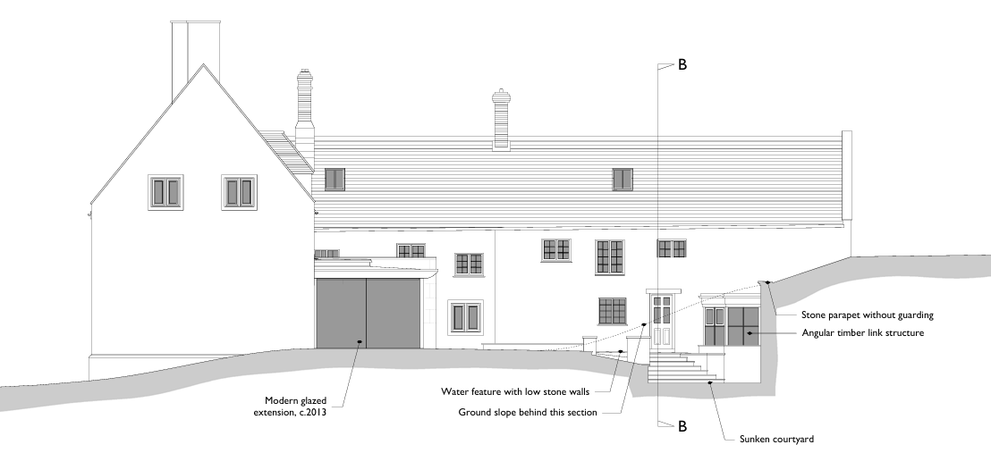

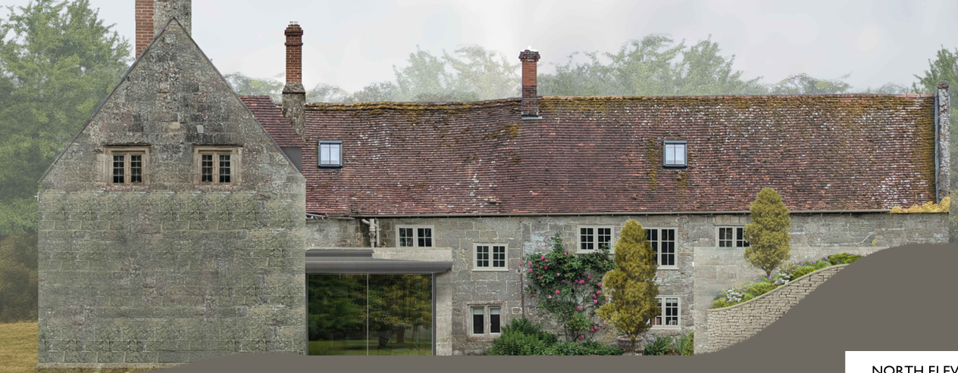

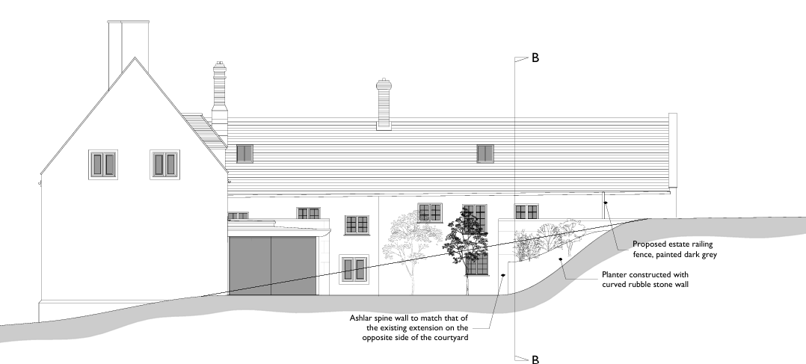

SITE DESCRIPTION/CONTEXT

The application site relates to a grade 2* listed dwelling situated within a large residential curtilage, located in Ansty which is defined as a small village by core policies 1, 2 and 27 of the Wiltshire Core Strategy.

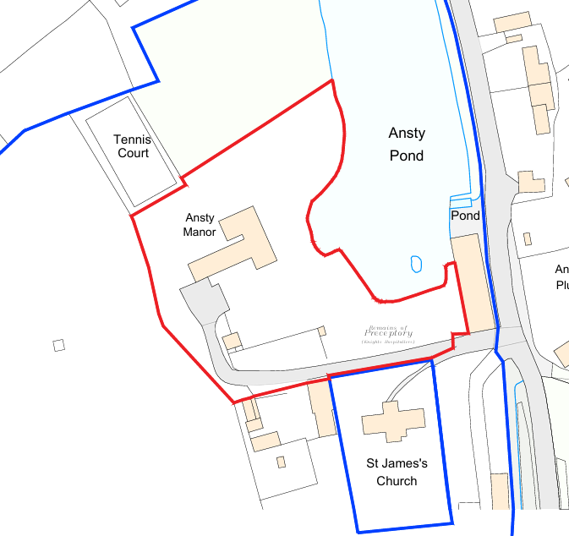

The site is located within the Ansty conservation area and other grade 2 and 2* listed buildings. The site is located Cranborne Chase & West Wiltshire Downs National Landscape (formerly AONB), the Chilmark Quarries Bat SAC and the Hampshire River Avon Catchment. Part of the site is located withing flood zones 2 and 3, but the works are outside of these flood risk areas.

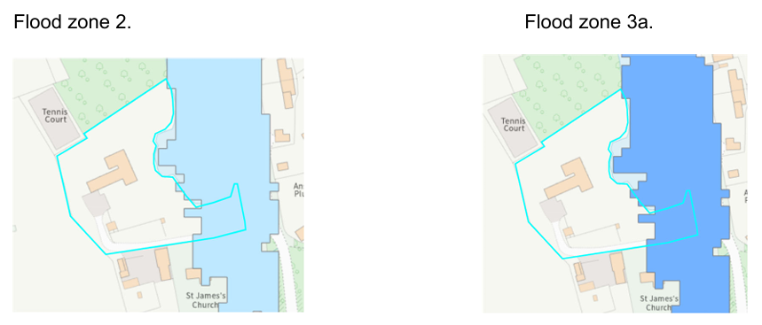

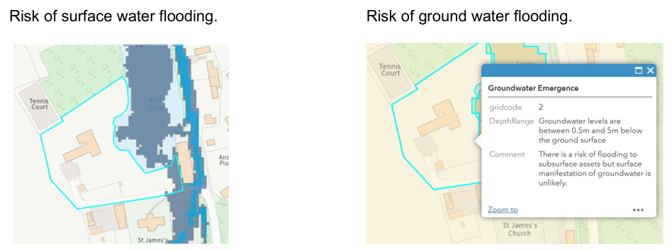

PLANNING HISTORY

Proposal / Summary
PL/2022/02365 - Full planning permission Decision - Approve with Conditions Date: 31/10/2022 – Retrospective planning for a wooden footbridge to a small island and rebuild collapsed stonewall
S/2000/0238 - Full planning permission Decision - Approve with Conditions Date: 11/4/2000 – EXTENSION OF MANOR HOUSE TO PROVIDE SWIMMING POOL ROOM ANCILLARY AND SERVICE ROOMS
S/2000/0239 - Listed building consent Decision - Approve with Conditions Date: 10/11/2000 – EXTEND BUILDING TO ADD SWIMMING POOL ROOM AND ANCILLARY AND SERVICE ROOMS
S/1993/1185 - Listed building consent Decision - Approve with Conditions Date: 26/10/1993 – L/B APPLICATION - INTERCHANGE EXISTING REAR DOOR AND WINDOW
S/1999/0102 - Full planning permission Decision - Approve with Conditions Date: 16/4/1999 – STONE ORANGERY. UNDERGROUND SWIMMING POOL
S/1999/0103 - Listed building consent Decision - Approve with Conditions Date: 5/5/1999 – STONE ORANGERY. STONE OPENING TO UNDERGROUND SWIMMING POOL
S/1989/1401 - Full planning permission Decision - Approved Date: 11/10/1989 – NEW DORMER IN REAR (WEST) ELEVATION
S/1989/1402 - Listed building consent Decision - Approve with Conditions Date: 11/10/1989 – L/B APPLICATION - ALTERATIONS TO ATTIC ROOMS. NEW DORMERS AND NEW ROOFLIGHT
S/2012/0267 - Listed building consent Decision - Approve with Conditions Date: 30/3/2012 – Demolition of existing orangery to west elevation and replacement with garden room plus associated alterations. Internal alterations to ground floor and first floor
16/02891/FUL - Full planning permission Decision - Approve with Conditions Date: 30/6/2016 – Conversion of outbuilding from storage to provide garage space, storage and an annexe with office, loft bedroom and bathroom facilities
16/03059/LBC - Listed building consent Decision - Approve with Conditions Date: 30/6/2016 – Conversion of outbuilding from storage to provide garage space, storage and an annexe with office, loft bedroom and bathroom facilities
PL/2024/10604 - Listed building consent (Alt/Ext) Decision - Approve with Conditions Date: 14/2/2025 – Removal and relaying of the existing roof tiles. Renewal of the existing combined roofing felt / insulation layer.
S/1982/0133 - Listed building consent (Alt/Ext) Decision - Approve with Conditions Date: 29/3/1983 – Internal alterations to improve existing sanitary accommodation

RELEVANT POLICIES AND GUIDANCE

Section 16, 66 and 72 of the Planning (Listed Buildings and Conservation Areas) Act 1990

The National Planning Policy Framework (NPPF)
The Planning Practice Guidance
National Design Guide

The adopted Wiltshire Core Strategy (WCS), with particular regard to:

Core Policy 1 Settlement Strategy;
Core Policy 2 Delivery Strategy;
Core Policy 27 Spatial Strategy Tisbury Community Area
Core Policy 50 Biodiversity and Geodiversity;
Core Policy 51 Landscape;
Core Policy 57 Ensuring High Quality Design and Place Shaping;
Core Policy 58 Ensuring the Conservation of the Historic Environment;
Core Policy 67 Flood Risk;
Core Policy 69 River Avon SAC;

Salisbury District Local Plan Saved Policy

C24 extensions in the countryside.

Supplementary Planning Document:

Wiltshire Design Guide
Creating Places Design Guide
National Landscape Management Plan

CONSULTATION RESPONSES

Parish Council: None received

Archaeology: Ansty Manor is a Grade II* listed, 16th-century house with the ‘Guest House of the Knights of St John’, a nationally important Scheduled Monument (No. 1005648) and a Grade II* listed building, within its grounds.
This application proposes a new link structure to the to the east of the existing swimming pool. Prior to its construction, the footprint of the swimming pool was subject to exploratory archaeological investigation (AC Archaeology, 1999). This recorded a shallow ditch, possibly a former field boundary, containing sherds of medieval pottery. A second trial trench on the footprint of the, now demolished, orangery recorded no archaeological deposits or finds. The new link structure is also proposed to be located within an existing sunken courtyard where it is likely that any buried remains will have been largely removed.
On this basis, I have no archaeological concerns with this proposal, and no further action is required as regards the buried archaeological heritage in relation to this planning application.

Historic England: Historic England provides advice when our engagement can add most value. In this case we are not offering advice. This should not be interpreted as comment on the merits of the application.

Conservation: No objection subject to conditions

Ecology: None received

REPRESENTATIONS

No comments were received.

ASSESSMENT

Section 38(6) of the Planning and Compulsory Purchase Act 2004 states:

"If regard is to be had to the development plan for the purposes of any determination to be made under the planning Acts, the determination must be made in accordance with the plan unless material considerations indicate otherwise."

In accordance with this statutory requirement, this application has been assessed against the relevant policies of the Development Plan, including the adopted Wiltshire Core Strategy (2015) and, where applicable, any made Neighbourhood Plans.

Character, design impact on the heritage assets and National Landscape.

CP58 of the WCS requires development to protect, conserve and, where possible, enhance the historic environment, including the character and setting of heritage assets.

This reflects the approach in Sections 16, 66 and 72 of the Planning (Listed Buildings and Conservation Areas) Act 1990, and paragraphs 212–221 of the NPPF. Where harm to a heritage asset is identified, there must be clear and convincing justification.

CP57 of the WCS seeks to ensure that all development proposals are of a high standard of design that responds positively to the local context and contributes to a sense of place. This includes consideration of layout, form, materials, scale, and relationship to the surroundings. Proposals should reinforce local distinctiveness, protect the character of settlements, and promote inclusive and attractive environments.

Core Policy 51 of the Wiltshire Core Strategy requires all development to protect, conserve, and where possible enhance the character and quality of Wiltshire’s landscapes, giving particular weight to designated areas such as National Landscapes.

The National Planning Policy Framework (NPPF), in Paragraph 189, states that “great weight” should be given to conserving and enhancing landscape and scenic beauty in National Landscapes (formerly Areas of Outstanding Natural Beauty). Development within or affecting the setting of a National Landscape must demonstrate that it will not result in unacceptable harm to the special qualities of that area.

Historic England Advice Note 2 – Making changes to Heritage Assets illustrates the application of policies set out in the NPPF in determining applications for PP and LBC.

The following points are taken from the Historic England document “The Setting of Heritage Assets: Historic Environment Good Practice Advice in Planning 3” (HE GPA3) that are considered to be particularly relevant:

HE GPA3 Part 1: “The NPPF makes it clear that the setting of a heritage asset is the surroundings in which a heritage asset is experienced. Its extent is not fixed and may change as the asset and its surroundings evolve. Elements of a setting may make a positive or negative contribution to the significance of an asset.”

“The extent and importance of setting is often expressed by reference to visual considerations. …views of or from an asset will play an important part…”

“While setting can be mapped in the context of an individual application or proposal, it cannot be definitively and permanently described for all time as a spatially bounded area or as lying within a set distance of a heritage asset. This is because the surroundings of a heritage asset will change over time.”

“The importance lies in what the setting contributes to the significance of the heritage asset or to the ability to appreciate that significance.”

In this instance, the main impacts of the proposals relate to the heritage assets, the Council’s conservation officer has provided the following comments

Ansty Manor is a grade II* listed building. The list description reads as follows: Detached house. C16, altered C17, C18, C20. Limestone ashlar, tiled roof with ashlar stacks. T-plan. 2-storey, 3-window front. C16 double-chamfered round-arched doorway with C20 door, to right of centre, to right is C18 Venetian window with square columns and keystone, to left is C20 3-light mullioned window with hoodmould and 3-light and single recessed chamfered mullioned window with hoodmoulds. First floor has 2-light, 1-light and 4-light mullioned windows. Cellar below right part has chamfered window. Right return has two 2-light recessed chamfered mullioned windows to attic. Left return has large external stack and small 12-pane sash, two 2-light recessed chamfered mullioned windows to attic and single to first floor. Rear of right part has inserted C20 round- arched glazed double door. Rear wing north side has C20 casements and doors with one Cl? 2-light chamfered mullioned window, south side has C20 door and windows to ground floor with three 2-light and one 1 light recessed chamfered mullioned window to first floor, straight joint divides wing into two builds. Interior: stone steps and door with 6 fielded panels to dining room to right of door, entrance hall has C18 stairs with Chinese Chippendale balustrade and moulded handrail. Large room to left of door, formerly two smaller rooms and possibly original open hall, floor inserted late C17, two open fireplaces, the larger with stone Tudor arch on brick jambs, round-arched double-chamfered doorway in wall to rear wing. Wing of two builds, probably C17, has chamfered beams and open fireplace with chamfered timber lintel with ogee stops. First and attic floor has good C17 chamfered doorcases with stopped jambs, planked doors with strap hinges. Two stone Tudor- arched fireplaces with herringbone brick backs in bedrooms at south end of main range. Winding newel stairs to attic. Unusual roof over main build has cruck-like principals on cross-rail below eaves-level, with interrupted tie-beam. The development of this building may have begun with C16 open hall with through passage at north end, floor inserted, rear wing added and the whole refenestrated in late C17, Venetian window inserted and stairs refitted C18. Formerly the property of the Arundells of Wardour (q.v.). Occupies a prominent position overlooking Ansty pond, the church (q.v.) and former Banqueting House (q.v.).

Nearby is the Church of St James, a grade II listed building, and also the Banqueting House (listed as workshop) a grade II* building.

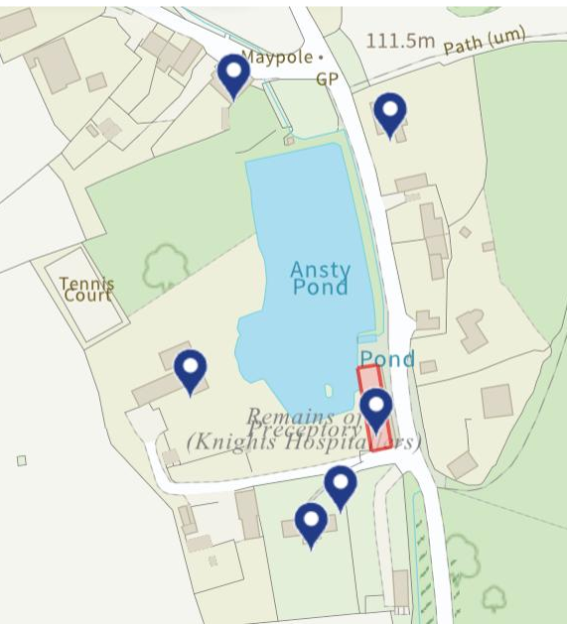

The house is also within the Ansty conservation area (for which there is no appraisal).

Proposal

GARAGE: Conversion of two-bay garage to a laundry. Externally the two existing doors would be replaced with hinged wooden doors, panelled below and with glazing in the upper half.

Internally the only change is a wall to separate the proposed laundry from the store.

Reconfiguration of the ‘front’ elevation of the underground swimming pool

This is currently accessed via a link building in the corner (no north indication on plan, please can they address this) of the courtyard. This is clearly modern.

The ‘front’ elevation of the swimming pool has three arched openings.

The proposal is to demolish the arches and create a larger ‘rectangular’ opening, replace the link and form a new ‘forward’ extension to the swimming pool building.

There are no change to the existing (house) openings.

The new extension would appear to be constructed from stone with a glazed link.

Issues: impact on the listed building, impact on the conservation area.

Information considered/provided:

Paragraph 207 requires that applicants describe the significance of any heritage assets affected, including any contribution made by their setting. This should include sufficient information to provide a clear understanding of the significance of the heritage asset and its setting and the potential impact of any proposals on that significance.

In this case, whilst the applications are accompanied by a “Design, Access and Heritage Statement” the document provides limited information about the building and fails to provide any objective assessment of the fabric affected, its date or significance or of the impact of the proposals and, as a result, it fails to meet the requirements of the NPPF.

In this case, the applications are accompanied by a “Design and Heritage Statement” which provides sufficient information to understand the impact of the proposals and is proportionate to their scope. The requirements of the NPPF are therefore met in this respect.

However, paragraph 208 also provides for the local planning authority to make its own assessment of impact and the following heritage recommendations are offered on this basis.

Significance of assets and contribution of setting

The NPPF defines significance as the “value of a heritage asset to this and future generations because of its heritage interest. The interest may be archaeological, architectural, artistic or historic. Significance derives not only from a heritage asset’s physical presence, but also from its setting.” Historic England assesses significance in a similar manner, referring to evidential, historic, aesthetic and communal values of a place.

The proposals have been supported by a heritage statement (Asset Heritage Consulting Ltd) which has been used to guide the proposals. The report is comprehensive and is welcomed. Section 3.2 is headed Significance and is comprehensive although does not refer to the contribution the building makes to the Ansty conservation area (although in respect of the current proposals, there is no change).

At 3.2.6 the report says:
‘The later additions (Garden Room, swimming pool and swimming pool link) are evidently of no heritage significance. The Garden Room was, however, a successful addition to the building in c.2012 in replacement of a previous Orangery addition of c.2000. The courtyard into which these structures face is a creation of the late 20th and early 21st century and its form and structures are not historic or of any heritage interest’.

Assessment:

The author of the heritage report concludes that the proposals will enhance the setting of the listed building and will not entail the loss of historic fabric.

I agree with their assessment that the proposals will meet the requirements of sections 16 and 66 of the Planning (LBCA) Act 1990. In respect of the conservation area, the proposals will preserve its character (being effectively concealed within a courtyard) and will therefore also meet the requirements of section 72 of the Planning (LBCA) Act 1990.

Summary & conclusion:

The NPPF confirms that when considering the impact of a proposed development on the significance of a designated heritage asset, great weight should be given to the asset’s conservation (and the more important the asset, the greater the weight should be). It makes clear that any harm to a designated heritage asset requires clear and convincing justification.

The impact of the proposals on heritage assets will be neutral/positive. On this basis no specific justification is required however it is considered the works will assist in securing the future use of a heritage asset in support of its long-term conservation. The requirements of current conservation legislation, policy or guidance are considered to be met and there is therefore no objection to the approval of the application.

If you are minded to approve the application, I recommend the following conditions:

Details of the new garage doors at 1:10 or 1:20 or a brochure detail;
Confirmation of the choice of stone for the spine wall/s of the extension;
Estate railings to be metal and painted a dark colour.

From a planning perspective, the proposed development relates to modest extensions and alterations to the existing dwelling; the works are contained within the centre of the site and will not be visible from the public realm. There are no concerns raised regarding the works as proposed, and Officers concur with the conservation officer that the works are an enhancement to the setting of the listed building. The scale, siting and design of the proposals are also not considered to pose significant harm to the National Landscape.

Amenity

Point vii of Core Policy 57 - Ensuring High Quality Design and Place Shaping of the Wiltshire Core Strategy seeks to ensure that developments do not adversely affect neighbouring properties.

The National Planning Policy Framework (NPPF), particularly Paragraph 135(f), stresses that planning decisions should ensure developments provide a high standard of amenity for existing and future users.

In this instance given that nature of the proposals and that the application has no immediate neighbours there are no residential amenity concerns.

The proposal therefore accords with Core Policy 57 point vii in respect of safeguarding residential amenity and Appendix D of the Wiltshire Design Guide.

Ecology Impact

Core Policy 50 of the Wiltshire Core Strategy seeks to protect and enhance biodiversity and geodiversity, including through ensuring that development avoids harm to protected species and habitats.

The National Planning Policy Framework (NPPF), in Paragraphs 193, requires that development minimises impacts on and provides net gains for biodiversity, including ensuring mitigation is secured where harm cannot be avoided.

The application has been submitted with an Ecological Impact Assessment by Darwin Ecology dated January 2026.

The Ecology report confirms that during the building inspection, bat droppings were found scattered within two loft voids of the main dwelling however the proposed works do not affect the loft voids and areas where bat droppings have been found and that the proposals are limited to a small, paved area at the north of the house and will not result in any loss of commuting or foraging habitat for bats or other protected species. The report confirms that the walls around the pool entrance were in good condition with no entry points for bats. A small crevice was noted on the small extension connecting building 2 to the underground pool. This was assessed as being too exposed for a bat.

The report also confirms that mitigation detailed within the report can ensure nearby waterbodies and the sites potential to support otter and GCN in the local area is not affected.

Chilmark Quarries Special Area for Conservation (SAC) -The site lies within a consultation zone for Barbastelle bats associated with the Chilmark Quarries Bats SAC and therefore has potential to result in significant adverse impact on the special features of that site. Appropriate Assessment (AA) under Section 63 of the Conservation of Habitats and Species Regulations 2017 (as amended) must be carried out by the relevant Competent Authority (the LPA) to determine the potential significant effects and the suitability of any measures proposed to avoid or mitigate those effects.

The Ecological Impact Assessment by Darwin Ecology confirms that the proposals do not impact on bat roost or foraging areas; the proposals only impact the lower portion of the northern courtyard which is sealed surface made of stone. This is a low impact, small-scale project that will not impact the vegetation on the site. The proposed development will not be clearing any suitable foraging habitat for bats within the site or the local landscape. The proposals will also not be altering the roof of the main dwelling and so any current potential to support roosting bats will not be impacted. If the development were to result in an increase of light spillage onto the main dwelling or the vegetated garden, this could reduce the sites suitability to support species associated with Chilmark Quarries SAC. Implementation of a compulsory sensitive lighting plan (detailed below) will eliminate this risk and consultation with Natural England will therefore not be necessary in this case. There is no mechanism for adverse effect to the bat SAC. The proposed works are also relatively minor nature and there is no likelihood of direct impacts to bat species. This proposal can therefore be screened out of Appropriate Assessment.

Officers note the comments regarding lighting however this development relates to modest works to an existing dwelling, the owner can install lights as/when they wish as these are not development and in cases like this cant be controlled and it would be unreasonable and unnecessary to add such a condition. Likewise, mitigation for impacts relating to other protected species such as newts, otters etc when the works are on a modest scale and located away from areas these protected species are location are not considered necessary or reasonable in this instance.

Hampshire River Avon Special Area for Conservation (SAC) - This development falls within the catchment of the River Avon SAC. The development therefore has potential to cause adverse effects alone or in combination with other developments through discharge of phosphorus in wastewater. An Appropriate Assessment (AA) under Section 63 of the Habitats Regulations must be carried out by the relevant Competent Authority (the LPA) to determine the potential significant effects and the suitability of any measures proposed to avoid or mitigate those effects. However, the issue of increases in phosphorous discharge in wastewater results from increases in overnight accommodation developments. Since the proposed development will not increase the number of overnight accommodation units in the catchment, there is no mechanism for adverse effect. The proposed works are also relatively minor nature and there is no likelihood of direct impacts to the river itself. This proposal can therefore be screened out of Appropriate Assessment.

Biodiversity Net Gain - Householder planning applications are exempt from the requirement to deliver Biodiversity Net Gain under Schedule 7A, Section 4(2)(a) of the Town and Country Planning Act 1990, as inserted by the Environment Act 2021.

As such, the development complies with Core Policy 50 and 69 of the Wiltshire Core Strategy and the relevant provisions of the NPPF and can be screened out of an AA.

CONCLUSION

The proposed development is considered to be acceptable in terms of its design, scale, and relationship with the surrounding area. It would not result in any unacceptable harm to the character of the locality, the amenities of neighbouring occupiers, or the interests of heritage, or ecology.

The proposal is therefore considered to comply with the relevant policies of the Wiltshire Core Strategy, Section 16, 66 and 72 of the Planning (Listed Buildings and Conservation Areas) Act 1990 and the provisions of the National Planning Policy Framework. As such, the application is recommended for approval, subject to the conditions set out below.

RECOMMENDATION: That Planning Permission be GRANTED subject to conditions.

1. The development hereby permitted shall be begun before the expiration of three years from the date of this permission.

REASON: to comply with the provisions of Section 91 of the Town and Country Planning Act 1990 as amended by the Planning and Compulsory Purchase Act 2004

2. The development hereby permitted shall be carried out in accordance with the following approved plans:

Application form received 16/02/2026
Location plan Drg no 25009/001 received 16/02/2026
Site plan as proposed Drg no 25009/040 received 16/02/2026
Basement plan as proposed Drg no 25009/041 received 16/02/2026
Ground floor plan as proposed Drg no 25009/042 received 16/02/2026
First floor plan as proposed Drg no 25009/043 received 16/02/2026
Second floor plan as proposed Drg no 25009/044 received 16/02/2026
Sections A-A & B-B as proposed Drg no 25009/050 received 16/02/2026
South and west elevations as proposed Drg no 25009/060 received 16/02/2026
North and east elevations as proposed Drg no 25009/061 received 16/02/2026
Courtyard elevations as proposed Drg no 25009/062 received 16/02/2026
Coloured north elevation as existing & as proposed Drg no 25009/063 received 16/02/2026
Coloured east elevation as existing & as proposed Drg no 25009/064 received 16/02/2026
Materials Schedule First Issue : 12th February 2026 received 16/02/2026
Ecology impact assessment received 16/02/2026

REASON: For the avoidance of doubt and in the interests of proper planning

3. Notwithstanding the approved plans, the proposed estates railings shall be metal and painted a dark colour

REASON: In the interests of protecting the character of the area and setting of the heritage assets.

4. The development shall be carried out in accordance with the enhancement measures specified at paragraph 7.2 of the submitted Ecology impact assessment.

REASON: In this interest of providing enhancement measures for bats.

Informatives

1. The effect of paragraph 13 of Schedule 7A to the Town and Country Planning Act 1990 is that planning permission granted for development of land in England is deemed to have been granted subject to the condition (biodiversity gain condition) that development may not begin unless:

(a) a Biodiversity Gain Plan has been submitted to the planning authority, and
(b) the planning authority has approved the plan.

The planning authority, for the purposes of determining whether to approve a Biodiversity Gain Plan, if one is required in respect of this permission would be Wiltshire Council.

There are statutory exemptions and transitional arrangements which mean that the biodiversity gain condition does not always apply. For further information on exempt developments please refer to:
https://www.gov.uk/guidance/biodiversity-net-gain-exempt-developments
Based on the information available this permission is considered to be one which will not require the approval of a biodiversity gain plan before development is begun because one or more of the statutory exemptions or transitional arrangements is considered to apply.

2. The applicant should note that under the terms of the Wildlife and Countryside Act (1981) and the Habitats Regulations (2010) it is an offence to disturb or harm any protected species, or to damage or disturb their habitat or resting place. Please note that this consent does not override the statutory protection afforded to any such species. In the event that your proposals could potentially affect a protected species you should seek the advice of a suitably qualified and experienced ecologist and consider the need for a licence from Natural England prior to commencing works. Please see Natural England’s website for further information on protected species.

RECOMMENDATION: That Listed Building Consent be GRANTED subject to conditions.

1. The works for which Listed Building Consent is hereby granted shall be begun before the expiration of three years from the date of this consent.

REASON: To comply with the provisions of Section 18 of the Planning (Listed Buildings and Conservation Areas) Act 1990 as amended by the Planning and Compulsory Purchase Act 2004.

2. The development hereby permitted shall be carried out in accordance with the following approved plans:

Application form received 16/02/2026
Location plan Drg no 25009/001 received 16/02/2026
Site plan as proposed Drg no 25009/040 received 16/02/2026
Basement plan as proposed Drg no 25009/041 received 16/02/2026
Ground floor plan as proposed Drg no 25009/042 received 16/02/2026
First floor plan as proposed Drg no 25009/043 received 16/02/2026
Second floor plan as proposed Drg no 25009/044 received 16/02/2026
Sections A-A & B-B as proposed Drg no 25009/050 received 16/02/2026
South and west elevations as proposed Drg no 25009/060 received 16/02/2026
North and east elevations as proposed Drg no 25009/061 received 16/02/2026
Courtyard elevations as proposed Drg no 25009/062 received 16/02/2026
Coloured north elevation as existing & as proposed Drg no 25009/063 received 16/02/2026
Coloured east elevation as existing & as proposed Drg no 25009/064 received 16/02/2026
Materials Schedule First Issue : 12th February 2026 received 16/02/2026
Ecology impact assessment received 16/02/2026

REASON: For the avoidance of doubt and in the interests of proper planning

3. Notwithstanding the approved plans, details of the new garage doors at a scale of 1:10 or 1:20 (can include a brochure detail) shall be submitted to the Local Planning Authority for written approval prior to the installation of the new garage doors. The development shall be carried out in accordance with the agreed details.

REASON: In the interest of protecting the character and appearance of the listed building.

4. Notwithstanding the approved plans, details/samples for the stone to be used in the construction of the spine wall/s of the extension shall be submitted to the Local Planning Authority for written approval prior to the erection of the spine walls. The development shall be carried out in accordance with the agreed details.

REASON: In the interest of protecting the character and appearance of the listed building.

