APPLICATION FOR HOUSEHOLDER PLANNING PERMISSION
DELEGATED REPORT

APPLICATION REFERENCE: | PL/2026/00425
APPLICATION TYPE: | Householder planning permission
SITE ADDRESS: | Three Parishes, Hugglers Hole, Semley, Shaftesbury, SP7 9HG
DEVELOPMENT DESCRIPTION: | Rear and side extensions to house, with internal alterations to form ancillary accommodation for housekeeper/carer. New timber framed garage with log store replacing existing shed.
RECOMMENDATION: | That Planning Permission be GRANTED

PROPOSAL
The proposal seeks planning permission for the conversion of the attached garage into habitable accommodation, a single storey extension on east elevation with covered porch, a rear (south) extension, internal alterations and changes to ground floor windows. It is proposed that part of the ground floor will be used as ancillary accommodation for a housekeeper/carer. The property would remains as a four bedroom dwelling.

A new single timber frame garage with lean-to log store is proposed for the north east corner of the site, replacing an existing shed.

Location plan Proposed site plan

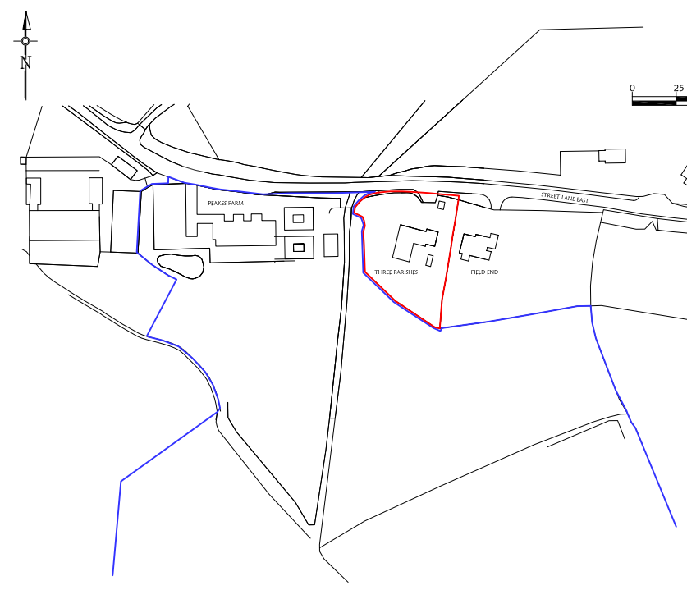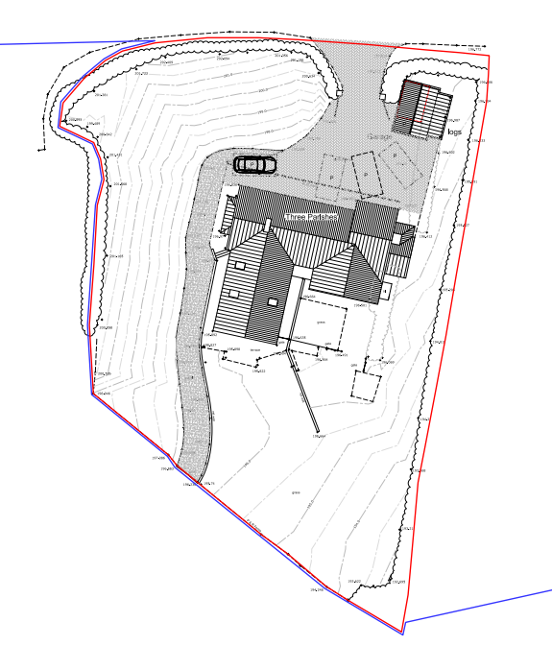

Existing Ground Floor Plan

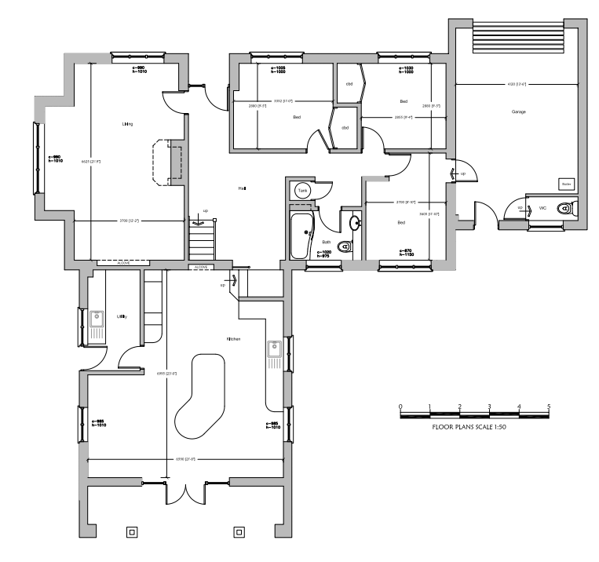

Proposed Ground Floor Plan

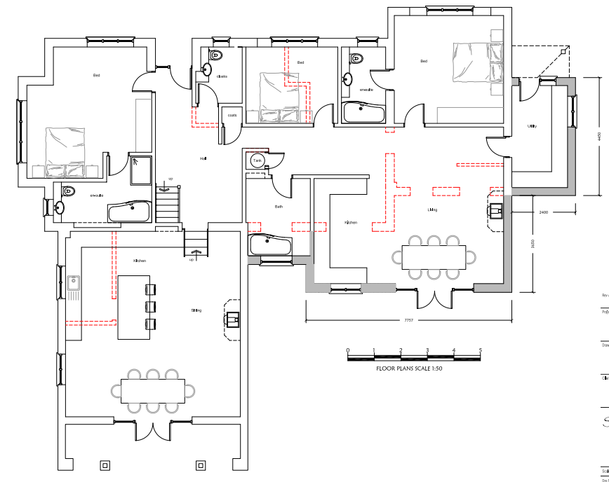

Existing elevations

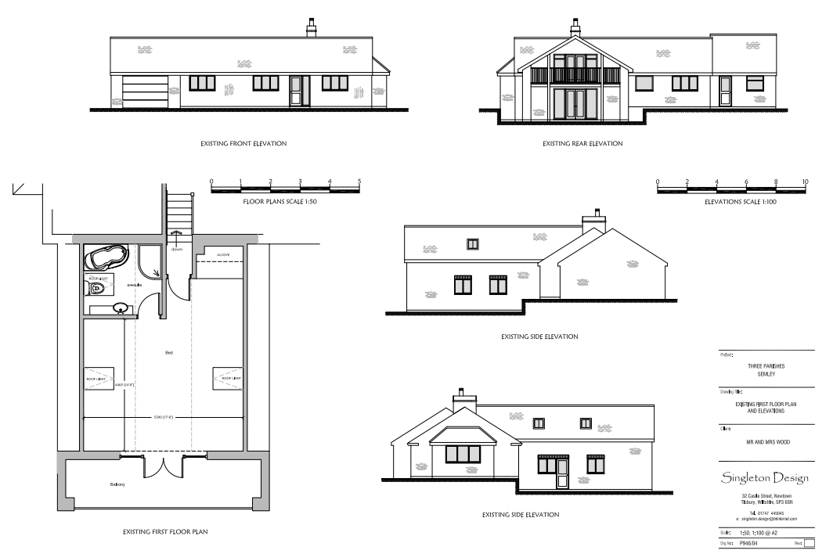

Proposed elevations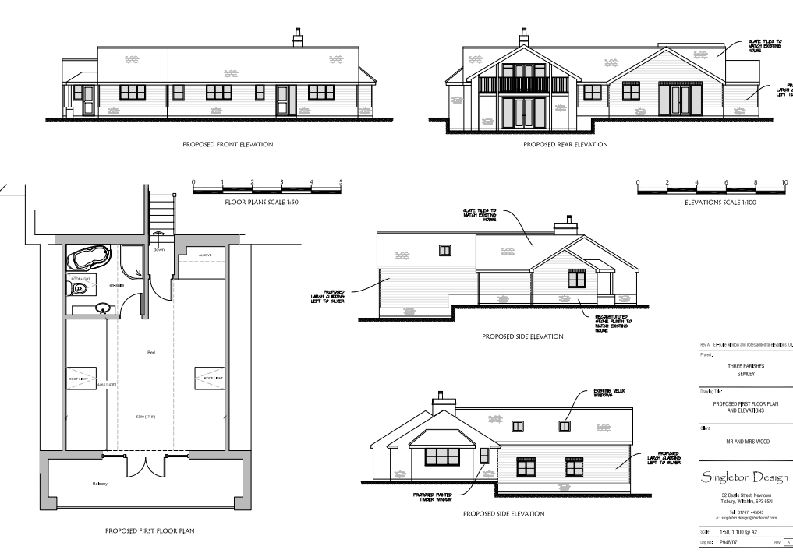

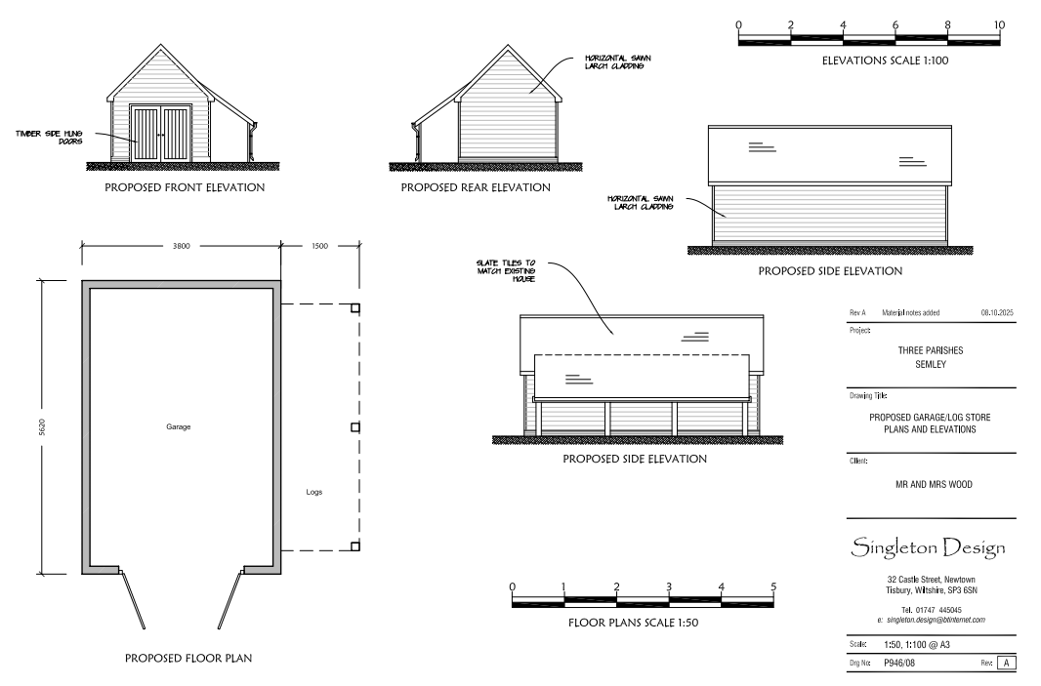

SITE DESCRIPTION/CONTEXT

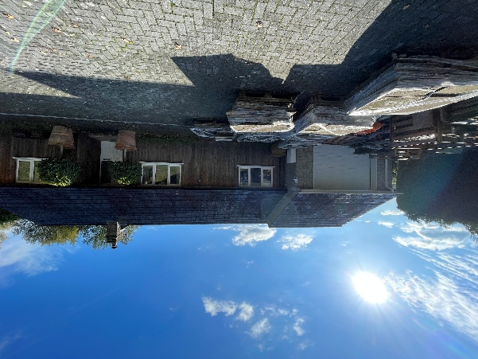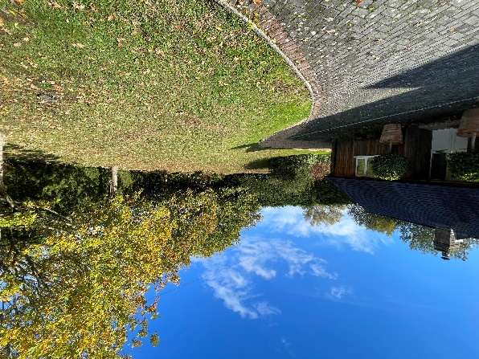

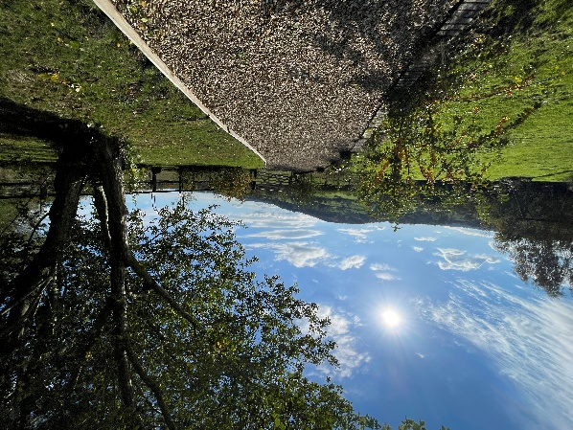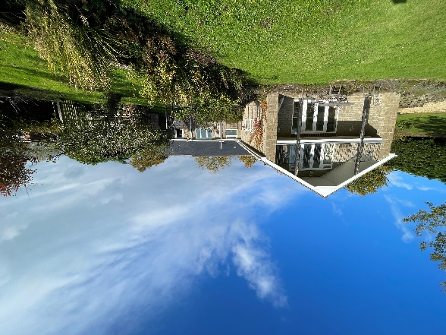

The application relates to Three Parishes, a detached dormer bungalow with a rear first floor balcony set within a large plot. The site is located on Street Lane, approx. 500m east of ‘Huggler’s Hole’ within the Sedgehill and Semley Civil Parish, within designated countryside, outside of any settlement boundary, as defined by Wiltshire Core Strategy (WCS) core policies 1 (Settlement Strategy), 2 (Delivery Strategy) and 17 (Spatial Strategy for the Mere Community Area)

The application site is subject to the following planning policy constraints:

- Countryside Character Areas - Blackmore Vale and Vale of Wardour
- Flood Zone 1
- Special Landscape Areas – SLA 3 The Blackmore Vale from Zeales to Sedgehill

The dwelling is located centrally to the plot with a driveway to the north and private gardens to the south and east. The land falls away to the south offering extensive views to the countryside to the south.

PLANNING HISTORY

Proposal / Summary
S/1985/0270 - Full planning permission Decision - Approved Date: 17/4/1985 – O/L APPLICATION - ERECTION OF BUNGALOW IN CONNECTIONWITH AGRICULTURE AND CONSTRUCTION OF NEW ACCESS
S/1985/1453 - Full planning permission Decision - Approved Date: 15/1/1986 – APPROVAL OF MATTERS RESERVED - ERECTION OF BUNGALOW INCONNECTION WITH AGRICULTURE & CONSTRUCTION OF NEW ACCESS
S/2005/0219 - Full planning permission Decision - Refused Date: 1/4/2005 – LOFT CONVERSION BY MEANS OF RAISING ROOF RIDGE HEIGHT TO PROVIDE 1ST FLOOR ACCOMMODATION & 2 STOREY SIDE EXTENSION WITH BALCONY
S/2005/1411 - Full planning permission Decision - Approve with Conditions Date: 2/9/2005 – TWO STOREY REAR EXTENSION WITH BALCONY TO FIRST FLOOR
PL/2024/02304 - Lawful development: Existing use Decision - Approve Date: 8/5/2024 – This application is for a Certificate of Lawfulness following a ten year continuous breach of occupancy at Three Parishes, Hugglers hole, Sedgehill, Shaftesbury, SP7 9HG

RELEVANT POLICIES AND GUIDANCE

Wiltshire Core Strategy:

- Core Policy 1: Settlement Strategy
- Core Policy 2: Delivery Strategy
- Core Policy 17: Spatial Strategy for the Mere Community Area
- Core Policy 50: Biodiversity and Geodiversity
- Core Policy 51: Landscape
- Core Policy 57 Ensuring High Quality Design and Place Shaping
- Core Policy 61: Transport and New Development

Saved Policies from Salisbury District Council Local Plan 2011:
H 31 Extensions to Dwellings in the Countryside

Wiltshire Design Guide: Appendix D – Design Guidance for Householder extensions

The National Planning Policy Framework (NPPF)

The Planning Practice Guidance

National Design Guide

CONSULTATION RESPONSES

Sedgehill & Semley Parish Council: No comment

Highways Officer: No objection

REPRESENTATIONS

No comments were received.

ASSESSMENT

Section 38(6) of the Planning and Compulsory Purchase Act 2004 states:

"If regard is to be had to the development plan for the purposes of any determination to be made under the planning Acts, the determination must be made in accordance with the plan unless material considerations indicate otherwise."

In accordance with this statutory requirement, this application has been assessed against the relevant policies of the Development Plan, including the adopted Wiltshire Core Strategy (2015) and, where applicable, any made Neighbourhood Plans.

Principle of Development
When assessing proposals for annexed accommodation, it is essential to determine whether the development genuinely constitutes an annexe or whether it functions as an independent dwelling. An annexe should have a clear physical and/or functional relationship with the main dwelling. This means it must be subordinate in scale and use, and typically reliant on the main house for access, services, or shared facilities.

This means considering:
- Physical relationship – proximity to the main dwelling, whether it is attached or detached, and how it integrates with the existing residential curtilage.
- Functional relationship – whether the annexe is intended for use by family members, whether it shares access, garden space, or utilities, and whether it is dependent on the main house for day-to-day living such as provision of care.

In assessing whether the accommodation is ancillary, consideration should be given to the presence of self-contained facilities such as a separate kitchen, bathroom, and independent access. These features may indicate a level of autonomy inconsistent with ancillary use and could suggest the accommodation functions as a separate dwelling.

Where the proposed accommodation does not demonstrate a clear physical or functional relationship with the host dwelling, it may constitute a new dwelling and therefore not in accordance with the terms of what has been applied for i.e., ancillary accommodation.

Saved policy H31 states that in the countryside extensions to existing dwellings will be permitted provided that:
- the extension is subservient in size of the existing dwelling and house plot and does not substantially alter the character of the dwelling’

(ii) the design of the extension is in keeping with that of the existing dwelling and uses complementary materials; and

(iii) the extension would not create, or be capable of creating, a separate dwelling.

The proposed annexe accommodation would be located within the ground floor of the existing dwelling, and consist of a bedroom, ensuite and kitchen/living area. Vehicular and pedestrian access would be the same as for the main dwelling and there is no proposed physical separation.

It is proposed to be used for a housekeeper/carer and would share utility and services. It is concluded that the proposed use of part of the dwelling for ancillary use is acceptable but a condition preventing the dwelling being occupied as an independent residential unit or for purposes other than those which are ancillary or incidental to the residential use and occupation of the main dwelling will be included in accordance with saved policy H31.

Design and Impact upon the character and context of the area

Core Policy 57 - Ensuring High Quality Design and Place Shaping of the Wiltshire Core Strategy seeks to ensure that all new development is of high design quality, reflecting local context, character, and distinctiveness.

The proposed development comprises the conversion of the attached garage into habitable accommodation, a single storey extension on east elevation with covered porch, a rear (south) extension, internal alterations and changes to ground floor windows. A new detached garage is proposed on the north east corner of the site.

Proposed rear (south) extension
The extension would extend beyond the rear wall of the existing garage by 3.65m and be 7.76m wide. The extension would introduce a new gable end to the south elevation with a set of glazed doors and a window. The window and doors would both have a solider course of bricks above the openings.

Proposed east extension
A side extension 2.4m x 4.45m is proposed on the east elevation to create a utility space and an access from the front elevation under a covered porch. The extension would have a gable roof with a pitch to match the existing roof. There is a new window proposed facing towards the boundary. The porch will be open with a timber corner post on a small pier.

External cladding
The proposals include a number of alterations to the size and positioning of window openings. Parts of the ground and first floors are proposed to be clad in horizontal larch cladding, which will weather naturally to a silver finish, set above a reconstituted stone plinth to match the existing dwelling. This treatment would create a cohesive elevation and enable the reconfiguration of window openings to integrate successfully. The proposed new roofs would be finished in slate to match the existing.

Garage
A new detached garage with log store is proposed on the north east corner of the site, replacing an existing shed. The garage would be 5.62m x 3.8m with double doors with a pitched roof and lean to log store. The materials would be horizontal larch cladding to match the proposed cladding for the main dwelling and a slate roof. A catslide roof would provide a log store.

Although the dwelling has previously been extended, the current proposals are modest in scale and, when considered cumulatively, would not result in a disproportionate or overly bulky form. The extensions would remain clearly subservient to the host dwelling, and the use of consistent cladding would visually unify the existing and proposed development. The design, form and materials of the extensions and alterations are sympathetic to the existing dwelling and would preserve the character and appearance of the area.

The proposed garage is modest in scale and would replace an existing shed. There is sufficient screening from the road by mature vegetation and the orientation, perpendicular to the road minimises the potential impact on the streetscene; its scale and design are therefore considered acceptable.

Having regard to the above, the proposal complies with the design principles set out in Core Policy 57 of the Wiltshire Core Strategy and Appendix D of the Wiltshire Design Guide.

Amenity

Point vii of Core Policy 57 - Ensuring High Quality Design and Place Shaping of the Wiltshire Core Strategy seeks to ensure that developments do not adversely affect neighbouring properties.

The National Planning Policy Framework (NPPF), particularly Paragraph 135(f), stresses that planning decisions should ensure developments provide a high standard of amenity for existing and future users.

The proposed development has been assessed in terms of its potential impact on the residential amenity of neighbouring properties, with particular regard to loss of light, overshadowing, loss of privacy, and overbearing effects.

The proposed extensions are single storey and due to the size of the plot and the distance from the dwelling to neighbours, it is considered that the proposed development is unlikely to result in any significant implications for neighbouring amenities in terms of loss of light, privacy or overlooking. The proposal therefore accords with Core Policy 57 point vii in respect of safeguarding residential amenity and Appendix D of the Wiltshire Design Guide.

Highways Impact
Core Policy 57 (xiv) of the Wiltshire Core Strategy seeks to ensure that development must meet the requirements of Core Policy 61. This policy requires proposals to be capable of being served by safe access to the highway network. Core Policy 64 seeks to ensure compliance with parking standards set out in the Local Transport Plan.

The National Planning Policy Framework (NPPF), particularly Paragraph 115 and 116, requires that development proposals do not have an unacceptable impact on highway safety and that safe and suitable access to the site can be achieved for all users.

The site can accommodate at least two spaces within the driveway, and no loss of on-site provision would result from the proposal. The annexe will be served by the same vehicular access as the main dwelling. No objection has been raised by the Highways Officer.

The proposed development would not result in any adverse impact on highway safety. Adequate parking and turning provision is provided in accordance with Wiltshire’s adopted parking standards, and access arrangements are acceptable.

The proposal is therefore considered to comply with Core Policies 57 (xiv), 61 and 64 of the Wiltshire Core Strategy, the NPPF, and the Wiltshire Local Transport Plan.

Ecology Impact
Core Policy 50 of the Wiltshire Core Strategy seeks to protect and enhance biodiversity and geodiversity, including through ensuring that development avoids harm to protected species and habitats.

The National Planning Policy Framework (NPPF), in Paragraphs 193, requires that development minimises impacts on and provides net gains for biodiversity, including ensuring mitigation is secured where harm cannot be avoided.

The proposal relates to modest single-storey extensions to a dwelling with no trees or roof voids affected. The site is not within or near any designated sites or known ecological interest. As such, there is no reasonable likelihood of protected species being present or affected. The development complies with Core Policy 50 and the relevant provisions of the NPPF.

Biodiversity Net Gain

Householder planning applications are exempt from the requirement to deliver Biodiversity Net Gain under Schedule 7A, Section 4(2)(a) of the Town and Country Planning Act 1990, as inserted by the Environment Act 2021.

CONCLUSION

The proposed development is considered to be acceptable in terms of its design, scale, and relationship with the surrounding area. It would not result in any unacceptable harm to the character of the locality, the amenities of neighbouring occupiers, or the interests of highway safety, heritage, or ecology.

The proposal is therefore considered to comply with the relevant policies of the Wiltshire Core Strategy, the Wiltshire Local Plan, and the National Planning Policy Framework. As such, the application is recommended for approval, subject to the conditions set out below.

RECOMMENDATION: That Planning Permission be GRANTED subject to conditions.

- The development hereby permitted shall be begun before the expiration of three
years from the date of this permission.
REASON: To comply with the provisions of Section 91 of the Town and Country
Planning Act 1990 as amended by the Planning and Compulsory Purchase Act
2004.

- The development hereby permitted shall be carried out in accordance with the
following approved plans and documents:

B946/01 Location Plan, received 16/01/2026
P946/06 Rev A, Proposed Ground Floor Plan, received 16/01/2026
P946/07 Rev A, Proposed First Floor Plan and Elevations 16/01/2026
P946/05 Rev A, Proposed Site Plan, received 27/01/2026
P946/08 Rev A, Proposed Garage/Log Store Plans and Elevations 16/01/2026

REASON: For the avoidance of doubt and in the interests of proper planning.

- The materials to be used in the construction of the external surfaces of the development hereby permitted shall match in material, colour and texture those used in the existing building and detailed on the application form and approved plans.
REASON: In the interests of visual amenity and the character and appearance of the area.
- The ancillary accommodation hereby permitted shall not be occupied at any time as an independent residential unit or for purposes other than those which are ancillary or incidental to the residential use and occupation of the main dwelling, known as Three Parishes. The accommodation shall remain within the same planning unit as the main dwelling as a single dwellinghouse (C3).
REASON: The additional accommodation would be unsuitable for occupation as a wholly separate dwelling having regard to the planning policies pertaining to the location of new residential development.

