APPLICATION FOR HOUSEHOLDER PLANNING PERMISSION
DELEGATED REPORT

APPLICATION REFERENCE: | PL/2026/00864
APPLICATION TYPE: | Householder Planning Permission
SITE ADDRESS: | 27 The Butts, Westbury, BA13 3EU
DEVELOPMENT DESCRIPTION: | Hip to Gable Loft Conversion with Flat Roofed Rear Dormer and Associated Internal Reconfiguration
RECOMMENDATION: | That Planning Permission be GRANTED

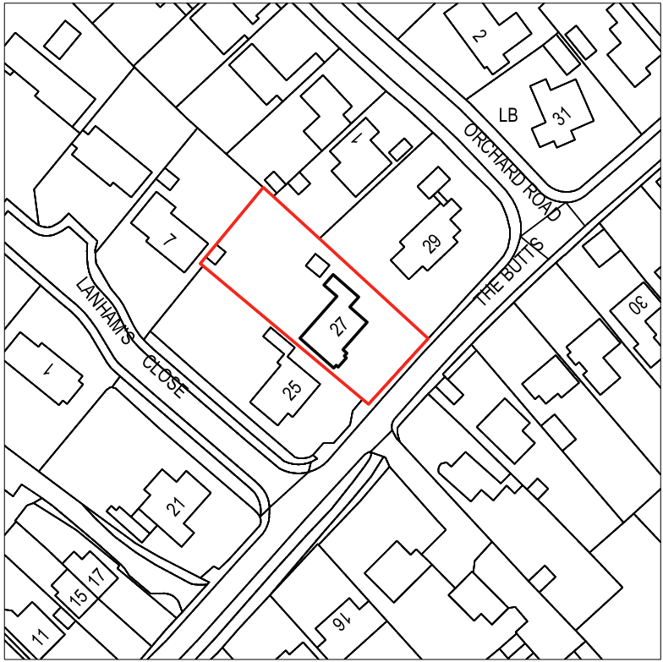

PROPOSAL

The proposal seeks planning permission for a hip‑to‑gable loft conversion to the existing detached bungalow, together with the construction of a flat‑roofed rear dormer and associated internal reconfiguration. The works would replace the current hipped roof form on both the north‑east and south‑west elevations with gable ends, and introduce a large box dormer to the rear roof slope. External materials are proposed comprising smooth render across all external-facing walls in place of the existing buff brick, with white uPVC fenestration to match the host property, while the dormer would be finished in anthracite fibre‑cement cladding and a ply‑membrane flat roof. The development also incorporates three new rooflights to the front roof slope. The proposed alterations seek to increase the internal living accommodation, while updating and rationalising the external appearance of the dwelling.

SITE DESCRIPTION / CONTEXT

The site comprises a detached bungalow situated within an established residential area of Westbury, located within the defined settlement boundary and within Flood Zone 1 for fluvial flood risk. Surrounding development is mixed in character, with a combination of bungalows and two-storey dwellings, most of which are detached. External materials in the locality vary, including red brick, pebbledash render, and red-tile roofs, giving the street a varied and evolving appearance; the host property itself is finished in buff Bradstone-style brick with red roof tiles. The immediate neighbour features a prominent front-facing dormer, reflecting the incremental and non-uniform pattern of development along the street. Many of the existing dwellings are set back from the road, providing front garden, on-site car parking provision and grass verges, with strong boundary vegetation, mature trees, and a narrow road alignment contributing to an organically developed town-edge vernacular. The site falls within several ecological constraint zones, including the Salisbury Plain SPA 6.4km buffer, a core roost buffer zone associated with the Bath and Bradford on Avon Bat Special Area of Conservation (SAC), and the Trowbridge and Westbury Bat Mitigation Strategy grey zone, with the site also being identified on the Council’s Strategic Flood Risk Assessment (SFRA) as being in an area at high risk of groundwater flood risk.

The application site is subject to the following planning policy constraints:

- Salisbury Plain SPA 6400m Buffer
- GHS 4km Core Roost Buffer
- Trowbridge and Westbury Bat Mitigation Strategy (TWBMS) Grey Zone
- Strategic Flood Risk Assessment (sFRA) indicates groundwater flood risk
- Flood Zone 1
- Within the Westbury Settlement Boundary (Market Town)

PLANNING HISTORY

No relevant planning history has been identified for the site subject of this application.

RELEVANT LEGILSATION, POLICIES AND GUIDANCE

Wiltshire Core Strategy:

Core Policy 1 Settlement Strategy;
Core Policy 2 Delivery Strategy;
Core Policy 32 Spatial Strategy: Westbury Community Area;
Core Policy 50 Biodiversity and Geodiversity;
Core Policy 51 Landscape;
Core Policy 57 Ensuring High-Quality Design and Place Shaping;
Core Policy 60 Sustainable Transport;
Core Policy 61 Transport and Development;
Core Policy 64 Demand Management;
Core Policy 67 Flood Risk;

Westbury Neighbourhood Plan 2023-2036 (March 2024)

The National Planning Policy Framework (NPPF)

The Planning Practice Guidance (PPG)

Wiltshire Design Guide - Appendix D – Design Guidance for Householder extensions

The Wiltshire Local Transport Plan 2011 – 2026: Car Parking Strategy (March 2015).

The Wiltshire Local Transport Plan 4 (LTP4) (March 2025)

Emerging Policy – Wiltshire Local Plan Review: The examination of the emerging Wiltshire Local Plan has been paused and the weight to be afforded to any part of the emerging plan can be no more than very limited. A decision on how to proceed will be made by the Council in May 2026.

CONSULTATION RESPONSES

Westbury Town Council: No Objection

Ecology (Wiltshire Council): No Objection

REPRESENTATIONS

No comments received.

ASSESSMENT

Section 38(6) of the Planning and Compulsory Purchase Act 2004 states:

"If regard is to be had to the development plan for the purposes of any determination to be made under the planning Acts, the determination must be made in accordance with the plan unless material considerations indicate otherwise."

In accordance with this statutory requirement, this application has been assessed against the relevant policies of the Development Plan, including the adopted Wiltshire Core Strategy (2015) and, where applicable, any made Neighbourhood Plans.

Design and Impact upon the upon the character and context of the area

Core Policy 57 of the adopted Wiltshire Core Strategy seeks to ensure that all new development is of high design quality, reflecting local context, character, and distinctiveness.

Section 12 of the NPPF emphasises that design should be visually attractive; functionally effective and contributes to the quality of the built environment.

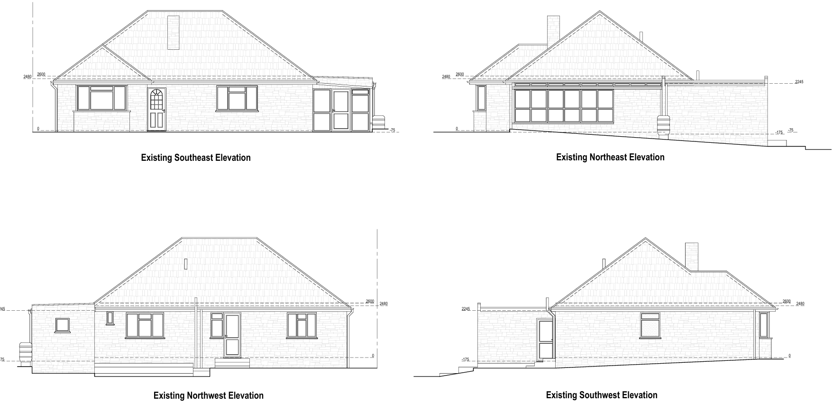
Existing Elevations

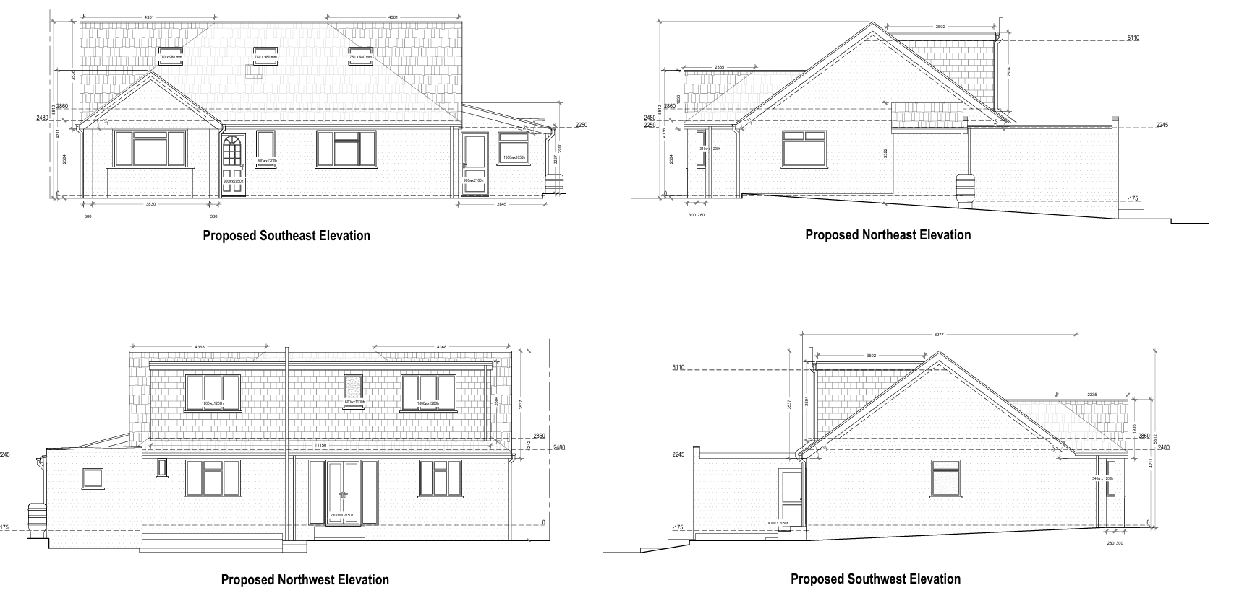
Proposed Elevations

From a design perspective, the proposal remains well-integrated within the varied architectural context of the surrounding area. The full re-rendering of the elevations is considered acceptable given that render is already a prominent material locally and there is no consistent or uniform design theme within the streetscene.

The anthracite cladding to the rear dormer, while not widespread, is a muted finish that sits comfortably within the character of the area and is positioned on the rear roof slope, limiting its prominence from the public realm. Whilst the proposed dormer would be large in size, it is duly noted that the neighbouring property has an existing flat roof dormer on the front elevation.

The proposed dormer at No. 27 would itself be proportionately scaled, set below the ridge, and set within the existing eaves, and reflects direct local precedent, including a similarly prominent front-facing dormer on the adjoining property and two further examples opposite.

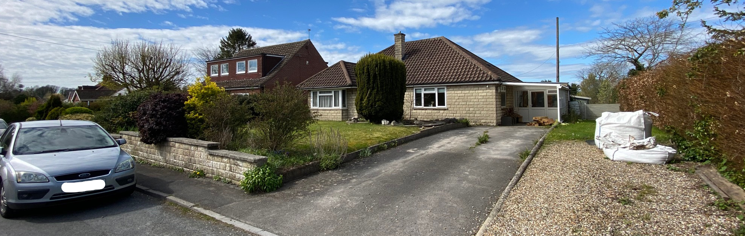
Site Visit (Front Elevation)
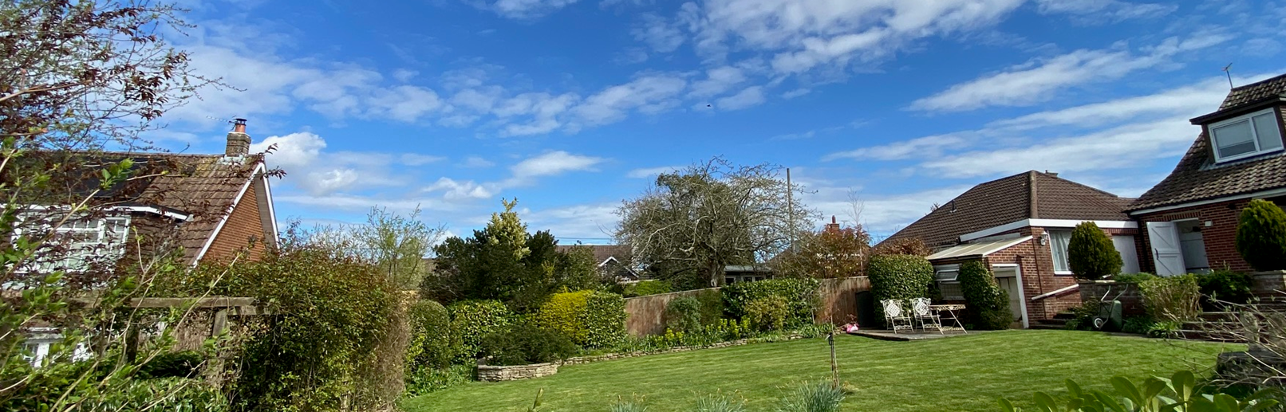
Site Visit (Rear Elevation from Lanham’s Close)

The proposed front-facing rooflights would be visually modest and significantly less dominant than the neighbour’s large dormer, ensuring their presence is cohesive and of minimal impact on the streetscene. The hip-to-gable treatment of the front bay projection is similarly appropriate: in the context of the larger roof alterations, it provides visual consistency, avoids an awkward mix of hipped and gabled forms, and reflects several nearby dwellings which feature matching front gabled bay elements.

The hip-to-gable enlargement to the main roof also responds well to the local context, as gabled-end properties are common in the immediate area. Finally, the minor alteration to the side elevation, replacing a lightweight glazed utility structure with a slightly more substantial timber-and-tile element, remains low-level, well-screened by boundary treatments, and visually modest. As such, it results in no material design impact and arguably improves coherence with the other proposed works. Overall, the scheme represents a proportionate and contextually sympathetic set of alterations that would integrate effectively with the established but varied character of the locality.

Having regard to the above, the proposal complies with the design principles set out in Core Policy 57 of the Wiltshire Core Strategy and Appendix D of the Wiltshire Design Guide.

Amenity

Point (vii) of Core Policy 57 of the Wiltshire Core Strategy requires development to protect the amenities of neighbouring occupiers, and paragraph 135 of the NPPF emphasises that proposals must secure a high standard of amenity for existing and future users.

The proposed loft conversion introduces new first-floor rear-facing windows; however, the primary outlook to the northwest achieves a separation distance of approximately 26.7 metres to the nearest dwelling, which is sufficient to avoid harmful overlooking. Views towards neighbouring properties to the northeast and southwest would be at an oblique angle, and even at a 45-degree line of sight, the distance remains around 14 metres, thereby mitigating any perception of direct overlooking. It is also appreciated that the application site is located within an established residential area, where a degree of mutual overlooking is commonplace.

In terms of scale and massing, the hip-to-gable enlargement on the southwest elevation runs parallel with the adjacent dwelling and therefore would not result in an overbearing impact or loss of privacy to its internal rooms or outdoor amenity space. On the northeast side, the alteration is set back by around 7 metres and constitutes only a modest increase in built form, meaning it would not give rise to demonstrable harm through overshadowing or visual dominance. The rear dormer is positioned on the north-western roof slope, largely outside the sun path and below the main ridge height, and as such would not materially affect light levels to neighbouring occupiers. Overall, the proposal is appropriately sited, designed, and orientated to safeguard the living conditions of surrounding occupiers, and therefore complies with Core Policy 57(vii) and the amenity principles set out in Appendix D of the Wiltshire Design Guide, as well as paragraph 135 of the NPPF.

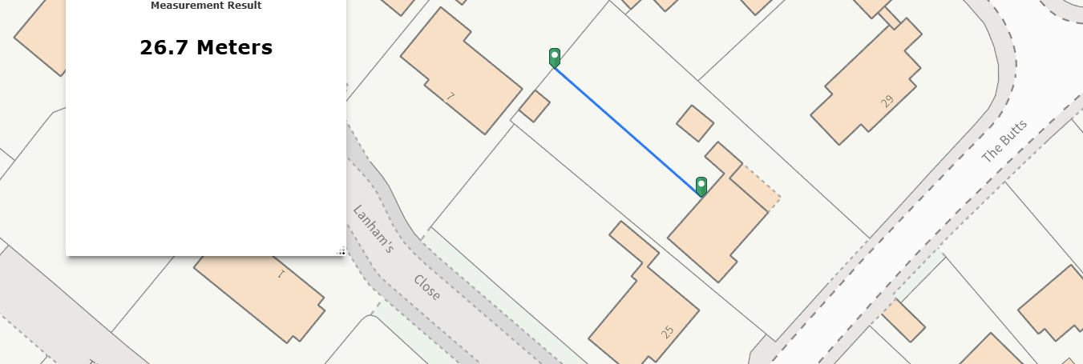
Distance to Northwest boundary

Other Issues

The proposal has been assessed against Core Policies 60, 61 and 64 of the Wiltshire Core Strategy, which collectively require development to promote safe and efficient movement, prioritise sustainable transport users, provide safe access to the highway network, and comply with adopted parking standards. Paragraph 116 of the NPPF further states that development should only be refused on highways grounds where it would result in an unacceptable impact on highway safety or where the residual cumulative impacts on the road network would be severe.

The existing dwelling contains two bedrooms, and the proposal would increase this to four through the loft conversion. Under Table 7.1 of the Wiltshire Car Parking Strategy, a dwelling of four or more bedrooms requires a minimum provision of three off-street parking spaces. The submitted block plan confirms that the existing driveway extends approximately 17.1 metres from the dwelling to the site boundary, which is sufficient to accommodate at least three standard parking spaces measuring 2.4m x 4.8m, and no alterations are proposed to the existing access arrangements. As the scheme maintains adequate off-street parking provision in accordance with Core Policy 64 and does not give rise to any highway safety concerns, the development is considered acceptable in highways and parking terms.

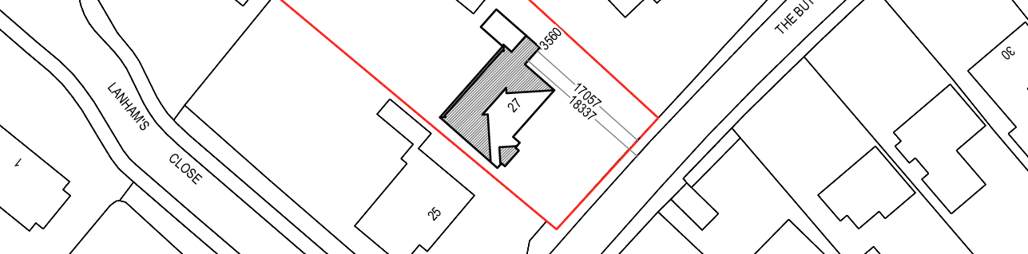
Proposed Block Plan

The proposal has been assessed against Core Policy 50 of the Wiltshire Core Strategy, which requires development to avoid and minimise harm to sensitive habitats and protected species while applying the mitigation hierarchy. Although Biodiversity Net Gain became mandatory from February 2024, Schedule 7A of the Town and Country Planning Act 1990 confirms that householder applications are exempt, and therefore no BNG requirement applies in this case.

The site lies within the 6.4km buffer of the Salisbury Plain SPA and within both the TWBMS grey zone and Greater Horseshoe Bat core roost buffer; however, the Council’s Habitat Regulations screening, undertaken as Competent Authority, concluded that the proposed loft conversion would not result in habitat loss or increased recreational pressure, and that the dwelling is unlikely to support Annex II bat species given its construction, urbanised context, and lack of suitable roost features. As such, the application is screened out of Appropriate Assessment for both the Salisbury Plain SPA and Bath & Bradford-on-Avon Bat SAC. While the risk of roosting bats is considered low, the Ecology Officer advises that a protected-species informative be attached to any permission due to the ecological sensitivities of the wider area, particularly as works involve the roof space, and encourages minor biodiversity enhancements where feasible. Subject to the inclusion of this informative, the development is considered acceptable with regard to ecology and compliant with CP50 and national policy

Core Policy 67 of the Wiltshire Core Strategy, Policy 95 of the emerging Wiltshire Local Plan and relevant sections of the NPPF require new development to appropriately manage flood risk through a risk-based, sequential approach and ensure that surface water run-off is not exacerbated. Although the site lies within Flood Zone 1, the SFRA identifies a potential risk of groundwater flooding; however, the works do not enlarge the footprint of the dwelling and therefore would not increase impermeable surface area or alter existing surface water pathways. The proposed bathroom within the converted roof space would utilise the existing foul drainage system, which appears to operate satisfactorily and raises no concerns. In line with NPPF paragraph 176, the development constitutes minor householder works below 250m² and is therefore exempt from the sequential and exception tests. Given the limited scope of the works, the absence of any identified drainage issues, and the reliance on existing drainage infrastructure, the proposal is considered to pose no material risk in terms of drainage or flood risk and is therefore compliant with CP67 and national policy.

CONCLUSION

The proposal is considered to be acceptable and in accordance with the relevant policies and guidance outlined above.

RECOMMENDATION: That Planning Permission be GRANTED subject to the following conditions:

1.
The development hereby permitted shall be begun before the expiration of three years from the date of this permission.
REASON: To comply with the provisions of Section 91 of the Town and Country Planning Act 1990 as amended by the Planning and Compulsory Purchase Act 2004.

2.
The development hereby permitted shall be carried out in accordance with the following approved plans and documents:

Proposed Section A-A D08 (16 February 2026)
Proposed Ground Floor and Loft Plans D03 (9 February 2026)
Proposed Elevations D07 (9 February 2026)
Proposed Roof Plan (9 February 2026)
Location Plan, Exisiting and Proposed Block Plans D01 (9 February 2026)

REASON: For the avoidance of doubt and in the interests of proper planning.

