APPLICATION FOR HOUSEHOLDER PLANNING PERMISSION
DELEGATED REPORT

APPLICATION REFERENCE: | PL/2026/00763
APPLICATION TYPE: | Householder planning permission
SITE ADDRESS: | 8 Lowmead, Trowbridge, BA14 8SX
DEVELOPMENT DESCRIPTION: | Side, rear and porch extension with a new roof
RECOMMENDATION: | That Planning Permission be GRANTED

SITE DESCRIPTION/CONTEXT

The subject property is a detached, two-storey dwelling in an area of C20 suburban Trowbridge, north of the city centre, characterised by shared design, materiality, modern road layout, and public open space opposite.

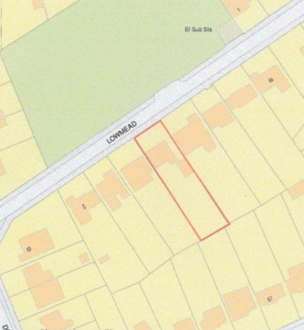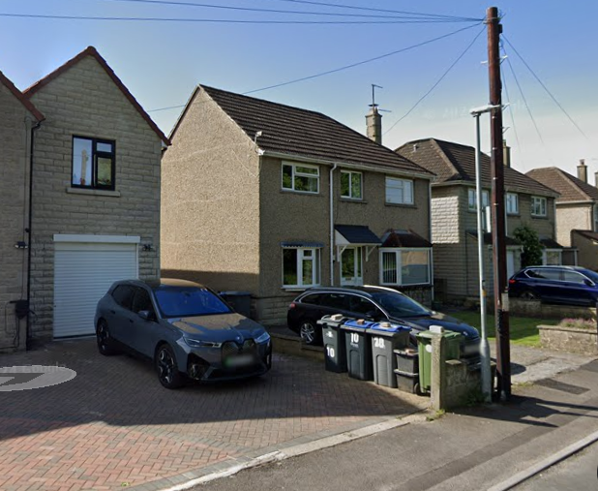

Location Plan and Google Earth Site Photo

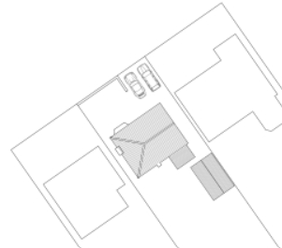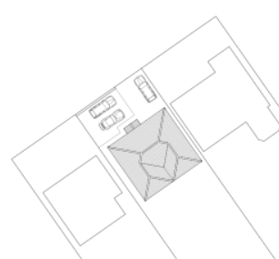

Existing and Proposed Block Plan

PROPOSAL

The proposal is to:
- Demolish existing rear garage, porch and chimney.
- Two storey side extensions reducing spatial gap to side boundaries
- Two storey rear extension, projecting no further than existing rear single storey extension.
- Reconfiguration of fenestration to front elevation, including removal of two bay windows, replacing with smaller windows, to create a double fronted elevation
- Addition of front porch
- Approx. 2.6m rear extension, 1.6m side extension.
- Creation of additional hardstanding across whole front garden for off-street parking

The proposal would basically see the rebuilding of the side and rear, with a new roof; adding a second hip to the front and two gables to the rear.

Only the hallway and staircase against the spine wall would be retained, all other rooms would be reconfigured. On the ground floor this would create an open-plan kitchen/dayroom, separate utility, WC and third reception room. On the first floor this would see the creation of a larger bedrooms, creating an ensuite bathroom, extending the landing area, and creation of replacement 4th bedroom.

Proposed materials include sandstone coloured K concrete render against existing pebble dash and brick, grey Stonewold roof tiles against existing profiled concrete roof tiles, and matching uPVC windows.

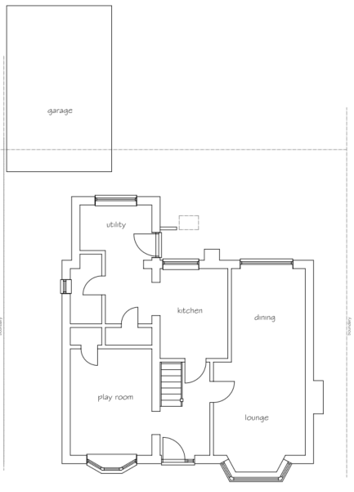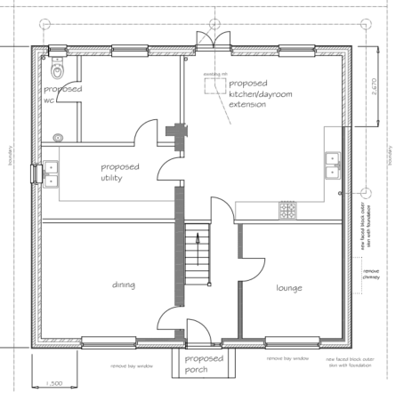

Existing and Proposed Ground Floor Plan

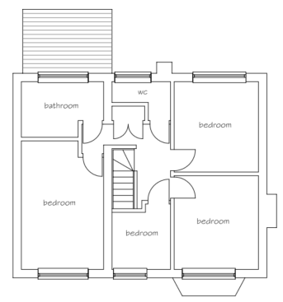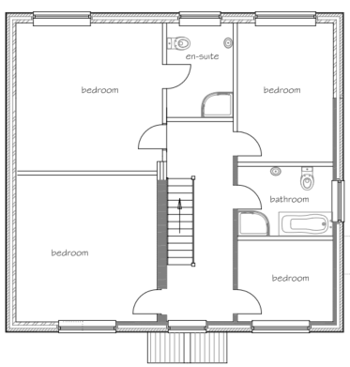

Existing and Proposed First Floor Plan

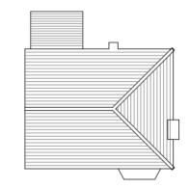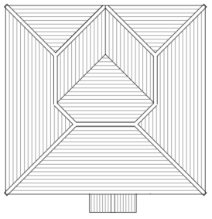

Existing and Proposed Roof Plans

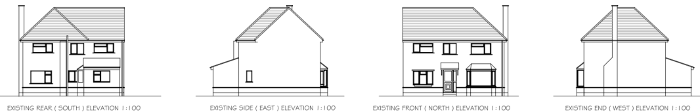

Existing Elevations

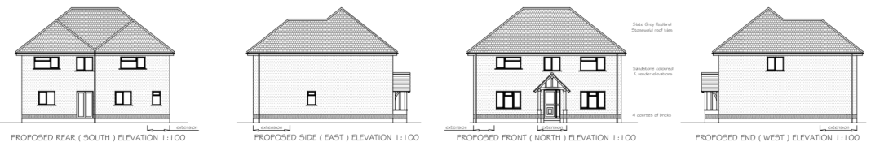

Proposed Elevations

PLANNING HISTORY
W/77/00016/HIS - Historic apps 1974 to 1983 Decision - Approved Date: 9/9/1977 – Extension to cottage (unclear why ‘cottage’ address – only fields before this dwelling)
W/98/00300/FUL - Full planning permission Decision - Approve with Conditions Date: 23/3/1998 – Ground floor extensions
W/81/00213/HIS - Historic apps 1974 to 1983 Decision - Approve with Conditions Date: 31/3/1981 – Alterations and additions to provide additional accommodation – no. 6
W/01/00894/FUL - Full planning permission Decision - Approve with Conditions Date: 25/7/2001 – Garage extension – no. 6
PL/2022/09852 - Householder planning permission Decision - Approve with Conditions Date: 21/2/2023 – Rear kitchen extension, first floor bedroom extensions – no.10
W/88/01110/FUL – extension and porch – approve with conditions – no.10

RELEVANT POLICIES AND GUIDANCE
The National Planning Policy Framework (NPPF)
The Planning Practice Guidance
National Design Guide
Wiltshire Design Guide: Appendix D – Design Guidance for Householder extensions

Wiltshire Core Strategy:
- Core Policy 57 Ensuring High Quality Design and Place Shaping
- Core Policy 61: Transport and New Development
- Core Policy 64: Demand Management

Trowbridge has a designated Neighbourhood Plan area, but no made plans as yet.

CONSULTATION RESPONSES
Trowbridge Town Council: No objection, subject to no significant adverse impact on neighbouring amenity.

REPRESENTATIONS
No comments were received.

ASSESSMENT

Principle of Development:
Section 70(2) of the Town and Country Planning Act 1990 and section 38(6) of the Planning and Compulsory Purchase Act 2004, require that the determination of planning applications must be made in accordance with the Development Plan, unless material considerations indicate otherwise.

The proposal comprises development to an existing residential property set in an established residential area within the settlement boundary of Trowbridge. The proposal is wholly within the residential curtilage, and as such, the principle of development is acceptable subject to the following considerations.

In accordance with this statutory requirement, this application has been assessed against the relevant policies of the Development Plan, including the adopted Wiltshire Core Strategy (2015) and, where applicable, any made Neighbourhood Plans.

Design and Impact upon the character and context of the area
Core Policy 57 - Ensuring High Quality Design and Place Shaping of the Wiltshire Core Strategy seeks to ensure that all new development is of high design quality, reflecting local context, character, and distinctiveness.

The proposal would see extensive remodelling of the dwelling, with a new roof form, external materials, widened footprint towards side boundaries, reconfiguration of fenestration and internal layout.

The proposal would introduce render above the existing recon stone foundation plinth to replace pebbledash, and Stonewold grey roof tiles, making considerable design and aesthetic alterations.

The dwelling is very much of its time, and lends itself to substantial reworking, and the opportunity for thermal upgrades.

The proposed roof form would reflect the double hips and gables as per precedent development along the street. Again, whilst proposed materials differ from existing, they can be considered modern replacements with intrinsic benefits, and as such, both are considered appropriate with the opportunity to integrate successfully within the streetscape.

Planning permission PL/2022/09852, saw immediate neighbour no.10 reduce the spatial gap to the subject dwelling, by a first floor extension over an existing garage. Similar to the current proposal, the neighbouring development created increased massing and bulk with an extension the full depth of the dwelling. Given this precedent, and the proposed development aligning to neighbouring building lines, with the roof ridge height retained, with a hip on each side, the proposal would not present as incongruous between its neighbours and so is considered to be within acceptable parameters.

The proposed increase of volume is considered commensurate to the plot and in line with similar developments and would continue to satisfactorily assimilate with the size of the plot, neighbouring properties and streetscene in this locality.

Having regard to the above, the proposal complies with the design principles set out in Core Policy 57 of the Wiltshire Core Strategy and Appendix D of the Wiltshire Design Guide.

Amenity
Point vii of Core Policy 57 - Ensuring High Quality Design and Place Shaping of the Wiltshire Core Strategy seeks to ensure that developments do not adversely affect neighbouring properties.

The National Planning Policy Framework (NPPF), particularly Paragraph 135(f), stresses that planning decisions should ensure developments provide a high standard of amenity for existing and future users.

The proposed development has been assessed in terms of its potential impact on the residential amenity of neighbouring properties, with particular regard to loss of light, overshadowing, loss of privacy, and overbearing effects. No third party representations have been received to indicate any particular aspects of concern to adjacent residents.

The proposal has been assessed to not result in a material loss of sunlight, with existing overshadowing to no.6 to the south in the morning not being substantially increased.

The existing rear building line would be adhered to, with massing to both side elevations, matching two storey massing of both immediate neighbours. Given that neighbouring dwellings are aligned, the impact of this additional massing is mitigated and considered acceptable. The proposed roof hip and dormers also reduce the sense of mass.

Given the precedent development at no.10 projecting towards the subject dwelling, and the proposed development aligning to neighbouring building lines, with the roof ridge height retained, with a hip on each side, the proposal would not see an unacceptable level of massing that would create overbearing impacts and so is considered to be within acceptable parameters in respect of amenity.

However, no.10 does have windows on its side elevation. These windows however all have conditioned opaque glazing to all 3 windows of uninhabitable rooms facing the subject dwelling in recognition of impact to privacy. As such the proximity to these windows is not considered to be unduly harmful.

A new bathroom window is proposed to the side elevation at first floor level, and as such this would need to be conditioned for opaque glazing only to manage neighbouring privacy.

The proposal therefore accords with Core Policy 57 point vii in respect of safeguarding residential amenity and Appendix D of the Wiltshire Design Guide.

Highways Impact
Core Policy 57 (xiv) of the Wiltshire Core Strategy seeks to ensure that development must meet the requirements of Core Policy 61. This policy requires proposals to be capable of being served by safe access to the highway network. Core Policy 64 seeks to ensure compliance with parking standards set out in the Local Transport Plan.

The National Planning Policy Framework (NPPF), particularly Paragraph 115 and 116, requires that development proposals do not have an unacceptable impact on highway safety and that safe and suitable access to the site can be achieved for all users.

The proposal does not seek to increase the number of bedrooms nor associated potential parking demand. The proposal does propose increased hardstanding for off-street parking. A condition is considered necessary to ensure the design of the hardstanding integrates SuDS appropriate materials, given the extent of the proposed hardstanding.

The proposed development would not result in any adverse impact on highway safety. Adequate parking and turning provision is provided in accordance with Wiltshire’s adopted parking standards, and access arrangements are acceptable.

The proposal is therefore considered to comply with Core Policies 57 (xiv), 61 and 64 of the Wiltshire Core Strategy, the NPPF, and the Wiltshire Local Transport Plan.

Biodiversity Net Gain
Householder planning applications are exempt from the requirement to deliver Biodiversity Net Gain under Schedule 7A, Section 4(2)(a) of the Town and Country Planning Act 1990, as inserted by the Environment Act 2021.

CONCLUSION
The proposed development is considered to be acceptable in terms of its design, scale, and relationship with the surrounding area. It would not result in any unacceptable harm to the character of the locality, the amenities of neighbouring occupiers, or the interests of highway safety.

The proposal is therefore considered to comply with the relevant policies of the Wiltshire Core Strategy, the Wiltshire Local Plan, and the National Planning Policy Framework

RECOMMENDATION: That Planning Permission be GRANTED subject to conditions.

