APPLICATION FOR HOUSEHOLDER PLANNING PERMISSION
DELEGATED REPORT

APPLICATION REFERENCE: | PL/2026/00599
APPLICATION TYPE: | Householder planning permission
SITE ADDRESS: | 40 Shaftesbury Road, Wilton, Salisbury, SP2 0DR
DEVELOPMENT DESCRIPTION: | Single storey rear extension, new porch, conversion of garage to habitable accommodation, internal alterations and landscaping to front garden to create additional parking
RECOMMENDATION: | That Planning Permission be GRANTED

PROPOSAL

The proposal seeks planning permission for a single storey rear extension, internal alterations, including the conversion of attached garage to habitable accommodation, a new porch on the south elevation and alterations to the front garden/driveway to provide a second parking space. The property will retain four bedrooms.

Revised plans were received 04.03.2026 confirming proposed materials and responding to comments from the Highways Officer.

Existing Proposed

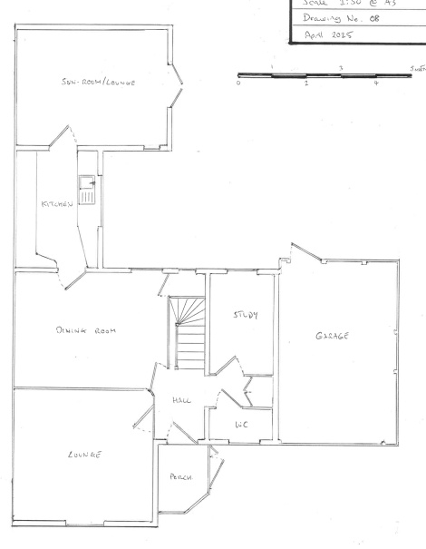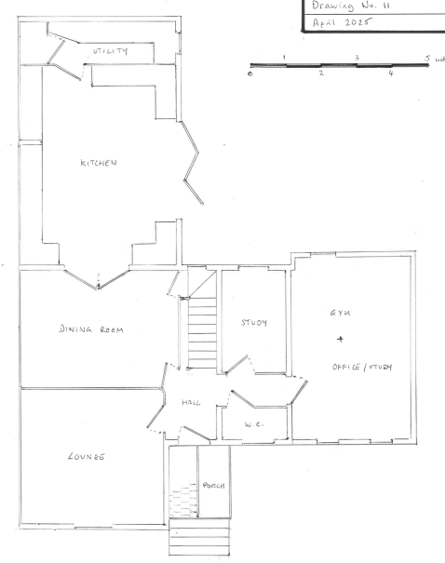

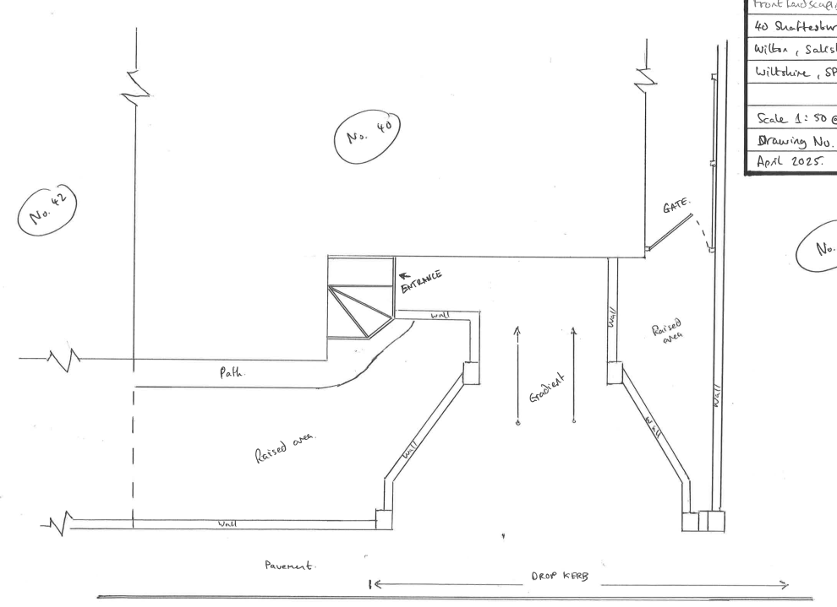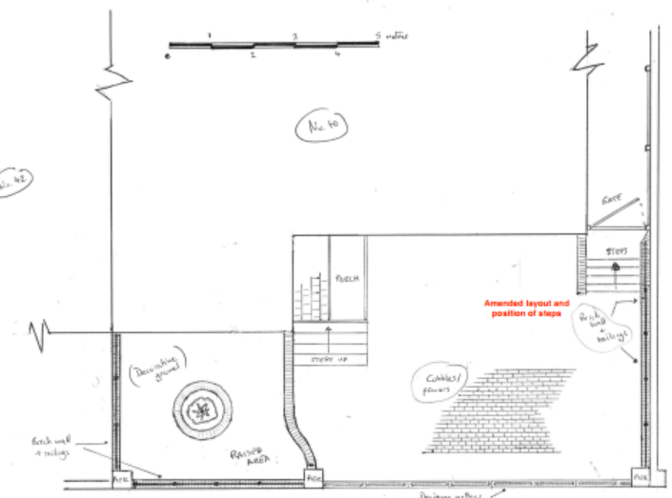

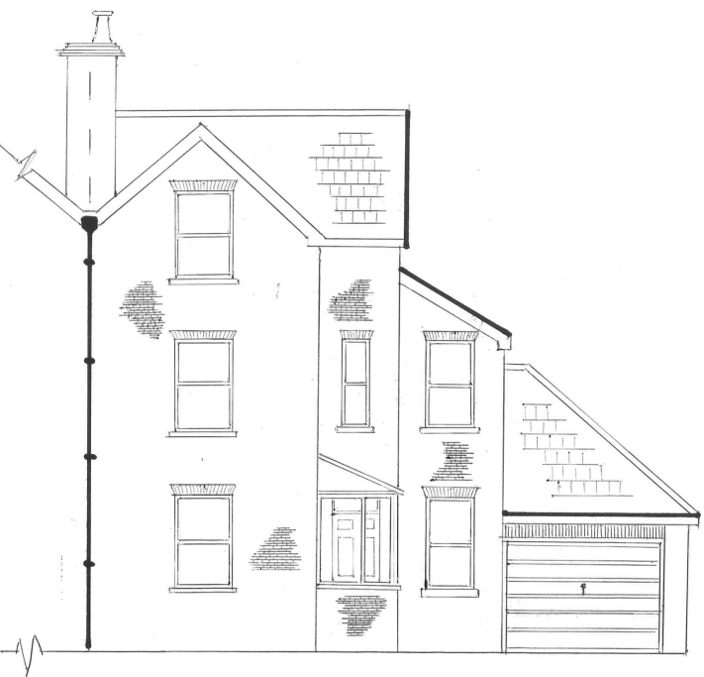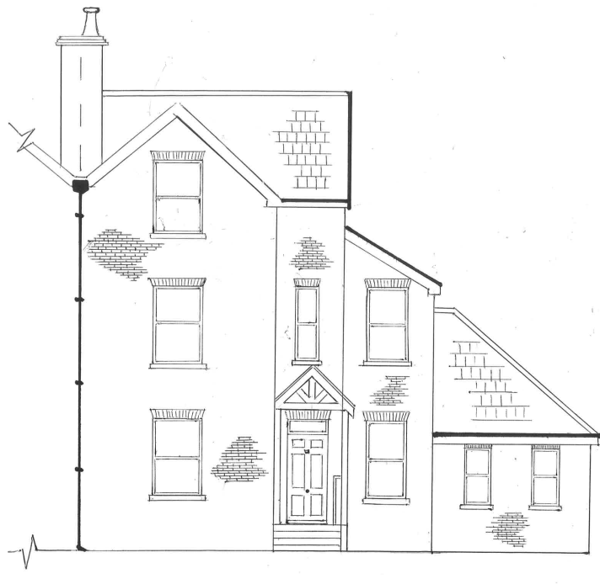

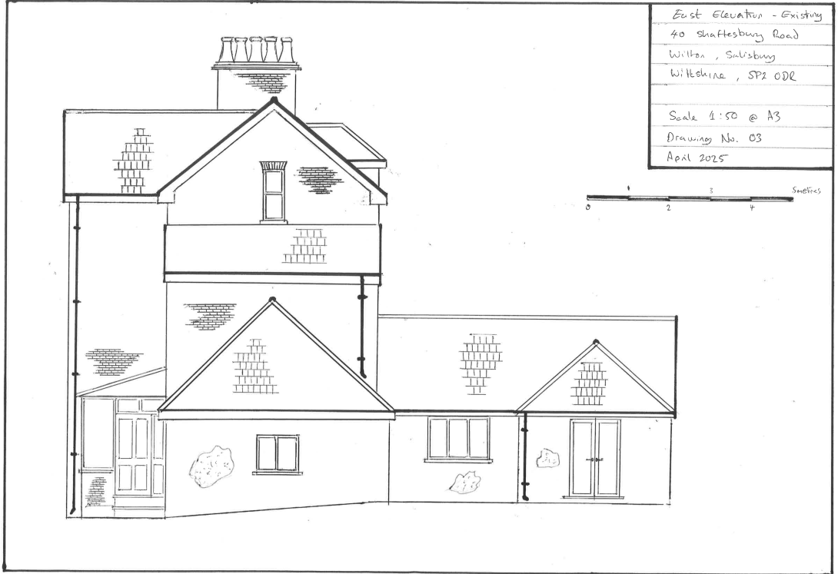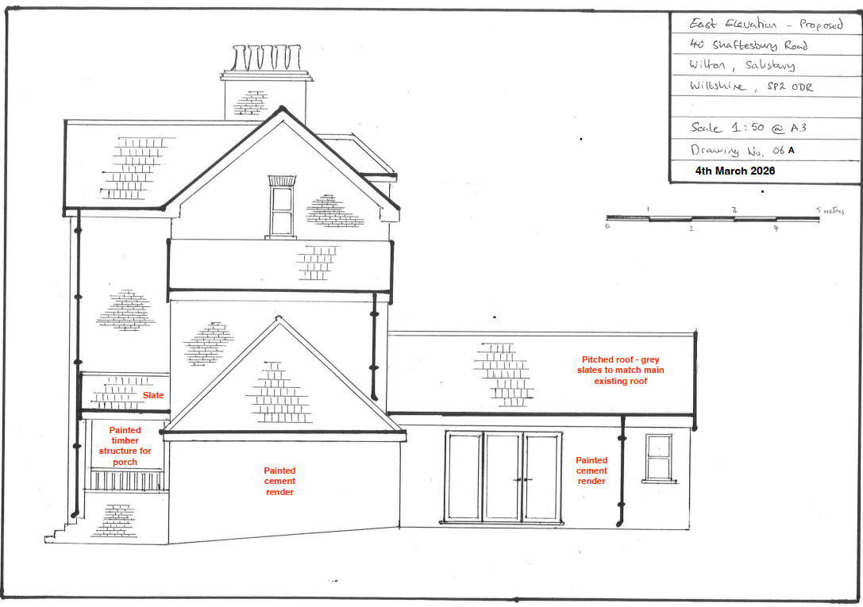

SITE DESCRIPTION/CONTEXT

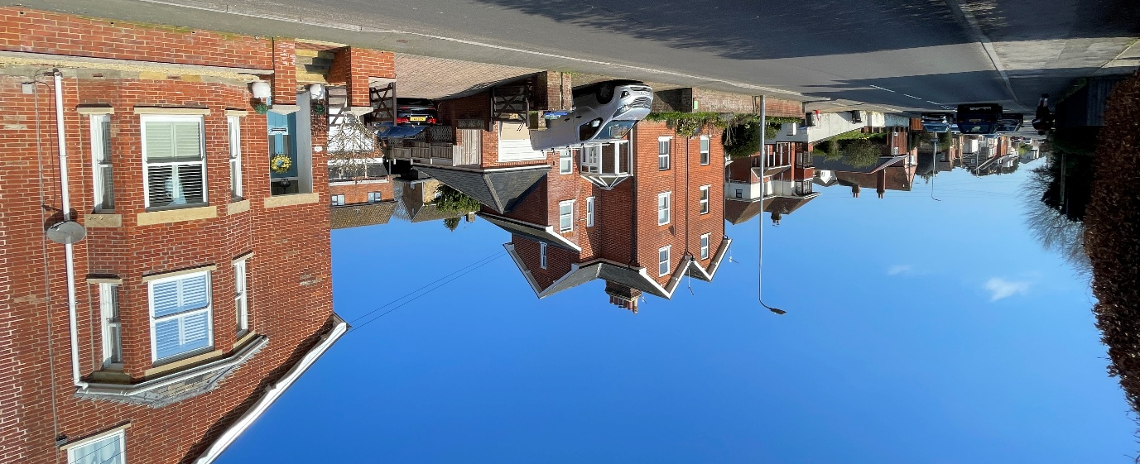

The application relates to 40 Shaftesbury Road, a semi-detached three storey dwelling located within the settlement boundary of the Local Service Centre of Wilton, as defined by Wiltshire Core Strategy (WCS) core policies 1 (Settlement Strategy), 2 (Delivery Strategy) and 33 (Spatial Strategy for the Wilton Community Area).

The property has been extended several times resulting in a variety of roof pitches and materials. There is a level change across the site with the rear garden at two levels and the ground rising towards Victoria Road.

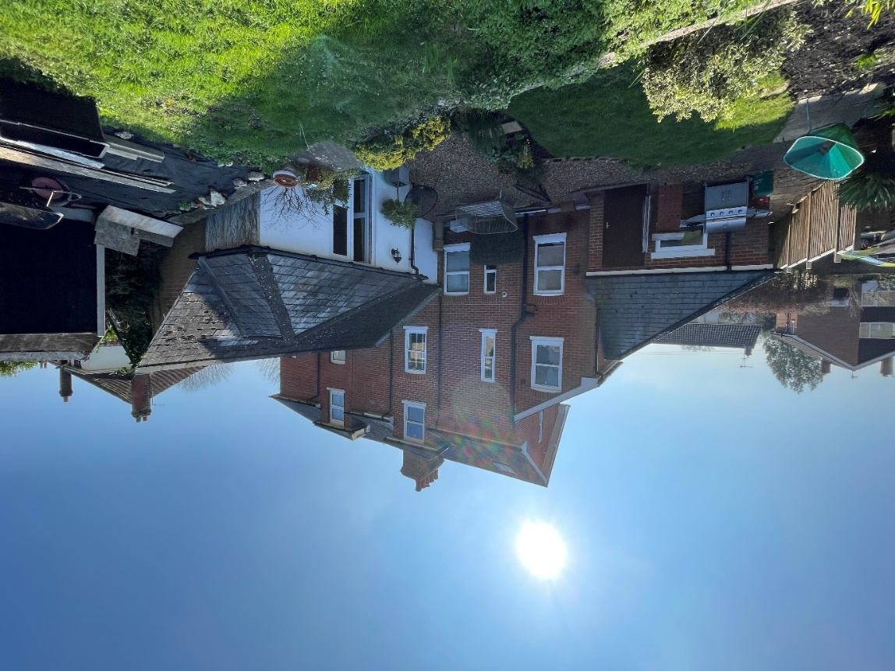

The property is surrounded by residential dwellings. The neighbours to the north (27 and 29 Victoria Road) are part of a modern development and are situated at a significantly higher level than 40 Shaftesbury Road.

View from garden looking north

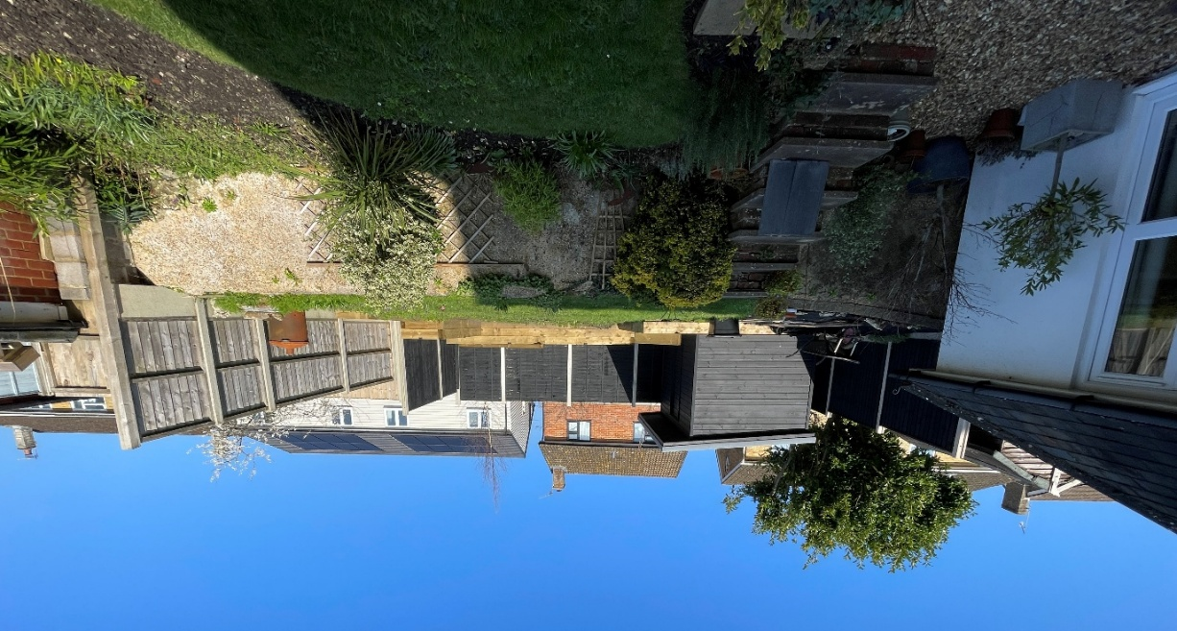

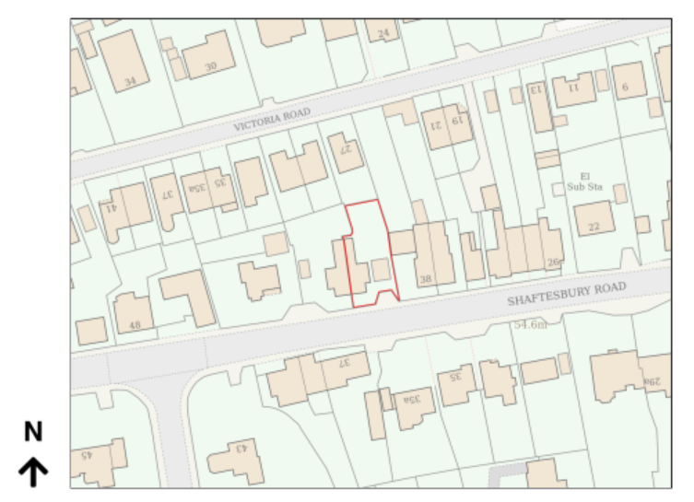

The application site is opposite Grade II listed 37, 39 and 41 Shaftesbury Road but outside of the conservation area.

The application site is within the catchment of the Hampshire River Avon Special Area for Conservation (SAC) and within Flood Zone 1.

PLANNING HISTORY

Proposal / Summary
S/2003/1710 Two storey side extension, single storey rear extension, pitched roof over garage, approve with conditions 06/10/2003

RELEVANT POLICIES AND GUIDANCE

Wiltshire Core Strategy:
- Core Policy 1: Settlement Strategy
- Core Policy 2: Delivery Strategy
- Core Policy 33: Spatial Strategy for the Wilton Community Area
- Core Policy 50: Biodiversity and Geodiversity
- Core Policy 57 Ensuring High Quality Design and Place Shaping
- Core Policy 58: Ensuring the Conservation of the Historic Environment
- Core Policy 67: Flood Risk
- Core Policy 69: Protection of the River Avon SAC

Wiltshire Design Guide: Appendix D – Design Guidance for Householder extensions

The National Planning Policy Framework (NPPF)

The Planning Practice Guidance

National Design Guide

CONSULTATION RESPONSES

Wilton Town Council: Support

Highways Officer: Holding objection
The number of bedrooms in the property is remaining at 4 and therefore the current parking provision of 2 spaces must be maintained. The proposal to extend the front parking area is acceptable in principle, however the steps to the rear gate extend into the parking area which must be a minimum of 4.8m in length and 2.4m x 2 = 4.8m in width, this is easily achievable if the steps to the rear gate are re-orientated so they are accessed south-north rather than west-east.
Therefore I offer a holding objection and look forward to revised plans.

Following receipt of revised plans: no objection subject to conditions

I refer to the amended plans for the above application which show the steps to the rear garden gate moved to be accessed from the south. This is now acceptable and two parking spaces are provided.
I raise no highway objection providing the following conditions are imposed:
The development hereby permitted shall not be first brought into use until the whole of the parking area, has been consolidated and surfaced (not loose stone or gravel). The access shall be maintained as such thereafter.
REASON: In the interests of highway safety.
The vehicle access and parking spaces shall remain ungated.
REASON: In the interests of highway safety.
The proposed development shall not be first brought into use until means/works have been implemented to avoid surface water from entering the highway.
REASON: To ensure that the highway is not inundated with surface water.

REPRESENTATIONS

No comments were received.

ASSESSMENT

Section 38(6) of the Planning and Compulsory Purchase Act 2004 states:

"If regard is to be had to the development plan for the purposes of any determination to be made under the planning Acts, the determination must be made in accordance with the plan unless material considerations indicate otherwise."

In accordance with this statutory requirement, this application has been assessed against the relevant policies of the Development Plan, including the adopted Wiltshire Core Strategy (2015); the saved policies in the Salisbury District Local Plan and, where applicable, any made Neighbourhood Plans.

Design and Impact upon the character and context of the area

Core Policy 57 - Ensuring High Quality Design and Place Shaping of the Wiltshire Core Strategy seeks to ensure that all new development is of high design quality, reflecting local context, character, and distinctiveness.

The proposal seeks planning permission for a single storey rear extension, internal alterations, including the conversion of an attached garage to habitable accommodation, a new porch on the south elevation and alterations to the front garden/driveway to provide a second parking space in lieu of the garage. The property will retain four bedrooms.

The proposed rear extension would infill between an existing single storey rear extension and the original dwelling, creating a larger kitchen and a utility room. It is proposed to remove a hipped section of roof and replace it with an area of flat roof. There would be a small window and set of glazed doors on the east elevation. The walls are proposed to be painted render, to match the existing.

The existing attached garage is proposed to be converted into habitable accommodation (gym/office/study) with the existing garage door proposed to be infilled with facing brick and two windows on the street facing (south) elevation and a window infilled on the east elevation and window infilled and a door replaced with a window on the garden facing (north) elevation. The windows are proposed to be in proportion to the existing dwelling.

The proposed timber frame porch will replace an existing uPVC porch. Works are proposed to the front garden to create a second off-road parking space and steps up to the proposed new porch. A new brick wall with piers and railings are proposed to the east and west boundaries and part of the south boundary. The driveway area will be surfaced with cobbles/pavers.

It is considered that the proposed extension and alterations reflect the existing dwelling character in terms of materials and detailing. The extension would remain subservient and would not detract from the integrity of the existing building.

The proposed changes to the front garden and porch are traditional in design and materials and preserve the character and appearance of the area.

Having regard to the above, the proposal complies with the design principles set out in Core Policy 57 of the Wiltshire Core Strategy and Appendix D of the Wiltshire Design Guide.

Amenity

Point vii of Core Policy 57 - Ensuring High Quality Design and Place Shaping of the Wiltshire Core Strategy seeks to ensure that developments do not adversely affect neighbouring properties.

The National Planning Policy Framework (NPPF), particularly Paragraph 135(f), stresses that planning decisions should ensure developments provide a high standard of amenity for existing and future users.

The proposed development has been assessed in terms of its potential impact on the residential amenity of neighbouring properties, with particular regard to loss of light, overshadowing, loss of privacy, and overbearing effects.

The proposed windows face the rear garden in a similar orientation to existing windows and do not introduce any new opportunities for overlooking. The proposed extension is modest in scale and single storey so there are no concerns regarding overbearing impact or overshadowing.

The proposal therefore accords with Core Policy 57 point vii in respect of safeguarding residential amenity and Appendix D of the Wiltshire Design Guide.

Highways Impact
Core Policy 57 (xiv) of the Wiltshire Core Strategy seeks to ensure that development must meet the requirements of Core Policy 61. This policy requires proposals to be capable of being served by safe access to the highway network. Core Policy 64 seeks to ensure compliance with parking standards set out in the Local Transport Plan.

The National Planning Policy Framework (NPPF), particularly Paragraph 115 and 116, requires that development proposals do not have an unacceptable impact on highway safety and that safe and suitable access to the site can be achieved for all users.

The conversion of the garage into habitable accommodation will result in the loss of one parking space. The property is to retain 4 bedrooms and so the current provision of two off-road parking spaces must be maintained. The proposals include for hard landscaping works to the front garden to create a second off-road parking space.
Following initial comments from the Highways Officer, a revised site plan was received, and no objection was confirmed by the Highways Officer, subject to conditions relating to the surface of the parking area, the access remaining ungated and surface water works being completed. These conditions will be included in the decision notice.
The proposed development would not result in any adverse impact on highway safety. Adequate parking and turning provision is provided in accordance with Wiltshire’s adopted parking standards, and access arrangements are acceptable.

The proposal is therefore considered to comply with Core Policies 57 (xiv), 61 and 64 of the Wiltshire Core Strategy, the NPPF, and the Wiltshire Local Transport Plan.

Ecology Impact
Core Policy 50 of the Wiltshire Core Strategy seeks to protect and enhance biodiversity and geodiversity, including through ensuring that development avoids harm to protected species and habitats.

The National Planning Policy Framework (NPPF), in Paragraphs 193, requires that development minimises impacts on and provides net gains for biodiversity, including ensuring mitigation is secured where harm cannot be avoided.

The application site is within the catchment of the Hampshire River Avon Special Area for Conservation (SAC) but due to the nature of the development, ecological impact is not an issue for this application. There is no reasonable likelihood of protected species being present or affected.
As such, the development complies with Core Policy 50 of the Wiltshire Core Strategy and the relevant provisions of the NPPF.

Biodiversity Net Gain

Householder planning applications are exempt from the requirement to deliver Biodiversity Net Gain under Schedule 7A, Section 4(2)(a) of the Town and Country Planning Act 1990, as inserted by the Environment Act 2021.

CONCLUSION

The proposed development is considered to be acceptable in terms of its design, scale, and relationship with the surrounding area. It would not result in any unacceptable harm to the character of the locality, the amenities of neighbouring occupiers, or the interests of highway safety or ecology.

The proposal is therefore considered to comply with the relevant policies of the Wiltshire Core Strategy, and the National Planning Policy Framework. As such, the application is recommended for approval, subject to the conditions set out below.

RECOMMENDATION: That Planning Permission be GRANTED subject to conditions.

- The development hereby permitted shall be begun before the expiration of three years from the date of this permission.

REASON: To comply with the provisions of Section 91 of the Town and Country Planning Act 1990 as amended by the Planning and Compulsory Purchase Act 2004.

- The development hereby permitted shall be carried out in accordance with the following approved plans and documents:

Location Plan PP-13917084v1, received 28/01/2026
Proposed Block Plan TQRQM25352170103589, received 28/01/2026
Drawing No. 11 Ground Floor – Proposed, received 13/02/2026
Drawing No. 12 First Floor – Proposed, received 13/03/2026
Drawing No. 13 Second Floor – Proposed, received 13/03/2026
Drawing No. 15/A Front Landscaping – Proposed, received 04/03/2026
Drawing No. 04/A South Elevation – Proposed, received 04/03/2026
Drawing No. 05/A North Elevation – Proposed, received 04/03/2026
Drawing No. 06/A East Elevation – Proposed, received 04/03/2026
REASON: For the avoidance of doubt and in the interests of proper planning.

- The materials to be used in the construction of the external surfaces of the development hereby permitted shall match in material, colour and texture those used in the existing building and detailed on the application form and approved plans.

REASON: In the interests of visual amenity and the character and appearance of the area.

- Notwithstanding the provisions of the Town and Country Planning (General Permitted Development) (England) Order 2015 (as amended) or any subsequent Order that revokes, re-enacts, amends (with or without modification), no windows, doors or other form of openings other than those shown on the approved plans, shall be inserted in the east elevation of the converted garage of the development hereby permitted.
﻿REASON: In the interests of residential amenity and privacy

- The development hereby permitted shall not be first brought into use until the whole of the parking area, has been consolidated and surfaced (not loose stone or gravel). The access shall be maintained as such thereafter.

REASON: In the interests of highway safety.
6. The vehicle access and parking spaces identified on the approved plans shall remain ungated.
REASON: In the interests of highway safety.
6. The development hereby permitted shall not be first brought into use until means/works have been implemented to avoid surface water from entering the highway.
REASON: To ensure that the highway is not inundated with surface water.

