Mr K R Merrick LCGI

Planning Department
Wiltshire Council
County Hall
Bythesea Road
Trowbridge
BA14 8JN

27 March 2026

Re: Formal Objection – Planning Application PL/2026/01525 (Planning in Principle)

Dear Sir/Madam,

I write as a long-standing resident of Common Platt, within the Parish of Lydiard Millicent, to register my formal objection to the above application by Messrs H & P Birch of Petroil Ltd who are my neighbours.

While the Petroil site currently operates as a well-maintained and viable business premises—offering employment opportunities and attracting interest from other companies—the proposed redevelopment raises serious concerns in relation to:

- Misrepresentation of site context and classification
- Flood risk
- Highway safety
- Loss of biodiversity
- Harm to local character
- Residential amenity
- Lack of strategic need

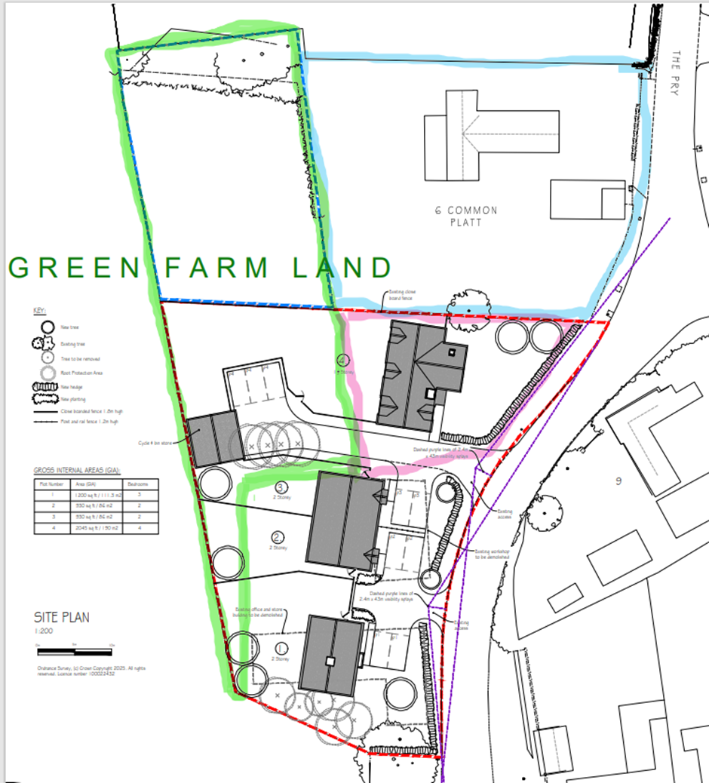
- Site Composition and Misrepresentation
The application misleadingly describes the entire site. In reality, it comprises:
- A viable and desirable operational business unit and offices with residential flats above and parking which they plan to destroy if permission is granted
- A small parcel of former residential garden (my own, sold to them circa 2012 after an annex application for my disabled mother was refused)
- A large greenfield area of open farmland with mature trees, shrubs, and established wildlife habitats which they are choosing to include and formally declared as within the NNR & SSSI (National Nature Reserve and Site of Special Scientific Interest)
The Planning Statement also contains inaccuracies regarding public transport links, nearby amenities, and public rights of way. For example:
- There is no safe pedestrian access or viable public transport serving the site
- Public rights of way do exist locally, contrary to the application’s claim
2. Flood Risk and Drainage
The site, particularly the green farmland to the west, lies in an area with a documented history of flooding—an issue Wiltshire Council is aware of.
- Surface water flooding has occurred regularly over the past 15 years, and is ever increasing and exacerbated by inadequate drainage and blocked ditches
- Floodwaters have contained visible oil pollutants, impacting local wildlife and water quality in the nearby lagoon which maybe as a consequence of buried waste
- The farmland sits at the base of a slope; during heavy rainfall, runoff water floods my garden and surrounds my property like that of a moat
Development here, with increased hardstanding, would significantly worsen this risk for my home and neighbouring properties.
3. Highway Safety
The proposed two new accesses open directly onto a narrow and fast-moving “C” road just metres from a hazardous roundabout. This route is already heavily used as a “rat run” between North Swindon, the M4, and Royal Wootton Bassett.
- Visibility is poor and vehicle speeds are high with numerous incidents
- Additional and unsafe traffic movements will heighten the risks for drivers, cyclists, pedestrians and horse riders
4. Loss of Biodiversity
The undeveloped areas with the NNR & SSSI have evolved into a valuable wildlife habitat supporting bats, owls, woodpeckers, finches, deer (both Roe and Muntjac), foxes, hedgehogs, amphibians, and numerous other species and much needed insects such as bees, butterflies and bugs. The claim of “notable biodiversity gains” is unsubstantiated and at odds with the likely outcome: significant habitat loss and ecological harm.
5. Impact on Local Character
Destroying a viable and much needed form of employment business facility (including residential flats) in order to build further unnecessary and unaffordable homes for local residents here in Common Platt is in my opinion absurd.
- From records this extremely well-constructed and well-maintained building was given permission to be built by Wiltshire Council (late 1990’s) with a view for being used as flats, a much more suited compromise than destruction and landfill
- Risks setting a precedent for piecemeal, unsympathetic infill that erodes the distinct character of the area
6. Residential Amenity
The northernmost proposed dwelling directly adjoins my boundary. This would cause if they fail to keep to the 1 ½ storey:
- Loss of privacy
- Overbearing impact on my home and garden
- Overshadowing
Such proximity is inconsistent with the prevailing development pattern and would materially harm the enjoyment of my property and significantly affect my life.
7. Lack of Strategic Need
Recent and forthcoming developments in the wider area—such as Roughmoor, Coped Hall and Washpool already contribute substantially to Wiltshire’s housing supply. This site’s contribution would be minimal and comes at the cost of environmental and community harm.
Conclusion
For the reasons set out above, I respectfully request that Wiltshire Council refuse application PL/2026/01525. The proposal conflicts with principles of sustainable development and would cause unacceptable harm to flood resilience, biodiversity, highway safety, residential amenity, and the rural character of Common Platt.
I note from Mr Mark Pettitt (PL/2025/06148) that the applicants have never witnessed flooding on the site, yet in their previous objections to which I strongly encourage the adjudicating officers to read;
a development in Stone Lane and that of their Neighbour of a property in Stone Lane, they object strongly with references to flooding which is a direct contradiction.
PL/2023/02797
PL/2021/04439
20/08074/FUL
They’ve owned this site and grown up in the area since the 1960’s which contravenes Mr Mark Pettitt’s words. There will undoubtedly be issues of overlooking and many other amenity concerns as witnessed by Cllr Matthews who was called to visit.
Flooding is of grave concern for many, one that the Wiltshire Drainage team are very familiar with.
Greenfield objection made by them against others is well documented on the WCC planning stages and perhaps they should refer back to them themselves, as a precedent they themselves fought against so much of what they are now asking for.
Their attention to detail in this application is riddle with errors in an effort to confuse
councillors and falsely obtain permissions.

Thank you for your consideration.
Yours faithfully,
Mr K R Merrick LCGI

