APPLICATION FOR HOUSEHOLDER PLANNING PERMISSION
DELEGATED REPORT

APPLICATION REFERENCE: | PL/2026/01070
APPLICATION TYPE: | Householder planning permission
SITE ADDRESS: | 1 Greenlands, Heytesbury, Warminster, BA12 0EJ
DEVELOPMENT DESCRIPTION: | Demolish outbuilding and erect single storey extension
RECOMMENDATION: | That Planning Permission be GRANTED

PROPOSAL

The proposal seeks planning permission to Demolish outbuilding and erect single storey extension at 1 Greenlands, Heytesbury.

The extension would be on the front and side elevations of the host building and would have rendered walls to and roof tiles to match the existing building. The extension would be for a porch, bedroom, utility room and shower.

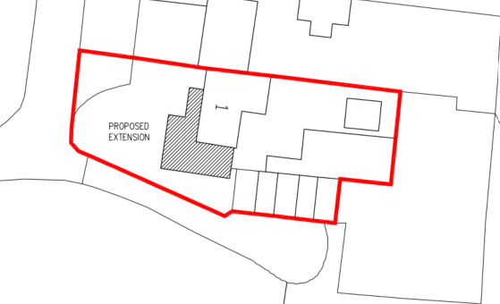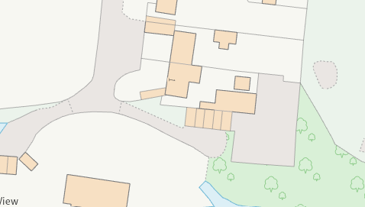

Proposed Site Plan and Council Mapping Image of the Site

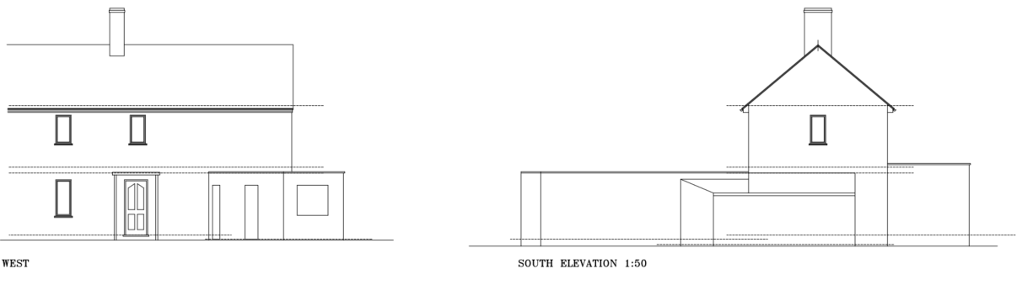

Existing Elevations

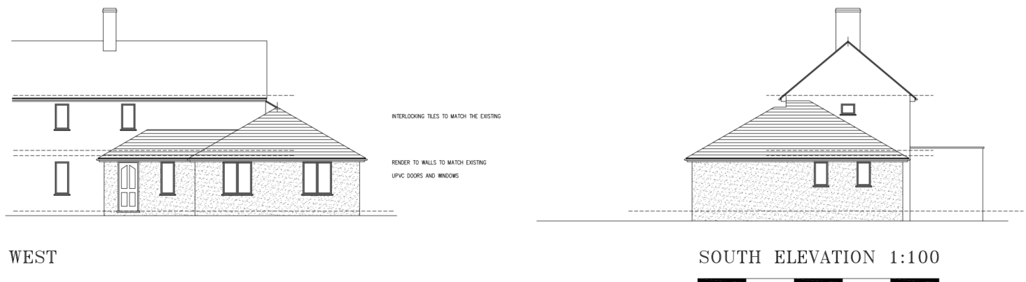

Proposed Elevations

SITE DESCRIPTION/CONTEXT

Greenlands is a small cul-de-sac located off the main high street on the western edge of the village. There are some long distance views into the site from the High Street as seen in the street view images below.

No 1 is a two storey semi-detached dwelling with a very wide front elevation that is wide enough to be a terraced row. However, the main two storey element of No 1 and its neighbour No 2 are a well-balanced and symmetrical pair.

No 1 however has an existing ‘spur’ front and side elevation extension/outbuilding (that it proposed to be demolished). No 2 also has a front extension that links across to the next semi-detached pair No’s 3 and 4.

No 4 also has a significant two and single storey front extension, clad in timber and a different render colour and texture.

Behind and to the south of the application site is a road that access that leads to a garage block and another dwelling Southview.

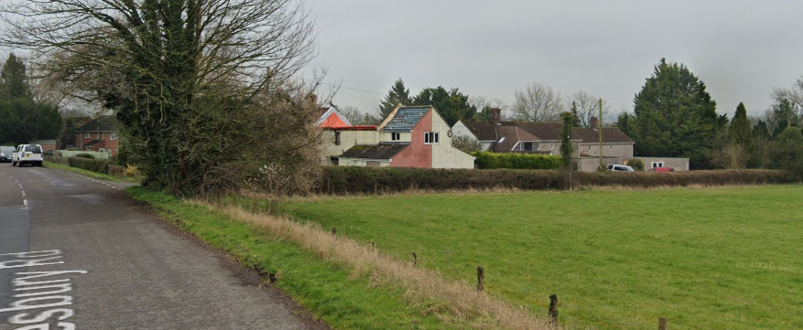

View from the High Street with No 1 (application site) on the far right

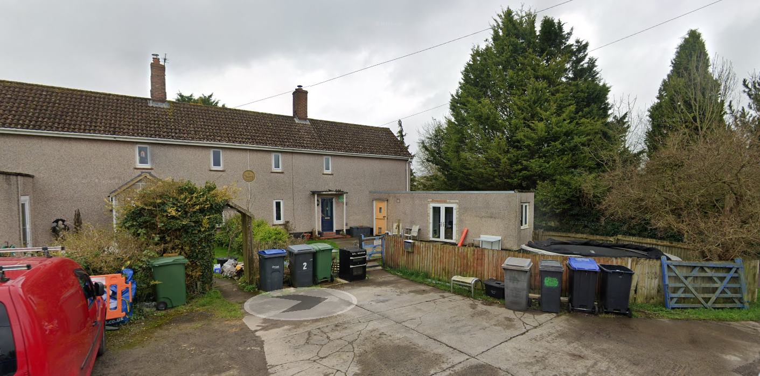

March 2024 Google Street View Image of the application site

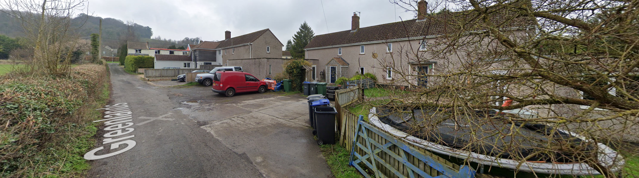

View of application site (right) looking north towards the High Street

The application site is subject to the following planning policy constraints:

The site is approximately 140m from the conservation area which is considered to be a sufficient distance to preserve its character and appearance and cause no harm to its historic significance.

The site is within the 6.4km Salisbury Plan Special Protection Area zone.

The site is also not subject to surface or ground water flood risk (where levels are understood to be between 0.5 and 5m below ground surface.

PLANNING HISTORY

There is no relevant planning history on the site.

RELEVANT POLICIES AND GUIDANCE

National Context:
The National Planning Policy Framework (NPPF)
The Planning Practice Guidance

Local Context:
Wiltshire Core Strategy:

- Core Policy 50: Biodiversity and Geodiversity
- Core Policy 57 Ensuring High Quality Design and Place Shaping
- Core Policy 61: Transport and New Development

Heytesbury does not have a Neighbourhood Plan or area designation

Wiltshire Design Guide: Appendix D – Design Guidance for Householder extensions

CONSULTATION RESPONSES

Heytesbury Imber and Knook Parish Council: No objection

REPRESENTATIONS

In accordance with the requirements of the Town and Country Planning (Development Management Procedure) (England) Order 2015 (as amended), the application was publicised by way of:

• 4x Neighbour notification letters sent to adjoining and nearby properties

No comments were received.

ASSESSMENT

Section 38(6) of the Planning and Compulsory Purchase Act 2004 states:

"If regard is to be had to the development plan for the purposes of any determination to be made under the planning Acts, the determination must be made in accordance with the plan unless material considerations indicate otherwise."

In accordance with this statutory requirement, this application has been assessed against the relevant policies of the Development Plan, including the adopted Wiltshire Core Strategy (2015) and, where applicable, any made Neighbourhood Plans.

Design and Impact upon the character and context of the area

Core Policy 57 - Ensuring High Quality Design and Place Shaping of the Wiltshire Core Strategy seeks to ensure that all new development is of high design quality, reflecting local context, character, and distinctiveness.

It is duly acknowledged that a front and side elevation extensions of this size can unbalance a host building (in this instance the semi-detached pair) and its appearance on the street scene. The extension would be in two different forms with the porch section leading into the larger side and front extension, which would also introduce a hipped roof design onto a building that has simple gable ends.

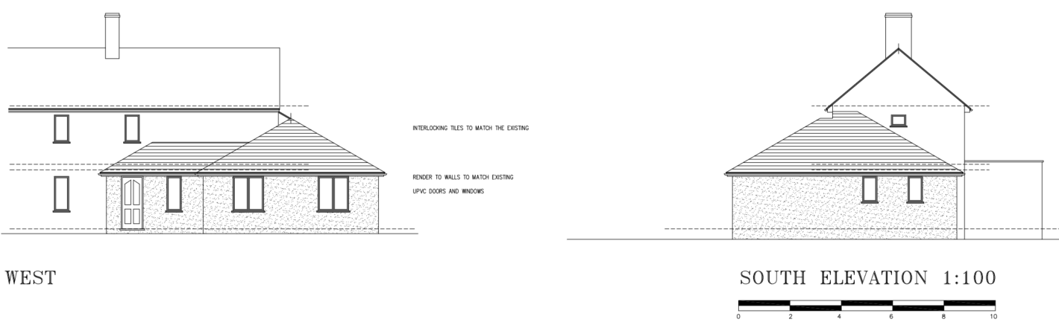

However, it is considered that there are a number of mitigating factors that would mitigate any considered harm of the proposals design. Firstly No 1 already has a large protruding front extension (with a flat roof). Whilst the 2-storey section of No’s 1 and 2 are balanced and symmetrical, their own single storey front extensions make for a fairly disjointed and incongruous overall appearance.

There is also the large single storey linking structure between the two semi-detached pairs and the large extension at the front of No 4, which also have different materials. These structures lead to a rather confused street scene.

The application site is also approximately 90m from the High Street to which views of the front elevation are from even more distant views from the High Street and across open countryside (which can also see the other semi-detached pair of No’s 3 and 4.

The proposal would also be built using matching materials helping the extension to assimilate into the host building.

It is submitted that in this context, whilst the proposal would not be a strictly appropriate extension to a semi-detached pair, given the lack of overall harm to the host building and visual amenity of the street scene, the harm would not warrant the refusal of the application.

Having regard to the above, the proposal complies with the design principles set out in Core Policy 57 of the Wiltshire Core Strategy and Appendix D of the Wiltshire Design Guide.

Amenity

Point vii of Core Policy 57 - Ensuring High Quality Design and Place Shaping of the Wiltshire Core Strategy seeks to ensure that developments do not adversely affect neighbouring properties.

The National Planning Policy Framework (NPPF), particularly Paragraph 135(f), stresses that planning decisions should ensure developments provide a high standard of amenity for existing and future users.

The proposed development has been assessed in terms of its potential impact on the residential amenity of neighbouring properties, with particular regard to loss of light, overshadowing, loss of privacy, and overbearing effects.

The proposal would not be of a size, height, design or in a position in which to cause adverse harm to any neighbouring property. Furthermore, no objections have been received from the public consultation.

The proposal therefore accords with Core Policy 57 point vii in respect of safeguarding residential amenity and Appendix D of the Wiltshire Design Guide.

Highways Impact

Core Policy 57 (xiv) of the Wiltshire Core Strategy seeks to ensure that development must meet the requirements of Core Policy 61. This policy requires proposals to be capable of being served by safe access to the highway network. Core Policy 64 seeks to ensure compliance with parking standards set out in the Local Transport Plan.

The National Planning Policy Framework (NPPF), particularly Paragraph 115 and 116, requires that development proposals do not have an unacceptable impact on highway safety and that safe and suitable access to the site can be achieved for all users.

The proposal would retain the properties existing off road parking spaces for two vehicles and therefore no harm would be caused to highway safety.

The proposed development would not result in any adverse impact on highway safety. Adequate parking and turning provision is provided in accordance with Wiltshire’s adopted parking standards, and access arrangements are acceptable.

The proposal is therefore considered to comply with Core Policies 57 (xiv), 61 and 64 of the Wiltshire Core Strategy, the NPPF, and the Wiltshire Local Transport Plan.

Ecology Impact

Core Policy 50 of the Wiltshire Core Strategy seeks to protect and enhance biodiversity and geodiversity, including through ensuring that development avoids harm to protected species and habitats.

The National Planning Policy Framework (NPPF), in Paragraphs 193, requires that development minimises impacts on and provides net gains for biodiversity, including ensuring mitigation is secured where harm cannot be avoided.

The Council’s Ecology Officer has not been consulted on this application, but the application site is within the 6.4km zone of influence of the Salisbury Plain SPA and in light of the HRA for the Wiltshire Core Strategy and the HRA for the Wiltshire Housing Site Allocations Plan it is screened into Appropriate Assessment due to the potential impact of recreational pressure on stone curlew in combination with other plans and projects.

A strategic Appropriate Assessment (AA) has been prepared pertaining to development within the 6.4 km zone of influence that could result in a likely significant effect on the SPA as a result of an increase in recreational / visitor pressure. The AA reached a conclusion of no adverse effects on the integrity of the SPA or its qualifying features provided that the council’s mitigation strategy continues to be implemented. Annual stone curlew monitoring and protection measures continue to be secured by the Council.

In January 2026 Natural England (NE) confirmed that the 2025 strategic AA for Salisbury Plain SPA continues to be supported by NE.

Biodiversity Net Gain

Householder planning applications are exempt from the requirement to deliver Biodiversity Net Gain under Schedule 7A, Section 4(2)(a) of the Town and Country Planning Act 1990, as inserted by the Environment Act 2021.

CONCLUSION

The proposed development is considered to be acceptable in terms of its design, scale, and relationship with the surrounding area. It would not result in any unacceptable harm to the character of the locality, the amenities of neighbouring occupiers, or the interests of highway safety or ecology.

The proposal is therefore considered to comply with the relevant policies of the Wiltshire Core Strategy, the Wiltshire Local Plan, and the National Planning Policy Framework. As such, the application is recommended for approval, subject to the conditions set out below.

RECOMMENDATION: That Planning Permission be GRANTED subject to conditions.

