APPLICATION FOR HOUSEHOLDER PLANNING PERMISSION
DELEGATED REPORT

APPLICATION REFERENCE: | PL/2026/00856
APPLICATION TYPE: | Householder planning permission
SITE ADDRESS: | 6 Dean Close, Melksham, SN12 7EZ
DEVELOPMENT DESCRIPTION: | Proposed Single Storey Side Extension
RECOMMENDATION: | That Planning Permission be GRANTED

PROPOSAL

The proposal seeks planning permission for a single storey side extension to be used as a porch and garage at 6 Dean Close, Melksham.

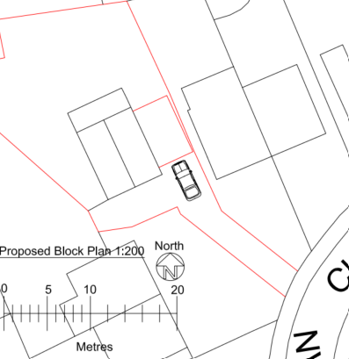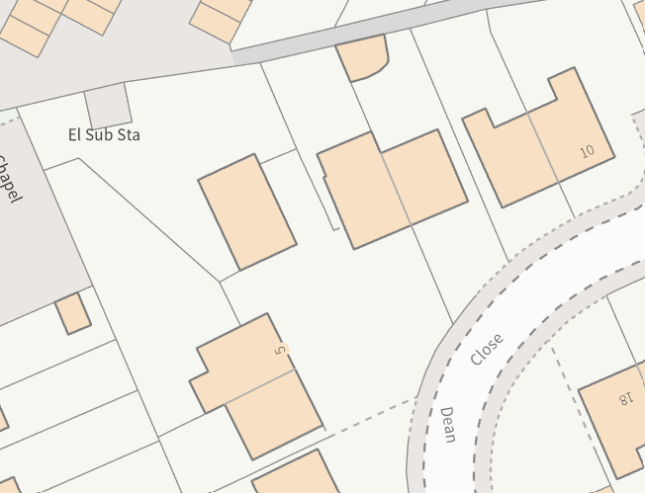

Block Plan and Council mapping image of the site

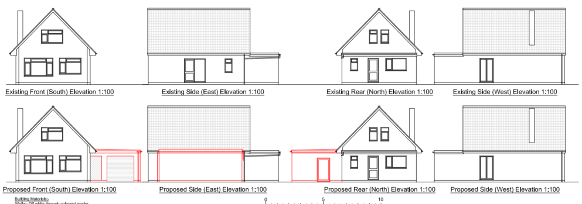

Existing and Proposed Elevations of the site

The proposed flat roofed extension would be finished with an off-white render and with matching upvc windows. The extension would be built close to the boundary with No 7.

SITE DESCRIPTION/CONTEXT

No 6 is a detached one of a half storey dwelling located in a corner between a semi-detached pair of buildings, No’s 4 and 5 and 7 and 8 Dean Close. Dean Close is a small cul-de-sac of mainly one and a half storey buildings but also has a semi-detached pair of bungalows.

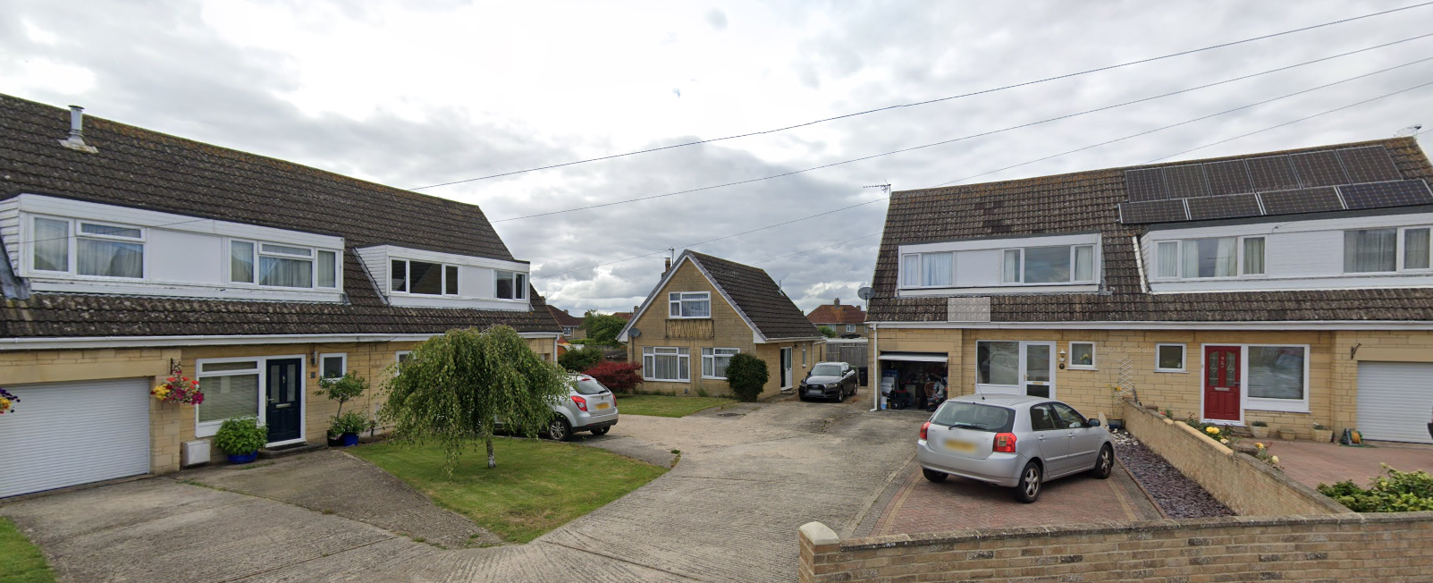

July 2024 Google Street View Image of the site

The application site is not subject to any policy designations or constraints.

PLANNING HISTORY

Proposal / Summary
W/04/01414/FUL - Full planning permission Decision - Approve with Conditions Date: 2/9/2004 – Erect lean-to conservatory on rear of property

RELEVANT POLICIES AND GUIDANCE

National Context:
The National Planning Policy Framework (NPPF)
The Planning Practice Guidance

Local Context:
Wiltshire Core Strategy:

- Core Policy 57 Ensuring High Quality Design and Place Shaping

Melksham Neighbourhood Plan - 2025

Wiltshire Design Guide: Appendix D – Design Guidance for Householder extensions

Wiltshire Council transport plan (LTP4 2026-2030) and Parking Strategy
CONSULTATION RESPONSES

Melksham Town Council: No objection

Wiltshire Council Highways Officer: No objection

No highway objection is raised to the proposal, however as an observation, the applicant may wish to install a sliding door into the garage so any parked car will not prevent the door opening fully.

REPRESENTATIONS

In accordance with the requirements of the Town and Country Planning (Development Management Procedure) (England) Order 2015 (as amended), the application was publicised by way of:

• 4x Neighbour notification letters sent to adjoining and nearby properties;
• Site Notice erected near to the site

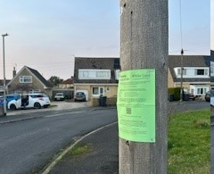

These methods were used to inform interested parties and provide a period of 21 days for comments to be submitted.

No comments were received.

ASSESSMENT

Section 38(6) of the Planning and Compulsory Purchase Act 2004 states:

"If regard is to be had to the development plan for the purposes of any determination to be made under the planning Acts, the determination must be made in accordance with the plan unless material considerations indicate otherwise."

In accordance with this statutory requirement, this application has been assessed against the relevant policies of the Development Plan, including the adopted Wiltshire Core Strategy (2015) and, where applicable, any made Neighbourhood Plans.

Design and Impact upon the character and context of the area

Core Policy 57 - Ensuring High Quality Design and Place Shaping of the Wiltshire Core Strategy seeks to ensure that all new development is of high design quality, reflecting local context, character, and distinctiveness.

The proposal would introduce a flat roofed extension which is unfortunate but there is a flat roofed garage opposite the site (No 18) and all of the one and a half storey semi-detached pairs in the close all have large flat roofed dormer windows. Therefore, in this context the addition of a flat roofed garage, whilst causing some limited harm to the host building would not harm the character and visual amenity of the street scene.

The use of render would also have limited impact on the street scene as the majority of the street scene facing material would be the garage and porch door.

Having regard to the above, the proposal complies with the design principles set out in Core Policy 57 of the Wiltshire Core Strategy and Appendix D of the Wiltshire Design Guide.

Amenity

Point vii of Core Policy 57 - Ensuring High Quality Design and Place Shaping of the Wiltshire Core Strategy seeks to ensure that developments do not adversely affect neighbouring properties.

The National Planning Policy Framework (NPPF), particularly Paragraph 135(f), stresses that planning decisions should ensure developments provide a high standard of amenity for existing and future users.

The proposed development has been assessed in terms of its potential impact on the residential amenity of neighbouring properties, with particular regard to loss of light, overshadowing, loss of privacy, and overbearing effects.

The garage extension would be close to No 7’s side boundary, leaving only a circa 1m access path. However, No 7 does not have any side elevation windows which is evidenced by the image below and from its own W/04/01414/FUL application to erect a rear conservatory. The floorplans for that application do not show any windows facing the application site.

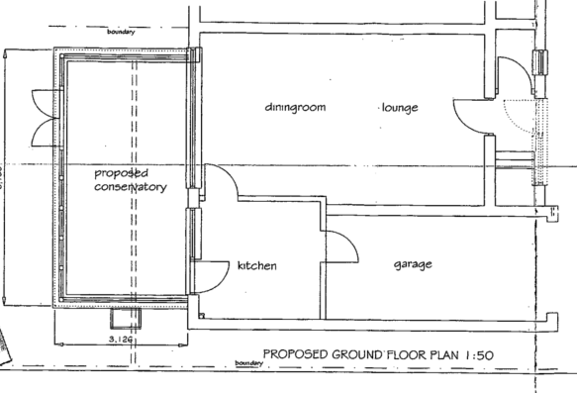

No 7’s ground floor (kitchen and garage) adjacent to the application site
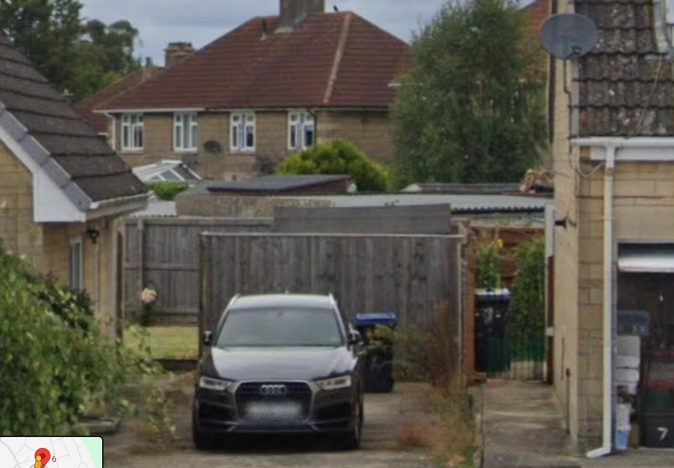

Application site and No 7’s garage and side elevation (right)

The proposal would cause some but limited overshadowing on No 7’s side elevation or rear conservatory but is considered not be of a size, height, bulk or mass to have an adverse overbearing impact of cause sufficient harm by overshadowing to warrant the refusal of the application. Furthermore, no objections have been received by neighbours.

The proposal therefore accords with Core Policy 57 point vii in respect of safeguarding residential amenity and Appendix D of the Wiltshire Design Guide.

Highways Impact

Core Policy 57 (xiv) of the Wiltshire Core Strategy seeks to ensure that development must meet the requirements of Core Policy 61. This policy requires proposals to be capable of being served by safe access to the highway network. Core Policy 64 seeks to ensure compliance with parking standards set out in the Local Transport Plan.

The National Planning Policy Framework (NPPF), particularly Paragraph 115 and 116, requires that development proposals do not have an unacceptable impact on highway safety and that safe and suitable access to the site can be achieved for all users.

The garage would measure internally 6x3m thereby meeting the size requirement to be counted as a parking space. The applicants would also maintain sufficient space in front of the garage for additional parking spaces without interfering with neighbours car parking spaces or use and access over the shared driveway onto Dean Close.

The proposed development would not result in any adverse impact on highway safety. Adequate parking and turning provision is provided in accordance with Wiltshire’s adopted parking standards, and access arrangements are acceptable.

The proposal is therefore considered to comply with Core Policies 57 (xiv), 61 and 64 of the Wiltshire Core Strategy, the NPPF, and the Wiltshire Local Transport Plan.

Biodiversity Net Gain

Householder planning applications are exempt from the requirement to deliver Biodiversity Net Gain under Schedule 7A, Section 4(2)(a) of the Town and Country Planning Act 1990, as inserted by the Environment Act 2021.

CONCLUSION

The proposed development is considered to be acceptable in terms of its design, scale, and relationship with the surrounding area. It would not result in any unacceptable harm to the character of the locality, the amenities of neighbouring occupiers, or the interests of highway safety.

The proposal is therefore considered to comply with the relevant policies of the Wiltshire Core Strategy, the Wiltshire Local Plan, and the National Planning Policy Framework. As such, the application is recommended for approval, subject to the conditions set out below.

RECOMMENDATION: That Planning Permission be GRANTED subject to conditions.

