APPLICATION FOR HOUSEHOLDER PLANNING PERMISSION AND LISTED BUILDING CONSENT DELEGATED REPORT

APPLICATION REFERENCE: | PL/2026/00546 and PL/2026/00870
APPLICATION TYPE: | Full planning permission and Listed building consent
SITE ADDRESS: | Thatch Cottage, Lower Road, Britford, Salisbury, SP5 4DU
DEVELOPMENT DESCRIPTION: | Replacing the defective cement render on the east, south and west elevations with traditional lime render, followed by decoration using a breathable stone coloured paint, and repainting the existing painted brickwork on the north elevation in the same finish. failed brickwork within the cottage’s brick plinth will be repointed using lime mortar to ensure a consistent and appropriate finish
RECOMMENDATION: | That Planning Permission and Listed building consent be GRANTED

PROPOSAL

The proposal seeks consent for the replacement of the existing cement render on the east, south and west elevations with a traditional lime render. The works also include external paintwork.

It is not clear that the proposals require planning permission as well as listed building consent however, for the avoidance of doubt Officers have considered both applications.

SITE DESCRIPTION/CONTEXT

The application site relates to a detached thatched grade two listed dwelling located in the village of Britford on the outskirts of the residential city of Salisbury within the Britford Conservation Area. Britford is defined as a small village and is therefore considered to be within the open countryside as defined by Wiltshire Core Strategy (WCS) policies CP1 (Settlement Strategy), CP2 (Delivery Strategy) and CP23 (South Wiltshire Community Area). The site is adjacent to other listed buildings as shown below marked with black hatching.

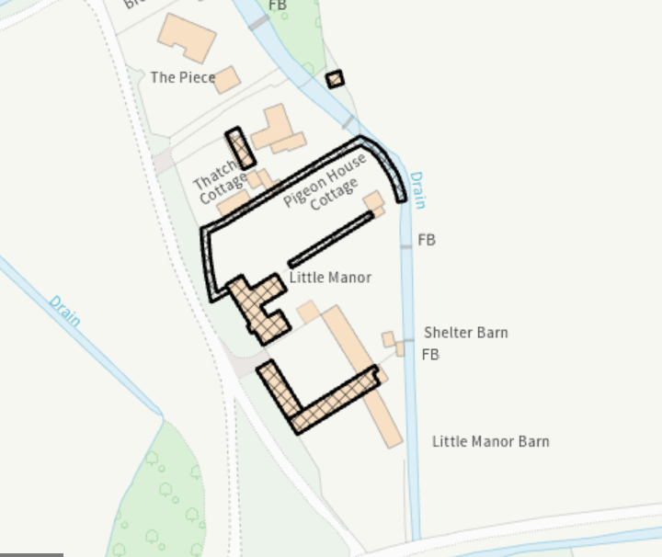

The dwelling is located within Flood Zone 2 and flood zone 3.

Flood zone 2 Flood zone 3

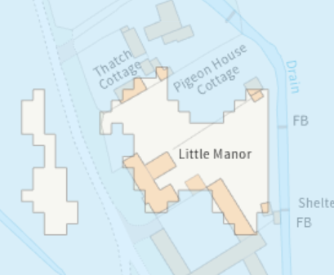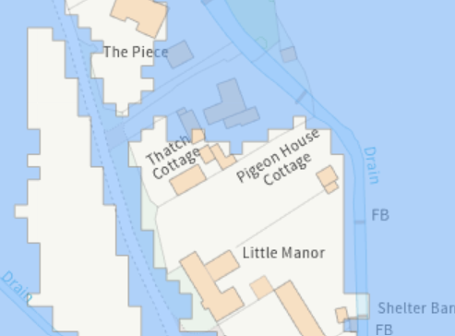

The site is located within the Special Landscape Area and the Hampshire River Avon Catchment. The site lies within the 13.8km zone of influence for the New Forest internationally protected sites, which comprises the New Forest SPA, New Forest SAC and New Forest Ramsar site.

PLANNING HISTORY

Proposal / Summary
19/05970/FUL - Full planning permission Decision - Approve with Conditions Date: 9/8/2019 – General refurbishment of cottage. Glazed link to single storey extension. Replacement garage. Replacement porch.
19/06133/LBC - Listed building consent Decision - Approve with Conditions Date: 9/8/2019 – General refurbishment of cottage. Glazed link to single storey extension. Replacement garage. Replacement porch.
PL/2024/10976 - Full planning permission Decision - Approve with Conditions Date: 26/3/2025 – Installation of a free standing Shepherds Hut for home working
S/1989/1416 - Full planning permission Decision - Refused Date: 25/10/1989 – GARAGE/BEDROOM EXTENSION AND KITCHEN EXTENSION AND CONSERVATORY

RELEVANT POLICIES AND GUIDANCE

Sections 16/66/72 of the Planning (Listed Buildings and Conservation Areas) Act 1990

The National Planning Policy Framework (NPPF)
The Planning Practice Guidance
National Design Guide

Wiltshire Core Strategy:

Core Policy 1 Settlement Strategy
Core Policy 2 Delivery Strategy
Core Policy 23 Southern Wiltshire Community Area
Core Policy 50 Biodiversity and Geodiversity
Core Policy 51 Landscape
Core Policy 57 Ensuring high quality design and place shaping
Core Policy 58 Ensuring the conservation of the historic environment
Core Policy 67 Flood Risk
Core Policy 69 Protection of the River Avon SAC

Saved Policy C6 Special Landscape Area

Wiltshire Design Guide: Appendix D – Design Guidance for Householder extensions
Creating Places Design Guide

CONSULTATION RESPONSES

Parish Council: No objection

Conservation: No objections subject to conditions

REPRESENTATIONS

No comments were received.

ASSESSMENT

Section 38(6) of the Planning and Compulsory Purchase Act 2004 states:

"If regard is to be had to the development plan for the purposes of any determination to be made under the planning Acts, the determination must be made in accordance with the plan unless material considerations indicate otherwise."

In accordance with this statutory requirement, this application has been assessed against the relevant policies of the Development Plan, including the adopted Wiltshire Core Strategy (2015) and, where applicable, any made Neighbourhood Plans.

Impact upon the character and context of the area and heritage assets

From the point of view of the historic environment the main statutory tests are set out within the Planning (Listed Building and Conservation Areas) Act 1990. Sections 16 (LBC) and 66 (PP) require that special regard be given to the desirability of preserving or enhancing listed buildings, their settings or any features of special architectural or historic interest which they possess.

Section 72(1) of the Planning (Listed Building and Conservation Areas) Act 1990 also requires the Council to pay special attention to the desirability of preserving or enhancing the character or appearance of designated Conservation Areas. The NPPF outlines government policy, including its policy in respect of the historic environment.

Section 16 of the NPPF 'Conserving and enhancing the historic environment' sets out the Government's high-level policies concerning heritage and sustainable development.

Paragraphs 214-16 of the NPPF require a balanced approach with any harm which would be caused being weighed against the potential public benefits which might be achieved. Paragraph 210 requires local planning authorities should take account of the desirability of sustaining and enhancing the significance of heritage assets and of new development making a positive contribution to local character and distinctiveness.

National Planning Practice Guidance provides guidance on interpreting the NPPF.

The Council’s Core Strategy Policy CP58 ‘Ensuring the conservation of the historic environment’ requires that “designated heritage assets and their settings will be conserved, and where appropriate enhanced, in a manner appropriate to their significance.”

Historic England Advice Note 2 – Making changes to Heritage Assets illustrates the application of policies set out in the NPPF in determining applications for PP and LBC.

Core Policy 57 - Ensuring High Quality Design and Place Shaping of the Wiltshire Core Strategy seeks to ensure that all new development is of high design quality, reflecting local context, character, and distinctiveness.

The main consideration for the proposed development relates to the impact on the heritage assets, specifically the listed building. The Council’s conservation officer has been consulted and provided the following comments –

Site and assets considered:

Thatch Cottage is a grade II listed building. The list entry (a means to identify a building) reads as follows:

‘Detached cottage. Early C18. Rendered cob on brick and flint plinth to front, with Flemish bond to rear and returns, thatched hipped roof with brick gable end stack to left. 2-storey, 2- window front. Central C20 porch, either side are 3-light wooden casements. First floor has two 2-light wooden casements. Right return has one casement on first floor. To left is weather-boarded lean-to extension. Rear is windowless. Interior not inspected.’

The building is within the Britford Conservation Area.

Proposal: Removal of render and replacement with a lime render.

Issues: impact on the listed building, impact on the setting of neighbouring listed buildings, impact on the conservation area.

Information considered/provided:

Paragraph 207 requires that applicants describe the significance of any heritage assets affected, including any contribution made by their setting. This should include sufficient information to provide a clear understanding of the significance of the heritage asset and its setting and the potential impact of any proposals on that significance.

In this case, whilst the applications are accompanied by a “Design, Access and Heritage Statement” the document provides limited information about the building and fails to provide any objective assessment of the fabric affected, its date or significance or of the impact of the proposals and, as a result, it fails to meet the requirements of the NPPF.

However, paragraph 208 also provides for the local planning authority to make its own assessment of impact and the following heritage recommendations are offered on this basis.

Significance of assets and contribution of setting

The NPPF defines significance as the “value of a heritage asset to this and future generations because of its heritage interest. The interest may be archaeological, architectural, artistic or historic. Significance derives not only from a heritage asset’s physical presence, but also from its setting.” Historic England assesses significance in a similar manner, referring to evidential, historic, aesthetic and communal values of a place.

In this case the significance of the building, insofar as it relates to the current proposals, lies in its traditional rural character, as result of the use of traditional materials (thatch, brick and flint and render on the front elevation), the small pane casement windows and hipped thatch roof with brick stack.

The building is a typical thatched cottage of rural character. As such, it makes a positive contribution to the character of the Britford Conservation Area which is rural in its nature.

Assessment Why

The D&A statement says: ‘The proposals are to remove the non-compliant Sand and Cement render and replace it with Traditional Lime Render.’

And

‘The sequence and specification of the re-rendering to the East, South and West Elevations and the re decoration of the painted brickwork to the Northern Elevation is set out on drawing number JD-100-D52AS’.

How The Method Works Schedule is included on a plan entitled Installation of ‘Shepherd’s hut for home working’. It does not say if this has been provided by a contractor and it does not say how the render will be removed from the elevation (ie hand, chisel, mechanical tools etc).

Summary & conclusion:

The NPPF confirms that when considering the impact of a proposed development on the significance of a designated heritage asset, great weight should be given to the asset’s conservation (and the more important the asset, the greater the weight should be). It makes clear that any harm to a designated heritage asset requires clear and convincing justification.

The proposals, which entail removing the cement render and replacing with a lime render, would be a positive step in replacing inappropriate modern materials with a traditional ‘breathable’ material, which, as the applicant notes, is in accordance with heritage guidance.

However, the specification is brief, particularly in relation to how the render would be removed (which could harm the substrate and do more damage than harm). It is also an area of specialist work.

I recommend that a condition is attached to any consent, requiring the approval of a detailed specification of work from a specialist contractor required for approval prior to the commencement of works. A sample of the lime render and a small patch area, for inspection, would also be advisable.

The applicant submitted further details regarding how the existing render is to be removed, however, a condition will be added to any permission for a test area of render removal be made available for the LPA to confirm that the technique used is appropriate. A condition will also be added to any permission for a sample of render/sample panel be made available for approval by the Council before works start on site.

From a planning perspective there are no concerns raised due to the nature of the development as proposed. It is considered that the proposed replacement render will be an enhancement and benefit to the existing dwelling and context.

Amenity

Point vii of Core Policy 57 - Ensuring High Quality Design and Place Shaping of the Wiltshire Core Strategy seeks to ensure that developments do not adversely affect neighbouring properties.

The National Planning Policy Framework (NPPF), particularly Paragraph 135(f), stresses that planning decisions should ensure developments provide a high standard of amenity for existing and future users.

The proposed development has been assessed in terms of its potential impact on the residential amenity of neighbouring properties, with particular regard to loss of light, overshadowing, loss of privacy, and overbearing effects.

Given the nature of the proposed development and context of the application site, there are no amenity concerns raised.

Biodiversity Net Gain

Householder planning applications are exempt from the requirement to deliver Biodiversity Net Gain under Schedule 7A, Section 4(2)(a) of the Town and Country Planning Act 1990, as inserted by the Environment Act 2021.

CONCLUSION

The proposed development is considered to be acceptable in terms of its impacts on the listed building and conservation area and relationship with the surrounding area. It would not result in any unacceptable harm to the character of the locality, the amenities of neighbouring occupiers, or heritage.

The proposal is therefore considered to comply with the relevant policies of the Wiltshire Core Strategy and the National Planning Policy Framework. As such, the application is recommended for approval, subject to the conditions set out below.

RECOMMENDATION: That Planning Permission be GRANTED subject to conditions.

- The development hereby permitted shall be begun before the expiration of three
years from the date of this permission.

REASON: To comply with the provisions of Section 91 of the Town and Country Planning Act 1990 as amended by the Planning and Compulsory Purchase Act 2004.

- The development hereby permitted shall be carried out in accordance with the
following approved plans and documents:

Application form received 27/01/2026
Location plan received 09/02/2026
Re-rendering specification and site plan Drg no JD-100-D52AS received 09/02/2026
Existing & proposed site plans Drg no JD-100-D53AS received 09/02/2026
Listed building statement received 17/03/2026
Re-rendering to East, West, South Elevations Drg no JD-100-D51 received 27/01/2026

REASON: For the avoidance of doubt and in the interests of proper planning

Informative

- BNG not required - The effect of paragraph 13 of Schedule 7A to the Town and Country Planning Act 1990 is that planning permission granted for development of land in England is deemed to have been granted subject to the condition (biodiversity gain condition) that development may not begin unless:

(a) a Biodiversity Gain Plan has been submitted to the planning authority, and
(b) the planning authority has approved the plan.

The planning authority, for the purposes of determining whether to approve a Biodiversity Gain Plan, if one is required in respect of this permission would be Wiltshire Council.

There are statutory exemptions and transitional arrangements which mean that the biodiversity gain condition does not always apply. For further information on exempt developments please refer to:
https://www.gov.uk/guidance/biodiversity-net-gain-exempt-developments
Based on the information available this permission is considered to be one which will not require the approval of a biodiversity gain plan before development is begun because one or more of the statutory exemptions or transitional arrangements is considered to apply.

RECOMMENDATION: That Listed Building Consent be GRANTED subject to conditions.

- The works for which Listed Building Consent is hereby granted shall be begun before the expiration of three years from the date of this consent.

REASON: To comply with the provisions of Section 18 of the Planning (Listed Buildings and Conservation Areas) Act 1990 as amended by the Planning and Compulsory Purchase Act 2004.

- The development hereby permitted shall be carried out in accordance with the
following approved plans and documents:

Application form received 27/01/2026
Location plan received 09/02/2026
Re-rendering specification and site plan Drg no JD-100-D52AS received 09/02/2026
Existing & proposed site plans Drg no JD-100-D53AS received 09/02/2026
Listed building statement received 17/03/2026
Re-rendering to East, West, South Elevations Drg no JD-100-D51 received 27/01/2026

REASON: For the avoidance of doubt and in the interests of proper planning

3. No works to remove the existing render shall commence until a trial area measuring approximately 1 metre square has been stripped of render in accordance with the method set out in the approved Listed Building Statement (received 17/03/2026). Following completion of the trial area, photographs clearly showing the condition of the underlying cob substrate shall be submitted to the Local Planning Authority for written approval. No further render removal shall take place until the Local Planning Authority has approved in writing the agreed method for removing the remaining render. The remaining render shall thereafter be removed strictly in accordance with the approved method.

REASON: To ensure that the method of cob removal does not harm the substrate in an unacceptable manner in the interests of protecting the fabric of the listed building.

4. No render shall be applied to any building or walls on site until a sample panel of the render to be used on the external walls not less than 1 metre square, has been made available on site, inspected and approved in writing by the Local Planning Authority. The panel shall then be left in position for comparison whilst the development is carried out. Development shall be carried out in accordance with the approved sample.

REASON: In the interests of visual amenity and the character and appearance of the listed building

