APPLICATION FOR OUTLINE PLANNING PERMISSION
CASE OFFICER REPORT

APPLICATION REFERENCE: | PL/2025/08865
APPLICATION TYPE: | Outline planning permission: Some matters reserved
SITE ADDRESS: | LAND EAST OF 3, LOWER MARSH ROAD, WARMINSTER
DEVELOPMENT DESCRIPTION: | Residential development (up to three dwellings).
RECOMMENDATION: | APPROVE SUBJECT TO CONDITIONS AND S111

SITE DESCRIPTION/CONTEXT: The subject site is located to the east of 3 Lower Marsh Road, which forms the end of a row of predominantly two-storey detached dwellings which border open countryside to the south. The site itself is located outside but adjacent to the defined settlement boundary for Warminster, as shown by the extract provided below, as taken from the Council’s mapping system (the settlement boundary is depicted by a solid block line):

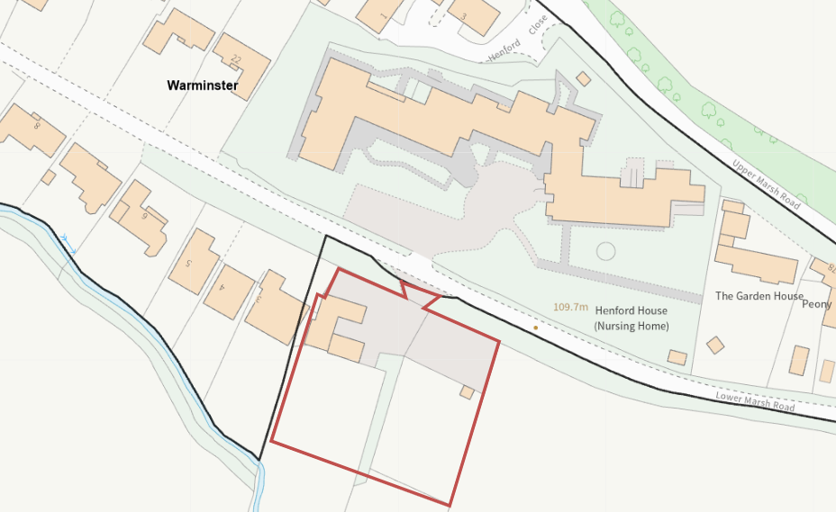

The existing site comprises a stable block (as approved under application reference W/11/03130/FUL).

The application site is located within Flood Zones 2 and 3, as detailed by the areas washed over in blue in the following extract taken from the Environment Agency’s Flood Map for Planning (as available from: Map – Flood map for planning – GOV.UK), but the site is not shown to be in an area susceptible to surface water flooding.

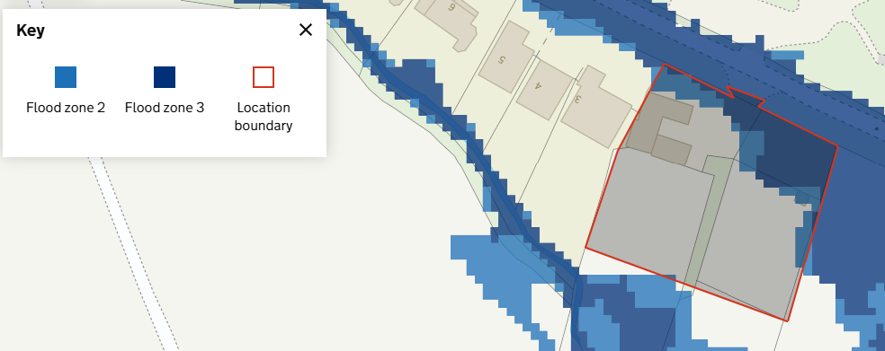

With reference to the Council’s Strategic Flood Risk Assessment (SFRA) mapping tool, the subject site is also shown to be in an area at high risk of groundwater flooding, as illustrated by the area washed over in red, in the extract below:

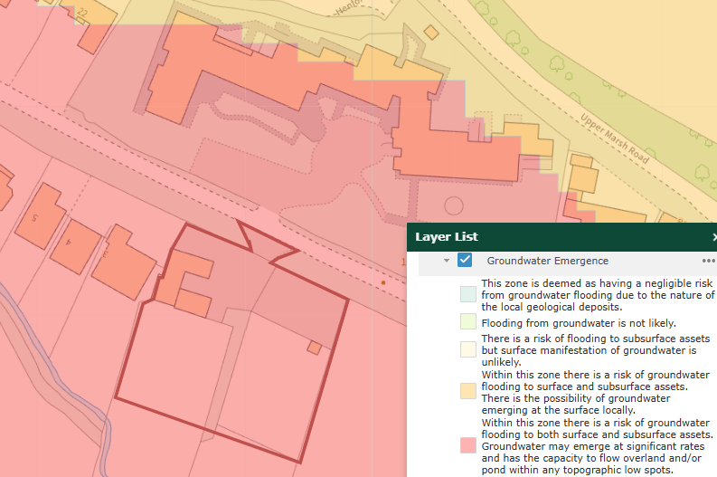

In addition to the above constraints, the site is located within the Hampshire River Avon Catchment and within the Salisbury Plain Special Protection Area (SPA) 6.4km buffer zone.

PROPOSAL: This outline application is seeking planning permission for the construction of up to 3 market dwellings, with the only matter open for approval at this stage being access. All other matters remain reserved for future consideration and appraisal.

Whilst this application is outline, with all matters apart from access reserved, the applicant has provided an indicative proposed site plan (drawing no. P - 01) to demonstrate how the proposed dwellings, with associated on-site car parking and turning and outside amenity space, could be accommodated within the application site:

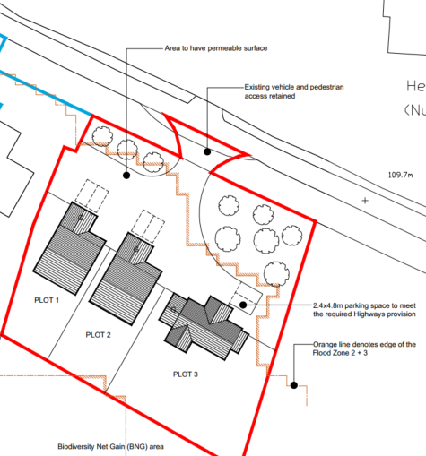

The existing access would be utilised to serve the proposed dwellings, which would require upgrading in terms of increasing the hardstanding to provide on-site car parking provision and turning space.

PLANNING HISTORY

W/09/02317/FUL - Full planning permission – Decision: Withdrawn, Date: 10/11/2009 – Stables with new vehicular access

W/11/03130/FUL - Full planning permission – Decision: Approve with Conditions, Date: 7/3/2012 – Stables with new vehicular access

RELEVANT LEGISLATION, POLICIES AND GUIDANCE

National Planning Policy: National Planning Policy Framework (NPPF); Planning Practice Guidance (PPG); National Design Guide

Development Plan: The development plan for Wiltshire comprises the Wiltshire Core Strategy (WCS) (adopted January 2015) and any made neighbourhood plans, which remain the principal statutory planning document guiding development across the county. In line with Section 38(6) of the Planning and Compulsory Purchase Act 2004, planning decisions must be made in accordance with the development plan unless material considerations indicate otherwise.

Though the development plan is considered as a whole, those parts deemed to be particularly relevant to this application are listed below:

The adopted Wiltshire Core Strategy (WCS), with particular regard to:

- Core Policy 1 Settlement Strategy;
- Core Policy 2 Delivery Strategy;
- Core Policy 31 Spatial Strategy: Warminster Community Area
- Core Policy 41 Sustainable Construction and Low-Carbon Energy;
- Core Policy 50 Biodiversity and Geodiversity;
- Core Policy 51 Landscape;
- Core Policy 52 Green Infrastructure;
- Core Policy 55 Air Quality;
- Core Policy 57 Ensuring High Quality Design and Place Shaping;
- Core Policy 58 Ensuring the Conservation of the Historic Environment;
- Core Policy 60 Sustainable Transport;
- Core Policy 61 Transport & Development;
- Core Policy 62 Development Impacts on the Transport Network;
- Core Policy 64 Demand Management;
- Core Policy 67 Flood Risk;
- Core Policy 69 Protection of the River Avon SAC

Draft Wiltshire Local Plan Policies: The examination of the emerging Wiltshire Local Plan has been paused, and the weight to be afforded to any part of the emerging plan can be no more than very limited. A decision on how to proceed will be made by the Council in May 2026.

Neighbourhood Plan: Warminster Neighbourhood Plan 2015-2026, made in November 2016

Supplementary Planning Documents and other Guidance:
- Wiltshire Design Guide, adopted March 2024)
- Wiltshire Local Transport Plan (LTP3) 2011-2026, adopted March 2011 - including the Car Parking Strategy, adopted 2015 and Cycling Strategy, adopted 2014
- Wiltshire Local Transport Plan 4 (LTP4) 2025-2038, adopted March 2025
- Wiltshire Council’s Waste Core Strategy, adopted July 2009
- Wiltshire Council’s Waste Storage and Collection: Guidance for Developers Supplementary Planning Document, January 2017
- A Green & Blue Infrastructure Strategy for Wiltshire: Wiltshire’s Natural Environment Plan 2022-2030
- Wiltshire Housing Site Allocations Plan, adopted 25 February 2020
- Wiltshire’s Community Infrastructure Levy

ISSUES: The main issues that need to be addressed in this case include: principle of the development; access and highway matters; flood risk and drainage; design and visual impact; neighbouring amenity; and ecology

CONSULTATION RESPONSES

Environment Agency: No objection subject to conditions

Warminster Town Council: Objection - “Members unanimously objected to the application due to the potential flood risk on the development”

Wiltshire Council Ecology: No objection subject to conditions

Wiltshire Council Drainage: No objection subject to conditions

Wiltshire Council Highways Department: No objection

REPRESENTATIONS
In accordance with the requirements of the Town and Country Planning (Development Management Procedure) (England) Order 2015 (as amended), the application was publicised by way of:

- Neighbour notification letters sent to adjoining and nearby properties;
- Publicised on the local authority’s website

These methods were used to inform interested parties and provide a period of 21 days for comments to be submitted.

Below is a summary of the representations received during the consultation period. Only material planning considerations have been taken into account in the assessment of this application. Non-material issues, such as property values or private legal disputes, cannot be considered in the determination process.

Third-party Representations: Two letters of support were received.

ASSESSMENT: Section 38(6) of the Planning and Compulsory Purchase Act 2004 states:

"If regard is to be had to the development plan for the purposes of any determination to be made under the planning Acts, the determination must be made in accordance with the plan unless material considerations indicate otherwise."

In accordance with this statutory requirement, this application has been assessed against the relevant policies of the Development Plan, including the Wiltshire Core Strategy (2015) and, where applicable, any made Neighbourhood Plans. Consideration has also been given to the policies of the National Planning Policy Framework (NPPF) as a material consideration in the assessment.

Principle of Development: The application site forms a parcel of land located outside any defined limits of development and is therefore considered to be in open countryside. The defined settlement boundary for Warminster (Market Town) does however border the site, as do established residential dwellings to the west and north of the application site, which are accessed via Lower Marsh Road.

Policy CP1 of the WCS establishes a hierarchy of settlements to guide where development should be focused. The policy prioritises growth in:
- Principal Settlements (e.g., Salisbury, Chippenham, Trowbridge) – main focus for strategic growth.
- Market Towns – support local services and employment; suitable for sustainable development.
- Local Service Centres – smaller towns and villages with a range of services; limited development supported.
- Large and Small Villages – development should be limited and respond to local needs.
- Outside the defined settlements – development is strictly controlled and generally not supported unless exceptional circumstances apply.
.
Policy CP2 of the WCS sets out how development would be distributed and delivered across Wiltshire. The policy emphasises:
- Sustainable patterns of growth, reducing the need to travel and supporting local services.
- Development should be plan-led, aligning with the settlement strategy and supported by infrastructure.
- Windfall development (not allocated in plans) must still comply with the principles of sustainable development.
- Development outside settlement boundaries is generally not permitted, unless it meets specific policy exceptions (as set out in paragraph 4.25 of the WCS).

Together, CP1 and CP2 ensure that new development is strategically located, sustainable, and supports the character and function of Wiltshire’s communities.

In terms of the settlement hierarchy set out in CP1, this application site is located outside any of the defined limits of development, and Policy CP2 is clear that outside the defined limits of development:

"Other than in circumstances as permitted by other policies within this plan, identified in paragraph 4.25, development will not be permitted outside the limits of development, as defined on the policies map. The limits of development may only be altered through the identification of sites for development through subsequent Site Allocations Development Plan Documents and neighbourhood plan" [emphasis added by the officer]

As detailed above, CP2 of the adopted WCS does permit new development outside the limits of development in certain circumstances which "seek to respond to local circumstance and national policy". These exception policies include the following: additional employment land (CP34), military establishments (CP37), development related to tourism (CP39 and CP40), rural exception sites (CP44), specialist accommodation provision (CP46 and CP47) and supporting rural life (CP48). It is not considered that this proposal for up to 3 market dwellings would comply with any of these 'exception policies' for the proposal to satisfy CP2.

Policy CP2 also acknowledges that the limits of development may be altered through site allocation plans and neighbourhood plans. However, for this site, there has been no such change to settlement limits to change its countryside status.

It is duly appreciated that CP2 supports limited infill at small villages (subject to satisfying a series of criteria as detailed in the policy text for CP2) however, this proposal does not constitute an infill proposal and is not located in a small village.

On the basis of the above, the proposal would fail to comply with CP1 and CP2 of the adopted WCS.

5 Year Housing Land Supply: Whilst the above assessment is duly noted, the Wiltshire Housing Land Supply Statement (published June 2025, using a base date of April 2024) provides the latest position on the Council’s ability to demonstrate a five-year supply of deliverable housing land, which is a material consideration in the determination of planning applications.

The NPPF was revised in December 2024 and reintroduced the requirement to meet five years’ worth of deliverable sites and a buffer to be applied to the five-year housing requirement in all circumstances, and it has revised the Local Housing Need calculation to establish the five-year housing requirement. These factors have resulted in a substantial increase in the five-year housing requirement to be met from the previous calculation. When this is assessed against the housing land supply that can be delivered within five years, the recalculation shows a significant reduction in the number of years' supply. The resulting position shows that the Council can currently demonstrate a 2.42-year housing land supply of housing at a unitary authority level. This is considered to be a substantial shortfall.

The absence of a five-year housing land supply is a material consideration in the determination of this application. In accordance with Paragraphs 78 and 11(d) of the NPPF, for applications involving the provision of housing, where there is a shortfall in the supply of deliverable housing sites, the most important policies for determining the application should be considered out of date. The current housing land supply shortfall is a factor that must be considered in the planning balance, and in this case, as a five-year housing land supply cannot be demonstrated, the weight that can be applied to the most important policies for determining this application should be assessed and altered in light of the shortage in housing land supply. The proposal must be assessed against the national policy context of the need to boost housing supply and the benefits of delivering new homes, whilst having particular regard to the key policies set out in paragraph 11(d)(ii) and footnotes 7-9 of the NPPF.

Based on the above, the ‘tilted balance’ is engaged for many applications, and paragraph 11d of the NPPF states that:

"where there are no relevant development plan policies, or the policies which are most important for determining the application are out-of-date, granting permission unless:

i. the application of policies in this Framework that protect areas or assets of particular importance provides a strong reason for refusing the development proposed; or
ii. any adverse impacts of doing so would significantly and demonstrably outweigh the benefits, when assessed against the policies in this Framework taken as a whole, having particular regard to key policies for directing development to sustainable locations, making effective use of land, securing well-designed places and providing affordable homes, individually or in combination".

Paragraph 11di includes footnote 7 that sets out the 'protect' policies in the NPPF, which includes areas at risk of flooding or coastal change. This is pertinent to this case, with the site including land designated as Flood Zones 2 and 3, and the entire site being at high risk of groundwater flooding. Therefore, a comprehensive assessment of how this proposal aligns with the policies relating to flood risk and drainage matters is undertaken further in this report.

Flood Risk and Drainage: Policy CP67 of the WCS and NPPF paragraphs 170–182 require:
- Avoidance of increased flood risk.
- Use of appropriate mitigation measures.
- Application of the sequential and exception tests for developments in Flood Zones 2 or 3.

Sustainable Drainage Systems (SuDS) are required for all major developments and must:
- Manage runoff near its source.
- Improve water quality.
- Support biodiversity and amenity.
- Be integrated into the site layout and green infrastructure.

The Council’s drainage department has clarified that in planning terms, “flood risk refers to the potential for development to increase the likelihood or severity of flooding on-site or elsewhere, while drainage considerations relate to the capacity of the site and surrounding infrastructure to manage surface water runoff in a sustainable and effective manner”. As such, officers must be satisfied that the proposed development would not result in an increased flood risk, either on-site or elsewhere, and that surface water can be appropriately managed in a sustainable and coordinated manner.

The application has been submitted with a Site-Specific Flood Risk Assessment (FRA) (produced by Urban Water, reference 536 FRA-v3, dated July 2025), which identifies that the application site lies within Flood Zone 3, representing a high probability of fluvial flooding as defined by the Environment Agency (EA). The FRA confirms that the site's flood risk is associated with the River Were and Cannimore Stream, with modelled data indicating potential flood depths across a range of return periods.

The Council’s drainage department has, however, stated that, based on flood-level data provided by the EA, the site is classified as within Flood Zone 2. As previously reported, the site is assessed to be at low risk of surface water flooding, but there is a high risk of groundwater flooding. The Council’s drainage engineer has commented that in 2025, the EA “updated its Flood Map for Planning using NaFRA2 data. The revised mapping shows that the central part of the site is no longer within any flood zone, while the existing access onto the highway still intersects Flood Zones 2 and 3”.

Detailed model outputs, including the Warminster Integrated Model (2020), show that in undefended conditions, the site may experience flood depths of approximately 0.21 m in the 1 in 100 year event, rising to 0.38 m in the 1 in 1000 year event.

The FRA sets out recommended mitigation measures, including ensuring finished floor levels are set above predicted flood levels, the incorporation of flood-resilient building materials, and the provision of safe access and egress during flood events where feasible. Overall, the FRA concludes that, with appropriate mitigation and adherence to recommended design measures, the development could proceed without increasing flood risk on or off the site.

In terms of the Sequential Test, the applicant has provided Shadow Sequential Test information within Appendix 2 of their submitted Planning, Design and Access Statement (produced by Lone Wolf Planning Ltd). The applicant’s assessment of sites identifies 67 sites, with only 6 being considered “reasonably available”. Whilst this indicates that other sites would be available in areas with the lowest risk of flooding, thus the Sequential Test would fail for this case, the submitted FRA has demonstrated that the proposed development could be made safe over its lifetime. Furthermore, it is considered that there is sufficient space within the site to locate the proposed dwellings within FZ1 (adopting a sequential approach on-site), avoiding the areas of Flood Zones 2 and 3. On this basis, the Council’s drainage engineer considers the indicative layout to be acceptable and has offered the following comments:

“For fluvial flooding, the design flood level has been conservatively taken as 110.6 m AOD. In terms of groundwater flooding, a potential flood depth of approximately 0.15 m has been considered, based on an average ground level of 110.25 m AOD, resulting in an estimated groundwater flood level of 110.4 m AOD. The applicant has stated that groundwater level monitoring will be undertaken on site to establish the risk of groundwater emergence on site.

Design flood level is considered to be 110.6 m AOD with proposed floor level to be 300 mm above the flood level and utilising material classified as “Good” under water exclusion strategy. New services and fittings (communications wiring, heating systems, electrical services, water, electricity and gas meters) should be placed at above the level of 111.25 m AOD. All service entries should be sealed (e.g., with expanding foam or similar closed cell material)”.

The guidance contained within the PPG is also of relevance and states in paragraph 027 Reference ID: 7-027-20220825 that:

In applying paragraph 175 [of the NPPF] a proportionate approach should be taken. Where a site-specific flood risk assessment demonstrates clearly that the proposed layout, design, and mitigation measures would ensure that occupiers and users would remain safe from current and future surface water flood risk for the lifetime of the development (therefore addressing the risks identified e.g. by Environment Agency flood risk mapping), without increasing flood risk elsewhere, then the sequential test need not be applied.

The absence of a 5-year housing land supply is not a relevant consideration in applying the sequential test for individual applications. However, housing considerations, including housing land supply, may be relevant in the planning balance, alongside the outcome of the sequential test.

The EA were also consulted on the application and has raised no objections but commented to say that the levels provided within the submitted FRA are incorrect, but they are satisfied that, subject to conditions relating to ground levels and restricting land rising, this could be effectively mitigated.

A planning condition would be imposed on any outline planning consent granted requesting the submission of a flood warning and evacuation plan, to ensure a procedure in place in case the access road does flood, so future occupiers are aware of what to do in a flood event and to ensure that safe access and egress which remains possible.

The discrepancy between the figures quoted within the drainage officer's comments and those included within the conditions recommended by the EA was raised with the Council’s drainage department, and in light of the EA acknowledging that the stated levels in the submitted FRA were incorrect, the quoted levels put forward within the EA’s response are considered appropriate to proceed with.

It is considered that suitable mitigation measures can be utilised on-site to ensure that the proposed development would be located outside the flood zones and would remain safe over its lifetime without increasing flood risk elsewhere. On this basis, subject to conditions, it is considered that the proposal would comply with CP67 of the adopted WCS and the NPPF.

Design and Impact on the Character and Appearance of the Area: Policy 57 of the WCS requires high-quality design that:
- Enhances local character.
- Responds to the natural, historic, and built environment.
- Retains important features (e.g., trees, hedges).
- Supports sustainable construction and compatibility with surrounding uses.
- Creates safe, legible, and accessible spaces.

Section 12 of the NPPF emphasises design that is:
- Visually attractive.
- Functionally effective.
- Contributes to the quality of the built environment.

The Wiltshire Design Guide encourages sensitivity to local character, materials, and architectural styles and supports modern living standards while maintaining aesthetic and functional quality.

Building for a Healthy Life Framework promotes healthy, inclusive, and sustainable places. The document encourages:

- Walkability.
- Access to green space.
- Active design principles for well-being.

Whilst the site's location outside the defined settlement boundary for Warminster is duly noted, it is appreciated that the application site is located along Lower Marsh Road, which is strongly characterised by established residential dwellings. Therefore, the addition of new housing on this particular site would not be significantly out of character with the immediate area.

It is acknowledged that the indicative plot sizes for the proposed dwellings would be of a smaller size compared to some of the properties immediately to the west of the application site, however a review of the Council’s mapping system does show other properties along Lower Marsh Road to have a range of plot sizes, some with much larger plots benefiting from large front and rear gardens with many further west having more modest plots. On this basis, the indicative layout would not be wholly out of character with the immediate area.

As this application is outline with all matters except access reserved, matters relating specifically to the appearance, layout, scale and landscaping are reserved for a future application and therefore cannot be taken into full consideration at this stage. It is however noted that the immediate area is predominantly characterised by detached two-storey dwellings and some bungalows, and whilst the submitted plans relating to the proposed dwelling are only indicative and illustrative at this stage, the drawings do demonstrate that up to three detached dwellings could be accommodated on site.

Any future layout at the reserved matters stage must therefore ensure that sufficient private amenity/garden space is provided with on-site car parking provision and turning space, for each dwelling, without being unduly cramped or resulting in the overdevelopment of the plot. The existing building line would also need to be respected.

It is important to mention that CP57 of the adopted WCS requires developments to respond “positively to the existing townscape and landscape features in terms of building layouts, built form, height, mass, scale, building line, plot size, elevational design, materials, streetscape and rooflines to effectively integrate
the building into its setting” and therefore any future reserved matters application would need to comply with these requirements.

In terms of the design and appearance of the proposed developments, the immediate area is strongly characterised by two-storey dwellings with some bungalows, completed in brick or stone with render. Any subsequent reserved matters submission would need to draw on this local appearance.

At this stage, judgment is reserved on specific details relating to the design appearance, layout and scale until the submission of a future reserved matters application(s), where such matters would be fully appraised.

Amenity: Policy CP57, criterion vii of the adopted WCS requires development to respect the amenity of existing occupants and ensure appropriate amenity levels for future residents.

The NPPF, particularly Paragraph 135, reinforces the need for development to provide a high standard of amenity for both existing and future users.

As matters relating to appearance, layout and scale are reserved, the proposal submitted as part of this outline cannot fully assess such matters. With due regard to the size of the application site, it is considered that design solutions can be found on-site to ensure that the amenity of neighbouring occupiers is preserved.

Although this is an outline application, with all matters except access reserved, the submitted indicative drawings do show that the plot is of a size capable of accommodating up to dwellings. It is important to ensure at the reserved matters stage that any dwellings are sensitively designed, with sufficient space to prevent any adverse impact upon the living conditions of existing neighbouring residents, while also ensuring that an acceptable level of accommodation and private outside amenity space would exist for the future occupiers of the dwelling.

Any future reserved matters application must comply with the requirements of the adopted Wiltshire Design Guide, which requires, in section 9.2, that all dwellings must be provided with a private amenity space, which should as a minimum should be equivalent to the footprint of the house. Section 9.2.2 also recommends the following garden depths to ensure that the amenity space is functional:

- In general, a north facing garden for a typical 2 storey house should be minimum of 12m long or up to 15m long for a typical 3 storey house
- In general, a south, east or west facing garden should be a minimum of 10m deep

The Design Guide also advises that gardens should not be subject to excessive shading from planting or overshadowing by buildings, with no more than one-third of the garden area in shade at any given time. It further recommends that garden spaces be genuinely usable, avoiding irregular pointed corners and narrow, impractical strips.

It is recommended that the above is taken into consideration when finalising plans for any future reserved matters application, in addition to ensuring all fenestration is appropriately laid out and to allow there to be adequate distances between dwellings to prevent any adverse impacts on neighbouring amenity through loss of privacy, overshadowing or overbearing.

Highways Impacts and Parking: Transport implications are a key factor in assessing planning applications, especially for larger developments. Proposals must demonstrate:
- Safe and suitable access for all users, including pedestrians, cyclists, and those with mobility impairments.
- No severe residual impacts on the surrounding highway network.
- Promotion of sustainable travel, reducing reliance on private vehicles.
- Adequate parking and cycle provision, in line with adopted standards.
- Protection and enhancement of public rights of way and active travel routes.

Relevant policies include Core Policies 60–64 of the WCS, supported by the Wiltshire Local Transport Plan, Car Parking Strategy, and Cycling Strategy. The Local Cycling and Walking Infrastructure Plan (LCWIP) and LTN 1/20 (DfT) provide further design guidance for active travel infrastructure.

This outline application is seeking consent with all matters apart from access reserved. It is proposed that the existing access via Lower Marsh Road would be utilised to serve the proposed dwellings and 6 car parking spaces would be provided on-site. As the proposed development would be served by an existing established access with adequate visibility splays, the Council’s highways department have raised no objections.

It is, however, important to mention that the on-site car parking provision should satisfy the Council’s adopted car parking standards, which require the following minimum on-site car parking spaces to be provided, depending on the number of bedrooms. The requirements below must be adhered to as part of any future reserved matters application:

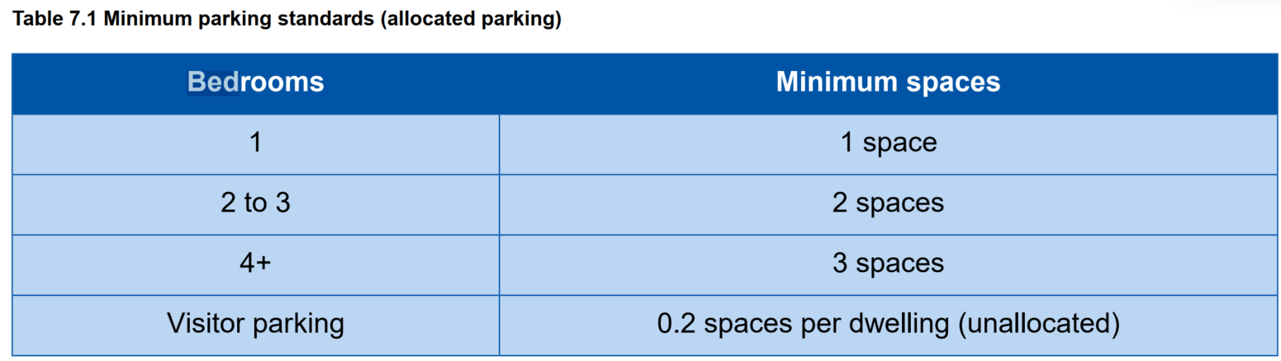

The Council’s Highways Officer has advised that on-site turning provision is required to allow all vehicles to enter and exit the site in forward gear. This requirement should be incorporated into the final layout design.

Ecology and Biodiversity: The ecological impact of development is a key planning consideration, especially for larger schemes. Proposals must assess and address potential effects on:

- Protected species
- Priority habitats
- Ecological networks
- Green and blue infrastructure

Core Policy 50 of the Wiltshire Core Strategy requires development to:

- Avoid harm to ecological assets.
- Deliver measurable Biodiversity Net Gain (BNG), in line with the Environment Act 2021.
- Support habitat restoration and connectivity.
- Integrate biodiversity into site design.

The Green & Blue Infrastructure Strategy (2022–2030) promotes nature recovery, ecosystem services, and habitat connectivity through development.

Unless exempt, National policy requires a minimum of 10% Biodiversity Net Gain (BNG) for major developments, demonstrated via:

- Biodiversity Metric calculations
- Ecological assessments (e.g. PEAs, Phase 1 surveys, protected species surveys)

The application site comprises a paddock area with stables, with existing residential to the west and north, and open countryside to the south and east. The Cannimore Stream is located to the south, but is outside the red line for this application.

The application has been supported by a Preliminary Ecological Appraisal (PEA) that includes a Bat and Protected Species Survey and Biodiversity Metric Assessment, a Compensation and Enhancement Plan, a Mitigation and Constraints Plan, and a Nutrient Calculator for the River Avon SAC.

The survey identified that the existing grassland and buildings offer suitable foraging and dispersal habitat for a range of common species including amphibians, badger, bats, birds, hedgehog, invertebrates and reptiles. However, no evidence of bat roosting, bird nesting, badger setts or other protected species was recorded within the buildings, although the grassland provides general wildlife value within the landscape.

The site falls within an amber risk zone for great crested newt; however, the grazed condition of the grassland and absence of nearby suitable aquatic habitat mean the likelihood of GCN presence is low.

Due to the scale of the works and the separation distances involved, no direct or indirect impacts upon designated sites are anticipated. Several priority habitats lie within 1km of the site, including deciduous woodland and lowland fen, but these would not be affected by the development.

The development would result in the loss of approximately 0.16ha of modified grassland, leading to the removal of some habitat for common species and a reduction in foraging potential for bats and birds. Additional lighting associated with new dwellings has the potential to affect nocturnal species if not appropriately controlled. To address these impacts, a package of mitigation including has been suggested in the PEA including: sensitive lighting design to avoid light spill onto retained or off-site habitats; vegetation management and maintenance of a short sward prior to and during the works; checks for nesting birds if works occur during the breeding season; precautionary working methods for amphibians, reptiles and hedgehog; and protection of the root protection areas of adjacent trees and hedgerows. Pollution prevention measures would also be required during construction.

The PEA includes compensation and enhancement measures to deliver biodiversity benefits, including new native planting, creation of modified grassland and garden habitats, installation of in-built bat, bird and invertebrate boxes within each dwelling, and provision of habitat piles along the site’s southern boundary.

The Council’s ecologist has commented that the application lies within the 6.4km zone of influence of the Salisbury Plain SPA and in light of the HRA for the Wiltshire Core Strategy and the HRA for the Wiltshire Housing Site Allocations Plan, it is screened into Appropriate Assessment (AA) due to the potential impact of recreational pressure on stone curlew in combination with other plans and projects.

A strategic AA was prepared pertaining to development within the 6.4km zone of influence that could result in a likely significant effect on the SPA as a result of an increase in recreational/visitor pressure. The AA reached a conclusion of no adverse effects on the integrity of the SPA or its qualifying features, provided that the Council’s mitigation strategy continues to be implemented. Annual stone curlew monitoring and protection measures continue to be secured by the Council. In March 2025 Natural England (NE) confirmed that the 2024 strategic AA for Salisbury Plain SPA continues to be supported by NE.

In terms of the River Avon SAC Hampshire Catchment, within which this development falls, the proposal has the potential to cause adverse effects alone or in combination with other developments through the discharge of phosphorus in wastewater. As such, an AA was required to determine the potentially significant effects and the suitability of any measures proposed to avoid or mitigate those effects. The Council’s ecologist has commented that the revised nutrient calculator that has been submitted calculates a total phosphorus budget of 0.72 kg TP/year pre 2030 and 0.64 kg TP/year post 2030, which has been approved by Wiltshire Council.

The Council’s ecologist has commented that a Council-led scheme of phosphorus credits would be available for development that meets certain criteria at a fixed cost per kilogram of phosphorus, provided the supply of mitigation is available. A completed Hampshire Avon Credit Screening Approval Certificate would be required for this scheme.

A strategic AA has been prepared for qualifying planning applications for residential and non-residential development within sewered and non-sewered areas of the River Avon SAC catchment. The AA concluded no adverse effects on the integrity of the SAC or its qualifying features and has been endorsed by NE provided that the Council’s mitigation strategy continues to be implemented. A Section 111 agreement is required to secure the credits.

The Council’s ecologist has commented that if “the application does not qualify for the Council-led scheme, or the applicant decides not to proceed with the scheme, details of an alternative mitigation strategy must be submitted for review and the Council’s ecology team consulted. Any alternative mitigation scheme would be subject to a bespoke Appropriate Assessment”.

The applicant provided an Ecological Parameters Plan (EPP), which shows the sensitive (e.g. light-sensitive) features and the enhancement areas. The enhancement plan states that all new planting would be wildlife-attracting and native. Furthermore, the mitigation plan states that the hedgerow boundary would not be directly illuminated, with at least a 15m buffer from the proposed dwellings, and includes some details of construction-related precautions for wildlife.

It is considered that the risk posed to any protected and notable species can be minimised through the implementation of sensitive working measures, which would be detailed within a Construction Method Statement (CMS). The CMS should also include precautionary measures to ensure that nearby habitats are protected from noise, light, run-off and dust pollution (e.g., hedgerow, and Cannimore Stream 10m to the south). The requirement for a CMS would be secured via a planning condition.

It is recommended that all details of biodiversity enhancements, including locations and specifications, are provided at the reserved matters stage and should remain in line with the submitted enhancement plan.

With regards to Biodiversity Net Gain (BNG), under Schedule 7A of the Town and Country Planning Act 1990 (as inserted by Schedule 14 of the Environment Act 2021), this application is required to deliver 10% BNG, and the Biodiversity Gain Plan condition would automatically apply. The submitted information confirms that proposals would deliver an increase of 0.10 (29.29%) increase in area habitat units through the creation of modified grassland and planting of trees, which is above the legal requirement.

The Council’s ecologist has commented that “There is a watercourse close to the site (Cannimore Stream) which appears to be ~10m from the nearest point of the red line boundary. Any works within the riparian zone (10m) must be assessed within the BNG metric. At the reserved matters stage, should the red line boundary change, or any encroachment into the riparian zone be proposed, the BNG metric will need to be updated. It is also noted that Appendix 5 of the Preliminary Ecological Appraisal shows a blue line boundary (for a “BNG area”) that encroaches the riparian zone. The baseline values estimated for this area must include a watercourse baseline; this is ultimately a post-determination matter, but it may be helpful for the applicant to provide this information at the reserved matters stage”.

It is considered, subject to conditions, that the proposal would satisfy the requirements of CP50 and the NPPF.

CIL: The proposed development would be liable for CIL as set out in the Wiltshire CIL Charging Schedule dated May 2015. This is a charge that local authorities can impose on new developments in their area. The money generated through the levy would contribute towards the funding of infrastructure to support growth and is payable upon commencement of development.

PLANNING BALANCE AND CONCLUSION: At the heart of the NPPF there is a presumption in favour of sustainable development requiring local planning authorities to approve development proposals that accord with an up-to-date development plan without delay; and where there are no relevant development plan policies, or the policies which are most important for determining the application are out-of-date, permission should be granted unless (taken from paragraph 11d of the NPPF):

- The application of policies in the NPPF that protect areas or assets of particular importance provides a clear reason for refusing development proposed; or
- any adverse impacts of doing so would significantly and demonstrably outweigh the benefits, when assessed against the policies in the NPPF taken as a whole;

NPPF Paragraph 11(d) and footnote 8 state that when a Council cannot demonstrate a five-year housing land supply then, for applications including housing provision, the policies which are most important for determining the application should be considered ‘out-of-date’.

As a result, the presumption in favour of sustainable development (often referred to as the ‘tilted balance’) should be applied, and permission should be granted unless protection policies set out in footnote 7 of the NPPF apply, or the adverse impacts of granting permission would significantly and demonstrably outweigh the benefits.

In weighing the planning balance, the following factors have been considered:

The application would provide up to three additional homes which would provide additional market housing that would make a contribution towards the Council's current housing shortfall, which is afforded substantial weight.

It is considered that whilst the application site is located outside the settlement boundary for Warminster, future occupants would benefit from a comparable access to amenities and facilities to existing occupiers in proximity to the application site.

The proposal would also provide BNG, which is afforded moderate weight.

With regard to flood risk, it is acknowledged that parts of the site fall within Flood Zones 2 and 3. Nevertheless, the supporting information demonstrates that a sequential approach can be applied within the site boundary to ensure that all built development is located within Flood Zone 1, thereby avoiding areas of highest risk. Both the Council’s drainage team and the EA have raised no objections to the proposal, subject to the imposition of planning conditions. On this basis, and with mitigation secured through planning conditions, the development is considered capable of being made safe for its lifetime without increasing flood risk elsewhere. The proposal therefore complies with the relevant requirements of the NPPF and CP67 of the WCS, and the residual flood-risk harm is afforded only limited weight.

On the basis of the above, the proposed development is considered acceptable in planning terms. In the context of paragraph 11d(ii), the presumption in favour of sustainable development therefore applies.
Accordingly, it is recommended that planning permission be granted, subject to the completion of a Section 111 agreement and the imposition of appropriate planning conditions and informatives.

RECOMMENDATION: That Planning Permission be GRANTED, subject to conditions and a Section 111 agreement for phosphorus mitigation.

