Design and Access Statement
Project: Proposed Strength and Conditioning Facility
Location: Trowbridge Rugby Club, Hilperton, Trowbridge
Applicant: Trowbridge Rugby Club (TRFC)
Date: 19th March 2026

1. Introduction
This statement is submitted in support of a planning application for a dedicated Strength and Conditioning (S&C) facility at Trowbridge Rugby Club (TRFC).
The proposal aims to improve the club’s existing sporting facilities by creating a private, high-quality training environment designed specifically for the physical development, injury rehabilitation, and mental well-being of its members. Beyond focusing on physical metrics like strength and speed, this facility will also serve as a sanctuary for mental health. Recognising the high rates of mental health issues within the young adult and middle-aged male demographics—core members of our community—the club intends to offer a non-clinical, communal space for stress relief and social connection. By training together in a private, club-owned area, members sustain a support network that is often lost during the "off-season" or after a serious injury. This facility is a proactive response to the increasing need for community-driven mental health initiatives. TRFC is an established sports hub. This proposal does not alter the land’s current use but modernises the existing "ancillary" sports facilities to comply with contemporary safety and wellness standards.
TRFC has been a cornerstone of the local sporting scene for over a century, offering a vital social and physical outlet for hundreds of active members across all age groups—from "Minis" to Senior XVs. The club is more than just a venue for competitive matches; it is a community asset that promotes discipline, teamwork, and lifelong health. As the club looks towards 2026 and beyond, there is a strategic need to modernise its infrastructure to meet the changing safety and wellness standards of 21st-century sport.
This planning application proposes constructing a dedicated, members-only Strength and Conditioning (S&C) facility. In modern Rugby Union, the physical demands on players have increased markedly. To promote player safety and competitiveness, the club needs to provide a controlled, professional environment where members can undertake "prehabilitation" and sport-specific conditioning. This plan shifts the club away from a traditional "pitch-only" approach towards a Holistic Wellness Hub, where physical excellence is complemented by comprehensive mental health support.
The proposed development has been carefully located on a marginal, underused area of the Hilperton grounds. By utilising an "ancillary" location, the project ensures there is zero loss of active playing pitch area, maintaining full compliance with both Sport England requirements and the Wiltshire Playing Pitch Strategy 2024. The design is intended to be secondary to the main clubhouse, using high-quality materials that respect the site's rural fringe character while demonstrating a commitment to long-term sustainable growth.
This statement offers a detailed analysis of the proposal’s design, scale, and access arrangements. It shows how the project meets the main objectives of the National Planning Policy Framework (NPPF) by encouraging healthy, safe, and inclusive communities. Most importantly, it explains how this "Member-Only" facility delivers a significant "Social Value" benefit to Trowbridge residents without adding any extra strain on local roads or public services.

2. Assessment of Need

2.1 Physical Athletic Development & Player Safety
Modern rugby at all levels demands specialised physical preparation to ensure player safety and reduce injury risks. The current facilities at TRFC lack a dedicated indoor space for strength training. Public commercial gyms in the Trowbridge area do not cater to "squad-based" conditioning, which is crucial for team cohesion and sport-specific movements. This facility guarantees that local talent has equal development opportunities as those in professional academies, enabling Trowbridge RFC to stay competitive within South West leagues.
2.2 Mental Health & Social Well-being
The club recognises that its role extends beyond the pitch. This facility is envisioned as a "Community Hub":
- Combatting Isolation: By training together, members maintain a consistent social support network.
- Squad Integration: Rugby is fundamentally a team sport, and strength sessions are most effective when conducted as a group to foster camaraderie and tactical cohesion. Commercial gyms cannot accommodate squads of players at once
- Resilience: The facility offers a well-organised, secure outlet for stress relief, promoting a culture of openness.
- The "Community Shed" Effect: For many members, the club serves as a main place for socialising; this gym offers a non-clinical environment that promotes positive mental health. This development will maximise the use of Doric Park, ensuring the club remains a year-round destination for health and fitness, not just a seasonal venue.

2.3 Injury Rehabilitation & Inclusion
Mental health often declines considerably when a player is sidelined by injury. An on-site facility dedicated to rehabilitation enables injured members to stay connected within the club environment, working alongside their teammates. This helps maintain their sense of identity and belonging, which are vital for psychological recovery.

2.4 Retention and Long-Term Sustainability of the Club
High-quality, on-site facilities are crucial for retaining local talent, preventing players from leaving for clubs with superior infrastructure.
In the competitive world of sport, players—especially those transitioning from youth to senior rugby—expect access to facilities that match their ambitions and support their development.

3. Policy Compliance (NPPF 2024/25)
The proposal aligns with the National Planning Policy Framework (NPPF):
- NPPF Paragraph 96: Recognises that access to high-quality opportunities for sport and physical activity is "important for the health and well-being of communities."
- NPPF Paragraph 104(b): The gym is "ancillary to the main use of the site." It is situated on a marginal, non-playing area of the grounds, ensuring no loss of active pitch space.

4. Evidence of Need & Precedent
Like the approved application at Bradford on Avon RFC, TRFC requires a dedicated indoor space to enable year-round training. In that case, Wiltshire Council agreed that "indoor training facilities are essential for the viability of community rugby clubs" and that such buildings are compatible with the rural or edge-of-settlement character when suitably designed.
The recently adopted Wiltshire Playing Pitch Strategy 2024 emphasises the significance of "quality ancillary facilities" to support player retention. By providing a dedicated S&C space, TRFC directly aligns with the Council’s strategic goals of improving club infrastructure and increasing participation in the Trowbridge area. The proposal also corresponds with the 'Action Plan' for Rugby Union in the Wiltshire Playing Pitch Strategy 2024 by delivering essential ancillary infrastructure that ensures the club remains a sustainable, high-quality venue for local sport

5. Design, Scale, and Appearance
- Size: The proposed building is a single-story structure of approximately 112 sqm.
- Height: The ridge height is limited to 3.74m, ensuring it sits below the skyline of the main clubhouse.
- Appearance: To maintain visual harmony, the building will utilise dark green cladding (RAL 6005) to blend with the existing clubhouse and the rural backdrop of the Hilperton site.
- Precedent Reference: This mirrors the material palette used in the successful spectator stand application at TRFC (PL/2024/09978), ensuring site-wide architectural cohesion.
- Sustainability: The unit will be highly insulated to reduce energy demand and minimise its carbon footprint. It will use LED lighting with motion sensors throughout.
- Active Design: "Active Buildings, Inside and Out": The gym is designed to be an "active building" that encourages movement and provides a safe, inclusive environment for all ages. "Activity for All”: The gym will be used by all sections of the club (Junior, Senior, and Women’s teams), aligning with Sport England's 2026 focus on "Uniting the Movement."

6. Access and Management

6.1 Traffic and Highways
- Exclusivity: The facility is for the sole use of Trowbridge Rugby Club members.
- Traffic & Parking: As users are existing members already attending the site for training/matches, there will be no measurable increase in traffic. Existing parking provision is more than sufficient.
- 6-8 covered cycle parking spaces: The facility is designed to encourage 'Active Commuting' for our local members. By providing secure bike storage, we aim to reduce car dependencies for mid-week training sessions, aligning with the Trowbridge Transport Strategy 2026 (Local Cycling and Walking Infrastructure Plan (LCWIP))
- Inclusive Access: The design features level-threshold entrances and wide-access doors to ensure the facility is fully DDA (Disability Discrimination Act) compliant.

6.2 Environmental Mitigation
- Noise: The building will be highly insulated to contain any noise from equipment or coaching.
- Lighting: Downward-pointing, shielded LED lights will be used, consistent with the club’s existing ecological commitments to protect local bat corridors.

6. Summary of Policy Compliance
Policy | Compliance Detail
NPPF Para 96 | Promotes health and well-being through high-quality sports provision.
NPPF Para 104 | Proves the facility is ancillary and results in no loss of active playing pitch.
Wiltshire Core Policy 52 | Protects and enhances existing green infrastructure and sports assets.

7. Conclusion
The proposed gym represents a vital evolution for Trowbridge Rugby Club. It addresses a clear gap in the club’s ability to provide for the physical safety and mental health of its members. By repurposing a small, underutilised area of the site, the club can offer a transformative community asset that supports the longevity of local sport. A 2025 study on sports infrastructure in England found that every £1 spent on sports facilities generates roughly £4 in social value through improved mental health and reduced GP visits. By providing a year-round social and physical hub, TRFC is acting as a community frontline for mental health support, specifically targeting the 'at-risk' male demographic, as recognised by the Sport England Mental Health report (2024).

SITE PLAN
• Site Selection: The proposed gym will be situated in an underused, mown grassy area next to the main clubhouse. This site has been carefully selected to keep the new development close to existing buildings and carpark, minimising its impact on the surrounding green space. A site plan is attached for reference.
• Aesthetic: The building will feature dark green metal cladding, ensuring that it blends sympathetically with the rural-fringe setting of Hilperton and complements the existing club architecture.

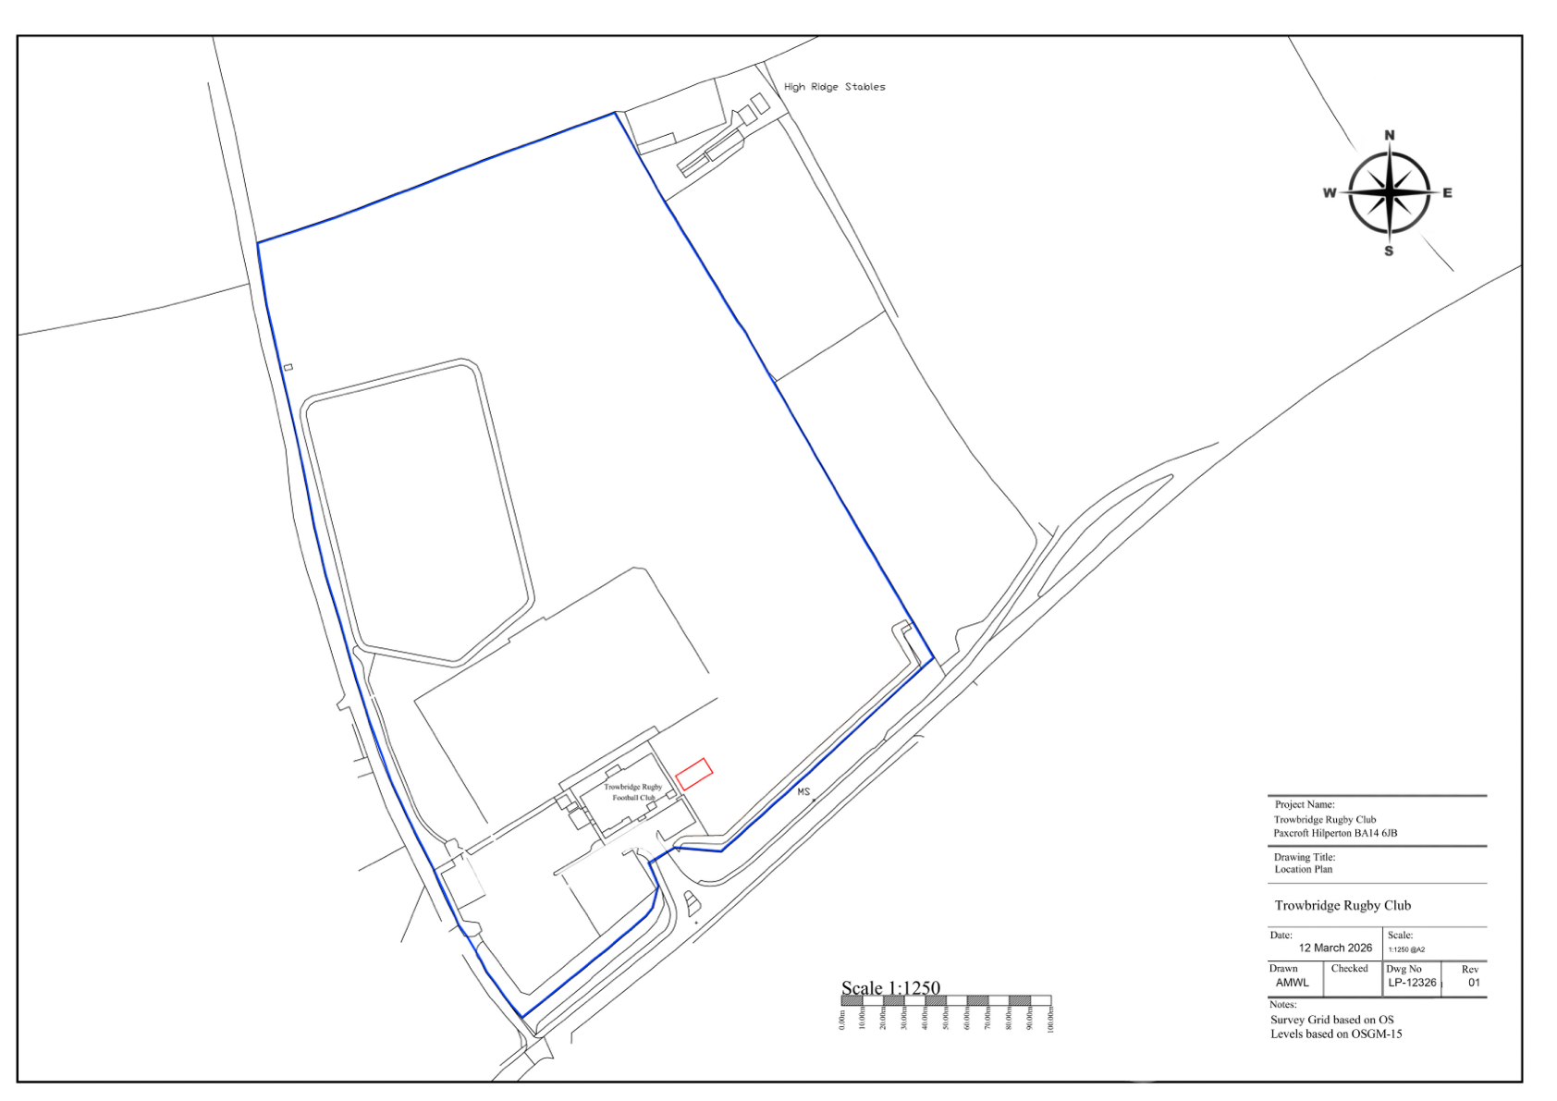

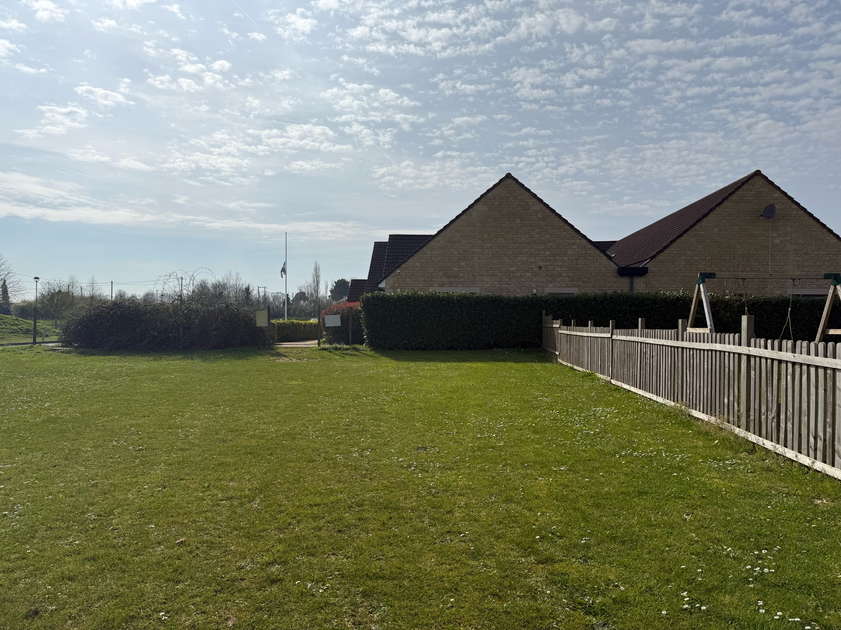
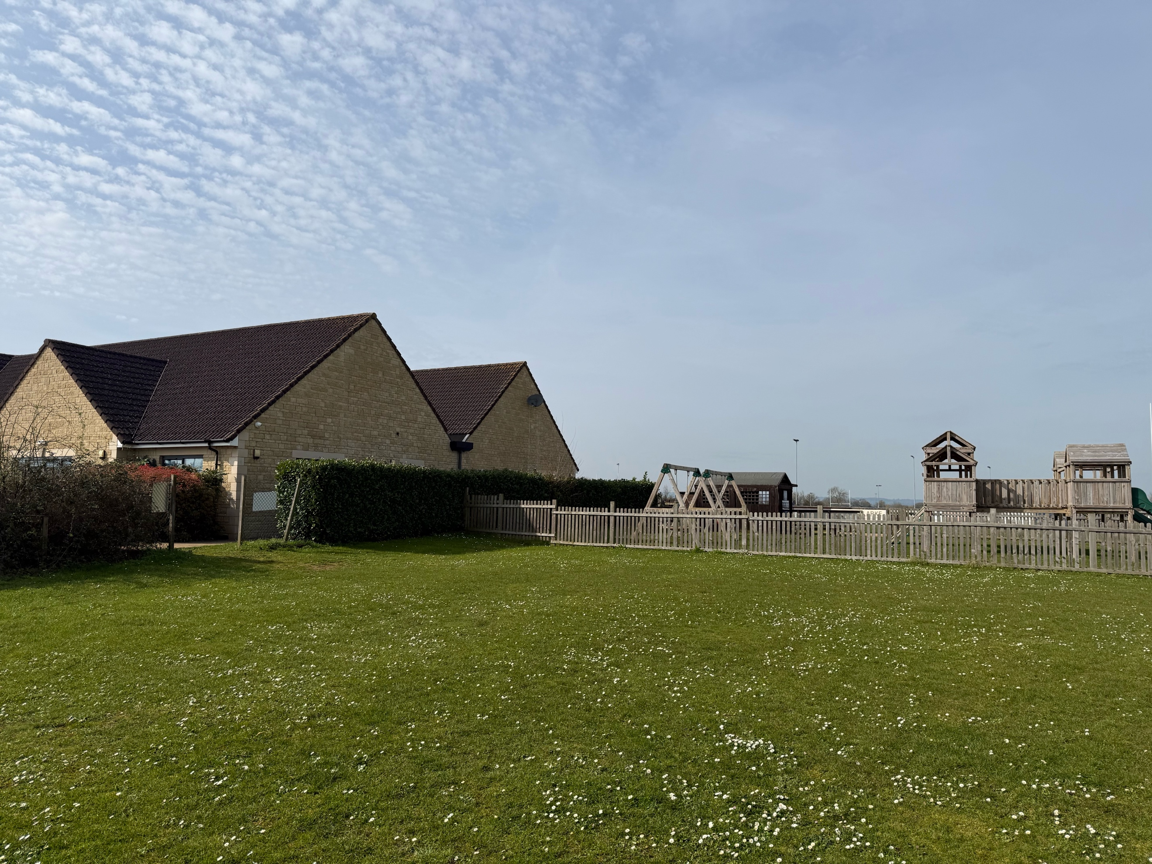
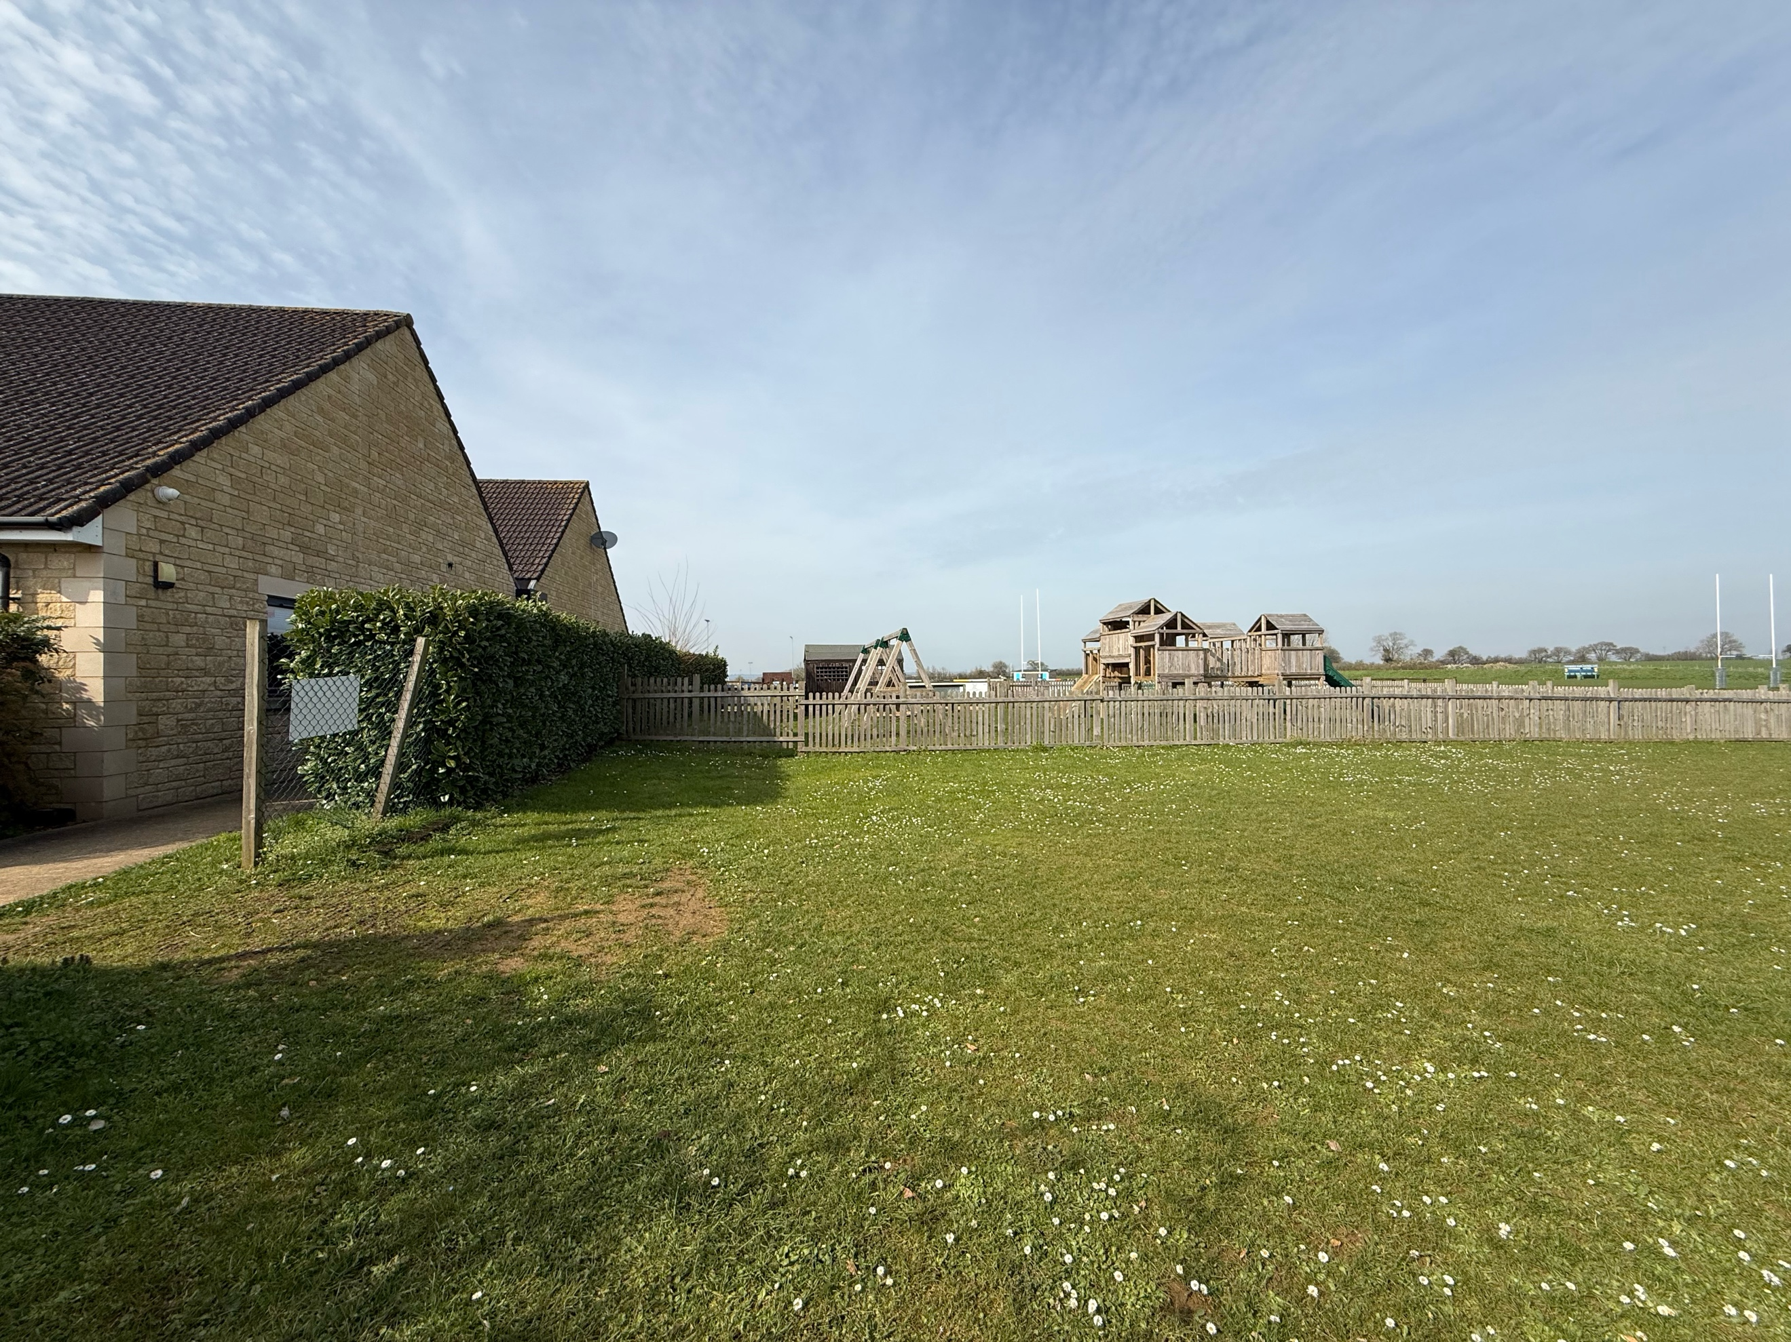
PROPOSED ELEVATIONS

