APPLICATION FOR HOUSEHOLDER PLANNING PERMISSION
DELEGATED REPORT

APPLICATION REFERENCE: | PL/2026/00817
APPLICATION TYPE: | Householder planning permission
SITE ADDRESS: | Summers House, 122 The Street, Broughton Gifford, Melksham, SN12 8PH
DEVELOPMENT DESCRIPTION: | Proposed Replacement Single Storey Rear Extension
RECOMMENDATION: | That Planning Permission be GRANTED

SITE DESCRIPTION/CONTEXT
The subject property is a semi-detached, two-storey dwelling within a small area of modern C20 infill housing within the historic village of Broughton Gifford.

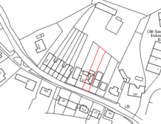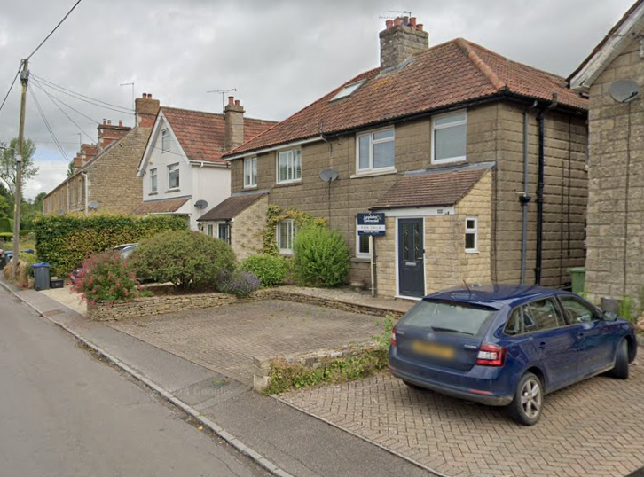

Location Plan and Google Earth Site Photo

The site is within the Broughton Gifford Conservation Area, at its central narrowest point as it encompasses only the High Street. The site is 50m from GII designated no. 30 across the High Street.

As a brook is redirected underground from the west at The Chapel, to east past the Old Sawmills, the site is within a 20m buffer zone of a watercourse, with associated increased ground water flooding risks

PROPOSAL

The proposal seeks planning permission for:
- Demolish existing conservatory
- Replace with a single storey rear extension

Proposed materials include recon stone to match existing, Redland reget tiles against existing concrete profiled roof tiles, and matching white uPVC windows/doors.

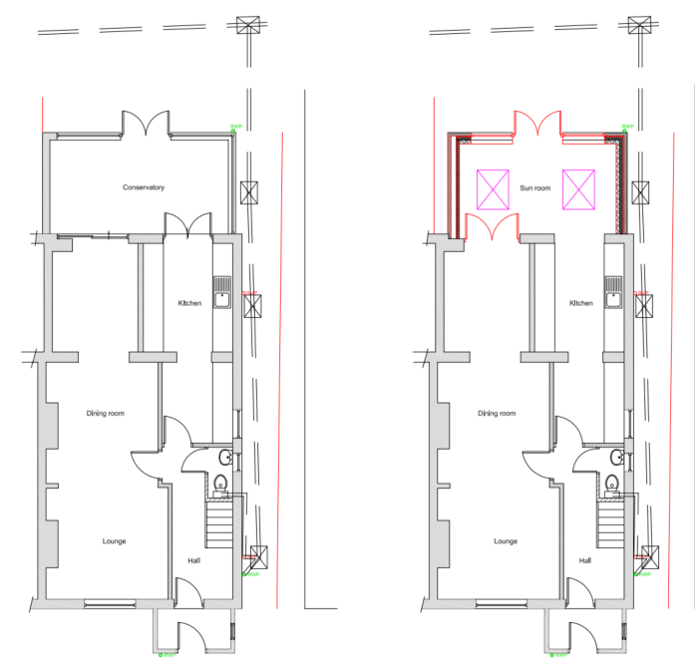

Existing and Proposed Ground Floor Plans

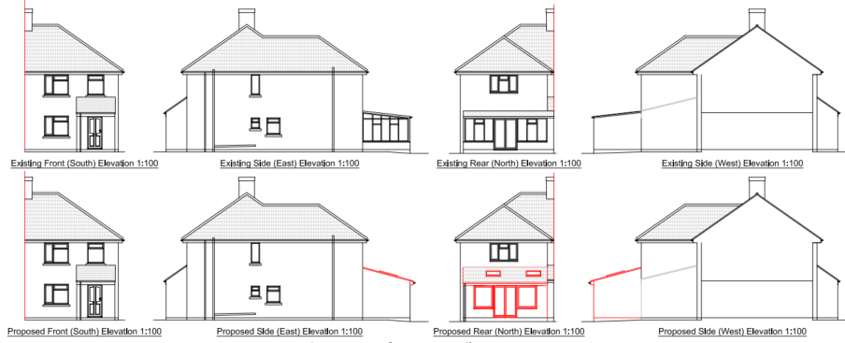

Existing and Proposed Elevations

PLANNING HISTORY
W/96/00952/FUL - Single storey rear extension and vehicular access - Approve with Conditions
W/97/00035/FUL – Conservatory - Approve with Conditions.
14/08146/FUL – first floor rear bedroom extension – Approve with conditions
W/06/02437/FUL - Full planning permission Decision - Approve with Conditions Date: 29/9/2006 – Loft conversion and single storey extension with associated works along with enlargement of off-street parking area – no. 123
W/88/00638/FUL - Full planning permission Decision - Approve with Conditions Date: 10/5/1988 – Extension – no. 123
W/99/00608/FUL - Full planning permission Decision - Approve with Conditions Date: 7/6/1999 – Two storey and single storey rear extension – no. 121

RELEVANT POLICIES AND GUIDANCE
The National Planning Policy Framework (NPPF)
The Planning Practice Guidance
National Design Guide
Wiltshire Design Guide: Appendix D – Design Guidance for Householder extensions

Wiltshire Core Strategy:
- Core Policy 57 Ensuring High Quality Design and Place Shaping
- Core Policy 58: Ensuring the Conservation of the Historic Environment
- Core Policy 67: Flood Risk

Broughton Gifford does not have a designated Neighbourhood Plan Area, and no made plans.

CONSULTATION RESPONSES
Broughton Gifford Parish Council: No objection.

REPRESENTATIONS
No comments were received.

ASSESSMENT

Principle of Development:
Section 70(2) of the Town and Country Planning Act 1990 and section 38(6) of the Planning and Compulsory Purchase Act 2004, require that the determination of planning applications must be made in accordance with the Development Plan, unless material considerations indicate otherwise.

The proposal comprises development to an existing residential property set in an established residential area within the settlement boundary of Broughton Gifford. The proposal is wholly within the residential curtilage, and as such, the principle of development is acceptable subject to the following considerations.

In accordance with this statutory requirement, this application has been assessed against the relevant policies of the Development Plan, including the adopted Wiltshire Core Strategy (2015) and, where applicable, any made Neighbourhood Plans.

Heritage, Design and Impact upon the character and context of the area
From the point of view of the historic environment the main statutory tests are set out within the Planning (Listed Building and Conservation Areas) Act 1990.

Section 72(1) of the Act requires the Council to pay special attention to the desirability of preserving or enhancing the character or appearance of designated Conservation Areas.

The Council’s Core Strategy Policy CP58 ‘Ensuring the conservation of the historic environment’ requires that designated and non-designated heritage assets and their settings will be conserved, and where appropriate enhanced, in a manner appropriate to their significance and encourages proposals which improve the condition of heritage assets at risk.

The Council’s Core Strategy CP 57: Ensuring high quality design requires a high quality of design in all new developments. The policy requires applicants to “demonstrate how the proposal will make a positive contribution to the character of Wiltshire through (amongst other things) responding to the value of the natural and historic environment and being sympathetic to and conserving historic buildings and landscapes. Development is required to respond positively to the existing in terms of building layouts, built form, height, mass, scale, building line, plot size, elevational design, materials, streetscape and rooflines to effectively integrate the building into its setting.

The NPPF outlines government policy for planning. Chapter 16 of the NPPF 'Conserving and enhancing the historic environment' sets out the Government's high-level policies concerning heritage and sustainable development.

The site is 50m from GII designated no. 30 across the High Street but given the intervening modern development, there is no impact on setting.

The site is within the Broughton Gifford Conservation Area but given that the proposal is a replacement rear extension, at single storey, all to the rear so not visible to the streetscape, there are no concerns regarding impact to the special character of the Conservation Area.

The proposed replacement rear extension would see a de minimis increase of pitch and two lanterns.

Proposed materials would match existing except the roof tiles, chosen to manage the pitch, but in line with the existing concrete profiled roof tiles, meaning materials would ensure the extension integrates successfully with the host dwelling.

Overall, the proposal is a welcome improvement upon the existing arrangement, materially, by design and improved thermal efficiency.

The development is therefore considered to comply with Core Policy 58 of the Wiltshire Core Strategy and Sections 66 and 72 of the Planning (Listed Buildings and Conservation Areas) Act 1990, as well as the relevant provisions of the NPPF.

Amenity
Point vii of Core Policy 57 - Ensuring High Quality Design and Place Shaping of the Wiltshire Core Strategy seeks to ensure that developments do not adversely affect neighbouring properties.

The National Planning Policy Framework (NPPF), particularly Paragraph 135(f), stresses that planning decisions should ensure developments provide a high standard of amenity for existing and future users.

The proposed development has been assessed in terms of its potential impact on the residential amenity of neighbouring properties, with particular regard to loss of light, overshadowing, loss of privacy, and overbearing effects.

As the proposal is a replacement of an existing structure, with reduced fenestration and with only a slight increase of roof pitch and two additional rooflights, at a height to not cause a negative impact to neighbouring amenity, there are no concerns.

The proposal therefore accords with Core Policy 57 point vii in respect of safeguarding residential amenity and Appendix D of the Wiltshire Design Guide.

Drainage and Flood Risk
Core Policy 67 of the Wiltshire Core Strategy and paragraph 181 of the NPPF requires that all new development avoids increasing flood risk on-site or elsewhere and, where appropriate, incorporates sustainable drainage measures. Development must also comply with national policy on flood risk management and drainage design. Paragraph 176 (via footnote 62) of the NPPF states that householder development should not be subject to the sequential test, nor the exception test.

The proposal site is within flood risk zone 1, with the additional risk of groundwater flooding.

Householder development is considered Minor Development, under the Flood Risk planning guidance, if “physical extensions to the existing dwelling itself,” and, barring a few exceptions not relevant here, “are unlikely to raise significant flood risk.” The proposal to remodel an existing property, is therefore deemed to not result in any loss of land prone to flood risk. The existing drainage arrangements are unaltered by the proposals.

As such, the proposal is deemed to be safe for its users for the intended lifetime of the development with respect to the level and nature of the flood risk.

Biodiversity Net Gain
Householder planning applications are exempt from the requirement to deliver Biodiversity Net Gain under Schedule 7A, Section 4(2)(a) of the Town and Country Planning Act 1990, as inserted by the Environment Act 2021.

CONCLUSION
The proposed development is considered to be acceptable in terms of its design, scale, and relationship with the surrounding area. It would not result in any unacceptable harm to the character of the locality, the amenities of neighbouring occupiers, or the interests of drainage.

The proposal is therefore considered to comply with the relevant policies of the Wiltshire Core Strategy, the Wiltshire Local Plan, and the National Planning Policy Framework.

RECOMMENDATION: That Planning Permission be GRANTED subject to conditions.

