APPLICATION FOR HOUSEHOLDER PLANNING PERMISSION
DELEGATED REPORT

APPLICATION REFERENCE: | PL/2026/00118
APPLICATION TYPE: | Householder Planning Permission
SITE ADDRESS: | 14 Tower Close, Trowbridge, BA14 9EP
DEVELOPMENT DESCRIPTION: | Single story side extension to make open plan kitchen/dinning room. Change existing white PVCu windows to Anthracite grey PVCu windows.
RECOMMENDATION: | That Planning Permission be GRANTED

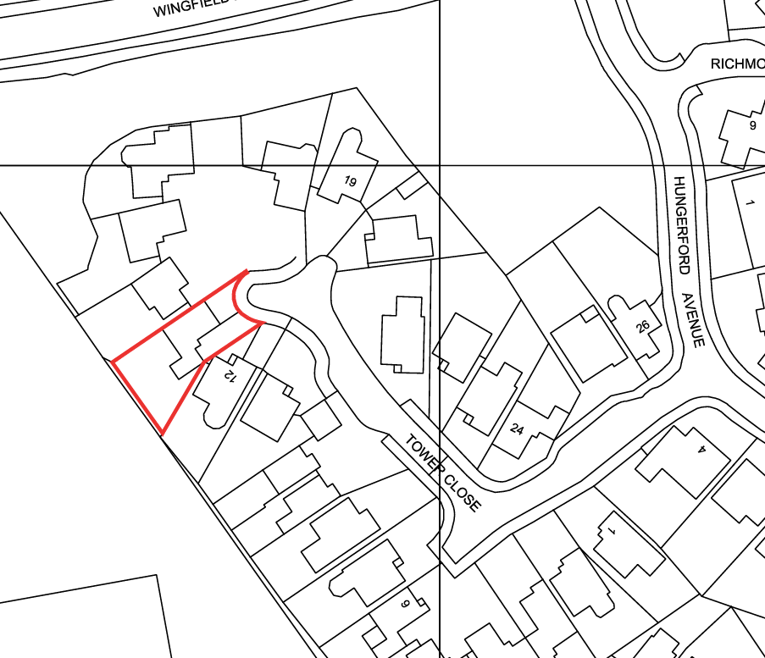

PROPOSAL

The proposal seeks permission for a single‑storey rear extension to create an open‑plan kitchen and dining area. The extension would follow the existing width of the dwelling and continue the rearward roof pitch of the attached garage across the rear elevation, integrating with the host building. New patio doors would face onto the private rear garden. As part of the works, the existing white PVCu windows throughout the property would be replaced with anthracite grey PVCu.

SITE DESCRIPTION / CONTEXT

The application site forms part of a modern residential cul-de-sac characterised by dwellings constructed in buff-coloured masonry with an irregular, subtly coursed blockwork pattern, dark concrete roof tiles, and white PVCu fenestration, all of which are common material themes in the locality. The property is predominantly surrounded by similar residential development, with the exception of the western boundary, which adjoins a playing field separated from the site by a hedgerow and fencing, alongside a public right of way (TROW5). The site lies within the Trowbridge Settlement Boundary (Principal Settlement). It is subject to several identified constraints, including a core roost buffer for greater horseshoe bats, the Grey Zone associated with the Trowbridge and Westbury Bat Mitigation Strategy, and mapped groundwater flood risk with reference to the Council’s Strategic Flood Risk Assessment mapping tool. However, the site itself is located within Flood Zone 1.

PLANNING HISTORY

Reference No. | Proposal / Summary | Decision
W/86/01255/OUT | Residential development | Approved
W/87/01653/REM | Erection of sixty houses and garages | Approved
W/91/00203/FUL | Erection of forty dwellings | Approved

RELEVANT LEGILSATION, POLICIES AND GUIDANCE

Wiltshire Core Strategy:

Core Policy 1 Settlement Strategy;
Core Policy 2 Delivery Strategy;
Core Policy 29 Spatial Strategy: Trowbridge Community Area;
Core Policy 50 Biodiversity and Geodiversity;
Core Policy 51 Landscape;
Core Policy 57 Ensuring High-Quality Design and Place Shaping;
Core Policy 60 Sustainable Transport;
Core Policy 61 Transport and Development;
Core Policy 64 Demand Management;
Core Policy 67 Flood Risk

The National Planning Policy Framework (NPPF)

The Planning Practice Guidance (PPG)

Wiltshire Design Guide - Appendix D – Design Guidance for Householder extensions

The Wiltshire Local Transport Plan 2011 – 2026: Car Parking Strategy (March 2015).

The Wiltshire Local Transport Plan 4 (LTP4) (March 2025)

Emerging Policy – Wiltshire Local Plan Review: The examination of the emerging Wiltshire Local Plan has been paused and the weight to be afforded to any part of the emerging plan can be no more than very limited. A decision on how to proceed will be made by the Council in May 2026.

CONSULTATION RESPONSES

Trowbridge Town Council: No objections, subject to no significant adverse impact on neighbouring amenity.

REPRESENTATIONS

No comments received.

ASSESSMENT

Section 38(6) of the Planning and Compulsory Purchase Act 2004 states:

"If regard is to be had to the development plan for the purposes of any determination to be made under the planning Acts, the determination must be made in accordance with the plan unless material considerations indicate otherwise."

In accordance with this statutory requirement, this application has been assessed against the relevant policies of the Development Plan, including the adopted Wiltshire Core Strategy (2015) and, where applicable, any made Neighbourhood Plans.

Design and Impact upon the upon the character and context of the area

Core Policy 57 Ensuring High Quality Design and Place Shaping of the Wiltshire Core Strategy seeks to ensure that all new development is of high design quality, reflecting local context, character, and distinctiveness.

Policy 57 of the adopted WCS requires that new development must enhance local distinctiveness, and relate positively to its landscape setting, as well as demonstrating a positive response to existing townscape and built form features such as height, scale, massing, building line, materials, and appearance.

The proposal is deemed acceptable in design terms. The submitted application form confirms that all external materials, including the Bradstone walling and grey concrete roof tiles, would match those of the existing dwelling, ensuring consistency with the established appearance of the property. The only somewhat noticeable change is the change from white to anthracite grey PVCu fenestration. While this colour finish is not common in the immediate streetscene, it represents a minor component of the overall external appearance and is not considered to result in significant visual harm to the wider appearance of the area.

In terms of the proposed extension, this would be of a modest size and would be well-integrated, effectively serving as an extension of the existing rear projection formed by the attached garage. By maintaining the established roof pitch and aligning with the host dwelling’s proportions, the addition achieves a harmonious relationship with the existing building.

Having regard to the above, the proposal complies with the design principles set out in Core Policy 57 of the Wiltshire Core Strategy and Appendix D of the Wiltshire Design Guide.

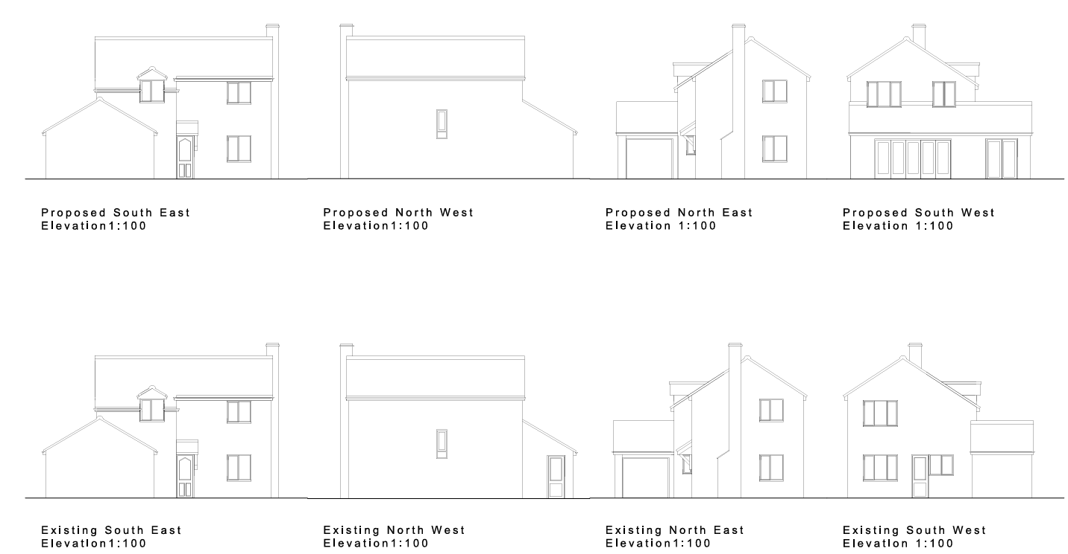
Proposed and Existing Elevations

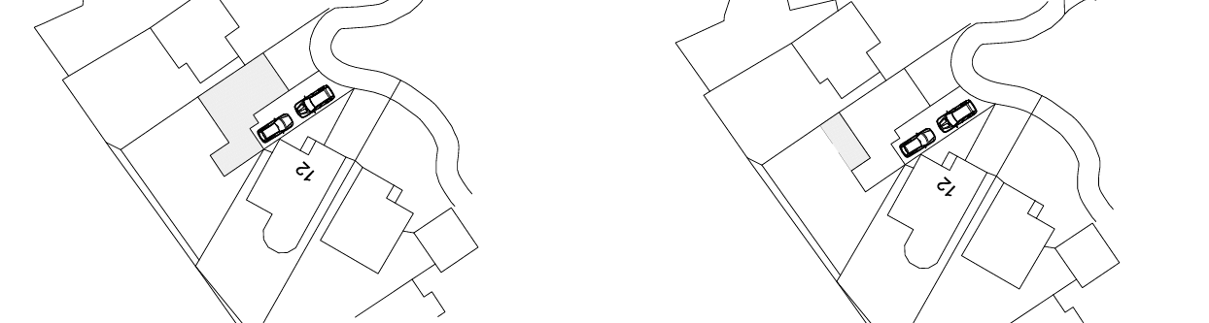
Existing and Proposed Block Plan

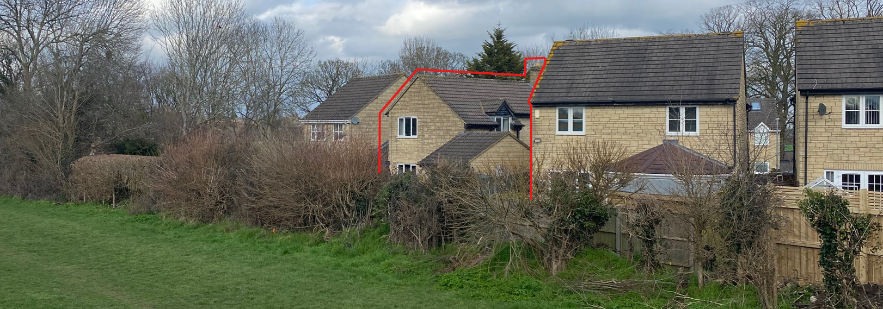
Site Visit Photo

Amenity

Point vii of CP57 of the adopted WCS requires that development does not adversely affect the amenities of neighbouring properties, and paragraph 135 of the NPPF similarly seeks to ensure a high standard of amenity for existing and future users. The proposal comprises a single-storey extension only, with new fenestration limited to the rear elevation facing directly into the property’s own private garden; no side-facing windows are proposed, and at ground-floor level any incidental views would in any case be restricted by existing boundary treatments. In terms of scale, the extension continues the existing roof form of the attached garage, matching its height and thereby maintaining a neutral impact along the southern boundary, where the built form already exists at this height. To the north, the structure sits on the boundary with an eaves height of approximately 2.3 m, rising to around 3.8 m at its junction with the dwelling, and projecting 2.6 m beyond the original rear elevation. Given its modest depth, single-storey nature, and lean-to roof form, the extension is not considered overbearing, nor would it result in any demonstrable harm to the amenity of neighbouring occupiers.

Overall, the proposal represents only a minor addition of built form and would have a minimal impact on neighbouring residential amenity, thereby complying with Core Policy 57 (point vii) and the guidance contained within Appendix D of the Wiltshire Design Guide.

Other Issues

The application does not propose the introduction of any additional bedrooms to the property, nor does it include any alteration to the existing parking and access arrangements. It is therefore considered that there are no highway or transportation concerns present with the proposal, and it is otherwise considered acceptable.

The site lies within Flood Zone 1, although the Strategic Flood Risk Assessment identifies a potential risk of groundwater flooding. The proposal, however, results in only a very modest increase in impermeable surface area, approximately 16.5 sqm, contained wholly within an established residential curtilage. Given the small scale of the extension, the exemption for householder development under paragraph 176 of the NPPF, and the absence of any evidence of existing drainage issues, the development falls well below any policy threshold requiring further sequential consideration. It is reasonable to assume that the extension would continue to utilise the existing drainage arrangements, which appear to function adequately, and the additional runoff generated would be negligible. As such, the proposal is not considered to give rise to any harmful drainage or flood-risk impacts and is compliant with Core Policy 67 of the Wiltshire Core Strategy and relevant provisions of the NPPF.

The development comprises a very modest area of built form within an established residential curtilage, where existing surfaces are already domestic in character and of negligible ecological value. In this context, any impact on habitats or protected species is expected to be effectively non-existent. Core Policy 50 of the Wiltshire Core Strategy require development to avoid harm to sensitive species and to apply the mitigation hierarchy; however, the scale and nature of the proposal present no realistic risk of disturbance. The scheme also falls within the householder exemption from mandatory Biodiversity Net Gain under Schedule 7A of the Town and Country Planning Act 1990 (as inserted by the Environment Act 2021). As such, the proposal is considered acceptable in ecological terms and compliant with relevant local and national policy requirements.

CONCLUSION

The proposal is considered to be acceptable and in accordance with the relevant policies and guidance outlined above.

RECOMMENDATION: That Planning Permission be GRANTED subject to the following conditions:

1.
The development hereby permitted shall be begun before the expiration of three years from the date of this permission.

REASON: To comply with the provisions of Section 91 of the Town and Country Planning Act 1990 as amended by the Planning and Compulsory Purchase Act 2004.

2.
The development hereby permitted shall be carried out in accordance with the following approved plans and documents:

Location / Site / Floor / Roof Elevation Plans (10 February 2026)

REASON: For the avoidance of doubt and in the interests of proper planning.

