41 MIDFORD LANE.
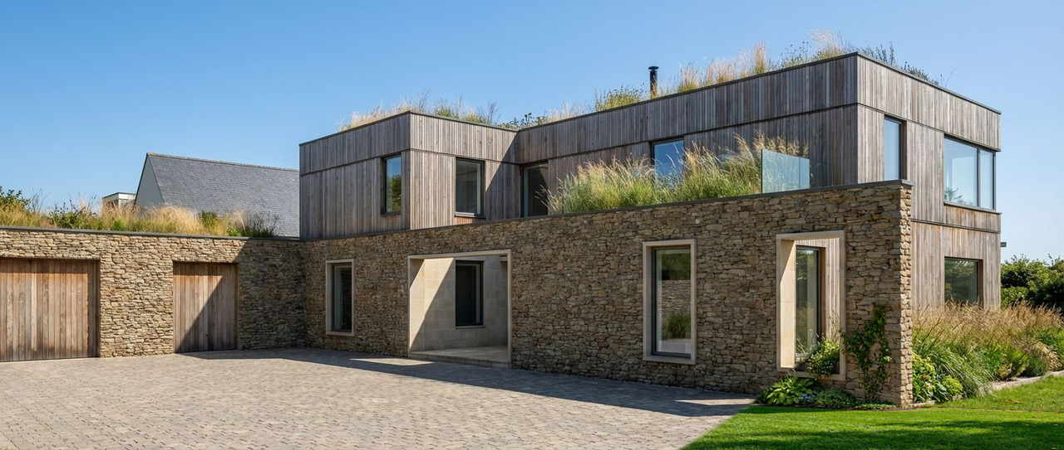

BRE365 Surface Water Infiltration Test Report
Project: Self-build residential home
Client: Jeremy Tudor-Pole
Location: 41 Midford Lane, Limpley Stoke, Bath, Wiltshire
Standard: BRE Digest 365:2016 Soakaway Design
Test dates: 8 February 2026 and 28 February 2026

Methodology

In order to comply with the percolation test requirement, a soil infiltration monitoring exercise was undertaken in accordance with BRE365. This is an industry standard method to assess soil infiltration and therefore the appropriateness of soakaways as a drainage solution. Infiltration into the ground via infiltration is at the top of the sustainable drainage system hierarchy and should be the first choice drainage solution if it is viable.

To undertake an infiltration test, BRE365 requires the following:
- Excavate a soakaway trial pit to the same depth as anticipated for the soakaway. This should be below the invert level of the drain discharging to the soakaway;
- The pit should be in the order of 1m to 2.5m depth, 0.3 to 1m in width and 1 to 3m, in length, and trimmed as appropriate;
- The pit should be rapidly filled with water to the design invert level of the drain discharging to the soakaway; and
- Recordings are to be made of the water depth to enable the infiltration rate to be calculated from the water levels at 75% and 25% of the initial depth. The process is to be repeated up to three times. The above method has been followed during an infiltration monitoring exercise undertaken

Ground Conditions
Trial pits revealed clay overburden overlying fissured oolitic limestone bedrock. Bedrock encountered at approximately 450–850mm depth across the site. The limestone exhibited visible fissures and demonstrated rapid drainage characteristics. Trial pits were excavated to 1000mm in depth where possible to carry out Infiltration Tests in accordance with this methodology.

Trial Pit Dimensions
Length: 2100 mm
Width: 350 mm
Depth: 1000 mm

Trial Test 1 – 28 February 2026
Pre-soaked pit filled to 750 mm depth and monitored until fully drained. Time to drain from 750 mm to empty was 39 minutes.

Trial Test 2 – 8 February 2026
Pre-soaked pit filled to 500 mm depth and monitored until fully drained. Time to drain from 500 mm to empty was 27 minutes.

Results and BRE365 Assessment
Calculated infiltration coefficient (Vp): approximately 3.2 x 10^-4 m/s equivalent (approximately 3120 seconds per metre).
This represents very good infiltration performance. Ground conditions are highly suitable for soakaway or infiltration trench drainage systems.

Conclusion
Based on BRE365 methodology and observed infiltration rates, the site is suitable for surface water disposal via infiltration trench or soakaway. The rapid infiltration into fissured limestone provides sufficient drainage capacity for the proposed 160 m² driveway.

Declaration
I confirm that infiltration testing was carried out in accordance with BRE365 methodology,
and results presented in this report are accurate and representative of site conditions.
Signed:
Name: JEREMY TUDOR-POLE MCIOB, MSc.
Date: 1ST MARCH 2026

APPENDICES
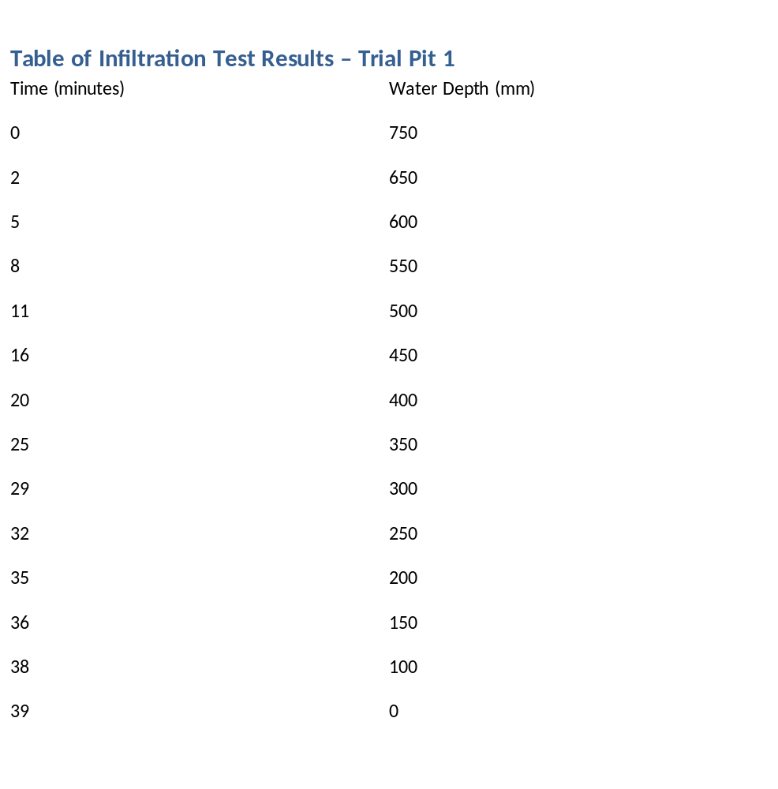

Graph of Infiltration Test Results
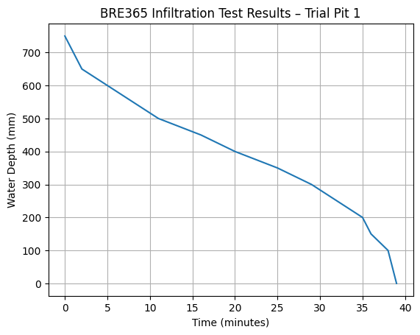

BRE365 Formula Calculations
BRE365 Formula:
Vp = t75–25 / (0.5 × h)
Where:
Vp = infiltration coefficient (seconds per metre)
t75–25 = time taken for water level to fall from 75% to 25%
h = water depth between 75% and 25% levels
Measured values:
75% level = 750 mm at 09:41
25% level = 250 mm at 10:13
Time difference = 32 minutes = 1920 seconds
h = 750 mm – 250 mm = 500 mm = 0.5 m
Therefore:
Vp = 1920 / (0.5 × 0.5)
Vp = 1920 / 0.25
Vp = 7680 seconds per metre
Equivalent infiltration rate:
f = 1 / Vp
f = 1.30 × 10^-4 m/s
This represents very good infiltration suitable for infiltration drainage.

Trench Sizing Justification for 160 m² Driveway
Driveway area = 160 m²
Design Rainfall Event
Assumed rainfall depth = 50 mm (0.05 m)
(Conservative approximation of a significant storm event)
Runoff Volume
$$\text{Volume}=\text{Area}×\text{Rainfall} \\ =160×0.05 \\ =8.0 {\text{m}}^{3}$$
Proposed Infiltration Trenches
Trench 1
- Length = 8.5 m
- Width = 0.6 m
- Depth = 0.9 m
$$\text{Volume}=8.5×0.6×0.9=4.59 {\text{m}}^{3}$$
Trench 2
- Length = 5.8 m
- Width = 0.6 m
- Depth = 0.9 m
$$\text{Volume}=5.8×0.6×0.9=3.13 {\text{m}}^{3}$$
Total Geometric Storage Volume
$$4.59+3.13=7.72 {\text{m}}^{3}$$
Effective Storage Volume (30% void ratio)
$$7.72×0.30=2.32 {\text{m}}^{3}$$Infiltration Performance (BRE365)
Tested infiltration rate:
$$f=1.3×{10}^{-4}\text{ m/s}$$
Infiltration Area
Infiltration occurs through the base and side walls of both trenches.
Trench 1:
- Base: 8.5 × 0.6 = 5.10 m²
- Sides: 2 × (8.5 × 0.9) = 15.30 m²
- Ends: 2 × (0.6 × 0.9) = 1.08 m²
Total = 21.48 m²

Trench 2:
- Base: 5.8 × 0.6 = 3.48 m²
- Sides: 2 × (5.8 × 0.9) = 10.44 m²
- Ends: 2 × (0.6 × 0.9) = 1.08 m²
Total = 15.00 m²

Combined Infiltration Area
$$21.48+15.00=36.48 {\text{m}}^{2}$$
Infiltration Discharge Rate
$$Q=f×A \\ =(1.3×{10}^{-4})×36.48 \\ =0.00474 {\text{m}}^{3}/s$$
Equivalent Hourly Infiltration Capacity
$$0.00474×3600=17.1 {\text{m}}^{3}/\text{hour}$$
Performance Assessment
- Total runoff volume: 8.0 m³
- Available storage: 2.32 m³
- Infiltration capacity: ~17.1 m³/hour

Interpretation
The infiltration capacity of the system significantly exceeds the total runoff volume generated during the design storm event.
This indicates that:
- Water will infiltrate rapidly during rainfall events
- The trenches will not reach full storage capacity under typical design conditions
- The system will drain down quickly between storm events

Conclusion
The proposed twin infiltration trench system is suitable for managing runoff from the 160 m² driveway.
Although the geometric storage volume is lower than the total runoff volume, the high infiltration rate and large infiltration area ensure that runoff is effectively dispersed into the ground during storm events.
The system therefore complies with BRE365 guidance and provides an effective and sustainable surface water drainage solution for the site.

