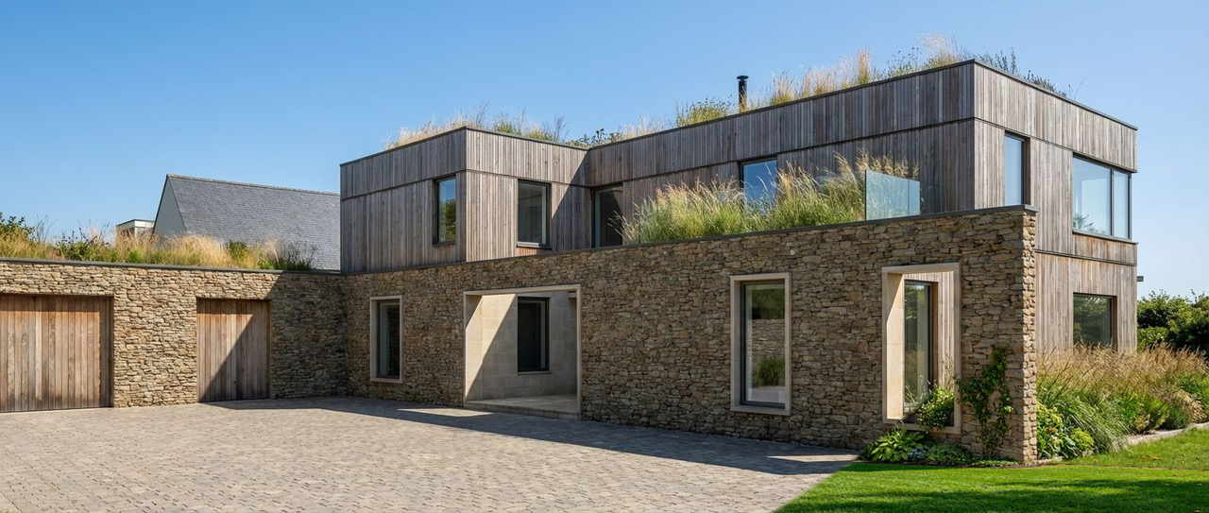

SURFACE WATER DRAINAGE STRATEGY REPORT
BRE365 COMPLIANT INFILTRATION DESIGN
Self‑Build Residential Development
Prepared to discharge pre‑commencement planning condition (Surface Water Drainage)
Planning Ref: ____PL/2025/07506_________
Site Address: __41 Midford Lane, Limpley Stoke, Bath BA2 7GT______
Client: Self‑Build Applicant
Prepared by: Jeremy Tudor-Pole MCIOB, MSc.
Date: 29th March 2026
Version 001

1. Purpose of Report
This report has been prepared to discharge planning condition requiring submission of a surface water drainage strategy in accordance with Wiltshire Council requirements, National Planning Policy Framework (NPPF), Planning Practice Guidance (PPG), and Non-Statutory Technical Standards for Sustainable Drainage Systems

2. Wiltshire Council Surface Water Drainage Planning Requirements
Wiltshire Council requires that all new developments manage surface water runoff in accordance with the principles of Sustainable Drainage Systems (SuDS). Planning policy requires that surface water runoff shall be managed on site where feasible using infiltration techniques. Discharge to public sewer systems is considered only where infiltration is demonstrated to be unfeasible. This report demonstrates that infiltration drainage is both feasible and appropriate at this site based on site investigation and BRE365 infiltration testing.

3. SuDS Hierarchy Compliance
The drainage strategy has been developed in accordance with the SuDS hierarchy, which prioritises disposal methods in the following order:
1. Infiltration to ground
2. Discharge to watercourse
3. Discharge to surface water sewer
4. Discharge to combined sewer
This site achieves the highest priority option by discharging surface water via infiltration to the underlying fissured limestone formation.

4. BRE365 Soakaway Design Guidance
Infiltration testing has been carried out in accordance with BRE365 'Soakaway Design'. BRE365 provides standardised methods for determining infiltration rates and sizing infiltration drainage systems. Testing undertaken at this site demonstrates rapid infiltration, confirming that infiltration drainage is appropriate.

5. Building Regulations Part H Compliance
The proposed drainage system complies with Building Regulations Part H, which requires that surface water shall be discharged to ground where reasonably practicable. The proposed infiltration trench system fully complies with these requirements.

6. Site Conditions and Ground Investigation
The site is underlain by clay over fissured oolitic limestone bedrock. Trial pit excavations encountered limestone bedrock between approximately 450 mm and 850 mm below ground level. BRE365 infiltration testing and site investigation confirm rapid infiltration into fissured limestone with no evidence of groundwater emergence or risk of offsite flooding.

7. Seasonal Groundwater Considerations
In accordance with BRE365 guidance, a conservative approach has been adopted, assuming that groundwater levels may rise seasonally. A minimum 1.0m clearance will be maintained between the base of the infiltration system and the maximum anticipated groundwater level in accordance with BRE365 guidance.
Infiltration testing was undertaken in February 2026, representing a period of typically elevated groundwater levels and reduced soil permeability. Trial pits excavated to depths between 0.45m and 1.0m did not encounter groundwater.
Given the absence of groundwater during winter testing and the recorded infiltration rate of 1.3 × 10⁻⁴ m/s, the proposed infiltration system is considered suitable for year-round operation.

8. Proposed Driveway Construction Build-Up
The proposed driveway construction will comprise:
• Egyptian limestone sett surface
• 40–60 mm bedding layer (grit sand or fine aggregate)
• 400–600 mm open graded Type 3 sub-base
• Geotextile separation layer (if required)
• Natural limestone formation
The open graded Type 3 sub-base provides interception storage and manages initial rainfall events in accordance with SuDS interception requirements. It also provides structural support and temporary surface water storage prior to infiltration.
During construction, exposed infiltration surfaces will be protected from sediment contamination and geotextile membranes installed to prevent clogging.
Based on BRE365 infiltration testing, an infiltration trench is confirmed as the primary surface water disposal method for the site. No alternative discharge method is proposed unless unforeseen ground conditions are encountered during construction

9. Exceedance Routing & Flood risk
In exceedance events, surface water will flow away from the dwelling toward the driveway entrance and infiltrate locally without risk to buildings. This is shown on the accompanying proposed drainage plan via green arrows draining towards infiltration trenches.
The site is located in Flood Level 1 and has Ground sure score of “negligible risk” with A-rated 5 year and A rated 30 year scores. Existing ground levels range between 137.86m and 138.26m AOD. As there is no flooding predicted it is proposed that the so finished floor level shall be minimum 150mm above adjacent ground levels, ensuring protection from surface water flooding and exceedance events.

10. Channel Drain System
A polymer concrete channel drain will be installed across the front boundary of the driveway. The channel drain will collect surface water runoff and convey it to the infiltration trench. The channel drain will be rated to minimum load class B125 and installed on concrete bed and haunch.

11. Infiltration Trench Specification
Length: 8.5 m
Width: 600 mm
Depth: 400–900 mm
Fill: 20/40 mm clean angular stone
Void ratio: approximately 30%
Geotextile wrap: Yes
Location: Front boundary
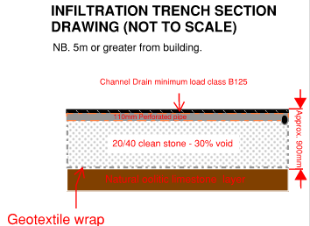

12. Infiltration Trench Performance and Sizing Justification
The proposed drainage system comprises two infiltration trenches:
- Trench 1: 8.5m × 0.6m × 0.9m
- Trench 2: 5.8m × 0.6m × 0.9m
Total effective storage volume (assuming 30% void ratio) is approximately 2.32m³.
Infiltration testing undertaken in accordance with BRE365 identified an infiltration rate of 1.3 × 10⁻⁴ m/s. The total infiltration area of both trenches (including sides and base) is approximately 36.5m².
This provides an infiltration capacity of approximately 0.00475 m³/s (equivalent to 17.1 m³/hour).
Given that the estimated runoff volume from the impermeable area is approximately 8.0m³, the infiltration capacity of the system significantly exceeds the runoff generation rate.
The system will therefore drain rapidly during storm events, and the combination of storage and infiltration ensures no surface water flooding will occur on site.

13. Maintenance Requirements
The channel drain shall be periodically inspected and cleared of debris. The infiltration trench or soakaway requires minimal maintenance due to the clean aggregate and geotextile wrap preventing sediment ingress.

14. Compliance Statement
The proposed surface water drainage system complies with Wiltshire Council planning policy, BRE365 soakaway design guidance, Building Regulations Part H, and SuDS design principles. BRE365 testing confirms infiltration is highly effective and represents the preferred and most sustainable drainage solution for the site.

15. Declaration
I confirm that this report has been prepared based on site investigation and BRE365 testing.

Signed: ______________________________________________

Name: _JEREMY TUDOR-POLE _MCIOB MSc._______

Date: 29.03.2026______________________________________

APPENDICES
- BRE365 – Infiltration Test Report
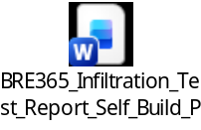

- Proposed Drainage Plan

- Proposed Site Plan


- Photographs
