APPLICATION FOR HOUSEHOLDER PLANNING PERMISSION
DELEGATED REPORT

APPLICATION REFERENCE: | PL/2026/00802
APPLICATION TYPE: | Householder planning permission
SITE ADDRESS: | 32 Huntingdon Rise, Bradford on Avon, BA15 1RJ
DEVELOPMENT DESCRIPTION: | Proposed garage conversion and new build detached garage
RECOMMENDATION: | That Planning Permission be REFUSED

SITE CONTEXT

32 Huntingdon Rise (the ‘site’) is a residential plot on the northeastern cul-de-sac of Huntingdon Rise and is situated in the northeastern area of Bradford on Avon (designated a Market Town in the Wiltshire Core Strategy).

The surrounding area forms part of a modern suburban estate characterised primarily by detached bungalows and two-storey houses laid out in a regular pattern. Most dwellings sit behind modest front gardens, contributing to a spacious and coherent streetscene. Immediately north of the site is a row of grade II listed cottages which feature a historic drystone boundary wall; these cottages lie within Bradford on Avon Conservation Area (CA) No. 1. To the east, the site adjoins Huntingdon Street, which also falls within the CA. The southern boundary abuts modern two-storey housing, while the western boundary adjoins Huntingdon Rise and a run of modern bungalows.

The application site comprises a modern detached two-storey dwelling with an integrated garage and associated amenity space. The building is formed of the principal two-storey pitched-roof range and a secondary two-storey hipped-roof element, the latter incorporating the original hallway and garage at ground-floor level and a first-floor extension approved in 2016. Its external materials include blockwork walling, concrete roof tiles and uPVC double-glazed windows. The proposal relates specifically to the front garden area which comprises an upper lawn with flowerbeds and a lower concrete driveway. The site slopes downward from the upper garden to the access onto Huntingdon Rise.

The application site is subject to the following planning policy designations/constraints:

- The site lies within immediate proximity of several grade II listed buildings, including:
  - 16-20 Huntingdon Street which adjoin the north site boundary.
  - Providence Baptist Chapel, Bearfield Buildings located circa 20m to the east.
  - 12 Huntingdon Street located circa 50m to the south.
- The site adjoins the Bradford on Avon Conservation Area No 1 to the north and east.
- Within Greater Horseshoe bat 4km Core Roost Buffer: Combined Windsley Sites, Winsley/Murhill Rift, Combined Gripwood Sites and Iford Manor.
- Within Greater Horseshoe bat 4km Special Area of Conservation Parcel Buffer.
- Within Lesser Horseshoe bat 2km Core Roost Buffer: Belcombe Court and Carpenter's Shop, Kingston Mills, BoA.

PROPOSAL

The proposal seeks householder planning permission for the conversion of the existing integrated garage to living space and the erection of a large garage in the front garden.

The conversion would involve replacing the garage door with blockwork walling to match that existing and a 3-pane window and internal insulation and utility works to create an office/study and utility room. The existing and proposed house plans are shown below.

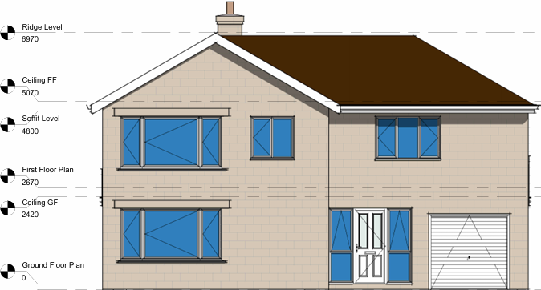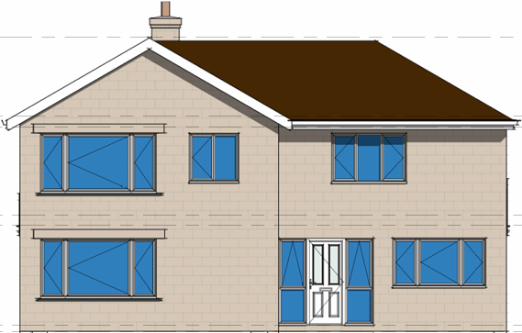

Left: Existing front elevation. Right: Proposed front elevation.

The garage is a single-storey pitched roof structure positioned in the northwest corner of the front garden and abutting the northern boundary. It measures 7m long by 3.5m wide with a gross internal area (GIA) of 22sqm. It has 2.4m high eaves and a circa 3.6m high ridge. The garage would be formed of blockwork walling and concrete tile roofing matching that of the host dwelling. The proposed garage plan is shown below.

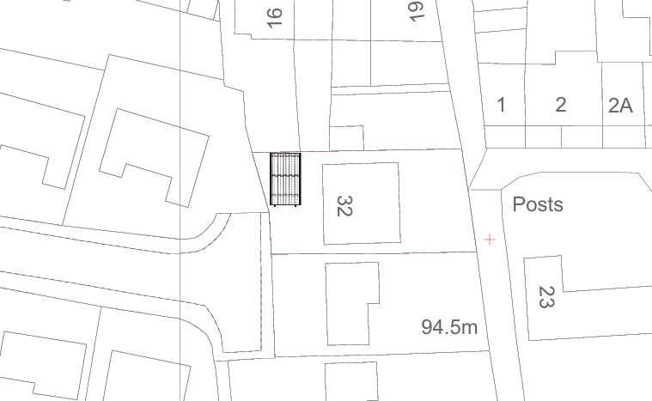

Proposed garage site plan.

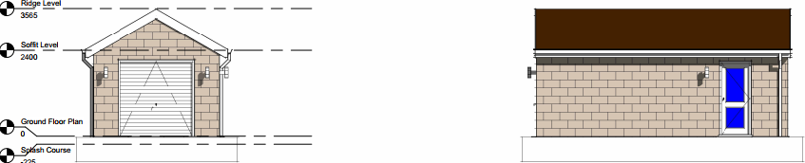

Proposed garage elevations.

In response to concerns regarding design, plan inaccuracies, and potential heritage and tree impacts (as detailed in the assessment below), officers invited the submission of amended plans and supporting information. These amendments were intended to clarify ground levels, pull the garage further from the sensitive historic drystone boundary wall, reduce the scale of the garage and safeguard planting within the CA. Additional information was also requested, including arboricultural reporting and foundation details to clarify the building impacts in immediate proximity of the historic wall and protected planting. The applicant declined to provide the requested revisions and additional information.

PLANNING HISTORY

Relevant Planning Records
Reference | Description | Decision | Date
16/03038/FUL | Proposed side and rear extensions | Approved | 23/05/2016

RELEVANT LEGISLATION, POLICIES AND GUIDANCE

Planning Legislation:

- Town and Country Planning Act 1990
- Planning and Compulsory Purchase Act 2004
- Planning (Listed Buildings and Conversation Areas) Act 1990

Development Plan:

- Wiltshire Core Strategy (Adopted January 2015):
  - Core Policy 41: Sustainable construction and low-carbon energy
  - Core Policy 57: Ensuring high quality design and place shaping
  - Core Policy 58: Ensuring the conservation of the historic environment
  - Core Policy 61: Transport and development
  - Core Policy 64: Demand management

- West Wiltshire District Plan (Adopted June 2004):
  - Saved Policy C40: Tree planting

- The Bradford on Avon Neighbourhood Plan 2013-2026 (Made October 2017):
  - Policy BE1 (relates to local distinctiveness and sense of place)
  - Policy BE2 (relates to land use efficiency and character of the area)

Material Considerations (Policy):

- National Planning Policy Framework (NPPF) December 2024
  - Section 2. Achieving sustainable development
  - Section 12. Achieving well-designed places

- Wiltshire Local Plan Submission Draft 2020-2038 (Regulation 24)*:
  - Policy 4: Addressing climate change
  - Policy 71: Transport and new development
  - Policy 73 Transport: Demand Management
  - Policy 85: Sustainable construction and low carbon energy
  - Policy 98: Ensuring high quality design and place shaping

*The examination of the emerging Wiltshire Local Plan has been paused and the weight to be afforded to any part of the emerging plan can be no more than very limited. A decision on how to proceed will be made by the Council in May 2026.

Material Considerations (Guidance):

- National Planning Practice Guidance
- National Design Guide (January 2021)
- Wiltshire Design Guide (March 2024)
- Wiltshire Local Transport Plan 2011-2026: Car Parking Strategy

CONSULTATION RESPONSES

Bradford on Avon Town Council: No objection.

Bradford on Avon Preservation Trust: “We are concerned about the adverse impact on the street scene due to the location and orientation of the proposed garage forward of the existing building line.”

Wiltshire Council Highways: No objection.

REPRESENTATIONS

None received.

ASSESSMENT

Section 38(6) of the Planning and Compulsory Purchase Act 2004 states that planning decisions must be made in accordance with the development plan unless material considerations indicate otherwise. In accordance with this requirement, this application has been assessed against the relevant policies of the development plan and the material considerations listed above.

Having regard to the planning context and nature of the proposal, the following key matters are considered pertinent to the assessment of the proposal and are addressed in turn:

- Design (including plan inaccuracies)
- Heritage
- Neighbouring amenity
- Transport
- Trees

Design (including Plan Inaccuracies)

Core Policy 57 of the Wiltshire Core Strategy requires that all development be of high design quality, create a strong sense of place and complement its context, including through enhancing local distinctiveness and responding positively to local characteristics. This requirement is carried forward in draft Policy 98 of the emerging Wiltshire Local Plan.

Appendix D of the Wiltshire Design advises that detached outbuildings placed in front of properties will not normally be acceptable and that they should be single storey in scale.

Policy BE1 of the Bradford on Avon Neighbourhood Plan states that development should reinforce local distinctiveness, help create a sense of place and respond positively to its immediate and wider context, including in respect of materials palette.

Policy BE2 states that development should make efficient use of land and respect the character of the area.

Plan inaccuracies: Paragraph 140 of the NPPF requires local planning authorities (LPAs) to ensure that planning conditions refer to clear and accurate drawings which provide visual clarity about the design of the development. This is to provide visual certainty regarding the approved design, assist applicants and developers in understanding how to comply with the permission, and enable authorities to effectively monitor and enforce any potential breaches.

As noted above, the site slopes downward from the upper garden to the access onto Huntingdon Rise, with an approximate level change of 0.5m between the rear and front of the proposed garage. No ground-level information has been provided and, given the sloping nature of the plot, it is unclear whether the proposal would require land to be built up or the garage to be partially set into the rising ground. This lack of clarity makes it difficult to fully assess the visual impact of the development, including its relationship with the adjacent historic boundary wall and protected planting. In addition, no details have been submitted regarding the soft and hard landscaping required to accommodate the garage.

The Wiltshire Validation Checklist: Validation Requirements for Planning Applications (published August 2025) requires that Householder Planning Applications which involve “a change in level – for example when on a sloping site or when a building is part cut into the ground” should be supported by existing and proposed site sections.

The applicant was invited to submit revised plans and advised that these should show the garage in relation to the rising ground levels. This request was declined. Based on the information available at the point of determination, the submitted plans do not provide sufficient clarity regarding what would be constructed if permission were granted. The proposal is therefore considered to be contrary to paragraph 140 of the NPPF.

Compliance with the development plan: The proposed garage would sit forward of the established building line and occupy a visually prominent position within the street scene, particularly if constructed on raised ground. Both the Bradford on Avon Preservation Trust and planning officers have expressed concern regarding its siting and relationship with the surrounding streetscape. Its forward position also conflicts with the outbuilding guidance in Appendix D of the Wiltshire Design Guide.

It is acknowledged that there is a front garage at No. 28. However, this garage is more discreetly positioned; it is significantly set back from the street scene, is not positioned on raised ground and is marginally smaller in scale. As such, while it does establish a degree of precedence, its presence does not justify the proposed garage at No. 32.

In addition, at 22sqm GIA, the proposed garage is also relatively large, approximately 25% greater than the 18sqm GIA recommended in Manual for Streets, and this additional size further increases its visual prominence.

The applicant was invited to submit revised plans to address these concerns by setting the garage further into the slope and reducing its scale; however, this request was declined. As a result, the issues identified remain unresolved.

Based on the submitted plans, the proposed garage, by reason of its prominent siting and scale, would fail to respond positively to the character, context and distinctiveness of the host dwelling and its setting. It would appear incongruous and overly dominant, detracting from the visual amenity of the surrounding area. As such, the proposal is contrary to the design principles of Core Policy 57, draft policy 98, Neighbourhood Plan Policies BE1 and BE2, the Wiltshire Design Guide and section 12 of the NPPF.

Heritage

Section 66(1) of the Planning (Listed Buildings and Conversation Areas) Act 1990 requires that special regard be had to the desirability of preserving listed buildings, their settings or any features of special architectural or historic interest which they possess.

Section 72(1) of the Planning (Listed Buildings and Conversation Areas) Act 1990 requires that special attention be paid to the desirability of preserving or enhancing the character or appearance of a Conservation Area.

Core Policy 57(i) and (iv) require that development proposals be sympathetic, respond positively to and conserve the historic environment.

Core Policy CP58 states that development should protect, conserve and, where possible, enhance the historic environment. The policy requires that heritage assets and their settings be conserved and/or enhanced in a manner appropriate to their significance. This requirement is carried forward in draft Policy 99.

Paragraph 207 of the NPPF states that local planning authorities should require applicants to describe the significance of any heritage asset affected by development, including any contribution made by their setting. The level of detail should be proportionate to the asset’s importance and no more than is sufficient to understand the potential impact of the proposal on the asset’s significance.

Paragraph 212 clarifies that great weight should be given to an asset’s conservation, irrespective of the level of harm.

Paragraph 213 states that any harm to the significance of a designated asset, including from development within its setting, requires clear and convincing justification.

Neighbourhood Plan Policies BE1 and BE2 also apply in respect of heritage matters.

The proposed garage abuts the historic drystone southern boundary wall of 16-20 Huntingdon Street, a group of grade II listed cottages which also fall within the Bradford on Avon Conservation Area (CA) No 1. The Historic England listing of these buildings is copied below:

A group of C17 cottages with No 20 at right angles to rear. 2 storeys, No 17 having a higher roof level and a gable with attic. Rubble with some stone-tiled and some pantiled roofs. Some original windows, 2-and 3-light casements with stone mullions. No 19 has original 3-light mullioned window in gable-end. Dripmoulds to No 18 only. Plain door openings. Included for group value.

Nos 16 to 20 (consec) form a group

The significance of the listed cottages derives from their architectural and historic interest, including their strong group value. The site also lies within proximity of the grade II listed Providence Baptist Chapel, Bearfield Buildings and 12 Huntingdon Street, however the proposal would have no impact on these assets.

The Bradford on Avon CA Character Assessment identifies this part of the CA as being characterised predominantly by residential development with an established ecclesiastical presence. Development is described as relatively dense and arranged in a linear pattern. The special interest of this part of the CA is derived from the historic character and aesthetic quality of the traditional properties fronting Huntingdon Street and Bearfield Buildings. It is acknowledged that significant modern development has occurred adjacent to the CA, notably at Huntingdon Rise, which now forms a material element of the CA’s wider setting.

The site plan indicates that the garage would be positioned within 0.1m from the site boundary; however, in the absence of a topographic survey, the true relationship with the historic drystone wall may be even closer. As this wall is a protected and positive feature of both the grade II listed cottages and the CA, officers have concerns that the construction of the garage could result in physical harm, particularly given the lack of information regarding proposed foundations, excavation, or land-grading works. Furthermore, the development would increase the density of modern built form immediately adjacent to these heritage assets, infilling a green gap opposite 16-17 Huntingdon Street.

The applicant was invited to submit revised plans to address these concerns by pulling the garage slightly away from the site boundary, setting it into the slope and reducing its scale, as well as to provide foundation details. This request was declined. As a result, the issues identified remain unresolved.

Based on the submitted information, due to the proximity of the proposed garage with the historic boundary wall, its prominent and elevated siting, combined with its larger scale, would result in a low to moderate level of less than substantial harm to the significance, character, appearance and setting of the adjoining grade II listed cottages and the CA. NPPF paragraphs 212 and 213 state that great weight must be given to the conservation of heritage assets, and that any harm must be clearly and convincingly justified. No such heritage justification has been provided, nor has any public benefit been demonstrated that might outweigh this harm. The proposal therefore fails to conserve or enhance the historic environment and is thus contrary to sections 66(1) and 72(1) of the Planning (Listed Buildings and Conservation Areas) Act 1990, Core Policies 57 and 58, draft Policies 98 and 99, Neighbourhood Plan Policies BE1 and BE2, the Wiltshire Design Guide, and section 16 of the NPPF.

Neighbouring Amenity

Core Policy 57(vii) requires that development be compatible with the adjoining uses and protect the residential amenity of existing and future users of the site and its surroundings, including in respect of natural lighting, privacy, outlook and pollution sources. This requirement is carried forward in draft Policy 98.

The Design Guide states that minimum garden areas for all houses should be equivalent to the footprint of the house and that a back-to-back separation distance of minimum 20m should be respected. The guide also refers to the BRE Site layout planning for daylight and sunlight as an appropriate source for assessing proposals. Appendix D of the guide states that extensions should not be unduly overbearing or obtrusive to neighbouring properties.

The development would not give rise to any unacceptable impacts on the residential amenity of nearby properties and would retain sufficient garden space for the host dwelling. As such, the proposal is considered to safeguard the residential amenity of the host and neighbouring properties in accordance with Core Policy 57(vii), draft Policy 98 and the Design Guide.

Transport

Core Policies 60-64 collectively aim to ensure development promotes sustainable transport, provides safe and suitable access and parking and has an acceptable impact on the highway network. These policies are broadly echoed by draft Policies 70-73.

The proposal does not add any additional bedrooms (which would require additional parking provision) and the garage exceeds the standard 3m wide by 6m size recommended in Manual for Streets. Furthermore, the Highways Engineer raises no objection. The proposal is therefore considered to comply with Core Policies 60-64.

Trees

Core Policy 57(ii) requires that development retain natural features (e.g. trees, hedges etc), in order to conserve and enhance biodiversity and integrate development into its setting. This requirement is carried forward in draft Policy 98.

Saved Policy C40 states that trees of visual amenity value will be retained, particularly within conservation areas. The policy requires the replacement of protected trees with new specimens of an appropriate size and species in the immediate locality.

The proposed garage would sit directly adjacent to the site boundary, where several semi-mature trees are located (see image below). These trees provide visual amenity, contribute positively to the setting of nearby heritage assets, and reinforce the green character of the area. Importantly, they are situated within the Conservation Area, where any tree with a stem diameter of 75mm or more at 1.5m above ground level is afforded statutory protection.

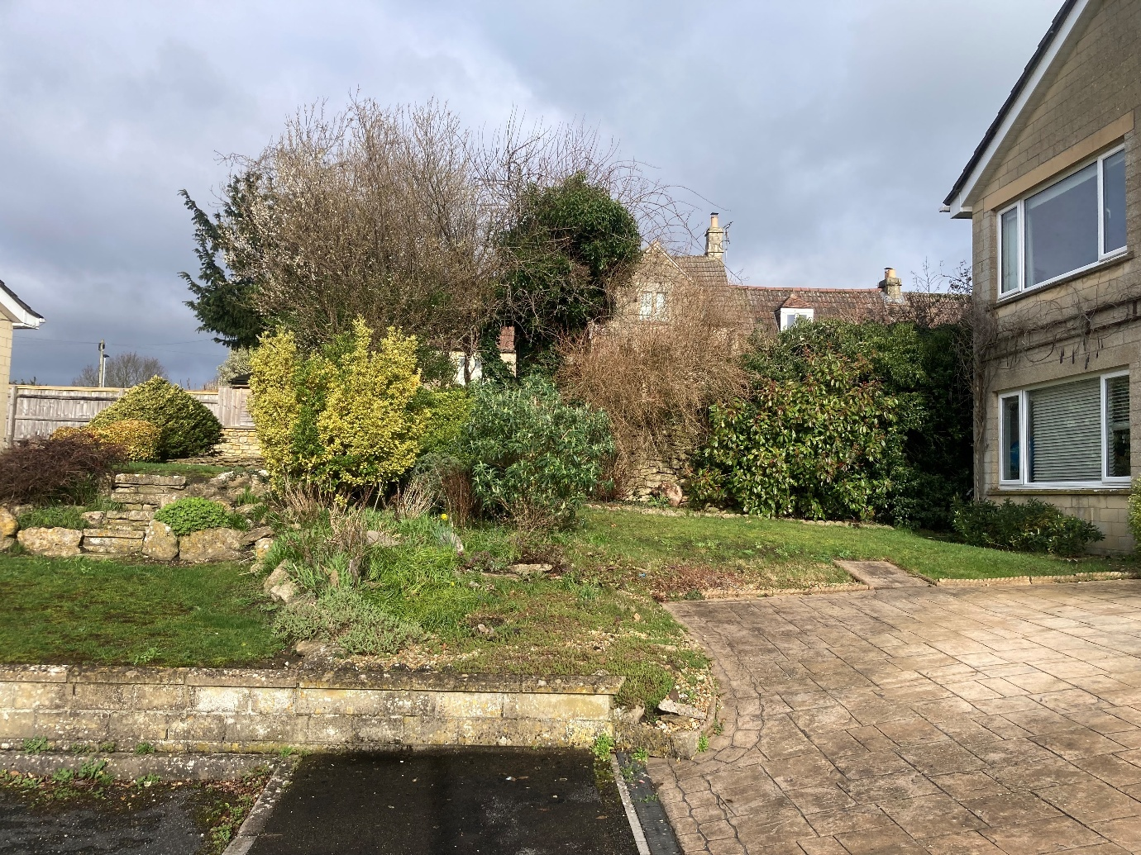

Officers are concerned that positioning the garage so close to these trees, particularly in the absence of confirmed details regarding foundations, excavation, and land-grading works, poses a high risk of unacceptable harm to their root protection area, canopy and overall health.

The applicant was invited to submit revised plans to address these concerns by pulling the garage slightly away from the site boundary, as well as to provide foundation details and arboricultural reporting. Again, this request was declined. As a result, the issues identified remain unresolved.

Based on the submitted information, the proximity of the proposed garage to the protected trees, combined with the absence of details regarding construction methods and arboricultural impacts, indicates a high likelihood of harm to trees that contribute positively to the visual amenity of the CA. No replacement planting has been proposed to mitigate this loss. The proposal is therefore contrary to Core Policy 57, draft Policy 98 and Saved Policy C40.

CONCLUSION

By reason of the identified harm in respect to the design of the proposed garage and its associated impact on visual amenity, the adjoining heritage assets and protected trees, is considered to conflict with the aims, objectives and policies of the Wiltshire Core Strategy, emerging Wiltshire Local Plan, Wiltshire Design Guide, Bradford on Avon Neighbourhood Plan, the Planning (Listed Buildings and Conservation Areas) Act 1990 and the NPPF. The proposal fails to demonstrate compliance with the relevant policies and guidance, and no overriding material considerations have been identified that would justify a departure from the development plan.

Accordingly, the application is recommended for refusal.

RECOMMENDATION: That Planning Permission be REFUSED for the following reasons:

- The proposed garage involves a change in land level and the application fails to provide any existing and proposed site sections or any other ground level information. In the absence of such information, the submitted plans do not provide clear and accurate drawings which provide visual clarity about the design of the development. The application therefore fails to meet the requirements of paragraph 140 of the NPPF which seeks to ensure sufficient clarity and certainty in approved plans.

- By reason of its prominent siting and overall scale, the proposed garage would fail to respond positively to the character, context and distinctiveness of the host dwelling and its setting. The development would appear incongruous and overly dominant within the streetscene, resulting in harm to the visual amenity of the surrounding area. The proposal is therefore contrary to Core Policy 57 of the Wiltshire Core Strategy, draft Policy 98 of the emerging Wiltshire Local Plan, Policies BE1 and BE2 of the Bradford on Avon Neighbourhood Plan, the Wiltshire Design Guide, and section 12 of the National Planning Policy Framework, which collectively seek to ensure high-quality design that respects local character and integrates appropriately with its surroundings.

- By reason of its close proximity to the historic drystone boundary wall, its prominent siting and overall scale, the proposed garage would result in a low to moderate level of less than substantial harm to the significance, character, appearance and setting of the adjoining grade II listed cottages and the Bradford on Avon Conservation Area. No such heritage justification has been provided, nor has any public benefit been demonstrated that would outweigh the identified harm. The proposal therefore fails to conserve or enhance the historic environment and is contrary to sections 66(1) and 72(1) of the Planning (Listed Buildings and Conservation Areas) Act 1990, Core Policies 57 and 58 of the Wiltshire Core Strategy, draft Policies 98 and 99 of the emerging Wiltshire Local Plan, Policies BE1 and BE2 of the Bradford on Avon Neighbourhood Plan, the Wiltshire Design Guide, and section 16 of the NPPF.

- By reason of the immediate proximity of the proposed garage to protected trees of visual amenity value within the Conservation Area and the absence of essential details regarding construction methods, foundations, excavation and arboricultural impacts, the proposal presents a high likelihood of causing harm to these protected trees and, by extension, the Conservation Area. Given the high likelihood of harm and the absence of necessary arboricultural information, the development is therefore contrary to Core Policy 57 of the Wiltshire Core Strategy, draft Policy 98 of the emerging Local Plan, and Saved Policy C40 of the West Wiltshire District Plan, which collectively seek to retain natural features including trees of visual amenity value, particularly within conservation areas.

