APPLICATION FOR FULL-PLANNING PERMISSION
CASE OFFICER REPORT

APPLICATION REFERENCE: | PL/2025/09061
APPLICATION TYPE: | Full planning permission
SITE ADDRESS: | Wyvern Hall, High Street, Wylye, Warminster, BA12 0QR
DEVELOPMENT DESCRIPTION: | Erection of temporary building to provide a village shop with associated landscaping & works to car park
RECOMMENDATION: | Approve with Conditions

SITE DESCRIPTION/CONTEXT

The application site relates to the Wyvern Hall car park/associated outside space in Wylye and is adjacent to the current playing field for Wylye village. The site is located in the heart of the small village of Wylye as defined by Wiltshire Core Strategy (WCS) core policies 1 Settlement Strategy), 2 (Delivery Strategy) and 4 (Spatial Strategy for the Amesbury Community Area).

The site is located within the Cranborne Chase & West Wiltshire Downs National Landscape (previously known as AONB), is within Wylye Conservation Area and adjacent to listed buildings (marked with black hatching on the map extract below).

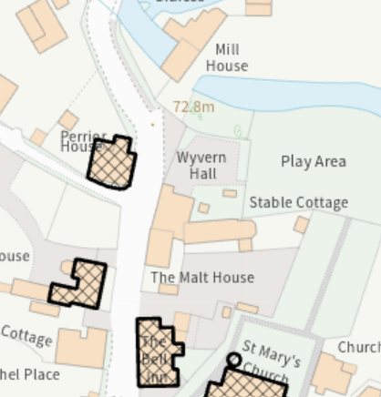

Part of the site is within flood zones 2 and 3 but the location for the proposed shop is outside of these flood zones.

Flood zone 2 Flood zone 3

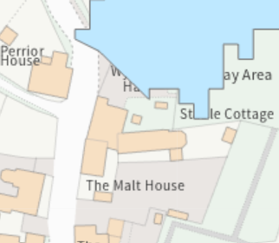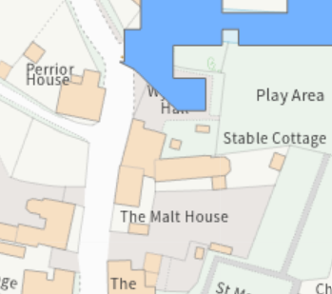

The site is within the Hampshire River Avon Catchment and within the Salisbury Plain SPA - 6400m Buffer

PROPOSAL

It is proposed to erect a single storey building for use as a village shop for temporary use for three years.

Proposed site plan

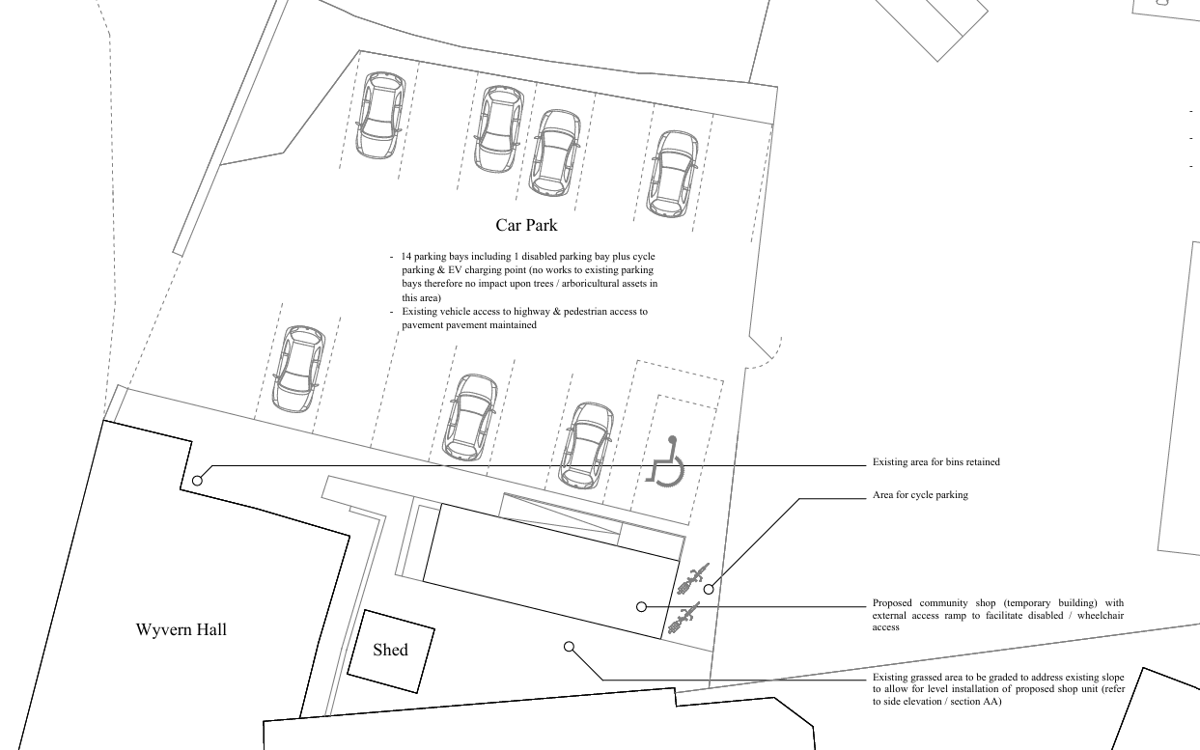

Proposed elevations

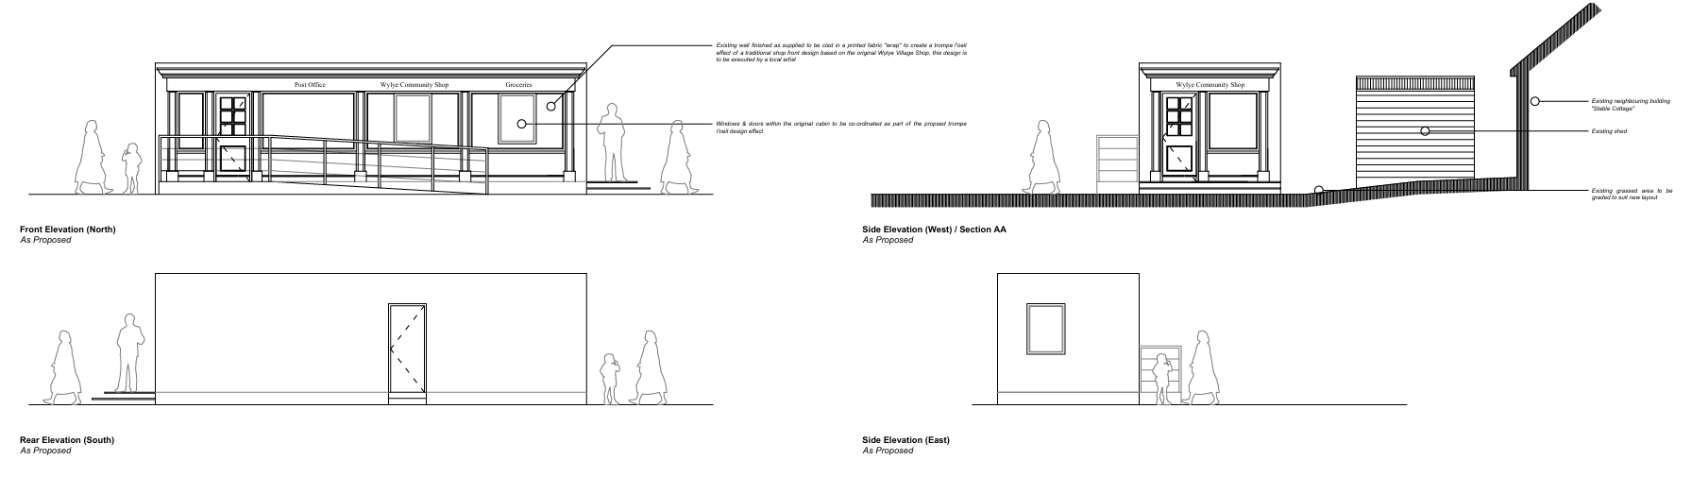

Proposed plan

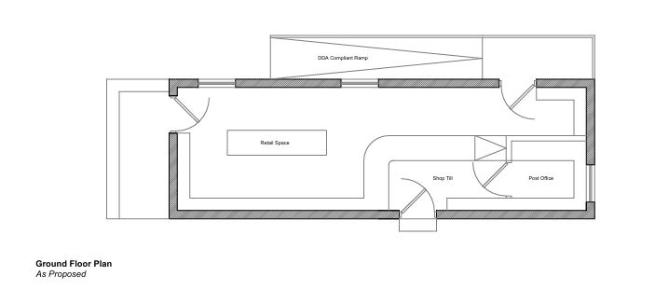

Proposed materials

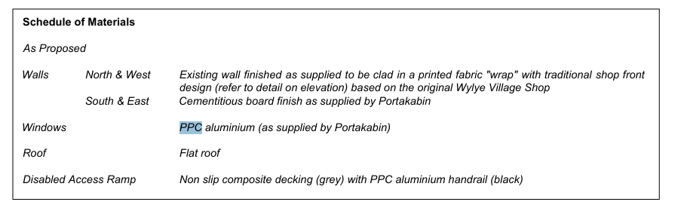

Examples of the external wrap used on other projects included below

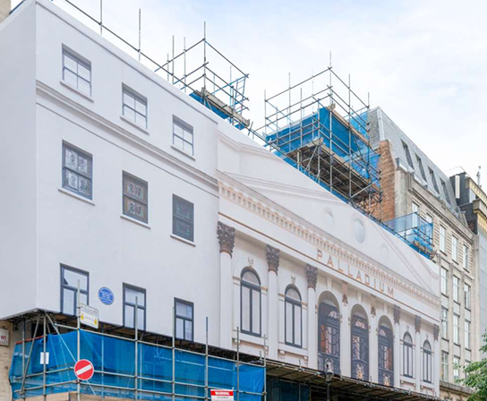

The following background to the proposed development has been taken from the submitted design and access statement-

There has been an existing village shop & Post Office in Wylye for over 100 years serving the village & the surrounding communities. In 2024 the shopkeeper passed away & business was taken over by the family who have been able to operate the business until earlier this year when they took the decision to close the business. Since this time the village has been without its Post Office with a small number of grocery items being offered for sale in the local pub. Since the closure of the original business the Parish Council have been exploring options to open a community shop which they would own & operate as a commercial venture but rooted at the heart of the community including a shop & community Post Office. Options to take over the existing shop premises have been explored but the current owners are unwilling to sell or lease the building to the community & the local pub do not see a commercial future in the small grocery offering they currently have available. Our application is being prepared to maintain a commercial offering in Wylye along with a Post Office counter.

Wyvern Hall has external space available as part of an open area which they are keen to make available to accommodate the proposals. This will allow sufficient space for the temporary building to be erected as well as allowing for sufficient parking & external space alongside the existing community facilities.

During the course of the application amended plans were received to address concerns raised by Officers, these included reducing the scope of development by omitting the café, outdoor seating, decking and moving the proposed building out of the playing field onto land within the car park of the village hall. The plans were also amended to omit the additional parking space to the north side of the car park due to the proximity to trees along the site boundary.

PLANNING HISTORY

None relevant

RELEVANT LEGISLATION, POLICIES AND GUIDANCE

Statutory Legislation:

Planning (Listed Building and Conservation Areas) Act 1990 sections 66 and 72

National Planning Policy:
- National Planning Policy Framework (NPPF)
- Planning Practice Guidance (PPG)
- National Design Guide

Development Plan:

The development plan for Wiltshire comprises the Wiltshire Core Strategy (WCS) (adopted January 2015) and any made neighbourhood plans, which remains the principal statutory planning document guiding development across the county. In line with Section 38(6) of the Planning and Compulsory Purchase Act 2004, planning decisions must be made in accordance with the development plan unless material considerations indicate otherwise.

Though the development plan is considered as a whole, those parts deemed to be particularly relevant to this application are listed below:

The adopted Wiltshire Core Strategy (WCS), with particular regard to:

Core Policy 1 Settlement Strategy
Core Policy 2 Delivery Strategy
Core Policy 3 Infrastructure Requirements
Core Policy 4 Spatial Strategy Amesbury Community Area
Core Policy 34 Additional Employment Land
Core Policy 35 Existing Employment Land
Core Policy 38 Retail and Leisure
Core Policy 48 Supporting Rural Life
Core Policy 50 Biodiversity and Geodiversity
Core Policy 51 Landscape
Core Policy 57 Ensuring High Quality Design and Place Shaping
Core Policy 58 Ensuring the Conservation of the Historic Environment
Core Policy 60 Sustainable Transport
Core Policy 61 Transport & Development
Core Policy 62 Development Impacts on the Transport Network
Core Policy 64 Demand Management
Core Policy 67 Flood Risk
Core Policy 69 River Avon SAC

Creating Places Design Guide
Wiltshire Design Guide
Cranborne Chase National Landscape Management Plan
Wiltshire Local Transport Plan – Car Parking Strategy

ISSUES

Principle
Character, design, heritage impacts and impacts on National Landscape
Neighbour amenity
Highways
Ecology

CONSULTATION RESPONSES

Parish Council - none received

Highways - no objection subject to condition

Conservation – no objection subject to condition

Public Protection – no objection subject to conditions

Drainage – no objection

REPRESENTATIONS

In accordance with the requirements of the Town and Country Planning (Development Management Procedure) (England) Order 2015 (as amended), the application was publicised by way of:

- Neighbour notification letters sent to adjoining and nearby properties;
- A site notice displayed near the site;
- An advertisement placed in the local press

These methods were used to inform interested parties and provide a period of 21 days for comments to be submitted.

Below is a summary of the representations received during the consultation period. Only material planning considerations have been taken into account in the assessment of this application. Non-material issues, such as property values or private legal disputes, cannot be considered in the determination process.

Seven letters of support have been received and summarised below -

- Will provide a vital amenity for the village since the closure of the existing shop and reduce the need to travel by car.
- It will also serve as a social hub for residents and neighbouring villages and reduce feelings of isolation for those without transport as it is within walking distance to everyone in the village.
- It will be of huge benefit to the village and surrounding areas.
- A vital replacement and enhancement for the old shop (now closed). The village community will wither and die unless this application is approved.
- The application is a simple request and will have huge benefit to the Wylye community and surrounding area.
- The concept of “Community” and “pulling together for the better good” of a small rural community should not be prejudiced by overbearing regulation. All the villagers want is a simple shop, a place to gather and feel like a community again.

ASSESSMENT

Section 38(6) of the Planning and Compulsory Purchase Act 2004 states:

"If regard is to be had to the development plan for the purposes of any determination to be made under the planning Acts, the determination must be made in accordance with the plan unless material considerations indicate otherwise."

In accordance with this statutory requirement, this application has been assessed against the relevant policies of the Development Plan, including the Wiltshire Core Strategy (2015) and, where applicable, any made Neighbourhood Plans. Consideration has also been given to the policies of the National Planning Policy Framework (NPPF) as a material consideration in the assessment.

Principle of Development

Wiltshire Core Strategy Policies CP1 (Settlement Strategy) and CP2 (Delivery Strategy) set out the spatial strategy for sustainable development across Wiltshire. These policies direct new development to the most sustainable locations, primarily within the limits of development of market towns, local service centres, and large villages. Proposals outside these limits are generally only supported in exceptional circumstances.

The site is located in the small village of Wylye as defined by Wiltshire Core Strategy (WCS) core policies 1 (Settlement Strategy), 2 (Delivery Strategy) and 4 (Spatial Strategy for the Amesbury Community Area).

Core Policy 48 explains the approach that will be taken to support rural communities, outside the limits of development of Principal Settlements, Market Towns, Local Service Centres and Large Villages and outside the existing built areas of Small Villages. The policy is based on the following key objectives:

• Protecting the countryside and maintaining its local distinctiveness.
• Supporting the sensitive reuse of built assets to help meet local needs.
• Supporting improved access between places and to services; and
• Supporting the community in taking ownership of local services

CP48 also states that - Community ownership and/or management of local shops, pubs and other services will be supported where appropriate to retain a local facility through the following measures:

vi. Development proposals for the adaptation of a building, such as sub-division or change of use, will be supported where these are necessary to allow a viable continued use.
vii. Appropriately scaled enabling development will be considered, where this is environmentally acceptable and justified through a supporting viability study, and where it can help maintain and enhance the community uses provided.
viii. The facility may be protected from loss of its current use until such time as the community has had a realistic opportunity to take control of the asset.

And that - new shops in villages will be supported where they are small in scale and would not threaten the viability of nearby centres. Farm shops will be supported where they utilise existing buildings, are small in scale and cause no unacceptable impact on nearby village shops or the character of the area.

Core Policy 49 seeks to protect rural services and community facilities particularly those that benefit the local community such as local shops, meeting places, sports venues, cultural buildings, public houses and places of worship. CP49 also states that - there is a need to protect and encourage the development of rural services and facilities in Wiltshire to ensure that settlements, particularly those named in this Strategy, can still meet some of the day to day needs of the people who live in them. Therefore, in principle policy supports rural services and therefore the principle of a small local shop in the small village of Wylye is acceptable subject to compliance with other polices and material considerations such as design, character, siting, heritage impacts, amenity impacts, flood risk, ecology and highway safety.

Character, design, heritage impacts and impacts on National Landscape

From the point of view of the historic environment the main statutory tests are set out within the Planning (Listed Building and Conservation Areas) Act 1990.

Section 66 requires that special regard be given to the desirability of preserving listed buildings, their settings or any features of special architectural or historic interest which they possess. Section 72(1) of the Act requires the Council to pay special attention to the desirability of preserving or enhancing the character or appearance of designated Conservation Areas.

The Council’s Core Strategy CP58 ‘Ensuring the conservation of the historic environment’ requires that designated and non-designated heritage assets and their settings will be conserved, and where appropriate enhanced, in a manner appropriate to their significance and encourages proposals which improve the condition of heritage assets at risk.

The Council’s Core Strategy CP 57: Ensuring high quality design requires a high quality of design in all new developments that responds positively to the local context and contributes to a sense of place. The policy requires applicants to “demonstrate how the proposal will make a positive contribution to the character of Wiltshire through (amongst other things) responding to the value of the natural and historic environment and being sympathetic to and conserving historic buildings and landscapes. Development is required to respond positively to the existing in terms of building layouts, built form, height, mass, scale, building line, plot size, elevational design, materials, streetscape and rooflines to effectively integrate the building into its setting.

CP51 requires that proposals protect, conserve and, where possible, enhance the character and quality of Wiltshire’s landscapes. Particular weight is given to National Landscapes (formerly AONBs), locally valued landscapes, and key visual receptors.

The location proposed for the village shop is prominent within the streetscene as seen in the Google maps images below and therefore any development in this location has the potential to adversely impact the character of the conservation area and national landscape as well as the setting of the adjacent listed buildings.

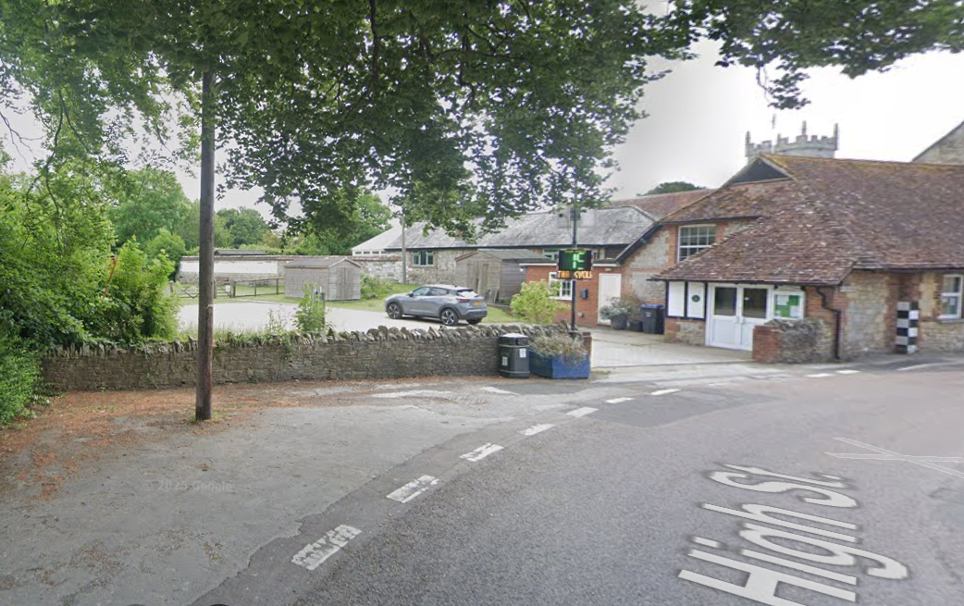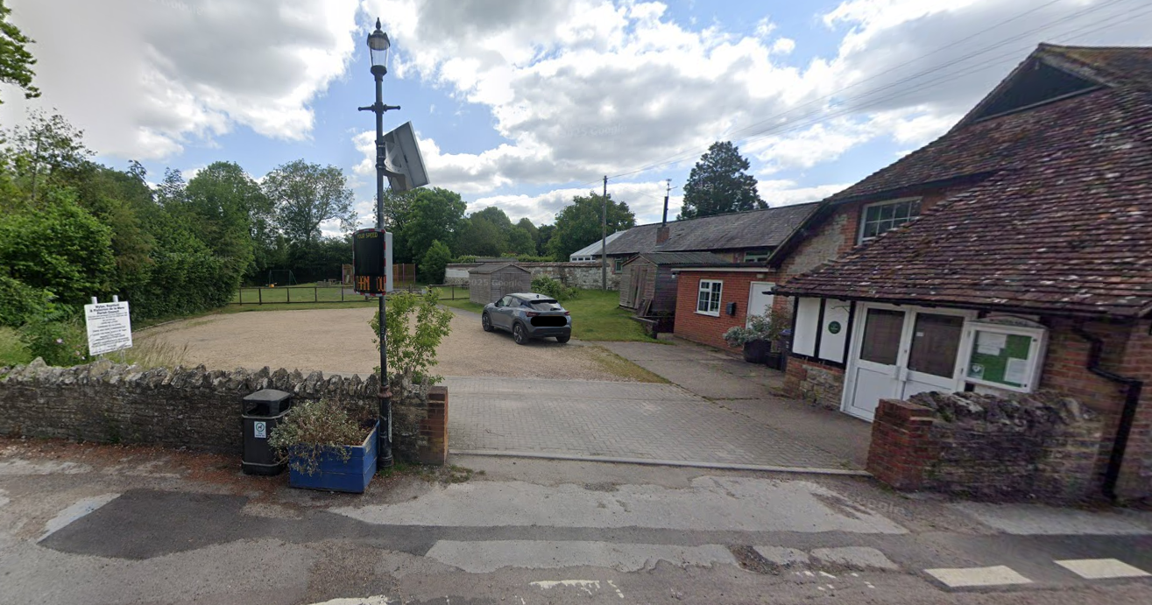

In terms of the impacts on the heritage assets the Council’s conservation officer has provided the following comments on the revised plans

I do consider that a low level of less than substantial harm remains to the character of the streetscene of the CA, it is also in the interests of the CA to have a shop, and the temporary structure facilitates the testing of its viability. The public benefits could reasonably be considered to outweigh the harm, as facilitated by the NPPF. A general idea of the proposed colour scheme of the shop's exterior would be prudent.

The flat roof portacabin style for the proposed shop is not a visually attractive building but is practical for temporary use, a temporary consent would minimise the harm of the development in this respect. It is understood that the applicants aim is to use the temporary shop to confirm if there is indeed a need for a shop in this location and if it is a viable use. During the period of a temporary consent which in this instance has been requested for three years, it is hoped that another more permanent site can be found if the need for the shop is found to be viable. Should at the end of the temporary consent the applicant wish for a permanent shop in this location or a further extension of the use this would be assessed at the time however, given that the design of the building is only considered appropriate for temporary consent, its retention as a permanent feature in the locality may be resisted. This, however, is not a matter for further consideration at this time.

The siting of the proposed building is close to the southern boundary of the site to the side of the existing village hall on an area of raised grass bank. The left hand shed seen in the photo below will be removed to allow the erection of the proposed shop in its place. Some levelling work will be required to this area of grass bank; this is considered to be a modest adjustment to the land levels in this location.

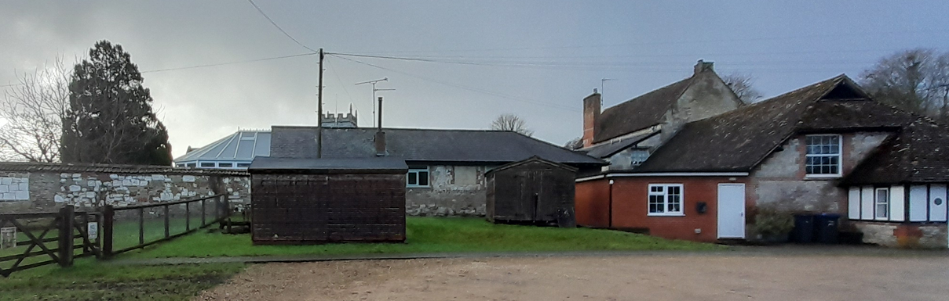

In terms of the overall finish to the proposed shop, an external wrap is to be used which gives the appearance of a building rather than a portacabin with fake windows, etc as per the examples above. Subject to the final details of the wrap such as colour and appearance there are no particular concerns, the final details will be conditioned on any permission given.

Bins will be located in the existing area by the village hall and therefore should not have significantly greater impact than the existing situation.

The proposal does not include any details relating to external lighting once the shop is up and running. It is understood that there may be existing lighting associated with the village hall which could also be used in conjunction with the new shop. Having discussed with the agent, it is understood that it is not proposed to install any lighting other than some small lights around the entrance to the shop and ramp. Given the proposed opening hours of the shop which will be predominantly during the day time except for the winter months, there are no particular concerns in terms of impact on the dark skies status of the National Landscape. A condition will be added to any permission relating to lighting to ensure any new lighting meets the appropriate criteria for Environmental Zone E0 as defined by the Institute of Lighting Professionals ‘Guidance Notes for the Reduction of Obtrusive Light’ 2021.

Overall, subject to the agreement of the final external finish to the building and subject to the three year temporary consent it is considered that the addition of a temporary shop in this location and design whilst having some harmful impacts on the heritage assets and character of the area, the public benefits to the community outweigh these harms in this instance.

Amenity

Core Policy 57 (Point vii) of the Wiltshire Core Strategy requires development to respect the amenity of existing occupants and ensure appropriate amenity levels for future residents.

The National Planning Policy Framework (NPPF), particularly Paragraph 135, reinforces the need for development to provide a high standard of amenity for both existing and future users.

The application site is located adjacent to the existing village hall with associated car park and the village playing field. There are nearby dwellings to the west, north and south. The main neighbouring dwelling affected by the proposed development is Stable Cottage located to the south, the north elevation of this adjacent dwelling forms the boundary between the application site and Stable Cottage with two windows facing onto the application site.

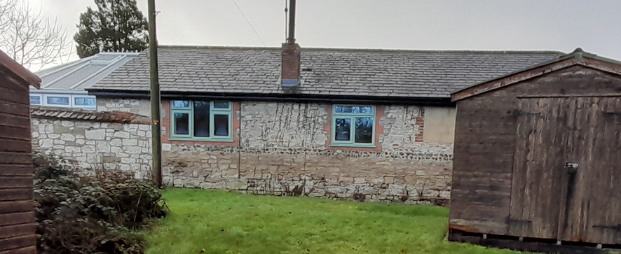
From details found on Right Move, the windows shown in the photo above serve a sitting room and bedroom (highlighted yellow below).
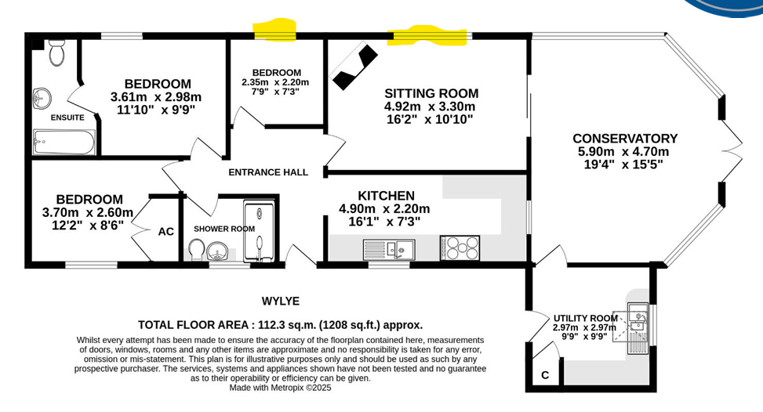
There are concerns that the proposals will impact on the amenity of the occupiers of Stable Cottage given the siting of the proposed shop, proximity to the boundary with Stabel Cottage and impact on light to the above mentioned windows. However, no letters of objection or otherwise have been received from the occupiers of Stable Cottage. The proposed shop building is single storey with a flat roof and will be sited on lower ground following the levelling the grass area. The block plan shown below shows that an area of grass will be retained between the shop and the north elevation of Stable Cottage which is necessary to help minimise the impacts on this adjacent property. There are no proposed works to the rear of the shop such as plant, storage, bins, structures etc, it is considered prudent that this area is keep vacant in the interests of the amenity of the occupiers of Stable Cottage. It is acknowledged that there will be a change to the outlook from Stable Cottage to the north which is unfortunate but is not considered significant enough to warrant a refusal in this instance. There are also concerns regarding privacy impacts to the above mentioned windows however, as existing, anyone can access the land within the car park by the village hall and walk up to the north elevation of Stable Cottage; given the existing situation, it is not considered that the erection of the village shop will significantly change this existing arrangement. There may also be some loss of light to the two windows in the north elevation of Stable Cottage, these windows do however face north and therefore this lessens the concerns in this regard to a degree. With the proposed shop being sited away from the boundary with Stable Cottage this does still allow a good degree of light to reach these windows.
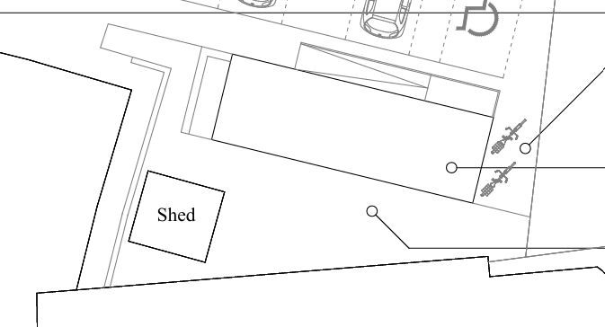
To the west and north of the site, Perrior House and Mill House are the nearest residential properties. Both of these dwellings over look the site and would potentially be affected by comings and goings through deliveries and patrons of the shop. However, give the existing use of the site and regular use of the car park, hall and playing field combined with the restricted opening hours of the shop it is not considered that the impacts would be significantly worse than the existing situation.

The proposed shop will have a tradable floor area of approx. 48 sqm, the enterprise would be fairly lowkey. The opening hours and delivery hours would be reasonable and will be conditioned as part of any planning permission given, to ensure no undue disturbance would arise to nearby occupiers.

The proposal would lead to some disturbance caused by patrons visiting, car movements and deliveries, but the level is unlikely to be harmful because of the small scale of the proposal. The existing village hall, adjacent playing field with associated car park already creates a degree of movement and associated noise/disturbance, therefore, on balance it is not considered that the impacts on neighbour amenity will be significantly detrimental as to warrant a refusal.

It is also noted that the permission would be temporary for three years, if during this time, the use and relationship with the surrounding properties isn’t working, then the permission would technically end at this time. There is also separate legislation through environmental health for noise nuisance should any significant issues arise. It is also noted that the shop will be run by the community for the community, and it is envisaged with the community working together that any issues could be addressed at the time.

It is noted that comments from the public protection officer refer to a café, this was part of the initial submission but was removed from the proposals and no longer forms part of the development.

Highways Impacts and Parking

The location of the proposed village shop is on a grass area to the south of the existing village hall car park; there will be no loss of existing parking spaces and sufficient parking provision can be accommodated as existing with no further parking provision required. The Highways Authority has been consulted and has raised no objections accordingly.

Ecology and Biodiversity

The effect of paragraph 13 of Schedule 7A to the Town and Country Planning Act 1990 is that planning permission granted for development of land in England is deemed to have been granted subject to the condition (biodiversity gain condition) that development may not begin unless:
(a) a Biodiversity Gain Plan has been submitted to the planning authority, and
(b) the planning authority has approved the plan.

The planning authority, for the purposes of determining whether to approve a Biodiversity Gain Plan, if one is required in respect of this permission would be Wiltshire Council. There are statutory exemptions and transitional arrangements which mean that the biodiversity gain condition does not always apply.

Based on the information available this permission is considered to be one which will not require the approval of a biodiversity gain plan before development is begun because one or more of the statutory exemptions or transitional arrangements, in particular it is considered in this instance that the proposal would be exempt from demonstrating Biodiversity Net Gain as it is a temporary development.

PLANNING BALANCE AND CONCLUSION

The proposed temporary development is considered to cause some harm to the character of the locality, heritage assets and neighbour amenity. However, as the permission is for temporary use only for three years, on this basis and subject to a number of conditions, it is considered that the public benefit of proving a village shop outweigh the harms identified within this report.

The proposal is therefore considered to comply with the relevant policies of the Wiltshire Core Strategy, the Wiltshire Local Plan, Planning (Listed Building and Conservation Areas) Act 1990: S66 and 72 and the National Planning Policy Framework. As such, the application is recommended for approval, subject to the conditions set out below.

RECOMMENDATION: That Planning Permission be GRANTED, subject to conditions

1. The development hereby permitted shall be begun before the expiration of three years from the date of this permission.

REASON: to comply with the provisions of Section 91 of the Town and Country Planning Act 1990 as amended by the Planning and Compulsory Purchase Act 2004

2. The development hereby permitted shall be carried out in accordance with the following approved plans:

Location plan Drg no PP001 Rev B received 27/03/2026
Proposed plans and elevations Drg no PP100 Rev B received 25/02/2026
Design and access statement received 25/02/2026
Proposed block plan Drg no PP 010 Rev E received 25/02/2026

REASON: for the avoidance of doubt and in the interests of proper planning.

3. The development hereby permitted shall be for a limited period being the period of three years from the date of this decision. The building hereby permitted shall be removed and the land shall be restored to its former condition on or before the expiration of the 3-year temporary period in accordance with a scheme of work that shall first have been submitted to and approved in writing by the local planning authority.

REASON: This permission is granted on a temporary basis solely to confirm that a new village shop in this location is viable whilst a more permanent site is found and to ensure a building of this appearance is not permanently sited in this sensitive location due to the impacts on heritage assets and character of the area.

4. No construction or demolition work shall take place on Sundays or Public Holidays or outside the hours of 08:00 to 18:00 Monday to Friday and 08:00 to 13:00 on Saturdays.
REASON: Core policy 57, Ensuring high design and place shaping such that appropriate levels of amenity are achievable.

5. No deliveries shall be made to or collections made from the development hereby approved except between the hours of 08:00 to 18:00 Monday to Saturday.
REASON: Core policy 57, Ensuring high design and place shaping such that appropriate levels of amenity are achievable.

6. The temporary use hereby permitted shall only take place between the hours of 0800 – 1800 Mondays to Saturdays and 0800 – 1600 on Sundays and bank holidays.

REASON: to protect neighbouring residential amenity.

7. No part of the development hereby permitted shall be first brought into use until the turning area & parking spaces [14 including 1 disabled] have been completed in accordance with the details shown on the approved plans. The areas shall always be maintained for those purposes thereafter and maintained free from the storage of materials.

REASON: In the interests of highway safety.

8. Any external lighting that is installed across the site shall be designed and implemented to minimise sky glow, glare and light trespass. It shall be designed in a downward facing position at all times and shall meet the criteria for Environmental Zone E0 as defined by the Institute of Lighting Professionals ‘Guidance Notes for the Reduction of Obtrusive Light’ 2021. Any external lighting installed at the site shall be retained and maintained as such thereafter for the lifetime of the development.

REASON: To ensure appropriate levels of amenity are achieved; to protect the Dark Skies Initiative and to avoid illumination of habitat used by bats

9. The strip of land comprising the grassed area located between the south elevation of the approved village shop building and the north elevation of the neighbouring dwelling known as Stable Cottage to the south shall be retained as an open, undeveloped buffer at all times. This area shall not be used for storage, display of goods, waste, seating, external activities, or any other ancillary use associated with the shop. No structures, enclosures, equipment, or paraphernalia shall be placed within this area unless first approved in writing by the Local Planning Authority.

REASON: To safeguard the amenity, outlook, and privacy of the neighbouring property known as Stable Cottage by ensuring an unobstructed separation between the commercial use and the adjacent dwelling, in accordance with Core Policy 57 (Ensuring High Quality Design and Place Shaping) of the Wiltshire Core Strategy.

10. Notwithstanding the approved plans, within three months of the installation of the approved shop building, full details of the design and colour of the proposed external wrap shall be submitted to, and approved in writing by, the Local Planning Authority. The external wrap shall be installed in full accordance with the approved details within three months of the date of that approval.

REASON: In the interests of preserving the character and appearance of the area and the setting of the surrounding heritage assets.

11. The development hereby approved shall be used only as a village shop falling within Use Class E(a) of the Town and Country Planning (Use Classes) Order 1987 (as amended), and for no other purpose within Class E or any other Use Class. Notwithstanding the provisions of the Town and Country Planning (General Permitted Development) (England) Order 2015 (as amended), or any re-enactment thereof.

REASON: To ensure the premises remains in a village shop use for which permission has specifically been granted preserving essential local services and protecting the character and amenity of the area.

Informatives

1. The effect of paragraph 13 of Schedule 7A to the Town and Country Planning Act 1990 is that planning permission granted for development of land in England is deemed to have been granted subject to the condition (biodiversity gain condition) that development may not begin unless:

(a) a Biodiversity Gain Plan has been submitted to the planning authority, and
(b) the planning authority has approved the plan.

The planning authority, for the purposes of determining whether to approve a Biodiversity Gain Plan, if one is required in respect of this permission would be Wiltshire Council.

There are statutory exemptions and transitional arrangements which mean that the biodiversity gain condition does not always apply. For further information on exempt developments please refer to:
https://www.gov.uk/guidance/biodiversity-net-gain-exempt-developments
Based on the information available this permission is considered to be one which will not require the approval of a biodiversity gain plan before development is begun because one or more of the statutory exemptions or transitional arrangements is considered to apply.

2. The applicant is requested to note that this permission does not affect any private property rights and therefore does not authorise the carrying out of any work on land outside their control. If such works are required, it will be necessary for the applicant to obtain the landowner’s consent before such works commence.

If you intend carrying out works in the vicinity of the site boundary, you are also advised that it may be expedient to seek your own advice with regard to the requirements of the Party Wall Act 1996.

3. Any alterations to the approved plans, brought about by compliance with Building Regulations or any other reason must first be agreed in writing with the Local Planning Authority before commencement of work.

4. The applicant is advised that the development hereby approved may represent chargeable development under the Community Infrastructure Levy Regulations 2010 (as amended) and Wiltshire Council's CIL Charging Schedule. If the development is determined to be liable for CIL, a Liability Notice will be issued notifying you of the amount of CIL payment due. If an Additional Information Form has not already been submitted, please submit it now so that we can determine the CIL liability. In addition, you may be able to claim exemption or relief, in which case, please submit the relevant form so that we can determine your eligibility. The CIL Commencement Notice and Assumption of Liability must be submitted to Wiltshire Council prior to commencement of development. Should development commence prior to the CIL Liability Notice being issued by the local planning authority, any CIL exemption or relief will not apply, and full payment will be required in full and with immediate effect. Should you require further information or to download the CIL forms please refer to the Council's Website https://www.wiltshire.gov.uk/dmcommunityinfrastructurelevy.

