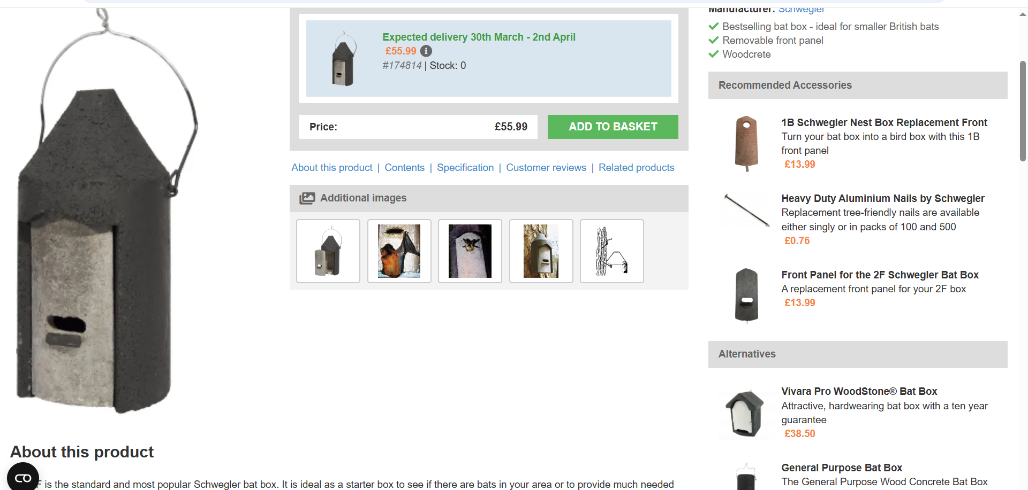

The 2F is the standard and most popular Schwegler bat box. It is ideal as a starter box to see if there are bats in your area or to provide much needed secure roosting space. It has been designed as a summer roosting space for bats and has a simple entrance hole at the front. The Schwegler 2F has a removable front panel and can be converted to a bird nest box using a replacement 1B front panel if there is no evidence of bat activity after a couple of years. The 2F is manufactured from long-lasting Woodcrete, which is a blend of wood, concrete and clay which will not rot, leak, crack or warp, and will last for at least 20 - 25 years, making it suitable for long-term mitigation projects. Woodcrete is breathable and maintains a stable temperature inside the box and the 2F is painted black to absorb warmth. It also provides a rough surface for bats to cling to and climb up.

