APPLICATION FOR FULL PLANNING PERMISSION
DELEGATED REPORT

APPLICATION REFERENCE: | PL/2025/05057
APPLICATION TYPE: | Full planning permission
SITE ADDRESS: | Braybrook, The Green, Marston, Devizes, SN10 5SW
DEVELOPMENT DESCRIPTION: | Two storey & single storey rear extension and new vehicle access.
RECOMMENDATION: | That Planning Permission be GRANTED

PROPOSAL

The proposal seeks full planning permission for Two storey & single storey rear extension and new vehicle access including bridge over adjacent watercourse at Braybrook, The Green, Marston, Devizes. Full planning permission is required due to the change of use of ‘common land’ to a private driveway and access owned by the Parish Council.

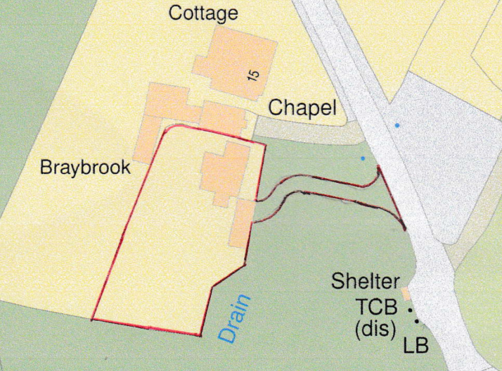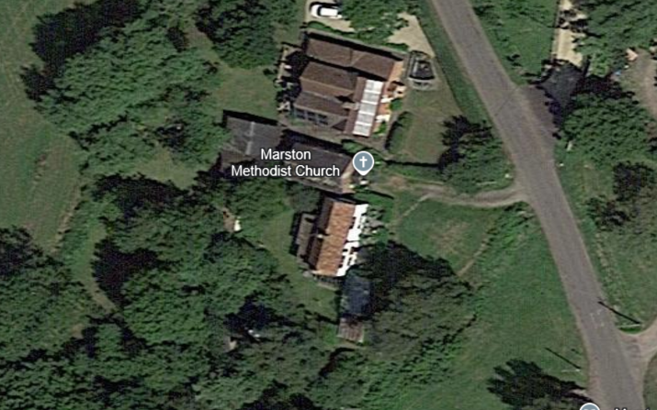

Site Location Plan and 2021 aerial image of the site

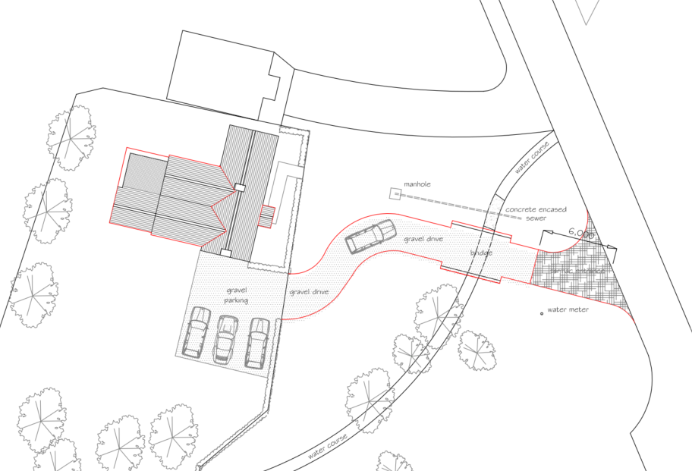

Proposed Site Plan

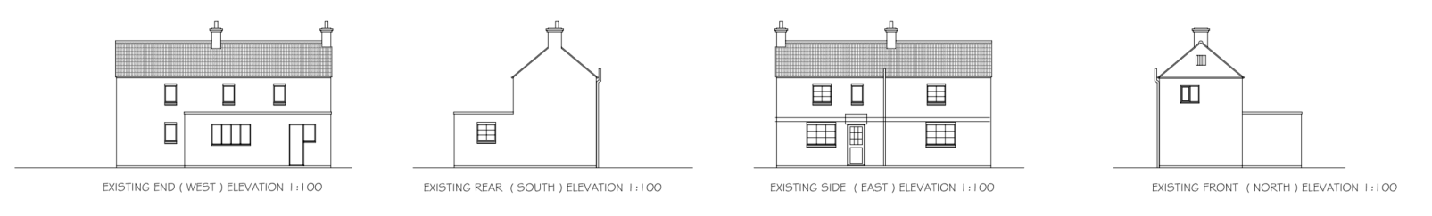

Existing Elevations

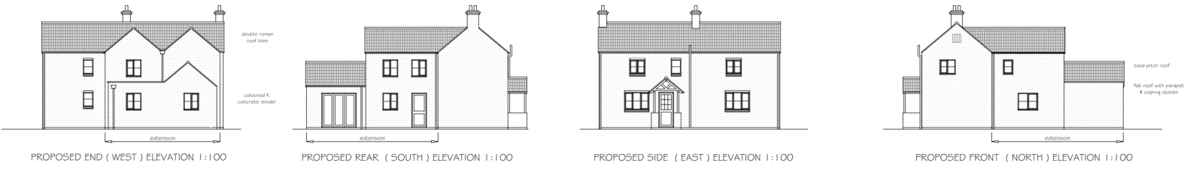

Proposed Elevations

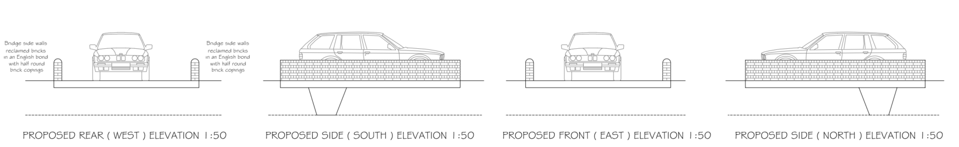

Proposed Bridge Details (proposed English Bond brick pattern)

This application has experienced several delays with the bridge and access being shown in the wrong location on the site location and block plans to that actually proposed on site, requiring a re-submitted site location plan (red outline) and fresh consultation after re-starting the application. The applicant also signed certificate B, identifying that the access would need to be built over land owned by the Parish Council, having failed to serve the notice itself until 18 November 2025 meaning a further 3-week delay in the application.

The application had to be re-started for a second time as the applicant had only paid for a householder fee, when a full planning application was required due to the driveway and bridge being proposed over ‘common land’ requiring a change of use (and to be included in the application description). The applicant also had to supply an updated flood risk assessment and a BNG metric.

The application form states that the extension would be built with matching concrete render under a replacement double roman tile roof (replacing existing pantiles). The applicant has also clarified reclaimed clay double roman tiles would be proposed for the roof. The timber windows would be replaced with double glazed upvc windows. From the site visit the windows have already been replaced with upvc windows and the front porch has also already been erected.

The proposal has also been supported by a Tree Protection Plan, following a joint site visit by the case officer, Tree officer and applicant, which identified the extent of the tree roots and the acceptable path for the proposed access to not interfere with the root protection zones of the trees.

SITE DESCRIPTION/CONTEXT

Braybrook is a detached two storey cottage that is located immediately adjacent to Marston Methodist Church/Chapel. The application site is within the Marston Conservation Area but there are no listed buildings nearby. Both buildings are identified as being significant unlisted buildings within the Marston Conservation Area Statement.

Braybrook and the Chapel share an access onto the main road which has a restricted visibility splay to the north (hence the applicants reason for the new access to serve Braybrook). The chapel does not appear to have a car park other than the grass strip in front of the building.

Braybrook has a parking area on the southern side of the dwelling and, as it is understood, currently has either a shared access or vehicle access rights from the existing access and across the grass strip.

The application site is part of ‘The Green’ to which the Marston Conservation Area statement describes as “Visually, the village’s primary focus is its largest open space, The Green, which lies to the south of the main built area. This green expanse, once communal grazing land, continues into the wide verges that border the lanes leading out of the village – the former ‘driftways’ along which cattle were driven to pasture.

The area is roughly mown at intervals and is fringed by the historically important hedgerows of the surrounding field boundaries. The lanes that cross the space from north-west to south-east and south-west to north-east are narrow, without formal kerbs or footways. Where they cross the several small watercourses, they are guarded by simple white rails which, whilst modern and not in the best of repair, appear appropriate to the informality of the area. In the south-east corner of The Green, the main stream widens into a pond. This recently restored wildlife habitat is an attractive amenity.

Along its northern edge, The Green is bordered by a number of cottages, encroachment onto the, once larger, area of communal land. The village pound was also located here and is presence is still reflected in the curved boundary and name of Pound Cottage. A second small group in the north-west corner include the village’s only public amenity – a Methodist chapel constructed in 1835. The neat hedges, unmade access tracks and traditional construction of the cottages and chapel contribute to an attractive and timeless appearance.

The space as a whole would be particularly sensitive to even minor change and the introduction of further clutter or the formalisation of existing features would be inappropriate. Similarly, the open nature of the area and the distinct boundary hedges should be maintained by the restriction of tree planting to the replacement of trees in those area which are already wooded.”

Officers note that the conservation area statement goes on to state;

“Crossing The Green and in the adjacent lane entrances there are attractive views across the
broad grassy area, those of the properties north of The Green in particular, are essential
ingredients in defining the character of the village.

Unmade access tracks across The Green to the cottages are also important to the rural character of the area, contrasting with the tarmac surfaces of the principal lanes.”

The Statement shows that the proposed driveway access would be located within the identified ‘significant green spaces – map 7’.

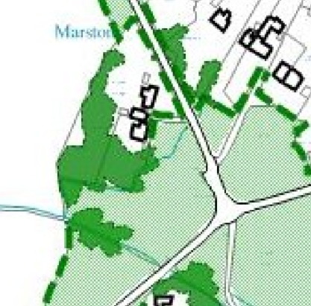

Map 7 – Significant green spaces, verges, trees, hedges and public footpaths

The access would cross land forming part of The Green, which is registered common land. Although the Parish Council is the landowner and has been correctly notified via Certificate B, ownership does not alter the land’s common-land status, nor the sensitivity identified in the Marston Conservation Area Appraisal. Works involving surfacing, embankment alterations or structures on common land may require separate consent under Section 38 of the Commons Act 2006. Planning permission does not remove or replace this requirement. The impact of the proposed access must therefore be assessed on its planning merits, including the effect of formalising part of a historically communal and informal landscape.

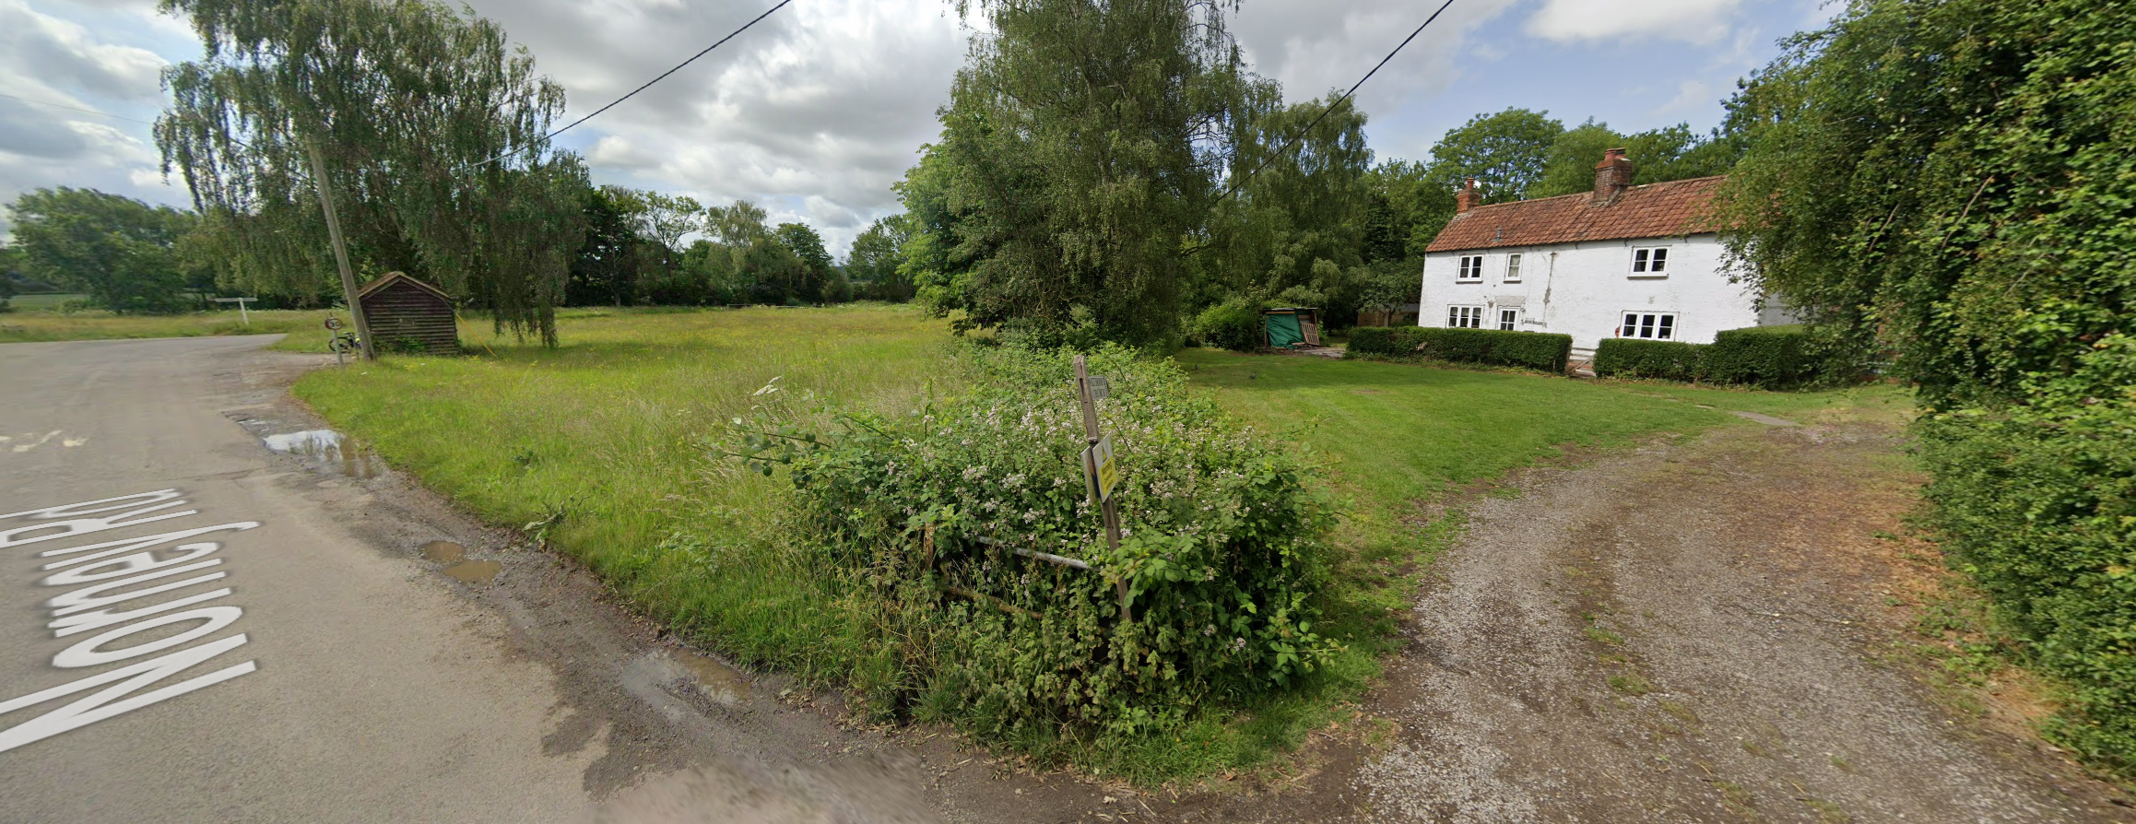

Google Street View image of the site and shared ‘unmade’ access (right) and bus stop (left)

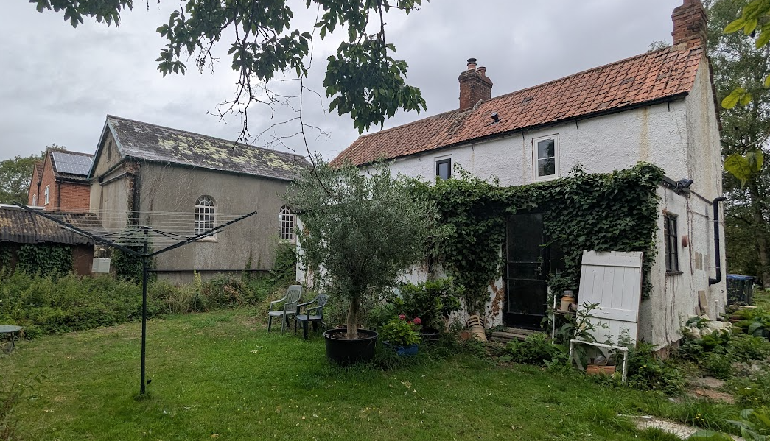

Rear Elevation of main dwelling with chapel behind

The statement also identifies that from the 18th century; clay became a significant building material – and is used a lot in the conservation area.

The site is not subject to any ground water flood risk but parts of the site are subject to 1:30, 1:100 and 1:1000 year surface water flood risk and are recognised as falling within flood zones 2 and 3.

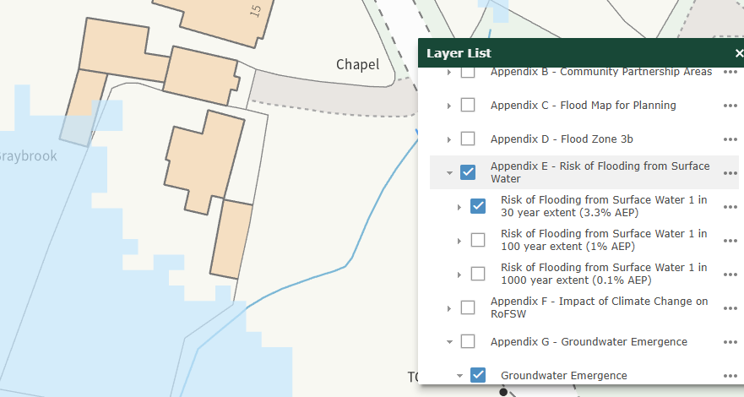

1:30 Surface Water Flood Risk

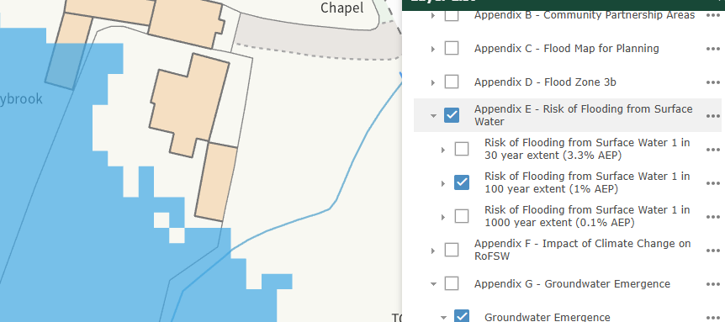

1:100 Surface Water Flood Risk

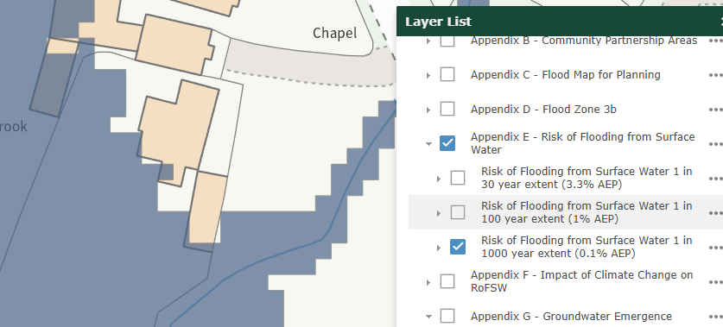

1:1000 Surface Water Flood Risk

PLANNING HISTORY

PL/2024/08409 - Two Storey Extension – Withdrawn

To clarify the two-storey extension would have been in close proximity to the boundary with the chapel to which Officers considered would have warranted the refusal of the application. In this application, the two-storey element is proposed to be further away from the boundary with the Chapel.

RELEVANT POLICIES AND GUIDANCE

National Context:

The National Planning Policy Framework (NPPF)

The NPPF outlines government policy, including its policy in respect of the historic environment. Section 16 of the NPPF 'Conserving and enhancing the historic environment' sets out the Government's high-level policies concerning heritage and sustainable development. Paragraphs 214-216 of the NPPF require a balanced approach with any harm which would be caused being weighed against the potential public benefits which might be achieved. Paragraph 210 requires local planning authorities should take account of the desirability of sustaining and enhancing the significance of heritage assets and of new development making a positive contribution to local character and distinctiveness.

The Planning Practice Guidance

From the point of view of the historic environment the main statutory tests are set out within the Planning (Listed Building and Conservation Areas) Act 1990.
Section 72(1) of the Planning (Listed Building and Conservation Areas) Act 1990 also requires the Council to pay special attention to the desirability of preserving or enhancing the character or appearance of designated Conservation Areas.

Local Context:

Wiltshire Core Strategy:

- Core Policy 57 Ensuring High Quality Design and Place Shaping
- Core Policy 58: Ensuring the Conservation of the Historic Environment
- Core Policy 61: Transport and New Development
- Core Policy 64: Demand Management
- Core Policy 67: Flood Risk

Wiltshire Local Plan review:
- The examination of the emerging Wiltshire Local Plan has been paused and the weight to be afforded to any part of the emerging plan can be no more than very limited. A decision on how to proceed will be made by the Council in May 2026.

Marston does not have a Neighbourhood Plan or designation.

Marston Conservation Area Character appraisal – February 2008

Wiltshire Design Guide: Appendix D – Design Guidance for Householder extensions

CONSULTATION RESPONSES

Marston Parish Council: No objection although they still have some observations and comments to accompany this stance.

The Parish Council confirms that they received the formal notice served under certificate B of the ownership section.

The anomalies between the plans and the elevations have been corrected on the current drawings.

The Parish Council register their disappointment that UPVC windows have already been installed, and the porch has now been constructed ahead of this application being determined.

The Parish Council strongly request that if any approval is given, a condition should be added to ensure that the access drive shown within the proposals is constructed ahead of the building works commencing.

This is to ensure highway safety by virtue of the improved sightlines onto the public highway. It will also set a clearly defined, safe access, which is both suitable for domestic vehicles and construction traffic thus ensuring no damage to the Marston Green.

We also request a condition is added on any approval given to ensure any damage caused to Marston Green as a result of the construction process is made good.

Environment Agency – No objection

The site is within flood zone 1 and the watercourse is not a main river under our control. Therefore, we have no comments to provide regarding the bridge structure.

Wiltshire Council Drainage Officer – No objection subject to condition

The application has been supported with a Site-Specific Flood Risk Assessment (FRA). It should be noted that our comments below are reliant on the accuracy and completeness of the FRA and we do not take any responsibility for incorrect data or interpretation made by the authors.

The proposal is for a two-storey rear extension together with a new vehicular access that crosses over the existing watercourse via a bridge, as indicated on the submitted site plan. Surface water management has not been detailed in a formal drainage strategy; however, the Flood Risk Assessment notes that the development will incorporate concrete ground floors, flood board guides to external doors, and that the new floor levels will be set at the same height or slightly higher than the existing, providing a degree of flood resilience.

The FRA confirms the site lies within Flood Zones 2 and 3, with predicted flooding occurring mainly to the west and south of the garden, rather than at the dwelling itself, and identifies the overall likelihood of flooding as low based on Environment Agency modelling. While the proposal includes basic resilience measures, no specific information has been provided regarding the hydraulic capacity of the watercourse, the potential effect of the proposed bridge, or how surface water runoff from the new access and extension will be managed. Therefore, further detail is required to ensure the bridge does not obstruct flows in the watercourse and that the development does not increase flood risk on or off the site-water runoff from the new access and extension will be managed.

Wiltshire Council Tree Officer – No objection subject to condition

There is no arboricultural objection to the proposal, and it is clear from the Tree Protection Plan that the adjacent trees have been considered for retention with clear details of the type of protective fencing proposed. However, there is insufficient information regarding the position of this fencing, which at the very least should be at the outer edge of the trees RPAs. Please can the exact position of the Tree Protective Fencing be clarified and ideally plotted on the Tree Protection Pan Drawing No 2424-1 Issue 1 dated October 2025.

The details of the proposed pruning on the most northerly tree as previously discussed, is appropriate as should undertaken in accordance with good practice as set out in British Standard Tree Work - Recommendation for Tree Work”, BS 3998: 2010 or arboricultural techniques where it can be demonstrated to be in the interest of good arboricultural practice.

Wiltshire Council Highways Officer – No objection subject to condition

The site is located with existing access onto Norney Road, a C Classified section of public highway subject to a speed limit of 30mph. The access is currently shared with the adjacent church and the property is not afforded vehicle parking within the curtilage. Further amended plans have been received which do not alter my previous stance in regard to highways, therefore I have copied my previous response with minor amendments below.

It is proposed to provide a two storey and single storey extension to enable a larger living
space at ground floor and additional bedroom accommodation at first floor. The proposals
would increase the bedroom quantum to a 4-bed unit requiring a minimum parking provision
of 3 spaces within the curtilage.

The parking provision for the site of 3 spaces has been incorporated within the garden and
would be accessed via a new access to the south of the existing access currently used. This
is proposed with tarmac surfacing over the first 6m of the access point where it meets the
public highway. The access would be afforded a similar visibility splay to the south, with
slightly improved visibility to the north when moved further from the vegetation directly
adjacent to the existing access. The provision of a new point of access would require a
Licence/Permit to work within the public highway. It is considered that a new point of access
for the dwelling would provide an improvement to the visibility splay to the north, the area to
the south is afforded visibility due to the green at the frontage, with a minor obstruction due
to the bus shelter.

A new bridge structure is incorporated into the access, however this is over 5m from the
edge of the public highway and as such would not require highways structural approval. The
direct impact on the water course would require Land Drainage Consent or consultation with
the Environment Agency.

Wiltshire Council Conservation Officer – No objection

The site is an unlisted building located in Marston Conservation. The building is adjacent to a chapel which is a non-designated heritage asset (NDHA) and a significant unlisted building.

The NPPF confirms that when considering the impact of a proposed development on the significance of a designated heritage asset, great weight should be given to the asset’s conservation (and the more important the asset, the greater the weight should be). It makes clear that any harm to a designated heritage asset requires clear and convincing justification.

All details are acceptable.

Wiltshire Council Ecology Officer – No objection subject to conditions

Salisbury Plain Special Protection Area (SPA)
This application lies within the 6.4km zone of influence of the Salisbury Plain SPA and in light of the HRA for the Wiltshire Core Strategy and the HRA for the Wiltshire Housing Site Allocations Plan it is screened into Appropriate Assessment due to the potential impact of recreational pressure on stone curlew in combination with other plans and projects.

A test of likely significance has been carried out by the relevant Competent Authority (Wiltshire Council) as required by Regulation 63 of the Conservation of Habitats and Species Regulations 2017 (as amended). This concluded that given the scale and nature of the development combined with the separation of 5.5km between the SAC and the application site, any temporary construction impacts and operational impacts would be de-minimus. The HRA has concluded that the application is not likely to have significant impacts on the SAC and subsequently the application is screened out of Appropriate Assessment.

Biodiversity Net Gain
Under Schedule 7A of the Town and Country Planning Act 1990 (as inserted by Schedule 14 of the Environment Act 2021) this application is required to deliver 10% Biodiversity Net Gain (BNG). The Biodiversity Gain Plan condition will automatically apply if approval is forthcoming.
A completed statutory biodiversity metric calculation (Small Sites Metric (The Statutory Biodiversity Metric). 08 January 2026) confirming the baseline and predicted post- development biodiversity units of the site has been submitted.

Information in the completed on-site baseline habitat tabs is accepted as accurate based on the information submitted. The pre-development (baseline) situation is summarised below.

On-site pre-development (baseline) biodiversity value | 0.736 Habitat units
On-site pre-development (baseline) biodiversity value | 0.12 Hedgerow units
On-site pre-development (baseline) biodiversity value | 0.36 Watercourse units
Are there  any irreplaceable habitats on- site? | No
Has any habitat degradation of occurred? | No

The Biodiversity Gain Plan condition will require the submission of a Biodiversity Gain Plan demonstrating how the biodiversity objective (10% biodiversity net gain) will be met. The development can only legally commence once the Biodiversity Gain Plan condition has been discharged.

The Biodiversity Gain Plan must be accompanied by a completed Biodiversity Metric with the following issues addressed:

• Other Neutral Grassland is unlikely to achieve “good” condition within this environment, we would advise that the proposed condition should be revised to a more appropriate target.
• All habitats shown on the Proposed Site Plan with BNG Enhancement (January 2025. SJF Planning & Design Service. Drawing No. 2424-8. Issue.1), including hedgerows, trees and the pond, must be fully and accurately recorded within the biodiversity metric.
• All proposed habitat areas must be accounted for within the metric, whether habitats are retained, enhanced, lost or newly created. The submitted metric records 100 m² of habitat to be retained, 220 m² to be enhanced and 667 m² to be lost; however, the total area of lost habitat (667 m²) is not balanced by an equivalent area of habitat creation (0.0 m²). For area-based habitats, the total area of habitat lost must be matched by the total area of habitat created and/or enhanced, and the metric must be amended accordingly.

Note to case officer: The Statutory Biodiversity Metric identifies the areas of habitat creation/enhancement which contributes to the applications proposed BNG, however there are several inconsistencies and errors within the provided biodiversity metric. Confirmation of how the development will achieve BNG is a post determination matter however consideration should be given to how any proposed BNG will be secured.

Core Policy 50
Core Policy 50 of the Wiltshire Core Strategy requires all development to demonstrate no net loss of biodiversity and to seek opportunities to enhance biodiversity. The NPPF also encourages applications to deliver measurable net gains (para 187 d).

While it is not expected that this development will result in significant loss of habitat, both CP50 and NPPF requires the inclusion of biodiversity enhancements. The location of these ecological/biodiversity enhancements must be included in the site plan drawings.

Wiltshire Council Public Rights of Way Officer – No comments received

Planning Inspectorate (Common Land consultations) – No comments received

REPRESENTATIONS

In accordance with the requirements of the Town and Country Planning (Development Management Procedure) (England) Order 2015 (as amended), the application was publicised by way of:
- Neighbour notification letters sent to adjoining and nearby properties;
- A site notice displayed near the site;

These methods were used to inform interested parties and provide a period of 21 days for comments to be submitted (each time the application was re-started).

No comments were received.

ASSESSMENT

Section 38(6) of the Planning and Compulsory Purchase Act 2004 states:

"If regard is to be had to the development plan for the purposes of any determination to be made under the planning Acts, the determination must be made in accordance with the plan unless material considerations indicate otherwise."

In accordance with this statutory requirement, this application has been assessed against the relevant policies of the Development Plan, including the adopted Wiltshire Core Strategy (2015) and, where applicable, any made Neighbourhood Plans.

Design and Impact upon the character and context of the area

Core Policy 57 - Ensuring High Quality Design and Place Shaping of the Wiltshire Core Strategy seeks to ensure that all new development is of high design quality, reflecting local context, character, and distinctiveness. The design guidance in Appendix D of the Wiltshire Design Guide also applies, particularly given the property’s location within the Marston Conservation Area.

The proposal introduces a two-storey rear extension and a smaller single-storey element.
The extensions would be on the rear elevation, however, due to the orientation of the dwelling and the open countryside to the south (‘The Green’), there is potential for the extensions to be publicly visible from Goose Street. However, the side and rear elevations are heavily screened by a tree belt which would screen the rear elevation from view for much of the year.

The two-storey extension is proportionate in scale and retains the cottage’s simple and modest form. The single-storey extension adopts a pitched roof facing south, which helps visually integrate it and reduces the apparent mass when viewed from The Green. The use of render to match the existing cottage is appropriate.

The existing clay pantiles contribute positively to the building’s character. While the proposed use of reclaimed clay double-roman tiles will alter the roof texture, this remains consistent with the broader material palette of the Conservation Area, where clay tiles are prevalent. A condition will ensure the use of high-quality clay tiles and secure appropriate detailing.

An informative note will be added to the permission advising that reclaimed tiles should be located on the public elevations (east and south) where the less public elevations (north and west) could accommodate new tiles, if sufficient quantities of reclaimed tiles are not able to be sourced.

The recently installed uPVC windows are not ideal in a Conservation Area; however, they now form part of the baseline and the Conservation Officer has not raised objection. Their white colour allows them to assimilate reasonably well with the rendered façade.

Overall, the proposed extensions respond adequately to the site’s context, preserve the simple cottage form, and are of an appropriate scale and appearance. Subject to material controls, the proposal accords with CP57 and Appendix D of the Design Guide.

Heritage Impact

The site lies within the Marston Conservation Area, a designated heritage asset for the purposes of Section 72(1) of the Planning (Listed Buildings and Conservation Areas) Act 1990. The statutory duty requires the Council to pay special attention to the desirability of preserving or enhancing the character or appearance of the area.

Paragraphs 214–216 of the NPPF (Dec 2024) require that any harm to the significance of a designated heritage asset be outweighed by clear and convincing justification, with great weight afforded to the conservation of the asset regardless of the degree of harm.

The Council’s Core Strategy Policy CP58 ‘Ensuring the conservation of the historic environment’ requires that “designated heritage assets and their settings will be conserved, and where appropriate enhanced, in a manner appropriate to their significance.”
The Conservation Area derives its significance from:
- The openness of The Green and its informal, rural qualities;
- The simple and historically characteristic arrangement of watercourse crossings;
- Traditional building forms and materials, including clay tile roofing;
- The setting of the Methodist Chapel, identified as a significant unlisted building within the Conservation Area Appraisal.

The Council’s conservation Officer has no objection and is content with all the submitted details of the application.

Extension:

The proposed two-storey and single-storey rear extensions are located to the south-west of the dwelling. Due to established tree cover, orientation, and the subservient nature of the additions, views from the public realm are limited. The design, proportions, and proposed use of clay tiles (secured by condition) ensure the extensions respect local character and relate appropriately to the existing cottage.

It is considered that changing the windows from black painted timber frames (with double horizontal glazing bar) to white upvc windows with single glazing bar would not have been permitted development, given the differences in the thickness of the frame and change of colour. Officers consider that the white frames of the new windows do not detract from the significance of the dwelling or that of the area.

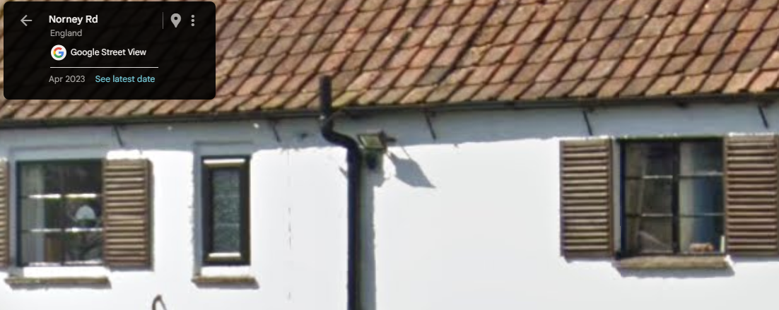

Google Street View April 2023 image
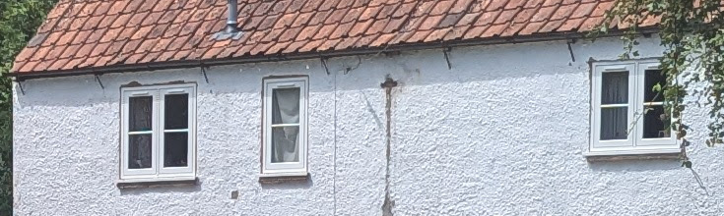

Site Visit windows

The Conservation Officer raises no objection, and the proposals are considered to preserve the character and appearance of the Conservation Area in accordance with WCS CP57, CP58, and NPPF paragraphs 214 and 215.

New Access and Bridge:

The introduction of a new access across part of The Green and a modest bridge over the watercourse will inevitably alter an area identified as sensitive to even minor change within the Conservation Area Appraisal. The works introduce a more formal intervention, replacing informal grassed surface with a combination of tarmac (for the initial 5m), then gravel, and low brick walls to the bridge.

The proposals therefore result in a degree of change that introduces limited urbanisation to a historically informal landscape. On balance, this results in “less than substantial harm” at the lower end of the scale as defined by NPPF paragraph 215.

The harm arises from:
- Formalisation of a currently informal part of The Green;
- Introduction of a new engineered crossing;
- Erosion of part of the open rural character identified as significant within the Conservation Area Appraisal.

However, the harm is tempered by:
- The small scale and low height of the bridge walls;
- The use of brickwork reflecting nearby built forms, including the Chapel;
- Existing tree cover that helps filter views;
- The presence of several nearby existing accesses of similar form and scale.

In accordance with NPPF paragraph 216, the identified less than substantial harm must be weighed against public benefits. Subject to the planning balance, the proposal accords with CP58, the statutory duty under Section 72(1), and relevant sections of the NPPF.

Amenity

Point vii of Core Policy 57 - Ensuring High Quality Design and Place Shaping of the Wiltshire Core Strategy seeks to ensure that developments do not adversely affect neighbouring properties.

The National Planning Policy Framework (NPPF), particularly Paragraph 135(f), stresses that planning decisions should ensure developments provide a high standard of amenity for existing and future users.

The proposed development has been assessed in terms of its potential impact on the residential amenity of neighbouring properties, with particular regard to loss of light, overshadowing, loss of privacy, and overbearing effects.

The proposed two storey extension would be set in approximately 3.7m from the host buildings side elevation and would be approximately 4.5m from the side wall of the Chapel. As the extension would be to the south of the Chapel it would cause direct overshadowing and some loss of natural daylight (an issue identified with the withdrawn application).

The Chapel has two large windows on its southern side elevation, which would be affected, but it also has two large windows on the other side elevation and two windows on the front, eastern elevation as well as a fanlight/transom window above the front door. Given the size of the building, which would only be circa 8x5m internally, these windows would be sufficient to provide the Chapel with both direct sunlight and natural daylight even taking into account the loss caused by the rear extensions to Braybrook Cottage. As such it is considered that the proposed development would not have a significant impact on the amenity of the adjoining property that would warrant a refusal in this instance.

On balance, the proposal accords with Core Policy 57 point vii in respect of safeguarding residential amenity and Appendix D of the Wiltshire Design Guide.

Highways Impact

Core Policies CP61 and CP64 require development to demonstrate safe and suitable access for all users and to meet adopted parking standards. Paragraphs 115–116 of the NPPF (Dec 2024) reinforce that planning decisions must ensure that developments do not result in an unacceptable impact on highway safety.

The existing access serving both Braybrook and the adjacent Chapel has restricted visibility to the north. The proposal includes a new, dedicated vehicular access positioned further south, improving sightlines and enabling the applicant to provide the required three on-site parking spaces for a four-bedroom dwelling in accordance with Wiltshire’s adopted parking standards.

The Highways Officer raises no objection, subject to a condition securing details of the access construction. The provision of tarmac surfacing for the initial 5m is necessary to prevent loose material entering the highway, followed by gravel surfacing which reflects the more rural setting.

The Parish Council requested a condition requiring the new access to be constructed prior to the extension works, but this has not been supported by Highways and does not meet the NPPF tests for planning conditions (necessity, relevance, precision, enforceability). The extension is not dependent on the new access for construction and the bridge may not be engineered to accommodate heavier construction traffic.

The proposal offers a modest improvement to local highway safety by reducing reliance on a constrained shared access and enhancing visibility splays. The development accords with CP61, CP64, the Local Transport Plan, and paragraphs 115–116 of the NPPF.

Drainage and Flood Risk

Core Policy 67 of the Wiltshire Core Strategy and paragraph 181 of the NPPF requires that all new development avoids increasing flood risk on-site or elsewhere and, where appropriate, incorporates sustainable drainage measures. Development must also comply with national policy on flood risk management and drainage design. Paragraph 176 (via footnote 62) of the NPPF states that householder development should not be subject to the sequential test, nor the exception test.

The submitted Flood Risk Assessment (FRA) confirms that while the dwelling itself lies within Flood Zone 1, parts of the wider site—specifically the garden area and land surrounding the watercourse—fall within Flood Zones 2 and 3, with predicted flooding from surface water pathways during 1:30, 1:100, and 1:1000 year events. The presence of these higher-risk zones requires careful consideration of both watercourse capacity and the impact of the proposed access and bridge.

The Environment Agency raises no objection, noting that the watercourse is not a Main River and therefore does not fall under their direct remit. The Council’s Drainage Officer also raises no objection, subject to conditions, but notes that further detail is required to ensure the development does not inadvertently increase flood risk.

While the FRA includes basic flood-resilience measures (such as maintaining or raising finished floor levels and incorporating flood-resistant construction methods), it does not yet provide detailed technical information regarding:
- the hydraulic capacity of the watercourse during flood events;
- the impact of the proposed bridge structure on flow conveyance;
- the management of run-off from the new access and extensions;
- measures to ensure the development does not increase off-site flood risk, particularly given the presence of Flood Zones 2 and 3 within the application boundary.

These matters can be satisfactorily addressed through a pre-commencement condition requiring a detailed drainage strategy and bridge capacity assessment.

Subject to such conditions, the proposal is considered acceptable in flood risk terms and compliant with CP67 and relevant paragraphs of the NPPF. The development does not place vulnerable built form within Flood Zones 2 or 3, and appropriate mitigation can ensure that flooding is neither worsened nor redirected.

Other issues

The inaccuracies in the plans over window sizes have been addressed by further revised plans. Officers determined that these revisions did not require re-consultation as they only clarified how big the windows would be, which are considered to be acceptable within the overall design of the proposal.

Ecology and Biodiversity Net Gain

Core Policy CP50 requires development to avoid biodiversity loss and to deliver enhancement where possible. Paragraph 187(d) of the NPPF requires measurable net gains for biodiversity. Under Schedule 7A of the Town and Country Planning Act 1990 (as amended), this application must deliver a minimum 10% Biodiversity Net Gain.

The site lies within the 6.4km zone of influence for the Salisbury Plain SPA. Habitats Regulations Assessment by the Competent Authority confirms that the proposal would not give rise to likely significant effects and is screened out of Appropriate Assessment. The Ecology Officer raises no objection.

A completed statutory biodiversity metric has been submitted, providing baseline habitat values for the site. However, inconsistencies in the calculation of habitat creation and enhancement have been identified. These do not prevent determination but must be rectified within the statutory Biodiversity Gain Plan required by condition.

The Biodiversity Gain Plan (required prior to commencement) must:
- update habitat condition targets to achievable levels (e.g., neutral grassland condition);
- accurately record all habitats on the proposed site plan;
- demonstrate that habitat creation/enhancement equals or exceeds areas of loss;
- confirm how the 10% net gain will be secured for a minimum 30-year period.

Subject to the statutory condition requiring approval of the Biodiversity Gain Plan, the proposal complies with CP50, the Environment Act 2021 obligations, and paragraph 187(d) of the NPPF.

Planning Balance

Section 38(6) of the Planning and Compulsory Purchase Act 2004 requires that decisions be taken in accordance with the Development Plan unless material considerations indicate otherwise.

The development would deliver several benefits. The new vehicular access would provide improved visibility and a safer arrangement than the existing shared access, which is constrained and below standard; this results in a modest but genuine public safety benefit. The extensions would allow the continued viable use of the dwelling, supporting the long-term maintenance of a non-designated heritage asset within the Conservation Area. The proposal also aligns with policies relating to design quality, amenity, and ecology, subject to conditions.

Set against these benefits is a limited degree of harm to the character and appearance of the Marston Conservation Area arising from the formalisation of part of The Green through the creation of the new access and bridge. This is assessed as “less than substantial harm” at the lower end of the scale, for the purposes of paragraph 215 of the NPPF, and must be afforded great weight. However, the scale of the bridge and its integration into the existing pattern of crossings, along with retained tree cover, reduces the magnitude of impact.

In terms of drainage and flood risk, the dwelling itself is located in Flood Zone 1, while parts of the garden and watercourse corridor fall within Flood Zones 2 and 3. The proposed works do not introduce vulnerable built form into higher-risk areas. The Drainage Officer has confirmed that outstanding matters relating to the hydraulic capacity of the watercourse, the design and construction of the bridge, exceedance routing, and the management of runoff from the access and extensions can be fully addressed through pre-commencement conditions. As these issues can be satisfactorily resolved and do not result in increased flood risk on or off the site, they carry neutral weight in the overall planning balance.

Having considered all material considerations, and applying the heritage balance required by NPPF paragraphs 214–216, the limited level of “less than substantial harm” is judged to be outweighed by the public benefits of the scheme. When read as a whole, the proposal accords with the relevant policies of the Wiltshire Core Strategy, the NPPF, and other material considerations.

Conclusion

The proposed development has been assessed against the relevant policies of the Development Plan and the National Planning Policy Framework (December 2024). The extensions are of an appropriate scale and design, responding positively to the character of the existing dwelling, and would not result in unacceptable harm to residential amenity, highway safety, or ecological interests. The dwelling itself lies within Flood Zone 1, and although parts of the wider garden fall within Flood Zones 2 and 3, the development does not introduce vulnerable built form into those higher-risk areas. The Drainage Officer has confirmed that outstanding matters relating to surface water management, bridge capacity, and exceedance routing can be satisfactorily secured and resolved through pre-commencement conditions. As such, flood risk concerns do not weigh against the proposal.

In heritage terms, the proposed extensions are considered to preserve the character and appearance of the Marston Conservation Area. The formation of a new access and bridge would introduce some limited urbanising effects within The Green, resulting in a low level of “less than substantial harm” at the lower end of the NPPF scale. When applying the statutory duty under Section 72 and the heritage tests within the NPPF, this harm has been afforded great weight in the decision-making process. However, the identified harm is outweighed by the public benefits of the scheme, including improved highway safety through the provision of a safer and more functional access in place of the existing substandard shared arrangement.

Taking the above into account, and subject to the imposition of conditions relating to materials, landscaping, ecology, surface water drainage, and the final design and engineering of the bridge, the proposal is considered to comply with the relevant policies of the Wiltshire Core Strategy, the NPPF, and other material considerations. The application therefore attracts support, and planning permission can be granted.

RECOMMENDATION: That Planning Permission be GRANTED subject to conditions:

