APPLICATION FOR FULL PLANNING PERMISSION
DELEGATED REPORT

APPLICATION REFERENCE: | PL/2026/00707
APPLICATION TYPE: | Full planning permission
SITE ADDRESS: | Christchurch Primary School, Berryfield Road, Bradford on Avon, BA15 1ST
DEVELOPMENT DESCRIPTION: | To renew the Planning Permission for 5 years for the existing mobile classroom at BoA Christchurch Primary School, Mobile 663(94)
RECOMMENDATION: | That Planning Permission be GRANTED

PROPOSAL

This application seeks the renewal of application 20/11417/DP3 for a mobile classroom for an additional 5 years. The mobile classroom measures 8 metres wide and 10.9 metres long and 2.9 metre high with a flat roof. Primary school numbers for the school are predicted to be maintained as currently exists for the period 2025 to 2028 therefore the additional classroom is required to be retained to accommodate the number of children.

This mobile classroom has been granted temporary permissions since 31.01.1994 and has been renewed every 3 to 5 years since.

SITE DESCRIPTION/CONTEXT

The school is located outside of the Bradford on Avon Conservation Area, although the boundary to the Conservation Area runs along the edge of the school playing fields. There are two listed buildings which share a boundary with the school, a Grade II dwelling and the Grade II* church, Christchurch.

PLANNING HISTORY
Proposal / Summary
15/08945/DP3 - Wiltshire Council R3 Decision - Approve with Conditions Date: 2/11/2015 – Retention of existing single mobile classroom, 663(94)
20/11417/DP3 - Wiltshire Council R3 Decision - Approve with Conditions Date: 16/2/2021 – To renew the planning permission for the existing single mobile classroom with toilets, mobile no. 663 (94)

RELEVANT POLICIES AND GUIDANCE
The Wiltshire Core Strategy (WCS) 2015
Core Policy 2: Delivery Strategy
Core Policy 7: Spatial Strategy for the Bradford on Avon Community Area
Core Policy 50: Biodiversity and Geodiversity
Core Policy 57: Ensuring High Quality Design and Place Shaping

Core Policy 58: Ensuring the Conservation of the Historic Environment
Bradford on Avon Neighbourhood Plan
Wiltshire Design Guide
The National Planning Policy Framework (NPPF)
The Planning Practice Guidance
Planning (Listed Buildings and Conservation Areas) Act 1990
National Design Guide

CONSULTATION RESPONSES
Bradford on Avon Town Council: No objections

REPRESENTATIONS
No comments were received.

ASSESSMENT
Section 38(6) of the Planning and Compulsory Purchase Act 2004 states:

"If regard is to be had to the development plan for the purposes of any determination to be made under the planning Acts, the determination must be made in accordance with the plan unless material considerations indicate otherwise."

In accordance with this statutory requirement, this application has been assessed against the relevant policies of the Development Plan, including the adopted Wiltshire Core Strategy (2015) and, where applicable, any made Neighbourhood Plans.

Design and Impact upon the character and context of the area
Core Policy 57 - Ensuring High Quality Design and Place Shaping of the Wiltshire Core Strategy seeks to ensure that all new development is of high design quality, reflecting local context, character, and distinctiveness.

The classroom is single storey in height and sits at a maximum height of 2.9m extending over a footprint of 88m2. The materials are appropriate for the development type, and the building is seen as an appropriate form of development within the context of the school setting.

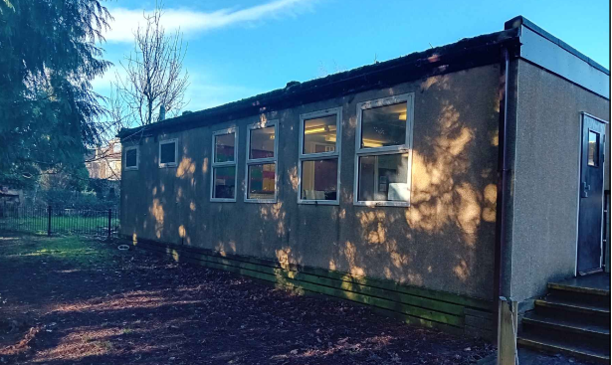

South elevation of the mobile classroom

The mobile classroom is screened by the existing school buildings when viewed from the northwest and east, and when viewed from the south and east the building is seen against the backdrop of existing school buildings.

Therefore, due to its low height and screened position the development would have no adverse impact on the character of the area

Having regard to the above, the proposal complies with the design principles set out in Core Policy 57 of the Wiltshire Core Strategy and the Wiltshire Design Guide.

Impact on the Living Conditions of adjoining neighbours
Point vii of Core Policy 57 - Ensuring High Quality Design and Place Shaping of the Wiltshire Core Strategy seeks to ensure that developments do not adversely affect neighbouring properties.

The National Planning Policy Framework (NPPF), particularly Paragraph 135(f), stresses that planning decisions should ensure developments provide a high standard of amenity for existing and future users.

The proposed development has been assessed in terms of its potential impact on the residential amenity of neighbouring properties, with particular regard to loss of light, overshadowing, loss of privacy, and overbearing effects.

The mobile classroom would be located just over 20 metres from the southern boundary of the school and just under 15 metres from the western boundary. No windows are located on the west elevation of the building.

Therefore, due to the screening of the site, separation distance to the boundary and low height of the building the development would have no adverse impact on the living conditions of neighbouring residents in terms of overlooking or overshadowing. The proposal therefore accords with Core Policy 57 point vii in respect of safeguarding residential amenity and Appendix D of the Wiltshire Design Guide.

Heritage Impact
From the point of view of the historic environment the main statutory tests are set out within the Planning (Listed Building and Conservation Areas) Act 1990.

Section 66 requires that special regard be given to the desirability of preserving listed buildings, their settings or any features of special architectural or historic interest which they possess.

Section 72(1) of the Act requires the Council to pay special attention to the desirability of preserving or enhancing the character or appearance of designated Conservation Areas.

The Council’s Core Strategy Policy CP58 ‘Ensuring the conservation of the historic environment’ requires that designated and non-designated heritage assets and their settings will be conserved, and where appropriate enhanced, in a manner appropriate to their significance and encourages proposals which improve the condition of heritage assets at risk.

The Council’s Core Strategy CP 57: Ensuring high quality design requires a high quality of design in all new developments. The policy requires applicants to “demonstrate how the proposal will make a positive contribution to the character of Wiltshire through (amongst other things) responding to the value of the natural and historic environment and being sympathetic to and conserving historic buildings and landscapes. Development is required to respond positively to the existing in terms of building layouts, built form, height, mass, scale, building line, plot size, elevational design, materials, streetscape and rooflines to effectively integrate the building into its setting.

The NPPF outlines government policy for planning. Chapter 16 of the NPPF 'Conserving and enhancing the historic environment' sets out the Government's high-level policies concerning heritage and sustainable development.

The application site lies just north of the Bradford on Avon Conservation Area (green shading) and to the south of the classroom two listed buildings are positioned (as illustrated by the black hatching within the map inset below).Therefore due consideration needs to be given to the preservation of the character and appearance of the conservation area and the setting of the listed buildings.

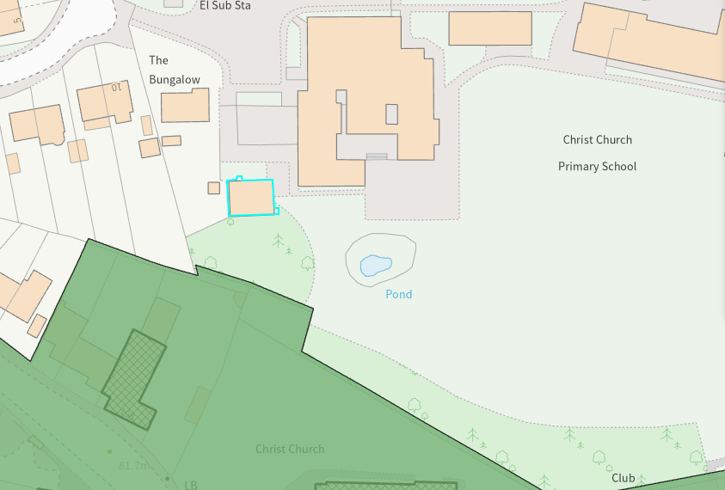

Given this proposal relates to the retention of an existing outbuilding, set within the built envelope of the application site, it is considered that there would be nominal impact in respect of the setting of the conservation area. The proposal, by virtue of its scale, design, and use of materials, is considered to preserve the character and appearance of the conservation area and the setting of the listed buildings nearby.

Officers consider that the retention of the building for a further temporary period would not result in harm to the significance of any heritage assets, the development is therefore considered to comply with Core Policy 58 of the Wiltshire Core Strategy and Sections 66 and 72 of the Planning (Listed Buildings and Conservation Areas) Act 1990, as well as the relevant provisions of the NPPF.

Ecology Impact
Core Policy 50 of the Wiltshire Core Strategy seeks to protect and enhance biodiversity and geodiversity, including through ensuring that development avoids harm to protected species and habitats.

The National Planning Policy Framework (NPPF), in Paragraphs 193, requires that development minimises impacts on and provides net gains for biodiversity, including ensuring mitigation is secured where harm cannot be avoided.

The application site sits within the Bath and Bradford on Avon Special Area of Conservation for bats therefore due consideration has to be given to the potential disturbance of any bats because of the development. However, given this scheme relates to the retention of an existing temporary building that is already in situ the nature of development is such that effects on biodiversity can be ruled out.

As such, the development complies with Core Policy 50 of the Wiltshire Core Strategy and the relevant provisions of the NPPF.

Biodiversity Net Gain
Due to the nature of the proposal, the renewal of temporary permission, the application is exempt from the requirement to deliver Biodiversity Net Gain under Schedule 7A, Section 4(2)(a) of the Town and Country Planning Act 1990, as inserted by the Environment Act 2021.

CONCLUSION
The proposed development is considered to be acceptable in terms of its design, scale, and relationship with the surrounding area. It would not result in any unacceptable harm to the character of the locality, the amenities of neighbouring occupiers, or the interests of heritage, or ecology.

The proposal is therefore considered to comply with the relevant policies of the Wiltshire Core Strategy, the Wiltshire Local Plan, and the National Planning Policy Framework. As such, the application is recommended for approval, subject to the conditions set out below.

RECOMMENDATION: That Planning Permission be GRANTED subject to conditions.

Conditions
- The mobile classroom hereby permitted shall be removed and the land restored to its former condition on or before 26th of April 2031 in accordance with a scheme of works to be submitted and approved in writing by the Local Planning Authority.

REASON: In the interests of amenity, in order to secure the restoration of the land upon removal/extinguishment of a building/use for which permission can be justified only on the basis of a special temporary need.

2. The development hereby permitted shall be carried out in accordance with the following approved plans and documents:
Location Plan DWG No DWG No 1443/25 Rev 0
Plans Elevations, Site Plan & Photos DWG No 1443/24 Rev 0
All Plans Received 02.02.2026

REASON: For the avoidance of doubt and in the interests of proper planning.

