APPLICATION FOR FULL PLANNING PERMISSION
CASE OFFICER REPORT

APPLICATION REFERENCE: | PL/2025/09349
APPLICATION TYPE: | Full planning permission
SITE ADDRESS: | Melksham Community Hospital, Spa Road, Melksham, SN12 7NZ
DEVELOPMENT DESCRIPTION: | Reconfiguration and resurfacing of the designated car parking area for the main entrance at Melksham Community Hospital, and the replacement and installation of associated external lighting.
RECOMMENDATION: | APPROVE SUBJECT TO CONDITIONS

SITE DESCRIPTION/CONTEXT: The application relates to Melksham Community Hospital, with the wider site comprising one and two-storey buildings providing the facilities for the on-site healthcare services.

The existing vehicular and pedestrian access to the hospital is via Spa Road to the north-east of the site, with car parking being provided immediately in front of the hospital. The existing car parking area comprises an area of hard standing providing 19 designated car parking bays, four of which are accessible, with one ambulance bay. The car parking area is lit by three existing external lighting columns and three bollard lights.

With reference to the submitted Supporting Planning Statement (produced by NHS Property Services), parts of the site are being informally used for car parking purposes, which restricts vehicular access to the site, particularly for emergency vehicles. Therefore, this application seeks to provide betterment and improvements to the on-site car parking provision, to ensure that safe and continual access can be provided.

The application site does not fall within any landscape, ecological or heritage designations, and with reference to the Environment Agency's Flood Map for Planning, the site is shown to be within Flood Zone 1, but there is a risk of surface water flooding in a 1 in 100 year event, as illustrated below:

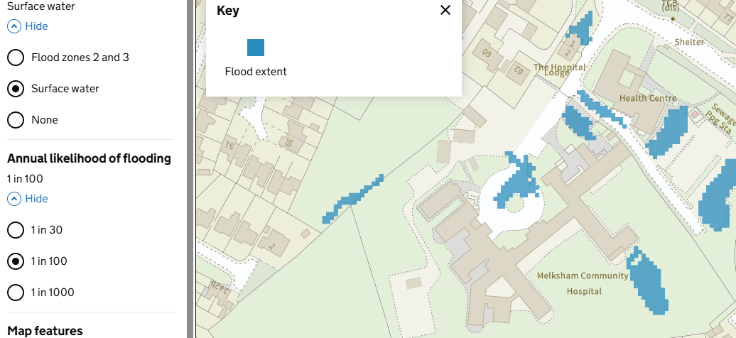

Map extract taken from Map – Flood map for planning – GOV.UK and illustrates the extend of surface water flooding in a 1 in 100 event

The application site has also been screened on the Council’s Strategic Flood Risk Assessment (SFRA), which identifies the site as having a low risk of groundwater flooding.

PROPOSAL: This application seeks to reconfigure and resurface the designated car parking area to the front of Melksham Community Hospital, to improve the existing car parking arrangements. The proposal also seeks to replace and install new external lighting.

The proposal relates to an existing area of hardstanding, which is currently used to park cars accessing the wider hospital site. The existing surfacing material comprises grey tarmac with faded yellow demarcations, with the proposed replacement finish to be grey tarmac, which would be partly permeable, with fresh yellow markings.

The proposed reconfiguration of the car parking area would increase the number of spaces from 19 to 28 (an increase of 9 car parking spaces), with one additional disability space to be provided and for an ambulance parking space to continue to be provided.

The submitted Supporting Planning Statement summarises the proposed works in section 3.5 on page 7 as follows:

- 28no. car parking spaces, which includes 5no. accessible spaces,
- 1no. ambulance bay (as existing),
- 2no. pull-in bays, and
- New grassed areas comprising of 0.456 hectares of neutral grassland.
- Installation of 11no. external lighting columns, and
- Replacement of 3no. existing external lighting bollards.

Extracts of the existing and proposed site plans are provided below:

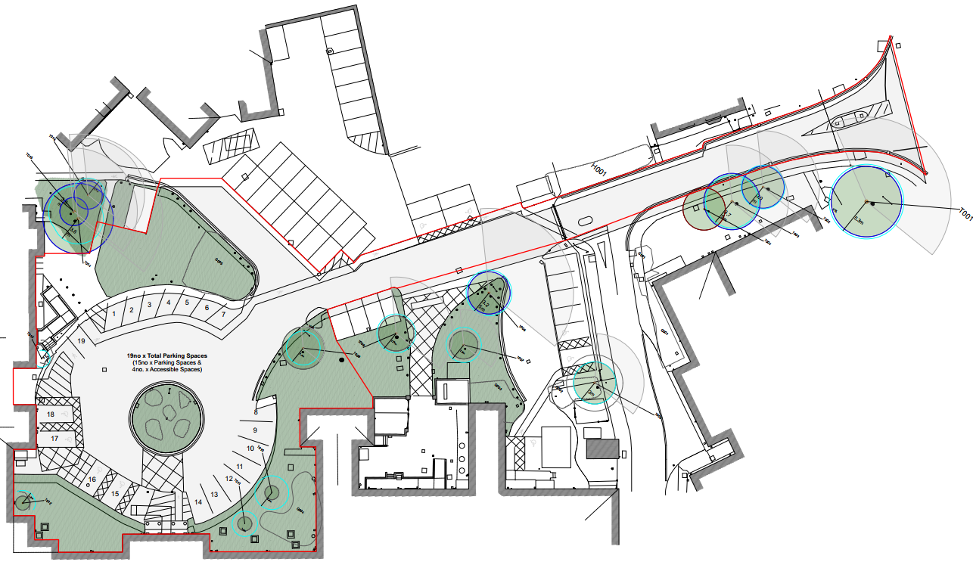

Existing site plan – reference no. 241046-MHR-KK-XX-XX-DR-X-1001 P09

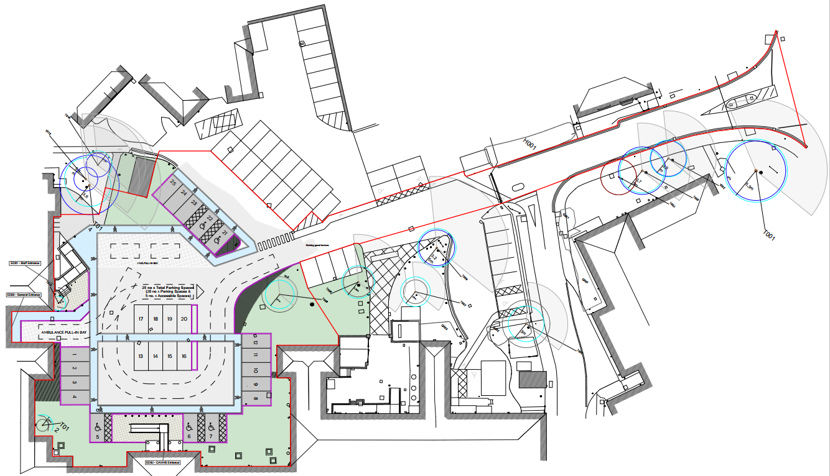

Proposed site plan – reference no. 241046-MHR-KK-XX-XX-DR-X-1101 P05

RELEVANT PLANNING HISTORY

W/99/01871/FUL - Provide 24 car parking spaces – Approved with conditions

W/09/02753/FUL - Enlargement of existing public car park at Melksham Community Hospital – Approved with conditions

RELEVANT LEGISLATION, POLICIES AND GUIDANCE

National Planning Policy: National Planning Policy Framework (NPPF); Planning Practice Guidance (PPG)

Development Plan: The development plan for Wiltshire comprises the Wiltshire Core Strategy (WCS) (adopted January 2015) and any made neighbourhood plans, which remain the principal statutory planning document guiding development across the county. In line with Section 38(6) of the Planning and Compulsory Purchase Act 2004, planning decisions must be made in accordance with the development plan unless material considerations indicate otherwise.

Though the development plan is considered as a whole, those parts deemed to be particularly relevant to this application are listed below:

The adopted Wiltshire Core Strategy (WCS), with particular regard to:

- Core Policy 1 Settlement Strategy;
- Core Policy 2 Delivery Strategy;
- Core Policy 15 Spatial Strategy: Melksham Community Area;
- Core Policy 50 Biodiversity and Geodiversity;
- Core Policy 51 Landscape
- Core Policy 52 Green Infrastructure
- Core Policy 57 Ensuring High Quality Design and Place Shaping;
- Core Policy 60 Sustainable Transport;
- Core Policy 61 Transport & Development;
- Core Policy 62 Development Impacts on the Transport Network;
- Core Policy 63 Transport Strategies
- Core Policy 64 Demand Management
- Core Policy 67 Flood Risk

Saved policies of the West Wiltshire District Plan (1st Alteration) adopted June 2004: C40 (Tree Planting); CF8 (Community Health); I3 (Access for Everyone)

Emerging Wiltshire Local Plan (WLP) Policies: Policy 1: Settlement Strategy; Policy 2: Delivery Strategy; Policy 4: Addressing climate change; Policy 5: Securing infrastructure provision from new development; Policies 6-20: Chippenham Area Strategy; Policies 70 – 75: Transport and development; Policies 76 – 84: Social, housing, community, public open space and wellbeing; Policies 80– 101: Sustainability, ecology, water and landscape, heritage, air quality

The above reflects the strategic policies set out within the emerging WLP, and it should be noted that at the time of determining this PIP, the examination of the emerging WLP has been paused by the local plan examiners.

Neighbourhood Plan: The ‘made’ Joint Melksham Neighbourhood Plan 2 (JMNP2) 2020-2038, formally made on 4 August 2025

Supplementary Planning Documents and other Guidance:

- Wiltshire Design Guide (adopted April 2024)
- Wiltshire Local Transport Plan 2011-2026 (LTP3), adopted 2015 (including the Car Parking Strategy and Cycling Strategy) and Local Transport Plan 2025-2038 (LTP4), adopted 2025

KEY ISSUES: Principle of the development; highway safety and parking; visual impact ecology; neighbour amenity; flooding and drainage

CONSULTATION RESPONSES

Melksham Town Council: No objections

Wiltshire Council Arboricultural Officer: No objection

Wiltshire Council Drainage: No objection, subject to conditions

Wiltshire Council Ecology: No objection, subject to conditions

Wiltshire Council Highways: No objections

Wiltshire Council Public Protection: No objection

REPRESENTATIONS
In accordance with the requirements of the Town and Country Planning (Development Management Procedure) (England) Order 2015 (as amended), the application was publicised by way of:

- Neighbour notification letters sent to adjoining and nearby properties; and
- A site notice displayed near the site

These methods were used to inform interested parties and provide a period of 21 days for comments to be submitted.

Below is a summary of the representations received during the consultation period. Only material planning considerations have been taken into account in the assessment of this application. Non-material issues, such as property values or private legal disputes, cannot be considered in the determination process.

Third-party Representations: No letters of objection received

ASSESSMENT: Section 38(6) of the Planning and Compulsory Purchase Act 2004 states:

"If regard is to be had to the development plan for the purposes of any determination to be made under the planning Acts, the determination must be made in accordance with the plan unless material considerations indicate otherwise."

In accordance with this statutory requirement, this application has been assessed against the relevant policies of the Development Plan, including the Wiltshire Core Strategy (2015) and, where applicable, any made Neighbourhood Plans. Consideration has also been given to the policies of the National Planning Policy Framework (NPPF) as a material consideration in the assessment.

Principle of Development: Policy CP1 (Settlement Strategy) of the WCS establishes a hierarchy of settlements to guide where development should be focused. The policy prioritises growth in:
- Principal Settlements (e.g., Salisbury, Chippenham, Trowbridge) – main focus for strategic growth.
- Market Towns – support local services and employment; suitable for sustainable development.
- Local Service Centres – smaller towns and villages with a range of services; limited development supported.
- Large and Small Villages – development should be limited and respond to local needs.
- Outside the defined settlements – development is strictly controlled and generally not supported unless exceptional circumstances apply.
.
Policy CP2: Delivery Strategy of the WCS sets out how development will be distributed and delivered across Wiltshire. The policy emphasises:
- Sustainable patterns of growth, reducing the need to travel and supporting local services.
- Development should be plan-led, aligning with the settlement strategy and supported by infrastructure.
- Windfall development (not allocated in plans) must still comply with the principles of sustainable development.
- Development outside settlement boundaries is generally not permitted, unless it meets specific policy exceptions (as set out in paragraph 4.25 of the WCS).

Together, CP1 and CP2 ensure that new development is strategically located, sustainable, and supports the character and function of Wiltshire’s communities.

Saved Policy I3 of the West Wiltshire District Local Plan also requires the needs of disabled people to be adequately catered to, including having adequate access around buildings and the provision of external facilities for disabled people in the layout of development. Policy I3 also requires proposals to have regard to “the relationship between buildings and the location and amount of disabled parking, other public access points and the design of the access facilities to be provided”.

The application concerns the existing car parking area serving Melksham Community Hospital. It proposes a revised parking layout to enhance on-site parking arrangements and ensure safe, convenient access to the hospital for all users. The application does not include any alterations to the current vehicular access from Spa Road.

The subject site relates to an existing area of hardstanding that does not fall within any statutory designations. The proposal seeks to support and improve safe and efficient access to the established healthcare facility for fall used.

It is therefore considered that the principle of the development is supported, as the proposal aims to address current operational and safety issues arising from the existing car parking situation which can constrain vehicle movements, and the absence of a dedicated pedestrian route. These improvements are intended to support the safe and efficient functioning of the wider hospital site.

Design and Visual Impact: Core Policy 57 of the WCS requires high-quality design that:
- Enhances local character.
- Responds to the natural, historic, and built environment.
- Retains important features (e.g., trees, hedges).
- Supports sustainable construction and compatibility with surrounding uses.
- Creates safe, legible, and accessible spaces.

Section 12 of the NPPF emphasises design that is:
- Visually attractive.
- Functionally effective.
- Contributes to the quality of the built environment.

The Wiltshire Design Guide encourages sensitivity to local character, materials, and architectural styles and supports modern living standards while maintaining aesthetic and functional quality.

Saved Policy C40 of the West Wiltshire District Local Plan requires the character and appearance of an area to be conserved and for trees of visual amenity value to be retained.

The application has been submitted with tree constraints plans, an Arboricultural Method Statement (AMS) (produced by GE Consulting, reference 3209-AMS-MU), a Tree Protection Plan (drawing no. 3209-TPP-MU) and an Arboricultural Constraints and Implications Report (produced by Hi-Line, reference RSKHL_8795.25_TCR).

The AMS confirms that several trees and shrub groups are to be retained and protected, while limited removals are required to accommodate the proposed reconfiguration of the car parking area. The specified tree works include the felling of Cotoneaster (G005) and Pyracantha (T013), and pruning of a magnolia (T009) to facilitate the revised layout. The AMS confirms that all tree works would be carried out in accordance with BS3998:2010, and checks for nesting birds and roosting bats are required before any felling or pruning takes place.
The AMS sets out the methodology and measures to be used as part of the tree works and the protection measures for the retained trees, including the installation of Tree Protection Fencing (TPF) around all retained trees, as shown on the Tree Protection Plan.

The Council’s tree officer has not raised any objection to the proposal, subject to the submitted AMS and Tree Protection Plan being conditioned.

In terms of the design of the proposed reconfiguration of the car parking area, the current situation lacks a clear pedestrian route, with problems of informal parking and congestion around the existing turning circle. The proposal seeks to address through clearer car parking, improve pedestrian access, wayfinding, provide compliant accessible spaces, and to enhance the arrival experience for patients, staff, and visitors.

The scheme put forward as part of this application seeks to provide a one-way vehicular circulation route, clearly demarcated pedestrian paths, a pull-in drop-off bay, and a rationalised parking layout, providing 28 marked parking spaces (including five accessible), two pull-in bays, and a retained ambulance bay. The surface treatments include the use of contrasting colours, hard kerbing, and new lighting in order to improve the legibility, pedestrian priority, and night-time safety of the site for all users.

The rationale behind the proposal is duly noted, and no design-based or visual impact concerns are raised with the proposal.

Amenity: Policy CP57 (criterion vii) of the WCS requires development to respect the amenity of existing occupants and ensure appropriate amenity levels for future residents.

Paragraph 135 of the NPPF reinforces the need for development to provide a high standard of amenity for both existing and future users.

The proposed works would be fully contained within the context of the hospital site, with the proposed works relating to the reconfiguration of the existing hardstanding area to improve car parking and pedestrian access. The proposal would involve the installation of 11 new external lighting columns and the replacement of 3 existing lighting bollards, which would again be located within the existing grounds of the hospital.

The application has been submitted with a Lighting Design Statement and lighting layout plan, which concludes that the lighting would use energy-efficient LED luminaires with a 0% upward light output ratio to prevent skyglow and reduce obtrusive light. The lighting would be directional, with hoods and shields where necessary to avoid horizontal and vertical spill.

With due regard to the extent and scale of the proposed development, it is considered that the proposed development would not result in any adverse impact on neighbouring occupants. The proposal therefore complies with CP57 of the WCS and the NPPF.

Highways Impacts and Parking: Transport implications are a key factor in assessing planning applications, especially for larger developments. Proposals must demonstrate:
- Safe and suitable access for all users, including pedestrians, cyclists, and those with mobility impairments.
- No severe residual impacts on the surrounding highway network.
- Promotion of sustainable travel, reducing reliance on private vehicles.
- Adequate parking and cycle provision, in line with adopted standards.
- Protection and enhancement of public rights of way and active travel routes.

Relevant policies include Core Policies 60–64 of the Wiltshire Core Strategy, supported by the Wiltshire Local Transport Plan, Car Parking Strategy, and Cycling Strategy. The Local Cycling and Walking Infrastructure Plan (LCWIP) and LTN 1/20 (DfT) provide further design guidance for active travel infrastructure.

The proposal comprises 0.25ha of existing developed (predominantly hardscaping) land within the hospital grounds, comprising car parking spaces and an area of grass and trees.

The proposal seeks to reconfigure the layout of the existing car parking area, to provide 28 marked parking spaces. A one-way circulation system and a dedicated pedestrian route are proposed to improve safety and legibility. Eleven new lighting columns and three replacement bollards are to be installed, designed to align with existing lighting and minimise light spill. This application does not seek to revise or change the existing access point from Spa Road.

The Council’s highways department was consulted on the application and has not raised any objections to the proposal. They have commented to say that the proposed car parking arrangement is acceptable. On this basis, it is considered that the proposal would comply with the requirements of the WCS and the NPPF.

Ecology and Biodiversity: The ecological impact of development is a key planning consideration, especially for larger schemes. Proposals must assess and address potential effects on:

- Protected species
- Priority habitats
- Ecological networks
- Green and blue infrastructure

Core Policy 50 of the Wiltshire Core Strategy requires development to:

- Avoid harm to ecological assets.
- Deliver measurable Biodiversity Net Gain (BNG), in line with the Environment Act 2021.
- Support habitat restoration and connectivity.
- Integrate biodiversity into site design.

The Green & Blue Infrastructure Strategy (2022–2030) promotes nature recovery, ecosystem services, and habitat connectivity through development.

Unless exempt, National policy requires a minimum of 10% Biodiversity Net Gain (BNG) for major developments, demonstrated via:

- Biodiversity Metric calculations
- Ecological assessments (e.g. PEAs, Phase 1 surveys, protected species surveys)

The application has been supported by a Preliminary Ecological Appraisal Report (PEA) and Biodiversity Net Gain Approach (produced by Davidson-Watts Ecology Limited, reference DWE 1064) and a Bat Survey Report (produced by Davidson-Watts Ecology Limited, reference DWE 1072) in addition to Grassland Condition Assessment, a Biodiversity Enhancement Plan and a Biodiversity Gain Plan.

As previously mentioned, the application site comprises an existing car parking area for the established hospital site, and the site does not fall within any statutory or non-statutory ecological designations. The existing site comprises predominantly of development land, including existing hardstanding relating to the existing car parking area and associated roads and walkways. The immediate area is considered to be largely urban in character, with established residential use and fragmented parcels of green open area.

The submitted PEA confirmed that on-site habitats are of low ecological value, comprising modified grassland of site-level importance and extensive hardstanding of negligible value. Small amounts of scattered scrub and ornamental planting provide minor nesting opportunities for common bird species and potential shelter for hedgehog, although no evidence of hedgehog was recorded during the survey. The site supports no suitable habitat for other notable or protected species likely to be present at this location. The PEA does include measures to reduce impact on species in Section 6, including minimising vegetation clearance, avoiding the nesting bird season where possible, and implementing hedgehog-sensitive working methods such as carrying out vegetation clearance in stages and covering trenches overnight.

The application was also supported by a Preliminary Roost Assessment based on two dusk emergence surveys carried out in 2025. Two buildings were identified as having potential for roosting bats, however these are located outside the red line for this application. In terms of commuting and foraging habitat, there is limited good quality habitat for bats on site.

Whilst the two buildings are not included within the red line for this application, assessments were completed that included these buildings because the proposed lighting changes could influence any potential roost features. Building 1 was assessed as having low suitability for roosting bats, with minor external gaps but no internal features. Building 2 was assessed as moderate (precautionary) suitability due to external gaps, although no internal access was possible. Neither building provided conditions suitable for maternity or hibernation roosts, and no trees with roost potential were present on or adjacent to the site. A derelict building nearby also contained roost features but is unaffected by the proposals.

The two dusk emergence surveys recorded no bat emergences and only very low levels of bat activity, limited to a few passes of common pipistrelle at the site edges. Although a wide range of bat species is recorded within 2 km of the site, the development area itself offers negligible foraging or commuting value. Given the absence of roosting bats and the low level of bat activity, the proposed development is considered unlikely to impact bats or contravene bat legislation, and no bat-specific mitigation is required.

With regards to Biodiversity Net Gain (BNG), it has been demonstrated that the proposed scheme would achieve a 10.3% net gain in habitat units, meeting statutory requirements. This is achieved through replacing modified grassland with neutral grassland. The enhancement measures detailed in section 6.4 of the PEA, such as native planting, provision of bird and bat boxes on adjacent trees, and grassland management, are recommended to further maximise ecological benefits.

The Council’s ecology department have raised no objections to the proposed, subject to compliance-based conditions being imposed on any consent granted. The applicant provided additional information, including a biodiversity enhancement plan, a biodiversity gain plan and a plan to show the indicative locations of the proposed biodiversity enhancement measures to satisfy the initial ecology response and prevent the need for pre-commencement conditions. This additional information has been accepted by the ecologist. The proposal is considered to conform to the NPPF and CP50 of the WCS.

Flood Risk and Drainage: Core Policy 67 of the Wiltshire Core Strategy and NPPF paragraphs 170–182 require:
- Avoidance of increased flood risk.
- Use of appropriate mitigation measures.
- Application of the sequential and exception tests for developments in Flood Zones 2 or 3.

Sustainable Drainage Systems (SuDS) are required for all major developments and must:
- Manage runoff near its source.
- Improve water quality.
- Support biodiversity and amenity.
- Be integrated into the site layout and green infrastructure.

The application has been supported by a SUDS Strategy (produced by JDL Consultants), which confirms that the site lies within Flood Zone 1 and is subject to only low levels of surface water flood risk, with no identified groundwater or reservoir flooding concerns. However, the ground investigations confirm that the underlying geology comprises clay and silt over Oxford Clay, resulting in poor infiltration rates. As such, infiltration-based drainage solutions would not be feasible. The existing drainage on site consists of separate foul and surface water networks, with the surface water system discharging via an existing outfall whose full route and final outfall point are unconfirmed.

The proposed SuDS design provides a substantial reduction to the existing discharge, with a combined controlled rate of 2.0 l/s for the 1-in-100-year plus climate change event, representing a significant improvement over the current brownfield performance. This would be achieved using a combination of permeable paving and shallow geocellular attenuation units within the parking bays, with impermeable aisles retained for structural capacity. Due to level limitations, the drainage would be split into eastern and western catchments, each controlled by an orifice plate with proprietary leaf and debris filters. Discharge would be restricted to 1.6 l/s in the east and 0.4 l/s in the west, delivering the overall 2.0 l/s limit. Climate change has been assessed using a 35% uplift for the 1-in-30-year event and 40% for the 1-in-100-year event, consistent with local management catchment allowances. All below-ground attenuation is designed to accommodate storms up to the 1-in-100-year plus climate change event.

The Council’s drainage department have raised no objections to the proposal. The applicant provided additional information, including a SuDS strategy and exceedance routing plan, to satisfy the initial drainage response to prevent the need for pre-commencement conditions, and this information has been accepted by the council’s drainage department

The proposed SuDS design provides a substantial reduction in discharge when compared with existing brownfield conditions, and would manage runoff safely within the site for events up to the 1-in-100-year plus climate change standard. The proposal would not generate additional foul flows, and the scheme does not increase flood risk on or off-site. The strategy is therefore considered appropriate and proportionate to the scale and constraints of this redevelopment. The proposal therefore complies with CP67 of the WCS and the requirements of the NPPF.

PLANNING BALANCE AND CONCLUSION: At the heart of the NPPF there is a presumption in favour of sustainable development requiring local planning authorities to approve development proposals that accord with an up-to-date development plan without delay; and where there are no relevant development plan policies, or the policies which are most important for determining the application are out-of-date, permission should be granted unless (taken from paragraph 11d of the NPPF):

- The application of policies in the NPPF that protect areas or assets of particular importance provides a clear reason for refusing development proposed; or
- any adverse impacts of doing so would significantly and demonstrably outweigh the benefits, when assessed against the policies in the NPPF taken as a whole;

The principle of development is considered acceptable when assessed against the settlement strategy of the Wiltshire Core Strategy and the emerging Local Plan.

The proposal is broadly compliant with relevant local and national planning policies in respect of residential amenity, highway safety, flood risk and drainage, ecology and biodiversity, subject to the recommended conditions and any necessary mitigation measures.

No material considerations have been identified that would significantly and demonstrably outweigh these benefits or indicate that permission should be refused, having regard to the assessment above and the representations received.

Accordingly, the proposal is considered acceptable in planning terms and in accordance with the Wiltshire Core Strategy, the National Planning Policy Framework, and all other relevant material considerations.

RECOMMENDATION: That Planning Permission be GRANTED, subject to conditions

