APPLICATION FOR FULL PLANNING PERMISSION
CASE OFFICER REPORT

APPLICATION REFERENCE: | PL/2026/00264
APPLICATION TYPE: | Full planning permission
SITE ADDRESS: | United Reformed Church, The Street, Holt, BA14 6RS
DEVELOPMENT DESCRIPTION: | Widening and reconfiguration of the existing vehicular access from The Street, including partial removal and reconstruction of the existing natural rubble stone boundary wall.
RECOMMENDATION: | Approve with Conditions

SITE DESCRIPTION/CONTEXT

The site comprises a GII listed Church Hall as the principal building, the Church building itself which is curtilage listed due to its close functional association and ownership at time of listing, itself considered a non-designated heritage asset and two modern outbuildings.

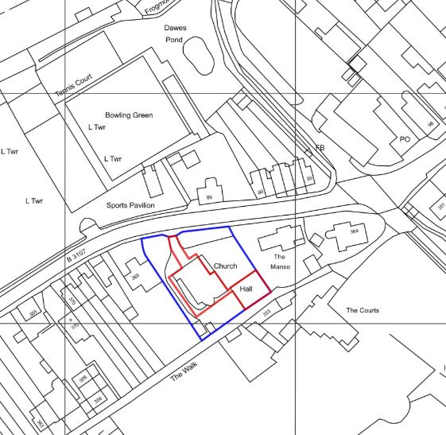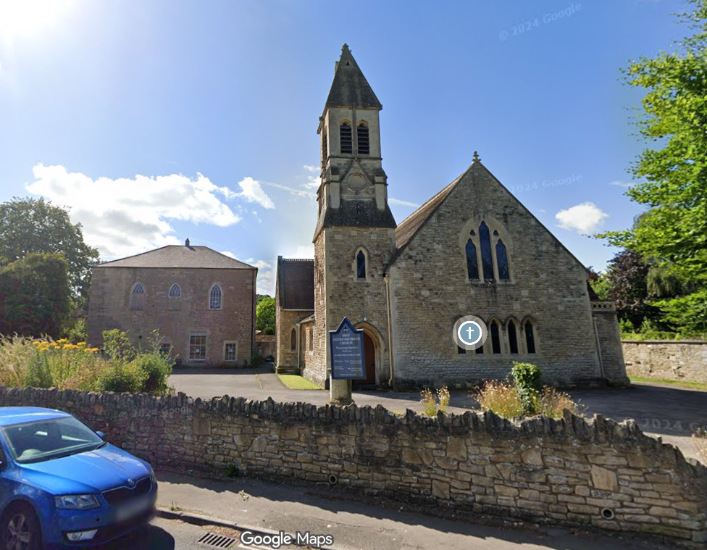

Location Plan and Google Earth Site Photo

The Church Hall was the original congregational chapel, known as Hope Chapel, built circa 1810 of a square plan in coursed rubble stone under a hipped Welsh slate roof (almost pyramidal). The building was extended in 1846, which is legible in the brickwork and detailing but still presents as a typical Georgian non-conformist chapel. A floor was inserted to create a building of two storeys to create a school room on the GF and church meeting room on the FF. There were further extensive renovations in the 1970s

Historic maps confirm that the Church Hall later became the village’s School building, active as such until 1973.

The Church building however was built later circa 1880, in the Victorian Gothic Style with an apse, tower and spire, taking the name United Reformed Church in 1972 when merging with the Presbyterians.

The Church is built of rubble stone with ashlar detailing under a steep slate roof with banding.

The site lies within the historic core of Holt which stretches from Ham Green to the south along the linear form of the village, with the proposal site very much central and highly visible. The site is within the Holt Conservation Area in an area where historic from and character are still legible.

There are two areas of hardstanding for car parking; one in front of the Hall, beside the Church, the second to the rear of the Church.

Vehicle and pedestrian access is via The Street; the B3107; the main High Street running the length of the village, and which lies to the north of the site.

There is also pedestrian access to the rear of the site via Public Right of Way HOLT64, known as The Walk, which is a popular historic route away from the busy road, and separates the proposal site from The Courts; a GII* Georgian Country House. Against the boundary wall to The Walk are a range of intervening outbuildings, both Church outbuildings and those of The Courts.

Built circa 1720, The Courts cover a rambling L-plan surrounded by C20-designed Registered Park and Garden and is now owned by the National Trust. The Historic England listing of The Courts includes a photo that just shows the roof of the Church Hall.

Mid C19 GII-designated Beak House lies to the immediate west of the proposal site, and includes many details seen in the listed Hall.

The Church is just outside of buffer zones of any known bat roosts nor within any statutory protected area but has been demonstrated to include roosting bats.

The site benefits from Ecclesiastical Exemption, such that a separate LBC to United Reformed Church’s South Western Synod LB Advisory Committee has been made but comment/determination not available at the time of writing.

PROPOSAL

The proposal is to reconfigure the eastern section of the existing vehicular access from The Street by partially removing a section of rubble stone boundary wall to the east of the existing access, with cock and hen detailing, and reconstructing a smaller section with recycled stone, at a position further back within the site, effectively replicating and repositioning a chamfer/splay. This will effectively widen the access and set back/improve visibility splays.

The access is currently 3.2m wide, the proposal widening it to 4.8m such that two vehicles could pass, with the area revealed to be regressed and integrated to the existing verge.

The proposed Site Plan states that the gate to The Walk is to be refurbished, but this is not included in the description of development or details provided, so not assessed or included her.

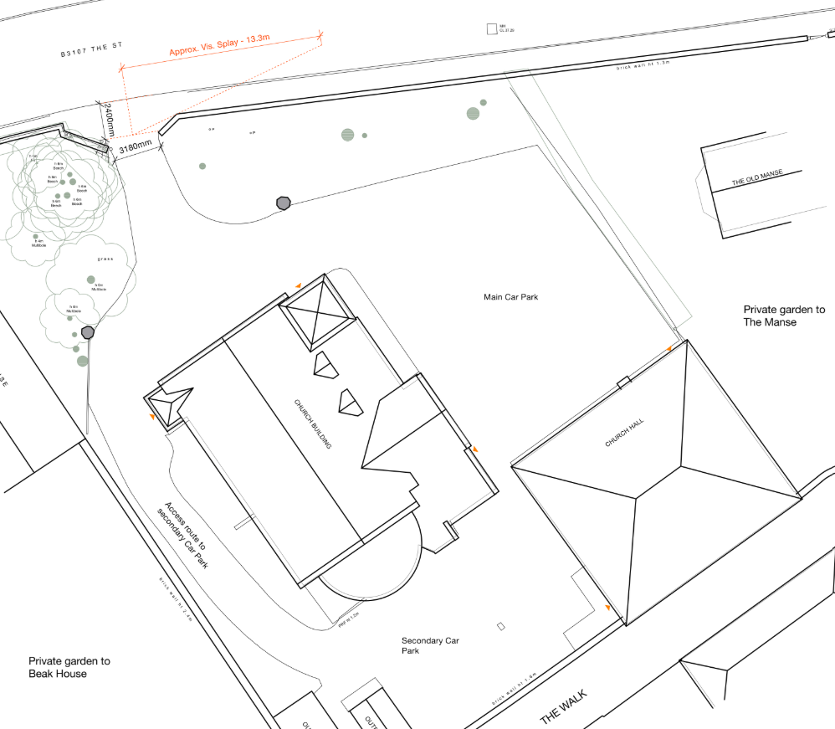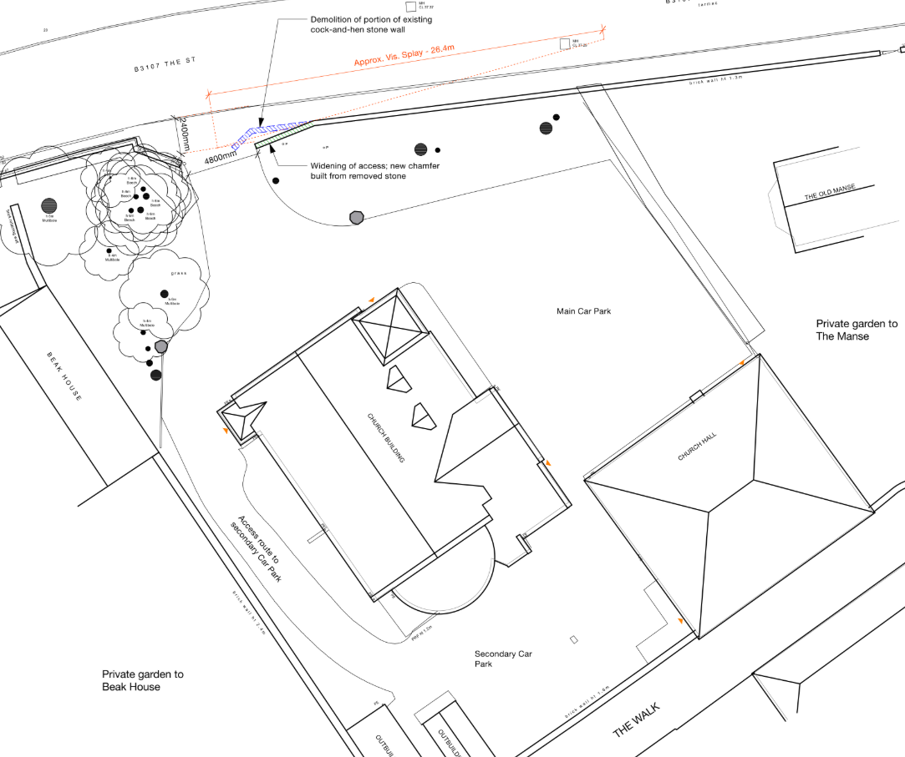

Existing and Proposed Site Plan

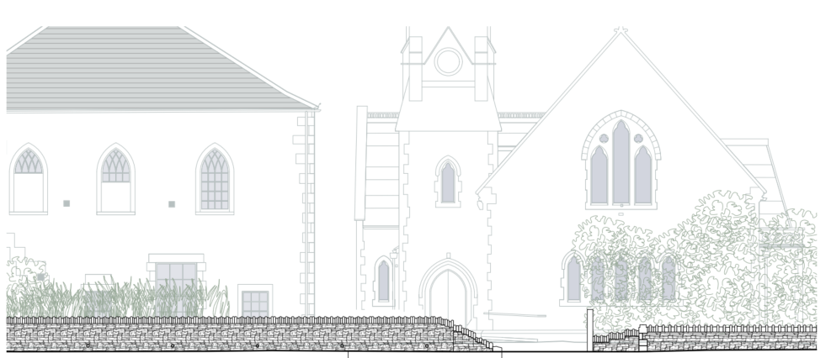

Existing Boundary Wall Elevation

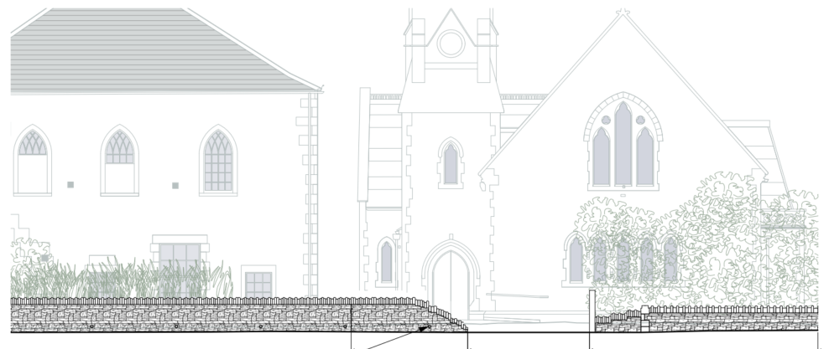

Proposed Boundary Wall Elevation

PLANNING HISTORY
S/1988/2014 - Full planning permission Decision - Withdrawn Date: 26/1/1989 – ALTERATIONS TO BUILDING TO FORM DWELLING, ALTERATION OF ACCESS AND GARAGE SITING
PL/2026/00089 - Full planning permission Decision - Approve with Conditions Date: – External works to the church and hall comprising the installation of a photovoltaic array with associated battery storage, new access ramp and handrails to the main church entrance, reconfiguration of a ground floor window and entrance door to the south-e

RELEVANT LEGISLATION, POLICIES AND GUIDANCE

Statutory Legislation:
The Planning (Listed Building and Conservation Area) Act 1990,
Sections 66: Listed Buildings
Section 72: Conservation

National Planning Policy:
- National Planning Policy Framework (NPPF)
- Planning Practice Guidance (PPG)
- National Design Guide
Development Plan:
The development plan for Wiltshire comprises the Wiltshire Core Strategy (WCS) (adopted January 2015) and any made neighbourhood plans, which remains the principal statutory planning document guiding development across the county. In line with Section 38(6) of the Planning and Compulsory Purchase Act 2004, planning decisions must be made in accordance with the development plan unless material considerations indicate otherwise.

Though the development plan is considered as a whole, those parts deemed to be particularly relevant to this application are listed below:

The adopted Wiltshire Core Strategy (WCS), with particular regard to:
- Core Policy 55 Air Quality;
- Core Policy 57 Ensuring High Quality Design and Place Shaping;
- Core Policy 58 Ensuring the Conservation of the Historic Environment;
- Core Policy 60 Sustainable Transport;
- Core Policy 61 Transport & Development;
- Core Policy 62 Development Impacts on the Transport Network;
- Core Policy 63 Transport Strategies
- Core Policy 64 Demand Management

Holt Neighbourhood Plan, made 2017

Supplementary Planning Documents and other Guidance:
- Wiltshire Design Guide (adopted April 2024)
- Wiltshire Local Transport Plan 2011-2026, adopted 2015 - including the Car Parking Strategy and Cycling Strategy, adopted 2015
- Wiltshire Local Cycling and Walking Infrastructure Plan (LCWIP)
- Active travel infrastructure design standards 2022
- Active travel parking standards and design guide 2022
- LTN1/20 – Cycle Infrastructure Design (July 2020)

ISSUES
The main issues that need to be addressed in this case include:
- Whether the scheme would preserve or enhance the historic environment (CP 58)
- Whether the proposal would have a negative effect upon highway safety, including if there is sufficient parking for the proposed development (CP 61 and 64)

CONSULTATION RESPONSES
WC Highways: No objection.
WC Conservation: No comment received.
Holt Parish Council: Support.

REPRESENTATIONS
In accordance with the requirements of the Town and Country Planning (Development Management Procedure) (England) Order 2015 (as amended), the application was publicised by way of:

- Neighbour notification letters sent to adjoining and nearby properties;
- A site notice displayed near the site;
- An advertisement placed in the local press.

These methods were used to inform interested parties and provide a period of 21 days for comments to be submitted.

Below is a summary of the representations received during the consultation period. Only material planning considerations have been taken into account in the assessment of this application. Non-material issues, such as property values or private legal disputes, cannot be considered in the determination process.

One comment received in support of the application highlighting proposed improvements to visibility and therefore access/highway safety.

ASSESSMENT

Principle of Development:
Section 70(2) of the Town and Country Planning Act 1990 and section 38(6) of the Planning and Compulsory Purchase Act 2004, require that the determination of planning applications must be made in accordance with the Development Plan, unless material considerations indicate otherwise.

The proposal comprises development to an existing residential property set in an established residential area within the settlement boundary of Westwood. The proposal is wholly within the residential curtilage, and as such, the principle of development is acceptable subject to the following considerations.

In accordance with this statutory requirement, this application has been assessed against the relevant policies of the Development Plan, including the adopted Wiltshire Core Strategy (2015) and, where applicable, any made Neighbourhood Plans.

Heritage, Design and Impact on the Character and Appearance of the Area
From the point of view of the historic environment the main statutory tests are set out within the Planning (Listed Building and Conservation Areas) Act 1990.

Section 66 requires that special regard be given to the desirability of preserving listed buildings, their settings or any features of special architectural or historic interest which they possess.

Paragraph 58B of the Planning Act 1990 requires that in considering whether to grant planning permission or permission in principle for the development of land in England which affects a registered park and garden, the LPA must have special regard to the desirability of preserving or enhancing the asset or its setting.

Section 72(1) of the Act requires the Council to pay special attention to the desirability of preserving or enhancing the character or appearance of designated Conservation Areas.
The NPPF outlines government policy for planning. Chapter 16 of the NPPF 'Conserving and enhancing the historic environment' sets out the Government's high-level policies concerning heritage and sustainable development. In particular:

Paragraph 208 requires LPAs should “avoid or minimise any conflict” between the heritage asset’s conservation (which includes achieving its optimum viable use) and any aspect of a proposal.

Paragraph 210 requires local planning authorities should take account of the desirability of sustaining and enhancing the significance of heritage assets and putting them to viable new uses and of new development making a positive contribution to local character and distinctiveness.

Paragraphs 212 requires “great weight” to be given to an asset’s conservation “irrespective of whether any potential harm amounts to substantial harm, total loss or less than substantial harm to its significance.”

Paragraph 213 advises that harm to the significance of a designated heritage asset should require “clear and convincing justification”.

Paragraphs 213-215(214-216) require a balanced approach with any harm which would be caused being weighed against the potential public benefits which might be achieved.

Paragraph 220 advises that not all elements of a Conservation Area or World Heritage Site will necessarily contribute to its significance. Loss of a building (or other element) which makes a positive contribution to the significance of the Conservation Area or World Heritage Site should be treated either as substantial harm or less than substantial harm as appropriate.

The Planning Practice Guidance provides guidance on interpreting the NPPF.
The Council’s Core Strategy Policy CP58 ‘Ensuring the conservation of the historic environment’ requires that designated and non-designated heritage assets and their settings will be conserved, and where appropriate enhanced, in a manner appropriate to their significance and encourages proposals which improve the condition of heritage assets at risk.

The Council’s Core Strategy CP 57: Ensuring high quality design requires a high quality of design in all new developments. The policy requires applicants to “demonstrate how the proposal will make a positive contribution to the character of Wiltshire through (amongst other things) responding to the value of the natural and historic environment and being sympathetic to and conserving historic buildings and landscapes. Development is required to respond positively to the existing in terms of building layouts, built form, height, mass, scale, building line, plot size, elevational design, materials, streetscape and rooflines to effectively integrate the building into its setting.

This assessment must determine if this proposal would preserve the listed building’s special architectural and historic character and setting, and special character of the Conservation Area.

The Church and the designated Church Hall, are both notable buildings within the village, making a strong, positive contribution to the streetscape and Conservation Area.

The proposal seeks to alter a small section of front boundary wall; demolishing a small section and rebuilding a section in an altered siting.

The proposed works would not impact the listed asset itself but its historic environment. The significance of the Church Hall relates to its functional design and use, use of local materials, age, scale and prominence, and is entwined with the history and community of the village. The proposal therefore would not impact the significance of the designated asset, nor of the NDHA Church.

By demolishing a section of historic wall, there is innate harm, but this is offset by the clear highways and accessibility public gains, improving visibility at a congested section of the street and enabling continued viability of both buildings.

The siting of the wall is not as important to the character of the Conservation Area, as the materials, scale and design of the wall, all of which are to replicated, reusing materials where possible.

Given that the application states that materials are to be reused, and design replicated, conditions are not considered necessary.

At this scale, with sensitivity of design and reused materials, the proposed works would not harm the character of the Conservation Area, and the proposals are considered policy compliant.

Highways Impacts and Parking
Transport implications are a key factor in assessing this planning applications. Proposals must demonstrate:
- Safe and suitable access for all users, including pedestrians, cyclists, and those with mobility impairments.
- No severe residual impacts on the surrounding highway network.
- Promotion of sustainable travel, reducing reliance on private vehicles.
- Adequate parking and cycle provision, in line with adopted standards.
- Protection and enhancement of public rights of way and active travel routes.

Relevant policies include Core Policies 60–64 of the Wiltshire Core Strategy, supported by the Wiltshire Local Transport Plan, Car Parking Strategy, and Cycling Strategy. The Local Cycling and Walking Infrastructure Plan (LCWIP) and LTN 1/20 (DfT) provide further design guidance for active travel infrastructure.

Proposals must also ensure safe access for refuse collection vehicles and comply with the Wiltshire Council Waste Storage and Collection SPD (2017).

The proposal does not seek to increase parking demand or circulation, but to improve highway safety by improve access to the site, so all cars can access and exit in a forward gear with improved visibility splays. In line with the WC Highways Officer’s comment of no objection, the proposals are considered policy compliant.

CONCLUSION
The scheme is appraised as complying with the relevant policies in the NPPF, the Adopted (2015) Wiltshire Core Strategy and other relevant planning documents/policies and legislation. It is therefore recommended that this application is approved with conditions.

RECOMMENDATION:
That Planning Permission be GRANTED, subject to conditions.

