APPLICATION FOR HOUSEHOLDER PLANNING PERMISSION
DELEGATED REPORT

APPLICATION REFERENCE: | PL/2026/00675
APPLICATION TYPE: | Householder planning permission
SITE ADDRESS: | The Laurels, Tytherton Lucas, Chippenham, SN15 3RJ
DEVELOPMENT DESCRIPTION: | Erection of stand alone timber greenhouse
RECOMMENDATION: | That Planning Permission be GRANTED

SITE CONTEXT

The Laurels (the ‘site’) is a residential plot situated on the north side of a country lane at the very southern end of the hamlet named Tytherton Lucas (designated as open countryside in the Wiltshire Core Strategy).

The site is occupied by an attractive historic two storey dwelling and its large garden which contains a small deteriorating greenhouse (to be removed) and moderate timber shed. The proposal specifically relates to the northern portion of the garden which is visually separated from the host dwelling by a hedgerow. Much of the garden used for growing vegetables. The garden is also visually enclosed with mature boundary planting and is depicted below:

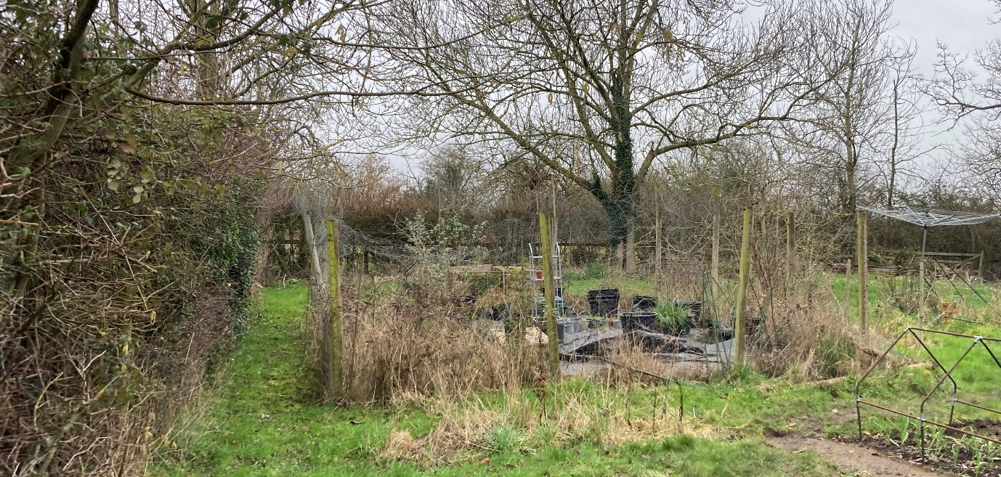

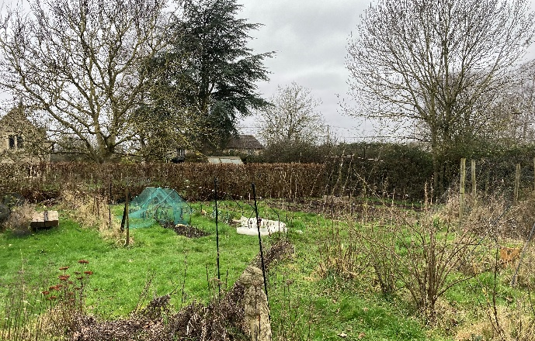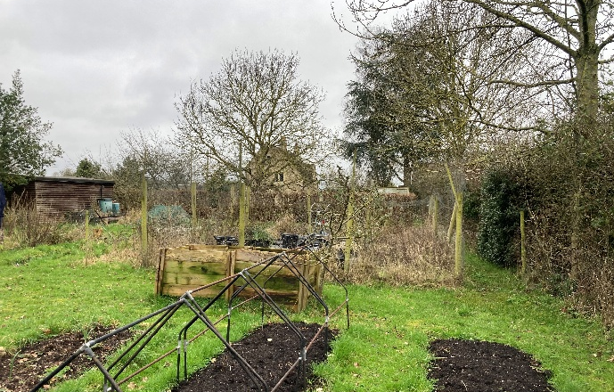

Images of the site looking northeast (top) and west (lower left) and southwest (lower right).

In terms of immediate surroundings, an elongated cottage adjoins the northwestern aspect of the host dwelling with further dwellings scattered beyond, otherwise the site is surrounded by a patchwork of small fields with the public highway running along the southwest site boundary.

The application site is subject to the following planning policy designations/constraints:

- Within Tytherton Lucas Conservation Area.
- The southwest site boundary is subject to high risk of surface water flooding and the host dwelling is subject to a low risk of surface water flooding.

PROPOSAL

The proposal seeks householder planning permission for the erection of a greenhouse situated circa 33m to the northeast of the host dwelling. The greenhouse is a pitched roof structure with a central gable porch. It measures circa 3m deep and 6.4m wide, plus the 0.3m deep and 2m wide porch and has 1.7m high eaves and a 3m high ridge. It is styled as a Victorian greenhouse with a brick plinth and timber framed glazing above. Plans of the greenhouse are shown below.

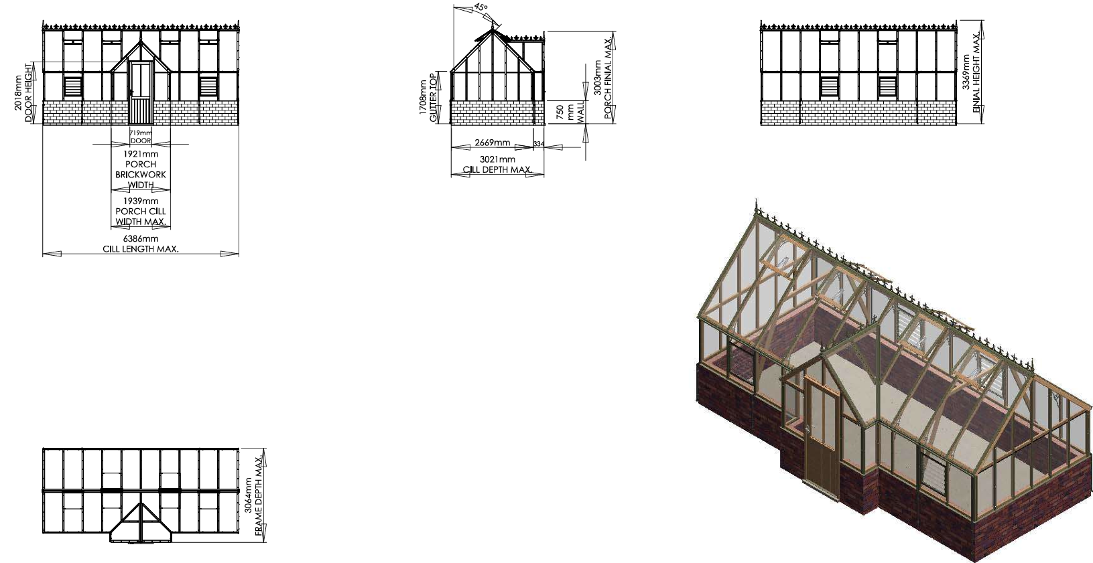

PLANNING HISTORY

Relevant Planning Records
Reference | Description | Decision | Date
N/99/02434/FUL | Extension to dwelling | Unknown | 18/11/1999
N/00/02118/FUL | Extension to dwelling (amendment to N.99.02434.FUL) | Approved | 01/11/2000
N/08/02152/TCA | Fell 1 No Eucalyptus & 1 No Poplar | Approved | 20/10/2008

RELEVANT LEGISLATION, POLICIES AND GUIDANCE

Planning Legislation:

- Town and Country Planning Act 1990
- Planning and Compulsory Purchase Act 2004
- Planning (Listed Buildings and Conversation Areas) Act 1990

Development Plan:

- Wiltshire Core Strategy (adopted January 2015):
  - Core Policy 41: Sustainable construction and low-carbon energy
  - Core Policy 51: Landscape
  - Core Policy 57: Ensuring high quality design and place shaping
  - Core Policy 58: Ensuring the conservation of the historic environment

- Bremhill Parish Neighbourhood Plan (made February 2018):
  - Policy 1: General development

Material Considerations (Policy):

- National Planning Policy Framework (NPPF) December 2024:
  - Section 2. Achieving sustainable development
  - Section 12. Achieving well-designed places
  - Section 15. Conserving and enhancing the natural environment
  - Section 16. Conserving and enhancing the historic environment

- Wiltshire Local Plan Submission Draft 2020-2038 (Regulation 24)*:
  - Policy 4: Addressing climate change
  - Policy 85: Sustainable construction and low carbon energy
  - Policy 91: Conserving and enhancing Wiltshire’s landscapes
  - Policy 98: Ensuring high quality design and place shaping
  - Policy 99: Ensuring the conservation and enhancement of the historic environment

*The examination of the emerging Wiltshire Local Plan has been paused and the weight to be afforded to any part of the emerging plan can be no more than very limited. A decision on how to proceed will be made by the Council in May 2026.

Material Considerations (Guidance):

- National Planning Practice Guidance
- National Design Guide (January 2021)
- Wiltshire Design Guide (March 2024)

CONSULTATION RESPONSES

Bremhill Parish Council: Support the proposal.

REPRESENTATIONS

No comments were received.

ASSESSMENT

Section 38(6) of the Planning and Compulsory Purchase Act 2004 states that planning decisions must be made in accordance with the development plan unless material considerations indicate otherwise. In accordance with this requirement, this application has been assessed against the relevant policies of the development plan and the material considerations listed above.

Having regard to the planning context and nature of the proposal, the following key matters are considered pertinent to the assessment of the proposal and are addressed in turn:

- Design
- Heritage
- Landscape
- Neighbouring amenity

Design

Core Policy 57 of the Wiltshire Core Strategy requires that all development be of high design quality, create a strong sense of place and complement its context, including through enhancing local distinctiveness and responding positively to local characteristics. This requirement is carried forward in draft Policy 98 of the emerging Wiltshire Local Plan.

Appendix D of the Wiltshire Design advises that detached outbuildings placed in front of properties will not normally be acceptable and that they should be single storey in scale.

Neighbourhood Plan Policy 1 permits development in the countryside only where it would have an acceptable impact on rural character and meets one of the identified purposes – in this case, purpose (v), which allows development supported by national or local planning policies. Proposals must also comply with Design Statement Policies (DSPs) 1-3, which collectively require the conservation and enhancement of landscape features and ensure that development is appropriate to, and compatible with, its surrounding context.

Although the proposed greenhouse is set some distance from the host dwelling, it remains firmly within a domestic context and directly supports the horticultural use of this part of the garden. Its modest scale is proportionate to its setting, and its low height and lightweight materials clearly express its auxiliary status relative to the host dwelling. Its appearance, including its form, style and materiality are appropriate to both its function and its surroundings. Overall, the greenhouse appears as a discreet, inoffensive structure within the visually contained domestic curtilage and wider rural setting.

Having regard to the above, the proposal is considered to comply with the design principles set out in Core Policy 57 of the Core Strategy, draft Policy 98 of the emerging Local Plan, Neighbourhood Plan Policy 1 and the Wiltshire Design Guide.

Heritage

Section 72(1) of the Planning (Listed Buildings and Conversation Areas) Act 1990 requires that special attention be paid to the desirability of preserving or enhancing the character or appearance of a Conservation Area.

Core Policy 57(i) and (iv) require that development proposals be sympathetic, respond positively to and conserve the historic environment.

Core Policy CP58 states that development should protect, conserve and, where possible, enhance the historic environment. The policy requires that heritage assets and their settings be conserved and/or enhanced in a manner appropriate to their significance. This requirement is carried forward in draft Policy 99.

Paragraph 207 of the NPPF states that local planning authorities should require applicants to describe the significance of any heritage asset affected by development, including any contribution made by their setting. The level of detail should be proportionate to the asset’s importance and no more than is sufficient to understand the potential impact of the proposal on the asset’s significance.

Paragraph 212 clarifies that great weight should be given to an asset’s conservation, irrespective of the level of harm.

Having regard to the above design assessment, the proposal is therefore considered to conserve the historic environment in accordance Core Policies 57 and 58 of the Core Strategy, draft Policies 98 and 99 of the emerging Local Plan, Neighbourhood Plan Policies BE1 and BE2, section 16 of the NPPF and the Design Guide.

Landscape

Core Policy 51 requires development to protect, conserve and, where possible, enhance the character of Wiltshire’s landscapes through sensitive design and landscape mitigation and enhancement measures. Proposals should have due regard to the relevant Landscape Character Assessments. This requirement is carried forward in draft Policy 91.

Having regard to the domestic context of the site, its mature boundary planting and the low scale and appropriate appearance of the greenhouse, the proposal is considered to conserve Wiltshire’s landscape in accordance with Core Policy 51 and draft Policy 91.

Neighbouring Amenity

Core Policy 57(vii) requires that development be compatible with the adjoining uses and protect the residential amenity of existing and future users of the site and its surroundings, including in respect of natural lighting, privacy, outlook and pollution sources. This requirement is carried forward in draft Policy 98.

The Design Guide states that minimum garden areas for all houses should be equivalent to the footprint of the house and that a back-to-back separation distance of minimum 20m should be respected. The guide also refers to the BRE Site layout planning for daylight and sunlight as an appropriate source for assessing proposals. Appendix D of the guide states that extensions should not be unduly overbearing or obtrusive to neighbouring properties.

Given the significant separation of the greenhouse from the host and neighbouring properties and its setting within a large garden, the proposal would maintain an acceptable standard of residential amenity in accordance with Core Policy 57(vii) and the Wiltshire Design Guide.

CONCLUSION

Having regard to its discreet and visually screened siting, modest scale and appropriate appearance, the proposed greenhouse is acceptable in respect of design, heritage, landscape and neighbouring amenity. The proposal therefore complies with the policies and guidance of the Wiltshire Core Strategy, emerging Wiltshire Local Plan, Bremhill Parish Neighbourhood Development, NPPF and the Wiltshire Design Guide. As such, the application is recommended for approval, subject to the conditions set out below.

RECOMMENDATION: That Planning Permission be GRANTED subject to the following conditions:

- The development hereby permitted shall be begun before the expiration of three years from the date of this permission.

REASON: To comply with the provisions of Section 91 of the Town and Country Planning Act 1990 as amended by the Planning and Compulsory Purchase Act 2004.

- The development hereby permitted shall be carried out in accordance with the following approved plans and documents:

- Location Plan, ref: PP-14668294v1
- Proposed Block Plan (received: 02/02/2026)
- Proposed Plans – Alton Victorian Elmhurst Dwarf Porched Model 9x20 (received: 02/02/2026)

REASON: For the avoidance of doubt and in the interests of proper planning.

- The materials to be used in the construction of the external surfaces of the development hereby permitted shall match in material, colour and texture those stated on the approved documents.

REASON: In the interests of visual amenity and the character and appearance of the area.

