24 Mar 26
Primrose Cottage: Greenhouse images
Mark Conlin
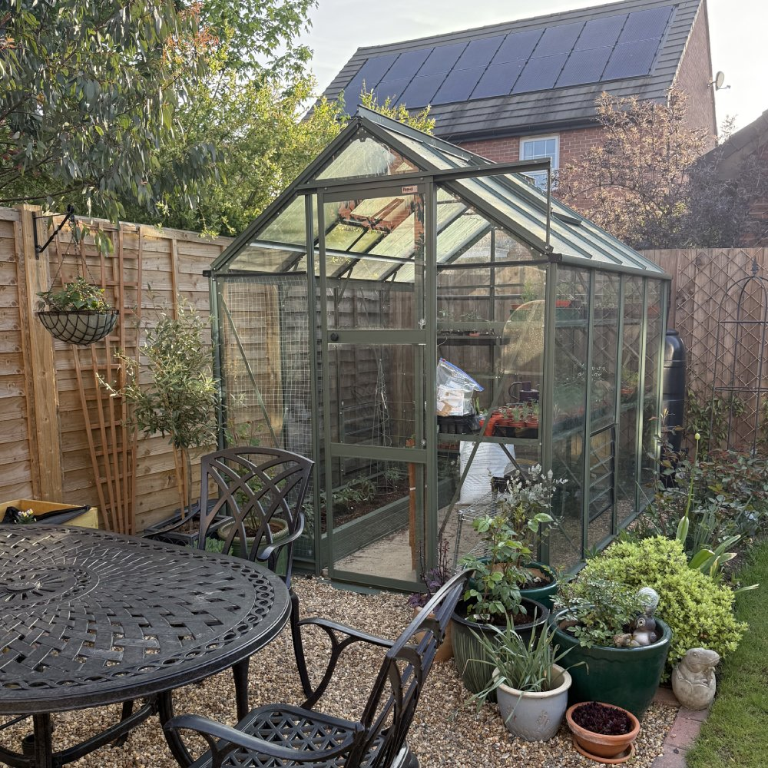
Fig 1: Front elevation (Stock image from website)

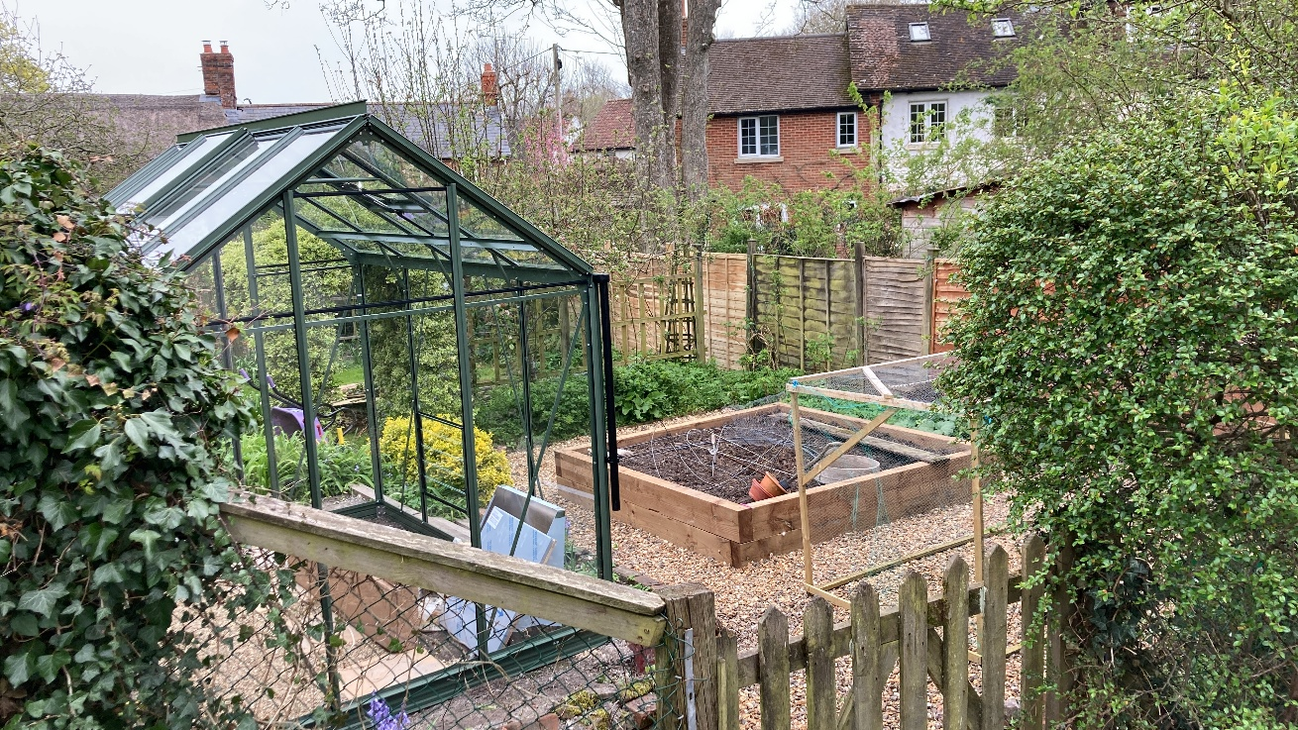
Fig 2: Rear elevation (image taken from edge of driveway that meets public bridleway)

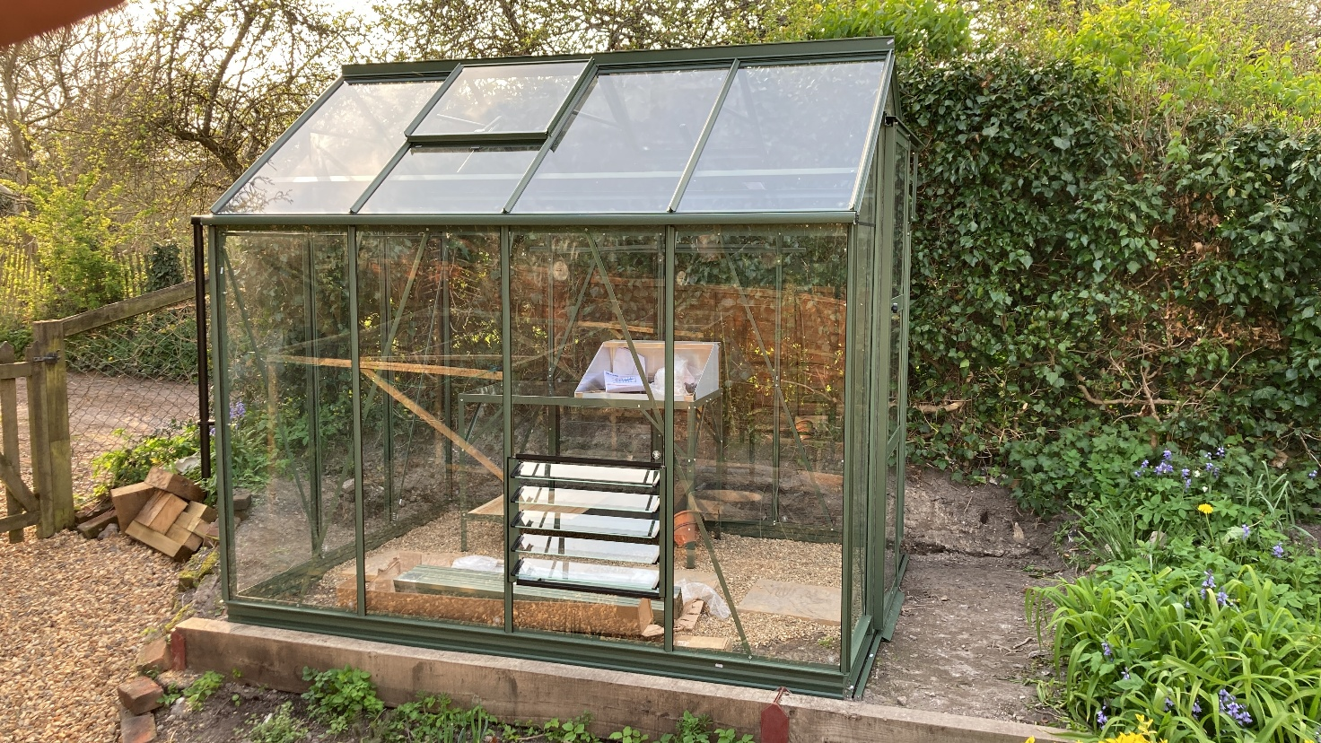
Fig 3: Side elevation (the opposite side is a mirror-image – capture not possible owing to proximity to hedgerow)

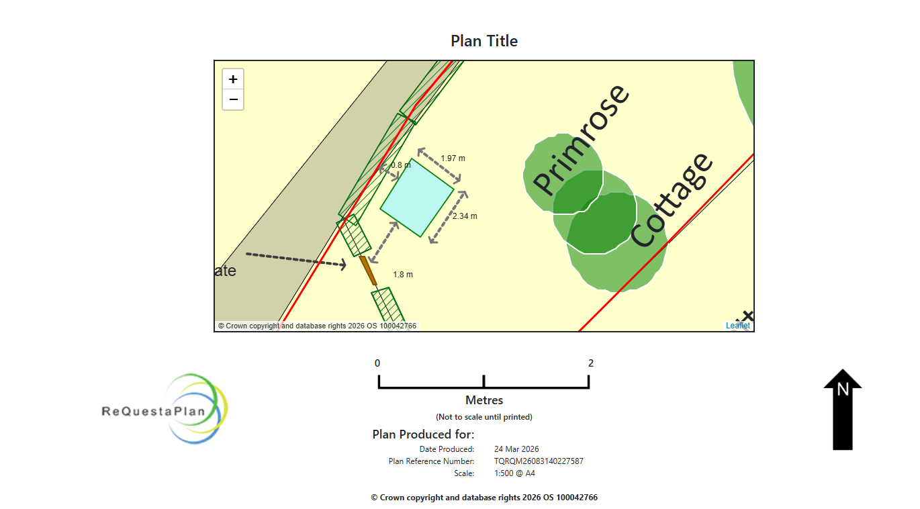
Fig 4: Closeup of Site Plan

