APPLICATION FOR HOUSEHOLDER PLANNING PERMISSION
DELEGATED REPORT

APPLICATION REFERENCE: | PL/2025/08575 & PL/2025/08825
APPLICATION TYPE: | Householder planning permission & Listed Building Consent
SITE ADDRESS: | Old Bengers, Longstreet, Enford, Pewsey, SN9 6AW
DEVELOPMENT DESCRIPTION: | Removal of rear porch and external boiler and erection of new kitchen extension at rear
RECOMMENDATION: | That Planning Permission and Listed Building Consent be REFUSED

This report covers both the householder planning permission (PL/2025/08575) and listed building consent (PL/2025/08825) applications.

PROPOSAL

The proposal seeks planning permission for the removal of a porch and external boiler on the east elevation and a new single storey, pyramidal, kitchen extension with a glazed link on the east elevation of the listed dwelling.

A revised set of plans were received 26.01.2026, following comments from the Conservation Officer.

Proposed site plan

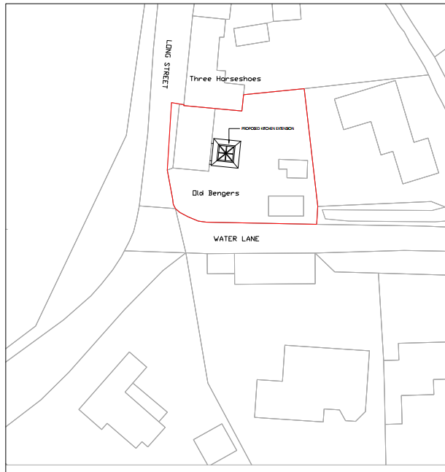

Proposed ground floor plan

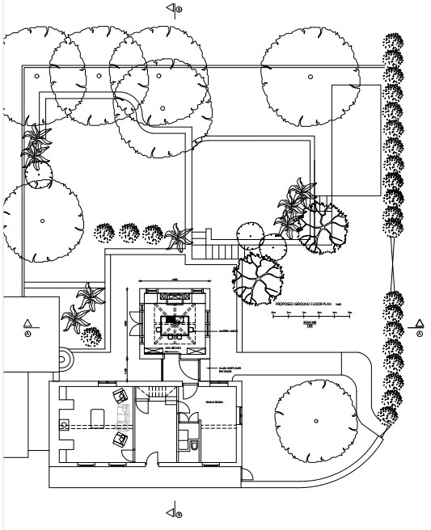

Proposed east elevation

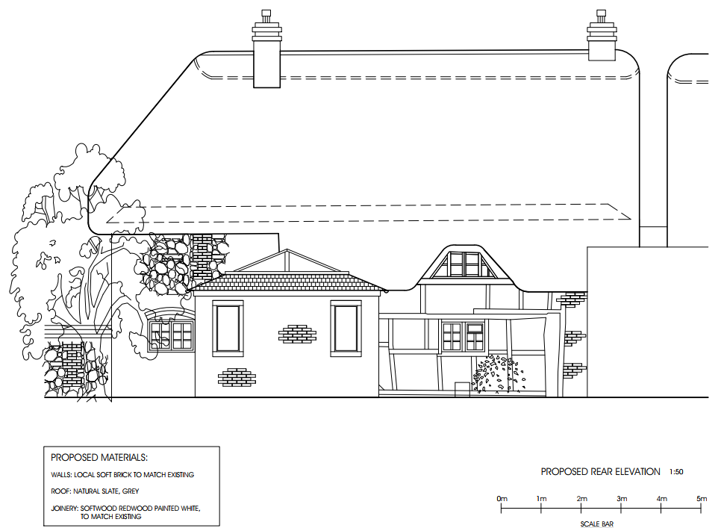

Proposed south elevation

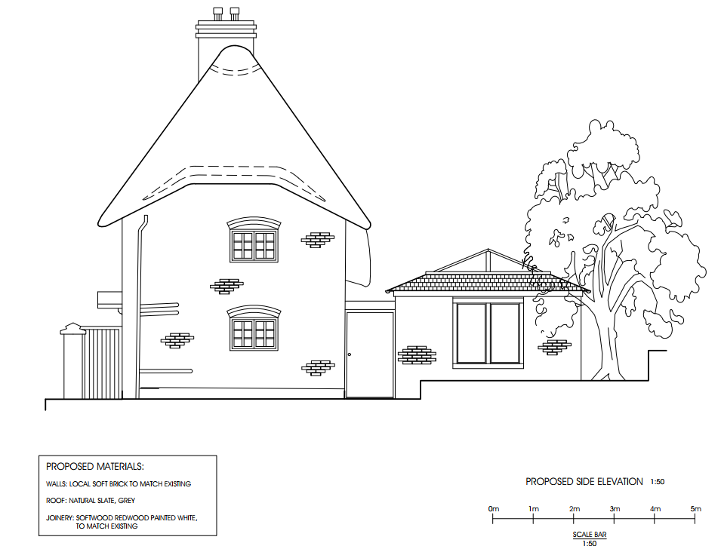

Proposed section through link

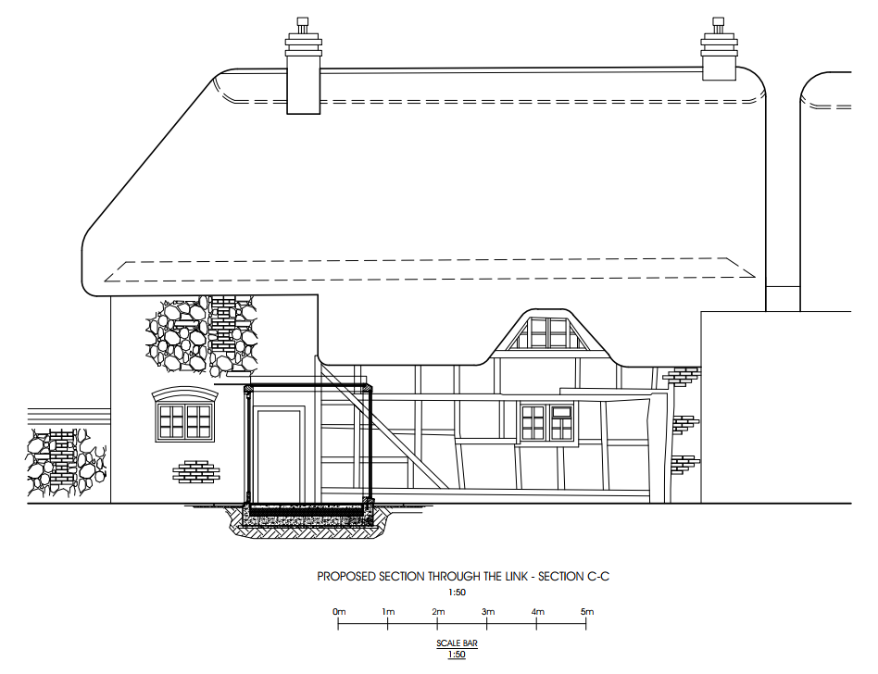

SITE DESCRIPTION/CONTEXT
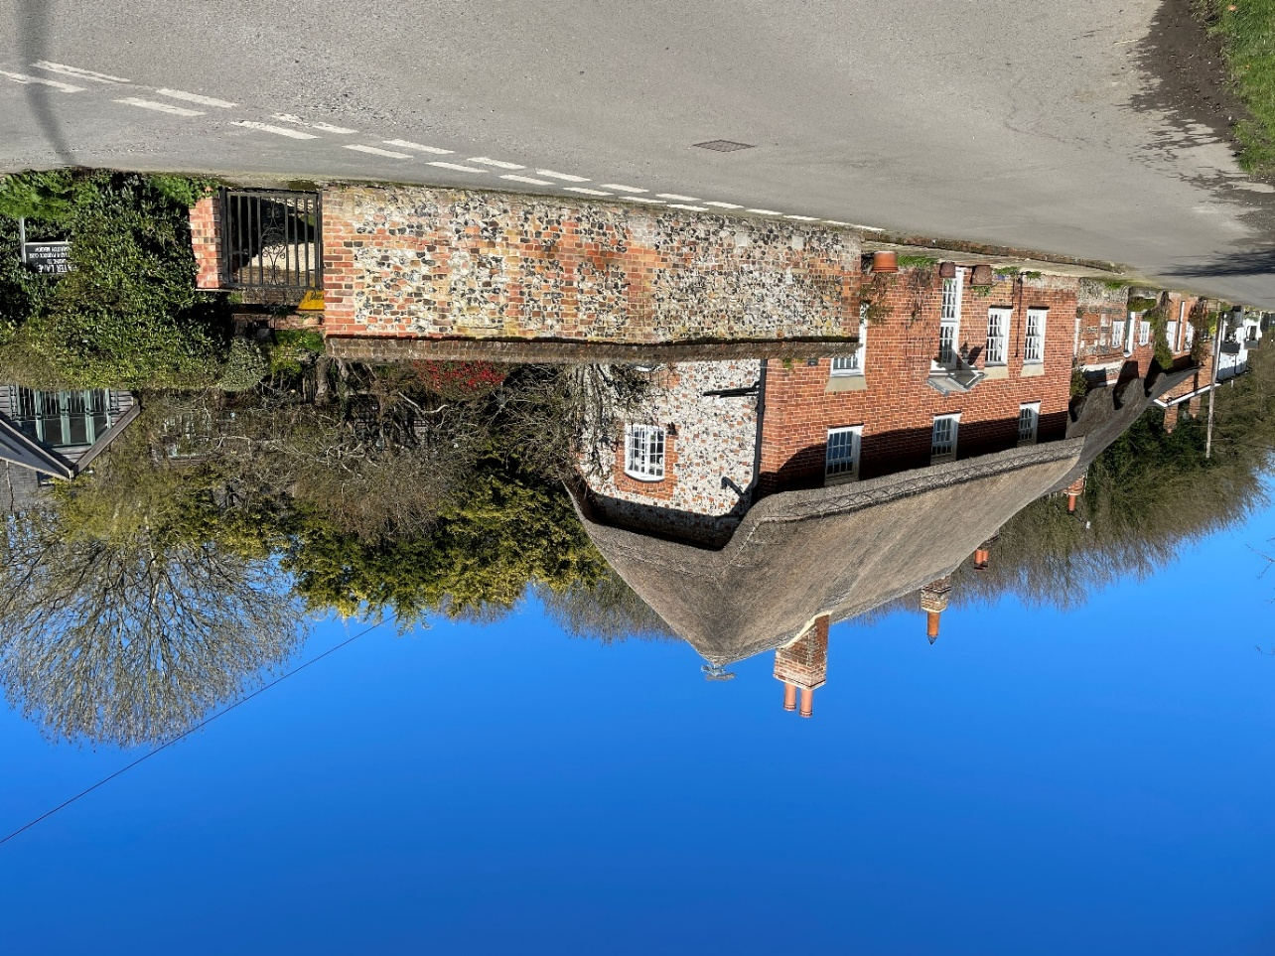

The application relates to Old Bengers, a Grade II listed dwelling, prominently sited within a corner plot between Long Street and Water Lane within the small village of Enford as defined by Wiltshire Core Strategy (WCS) core policies 1 (Settlement Strategy), 2 (Delivery Strategy) and CP 26 (Spatial Strategy for the Tidworth Community Area).

The listing is as follows:

ENFORD LITTLECOTT SU 15 SW (east side) 5/35 Old Bengers GV II Cottage. Early C19. Clunch, flint and brick with a brick facade. Thatched roof. Two storeys, 3 bays. Central C20 glazed door with original pedimented head on brackets. Sixteen-pane sashes with 12- pane single hung to first floor, all with moulded boxes and wedge lintels to ground floor. Window to left of door replaces former door. Roof half-hipped.
Listing NGR: SU1428351550

Old Bengers is built from various local vernacular materials under a thatched roof and has a timber framed core. The roadside elevation is brick, the gable end is flint with brick banding and the rear elevation is timber framed with brick noggings on a brick plinth. It is in a prominent location within the Enford Conservation Area and ‘Long Street Character Area’, it adjoins Grade II listed ‘Three Horseshoes’.

Snip from ‘Enford Conservation Area Character Appraisal and Management Proposals’ showing conservation area and listed and significant buildings.

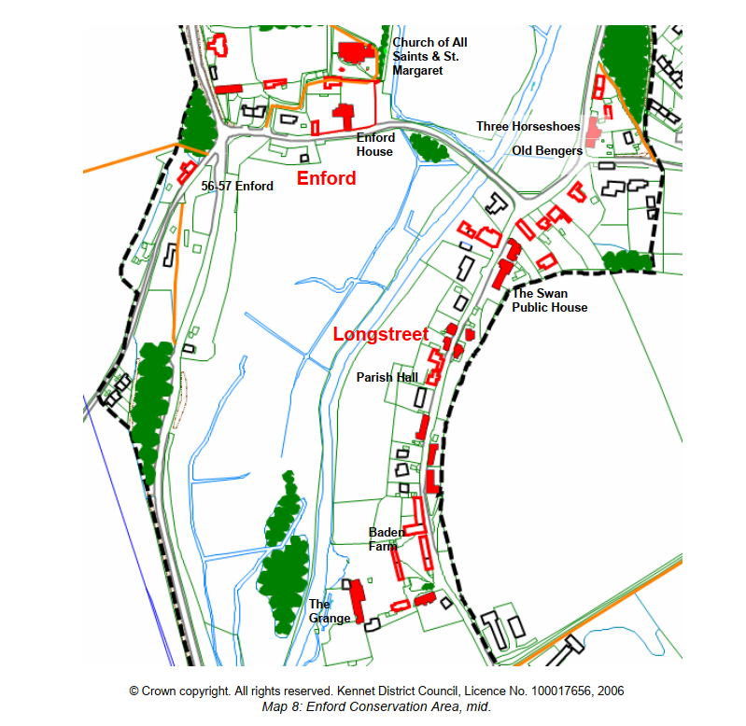

There is a garden wall to the west, a pedestrian gate, hedge and then a five bar gate that gives access into an off-road parking area. Through the pedestrian and driveway gates, the rear of the elevation is highly visible.

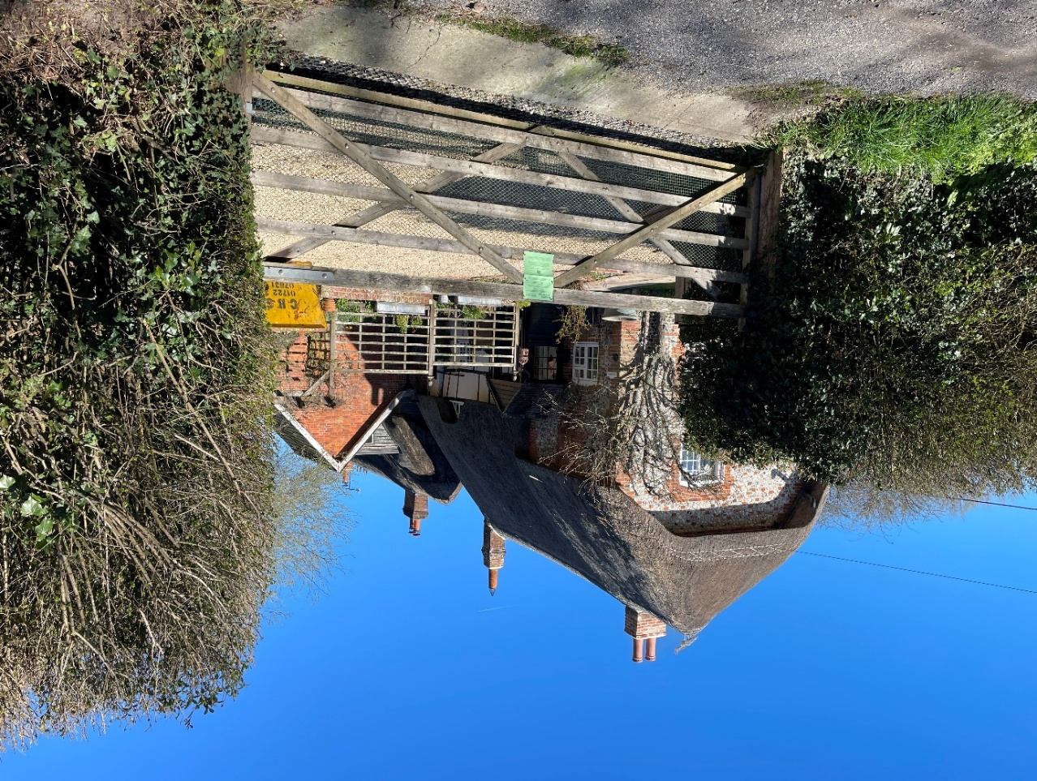

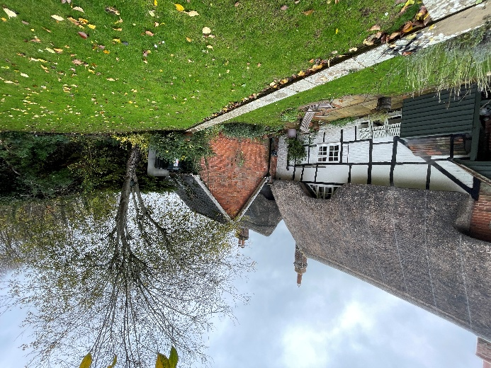
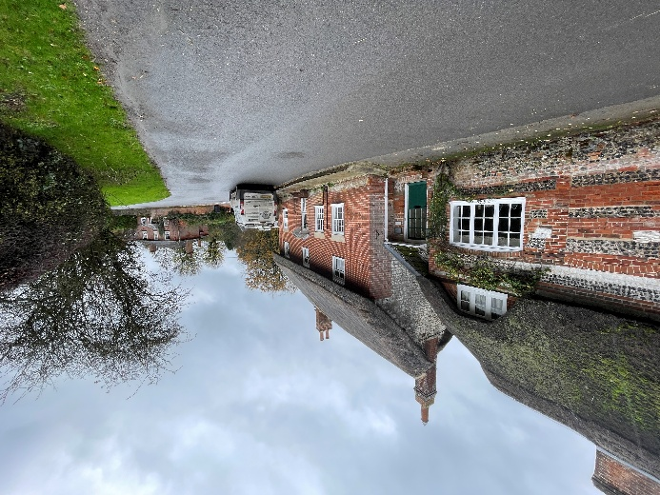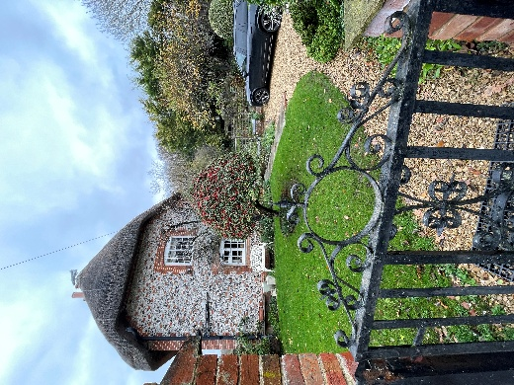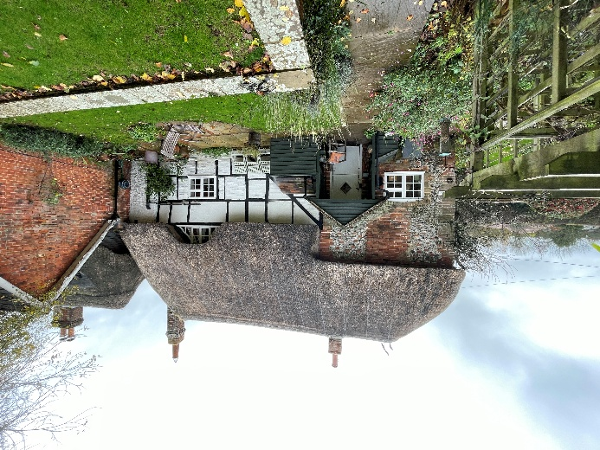

The application site is within the catchment of the Hampshire River Avon Special Area for Conservation (SAC) and is within the 6.4km recreational buffer of the Salisbury Plain Special Protection Area (SPA). The site is within Flood Zone 2.

PLANNING HISTORY

Proposal / Summary
13/06694/FUL - Full planning permission Decision - Approve with Conditions Date: 12/2/2014 – Removal of existing garden sheds, lower ground level and construct garden store and log store with studio over
16/03848/LBC - Listed building consent Decision - Approve with Conditions Date: 19/7/2016 – Internal alterations and external vent to the toilet facility
E/2011/1527/LBC - Listed building consent Decision - Refused Date: 10/1/2012 – To install a Schrijver System to remove moisture from the walls and treat penetrating damp and condensation which is causing damage to the structure of the building that cannot otherwise be treated effectively by traditional damp-proofing methods.
E/2013/0253/FUL - Full planning permission Decision - Refused Date: 24/4/2013 – Remove existing garden sheds, lower ground level to drive level and construct garden and log store with studio above
E/2013/0254/LBC - Listed building consent Decision - Withdrawn Date: 23/4/2013 – Remove existing garden sheds, lower ground level to drive level and construct a garden and log store with studio above

RELEVANT POLICIES AND GUIDANCE

Wiltshire Core Strategy:
- Core Policy 1: Settlement Strategy
- Core Policy 2: Delivery Strategy
- Core Policy 26: Spatial Strategy for the Tidworth Community Area
- Core Policy 50: Biodiversity and Geodiversity
- Core Policy 51: Landscape
- Core Policy 57: Ensuring High Quality Design and Place Shaping
- Core Policy 58: Ensuring the Conservation of the Historic Environment
- Core Policy 67: Flood Risk

Enford Conservation Area Character Appraisal and Management Proposals February 2007

Wiltshire Design Guide: Appendix D – Design Guidance for Householder extensions

Section 66 of the Planning (Listed Buildings and Conservation Areas) Act 1990 requires ‘special regard’ to be given to the desirability of preserving a listed building or its setting.
Section 72 of the Planning (Listed Buildings and Conservation Areas) Act 1990

The National Planning Policy Framework (NPPF)

The Planning Practice Guidance

National Design Guide

CONSULTATION RESPONSES

Enford Parish Council: No objection

Conservation Officer: Objection
The proposal is considered to cause harm to the character of the building, due to the impact of obscuring and enclosing a significant part of its most interesting elevation, and by interfering with its simple linear form. There would be a small degree of harm to the character of the CA by the loss of this visibility and the introduction of the rather unusual pyramidal kitchen extension, but this is essentially an extrapolation of the harm to the LB itself. The harm falls within the ‘less than substantial’ range in NPPF terms, perhaps towards the middle, and the weighing of public benefits is appropriate. In this instance, there is no clear or convincing justification for the proposals and no obvious public benefits that might outweigh the harm.

See full response below but in summary:
- The properties significance lies in its high degree of survival of early fabric and the legibility from the ear of the original cottage
- Example of vernacular domestic architecture in village setting
- Evolution of the building is visible with aggrandise frontage and rear untouched
- Some social significance as a former village post office
- Linear from is traditional characteristic of steeply roofed thatched buildings
- No concern for removal of porch
- Concerns regarding the attaching and weatherproofing of junction between flat-roofed link and timber frame structure
- Exposed timber framing would be obscured from the street and rear garden.
- Any harm to designated heritage assets required clear and convincing justification.

Additional comments received 10/03/2026 following receipt of amended proposals:

I have reviewed the revised plans, noting that the pyramidal element has been pushed very slightly further away from the house, its top almost imperceptibly lowered, the roof of the link lowered, the glazing bars removed, and the link has been narrowed, leaving a little more of the timber frame exposed. These might all be considered improvements, but my essential concern regarding the interruption of the rear elevation and obscuring of most of it from public view, and the challenge of a successful junction with the timber-framed walling remains, and I refer you to the conclusion of my earlier response.

REPRESENTATIONS

No comments were received.

ASSESSMENT

Section 38(6) of the Planning and Compulsory Purchase Act 2004 states:

"If regard is to be had to the development plan for the purposes of any determination to be made under the planning Acts, the determination must be made in accordance with the plan unless material considerations indicate otherwise."

In accordance with this statutory requirement, this application has been assessed against the relevant policies of the Development Plan, including the adopted Wiltshire Core Strategy (2015) and, where applicable, any made Neighbourhood Plans.

Design and Impact upon the upon the character and context of the area

Core Policy 57 - Ensuring High Quality Design and Place Shaping of the Wiltshire Core Strategy seeks to ensure that all new development is of high design quality, reflecting local context, character, and distinctiveness.

Appendix D of the Wiltshire Design Guide advises that a well-designed extension respects the original building and the neighbouring properties by being subservient, supporting additions and by seeking to fit into the general street scene.

The proposed extension would be sited on the east of the existing dwelling. It is proposed to be a 4.6m x 4.6m with a pyramid roof with slate tiles for part and then a glazed apex. The walls are proposed to be a “soft brick to match existing”. Joinery is proposed to be painted timber. A glazed ‘link’ element is proposed between the existing dwelling and the extension, this would have a flat roof.

A revised set of plans were received 26.01.2026 in response to comments from the Conservation Officer with the following revisions:
- Reduced height of roof and link element by 0.28m
- Increasing width of link element
- Removal of glazing bars from doors and windows to aid glimpse of the rear elevation
- Reducing length of link from 1.15m to 2.4m

Old Bengers is located in a prominent corner position with view into the site possible from Long Street and Water Lane. Core Policy 57 (i) states that “important views into, within and out of the site are to be retained and enhanced”. The rear elevation is of significance, in its high degree of survival of early fabric and the legibility from the rear of the original cottage. The proposed extension obscures views of the historic rear elevation.

The use of link-detached extensions to listed buildings is not uncommon (the agent sites E/09/1081/LBC as a local example), however the rear elevation of Old Bengers is of higher-than average significance (even for a listed building) and is publicly visible. The glazed link would facilitate some sight through the property to the rear elevation, but the massing and positioning of the extension is such that the majority will be obscured and it is not considered that the proposal would adequately preserve the character or significant of the listed building.

The amendments to remove the glazing bars from the link element, reduce the height of the extensions and reduce the width of the glazed link are an improvement but the main issues remain.

Although the extension is subservient by its scale and single storey height, the proposed pyramidal design is an unsympathetic addition that does not respond to the linear form of the existing dwelling, harming the proportions and character of the dwelling. The design neither replicates the style of the original dwelling nor creates a contrast with a modern aesthetic. The materials are proposed to be a slate roof with a facing brick to match the existing. The design and materials fail to respect the architectural context and would detract from the visual amenity of the area.

The proposal include for the removal of the existing rear porch and external boiler. The agent has confirmed that this wall would be “repaired to match the relevant part of rear elevation on like for like basis and would be left exposed within the glass link without any finishes applied to it”, this is considered acceptable.

The proposal does not represent high-quality design resulting in harm to the character and appearance of the locality. Therefore, it is contrary to Core Policy 57 of the Wiltshire Core Strategy, Appendix D of the Wiltshire Design Guide, and the relevant provisions of the National Planning Policy Framework. The application must therefore be refused on design grounds.

Heritage Impact

From the point of view of the historic environment the main statutory tests are set out within the Planning (Listed Building and Conservation Areas) Act 1990.

Section 66 requires that special regard be given to the desirability of preserving listed buildings, their settings or any features of special architectural or historic interest which they possess.

Section 72(1) of the Act requires the Council to pay special attention to the desirability of preserving or enhancing the character or appearance of designated Conservation Areas.

The Council’s Core Strategy Policy CP58 ‘Ensuring the conservation of the historic environment’ requires that designated and non-designated heritage assets and their settings will be conserved, and where appropriate enhanced, in a manner appropriate to their significance and encourages proposals which improve the condition of heritage assets at risk.

The Council’s Core Strategy CP 57: Ensuring high quality design requires a high quality of design in all new developments. The policy requires applicants to “demonstrate how the proposal will make a positive contribution to the character of Wiltshire through (amongst other things) responding to the value of the natural and historic environment and being sympathetic to and conserving historic buildings and landscapes. Development is required to respond positively to the existing in terms of building layouts, built form, height, mass, scale, building line, plot size, elevational design, materials, streetscape and rooflines to effectively integrate the building into its setting.

The NPPF outlines government policy for planning. Chapter 16 of the NPPF 'Conserving and enhancing the historic environment' sets out the Government's high-level policies concerning heritage and sustainable development.

Old Bengers is a grade II listed property, and the application site lies with the Enford Conservation area. An objection has been received from the Conservation Officer as follows:

Site and assets considered:
Old Bengers is a thatched dwelling prominently sited at a corner between the Longstreet and Littlecott settlements of the Enford Conservation Area. Grade II listed in 1986, the list description is very brief and dates the building to the C19. The two-storeyed west front elevation is of mid C19 brickwork with near symmetrical openings containing vertical sliding sashes, however these sashes are set flush with the brickwork suggesting it is a skin over an earlier building, and sight of the rear elevation immediately confirms this, with a probable C17 timber-framed cottage exposed to the rear, with a single-bay C19 extension to the south. The north gable elevation is of rough clunch/stone blocks; the eaves of the original building were raised (indicated by the eyebrow dormer to the rear) but it is not clearly indicated in the stonework of the gable. Immediately to the north, connected by a narrow single-storeyed infill structure, is Three Horseshoes Cottage, a grade II listed thatched cottage of one and a half storeys, brick, stone and flint and dating from circa 1700. Most of the surrounding buildings to north and south are identified within the Enford Conservation Area Appraisal (2007) as making a positive contribution to the CA’s character.

Assessment
The application does provide some description of the building’s evolution based on documentary sources, but little is derived from close inspection of the building itself. We are told little about the surviving fabric of the timber-framed cottage, which one would imagine could be quite accurately dated by an appropriate specialist, such as the staff of Wiltshire Buildings Record. Historic maps indicate the southern bay (which has brick and flint to the south gable and rear) was added between 1841 and 1886. A structure was added to the north of the rear elevation, abutting the neighbour, between 1899 and 1922, and remained for most of the C20; no photos show this structure and there is no clear indication remaining of its attachment to either of the adjacent buildings. It appears to have covered the well and was probably of lightweight construction. Structures also appeared and disappeared from the southern gable during the C20.

The property’s significance lies in its high degree of survival of early fabric and the legibility from the rear of the original cottage; its representation of vernacular domestic architecture in a village setting, the evolution of the building and the decision to aggrandise its frontage with smart brickwork and sash windows in the C19 while leaving the rear untouched. It has some social significance as a former village post office. The building’s linear form is a strongly traditional characteristic of steeply roofed thatched buildings. The exposed timber framing is apparently little altered, with the exception of the later C20 ground floor window that cuts through a post, possibly part of an earlier doorframe. The simple open timber porch to the rear serves a doorway within the C19 southern bay, and is abutted to the north by a low enclosure around an external boiler. The porch and adjacent joinery are all modern and unobjectionable although there is no obviously related planning history.
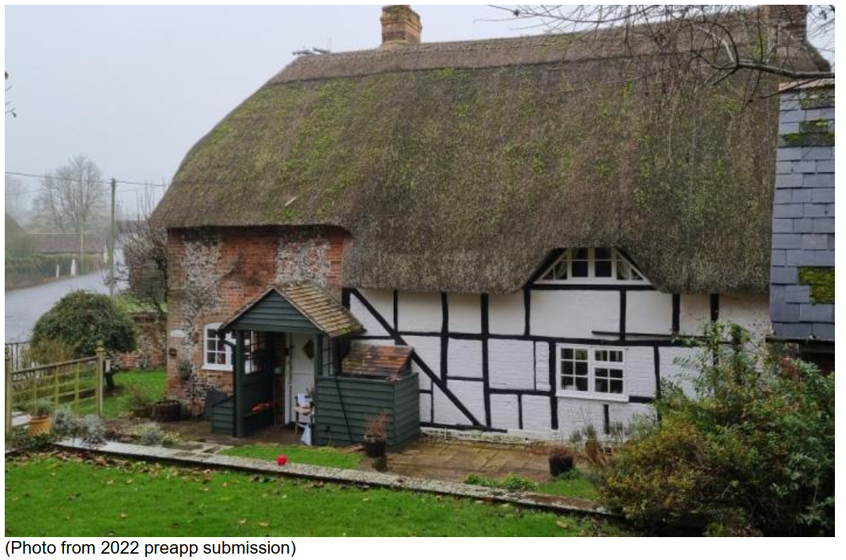

The proposal is to replace the porch with a single-storeyed kitchen-diner extension, built of brick under a pyramidal roof of slate and glass. Removal of the porch raises no concerns. The 4.6m square extension projects 5.8m from the rear elevation of the property including its link, while the link section encloses 2.3m of the timber-framed section, including nearly all of the large diagonal brace. The manner of attaching to and weatherproofing the junction between the flat-roofed link and the timber-framed structure is not described, but appears likely to interfere with the eaves of the lower parts of the roof and to introduce an unsatisfactory detail with regard to confidence in rainwater disposal adjacent to some of the building’s most significant fabric. The section drawn through this only shows the higher level thatch. The eaves of the new kitchen would be slightly higher than the eaves of the lower thatch eaves, so that none of the timber framing would be visible from the street nor from most of the garden.

Summary & conclusion:
The NPPF confirms that when considering the impact of a proposed development on the significance of a designated heritage asset, great weight should be given to the asset’s conservation (and the more important the asset, the greater the weight should be). It makes clear that any harm to a designated heritage asset requires clear and convincing justification.

The proposal is considered to cause harm to the character of the building, due to the impact of obscuring and enclosing a significant part of its most interesting elevation, and by interfering with its simple linear form. There would be a small degree of harm to the character of the CA by the loss of this visibility and the introduction of the rather unusual pyramidal kitchen extension, but this is essentially an extrapolation of the harm to the LB itself. The harm falls within the ‘less than substantial’ range in NPPF terms, perhaps towards the middle, and the weighing of public benefits is appropriate. In this instance, there is no clear or convincing justification for the proposals and no obvious public benefits that might outweigh the harm.

Additional comments received 10/03/2026 following receipt of amended proposals:

I have reviewed the revised plans, noting that the pyramidal element has been pushed very slightly further away from the house, its top almost imperceptibly lowered, the roof of the link lowered, the glazing bars removed, and the link has been narrowed, leaving a little more of the timber frame exposed. These might all be considered improvements, but my essential concern regarding the interruption of the rear elevation and obscuring of most of it from public view, and the challenge of a successful junction with the timber-framed walling remains, and I refer you to the conclusion of my earlier response.

As such, the proposed development would result in harm to the setting and significance of a Grade II listed building. The proposal fails to preserve the special architectural and historic interest of the heritage asset(s), contrary to the statutory duty under Section 66(1) of the Planning (Listed Buildings and Conservation Areas) Act 1990.

A justification statement regarding the need for the extension was provided as follows: “Old Bengers is three bedrooms, bathroom + ensuite house with existing kitchen/dining area of 14.75m2, which is very small kitchen/dining area for the size of the house. By providing the separate kitchen within the extension and creating the dining room only from the existing kitchen/dining room we would make the kitchen/dining facility more in proportion to the size of the house and therefore, make it possible to accommodate a larger family and allow the optimum viable use of this heritage asset after the current ownership. The extension would help to secure the buildings future as it would make it more acceptable to families to live in thus the Public Benefit would exceed the benefit to the current owner only and we believe it should be evaluated as such.” This is not considered a public benefit and does not form a material planning consideration.

The harm identified is not outweighed by any public benefits and therefore conflicts with Core Policy 58 of the Wiltshire Core Strategy and the relevant provisions of the National Planning Policy Framework, particularly paragraph 215.

The proposed development would fail to preserve or enhance the character and appearance of the Enford Conservation Area. Therefore, the proposal is contrary to the statutory duty under Section 72(1) of the Planning (Listed Buildings and Conservation Areas) Act 1990, Core Policy 58 of the Wiltshire Core Strategy, and the relevant provisions of the National Planning Policy Framework, notably paragraph 215.

The application must therefore be refused on heritage grounds.

Amenity

Point vii of Core Policy 57 - Ensuring High Quality Design and Place Shaping of the Wiltshire Core Strategy seeks to ensure that developments do not adversely affect neighbouring properties.

The National Planning Policy Framework (NPPF), particularly Paragraph 135(f), stresses that planning decisions should ensure developments provide a high standard of amenity for existing and future users.

The proposed development has been assessed in terms of its potential impact on the residential amenity of neighbouring properties, with particular regard to loss of light, overshadowing, loss of privacy, and overbearing effects.

There are residential neighbours to the east (Highbanks) and north (Three Horseshoes), given the modest single-storey nature of the extension, located away from shared boundaries, it is considered that the proposed development would not materially impact upon the occupiers of the neighbouring property as a consequence of overbearing impact, overshadowing or loss of privacy and accords with Core Policy 57 point vii in respect of safeguarding residential amenity and Appendix D of the Wiltshire Design Guide.

Ecology Impact

Core Policy 50 of the Wiltshire Core Strategy seeks to protect and enhance biodiversity and geodiversity, including through ensuring that development avoids harm to protected species and habitats.

The National Planning Policy Framework (NPPF), in Paragraphs 193, requires that development minimises impacts on and provides net gains for biodiversity, including ensuring mitigation is secured where harm cannot be avoided.

The proposal relates to a single-storey extension to a dwelling with no trees or roof voids affected. The application site is within the catchment of the Hampshire River Avon Special Area for Conservation (SAC) and is within the 6.4km recreational buffer of the Salisbury Plain Special Protection Area (SPA) but due to the nature of the development, ecological impact is not an issue for this application. There is no reasonable likelihood of protected species being present or affected.

As such, the development complies with Core Policy 50 of the Wiltshire Core Strategy and the relevant provisions of the NPPF.

Drainage and Flood Risk

Core Policy 67 of the Wiltshire Core Strategy and paragraph 181 of the NPPF requires that all new development avoids increasing flood risk on-site or elsewhere and, where appropriate, incorporates sustainable drainage measures. Development must also comply with national policy on flood risk management and drainage design. Paragraph 176 (via footnote 62) of the NPPF states that householder development should not be subject to the sequential test, nor the exception test.

The ‘Flood Map for Planning Service’ mapping shows that the site is partially within Flood Zones 2 & 3:

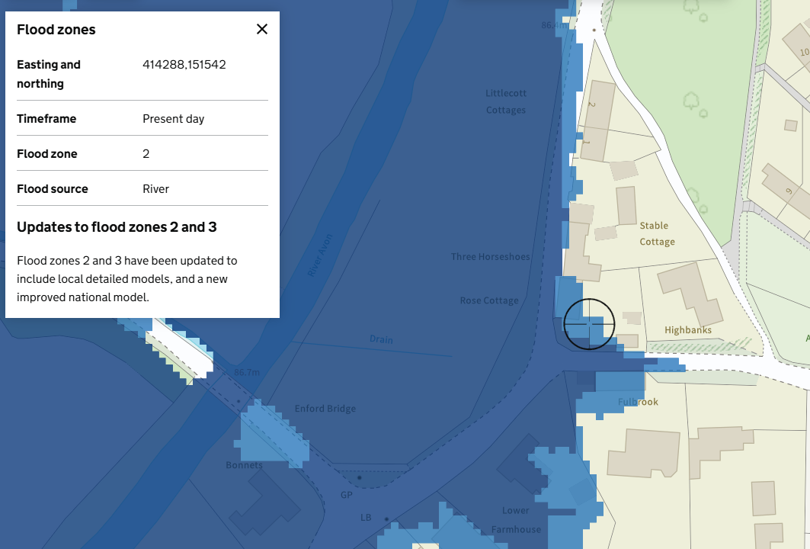

The proposed development fails to demonstrate that it would not result in an increased risk of flooding or that adequate drainage measures are in place. A Flood Risk Assessment hasn’t been provided, and as such the Local Planning Authority cannot be certain that the proposal would manage flood risk appropriately or incorporate suitable drainage measures.

As such, the application is contrary to Core Policy 67 of the Wiltshire Core Strategy and the provisions of the National Planning Policy Framework, particularly paragraph 181. The proposal is therefore unacceptable on flood risk and drainage grounds and must be refused accordingly.

Biodiversity Net Gain

Householder planning applications are exempt from the requirement to deliver Biodiversity Net Gain under Schedule 7A, Section 4(2)(a) of the Town and Country Planning Act 1990, as inserted by the Environment Act 2021.

CONCLUSION

The proposed development, by reason of the identified harm, is considered to conflict with the aims and objectives of the Wiltshire Core Strategy and the National Planning Policy Framework. The proposal fails to demonstrate compliance with the relevant policies and guidance, and no overriding material considerations have been identified that would justify a departure from the development plan.

Accordingly, the application is recommended for refusal.

RECOMMENDATION: That Planning Permission PL/2025/08575 and Listed Building Consent PL/2025/08825 be REFUSED.

- The proposed development, by reason of its form and design, would result in a form of development that fails to respond positively to the character, context and distinctiveness of the host dwelling and its setting. The proposal would appear visually incongruous unsympathetic to the character of the area and would detract from the visual amenity of the surrounding area.

As such, the proposal is contrary to Core Policy 57 (i and iii) of the Wiltshire Core Strategy (2015), the design principles set out in Appendix D of the Wiltshire Design Guide SPD, and paragraphs 131 and 135 of the National Planning Policy Framework, which collectively seek to ensure high-quality design that respects local character and integrates appropriately with its surroundings.

- The proposed development, by reason of its siting and form, obscuring and enclosing a significant part of the rear elevation, and by interfering with its simple linear form, would fail to preserve or enhance the character and appearance of the conservation area and setting of a listed building. The proposal would cause less than substantial harm to the significance of the heritage asset and no clear and convincing justification or public benefit has been demonstrated to outweigh this harm.

The proposal is therefore contrary to Core Policies 57 and 58 of the Wiltshire Core Strategy (2015), Sections 66(1) and 72(1) of the Planning (Listed Buildings and Conservation Areas) Act 1990, and Chapter 16 of the National Planning Policy Framework, which collectively require development to conserve heritage assets in a manner appropriate to their significance.

- The proposed development fails to demonstrate that it would not lead to increased flood risk on or off site. In the absence of sufficient information, it has not been demonstrated that the proposal would manage flood risk appropriately or incorporate suitable drainage measures.

The development is therefore contrary to Core Policy 67 of the Wiltshire Core Strategy (2015) and paragraph 181 of the National Planning Policy Framework, which require new development to ensure flood risk is not increased and to incorporate appropriate surface water drainage solutions.

