DESIGN AND ACCESS STATEMENT

CONCERNING

CONSTRUCTION OF A HABITAT POND

AT
THE GRANGE, GUNNERS LANE, WINTERBOURNE GUNNER,
WILTSHIRE, SP4 6ER.

The Design Component

Amount of Development.

The following elements are contained in this application.

1/ Construction of a Habitat Pond.
2/ Change of Use.

The Layout

The proposed Habitat Pond is located south west of the main residence on the other side of the River Bourne and between Taylors lane and Morgan’s Lane.

The Scale

The proposed Habitat Pond surface area is 7,500 sq metres with an approximate average depth of 1.3m.

Landscaping

There is a landscaping scheme attached to this application and the site also benefits from well- established natural screening.

Appearance

The proposed Habitat Pond is of an oval shape slightly larger at the southern end and narrows towards the northern end. There are two islands linked via a shallow area and approached from the bank via a wooden walkway.
On the larger of the two islands there will be a Wildlife Hide constructed of oak timber frame under a thatched roof. Similar to the Test Valley fishing huts found on the River Test.

The Context Appraisal

The Grange is a Grade II Listed property which was originally the parsonage to the village.
The main residence comprises of 7 bedrooms, 3 reception rooms, there are two cottages and a flat as additional accommodation.
There is a oak framed barn under a thatched roof and a further oak framed barn which houses an indoor swimming pool.
There are extensive gardens which are to undergo full restoration works to bring the grounds of The Grange to their former glory.

Involvement

No Pre App application was submitted.

Evaluation

This proposal is for a Habitat Pond to be established in a wet grassland field southwest of the main residence.

It was consented in 2022 under planning reference PL/2021/08492, this application lapsed last year and therefore, the applicant is re-submitting the application for a Habitat Pond, so that they can construct it hopefully this year.
The proposed site lies to the north of Tanners Lane to the western edge of Winterbourne Gunner – to the southern edge lies the River Bourne. The proposed site is currently a grassland field which is edged by trees and shrubs. To the west are arable fields and to the north and east are a mix of grassland fields with residential dwellings beyond. To the south are more grassland fields which are edged with trees and shrubs. To the east is a localised high spot: Figsbury Ring which is designated as a SSSI and SAM.
There is a network of Public Rights of Way- Footpaths within the vicinity of the proposed development site including one to the western boundary and another to the southern edge.
The proposed Habitat Pond will have a surface area is 7,500 sq metres with an approximate average depth of 1.3m which will vary in depth with shallow areas to allow wet plants to establish.

The design of the Habitat Pond has given it soft curved banks with two islands in the centre which are linked via a shallow water way. The larger of the two islands will have a Wildlife Hide on it, which is the similar style as a Test Valley Fishing Hut. It will be constructed of an oak timber frame under a thatched roof. See images below.

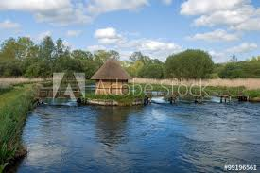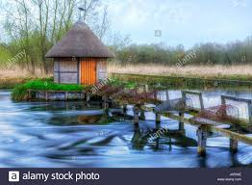

The islands would be approached from the bank via a timber walkway, which would blend into the surrounding environment. Image below of a timber bridge across a water way.

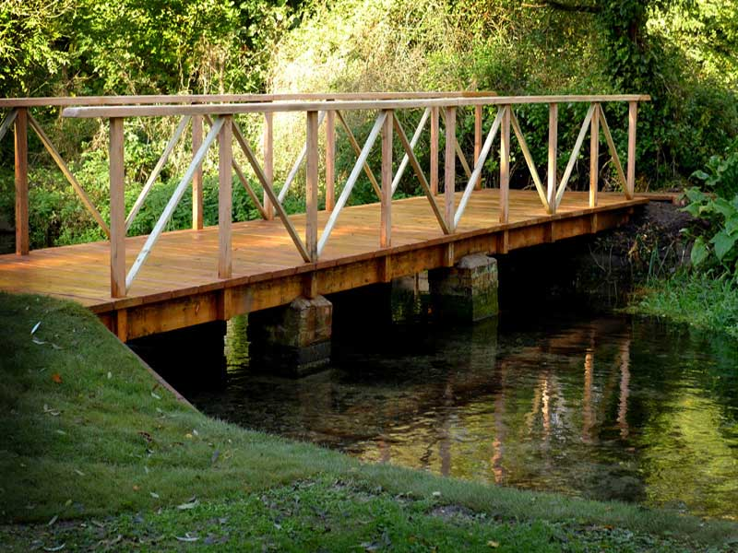

The banks will be of rough grass and constructed in such a way to hide the pond liner. Marginal planting beds will accommodate areas for aquatic plants to help keep the water clear.

A Change of Use is required for the pond from grassland area to Habitat Pond.

Landscaping around the Habitat Pond will be kept natural using the existing landscape to form the basis for new planting.

A landscape plan with a planting schedule is attached to this application.

An ecology survey and tree survey has been undertaken on the site and these are attached to the application.

There are two artist impressions of the Habitat Pond which gives an impression of how the pond will look and a view from the western boundary.

Ponds are a cherished part of the parish landscape; familiar features found at the heart of most village centres and in the wider countryside. Sadly, due to changes in land use and agricultural practices, the UK has lost around 50% of ponds in the 20th Century. This means the many species of plant and animal that rely on them are also under threat.

Ponds provide sanctuary by offering food, water, shelter, and a place for breeding of indigenous wildlife like dragonflies, frogs, and birds. Native plants to the area will provide sources of food and cover for native wildlife.

Ponds attract flocks of birds, such as starlings, to bathe, foxes to drink, and sparrows and pipistrelle bats to feed on their abundant insects. Damselflies/dragonflies will lay their eggs on aquatic plants or drop them onto the surface of a pond throughout the summer.

These days ponds are still vital to the farmed environment - as resources for wildlife. A wide array of flora and fauna is associated with pond habitats, including amphibians, grass snakes, bats, numerous dragonflies and other insects, water voles, otters, and many species of farmland bird. Many of these species are under threat. Sadly, due to changes in land use and agricultural practices, the UK has lost around 50% of ponds in the 20th Century alone.

‘Humans have created pond habitats for thousands of years, usually for purposes linked to agriculture’ said Lucy Jenkins, Farm Environment Adviser at FWAG East. ‘Over the past century however, humans have changed from being ‘net creators’ of clean water ponds to ‘net destroyers’ of pond habitats.
‘As farmland ecologists we know that digging and restoring ponds is one of the best things landowners can do to support nature on their land.

The Habitat Pond will benefit existing wildlife and encourage new and different species to the area around the pond.

The applicant is committed to this project, to provide additional habitat for the local wildlife and encourage more wildlife to the area.

Access Design Philosophy on the Scheme

There will be no increase in traffic movements.
The site is on level ground for easy access by the disabled.

Conclusions

This is a reasonable proposal for the site, it creates a Habitat Pond in the countryside on a wet area of land and will establish additional wildlife in the area.
The applicant is very committed to the local ecology and environment and will manage the Habitat Pond over the coming years to the benefit of the local ecology.

