APPLICATION FOR HOUSEHOLDER PLANNING PERMISSION
CASE OFFICER REPORT

APPLICATION REFERENCE: | PL/2026/00376
APPLICATION TYPE: | Householder Planning Application
SITE ADDRESS: | 186 The Common, Holt, Willtshire.
DEVELOPMENT DESCRIPTION: | Two storey side extension.
RECOMMENDATION: | Approve with Conditions

PROPOSAL
The proposal seeks planning permission for the construction of a two storey side extension.

SITE DESCRIPTION/CONTEXT
The principal host dwelling is located within the Large Village of Holt, it is on a corner location between Beckerley Lane and The Common and is not within a Conservation Area, and the site is also outside of all ecology bat catchment zones.

RELEVANT PLANNING HISTORY
Proposal / Summary
W/10/03812/FUL Proposed single storey side extension. Approved
W/99/00546/FUL Detached garage and covered walkway. Approved.

RELEVANT POLICIES AND GUIDANCE
Wiltshire Core Strategy:

- Core Policy 57 Ensuring High Quality Design and Place Shaping
- Core Policy 50: Biodiversity and Geodiversity
- Core Policy 51: Landscape
- Core Policy 58: Ensuring the Conservation of the Historic Environment
- Core Policy 61: Transport and New Development
- Core Policy 64: Demand Management
- Core Policy 67: Flood Risk

Holt ‘Made’ Neighbourhood Plan 2016 to 2026
Wiltshire Design Guide: Appendix D – Design Guidance for Householder extensions
The National Planning Policy Framework (NPPF)
The Planning Practice Guidance
National Design Guide

Emerging Wiltshire Local Plan:
The examination of the emerging Wiltshire Local Plan has been paused and the weight to be afforded to any part of the emerging plan can be no more than very limited. A decision on how to proceed will be made by the Council in May 2026.

CONSULTATION RESPONSES
Holt Parish Council: No objections and requested the need for the following information:
- Condition for the provision of a Construction Management Plan CMP) to control various aspects of the build process.
- Materials to match existing.

REPRESENTATIONS
No comments were received.

PRINCIPLE OF THE PROPOSAL.
The principle of the proposed scheme is considered to be acceptable for all of the reasons as discussed below.

ASSESSMENT
Section 38(6) of the Planning and Compulsory Purchase Act 2004 states:

"If regard is to be had to the development plan for the purposes of any determination to be made under the planning Acts, the determination must be made in accordance with the plan unless material considerations indicate otherwise."

In accordance with this statutory requirement, this application has been assessed against the relevant policies of the Development Plan, including the adopted Wiltshire Core Strategy (2015) and the Holt ‘Made’ Neighbourhood Plan.

Design and Impact upon the upon the character and context of the area

Core Policy 57 - Ensuring High Quality Design and Place Shaping of the Wiltshire Core Strategy seeks to ensure that all new development is of high design quality, reflecting local context, character, and distinctiveness.

The proposals can be viewed within the following plan snippets taken from the submitted plans:

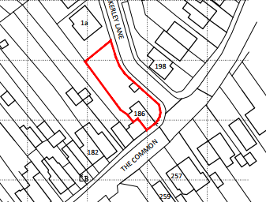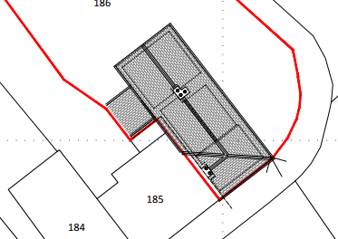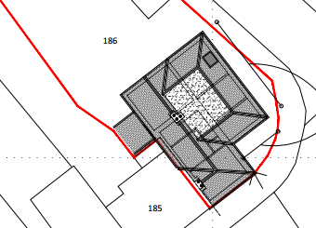
Location Plan Existing Site Plan Proposed Site Plan

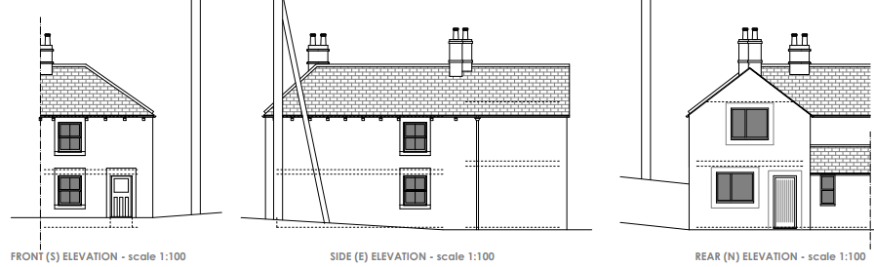
Existing Elevations

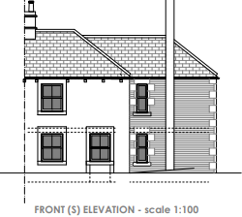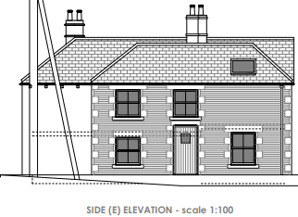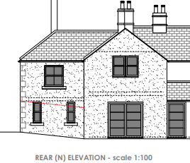
Proposed Elevations.

The proposal would see the construction of a two storey side extension on the east side elevation of the property, it would measure 3.6 metres in length and its roof ridge height would be below that of the main roof, thereby demonstrating an element of visual subservience.

The proposed use of materials would match that as existing and other design features such as the angle of the roof pitch and fenestration layout would also match that as existing.

With regard to materials, the majority of the building has been painted cream/off white, with its front consisting of a natural Bath Stone material. The proposed plans show the use of red brick and stone detailing to match the neighbouring property at No.184, together with white render, which is acceptable.

The main front door entrance to the property would be relocated to the east elevation, and the rear north elevation would have double French doors leading out to the private rear garden area of the site.

The front facing south elevation of the proposed extension would be set back by 3 metres from the existing front elevation of the host property, thereby allowing sufficient space at this corner location to maintain the intervisibility of the site with the public realm and which would not encroach onto the pavement.

The proposed two storey extension would represent a complimentary addition to the host dwelling, continuing the built form and roof profile of the original building. The scale and massing of the development proposal is also considered commensurate to the size of the property and plot thereby preserving the character and appearance of the host dwelling.

Therefore, in summary, having regard to the above, the proposal complies with the design principles set out in Core Policy 57 of the Wiltshire Core Strategy and Appendix D of the Wiltshire Design Guide.

Amenity
Point vii of Core Policy 57 - Ensuring High Quality Design and Place Shaping of the Wiltshire Core Strategy seeks to ensure that developments do not adversely affect neighbouring properties. The National Planning Policy Framework (NPPF), particularly Paragraph 135(f), stresses that planning decisions should ensure developments provide a high standard of amenity for existing and future users.
The proposed extension would be two storeys in height and would have high level fenestration at first floor level. The presence of such high-level windows within a developed urban environment is not unusual whereby there are numerous such examples within the vicinity.

The front and side facing windows would look out onto the highway and development beyond, with such separation distances being 12.3 metres to the front to the boundary of the opposite site; and 10.5 metres from the new side elevation to the opposite site boundary. This side elevation would look onto the open car parking area belonging to No.198, therefore, there would not be any harm to neighbouring amenity.

The final high-level window for consideration relates to the dwelling’s rear facing window, which would offer oblique views onto the site’s rear garden area.
Such separation distances as described are acceptable and would maintain the visual separation between properties, thereby minimising the impact on the character and appearance of the street, similarly, due to the location and orientation of the proposal, there would not be any significant overshadowing or loss of light to neighbours.

The proposal therefore accords with Core Policy 57 point vii. in respect of safeguarding residential amenity and Appendix D of the Wiltshire Design Guide.

Highway Matters.
Core Policy 57 (xiv) of the Wiltshire Core Strategy seeks to ensure that development must meet the requirements of Core Policy 61. This policy requires proposals to be capable of being served by safe access to the highway network. Core Policy 64 seeks to ensure compliance with parking standards set out in the Local Transport Plan.

The National Planning Policy Framework (NPPF), particularly Paragraph 115 and 116, requires that development proposals do not have an unacceptable impact on highway safety and that safe and suitable access to the site can be achieved for all users.

The proposed development would continue to use the established site access which would not be altered and would not have any adverse impact on highway safety. Adequate parking and turning provision is provided within the site and such access arrangements are acceptable. The council’s adopted parking strategy states that where there are two to three bedrooms there should be two car parking spaces made available. In this instance, there are two bedrooms at present with the creation of one additional bedroom bringing the total up to three in number, therefore there would be no change in the provision of such requirements.

The proposal is therefore considered to comply with Core Policies 57 (xiv), 61 and 64 of the Wiltshire Core Strategy, the NPPF, and the Wiltshire Local Transport Plan.

Ecology Impact CP50 requires no net loss of biodiversity on site. The site is not located within the Bath & Bradford on Avon Bat SAC nor within the Trowbridge Westbury Bat Mitigation Strategy Area. As such, the development complies with Core Policy 50 of the Wiltshire Core Strategy and the relevant provisions of the NPPF.

Biodiversity Net Gain. This application is exempt from the requirement to deliver Biodiversity Net Gain under Schedule 7A, Section 4(2)(a) of the Town and Country Planning Act 1990, as inserted by the Environment Act 2021, because the proposal is a householder extension.

Other matters.
Holt Parish Council have responded and have asked for a Construction Management Plan (CMP) to include details such as the unloading and storage of materials, whilst especially avoiding peak school times and hours of construction. The agent is aware of the proposed CMP and has agreed to its inclusion as a pre-commencement condition, which recognises the small scale of the development. The site has a large garden area which is easily accessed and so it is wholly feasible that the storage of materials and any plant equipment could be contained here, thereby avoiding any such impact on the paved areas and highway/s as highlighted by the parish council.

CONCLUSION
The proposed development is acceptable in terms of its design, scale, and relationship with the surrounding area. It would not result in any unacceptable harm to the character of the locality, the amenities of neighbouring occupiers.

The proposal is therefore considered to comply with the relevant policies of the Wiltshire Core Strategy, the Wiltshire Local Plan, and the National Planning Policy Framework. As such, the application is recommended for approval, subject to the conditions set out below.

RECOMMENDATION: Planning Permission be GRANTED subject to conditions.

