B18595 Semley: Hedgerow assessment
Hedgerow 1 (H1) – 3m section for removal
Grid Reference: ST 87848 27045
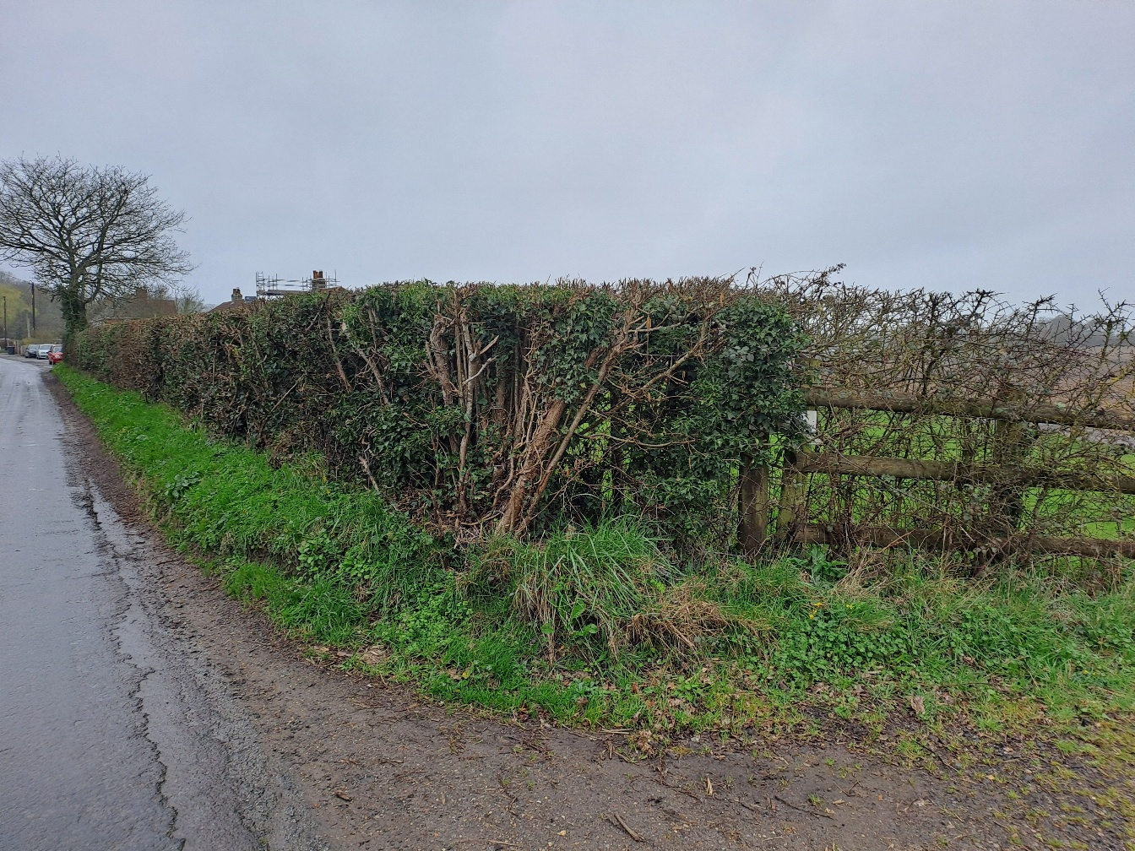

Ref. | Type | Description | Removal notice required | Important hedgerow (ecology)
H1 | Shrubby hedgerow with trees | Well managed hedgerow primarily consisting of blackthorn (Prunus spinosa) and mature hazel (Corylus avellana). The hedge is approx.. 1-1.2m in height and 1-1.2m wide. The section of the hedgerow to be removed primarily comprises a replanted section of blackthorn. Ground flora present includes ivy (Hedera helix), lords-and-ladies (Arum maculatum), curled dock (Rumex crispus), cleavers (Galium aparine), ground ivy (Glechoma hederacea), lesser celandine (Ficaria verna) and cow parsley (Anthriscus sylvestris). | Yes* | Yes
* Unless Non-intervention methods such as directional drill, hand dig or gateways are utilised.

Hedgerow ref: H1
Criteria | Results
General
Hedgerow over 30 years old | Y
Boundary of a dwelling | N
Length over 20m | Y
Length under 20m and joining hedgerows at both ends | N
Archaeology and history
Hedgerow incorporates archaeology | Not known
Hedgerow within archaeological site | Not known
Boundary of pre-1600 estate or manor | Not known
Hedgerow pre-dates Inclosure Acts | Not known
Wildlife and landscape
Schedule 1, 5 or 8 species | N
Red data book species | N
Native woody species per 30m section
Species (Section 1) | 2
Species (Section 2) | -
Species (Section 3) | -
Species (Mean) | -
Woodland species within 1m of hedgerow
Species (entire length) | 1
Features
Bank or supporting wall | N
Aggregate gaps do not exceed 10% | Y
Standard trees (<50m=1+, 50-100m=2+, >100m=1+ per 50m) | Y
At least 3 woodland species | N
Ditch along at least one half of length | N
Connections scoring 4 or more points | N
Parallel hedgerow within 15m | N
Footpath/bridgeway, 4 woody species and 2 features | N
Assessment | Not Important

