Old Paddock, Grittleton

N
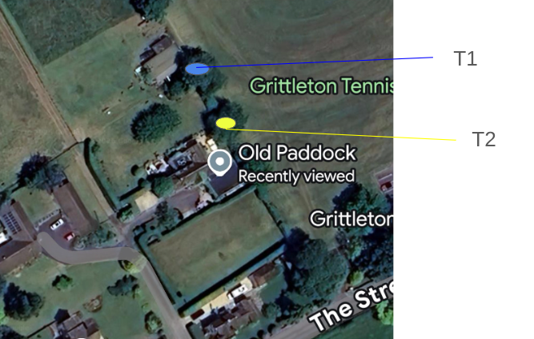

T1
Monolith Walnut tree to 12 foot. This needs to be carried out as the tree is in decline. It has lots of cavities over it and dead wood within it. The tree is also over a telegraph pole which has some low voltage wires, 2 sheds and overhangs a cricket pitch. So this work needs to be carried out for safety reasons. Leaving it as a monolith would be the best thing as it means it can still be used for habitat for different species of bugs.
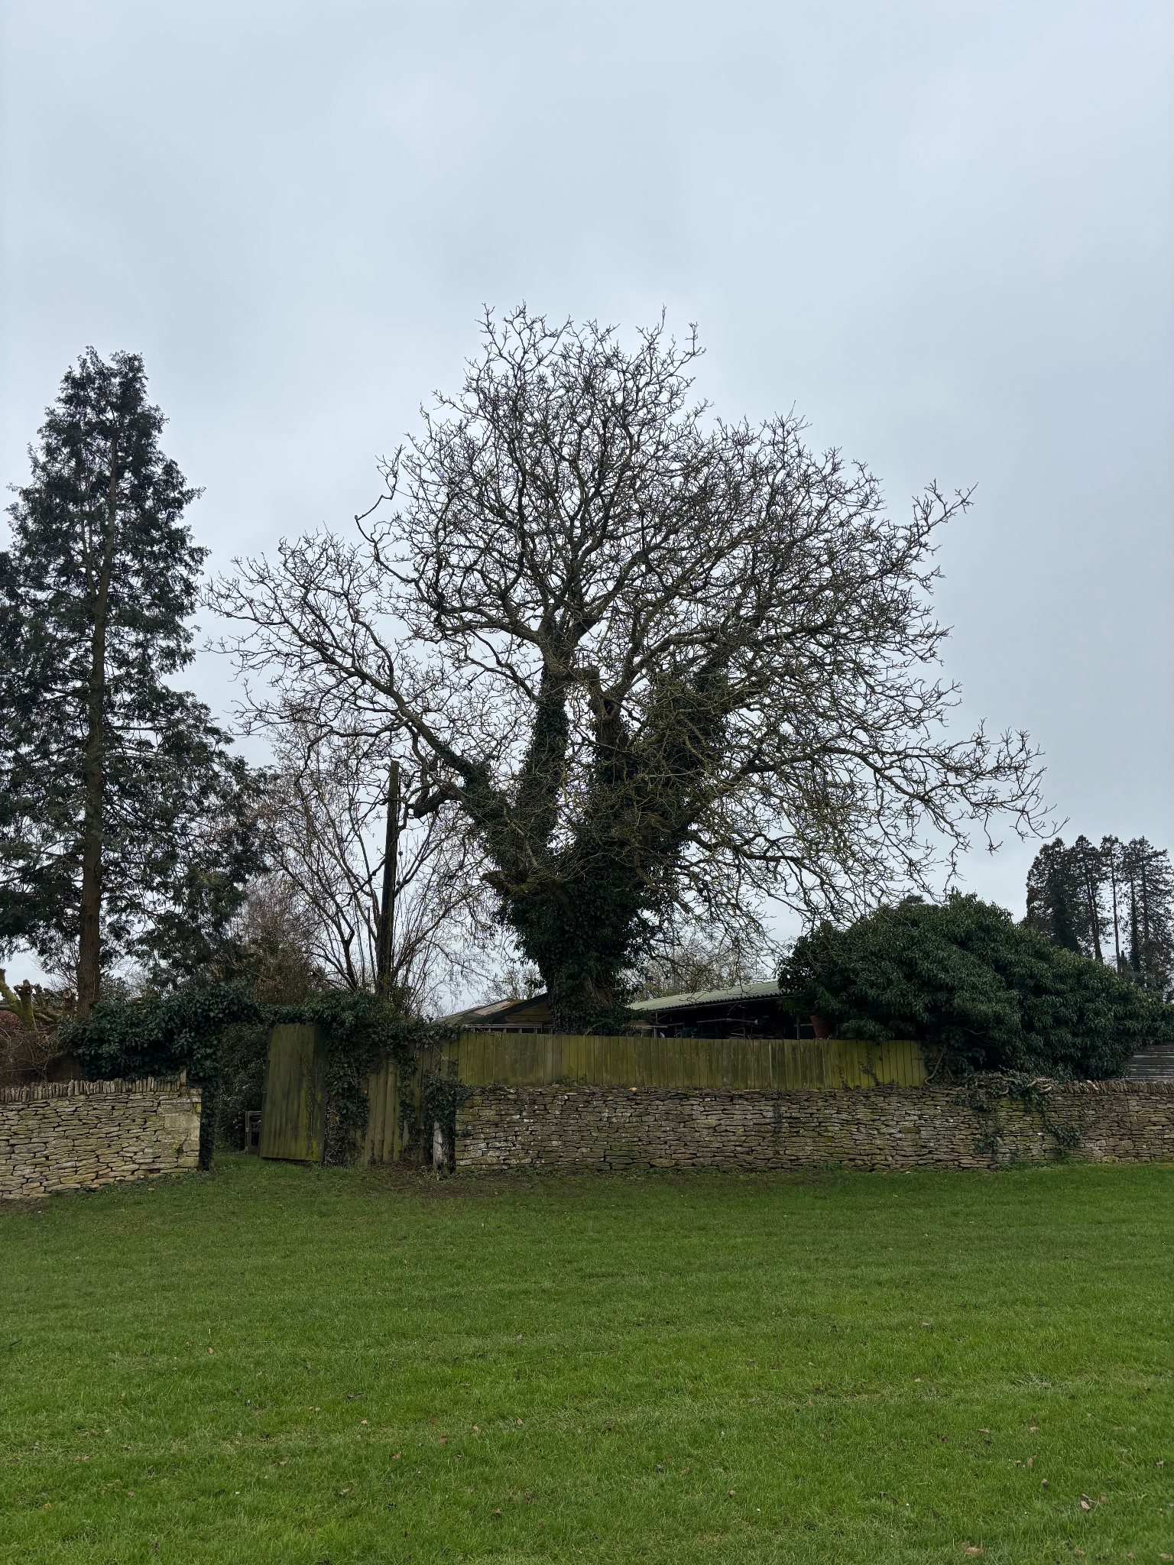

T2
Reduce Goat willow by 40%. This is because it is getting very out of hand and is starting to encroach on the house. It is also overhanging the cricket pitch and is starting to grow over it.
