 | Cranborne Chase  National Landscape  An area of outstanding natural beauty | 

NL Office, Rushmore Farm, Tinkley Bottom, Tollard Royal, Salisbury SP5 5QA
Tel: 01725 517417 info@cranbornechase.org.uk www.cranbornechase.org.uk

Georgina Wright
Development Management
Wiltshire Council

By email: Wright, Georgina <Georgina.Wright@wiltshire.gov.uk>

17th March 2026

Dear Georgina

pa 2025/10020 s73 Change of development at Service Station at Chicklade
Thank you for consulting CCNL on this change of details of development of the permission 2022/06298 by way of a s73 application varying condition 2. Despite the very obvious relevance of the National Landscape and International Dark Sky Reserve at this sensitive location neither the agent nor the applicant have sought advice from, or engaged with, this National Landscape.
The Partnership has the following comments on this application.
- The Cranborne Chase and West Wiltshire Downs NL (formerly AONB) has been established under the 1949 National Parks and Access to the Countryside Act to conserve and enhance the outstanding natural beauty of this area which straddles one County, three county scale Unitary, and one District Council. It is clear from the Act, subsequent government sponsored reports, and the Countryside and Rights of Way Act 2000 that natural beauty includes wildlife, scientific, and cultural heritage.

- It is also recognised that in relation to their landscape characteristics and quality, National Parks and National Landscapes are equally important aspects of the nation’s heritage assets and environmental capital.

- This NL/AONB’s Management Plan (2025-30) is a statutory document that is approved by the Secretary of State and is adopted by the constituent councils. It sets out the Local Authorities’ policies for the management of this nationally important area and the carrying out of their functions in relation to it, as required by section 89 (2) of the CRoW Act. The National Planning Practice Guidance [Natural Environment paragraph 040 (21.07.2019)] confirms that the NL and its Management Plan are material considerations in planning.

- The National Planning Policy Framework (February 2025) states (paragraph 187) that planning policies and decisions should contribute to and enhance the natural and local environment by protecting and enhancing valued landscapes, which include NLs, commensurate with their statutory status. Furthermore, it should be recognised that the ‘presumption in favour of sustainable development’ does not automatically apply within NLs, as confirmed by paragraph 11 and footnote 7, due to other policies protecting NLs elsewhere within the Framework.

- For decision making the application of NPPF policies that protect a NL ‘provides a clear reason for refusing development proposals’ (paragraph 11[d]). Furthermore paragraph 11(b) explains that, for plan making, being in a NL provides ‘a strong reason for restricting the overall scale, type or distribution of development in the plan area’.

- It also states (paragraph 189) that great weight should be given to conserving and enhancing landscape and scenic beauty in NLs, which have the highest status of protection in relation to landscape and scenic beauty. The conservation and enhancement of wildlife and cultural heritage are important considerations in these areas. This paragraph is also clear that the scale and extent of development within all the designated areas of NLs and National Parks should be limited. Furthermore, development within their setting should be sensitively located and designed to avoid or minimise impacts on the designated areas.

- Paragraph 190 is explicit that when considering applications for development planning permission should be refused for major development, other than in exceptional, public interest, circumstances. Footnote 67 also provides for the decision maker to regard development less than the threshold defined in the NPPF glossary as ‘major’ in the context of a NL or National Park.

- The National Planning Practice Guidance Natural environment - GOV.UK paragraph 042 highlights the importance of NL and National Park settings, their contributions to natural beauty, and the harm that can be done by poorly located or designed development especially where long views from or to the NL are identified. Paragraph 041 is clear that NPPF policies for protecting NLs may mean that it is not possible to meet objectively assessed needs for development, and any development in a NL will need to be located and designed in a way that reflects its status as a landscape of the highest quality.

- The NPPG explains [Natural Environment paragraph 039, (29.01.2025)] the statutory duty in section 85 of the CRoW Act, and confirms it applies to the setting of a NL. The duty applies to Local Government (including planning authorities), Ministers of the Crown, individual councillors, any public body, statutory undertakers and holders of public office. The recent change in s.85(1A) of CRoW Act 2000 applies equally across the Local Authority functions. The Levelling Up and Regeneration Act 2023 s.245 amended and strengthened s.85 of the Countryside and Rights of Way Act 2000 whereby a ‘relevant authority’, when carrying out any functions that may affect land in a NL, must seek to further the purposes of designation [namely, conserving and enhancing natural beauty]. The Council, its Councillors, and statutory undertakers all fall within the definition of ‘relevant authority’, as does the LPA and Planning Inspectorate. Government has provided guidance on this matter Guidance for relevant authorities on seeking to further the purposes of Protected Landscapes - GOV.UK as has the National Landscapes Association CRoW-s.85-duty-guidance-for-LPAs_NLA-Briefing-Nov-24.pdf on how relevant authorities demonstrate how they have sought to conserve and enhance the natural beauty of the designated area.

- More detailed information in connection with NL matters can be found on our NL website where there is not only the adopted NL Management Plan but also Position Statements and Good Practice Notes (Planning Related Publications). In particular when considering construction within the NL attention is drawn to our Good Practice Note on Colour in the Countryside.

- This NL is, as I expect you know, in one of the darkest parts of Southern England and hence the visibility of stars and, in particular, the Milky Way, is a key attribute of this NL. On the 18th October 2019 this NL/AONB was designated the 14th International Dark Sky Reserve in the world. Elements of a development that could contribute to light pollution, and hence impact adversely on those dark night skies, have to be designed out or modified so that such impacts are eliminated.

- This NL is, therefore, concerned about light pollution. Within the NL or on its periphery any external lighting should be explicitly approved by the Local Planning Authority and comply with the NL/AONB's Position Statement on Light Pollution and the more recent Good Practice Notes on Good External Lighting and Paper by Bob Mizon on Light Fittings. In this location that means all lighting complying with Environmental Lighting Zone E0 as defined by the Institute of Lighting Professionals 2021.

- On the 30th May 2022 the Cranborne Chase Area of Outstanding Natural Beauty Board endorsed a Position Statement on Biodiversity Gain (Position-Statement-12-Biodiversity-Net-Gain.pdf), and the Board looks to that guidance having immediate effect. That means that each home, or comparable sized development, should have at least one bird box, one bat box, and one bee brick incorporated into the structure. That level of provision is, nevertheless, fairly basic but it is our Board’s position that this National Landscape should, without delay, make a contribution to environmental net gain whenever and wherever there is development approved, at whatever scale, within this NL.

- The site is in the West Wiltshire Downs landscape character area of the Open chalk Downland landscape character type of the NL’s landscape character assessment. Greater details of the landscape, buildings and settlement characteristics can be found in Sustaining Landscape Character 2025, the Landscape Character Assessment 2024, and Cranborne Chase and Chalke Valley LCA 2018 Planning Resources - Cranborne Chase National Landscape. Those, and other relevant documents can be viewed on our website.

- I visited the area on Wednesday 4th March and observed that development is progressing, with not only the buildings having been cleared from the site but also much the excavation of the hillside completed and Instavolt advertising signs on the roadside verge, despite the pre-commencement conditions in the initial planning approval. The excavated chalk appeared to be being taken off site to a tipping area in a valley north-east of the site.

- The site is readily visible from the Ox Drove [Restricted Byway HIND4] an historic and popular recreational route on the high ground south of the site which runs more or less parallel to the A303. The vegetation on the sides of the Ox Drove cannot be guaranteed to persist and provide an element of screening as I observed areas where the PRoW had recently been cleared of fallen trees which had, of course, left gaps in that vegetation. There is a major PRoW crossways, where 3 parishes come together, on the ridgeline [where there is also a covered reservoir] and the route northwards [Bridleway CHIC5 & BOAT CHIC9], and down towards the A303, also provides views towards the site. The white excavated chalk cliff is extremely obvious and intrusive, providing the appearance of an industrial quarry which jars with the verdant countryside.

- I read that the covering letter with this application says development has commenced despite the explicit statement in condition 5 that ‘No development hereby approved shall commence on site until a boundary treatment and landscaping plan in respect of the strategic highway boundary; and a scheme of hard and soft landscaping for the rest of the site has been submitted to and approved in writing by the local planning authority.’ It appears, therefore, that the development is in breach of the original permission. This is not the first location in this NL where Instavolt have progressed developments in advance of planning approval and contrary to the National Landscape position.

- On Monday 9th March I received a ‘phone call from Patrick Durnford on behalf of the Fonthill Estate, which had been behind the original planning application. He confirmed that since the planning approval the Estate has leased the site to Instavolt which is why that company is now taking forward the development.

- You may be aware the Estate went to some lengths to engage with, and take into account the position of, CCNL in putting together the initial scheme which was approved 2022/06298. Considerable effort was expended by all parties to ensure the landscape and visual aspects, and particularly the lighting and control of light pollution in this International Dark Sky Reserve and the appearance of the development [including the signage], were mutually agreeable.

- It is, therefore, important that all the landscape and visual aspects, and particularly the lighting and control of light pollution and the appearance of the development [including the signage] are implemented as envisaged at that application stage. The black, white, and red standard Instavolt signage is not appropriate in a NL; highway users can be made aware of the facility without that overly stark and visually intrusive messaging.

- The s73 redesign changes the scope and extent of the developed area within the application area as well as amending the structures and parking areas within it. The number of EV charging points is significantly increased at the expense of landscape areas, and the landscape proposals appear to be watered down in both extent and specification from the approved scheme.

- I suggest it is relevant to take note of experience with another Instavolt site within this NL which is also located on a major A class and where the signage is excessive and unnecessary within a 30mph area. There, despite also being within a village, it is exceptional to see more than 2 of the 8 charging units being used at any one time and frequently none are in use. That experience indicates that increasing the charging points at the expense of important landscape elements of the Chicklade site is simply inappropriately industrialising the site and not focusing on the provision of a high quality site within a nationally important area.

- The Chicklade situation is both complicated and confused by the submitted landscape plans having the same numbers as the landscape plans for the discharge of landscape conditions application [25098 -LHC-00-XX-DR-L 9401 & 9402] whilst being significantly different and relating to a different site design.

- The additional backdrop of trees on the land immediately up the slope, northwards, shown on the discharge of conditions application is no longer proposed and the battery storage area is significantly enlarged.

- Furthermore, ‘new signage proposed to architects design’ has been added to the hardworks plan which is contrary to the agreement with the AONB [as it was then] only to have a single double-sided sign at the site entry.

- I saw on my site visit that the hillside has been excavated in a complete crescent, taking out the hillside behind the main building that would have supported a significant area of landscape planting. Furthermore, an additional area of hillside has been removed on the western side of the site which would also have supported significant landscape planting. With that excavation having taken place, it will be difficult for the plans submitted for the discharge of the landscape condition to be implemented. Although that excavation appears to echo the submitted s73 plan it does not comply with the approved plan.

- The proposed removal of the substantial landscape and planting area at the south-west corner of the main building and replacement by parking and charging spaces not only removes a significant green element at a key arrival position within the site that helps guide traffic but also the manoeuvring of vehicles in and out of those spaces will create an area of confusion at the entrance to the parking / charging areas. That is simply poor design that should be avoided.

- The lowering of the main building is likely to make it less of a signature building, and potentially less characterful internally. The change of proposed cladding materials is also likely to make the building less distinguished and less likely to achieve the high quality envisaged by the PPG for development within a NL [para 8 above].

- The approved scheme had PVs on the roof of the main building and a rainwater recycling system, but they do not appear on the submitted documents. The loss of PVs on its roof and the rainwater recycling count against the green credentials of the proposal. The elevations provided do not show the shelters over the charging points so it is unclear whether they are provided and whether they have PVs on them. Nevertheless, it appears that significant agreed sustainability features of the approved scheme would be lost if the current application to vary the condition listing the approved plans is approved.

- It is very concerning that not only is the amount of tree planting proposed to be reduced from the approved scheme but also the specification is being reduced, largely to mere 40-60cm whips. On a site of the scale proposed the small number of larger trees will have little impact, and it is not appropriate in a sensitive and nationally important area to have to wait a decade and more for the trees to achieve any meaningful size and effect. The wood pasture planting in the field to the north is now proposed as wildflower meadow with no trees, a much less biodiverse planting and not providing a wooded backdrop to the development.

- The Landscape and Boundary Treatment Strategy does not provide a specification and methods for getting the proposed landscape works established; it merely assumes everything is established and just needs maintaining. That is inadequate, as is the lack of focus on National Landscape matters in each of the ‘Design Intent’ sections.

- Furthermore, not only are the ‘Landscape Implementation and Management’ and ‘General Maintenance’ notes / statements on plan 9402 too vague to ensure the implementation of a scheme in a highly public situation in a NL but also the specification relies far too much on the goodwill of the landscape contractor. They lack the detail necessary to ensure the vision is rapidly and successfully established, and the precision necessary for the LPA to confirm the correct implementation and establishment.

- Regardless of other issues, in this NL situation, the reduction of identified specimen trees from 84 on the approved plan to 36 on the current submission is not acceptable. The loss of the wood pasture trees on the slope immediately north of the site, shown on the discharge of landscape condition plan, exacerbates the situation. Furthermore, the listing of ‘emergent native trees’ as percentage of a mixture with shrubs lacks the precision and clarity needed for both implementation and monitoring that would be provided by numbers of each species [which would be needed for tendering / ordering].

- The submitted documents create scope for confusion where the specification for a feathered whip is 40-60cm but is shown in a sketch as taller than a 1.2m post! I would have expected site sections and visuals to provide realistic demonstrations of what the landscape works would provide and look like.

- Discussions around the eventually approved scheme highlighted special concerns about the area between the service station circulation and the highway, and how glare from headlights would be avoided from the outset. Whilst the sections of this element appear to echo the original scheme, they do not include mature, containerised hedge planting to provide an immediate effect. Nevertheless, the sections appear to show two lines of feathered whips that are in the order of 1.5m high because they are twice the height of the 750mm closed boarded fence on the road side of the planting. However, the plan key shows that hedge as ‘New native species mixed hedgerow’ and the specification listed for that category of planting is ‘Feathered whip 40-60cm’. There is obvious scope for confusion and misunderstanding at this important point in the scheme. Whilst the dense planting of 1.5m high feathered whips could be acceptable, the 40-60cm plants would not.

- I read that soil from site would be used to create the bank between the highway and the site. As much of the site was already developed, the available soil is likely to be limited. The heights, levels, and structures in that critical area which faces the public domain do need to be set out clearly and in detail.

- Furthermore, it is not appropriate to refer to documents that are not submitted with the landscape proposals. The buildings and charging shelters do need to be shown in accurate visuals of the hard and soft landscape proposals.

- Importantly, from my site visit, it is obvious that the steepness of the excavated site has effectively created a crescent shaped white chalk cliff which is extremely visually obvious from a range of positions as well as providing an uncomfortably stark environment. Photos Annex A & Annex B. There is very little soil on site over the bedrock chalk, and the excavated sides of the site are so tall and steep that it will be difficult to get soil onto, and to stay on, the steep chalk face. Not only is there insufficient tree planting in relation to the approved scheme but also the proposed planting into the rockface will need the excavation of substantial tree pits and the provision of compost / topsoil which are not included in the specification.

- I am also very concerned that the created white cliff will remain as a stand out white scar in a predominantly verdant scene, not just from the surrounding countryside but also from the highway, for decades. That is because it will be challenging to establish the grassland backdrop within the site on that cliff which was envisaged and promoted as a feature of the original approval. ‘Greening’ that internal backdrop is a vital part of the landscape scheme that has not been addressed, beyond listing a seed mix. It seems likely, unless the terracettes discussed at the initial stage are installed across the slope, it will be very difficult to establish the envisioned south-facing grassland habitat and to maintain that habitat. Having a bare chalk backdrop, similar to the chalk exposure on the Winchester bypass, would be unacceptable to CCNL in such an obvious location.

- The ‘note’ on the drawings that they should not be used for Tender or Construction Purposes indicates that they are not sufficiently detailed to be enforceable by the LPA or to give confidence that the proposals are achievable.

- There is also the additional proposal for a solar farm on land to the north; Application 2026/00795. That would be a cumulative development, with it and the service station drawing attention to each other, and development extending up the rolling downland and out of the confines of the valley.

- The application for the solar farm proposal shows its access through the western side of the service station, from the service station entrance road, requiring further excavation of a roadway at right angles to, and through, the recently excavated chalk hillside. That route is not shown on the plans for the current variation / s73 application so there is not only a requirement for amended plans but also consideration of the extent to which that highly obvious route wrecks the symmetry of the excavated crescent which could, if successfully landscaped, be a positive feature of the development.

- It is very disappointing that neither a Lighting Strategy nor Lighting Specification have been provided, especially when it is clear that in this International Dark Sky Reserve there is an obligation to reduce light pollution year on year, and not merely to minimise the increase in light pollution. That is a sufficiently important topic that is not appropriate to leave to a condition because demonstrating that there will not be light pollution is a significant material consideration. Our Dark Skies Advisor is available to assist you in reviewing / evaluating lighting strategies and lighting specifications.

- I have not found anything in the submitted application that would enable the LPA to say that by approving the application it would be satisfactorily carrying out its duty under s85 of CRoW Act to seek to further conserving and enhancing the natural beauty of this National Landscape.

- As you will have gathered, CCNL is very concerned that excavation has proceeded beyond that envisioned in the approved scheme. That is exacerbated by the watering down of the landscape scheme, the scope for confusion with the remaining landscape proposals, concerns about the achievability of significant landscape elements, the apparent loss of the rainwater recycling, the loss of the PVs on the roof of the main building, the increase in the numbers of charging units at the expense of a significant landscape feature, the lack of clarity over the provision of shelters for the charging units and PVs on those roofs, the need for correction of the extent of signage, the need for a lighting strategy and specification that is IDSR compliant, and the potentially disruptive insertion of an additional roadway from the entrance into the steep encircling cliff to serve a potential solar farm. Until all those matters are resolved to the high quality appropriate to a national landscape, CCNL Partnership has to recommend most strongly that the proposal as submitted is refused.

I hope those comments are helpful to you.

Yours sincerely
Richard Burden

Richard Burden BSc DipCons MSc MCMI(rtd) MCIPD FLI PPLI
Chartered Landscape Architect
Principal Landscape & Planning Officer (part-time, Mon-Wed)
For and on behalf of Cranborne Chase National Landscape Partnership Board
richardburden@cranbornechase.org.uk

Attachments:
Annex A Site photo from south, Restricted byway HIND 4, with potential solar farm location behind.
Annex B Site photo from south west, Bridleway CHIC 5
Annex A Site photo from south, the Ox Drove, with potential solar farm location behind.

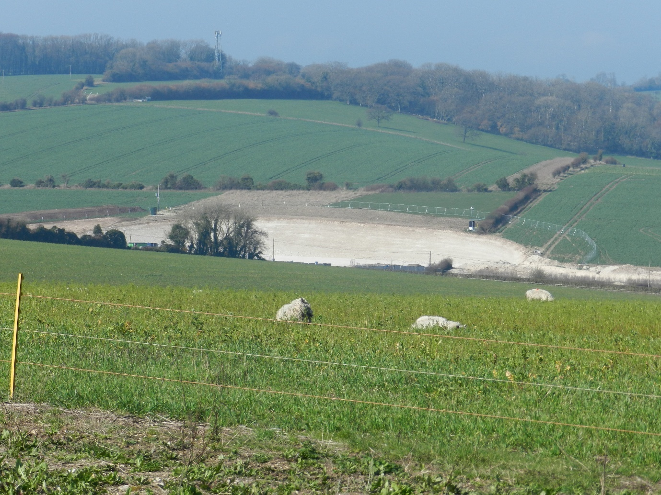

Annex B Site photo from south west, Bridleway CHIC 5

